
Title I, Part A: Quick Reference Guide on Services for Neglected Youth Reservation

Background
Districts are responsible for reserving Title I, Part A funds, as necessary, to provide services to eligible students living in locally operated facilities for neglected children within their district.
Specifically, districts must reserve sufficient Title I, Part A funds to ensure that these students receive services comparable to those provided to children attending Title I schools. Districts will achieve this through the Services for Neglected Youth reservation on the Title I, Part A District Reservations page in their ESSA application in GEM$. If a district does not have neglected students residing in a locally operated facility for neglected children, or if these children are already receiving Title I services at a district school, the district does not need to reserve funds.

This resource will guide you through the process of determining which students are eligible to be served by this reservation, selecting a methodology for reserving a reasonable amount of funding, and then identifying allowable uses of the reservation.

Definitions
A “local institution for neglected children” is defined as a public or private residential facility, other than a foster home, that is operated for the care of children who have been committed to the institution or voluntarily placed in the institution under applicable State law, due to abandonment, neglect, or death of their parents or guardians. To be considered a local institution for neglected children, the facility must primarily focus on serving neglected children (e.g., a mental health facility that serves some children who are neglected would not meet this definition because the facility’s focus is not mental health for neglected youth, but mental health for all youth).
For purposes of calculating this reservation, districts should not include neglected students in private foster homes and/or neglected students living in local facilities who are already receiving Title I services at a district Title I school.

Determining Student Eligibility for Services for Neglected Youth Reservation
Please use the decision tree below to determine whether your district must reserve funds for the Services for Neglected Youth Reservation on the Title I Reservations page in the ESSA Consolidated Application in GEM$. 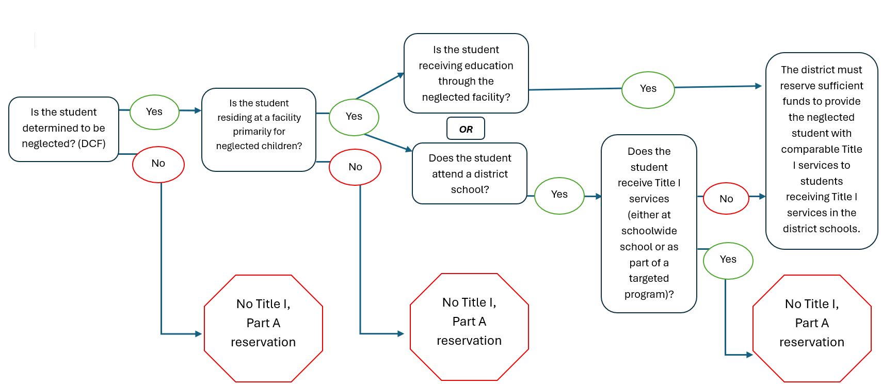

Acceptable Methods for Determining Reservation Amount
Districts must reserve enough funding to provide Title I services comparable to services provided at a Title I school/program. Neglected students should be included in the district’s Title I, Part A needs assessment. Districts should choose from the methods below to reserve an amount that is sufficient to provide services.
- Use the districtwide per-pupil minimum for Title I, if this is enough to satisfy the comparable services requirement.
- Reserve a percentage of the district’s total Title I, Part A allocation.
- Reserve a district-determined amount that is reasonable and necessary to satisfy the comparable services requirement.

Types of Allowable Supplemental Services that may be Provided with the Title I Neglected Reservation
The supplemental services provided to neglected students should be comparable to the services provided to children in Title I schools. At a basic level, Title I services are those supplemental services provided to students to allow them the opportunity to meet the same challenging state academic content and state student achievement standards that all children in the state are expected to meet. The district is responsible for providing these services (similar to providing services for private school students). Funds should not be provided to neglected facilities directly.
Please consider the following allowable uses of the reservation:
- Carrying out high-quality education programs supporting youth in meeting state academic standards. This can include but is not limited to tutoring programs, credit recovery or high school graduation supports, or other evidence-based interventions;
- Providing activities that facilitate the transition of such children and youth if they are moving between facilities or schools (e.g. increasing family engagement in transition by paying for transportation so parents can participate in transition team meetings or prerelease programming, paying for a transition specialist that works with youth in developing a plan and connects the student with available services);
- Coordinating health and social services so these students have the supports necessary for meeting state academic standards. Examples include planning time and coordination time for meetings between service providers, professional learning for educators to coordinate solutions that are working for students, providing space and time after school for the students and their families to have access to services they might not have easy access to during the school day;
- Special programing to meet the student’s academic needs, including vocational and technical education, career counseling, curriculum-based entrepreneurship education and assistance in securing student loans or grants for postsecondary education;
- Providing mentoring and peer mediation;
- Transporting students placed in neglected institutions to and from their school of origin;
- Offering professional learning opportunities for school district staff in order to support the identified needs of youth in neglected facilities;
- Paying LEA staff to coordinate and collaborate with the local child welfare agency and neglected institution to develop systems to transfer data in order for transitions to minimize disruption to the youth’s education to the extent possible.

