**Title I, Part D, Subpart 1 (State Agency Programs): Fiscal Reference Guide**

**Prevention and Intervention Programs for Children and Youth who are Neglected,**

**Delinquent, or At-Risk**

This fiscal reference guide is designed to support local and state agency staff in effectively managing and implementing Title I, Part D, Subpart 1 (Title I, D-1) funds. This guide provides information on fiscal requirements, reporting responsibilities, and best practices to ensure compliance with DESE and USED regulations.

**Program Purpose**: (Title I, D-1), also called The Prevention and Intervention Programs for Children and Youth Who Are Neglected, delinquent or At Risk, provides Title I, Part D, Subpart 1 funds to state agencies that operate educational programs for youth in adult correctional facilities, as well as for children and youth in the Department of Youth Services. (Title I, D-1) grants assist state educational agencies in preparing students in custody ages 12 to 21 (or up to 22 if they are eligible and still have a valid Individualized Education Plan) for a successful transition to education, training, or employment post-incarceration.

**GEM$ Application Workflow and Approval Requirements:**

* Grant applicants use the GEM$ grants management system to apply for funds for (Title I, D-1) grants in Massachusetts.
* Each grant application is required to go through a series of approval phases before the grant has final approval.

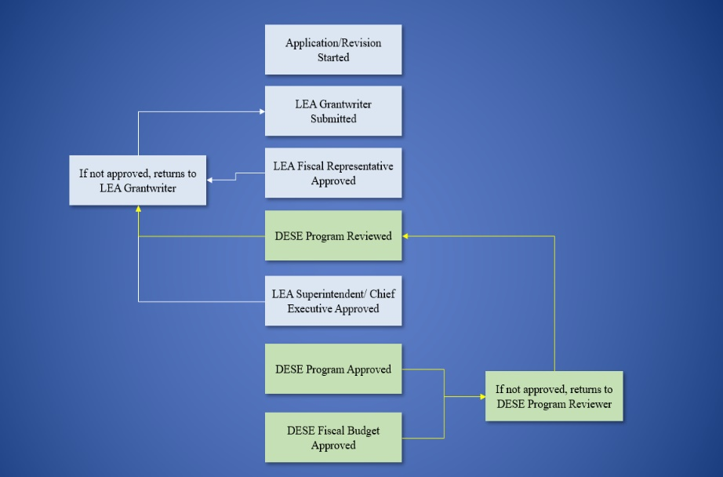

* Your DESE Federal Grants Liaison reviews/approves the application at the DESE Program Approval phase.
* Interdepartmental Service Agreement (ISA) is reviewed/approved at the DESE Fiscal Budget Approval phase.

**Workflow and Approval - Requirements**

**Regardless of the type of workflow, the following requirements must be observed:**

*Failure to follow these requirements will result in return of your funding application and possibly delay availability of funding.*

* The actual Superintendent/Chief Executive should be approving each funding application as the last LEA step in the workflow.
* In no case should the same person be submitting/approving a funding application in all LEA roles.
* Every instance of a funding application going through a workflow in GEM$ (whether it be a correction or revision/amendment), must have at least two different people submitting/approving for the LEA.
* If a surrogate is needed because the actual Superintendent/Chief Executive is not available such that a grant will be unreasonably delayed, that surrogate must be listed as an authorized signatory on the LEA’s current CASL form that has been submitted to DESE (see exception, noted above (*) for Community Colleges and other state entities with an ISA with DESE).

Please visit the “DESE Resources” tab in GEM$ for additional information regarding [GEM$ Application Workflows](https://mass.egrantsmanagement.com/DocumentLibrary/ViewDocument.aspx?DocumentKey=93788&inline=true) and [GEM$ User Role - Guidance and Forms](https://mass.egrantsmanagement.com/DocumentLibrary/Default.aspx?ccipSessionKey=638760117264477570).

**The Interdepartmental Service Agreement (ISA):**

The Interdepartmental Service Agreement (ISA) Form is issued by the Office of the Comptroller (CTR) pursuant to 815 CMR 6.00. The ISA Form is the “Contract” that documents the business agreement (joint venture) between two Commonwealth departments within the Executive, Judicial, and Legislative Branches of government.

For more information for completing this form, please see the [ISA Instructions](https://public.powerdms.com/MAComptroller/documents/2918141) and [CTR ISA Policy](https://www.macomptroller.org/announcement/updated-interdepartmental-service-agreement-isa-policy-and-form/) for guidance.

**Title I, Part D, Subpart 1 ISA Process and Timelines:**

The ISA documentation is required for State Agencies as part of the application process for (Title I, D-1) funding. The grant cannot be moved to the DESE Fiscal Approved status without a signed ISA.  Please note the ISA approval may add 4 to 6 weeks to the grant approval process. Keeping this in mind, it is important to plan ahead and submit your completed application in a timely fashion.

1. Once the application is moved to the “DESE Program Approved” step of the workflow in GEM$, Grants Management will begin the fiscal review.
2. The Grants Management (GM) office reviews the ISA budget information submitted as part of the application.
3. From information submitted on the ISA section and the budget tags selected, an ISA document will be generated by Grants Management.
4. The ISA document will then be uploaded into GEM$ as part of the grant file for the applicant to sign.
   1. To find the ISA document GM has prepared based on the approved budget, click into the grant, Sections>History log.
   2. Download the attachment.
5. Fill out all applicable parts of Attachment A in the ISA form before signing.
6. Once reviewed and signed by the applicant, the signed ISA should be uploaded to the grant file by the applicant.
   1. To do this, go to Sections>Create Comment.
   2. Create a comment and attach the completed ISA to your comment.
   3. Once the signed ISA is uploaded to the grant file by the applicant, Grants Management will receive a notification from GEM$.

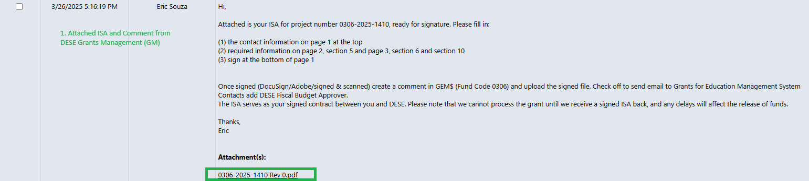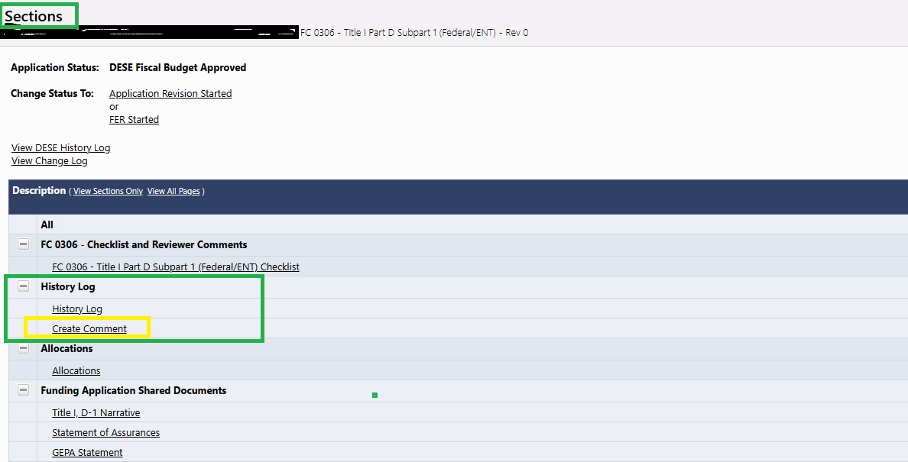

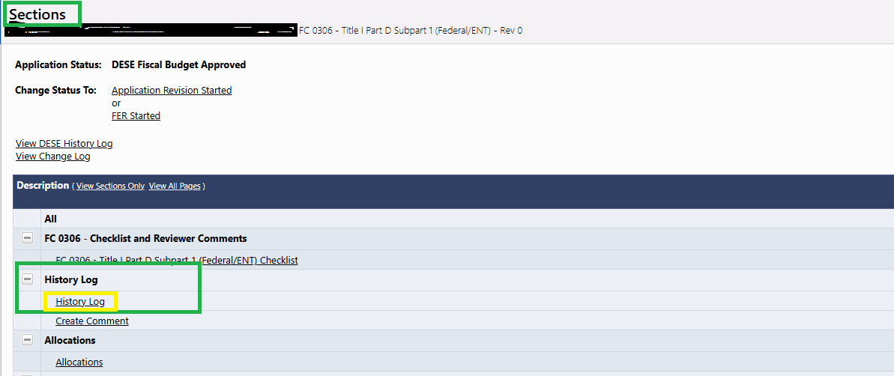

1. Next, the DESE budget office signs and processes the BGCN (MMARS document to establish fiscal year total ceiling for federal/trust ISAs) and BGRG (MMARS document to establish federal program code total (including all budget years covered by the ISA)) documentsin [MMARS](https://public.powerdms.com/MAComptroller/documents/1779234) and sends the ISA to Comptroller’s Office for final approval.
2. 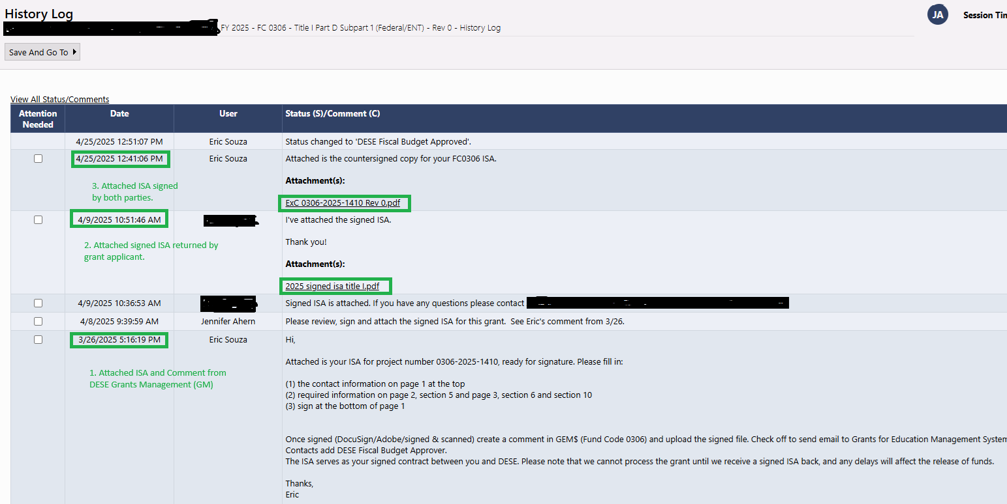Once the Office of the Comptroller (CTR) approves the ISA documents in MMARS, this fully executed ISA will then be attached to the GEM$ application file. Grants Management will notify you through GEM$ of final approval.
3. The grant will then be moved through the “DESE Fiscal Approved” step of the workflow in GEM$.
4. Since the ISA process is layered and funnels through many different DESE offices, it is imperative to get the signed ISA attached/uploaded as soon as possible so the setup can be completed timely, and applicants have access to their grant funding.
5. If an applicant wants to roll any unspent ISA budget into next fiscal year, they must confirm that they have sufficient uncommitted estimated receipts in the current fiscal year to roll. Send the ISA amendment to GM for review and processing. To initiate the process of amending your ISA, you will want to change the status of your application in GEM$ to “Application Revision Started” to make changes to the “ISA Budget Details” page. Amendments must be processed prior to the current ISA end date.

**ISA Close Out:**  
**If an ISA ended in the previous fiscal year (ending on 6/30):**

* ISA amendment is not needed – the remaining balance will be pulled back.

**If ISA ends in the current fiscal year (ending on 9/30):**

* Confirm that you have sufficient uncommitted estimated receipts in the current fiscal year and that all related fringe and indirect costs have been charged on the grant by the Office of the Comptroller (CTR).
* Send ISA amendment to return unspent funds back to DESE.

**Drawing Down Funds:**

All funds are transferred to the grantee via the ISA/MMARS setup process, so grantees are responsible for processing all eligible expenses in MMARS. All grant amendments and ISA requests for funds are managed through the GEM$ system.

**Final FER Reporting:**

At the conclusion of grant activities, recipients must submit a Final Expenditure Report (FER) to the Department, accounting for the expenditure on funds received. Please reference [Instructions for Submitting Final Financial Reports](https://www.doe.mass.edu/grants/edgrants/fr1-instructions.docx) for additional details.

**Resources:**

* [EdGrants & GEM$: User Guides, Information and Trainings](https://www.doe.mass.edu/grants/edgrants.html)
* [ISA Process and Timelines for ISAs on MMARS](https://view.officeapps.live.com/op/view.aspx?src=https%3A%2F%2Fwww.doe.mass.edu%2Fgrants%2Fedgrants%2Fisa-mmars-timeline.docx&wdOrigin=BROWSELINK)
* [MA Expenditure Classification Handbook](https://www.macomptroller.org/expenditure-classification-handbook/)
* [Grant Amendment vs ISA Amendment](https://view.officeapps.live.com/op/view.aspx?src=https%3A%2F%2Fwww.doe.mass.edu%2Fgrants%2Fedgrants%2Famendment-grant-vs-isa.docx&wdOrigin=BROWSELINK)
* [Federal Grants Cost Allocation](https://www.macomptroller.org/federal-grants-and-cost-allocation/)
* [GEM$ Revisions, Reimbursements and Reporting](https://mass.egrantsmanagement.com/DocumentLibrary/ViewDocument.aspx?DocumentKey=17685&inline=true)
* [Office of the Comptroller – State Finance Trainings](https://www.macomptroller.org/announcement/state-finance-training-for-new-finance-and-budget-employees/)

*For more in-depth information on Title I, Part D, Subpart 1, please visit* [*https://www.doe.mass.edu/federalgrants/titlei-d/stateprograms.html*](https://www.doe.mass.edu/federalgrants/titlei-d/stateprograms.html)

*For questions related to Title I, Part D, Subpart 1, ISA and Fiscal matters please contact the Grants Management Office at 781-338-6595 or email* [*EdGrants@mass.gov*](mailto:EdGrants@mass.gov)*.*