Author/Contributor Information
Regional Step-by-Step Team Members

The following are the members of the Massachusetts Association of Regional Schools (MARS) who wrote this Step-by-Step Process for Forming a Regional School District:

Stephen R. Hemman, Ed.D.
Executive Director MARS 2008 -present
Interim Superintendent for Somerset Berkley Regional School District
Consultant for Southwick, Tolland and Granville
Superintendent of Schools, Narragansett Regional School District 2000-2008
Business Administrator, Chittenden East School District, Vermont 1981-1985

Barbara J. Ripa, Ed.D.
Assistant Executive Director of MARS 2009 -present
Superintendent of Schools, Hampshire Regional School District 2005-2009
Consultant for Northern Berkshire Vocational Regional School District

Paul Gagliarducci, Ed.D.
Former Superintendent of Hampden Wilbraham Regional School District
Consultant for Southwick, Tolland and Granville regionalization process
Consultant for Northern Berkshire Vocational Regional School District

Ellen Holmes
School Committee Member, Ashburnham-Westminster Regional School
Committee, 1998-present
Chair, MASC Regional Schools Committee, 2004-present

Julie Ramos Gagliardi
Chair of Somerset Berkley Regional Planning District Committee
Presented Somerset Berkley Regional Agreement to Town Meetings

George Frost
Ayer Interim Superintendent, 2007-2011
Deputy Superintendent, Acton-Boxborough Regional Schools, 1994-2007
Regional School experience

Malcolm Reid
Shirley Superintendent and Helped Develop Ayer Shirley Regional School District
Boxborough Interim Superintendent
Director of Personnel, Groton-Dunstable and Acton-Boxborough Regional School
Districts
Principal in Groton-Dunstable, Boxborough and Acton-Boxborough Schools

Attorney Edward F. Lenox, Jr.
Partner in the law firm of Murphy, Hesse, Toomey and Lehane and has represented regional school systems for 30 years
Past President of the Massachusetts Council of School Attorneys
Counsel to the Ayer-Shirley Regional Planning Board and drafter of the Ayer-Shirley Regional Agreement
Counsel to the Chatham-Harwich Regional Planning Board and drafter of the Chatham- Harwich Regional Agreement

Table of Contents
Page

Author/Contributor Information. . . . . . . . . . . . . . . . . . . . . . . . . . . . . . . . . . . . . . . . i

Phase I Introduction. . . . . . . . . . . . . . . . . . . . . . . . . . . . . . . . . . . . . . . . . . . . . . . . . . . . . . . viii

Following the Pathway. . . . . . . . . . . . . . . . . . . . . . . . . . . . . . . . . . . . . . . . . . . . . . . . . . . x
Phase I Checklist. . . . . . . . . . . . . . . . . . . . . . . . . . . . . . . . . . . . . . . . . . . . . . . . . . . . . . . . . . xiv

Phase I: Forming/Expanding/Enlarging a Regional School District

Step 1: Preliminary Discussions

a. Begin Discussions and Contact DESE. . . . . . . . . . . . . . . . . . . . . . . . . . . . . 1
b. Identify Incentives to Regionalize. . . . . . . . . . . . . . . . . . . . . . . . . . . . . . . 6
c. Determine Type of Region. . . . . . . . . . . . . . . . . . . . . . . . . . . . . . . . . . . . . 8
MA Regionalization Models . . . . . . . . . . . . . . . . . . . . . . . . . . . . . . . . . . . . 11
d. Utilize Self- Assessment Tool for Measuring District Capacity . . . . . . . . 12
e. Determine Advantages to Regionalization. . . . . . . . . . . . . . . . . . . . . . . . 14
f. Determine the Challenges to Regionalization. . . . . . . . . . . . . . . . . . . . . . . . 15
g. Request Town Meeting for Appointing a Planning Committee . . . . . . . 18

Step 2: Regional Planning Committee and Regional Planning Boar
a. Form Regional Planning Committees . . . . . . . . . . . . . . . . . . . . . . . . . . . . 19
b. Form Planning Board and Elect Officers . . . . . . . . . . . . . . . . . . . . . . . . . . 21
c. Hire Consultants . . . . . . . . . . . . . . . . . . . . . . . . . . . . . . . . . . . . . . . . . . . . . 23
d. Confirm Selection of Regional School Model . . . . . . . . . . . . . . . . . . . . . . 25
e. Collect and Study Data. . . . . . . . . . . . . . . . . . . . . . . . . . . . . . . . . . . . . . . . 26
f. Develop Communications Plan . . . . . . . . . . . . . . . . . . . . . . . . . . . . . . . . . 30
g. Hold Focus Group Meetings (1st Series) . . . . . . . . . . . . . . . . . . . . . . . . . 37
h. Make Recommendation to Regionalize (Yes or No). . . . . . . . . . . . . . . . . 44
Step 3: Develop Regional Agreement and Long Range Plan
a. Contact DESE to Request Reorganization Needs Conference. . . . . . . . . 45
b. Develop the Draft Regional Agreement . . . . . . . . . . . . . . . . . . . . . . . . . . 47
c. Begin Writing the Long Range Educational and Structural Plan . . . . . . . 55

Step 4: Submission of Proposed Regional Agreement for Public Review
a. Conduct Focus Groups/Public Forums (2nd Series) . . . . . . . . . . . . . . . . 57
b. Planning Board Evaluates Feedback, Discusses Feedback, and Makes Appropriate Changes . . . . . . . . . . . . . . . . . . . . . . . . . . . . . . . 59
c. Present Final Regional Agreement to Public Prior to Vote . . . . . . . . . . . 61

Step 5: Voter and State Approval
a. Request Warrant Article for Town Meeting Vote . . . . . . . . . . . . . . . . . . 63
b. Vote by Ballot at Town Meeting . . . . . . . . . . . . . . . . . . . . . . . . . . . . . . . . 64
c. Sign Regional Agreement . . . . . . . . . . . . . . . . . . . . . . . . . . . . . . . . . . . . . . 65
d. Send Signed Agreement and Certified Votes to DESE for
Commissioner Approval . . . . . . . . . . . . . . . . . . . . . . . . . . . . . . . . . . . . . . 66

Phase II: Beginning as a New Regional School District
Phase II Introduction . . . . . . . . . . . . . . . . . . . . . . . . . . . . . . . . . . . . . . . . . . . . . . . . . . . . . . 68
Phase II Checklist . . . . . . . . . . . . . . . . . . . . . . . . . . . . . . . . . . . . . . . . . . . . . . . . . . . . . . . . . . 69
I. The First Stages of the Transition Period . . . . . . . . . . . . . . . . . . . . . . . . . . . . . . . 73
A. Powers and Duties of the Regional School Committee . . . . . . . . . . . . . . . . . . . . 73
B. Relationship between the Regional School Committee and
Local School Committees During the Transition . . . . . . . . . . . . . . . . . . . . . . . . . . 74
C. Termination of the Transitional Regional School Committee . . . . . . . . . . . . . . . 74
D. Calendar for School Committee Meetings . . . . . . . . . . . . . . . . . . . . . . . . . . . . . . 75
II. Develop Transition Timeframe
A. Calendar of Events . . . . . . . . . . . . . . . . . . . . . . . . . . . . . . . . . . . . . . . . . . . . . . . . . 75
B. The Tasks to Be Completed (in alphabetical order) . . . . . . . . . . . . . . . . . . . . . . . 76
III. Develop Process for New Policy Book . . . . . . . . . . . . . . . . . . . . . . . . . . . . . . . . . . 79
IV. Establish Sub-Committees
A. Communication . . . . . . . . . . . . . . . . . . . . . . . . . . . . . . . . . . . . . . . . . . . . . . . . . . . . 79
B. Negotiations . . . . . . . . . . . . . . . . . . . . . . . . . . . . . . . . . . . . . . . . . . . . . . . . . . . . . . 80
C. Regional Budget . . . . . . . . . . . . . . . . . . . . . . . . . . . . . . . . . . . . . . . . . . . . . . . . . . . 80
D. Policy . . . . . . . . . . . . . . . . . . . . . . . . . . . . . . . . . . . . . . . . . . . . . . . . . . . . . . . . . . . . 81
E. Strategic Plan . . . . . . . . . . . . . . . . . . . . . . . . . . . . . . . . . . . . . . . . . . . . . . . . . . . . . . 81
V. Technology
A. Web Site . . . . . . . . . . . . . . . . . . . . . . . . . . . . . . . . . . . . . . . . . . . . . . . . . . . . . . . . . . 81
B. E-mail System . . . . . . . . . . . . . . . . . . . . . . . . . . . . . . . . . . . . . . . . . . . . . . . . . . . . . 82
C. Hardware and Software for Central Office . . . . . . . . . . . . . . . . . . . . . . . . . . . . . . 82
D. Hardware and Software for Instruction . . . . . . . . . . . . . . . . . . . . . . . . . . . . . . . . 83
E. EPIMS . . . . . . . . . . . . . . . . . . . . . . . . . . . . . . . . . . . . . . . . . . . . . . . . . . . . . . . . . . . . 83
F. SIMS. . . . . . . . . . . . . . . . . . . . . . . . . . . . . . . . . . . . . . . . . . . . . . . . . . . . . . . . . . . . . 83
G. Phone System . . . . . . . . . . . . . . . . . . . . . . . . . . . . . . . . . . . . . . . . . . . . . . . . . . . . . 83
VI. Business Operations
A. Payroll and Accounting Systems . . . . . . . . . . . . . . . . . . . . . . . . . . . . . . . . . . . . . . 84
B. Retirement Systems - Teacher and County . . . . . . . . . . . . . . . . . . . . . . . . . . . . . . 84
C. Insurance Issues . . . . . . . . . . . . . . . . . . . . . . . . . . . . . . . . . . . . . . . . . . . . . . . . . . . 84
D. Obtain Federal ID Number and State LEA Number . . . . . . . . . . . . . . . . . . . . . . . 85
E. Bank Accounts . . . . . . . . . . . . . . . . . . . . . . . . . . . . . . . . . . . . . . . . . . . . . . . . . . . . . 85
F. Filing EOY (End-of-Year) Reports and E&D (Excess and Deficiency) . . . . . . . . . . 86
G. Hire Auditor . . . . . . . . . . . . . . . . . . . . . . . . . . . . . . . . . . . . . . . . . . . . . . . . . . . . . . 86
VII. Budget Development for the First Year of the Region (Including Grants) . . . . . . . . . . . . . . . . . . . . . . . . . . . . . . . . . . . . . . . . . . . . . . . . . . . . . 86
VIII. Curriculum and Instruction . . . . . . . . . . . . . . . . . . . . . . . . . . . . . . . . . . . . . . . . . . . . 88
IX. Professional Development . . . . . . . . . . . . . . . . . . . . . . . . . . . . . . . . . . . . . . . . . . . . . 89
X. Staffing for the New Region . . . . . . . . . . . . . . . . . . . . . . . . . . . . . . . . . . . . . . . . . . . . 89
A. Administration . . . . . . . . . . . . . . . . . . . . . . . . . . . . . . . . . . . . . . . . . . . . . . . . . . . . . 91
B. Teachers . . . . . . . . . . . . . . . . . . . . . . . . . . . . . . . . . . . . . . . . . . . . . . . . . . . . . . . . . . 91
C. Support Personnel . . . . . . . . . . . . . . . . . . . . . . . . . . . . . . . . . . . . . . . . . . . . . . . . . . 91
XI. Athletics . . . . . . . . . . . . . . . . . . . . . . . . . . . . . . . . . . . . . . . . . . . . . . . . . . . . . . . . . . . . . . . 92
XII. Special Education . . . . . . . . . . . . . . . . . . . . . . . . . . . . . . . . . . . . . . . . . . . . . . . . . . . . . . 92
A. Communication . . . . . . . . . . . . . . . . . . . . . . . . . . . . . . . . . . . . . . . . . . . . . . . . . . . . 92
B. Students . . . . . . . . . . . . . . . . . . . . . . . . . . . . . . . . . . . . . . . . . . . . . . . . . . . . . . . . . . 93
C. Staff . . . . . . . . . . . . . . . . . . . . . . . . . . . . . . . . . . . . . . . . . . . . . . . . . . . . . . . . . . . . . 93
D. Level of Services . . . . . . . . . . . . . . . . . . . . . . . . . . . . . . . . . . . . . . . . . . . . . . . . . . . 93
E. Technology . . . . . . . . . . . . . . . . . . . . . . . . . . . . . . . . . . . . . . . . . . . . . . . . . . . . . . . . 94
F. Location of Services . . . . . . . . . . . . . . . . . . . . . . . . . . . . . . . . . . . . . . . . . . . . . . . . 94
XIII. Merging Food Services and Custodial Services . . . . . . . . . . . . . . . . . . . . . . . . . . 94
XIV. If Building a New Building or Renovating and Old Building or a Combination
A. Working with the MSBA (Massachusetts School Building Authority). . . . . . . . . 95
B. Appoint a Building Committee . . . . . . . . . . . . . . . . . . . . . . . . . . . . . . . . . . . . . . . . 95
C. Feasibility Study . . . . . . . . . . . . . . . . . . . . . . . . . . . . . . . . . . . . . . . . . . . . . . . . . . . . 96
XV. Building Usage and Leases . . . . . . . . . . . . . . . . . . . . . . . . . . . . . . . . . . . . . . . . . . . . . 96
XVI. Transportation . . . . . . . . . . . . . . . . . . . . . . . . . . . . . . . . . . . . . . . . . . . . . . . . . . . . . . . . 97
Conclusion . . . . . . . . . . . . . . . . . . . . . . . . . . . . . . . . . . . . . . . . . . . . . . . . . . . . . . . . . . . . . . . . . 97

Appendices
A Massachusetts General Laws and Regulations Regarding
Regional School Districts . . . . . . . . . . . . . . . . . . . . . . . . . . . . . . . . . . . . . . . 98
B DESE Summary - Steps to Forming a Regional School District . . . . . 99
C Contact Information . . . . . . . . . . . . . . . . . . . . . . . . . . . . . . . . . . . . . . . . . . . . 109
D DART . . . . . . . . . . . . . . . . . . . . . . . . . . . . . . . . . . . . . . . . . . . . . . . . . . . . . . . . . . 111
E RFP - Request for Legal Services . . . . . . . . . . . . . . . . . . . . . . . . . . . . . . . . 112
F Self-Assessment Tool to Measure District Capacity . . . . . . . . . . . . . . 114
G Warrant Article . . . . . . . . . . . . . . . . . . . . . . . . . . . . . . . . . . . . . . . . . . . . . . . . 123
H1 Regional Agreement - Blank Form . . . . . . . . . . . . . . . . . . . . . . . . . . . . . . 124
H2 Sample Regional Agreement . . . . . . . . . . . . . . . . . . . . . . . . . . . . . . . . . . . 137
I Reorganization Needs Conference - DESE Form . . . . . . . . . . . . . . . . . 148
J Letter of Transmittal . . . . . . . . . . . . . . . . . . . . . . . . . . . . . . . . . . . . . . . . . . . 150
K Sample Transition Timeframe . . . . . . . . . . . . . . . . . . . . . . . . . . . . . . . . . . 151
L Sample Strategic Plan . . . . . . . . . . . . . . . . . . . . . . . . . . . . . . . . . . . . . . . . . . 157
M1 Audit Specifications . . . . . . . . . . . . . . . . . . . . . . . . . . . . . . . . . . . . . . . . . . . . 162
M2 Sample Audit . . . . . . . . . . . . . . . . . . . . . . . . . . . . . . . . . . . . . . . . . . . . . . . . . . 164
N1 Preparing the Regional Budget - DESE Publication . . . . . . . . . . . . . . . 170
N2 Budget Preparation - DESE Guidance . . . . . . . . . . . . . . . . . . . . . . . . . . . 176
O Stabilization Funds - DESE Advisory . . . . . . . . . . . . . . . . . . . . . . . . . . . . . 181
P Treasurer's Responsibilities . . . . . . . . . . . . . . . . . . . . . . . . . . . . . . . . . . . . . 183
Q Sample Lease Agreement . . . . . . . . . . . . . . . . . . . . . . . . . . . . . . . . . . . . . . . 186
R Regular Ed Trans. in the Transition Year - Sample Memo . . . . . . . . 200

Phase I - Introduction
“This agreement is entered into pursuant to Chapter 71 of the General Laws of Massachusetts, as amended and supplemented, between the Town of; and, the Town of ____________; and the Town of ___________; hereinafter sometimes referred to as the member towns for the establishment of a regional school district, hereinafter sometimes referred to as the District. In consideration of the mutual promises herein contained, it is hereby agreed as follows:” (M.G.L. Chapter 71, Sections 14-161 and the Regional School District Regulations, 603 CMR 41.00)

And so begins the legal document that will guide the educational future of the member communities that comprise a Massachusetts Regional School District. Steeped in more than a half century of tradition, communities have joined resources to provide outstanding educational opportunities to the school age children living within their boundaries. Regionalization is a “political, economic and educational marriage” that fulfills a constitutional responsibility to educate children in public schools. It is not an easy path. It is a process that demands goodwill, compromise and dedication. Most importantly, the process demands the trust of everyone involved albeit a citizen, a parent, or a political leader. The regional school district becomes an autonomous political entity with power and authority to set policy, budgets and determine educational programming. The involvement of the community in the establishment or re-design of a regional school district cannot be understated.
“A Pathway to Regionalization” is a cooperative document developed by the Massachusetts Association of Regional Schools (MARS) under the sponsorship of the Massachusetts Department of Elementary and Secondary Education (DESE). The document’s purpose is to provide a workable guide for communities who are considering developing or modifying a regional school district. The guide is divided into two parts: Phase I and Phase II. The format for Phase I is a detailed “step-by-step” process, outlining the statutory requirements and regulations in an understandable, chronological and workable format. The checklist provided for Phase I allows a Regional Planning Board to complete specific requirements as the committee moves toward a ballot vote and then transitions to the new regional school district. It is important to complete the steps in the order they are presented.
While the two organizations involved in this document are available for comment and guidance, the pathway approach reduces the need to rely solely on the agencies to respond to every question or issue. The document’s format highlights important statutes, legal issues and procedural steps that have been followed by other communities. The experiences of the organizations as presented in this document will help a Regional Planning Board avoid pitfalls that could potentially delay or doom the regionalization process.
A thorough analysis can make the challenge of merging independent districts less daunting by addressing community concerns. Superintendency Unions that move to full regionalization find the process somewhat easier since a centralized administration and coordination of services already exists. Planning studies also help districts resolve some areas of local concern through negotiation and via inclusion of language addressing concerns within the new Regional Agreement. Regional Agreement language can address elementary educational concerns, maintaining or closing town school buildings, determining the makeup/representation of the new regional School Committee, etc. Towns and districts that recognize that the advantages of greater articulation of curriculum and streamlined governance can, in the long-term, outweigh the fiscal challenges, and will discover creative ways to minimize those obstacles.
An extensive Appendix is located at the back of this manual and contains rich supporting information and sample documents. For example, Appendix A provides information regarding Massachusetts General Laws and Regulations regarding regional school districts and where specific information can be found. Appendix B provides a summary document prepared by the Department of Elementary and Secondary Education (DESE) regarding how to form a region, and Appendix C provides the names and contact information of individuals and agencies that districts will need to work with during the regionalization process.

The authors of this manual extend their best wishes as you begin this important process.

Following the Pathway
The basis for developing a regional agreement varies. Experience tells us that while there may be similarities, each time communities begin the discussion to investigate regionalization, the nuances and issues are never quite the same. New England communities historically have maintained a healthy but strong independence. Deciding to forego autonomy is not an easy decision. During the past decade, Massachusetts has experienced three very dramatic changes that have caused many communities to consider the possibility of utilizing district consolidation to improve their school district: 1) a decline in student enrollment; 2) economic uncertainty; and 3) facility issues and school building/renovation incentives. Consider these two examples:
A community that has operated its own K-8 school may come to realize that student population can no longer sustain adequate staffing levels to provide a full range of educational opportunities. While it may tuition its high school aged students to its neighbor’s high school, it may realize that administrative costs, staffing levels or meeting state and federal mandates can no longer be accomplished as an independent small district. The community may turn to its neighbor and ask to create a new regional district.
Two neighboring communities each operate their own small high schools. The costs to maintain and staff the two buildings may have reached a point where limited tax resources have been maximized. One or both of the buildings may also need major renovation or repair. The communities might begin a discussion of combining the two schools and seeking additional financial support from the MSBA to build a new or renovate a school. Such consolidation can result in an improved facility with increased programming, done in an affordable manner.

“A Pathway to Regionalization” sets a very clear process for communities to follow as they begin discussion. Each step along the way is detailed to allow a Regional Planning Board to meet the requirements of state law and the regulations, timelines and policies of DESE. The manual is divided into two distinct parts: Phase I and Phase II. In Phase I, “Pathway” begins with initial steps that will cause communities to ask the critical question: “Why regionalize?” Once substantial justification has been determined, the process identifies statutory and legal obligations that must be honored to begin the process. Along the way, steps are clearly identified, each step leading toward the ultimate goal of a new Agreement upon which each community’s electorate will decide.
The second phase of the process takes place after the new regional district has been approved by the electorate of each town involved. Phase II addresses the steps that are involved in transitioning away from the current, municipal district formats to the new single regional district format. This document provides steps that give legal and administrative advice including safeguards for the Regional Agreement to protect districts as they transition, and a quick reference of pertinent sections of state law.
Ultimately the goal of “Pathway” is to provide a user-friendly document that helps communities maintain control of their future through a less difficult process. The agencies involved in this project understand that forming a regional school district can appear to be a daunting task, but it doesn't need to be. The manual as presented is a comprehensive document, designed to address all steps necessary for districts with no current regional affiliation to follow as they form a new regional district. If however, you are seeking to expand or enlarge an existing regional school district, the process will be considerably easier, you may not need all sections of the manual and, quite possibly, you can reach your goal in a shorter period of time.
A successful process requires good faith, hard work and forming positive relationships. Establishing and maintaining regular conversations with the Regional School District Liaison at DESE will be invaluable. The Department is always ready to answer questions, provide helpful information, clarify a process, verify compliance and help you craft a comprehensive agreement document that meets the legal requirements and your local needs. When writing or re-writing the Regional Agreement, the Department can help you tailor the Agreement to address the unique concerns and circumstances of your district.
The end result of a new regional school district with a well-developed Regional Agreement provides compelling motivation and guidance through the process. The outcome of a new efficient region with a strong, vibrant and programmatically engaged course of study for students in the merging school communities can benefit many generations to come.

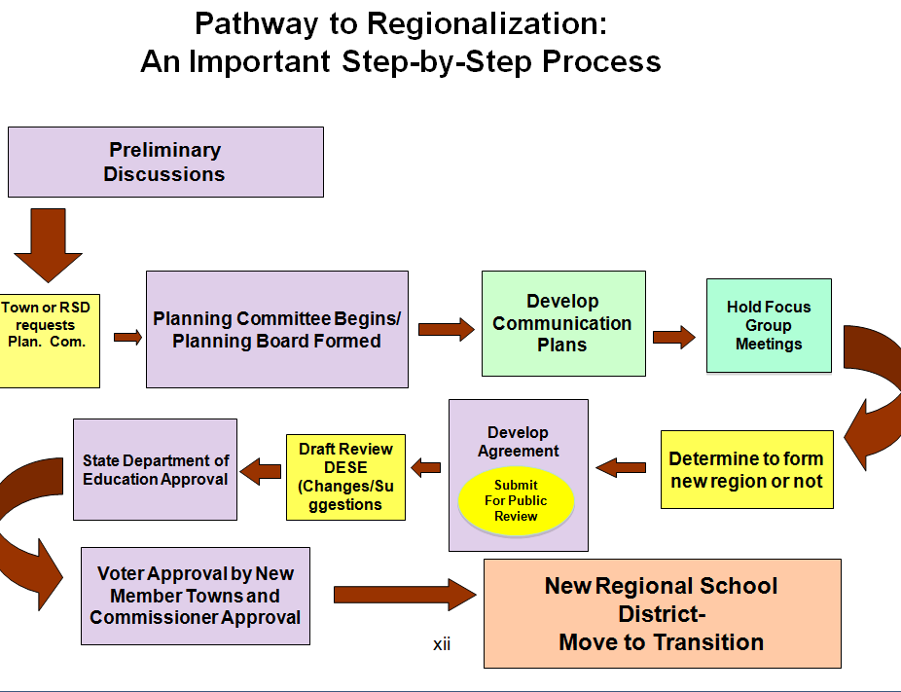

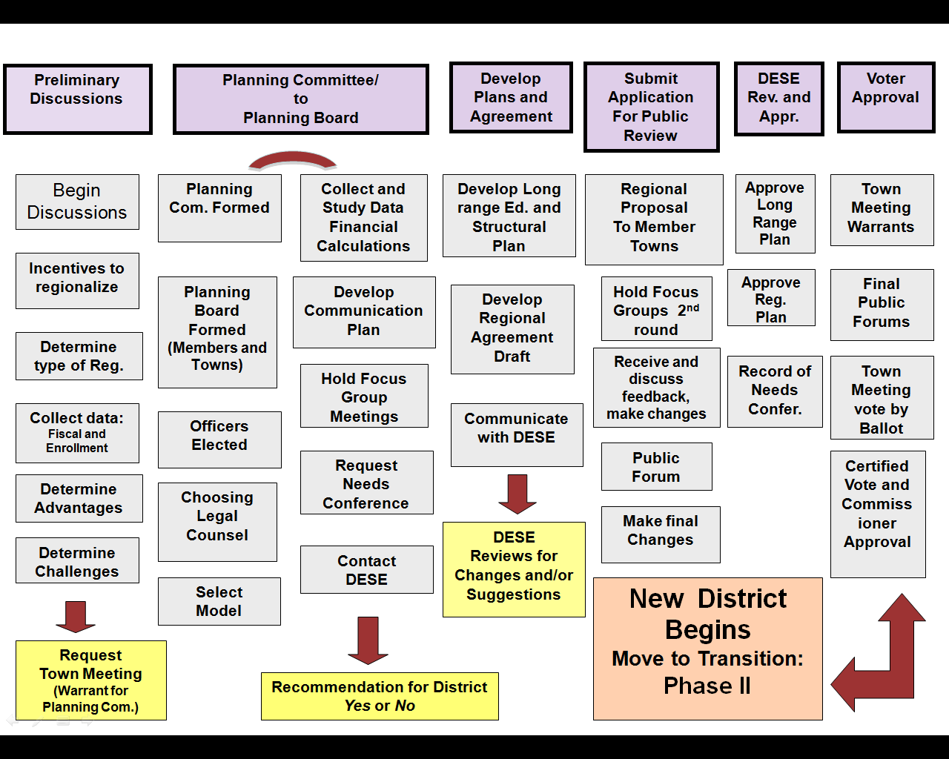

Phase I
Pathway to Regionalization
Checklist
Step 1: Preliminary Discussions Completed
- Begin Discussions and Contact ESE ___________
- Identify Incentives to Regionalize ___________
- Determine Type of Region ___________
- Utilize Self Assessment Tool for Measuring District Capacity ___________
- Determine Advantages to Regionalization ___________
- Determine Challenges to Regionalization ___________
- Request Town Meeting for Appointing Planning Committee ___________

Step 2: Regional Planning Committee and Regional
Planning Board Completed

- Form Planning Committees ___________
- Form Planning Board and Elect Officers ___________
- Hire Consultants ___________
- Confirm Selection of Regional School Model ___________
- Collect and Study Data ___________
- Develop Communications Plan ___________
- Hold Focus Group Meetings ___________
- Recommendation to Regionalize (Yes or No) ___________
Step 3: Develop Agreement and Long Range Plan Completed

- Contact DESE to Request Reorganization Needs Conference ___________
- Develop Draft Regional Agreement ___________
- Begin Writing Long Range Educational and Structural Plan ___________

Step 4: Submission of Proposed Regional Agreement
for Public Review Completed

- Conduct Focus Groups/Public Forums (2nd Series) ___________
- Planning Board Evaluates Feedback, Discusses Feedback,
and Makes Appropriate Changes ___________

- Present Final Regional Agreement to Public Prior to Vote ___________

Step 5: Voter and State Approval Completed

- Request Warrant Article for Town Meeting Vote __________
- Vote by Ballot at Town Meeting __________
- Sign Regional Agreement __________
- Send Signed Agreement and Certified Votes to DESE
for Commissioner Approval __________

