

**School Choice Spring Claim Form**

**User Guide**

July 2023

Version 2.0

Contents

Background Information 2

Overview 2

Accessing the School Choice Rosters and Claim Forms Application 3

Overview of the Spring Claim Form 5

Before getting started 5

Spring Claim Form 7

Section 1: District Contact Information 8

Section 2: District School Year Start and EndDates 8

Section 3: Spring Claim Form (October and March SIMS) 9

3.1 Sorting data 9

3.2 View student records 9

3.3 Export to Excel 10

3.4 Modifying student records 11

Final Rosters 19

Appendix A: Data Elements included in the *Spring Claim Form* 20

Appendix B: District Level and Student Level Validations in the *Spring Claim Form* 22

District Level Validations 22

Student Level Validations 23

# Background Information

The *School Choice Rosters and Claim Forms* application is now available in the School Finance Section on the [ESE Security Portal](https://gateway.edu.state.ma.us/). We will be using this new application to publish preliminary school choice rosters in the winter, process school choice claims in the spring, and publish final rosters in June at the end of the fiscal year. This application streamlines the school choice claiming process for districts by identifying students who were coded as school choice in the October and March SIMS collections. It also replaces the Excel-based rosters and claim forms with web-based forms, which will make it easier for districts to manage and update their data and allow the Department to implement stronger business rules to ensure accuracy of reporting. It is important to note that for now the *Special Education Increment Form* that is part of the *Spring Claim Forms* will continue to be an Excel-based form, but will be submitted through the *School Choice Rosters and Claim Forms* Application.

The Department releases aggregate school choice tuitions for sending and receiving districts twice a year, first in December based on the *Winter Rosters* and again in June based on the *Final Rosters*. The posted tuition amounts include adjustments to the prior year's calculations as well as special education increments and transportation costs.

On or before the last day of each month, the state treasurer assesses approximately one twelfth of each school district’s annual school choice tuition charges and pays one twelfth of the annual tuition receipts as part of the monthly local aid distribution. Since the annual estimates may change during the year to reflect current enrollments and special education increments and transportation, the monthly calculations will reflect these changes. These tuition amounts can be found on the monthly local aid distribution under School Choice Receiving Tuition and School Choice Sending Tuition.

# Overview

The *School Choice Rosters and Claim Forms* application contains student-level data and data elements obtained from SIMS. This information is used as the basis for calculating school choice payments (for receiving districts) and assessments (for sending districts) in the monthly local aid distribution each fiscal year.

Districts should review their school choice sending and receiving rosters after each school choice update, including the *Winter Rosters* (based on October, 1 SIMS) and the *Final Rosters* (based on October and March SIMS and final claim form submissions in April) to verify the accuracy of the data. If any edits are needed, district users can click *Request Edit(s)* at the top of the roster form on the *School Choice Rosters and Claim Forms Application* to request changes. A school finance staff member will respond to your request within two business days. Please note, if you have multiple edits, you only need to submit one request. Users will only need to request edits in the *Winter Rosters* and *Final Rosters* updates, for the *Spring Claim Forms* users will be able to make edits directly into the application.

Receiving districts are required to submit *Spring Claim Forms*, which will be populated with October and March SIMS, to finalize tuition payments for the fiscal year. This includes completing a separate *Special Education Increment Form* (Excel form) to claim instructional and transportation costs for special education students and updating start and/or end dates for students who are not enrolled as school choice students for the entire school year. The Department publishes *Final Rosters*, including receiving and sending rosters, based on the *Spring Claim Forms* in June of each fiscal year. The timeline is summarized below.

|  |  |  |  |
| --- | --- | --- | --- |
| **Application Update** | **Release Dates** | **Data Source** | **User Guide** |
| Winter Rosters | December/January | October SIMS | Winter and Final Rosters User Guide |
| Spring Claim Forms | April/May | October and/or March SIMS | Spring Claim Forms User Guide |
| Final Rosters | June | October and/or March SIMS and Claim Form data | Winter and Final Rosters User Guide |

# Navigating the School Choice Rosters and Claim Forms Application

##### Security Roles

There are two district-level security roles for this application in Directory Administration (DA).

* **School Choice Data User**: This role allows a person to review and update individual School Choice records to determine tuition amounts for school districts participating in the school choice program. This role should be assigned to the person who is verifying and entering the data.
* **School Choice Certification User**: This role allows a person to review and update individual School Choice records and certify the School Choice data for receiving school choice districts. This role should be assigned to the superintendent or superintendent's designee.

Please contact your district’s [Directory Administrator](https://www.doe.mass.edu/infoservices/data/diradmin/list.aspx) to be assigned the appropriate role. Please note that Department school finance staff cannot assign user roles for district-level staff. For questions about adding or changing a security role please see the Quick Reference Guide on the [Directory Administration - Information Services/Data Collection](https://www.doe.mass.edu/infoservices/data/diradmin/) website.

Once you have been assigned a security role and you have logged into the [ESE Security Portal](https://gateway.edu.state.ma.us/) the next step is to navigate to the Application List, locate the School Finance Section, and click on *School Choice Rosters and Claim Forms*.

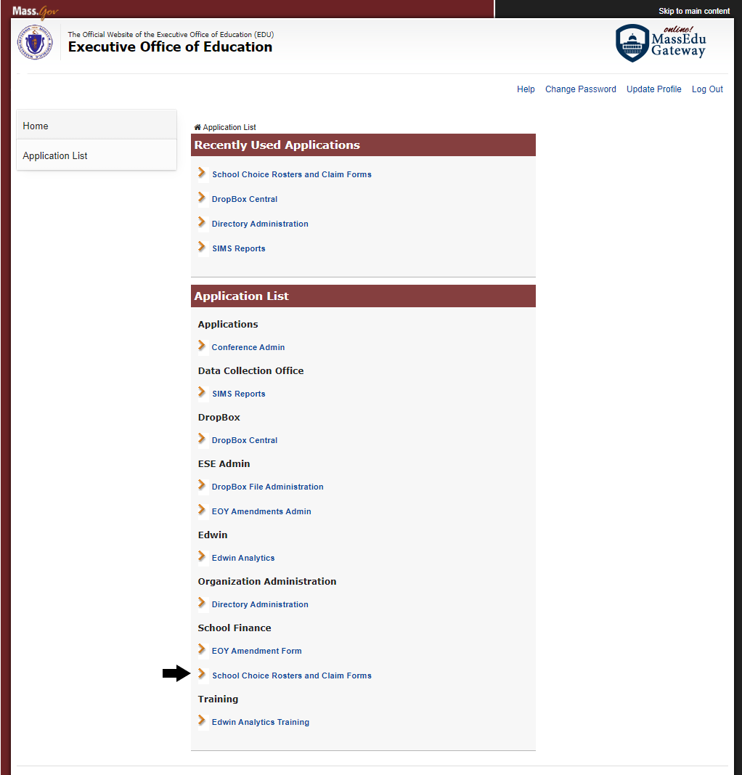

# Overview of the Spring Claim Form

Only receiving districts are required to submit a *Spring Claim Form*, which is populated with October and March SIMS data to finalize tuition payments for the fiscal year. This includes adding or updating student records and updating *Start* and/or *Leave Dates* for students who are not enrolled as school choice students for the entire school year. To claim reimbursements for school choice students receiving special education services, the specific cost associated with the student's program must be calculated using the school choice *Special Education Increment Form* available as part of the application. Once you click on the application you will select the fiscal year and roster type (receiving) to view your *Spring Claim Form*.

Please note, if your district does not participate in the school choice program, families still have the option to enroll their children in a participating district. When non-participating districts select their district name from the dropdown menu, the message, “No receiving school choice students reported in SIMS” will be shown for this update. Districts who are not participating in the school choice program do not need to submit a *Spring Claim Form*. Sending districts should review their *Final Rosters* that will be released in June.

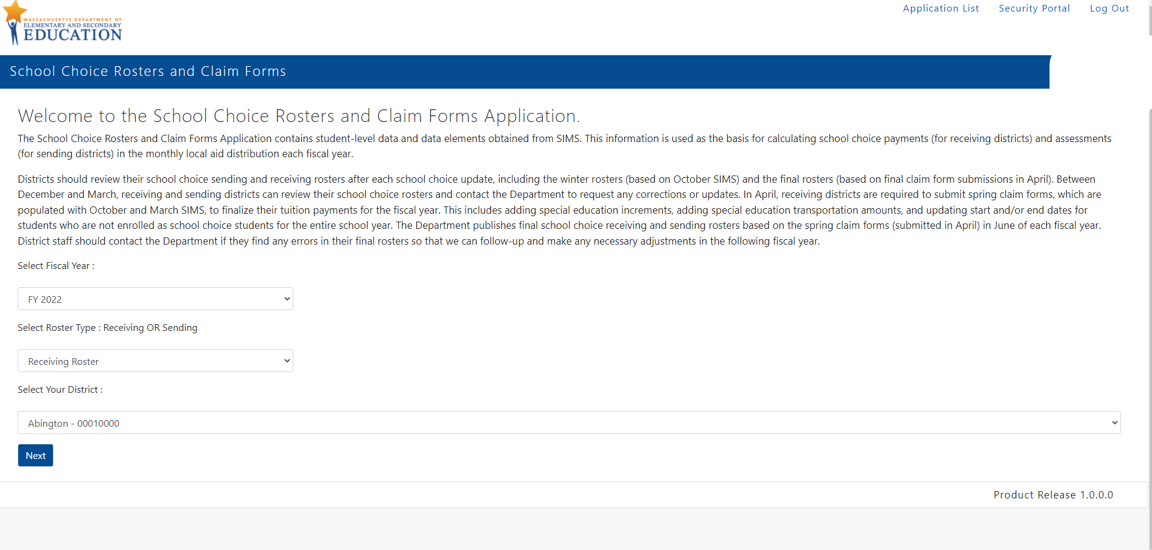

## Before getting started

There are few resources available within the application to help answer any questions that you have as you start to work on it:

* School Choice Spring Claim Form User Guide (this document)
* [SIMS Data Handbook](https://view.officeapps.live.com/op/view.aspx?src=https%3A%2F%2Fwww.doe.mass.edu%2Finfoservices%2Fdata%2Fsims%2Fsims-datahandbook.docx&wdOrigin=BROWSELINK)
* Contact Department staff at [SchoolChoice@mass.gov](mailto:SchoolChoice@mass.gov)

On left side bar under the *Spring Claim Form* section of the application you can find the most current *SIMS Data Handbook*. It contains information about the SIMS variables that are collected in the SIMS collections. Please refer to Appendix A to learn more about the variables displayed in the application.

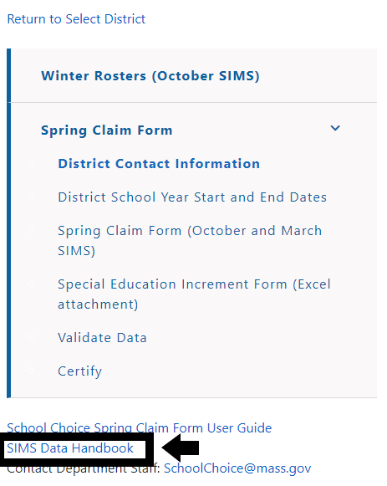

If you have questions about the application, you can select [SchoolChoice@mass.gov](mailto:SchoolChoice@mass.gov) on the left side bar under the Spring Claim Form section to generate an email. Please note you may need to change your email settings for this function to work, see below.

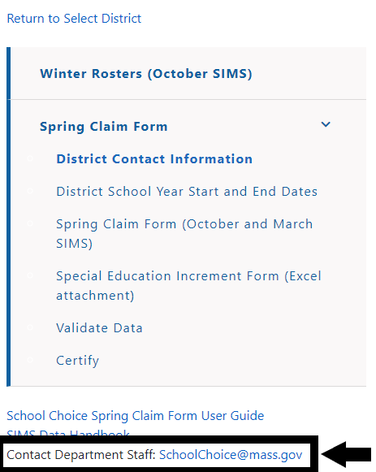

If you are unable to directly send an email you can either cut and paste the email address into a new email or you can change your email setting by following the steps below:

* Go to Settings on your computer’s task bar
* Navigate to Accounts
* Select Email and Accounts and add the account that you will be sending the email (e.g., Outlook, Office)

# Spring Claim Form

There are six sections in the *Spring Claim Form* that need to be completed by receiving districts. Users will see these sections on the left side bar after logging into the application:

* Contact Information
* School Year *Start* and *End Dates*
* Spring Claim Form (October and March SIMS)
* Special Education Increment Form (Excel attachment)
* Validate Data
* Certify

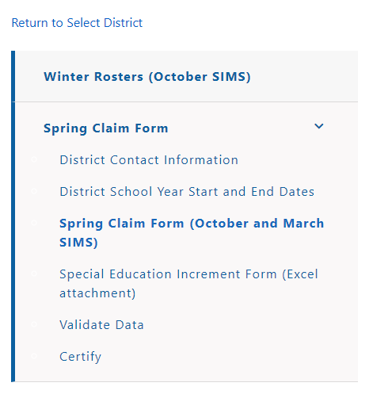

## Section 1: District Contact Information

In this section you will enter the contact information for district staff completing the *Spring Claim Form* and *Special Education Increment Form*. Please note, the district staff member who completes the district’s Special Education Circuit Breaker claim should also complete the *Special Education Increment Form* and be listed as the contact. If your district does not need to claim special education increments for any of your school choice students, you do not need to add a *Special Education Increment Form* contact. Remember to press *Save* once you complete this section. You will not be able to move to the next section of the form without providing this information. Please remember to include phone extensions in this form so that we can reach you if we have any questions about your submission.

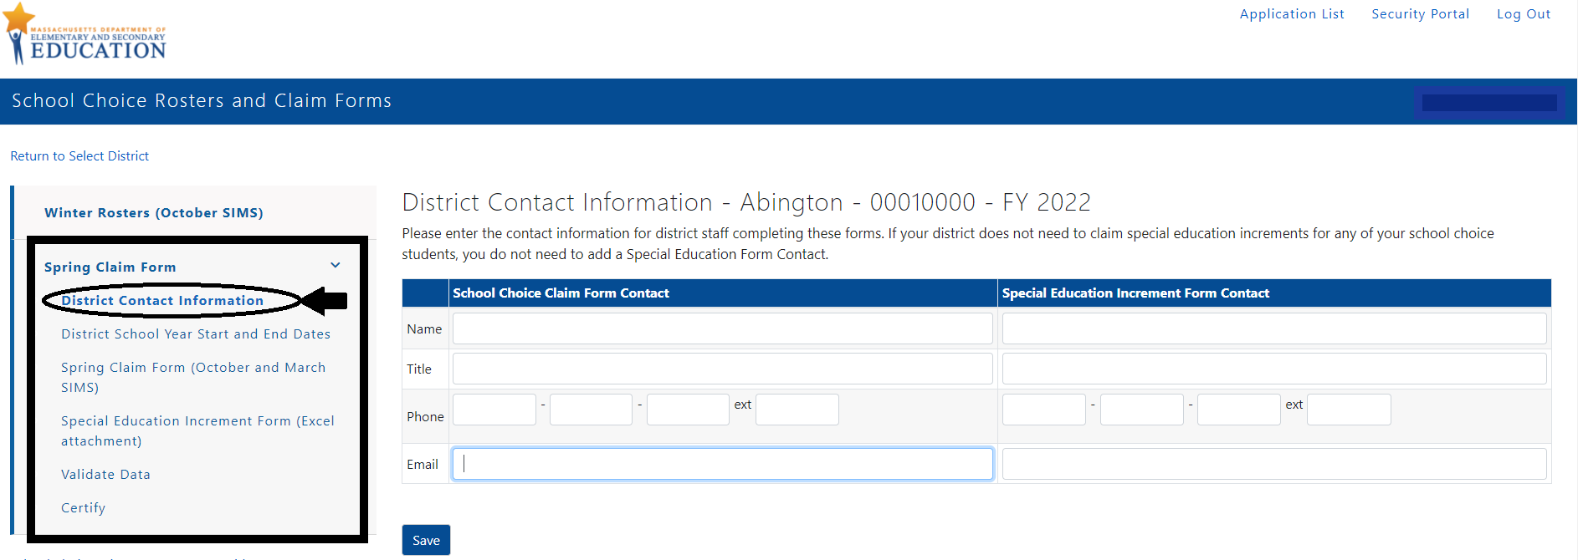

## Section 2: District School Year Start and EndDates

In this section you will enter the first day of school and the last day of school for the district for the 2022–23 school year. The dates that are entered on this tab will be populated into the *School Choice Claim Form* as the *Start* and *Leave* *Dates* for full-year students after you submit your district’s data. Remember to press *Save* once you complete this section. You will not be able to move to the next section of the form without providing this information.

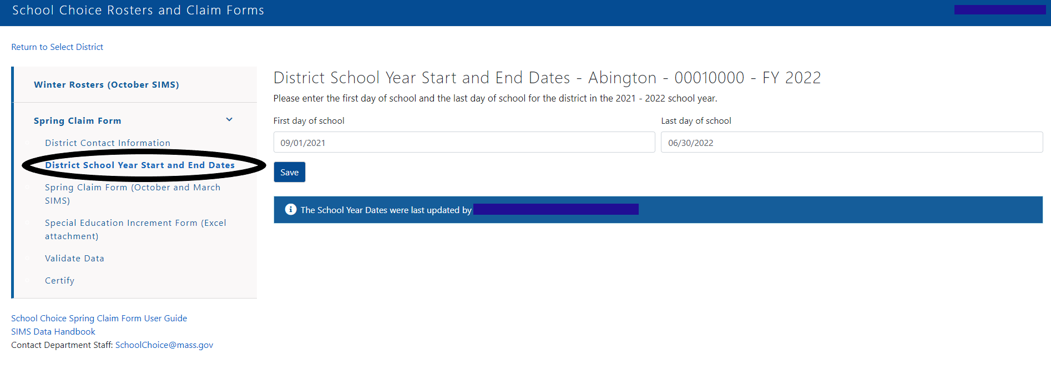

## Section 3: Spring Claim Form (October and March SIMS)

The *Spring Claim Form* includes the list of students that your district reported and certified as school choice in the October and/or March SIMS collections. On this form you can view additional details about each student, export the data to Excel, add and delete students, and edit student data. Some students will have two records on the form if their city/town of residence or Career Vocational Technical Education (CVTE) code changed between the October and March SIMS collections. You will be prompted to update the *Start* and *Leave* *Dates* for students reported as school choice in October or March SIMS on the *Validate Data* page, see below. It is important that you update *Start* and *Leave Dates* for students who were not enrolled as school choice in your district for the entire year or who moved during the course of the year so that the Department can prorate tuition to the correct sending district(s). You do not need to update dates for full-year students, the *Start* and *Leave Dates* for those students will be populated with the district’s Start and End Dates when you certify and submit the form.

It is important to note that the validation rules built into the application will not identify every student record that needs to be updated so it is important that you review each student’s record for accuracy and make the necessary changes.

### 3.1 Sorting data

Users can sort the data in the form based on different data elements, including SASID, first name, last name, grade level, and city/town name. We suggest that you sort based on SASID to make it easier to identify duplicate records. Several fields will be blank and not be able to be edited by district users including FTE, special education increment, special education transportation, regular/CVTE or virtual rate, school choice tuition, and total cost fields. These fields will be populated by Department staff when we release the *Final Rosters*.

### 3.2 View/Edit student records

The *View/Edit* link next to each student’s record on the summary table gives users access to detailed information on each student. Users can view or modify the student record by clicking on *View/Edit*.

View/Edit 
This image shows the View/Edit column in the application. 

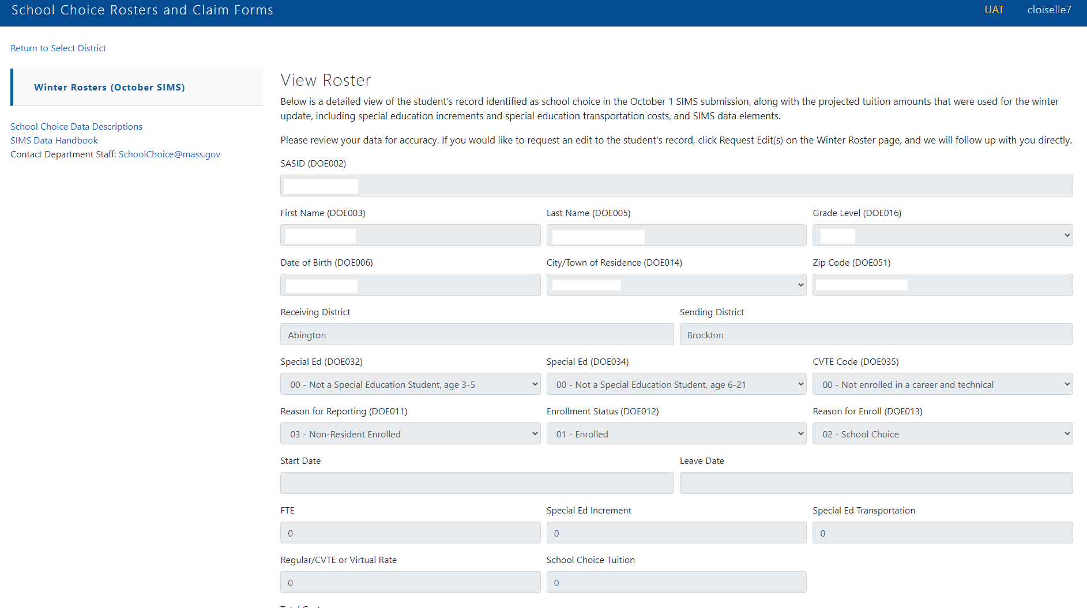

### 3.3 Export to Excel

Users can export their district’s data to Excel by clicking *Export to Excel* on the top right-hand corner of the page.

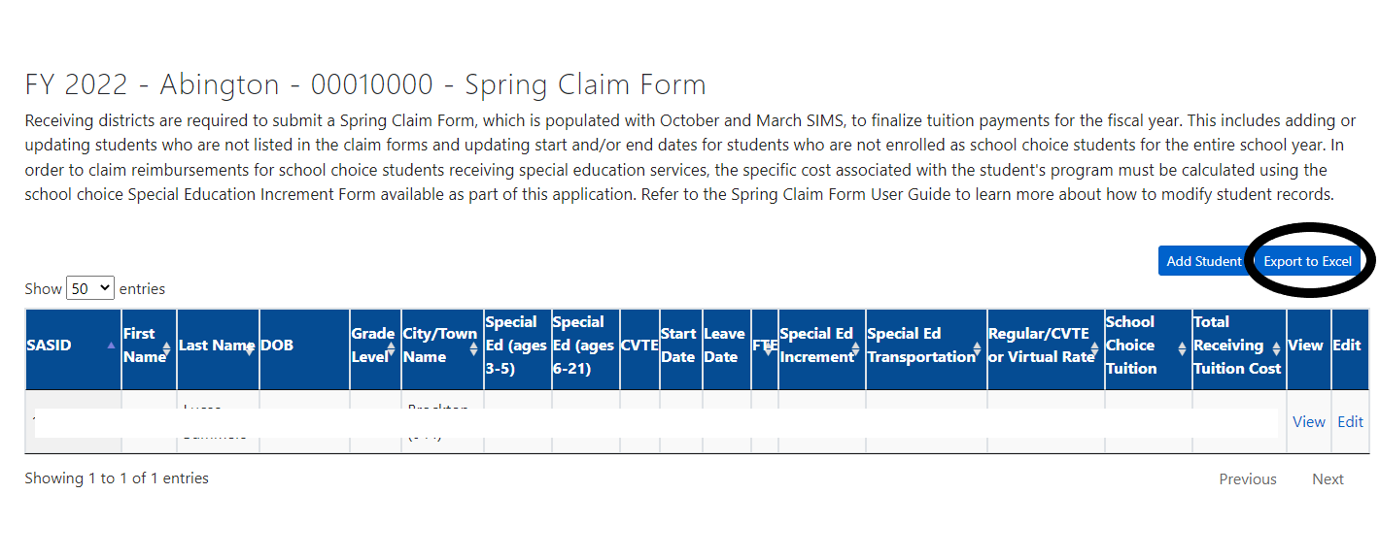

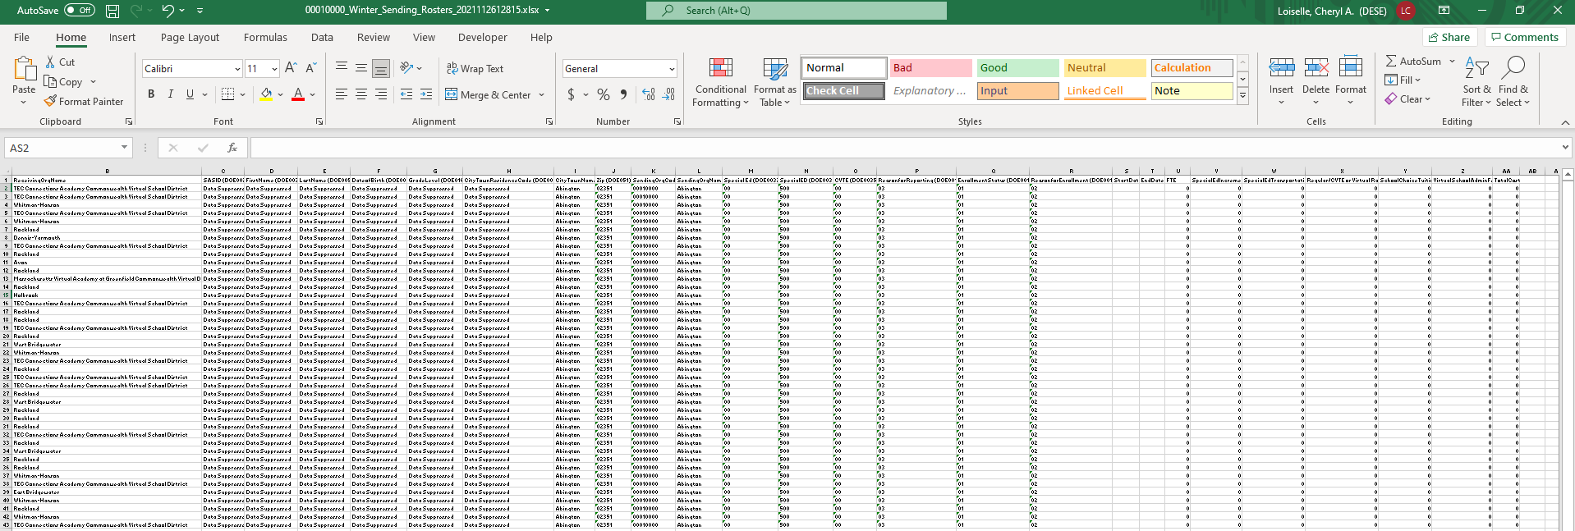

### 3.4 Modifying student records

Users should consider the following questions when reviewing the data and making modifications to student records:

1. Are there any students missing who should be coded as school choice but are not included on the *Spring Claim Form*? **(Adding students)**
2. Are there any students on the *Spring Claim Form* who should not be coded as school choice this school year? **(Request to Delete Student)**
3. Are there any students on the *Spring Claim Form* who attended the district as school choice for only part of the school year, rather than the whole year? **(Updating Start and Leave Dates)**
4. Are there any students on the *Spring Claim Form* who moved to a different city/town of residence or changed their CVTE status? (**Change of residence or CVTE status)**

In order to quickly identify student records that need to be modified, users can navigate to the *Validate Data* section of the *Spring Claim Form*, see the description below. In this section, student records that need to be updated based on the difference in how the students were reported in October and/or March SIMS are listed with a link to take you to the student record along with a description of the error that needs to be addressed. Please note that the business rules in the application will not identify every student record that needs to be modified, so users should check their data carefully and update records accordingly.

#### 3.4.1 Adding students

Click the *Add Student* link on the top right of the *Spring Claim Form*. Users will be prompted to enter the student’s SASID.

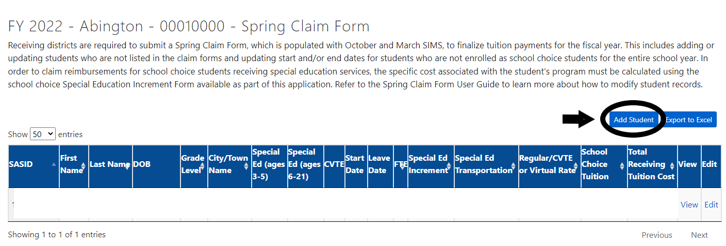

Once the student’s SASID is entered the student’s SIMS data will be populated. Users will need to update elements of the student’s record, see the list of data elements that will need to be updated below. Please refer to the [SIMS Data Handbook](https://view.officeapps.live.com/op/view.aspx?src=https%3A%2F%2Fwww.doe.mass.edu%2Finfoservices%2Fdata%2Fsims%2Fsims-datahandbook.docx&wdOrigin=BROWSELINK) for additional information. For new students, *Start* and *Leave Dates* need to be entered and will not be populated with the district’s first and/or last day of school. If the student was enrolled for the entire year, enter the district’s first and last days of school as the *Start* and *Leave Dates*, otherwise adjust the dates accordingly based on the days that the student was enrolled. For example, if the student started after the first day of school and you expect that they will be enrolled for the entire year, enter the date that they started attending as a school choice student as their *Start* *Date* and the district’s last day of school as their *Leave Date*.

* Grade (DOE16)
* City/town (of residence) (DOE014)
* Zip code (DOE051)
* Special Ed (DOE032)
* Special Ed (DOE034)
* CVTE Code (DOE035)
* Reason for Reporting (DOE011)
* Start Date
* Leave Date

Remember to press the *Add Student* at the bottom of the page after you have completed entering the student’s information.

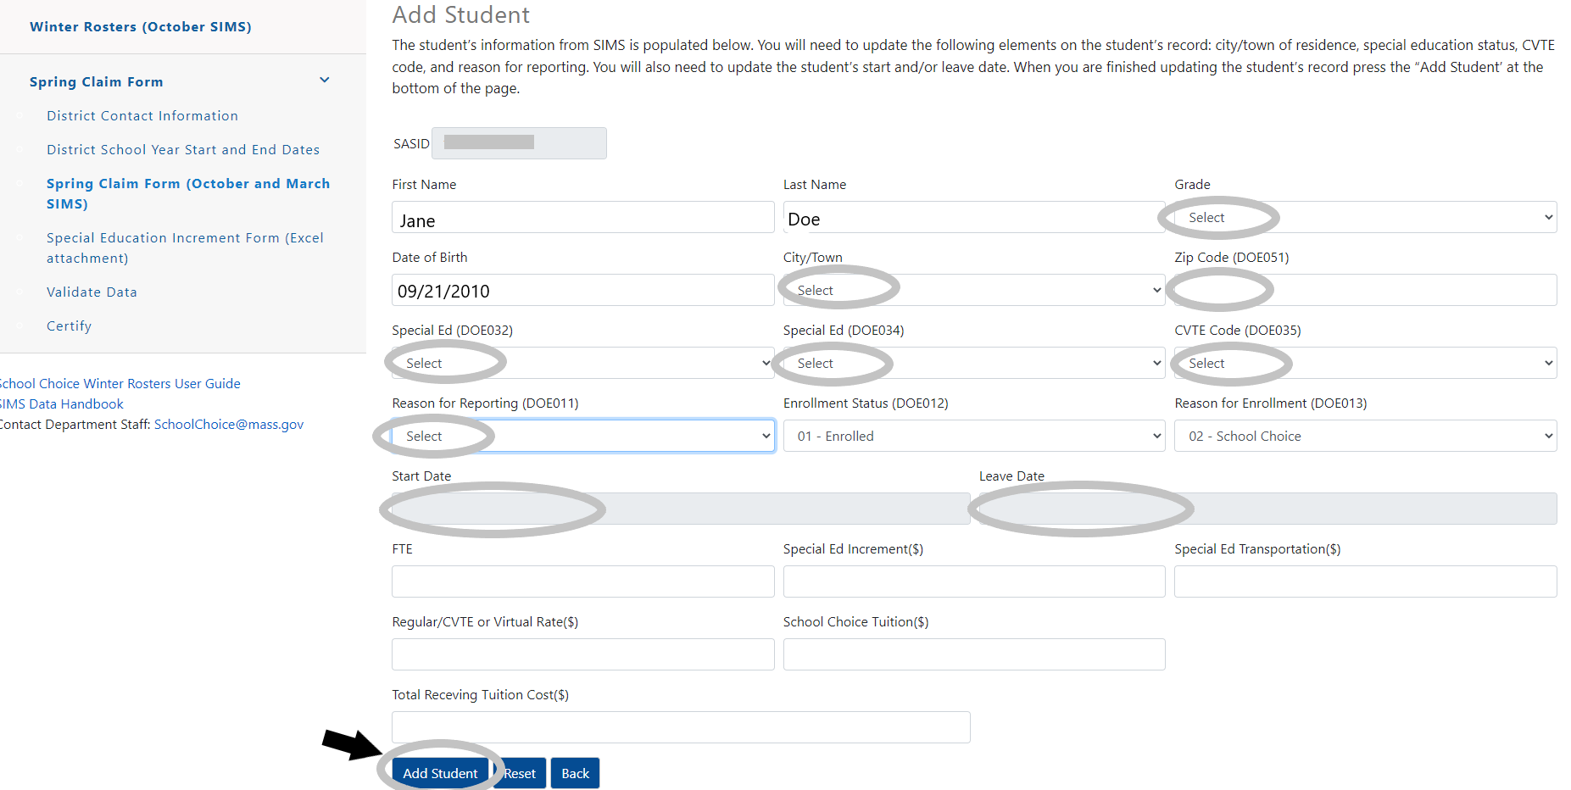

#### 3.4.2 Deleting student records

If a student is included on the *Spring Claim Form* who should not be claimed as school choice, click the *View/Edit* link next to the student’s record on the form.

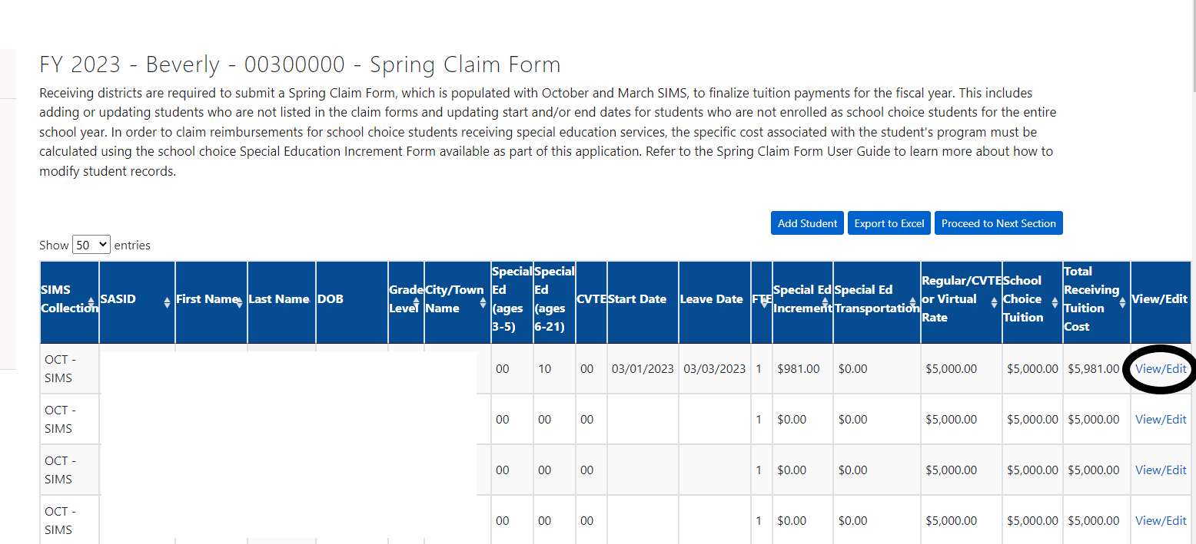

When you open the student’s record, scroll down to the bottom of the edit screen and click *Request to Delete Student*.

Edit Roster Page: 

Request to Delete Student button is circled. 

By clicking *Request to Delete Student* an email will be sent to [schoolchoice@mass.gov](mailto:schoolchoice@mass.gov) and Department staff will follow-up within in two business days to learn more about why the student should be deleted from the roster. Users will receive the following message to confirm that they would like to send an email.

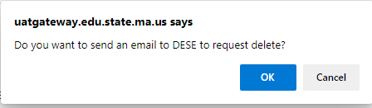

#### 3.4.3 Updating Start and Leave Dates

Districts will need to update the *Start* and/or *Leave Dates* for students who were not enrolled in the school choice program for the entire school year. The business rules in the application will identify these students if they were reported as school choice in October SIMS but not in March SIMS OR if they enrolled as school choice in March SIMS but not in October SIMS.

Users will see the error link for students whose dates of enrollment need to be updated on the *Validate Data* page if the error is not resolved. Please note that students could have started or exited the program at any time during the school year, but our business rules will only identify students who were in one SIMS collection and not another. Please review your data carefully. Remember that users should update students if they did not attend for the full school year and they are not identified by our business rules.

In order to update a student’s dates of enrollment, click *View/Edit* link next to the student’s record on your roster.



Once you open the record, update the student’s dates of enrollment and press *Update Student*.

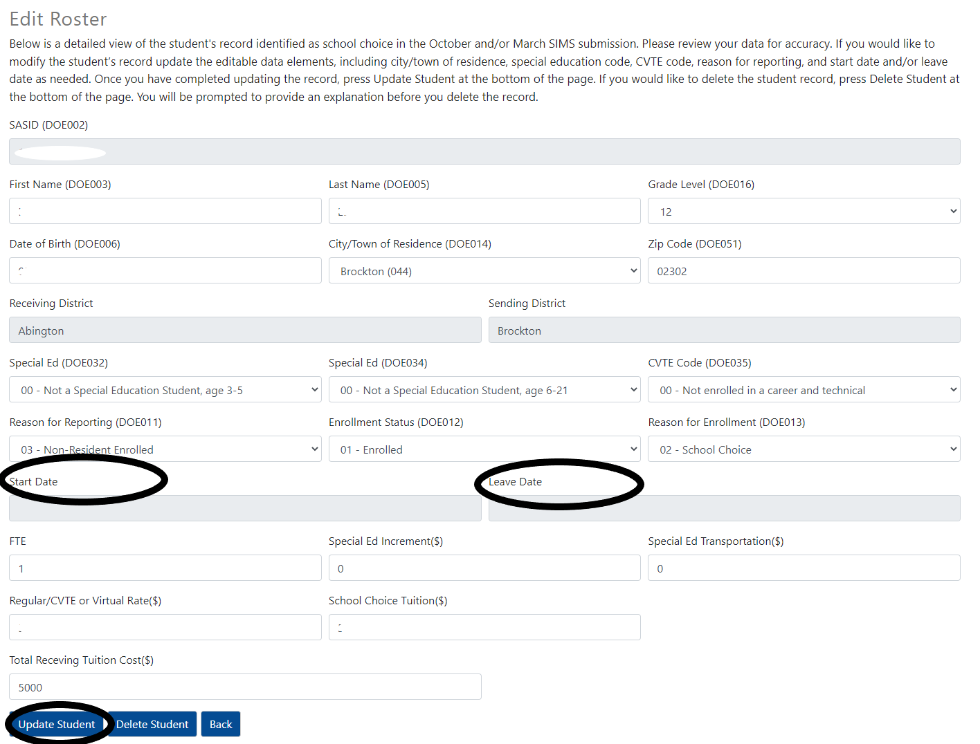

#### 3.4.4 Change of residence or CVTE status

If a student moved and/or changed their CVTE status during the year and these changes were captured in their March SIMS, the student will have multiple records on your *Claim Form*. Districts will be prompted to update the *Start* and/or *Leave Dates* for these students on the *Validate Data* page so that the Department can accurately prorate their tuition between sending districts. Remember that users should update students if they did not attend for the full school year and are not identified by our business rules.

If changes to a student’s city/town of residence or CVTE status (change from non-CVTE to CVTE or vice versa) were not captured in SIMS, you will need to click the *Edit* link on the student’s record on your roster to update the student’s record and/or click *Add Student* to add another record for the student. Make sure that you correctly update the *Start* and/or *Leave Dates* on the student’s record(s) so that the Department can prorate tuition between sending districts if the student’s district of residence has changed during the course of the year. Once the necessary changes are made, press *Update Student* at the bottom of the page. Keep in mind that editing or adding student records may generate new validation errors in the application that need to be resolved. Also, in the case of students with multiple records, make sure that you check each record carefully to ensure that you update each one correctly. See the additional instructions provided below.

##### Special Education Increment Form

In order to claim reimbursements for school choice students receiving special education services, the specific cost associated with the student's program must be calculated using the school choice *Special Education Increment Form*. The district staff member who completes the district’s Circuit Breaker claim should also complete the *Special Education Increment Form*.

If your district is claiming special education increments, download your district’s *Special Education Increment Form* template from the application. When you download the file, please do not change the filename or it will not function properly.

The file includes students identified as school choice in October SIMS who had a special education increment in the prior year or who were submitted in October SIMS with a special education code. Districts should review the students included on the form and add, remove, or update student information as needed based on valid IEPs to reflect current special education enrollment and program costs.

District should report special education transportation costs on their *Special Education Increment Form*. Districts can claim transportation costs for eligible students on the out-of-district claim worksheet on the file, whether the student is an in- or out-of-district student. Make sure that any students that you claim are enrolled in your district through school choice and included on your *Spring Claim Form*.

Once you have completed the *Special Education Increment Form*, please upload the file the same file name in the *Upload Special Education Increment Form* section of the page.

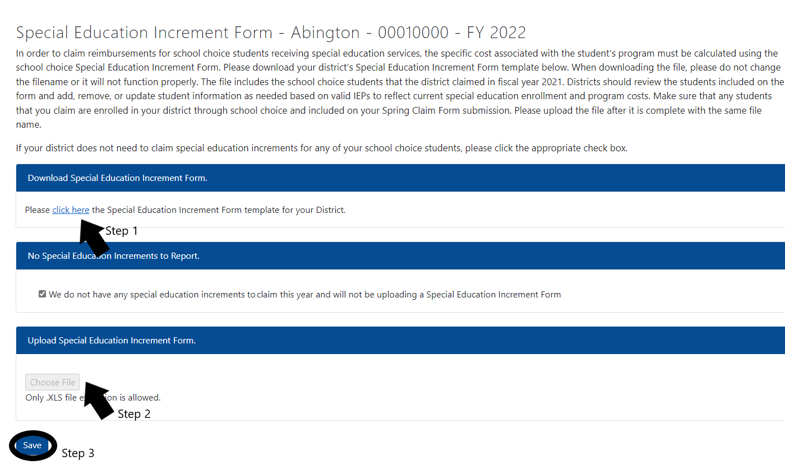

If your district does not need to claim special education increments for any of your school choice students, please clickthe checkbox under *No Special Education Increments to Report* and press save.

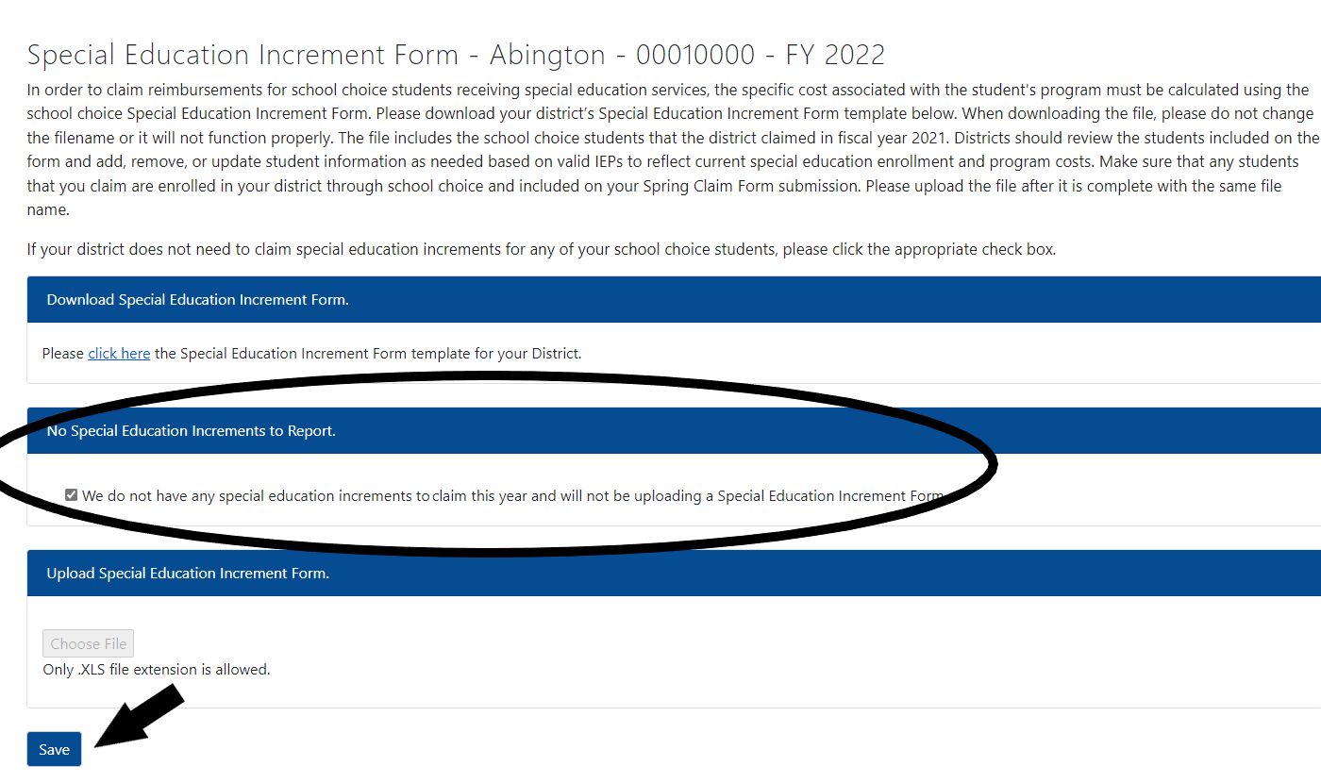

Department staff will review all claims submitted on the *Special Education Increment Form* and follow-up with district staff if there are any questions. Once the data is finalized, we will integrate the special education increment amounts with each district’s *Final Roster* to determine the total tuition for each student.

##### Section 5: Validate Data

Before the data can be certified, districts will need to resolve any errors in the *Spring Claim Form*. When you click the *Validate Data* button on the *Validate Data* page, you will see a list of district and/or student level errors with your submission that need to be resolved. By clicking on the hyperlink next to each error you will be able to resolve the error in a new tab.

The district level hyperlinks will direct you to the corrections that need to be made to the district-level sections, such as providing the district’s school year *Start* and *End Dates*. The SASID hyperlinks next to each student level error will take you directly to the student’s record where you can make the necessary updates. Student level errors are generated based on differences in reporting in a student’s record between October and March SIMS, such as a change in school choice status, change in city or town of residence, or a change in CVTE status. These differences will require that you update the *Start* and/or *Leave Date* on each student record so that the Department can prorate tuition between sending districts. For students with multiple records, remember to carefully review the differences in the student’s record and update the dates of enrollment as needed. Once the error is resolved, the error will clear on the *Validate Data* page. You will not be able to *Certify* your submission without resolving the errors on this page. Please refer to Appendix B for a full list of error descriptions.

Below is an example of a district level error. In order to resolve the error, press the *Please click here* link and resolve the error in a new window. The error will automatically clear when the error is resolved.

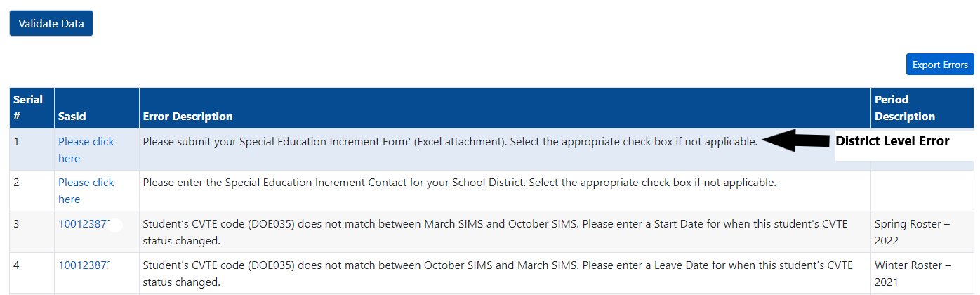

In the example below, the student changed their CVTE status between the October SIMS (*Winter Roster*) and March SIMS (*Spring Roster*) and the dates that the student was enrolled need to be updated in each record. After clicking the link, the user would need to carefully review the student’s CVTE code in each record and update the dates of enrollment accordingly.

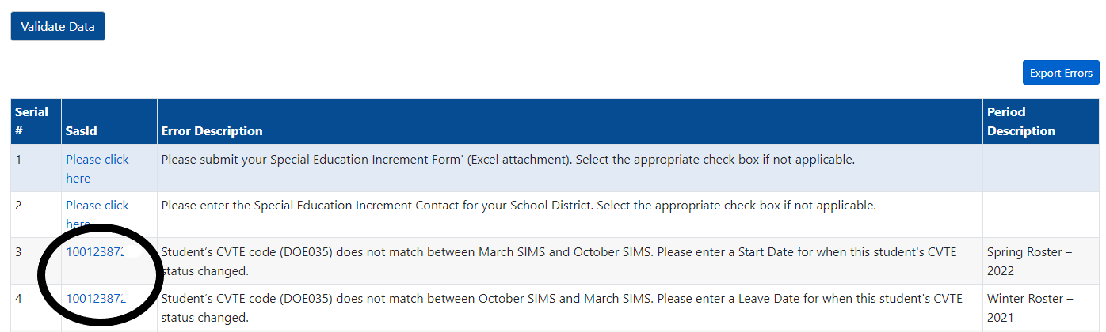

##### Section 6: Certify

Once you have made the necessary updates to your school choice data and uploaded your completed *Special Education Increment Form* (or indicated that you will not be claiming special education increments), you can certify your data submission. Only registered School Choice Certification Users can certify a district’s school choice data submission. By clicking the *Certify* button on the form, you are certifying the district’s school choice data for the fiscal year. You do not need to sign this form, the application will record the user ID for the School Choice Certification User who certified the data. If you find that you need to make corrections to any of your data after you have submitted, please email [schoolchoice@mass.gov](mailto:schoolchoice@mass.gov).

# **Final Rosters**

Once the Department reviews the data submitted on the *Spring Claim Forms* and finalizes tuition payments for the year, we will release *Final Rosters* for both receiving and sending districts though the *School Choice Rosters and Claim Forms* application. The rosters will provide the full list of school choice students claimed for the year along with their tuitions, including special education increments. District staff should review these rosters carefully. If there are any errors, the Department can make corrections as prior year adjustments in the following fiscal year. We will provide more information on the *Final Rosters* once they are released.

# Appendix A: Data Elements included in the *Spring Claim Form*

The following Student Information Management System (SIMS) data elements and tuition data elements are displayed on the *Spring Claim Form*. For more information about the SIMS elements please refer to the [*SIMS Handbook*](https://www.doe.mass.edu/infoservices/data/sims/sims-datahandbook.docx). If you have questions about the data in the application, please email [SchoolChoice@mass.gov](mailto:SchoolChoice@mass.gov).

* **Receiving Org Code (included in Excel download only):** Receiving school choice district code.
* **Receiving Org Name (included in Excel download only):** Receiving school choice district name.
* **SIMS Collection:** The SIMS collection(s) that the student was reported as school choice. Students can be reported as OCT SIMS, MARCH SIMS, OCT/MARCH SIMS or Added by District.
* **SASID (DOE002):** The state-assigned student identifier for each student.
* **First Name and Last Name (DOE003 and DOE005):** The names of all students enrolled in a school in your district who are non-residents and are attending under the school choice program ([Chapter 76, Section 12B](https://malegislature.gov/Laws/GeneralLaws/PartI/TitleXII/Chapter76/section12B)). Students who are non-resident students whose tuition is paid by other school districts through tuition agreements, METCO students, or non-resident children of district teachers who attend for free through collective bargaining agreements are not included.
* **Date of Birth (DOE006):** The student's month, day, and year of birth.
* **Grade Level (DOE016):** The student's grade level.
* **City/Town Residence Code/Name (DOE0014):** The three-digit LEA code of the student’s city or town of residence. The city/town of residence code determines the student’s Sending Org Code/Org Name (e.g., the district that is fiscally responsible for the student’s tuition).
* **Zip (DOE051):** The student’s zip code in their city/town of residence.
* **Sending Org Code (included in Excel download only):** The Department uses the city/town residence code to assign the sending district code. For example, the city/town might be part of a regional school district and the regional district will be assigned as the sending district rather than the city/town of residence.
* **Sending Org Name:** The Department uses the city/town residence code to assign the sending district. This is the district name associated with the code listed above. For example, the city/town might be part of a regional school district and the regional district will be assigned as the sending district rather than the city/town of residence.
* **Special Ed (ages 3-5) (DOE032):** The student's special education placement for students who are ages 3-5. Please note: Only preschool students (Grade Level DOE0016 = PK) with a DOE032 value of greater than 05 are included.
* **Special Ed (ages 6-21) (DOE034):** The student's special education placement for students who are ages 6-21. During the claim form process, the Department matches this variable with the *Special Education Increment Form*.
* **CVTE (DOE035):** The type of career/vocational technical education program the student is enrolled in.
* **Reason for Reporting (DOE0011):** For school choice students the code is either 02 (Resident Sending) or 03 (Non-Resident Enrolled).
* **Enrollment Status (DOE0012):** All students have an enrollment code of 01: Enrolled because they were enrolled as school choice at some point during the school year.
* **Reason for Enrollment (DOE0013):** For school choice students the code is 02: School Choice (DOE – School Choice Program).
* **Start Date (application only):** The start date that the student began the school choice program during the school year. If the start date is the same as the district school year start date, users should leave the field blank.
* **Leave Date (application only):** The leave date is date the student exited the school choice program during the school year. If the leave date is the same as the district’s last day of school in the school year, users should leave the field blank.
* **Full Time Equivalency (FTE**): The FTE will be calculated based on the actual dates of enrollment entered by districts in the *Spring Claim Form.* *School Choice Tuition* will be prorated for students who do not attend for the entire school year. The FTE will be updated in the Final Rosters.
* **Special Ed Increment:** For each school choice student receiving special education services, the specific cost associated with the student's program will be calculated using the *Special Education Increment Form*. In the *Spring Claim Form* the Special Ed Increment will be left blank and will be populated in the Final Rosters.
* **Special Ed Transportation:** For the students receiving transportation (as indicated on their IEPs) the cost will be calculated using the *Special Education Increment Form.* In the *Spring Claim Form* the Special Ed Transportation will be left blank and will be populated in the Final Rosters.
* **Regular/CVTE or Virtual Rate:** The full-day Regular/Career Vocational Technical Education (CVTE) Rate is $5,000 per student, which by statute is the same rate each year, and the tuition rate for the two Commonwealth Virtual Schools (Virtual Rate) is updated yearly. The Virtual Rate is adjusted annually for inflation using the same inflation index that is used for Chapter 70. In the *Spring Claim Form* the Regular/CVTE or Virtual Rate will be left blank and will be populated in the Final Rosters.
* **School Choice Tuition:** Tuition is Regular/CVTE or Virtual Rate for the student. If the student did not attend for the full school year, the tuition is prorated by the student’s FTE. In the *Spring Claim Form* the Tuition will be left blank and will be populated in the Final Rosters.
* **Total Receiving Tuition Cost:** Total cost per student based on the school choice tuition amount, special education increment, and special education transportation. In the Spring Claim Form the School Choice Tuition will be left blank and will be populated in the Final Rosters.
* **View/Edit (application only):** By clicking *View/Edit* in the application, you can click into each student’s record and view or edit their SIMS data. You can also request to delete student records from this link by clicking *Request to Delete Student*.

# Appendix B: District Level and Student Level Validations in the *Spring Claim Form*

## District Level Validations

|  |  |
| --- | --- |
| **Error Description** | **Validation** |
| Please enter the School Year Start and End Dates for your School District. | District school year start and end dates are not filled in on the District School Year Start and End Dates section in the application. |
| Please enter the School Choice Claim Form Contact information for your School District. | School Choice Claim Form Contact information is not filled in on the District Contact Information section of the application. |
| Please submit your Special Education Increment Form (Excel attachment). Select the appropriate check box if not applicable. | Special Education Increment form is not uploaded by the user OR No Special Education Increments to report checkbox is not clicked on the Special Education Increment Form (Excel attachment) page of the application. |
| Please enter the Special Education Increment Contact Information for your School District. | The Special Education Increment form is uploaded by the user but the Special Education Increment Contact Information is not provided yet OR the checkbox No Special Education Increments to Report is not clicked. |

## Student Level Validations

|  |  |
| --- | --- |
| **Error Description** | **Validation** |
| Student not reported in March SIMS as School Choice. Please enter a Leave Date for this student. | When a student record does not exist in March SIMS and is only reported in October SIMS by the district. |
| Student reported as School Choice in March SIMS only. Please enter a Start Date for this student | When a student record does not exist in October SIMS and is only reported in March SIMS by the district. |
| Student was reported as School Choice by a different district in October SIMS and identified as a new School Choice enrollment by your district in March SIMS. Please enter a Start Date for this student. | When a student record is reported in October SIMS by District A and is reported in March SIMS by District B, the user will need to enter a Start Date for this record. |
| Student is reported as School Choice by a different district in March SIMS. Please enter a Leave Date for this student. | When a student record is reported in October SIMS by District A and is reported in March SIMS by District B the user will need to enter a Leave Date for this record. |
| Student’s town of residence (DOE014) does not match between March SIMS and October SIMS. Please enter a Start Date for when this student started residing in this city/town. | When a student record is reported in both SIMS collections by District A but the DOE014 value of the student is different between the collections the user will need to enter a Start Date for this student on the March SIMS record. |
| Student’s town of residence (DOE014) does not match between October and March SIMS. Please enter a Leave Date for when this student moved out of this city/town. | When a student record is reported in both SIMS collections by District A but the DOE014 value for the student is different between collections the user will need to enter a Leave Date for this student on the October SIMS record. |
| Student’s CVTE code (DOE035) does not match between March SIMS and October SIMS. Please enter a Start Date for when this student's CVTE status changed. | When a student record is reported in both SIMS collections by District A but the DOE035 value of the student is different between the collections the user will need to enter a Start Date for this student on the March SIMS record. |
| Student’s CVTE code (DOE035) does not match between October SIMS and March SIMS. Please enter a Leave Date for when this student's CVTE status changed. | When a student record is reported in both SIMS collections by District A but the DOE035 value of the student is different between collections the user will need to enter a Leave Date for this student on the October SIMS record. |
| Student record identified as Duplicate Submission. Please delete the duplicate record. | When there is more than one student for the same district with same DOE016, DOE014, DOE032, DOE034, DOE035 and DOE012 values. |
| Student Start or Leave Dates are conflicting with another record within the district. Please adjust the dates accordingly to resolve the error. | When a student’s start or leave dates overlap with another record in the same district. |