School Choice Winter and Final Rosters User Guide

July 2023
Version 2.0

Contents

Background Information 2
Overview 2
Accessing the School Choice Rosters and Claim Forms Application 3
Security Roles 3
Selecting Receiving and Sending Rosters 4
Navigating the Winter and Final Rosters 5
Before Getting Started 6
SIMS Data Handbook 7
Contact Department Staff 7
Reviewing Student-Level Data 8
Spring Claim Forms 12
Appendix A: Data Elements included in the Winter and Final Rosters 13

Background Information
The School Choice Rosters and Claim Forms application is available in the School Finance Section on the ESE Security Portal. We use this application to publish preliminary school choice rosters in the winter, process school choice claims in the spring, and publish final rosters in June at the end of the fiscal year. This application streamlines the school choice claiming process for districts by identifying students who were coded as school choice in the October and March SIMS collections. The application allows districts to manage and update their data and includes rules to ensure accuracy of reporting. It is important to note that for now the Special Education Increment Form that is part of the Spring Claim Forms will continue to be an Excel-based form but will be submitted through the School Choice Rosters and Claim Forms Application.
The Department releases aggregate school choice tuitions for sending and receiving districts twice a year, first in December based on the Winter Rosters and again in June based on the Final Rosters. The posted tuition amounts include adjustments to the prior year's calculations as well as special education increments and transportation costs.
On or before the last day of each month, the state treasurer assesses approximately one twelfth of each school district’s annual school choice tuition charges and pays one twelfth of the annual tuition receipts as part of the monthly local aid distribution. Since the annual estimates may change during the year to reflect current enrollments and special education increments and transportation, the monthly calculations will reflect these changes. These tuition amounts can be found on the monthly local aid distribution under School Choice Receiving Tuition and School Choice Sending Tuition.

Overview
The School Choice Rosters and Claim Forms application contains student-level data and data elements obtained from SIMS. This information is used as the basis for calculating school choice payments (for receiving districts) and assessments (for sending districts) in the monthly local aid distribution each fiscal year.
Districts should review their school choice sending and receiving rosters after each school choice update, including the Winter Rosters (based on October, 1 SIMS) and the Final Rosters (based on March SIMS and final claim form submissions in April/May) to verify the accuracy of the data. If any edits are needed, district users can click “Request Edit(s)” at the top of the roster form on the School Choice Rosters and Claim Forms Application to request changes. A school finance staff member will respond to your request within 2 business days. Please note, if you have multiple edits, you only need to submit one request.
In April/May, receiving districts are required to submit Spring Claim Forms, which will be populated with October and March SIMS, to finalize tuition payments for the fiscal year. This includes completing a separate Special Education Increment Form (Excel form) to claim instructional and transportation costs for special education students and updating start and/or end dates for students who are not enrolled as school choice students for the entire school year. The Department publishes Final Rosters, including receiving and sending rosters, based on the Spring Claim Forms in June of each fiscal year. The timeline and user guides associated with each collection are summarized below.

Application Update | Release Dates | Data Source | User Guide
Winter Rosters | December/January | October SIMS | Winter and Final Rosters User Guide
Spring Claim Forms | April/May | October and/or March SIMS | Spring Claim Forms User Guide
Final Rosters | June | October and/or March SIMS and Claim Form data | Winter and Final Rosters User Guide

Accessing the School Choice Rosters and Claim Forms Application

Security Roles
There are two district-level security roles for this application in Directory Administration (DA).
- School Choice Data User: This role allows a person to review and update individual School Choice records to determine tuition amounts for school districts participating in the school choice program. This role should be assigned to the person who is verifying and entering the data.
School Choice Certification User: This role allows a person to review and update individual School Choice records and certify the School Choice data for receiving school choice districts. This role should be assigned to the superintendent or superintendent's designee.

Please contact your district’s Directory Administrator to be assigned the appropriate role. Please note that Department school finance staff cannot assign user roles for district-level staff. For questions about adding or changing a security role please see the Quick Reference Guide on the Directory Administration - Information Services/Data Collection website.
Once you have been assigned a security role and you have logged into the ESE Security Portal the next step is to navigate to the Application List, locate the School Finance Section, and click on School Choice Rosters and Claim Forms.

Application List: Sample
(Please note your application list may look different)
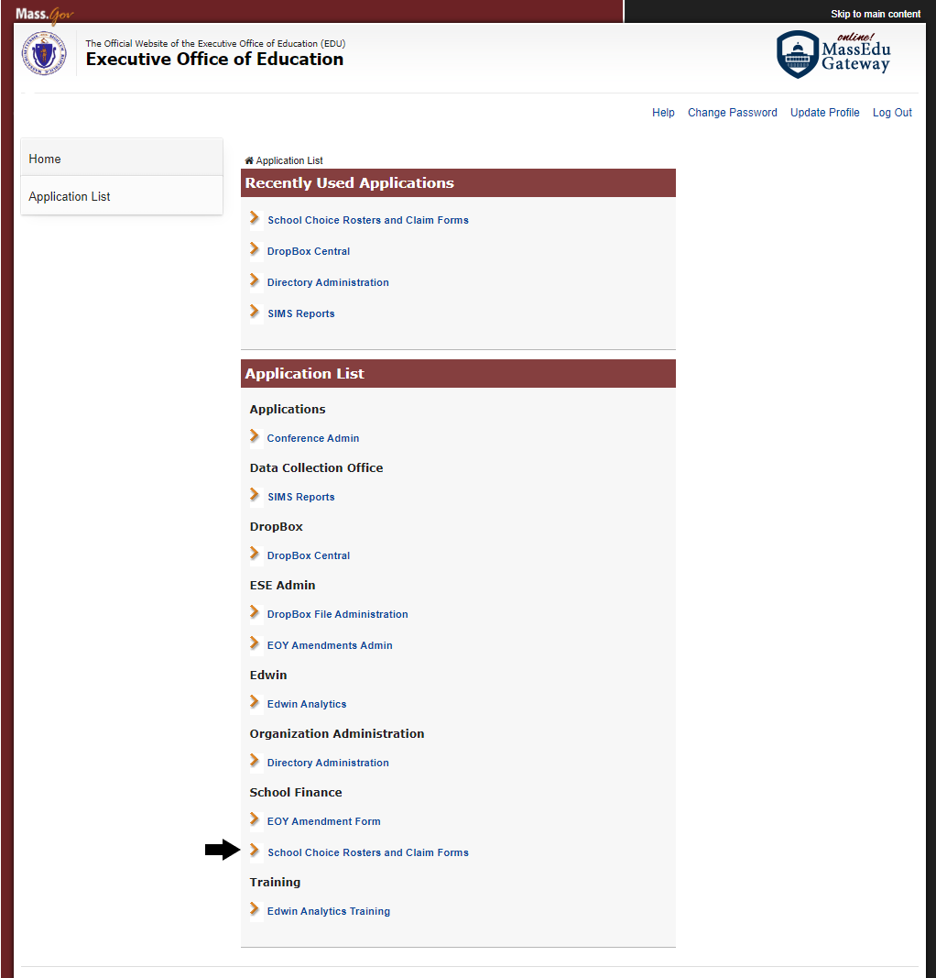

Selecting Receiving and Sending Rosters
Once you are in the application you will select the fiscal year, roster type (receiving or sending), and your district to view your rosters.

Please note, if your district does not participate in the school choice program, families still have the option to enroll their children in a participating district. If your district does not participate in the school choice program the message, “No receiving school choice students reported in SIMS” in the receiving dropdown menu will be shown. Districts who are not participating in the school choice program should review their sending rosters.

View Rosters
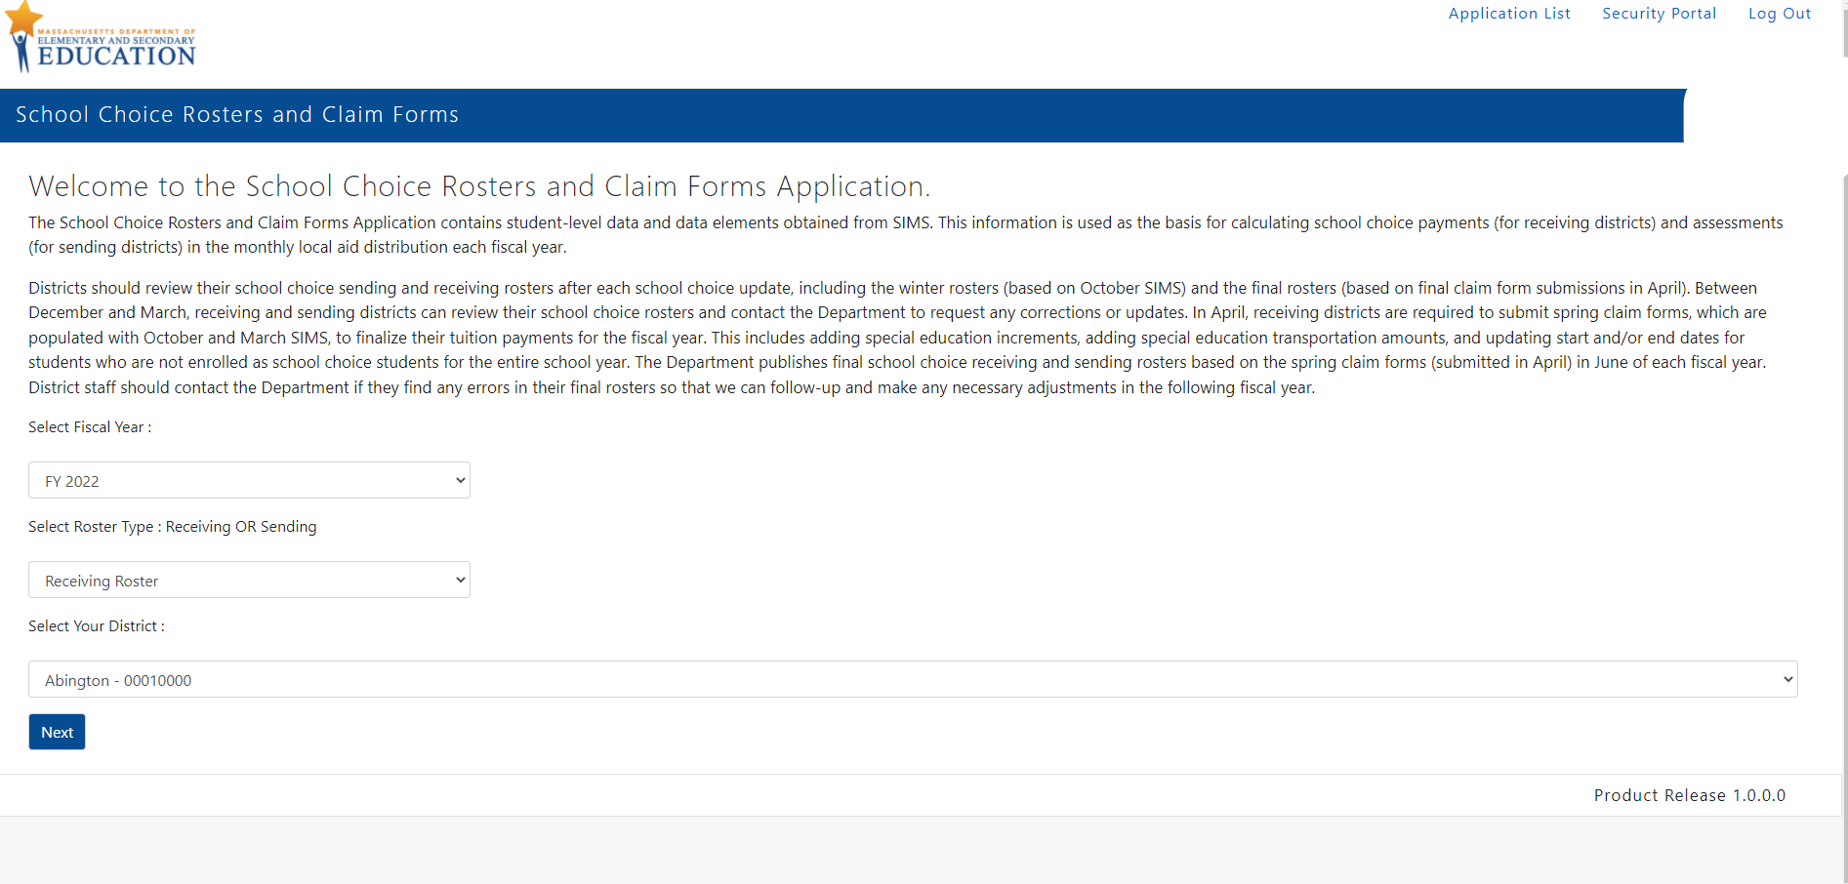

Navigating the Winter and Final Rosters
After you select the fiscal year, sending or receiving rosters, and click next, the system will navigate to your district’s School Choice Rosters and Claim Forms application page. The right side shows links to the three roster types: Winter Rosters, Spring Claim Form, and Final Rosters. Users will only be able to view the active roster type until that fiscal year’s Final Rosters are released.
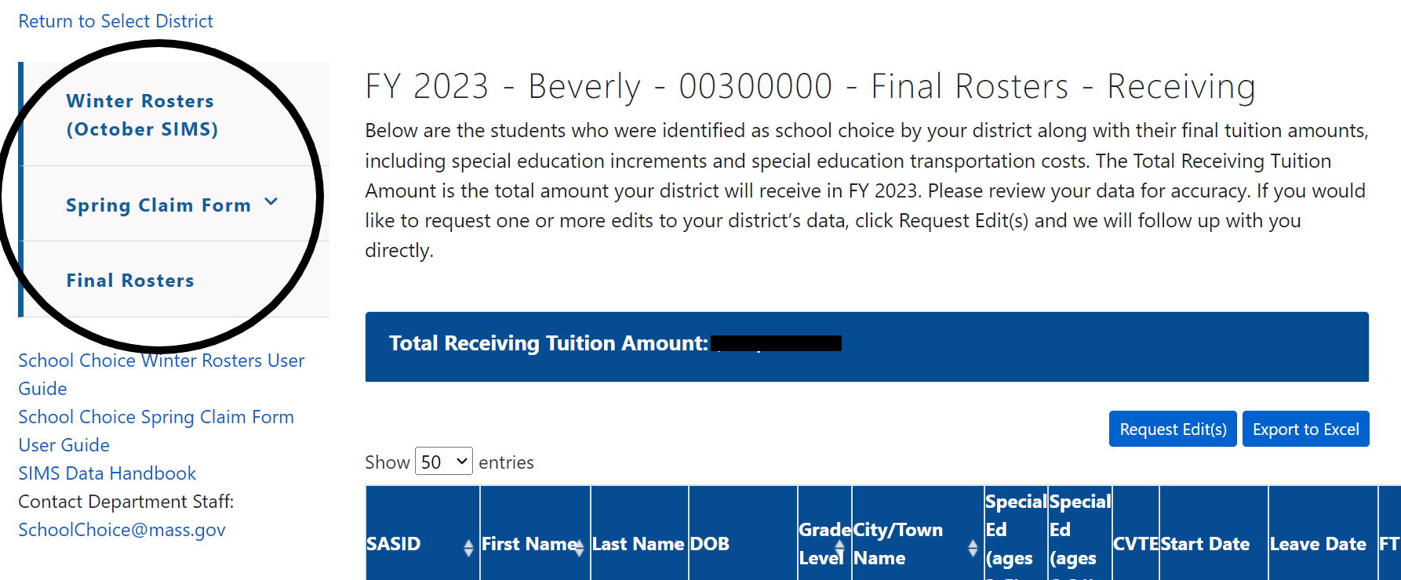

This user guide details the Winter Rosters and the Final Rosters, see the descriptions below. Please refer to the School Choice Spring Claim Form User Guide for information on the Spring Claim Form.
Winter Rosters: The receiving roster shows the students identified as school choice in the October 1 SIMS data that your district submitted and certified. The sending roster shows your resident students reported in October 1 SIMS by the districts where they are enrolled. The data is preliminary and includes estimated FTEs, base tuition amounts, special education increments, and special education transportation costs for the fiscal year.

Final Rosters: The receiving roster shows the students identified as school choice that your district updated, submitted, and certified. The sending roster shows your resident students reported by the districts where they were enrolled during the school year. The final rosters include student start and end dates, FTEs, base tuition amounts, and special education increments and special education transportation costs.

Before Getting Started
There are few resources available within the application to help answer any questions that you have as you start to work on it:

- School Choice Spring Claim Form User Guide (this document)
- SIMS Data Handbook
- Contact Department staff at SchoolChoice@mass.gov

On left side bar under the Winter or Final Rosters section of the application you can find the most current SIMS Data Handbook. It contains information about the SIMS variables that are collected in the SIMS collections. Please refer to Appendix A to learn more about the variables displayed in the application.
If you have questions about the application, you can select SchoolChoice@mass.gov on the left side bar under the Spring Claim Form section to generate an email. Please note you may need to change your email settings for this function to work, see below.
School Choice Winter Rosters User Guide Link
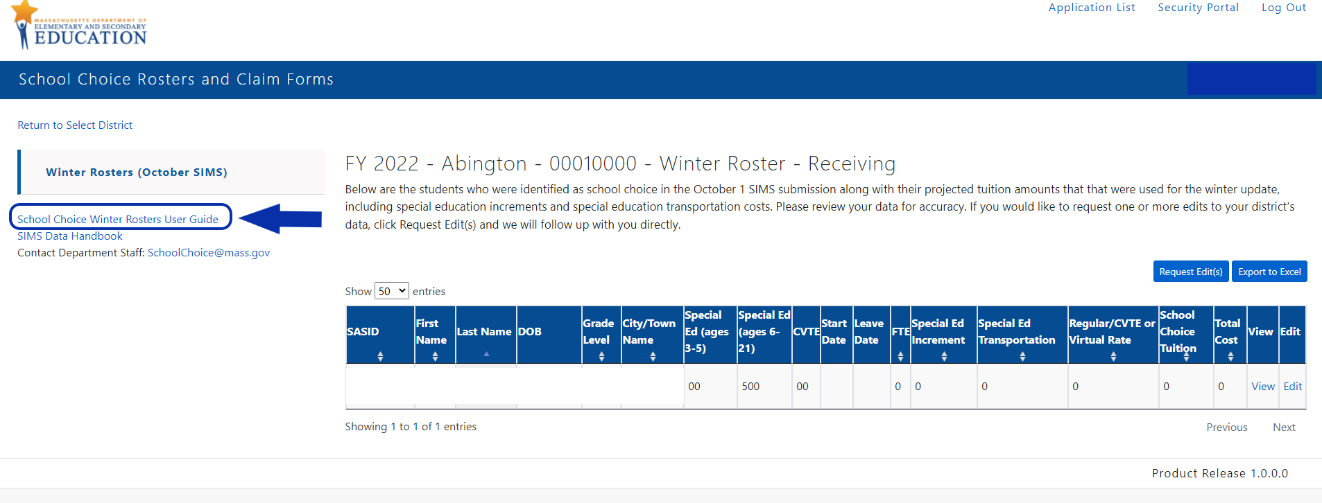

SIMS Data Handbook
On left side bar in the district’s sending or receiving roster page you can find the SIMS Data Handbook. It contains information about the SIMS data elements that are collected during each SIMS collection period. Please refer to Appendix A to learn more about the variables, including SIMS data elements, that are displayed in the application.

SIMS Data Handbook Link
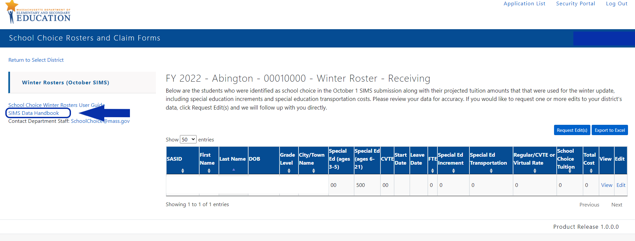

Contact Department Staff
If you have questions about the application, you can generate an email to SchoolChoice@mass.gov from the left side bar in your district’s sending or receiving roster page. Please note you may need to change your email settings for this function to work, see below.

Contact Department Staff Link
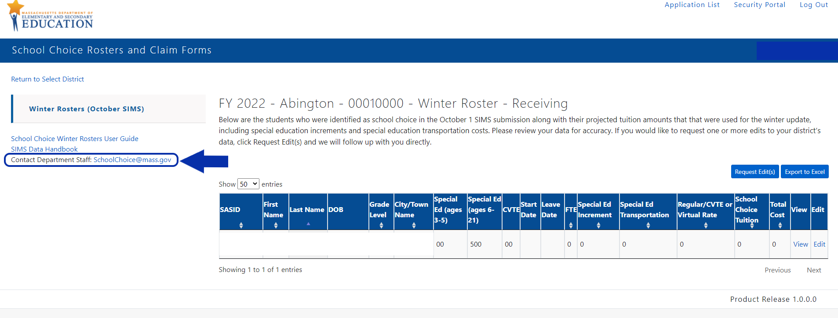

If you are unable to directly send an email you can either cut and paste the email address into a new email or you can change your email setting by following the steps below:
- Go to Settings on your computer’s task bar
- Navigate to Accounts
- Select Email & Accounts
Add the account that you will be sending the email (e.g., Outlook, Office)

Reviewing Student-Level Data
Once you select the fiscal year, roster type, and district you will be able to view student-level data for the students who are participating in the school choice program. You can view additional details about each student, export the data to Excel, and request edits on this page.
Sample: Winter Roster – Receiving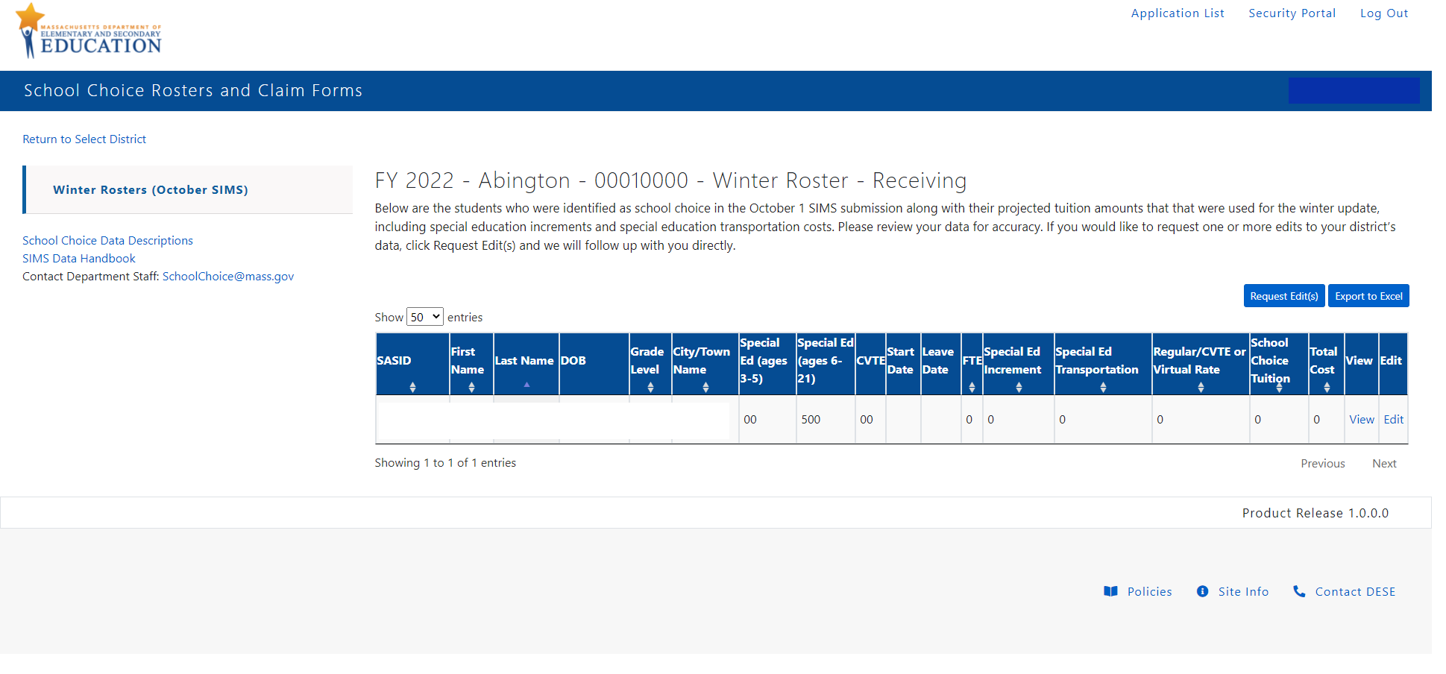Sample: Winter Roster – Sending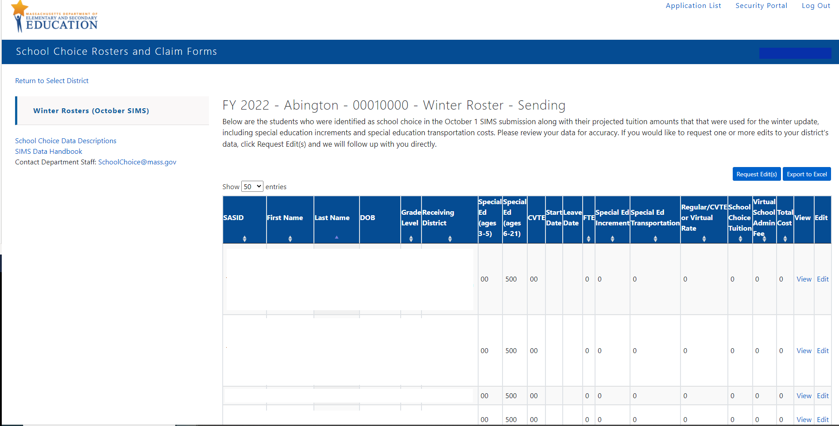

View
The View link provides detailed information about each student’s record along with the estimated tuition (Winter Rosters) or final tuition amounts (Final Rosters), including special education increments and special education transportation amounts if applicable. Please note that the estimated full-time equivalency (FTE) for full-day students is 1.0 and for half-day students is 0.5. Districts update the dates of enrollment on the Spring Claim Form and the FTE is prorated based on the actual dates of enrollment.
View Link
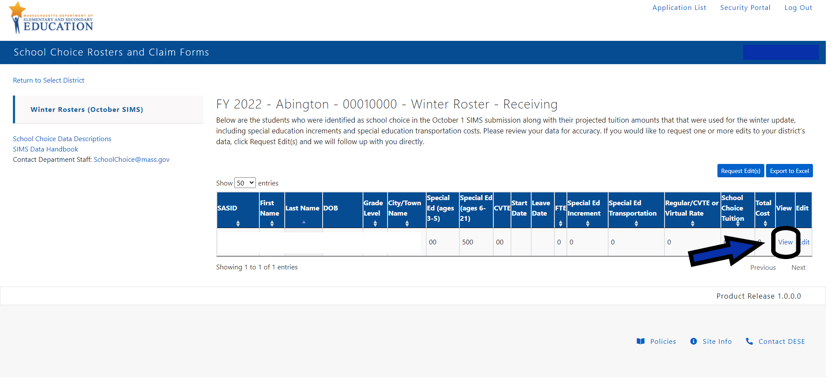
View Link: Student Information
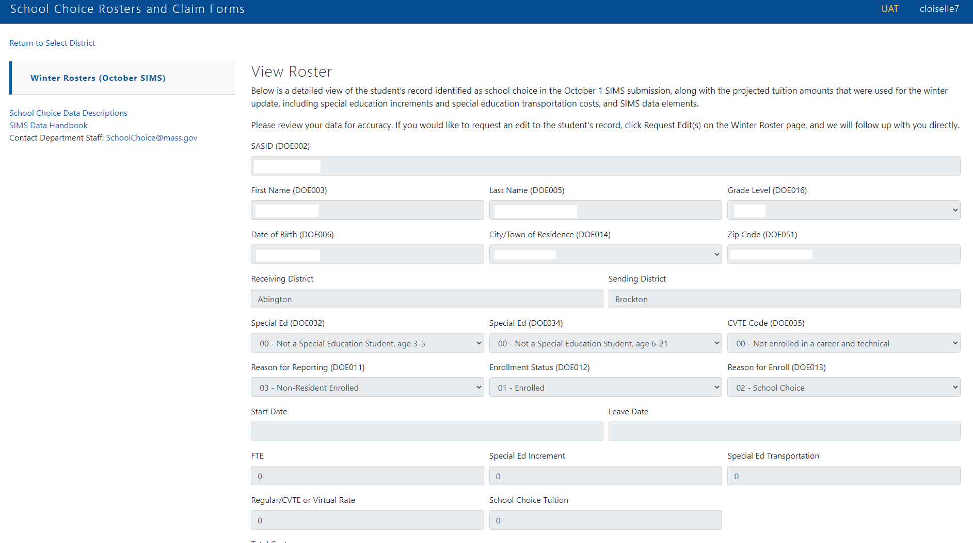

Export to Excel
You can also export your district’s file to Excel by clicking “Export to Excel” on the top right-hand corner of the page. Remember that only the roster that you are viewing (e.g., receiving or sending) will download.
Export to Excel Link
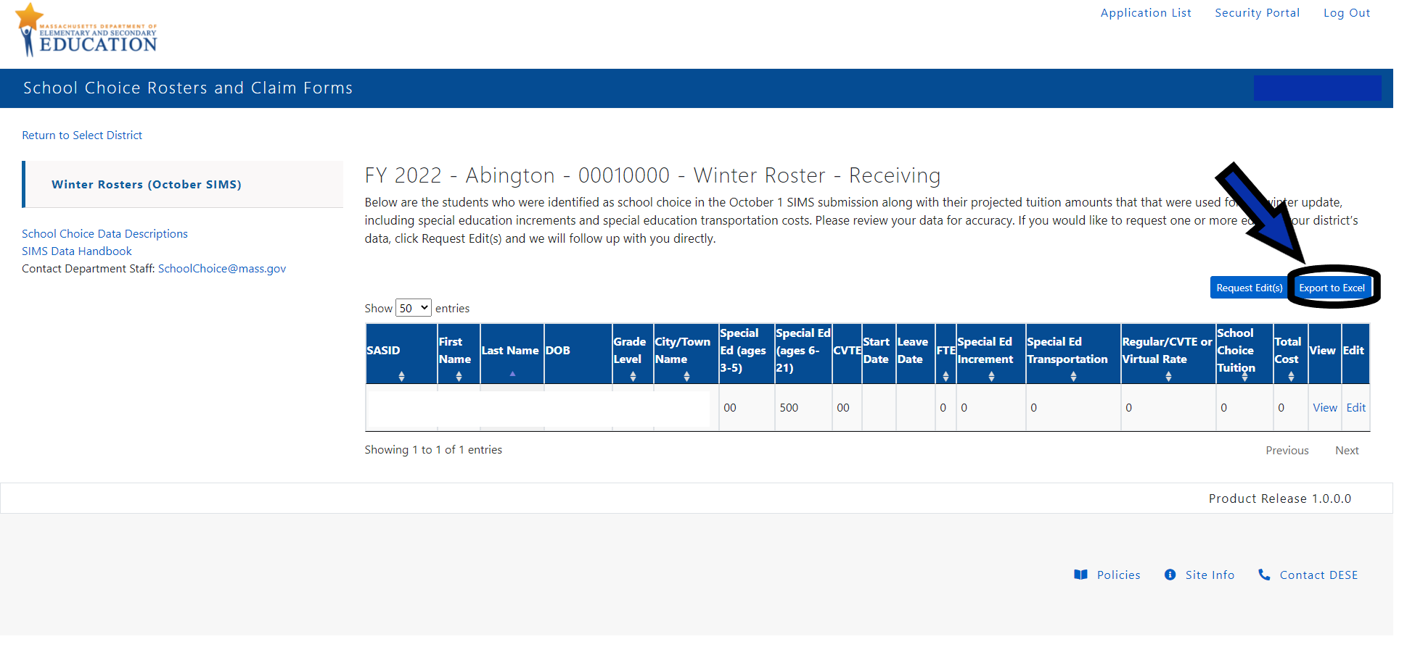
Sample Excel Download
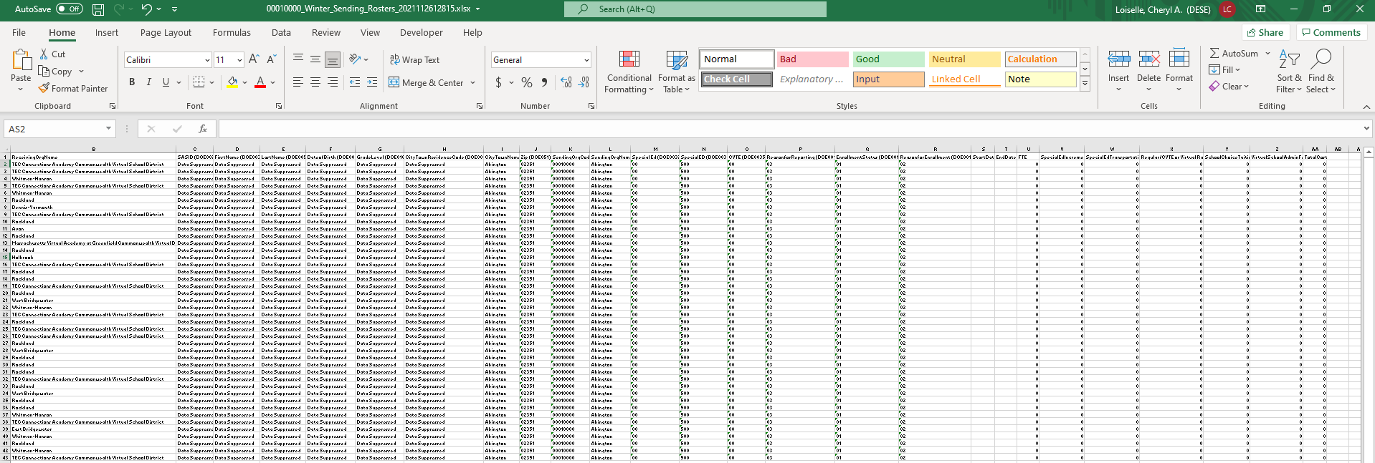

Request Edit(s)
Receiving and sending districts can review their school choice rosters and click “Request Edit(s)” to request one or more edits. A school finance staff member will respond to your request within 2 business days. Please note, if you have multiple edits for one district, you only need to click the button once and we will follow up with you directly regarding the requested edits.

Request Edit(s) Link:
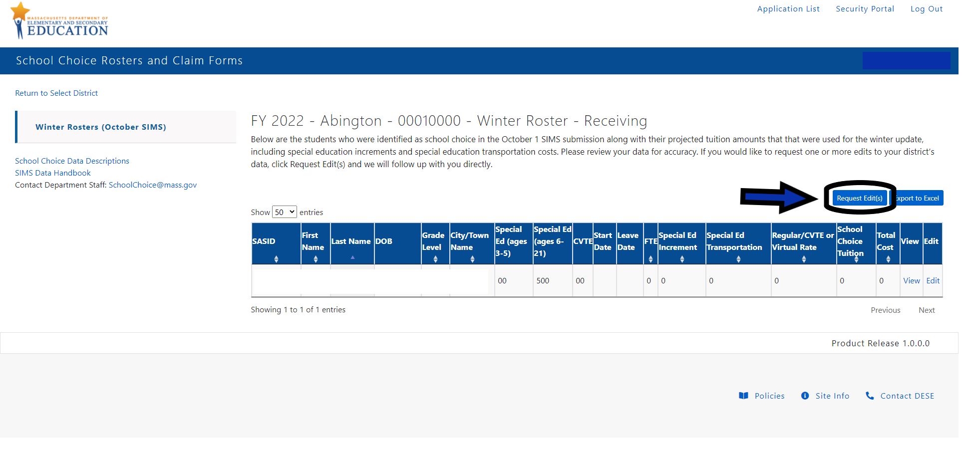
Once you request edit(s) you will receive a message confirming that your message was sent and that a school finance staff member will be in touch to discuss the requested changes. If you do not receive this message, you should contact SchoolChoice@mass.gov.

Sample Success Message for Edits(s) to Rosters:
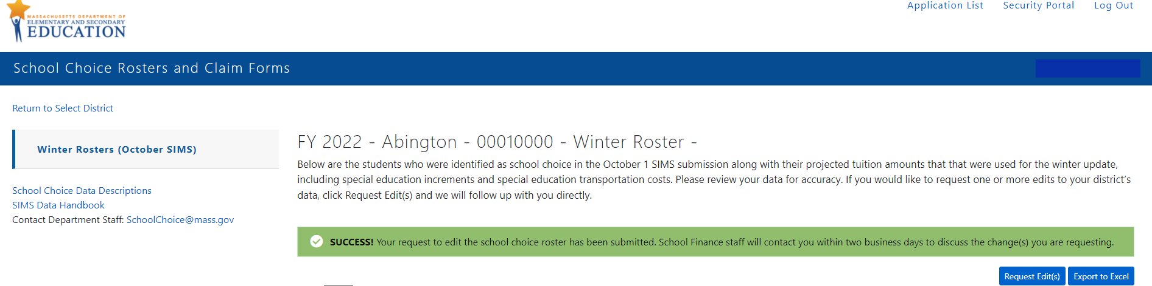

Spring Claim Forms
Every April, receiving districts complete the Spring Claim Form, which is populated with October and March SIMS data, to finalize tuition payments for the fiscal year. This includes completing a separate Special Education Increment Form (Excel form) to claim instructional and transportation costs for special education students and updating start and/or end dates for students who are not enrolled as school choice students for the entire school year. Receiving districts can make updates to their school choice data directly in the application during this data collection period. The web-based forms are pre-populated using certified SIMS data and incorporate a number of business rules to ensure accuracy of reporting. Please refer to the School Choice Spring Claim Form User Guide for information on the Spring Claim Form.

Appendix A: Data Elements included in the Winter and Final Rosters
The following SIMS elements are displayed on the Winter and Final Rosters. For more information about the SIMS elements please refer to the SIMS Handbook. If you have questions about the data in the application, please email SchoolChoice@mass.gov.
- Receiving Org Code (included in Excel download only): Receiving school choice district code.
- Receiving Org Name (included in Excel download only): Receiving school choice district name.
- Total Receiving/Sending Tuition Amount (Final Rosters included in the application only): Total receiving or sending school choice amount for the district
- SASID (DOE002): The state-assigned student identifier for each student.
- First Name and Last Name (DOE003 and DOE005): The names of all students enrolled in a school in your district who are non-residents and are attending under the school choice program (Chapter 76, Section 12B). Students who are non-resident students whose tuition is paid by other school districts through tuition agreements, METCO students, or non-resident children of district teachers who attend for free through collective bargaining agreements are not included.
- Date of Birth (DOE006): The student's month, day, and year of birth.
- Grade Level (DOE016): The student's grade level.
- City/Town Residence Code/Name (DOE0014): The three-digit LEA code of the student’s city or town of residence. The city/town of residence code determines the student’s Sending Org Code/Org Name (e.g., the district that is fiscally responsible for the student’s tuition).
- Zip (DOE051): The student’s zip code in their city/town of residence.
- Sending Org Code (included in Excel download only): The Department uses the city/town residence code to assign the sending district code. For example, the city/town might be part of a regional school district and the regional district will be assigned as the sending district rather than the city/town of residence.
- Sending Org Name (included in Excel download only): The Department uses the city/town residence code to assign the sending district. This is the district name associated with the code listed above. For example, the city/town might be part of a regional school district and the regional district will be assigned as the sending district rather than the city/town of residence.
- Special Ed (ages 3-5) (DOE032): The student's special education placement for students who are ages 3-5. Please note: Only preschool students (Grade Level DOE0016 = PK) with a DOE032 value of greater than 05 are included.
- Special Ed (ages 6-21) (DOE034): The student's special education placement for students who are ages 6-21. During the claim form process, the Department matches this variable with the special education increment and special education transportation forms.
- CVTE (DOE035): The type of career/vocational technical education program the student is enrolled in.
- Reason for Reporting (DOE0011): For school choice students the code is 03: District is not/has not been financially responsible for the student and the student is/has been enrolled or receiving services in the district during the current school year (non-resident enrolled).
- Enrollment Status (DOE0012): All students have an enrollment code of 01: Enrolled because the student was enrolled in the school choice program during the school year.
- Reason for Enrollment (DOE0013): For school choice students the code is 02: School Choice (DOE – School Choice Program).
- Start Date (application only): During the Winter Roster update, all students are estimated to attend for the entire school year and districts will be able to edit student start dates on the Spring Claim Form. In the Final Roster update, the start dates are displayed based on the updates made on the Spring Claim Form by receiving districts.
- Leave Date (application only): During the Winter Roster update, all students are estimated to attend for the entire school year and districts will be able to edit student leave dates on the Spring Claim Form. In the Final Roster update, the updated leave dates are displayed based on the Spring Claim Form updates made by receiving districts.
- FTE: On the Winter Rosters, the estimated full-time equivalency (FTE) for full-day students is 1.0 and for half-day students is 0.5. Districts have the opportunity to update the dates of enrollment on the Spring Claim Form and the FTE is prorated based on the actual dates of enrollment in the Final Rosters.
- Regular/CVTE or Virtual Rate: The full-day Regular/Career Vocational Technical Education (CVTE) Rate is $5,000 per student, which by statute is the same rate each year. The Virtual Rate is adjusted annually for inflation using the same inflation index that is used for Chapter 70.
- School Choice Tuition: In the Winter Rosters, all students are estimated to attend the entire school year and therefore the estimated rate is the full tuition rate. In the Final Rosters tuition is prorated for students who do not attend for the full school year and updated by districts on the Spring Claim Form.
- Special Ed Increment:
- Winter Rosters: For each school choice student receiving special education services, the specific cost associated with the student's program is estimated based on the previous school year’s school choice Special Education Increment Form. The costs for any new school choice students receiving special education services are estimated based on statewide averages according to their SIMS special education placement code. If the special education costs for any returning students have significantly changed since last year, please click “Request Edit(s)” and school finance staff will respond to determine next steps.
- Final Rosters: For each school choice student receiving special education services, the specific cost associated with the student's program is determined based on the Special Education Increment Form that receiving districts file along with their Spring Claim Form.
- Special Ed Transportation: For students receiving special education transportation (as indicated on their IEPs), the specific cost associated is estimated for the Winter Rosters based on the previous school year’s school choice special education transportation amount. The amount listed in the Final Rosters is the final transportation amount reported on the Special Education Increment Form that receiving districts file along with their Spring Claim Form.
- Virtual School Admin Fee (Sending Districts Only): A $75 per student administrative fee is assessed to districts sending students to one of the two Commonwealth Virtual Schools and retained by the Department to cover the costs of administering the Commonwealth Virtual School program.
- Total Receiving/Sending Cost: The total cost per student based on the tuition amount, Virtual School Admin Fee (if appliable), special education increment, and special education transportation. For the Winter Rosters, the total cost is estimated.
- View (application only): By clicking view on the application, you can open an individual student’s record and view their SIMS data. Districts can only update individual student records on the Spring Claim Form. Please press “Request Edit(s)” if you would like to modify records.

