Weathering and Erosion
Earth and Space Science, Grade 4
(Revised July 2018)
Standards addressed in unit:
4-ESS1-1 Use evidence from a given landscape that includes simple landforms and rock layers to support a claim about the role of erosion or deposition in the formation of the landscape over long periods of time. Clarification Statement: Examples of evidence and claims could include rock layers with shell fossils above rock layers with plant fossils and no shells, indicating a change from deposition on land to deposition in water over time; and, a canyon with rock layers in the walls and a river in the bottom, indicating that a river eroded the rock over time. Examples of simple landforms can include valleys, hills, mountains, plains, and canyons. Focus should be on relative time. State Assessment Boundary: Specific details of the mechanisms of rock formation or specific rock formations and layers are not expected in state assessment.
4-ESS2-1 Make observations and collect data to provide evidence that rocks, soils, and sediments are broken into smaller pieces through mechanical weathering and moved around through erosion. Clarification Statement: Mechanical weathering processes can include frost wedging, abrasion, and tree root wedging. Erosion can include movement by blowing wind, flowing water, and moving ice. State Assessment Boundary: Chemical processes are not expected in state assessment.

Through this unit students develop an understanding of the erosion and weathering processes that affect landforms. Students identify the processes that shape landforms, including weather processes and causes of erosion. Students carry out investigations and gain experience with interpreting and analyzing information to reason about what caused the shape of particular landforms.

This Model Curriculum Unit is designed to illustrate effective curriculum that lead to expectations outlined in the 2016 Science and Technology/Engineering Curriculum Frameworks (www.doe.mass.edu/STEM/STE) as well as the MA Curriculum Frameworks for English Language Arts/Literacy and Mathematics. This unit includes lesson plans, a Curriculum Embedded Performance Assessment (CEPA), and related resources. In using this unit it is important to consider the variability of learners in your class and make adaptations as necessary.

This document was prepared by the Massachusetts Department of Elementary and Secondary Education. Mitchell D. Chester, Ed.D., Commissioner
The Massachusetts Department of Elementary and Secondary Education, an affirmative action employer, is committed to ensuring that all of its programs and facilities are accessible to all members of the public. We do not discriminate on the basis of age color, disability, national origin, race, religion, sex, or sexual orientation.

© 2015 Massachusetts Department of Elementary and Secondary Education (ESE). ESE grants permission to use the material it has created under the terms of the Creative Commons Attribution-NonCommercial-ShareAlike 3.0 Unported License. Additionally, the unit may also contain other third party material used with permission of the copyright holder. Please see Image and Text Credits for specific information regarding third copyrights.

Every effort has been made to acknowledge copyright. Any omissions brought to our attention will be corrected in subsequent editions.

The contents of this Model Curriculum Unit were developed under a grant from the U.S. Department of Education. However, those contents do not necessarily represent the policy of the U.S. Department of Education, and you should not assume endorsement by the Federal Government.

Massachusetts Department of Elementary and Secondary Education, 75 Pleasant St, Malden, MA 02148-4906. Phone 781-338-3300, TTY: N.E.T. Relay 800-439-2370, www.doe.mass.edu

Table of Contents
Unit Assumptions and Comments on Sequence 4
Unit Plan 6
Lesson #1: Investigations into Different Forces that Cause Weathering 10
Lesson #2: Investigations into Different Forces that Cause Erosion 16
Lesson #3: Weathering and Erosion in Action Together 21
Lesson #4: What Made This Landform? 25
Curriculum Embedded Performance Assessment (CEPA) 32
Unit Resources 36

Unit Assumptions and Comments on Sequence
Sequence
The unit begins with investigations into the different types of physical weathering that cause erosion (chemical processes are not covered this unit or the standards the unit addresses). It then investigates the process and effects of deposition and concludes with reasoning about the processes by which sample landforms were made.
It is important to help students understand that “weathering” and “erosion” are two different concepts. Weathering is the process by which rocks are broken into smaller materials; erosion is the process by which those materials are moved from place to place. See the strand map, next page, for an overview of the standards that precede and follow this unit.
From National Geographic Education: “Weathering is the breaking down or dissolving of rocks and minerals on Earth’s surface. Water, ice, acids, salt, plants, animals, and changes in temperature are all agents of weathering. Once the rock has been broken down, a process called erosion transports the bits of rock and minerals away.” (http://education.nationalgeographic.com/education/encyclopedia/weathering/?ar_a=1)
Assumptions
- To be successful in this unit students should already understand that Earth materials can move (in a general sense; 2-ESS2-4(MA)) and that environments on Earth have changed over time (3-LS4-1).
- Students have a working knowledge of a science journal/notebook.
- Students should understand what a data table is.

Note: Many of the materials that are used in the investigations can be found at most home stores or garden centers.
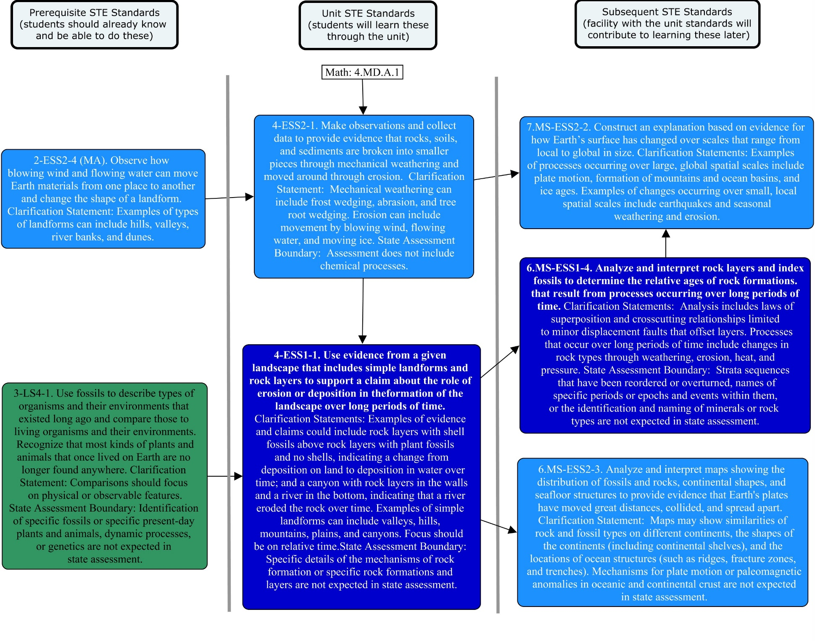

Unit Plan
Stage 1 Desired Results
ESTABLISHED GOALS G  4-ESS1-1 Use evidence from a given landscape that includes simple landforms and rock layers to support a claim about the role of erosion or deposition in the formation of the landscape over long periods of time. Clarification Statement: Examples of evidence and claims could include rock layers with shell fossils above rock layers with plant fossils and no shells, indicating a change from deposition on land to deposition in water over time; and, a canyon with rock layers in the walls and a river in the bottom, indicating that a river eroded the rock over time. Examples of simple landforms can include valleys, hills, mountains, plains, and canyons. Focus should be on relative time. State Assessment Boundary: Specific details of the mechanisms of rock formation or specific rock formations and layers are not expected in state assessment.  4-ESS2-1 Make observations and collect data to provide evidence that rocks, soils, and sediments are broken into smaller pieces through mechanical weathering and moved around through erosion. Clarification Statement: Mechanical weathering processes can include frost wedging, abrasion, and tree root wedging. Erosion can include movement by blowing wind, flowing water, and moving ice. State Assessment Boundary: Chemical processes are not expected in state assessment.  English Language Arts/Literacy  ELA.4.W.3.08 Recall relevant information from experiences or gather relevant information from print and digital sources; take notes and categorize information, and provide a list of sources. | Transfer
Students will be able to independently use their learning to… T
- Analyze mechanisms of cause and effect in natural and designed systems based on physical and chemical principles.

 | Meaning
 | UNDERSTANDINGS U  Students will understand that…  U1: Weathering involves landforms being broken down and erosion involves materials moving from one place to another  U2: Erosion is one of the forces that causes landforms to change  U3: The effects of erosion differ based on the causes of erosion and the composition of landforms  U4: Deposition over long periods of time result in rock layers and landforms that can be interpreted today | ESSENTIAL QUESTIONS Q  Q1: What causes changes to landscapes where we live?  Q2: How do we know what has happened to a landscape in the past?
 | Acquisition
 | Students will know… K  K1: The forces that cause weathering and erosion (including moving water, precipitation, freezing, wind, vegetation, mechanical abrasion, and moving ice)  K2: Weathering breaks rocks, soils and other Earth materials into smaller pieces  K3: How landforms are changed both by erosion and by deposition  K4: The relationship between weathering, erosion and deposition  K5: Features of an eroded landscape that can be used to identify erosion has occurred  K6: Features of a depositional landscape that can be used to identify deposition has occurred | Students will be skilled at… S  S1: Identifying the probable cause in different examples of erosion and deposition  S2: Observing and identifying forces that result in erosion  S3: Presenting results of their investigations in an organized manner  S4: Making a claim and supporting it with evidence  S5: Synthesizing information from more than one source
Stage 2 - Evidence
Evaluative Criteria | Assessment Evidence
See CEPA Rubric | CURRICULUM EMBEDDED PERFORMANCE ASSESSMENT (PERFORMANCE TASK)  Interpreting a Landscape  Goal: To interpret how two different landscapes formed  Role: You are a geologist  Audience: Fellow geologists  Situation: You have been asked to identify what processes have led to the formation of two current landscapes  Product: A written piece that explains your interpretation (including claims, evidence and reasoning) of the processes which created each landscape
OTHER EVIDENCE: OE
- Evidence of understanding shown in discussions and science journal entries
- Accuracy and relevance of evidence on the Investigation Chart
- Accuracy and completeness of Venn diagram comparing weathering and erosion
- Explanation and claims of landscape interpretations
Stage 3 – Learning Plan
Summary of Key Learning Events and Instruction

Lesson 1: Investigation into Different Forces That Cause Weathering (three 45-minute sessions)
This lesson is a series of investigations about the different processes that cause rocks, soil and sediment to be broken into smaller pieces.
Investigation 1: The effect of vegetation and frost wedging
Investigation 2: The effect of mechanical weathering (abrasion)

Lesson 2: Investigation into Different Forces That Cause Erosion (two 45-minute session)
This lesson is a series of investigations about the different processes that cause rocks, soil and sediment to be moved around and deposited elsewhere.
Investigation 3: The effect of water waves and precipitation (flowing water)
Investigation 4: The effect of wind

Lesson 3: Weathering and Erosion in Action Together (one 45-minute session)
This lesson is a series of investigations about the different processes that cause rocks, soil and sediment to be broken into smaller pieces, moved around and deposited elsewhere, causing peaks and valleys to form.
Investigation 5: The effect of moving ice (glaciers)
Investigation 6: Deposition and Sedimentation

Lesson 4: What Made This Landform? (two 45-minute sessions)
Students observe different landforms to infer how weathering, erosion and deposition worked to shape each landform.

CEPA: Interpreting a Landscape (two 45-minute sessions)
This CEPA is designed to ensure that students understand that the earth is constantly changing and how weathering, erosion and deposition lead to changes. Students make claims about how ice, water, wind and vegetation cause weathering, erosion and/or deposition that led to the formation of specific landscapes. They then do research to check and refine those claims.

Adapted from Understanding by Design 2.0 © 2011 Grant Wiggins and Jay McTighe Used with Permission

Lesson #1: Investigations into Different Forces that Cause Weathering

Brief Overview of Lesson: This lesson is a series of investigations about the different processes that cause rocks, soil and sediment to be broken into smaller pieces.
Prior Knowledge Required:
- Students should understand that materials can be broken into smaller and smaller pieces.
- Students should be able to independently follow a procedure to complete a scientific investigation.
- Students should be able to use a ruler and a scale to weight objects.

Estimated Time: three 45-minute sessions
Resources for Lesson:
- Science journals
- Investigation materials: small balloons, plaster of Paris, small milk cartons, cans with lids (or rock tumbler), sandstone rocks (or other “soft” rocks), rulers, scale
- Access to a freezer
Standard(s)/Unit Goal(s) to be addressed in this lesson:
- 4-ESS2-1 Make observations and collect data to provide evidence that rocks, soils, and sediments are broken into smaller pieces through mechanical weathering and moved around through erosion. Clarification Statement: Mechanical weathering processes can include frost wedging, abrasion, and tree root wedging. Erosion can include movement by blowing wind, flowing water, and moving ice. State Assessment Boundary: Chemical processes are not expected in state assessment.
- W 4.8 Recall relevant information from experiences or gather relevant information from print and digital sources; take notes and categorize information and provide a list of sources.

Essential Question(s) addressed in this lesson:
- What causes changes to landscapes where we live?

Objectives:
Students will be able to...
- Use evidence from investigations to support an explanation of weathering.
- Collect observations and data based on weathering investigations.

Language Objectives:
Students will be able to…
- Write observations of natural events based on investigations and orally discuss observations from investigations in small groups and as a whole class.

Targeted Academic Language:
- Domain-Specific Language: weathering, mechanical weathering (abrasion), frost wedging, landscape, landform, material, tree root wedging

Anticipated Student Preconceptions/Misconceptions:
- Students may believe that the Earth is unchanging, changes in the Earth are random, or that rock is so hard that nothing can break it.

Instructional Materials/Resources/Tools:
- Internet connection for animation and video
- A Venn diagram on poster paper (and handouts) with erosion and weathering in respective cells.
- Tree root wedging internet links (see Unit Resources)
- See prior page for investigation materials
- For additional links and resources, see Unit Resources

Instructional Tips/Strategies/Suggestions for Teacher:
- The first three lessons contain a series of investigations that are used to explore different types of weathering, erosion and deposition, and the effect each has on different types of Earth materials. This first lesson focuses on weathering, particularly breaking rocks into smaller pieces. It also supports students in learning how to gather and record relevant information from experience and digital sources.
- Have science journals, Venn diagrams, and investigation chart (see Unit Resources) set up and/or copied. The investigation chart can be copied into, or pasted into, students’ science journals.
- Students may need assistance setting up and filling in appropriate observations and data in their science notebook for each investigation. Be active in reviewing and providing input to students on this.
- Students should be encouraged to predict outcomes, record observations and draw conclusions using evidence from their investigations. Drawing conclusions using evidence in writing and discussion is a particularly good literacy connection.
- Pre-make Plaster-of-Paris set ups (see Investigation 1, Part2). Prepare small sandstone rocks – if a larger piece was purchase it needs to be broken into approximately 1-inch pieces.
- Investigations can be done individually, in pairs, in small groups, or whole group. They may be completed on different days or set up as a series of stations through which students rotate. The investigations are loosely ordered; they can be done in a different order.

Assessment:
- Can be completed through a group discussion or analysis of students’ journal entry using the suggested closing questions.

Lesson Details:

DAY 1
Before Investigations (15 minutes)
- Ask students to consider the essential question. Facilitate a brief class discussion highlighting students' ideas, preconceptions, and/or misconceptions about how Earth’s materials are broken down or worn away. Ask for examples of their thinking or where they have seen this happen.
- Introduce investigation stations and science journal/data collection procedure. Propose a set up that combines free space in their notebook that is summarized in the Investigation Chart but leave flexibility for students.
- Provide students a brief overview that today’s activities focus on learning about different types of weathering – how Earth’s materials are broken into smaller pieces.

Investigation 1: The effect of vegetation and frost wedging
Part 1: Tree Root Wedging (20 minutes)
Materials: Pictures of rocks that have been broken by the growth of tree roots (see unit resources)
Procedure:
- In small groups, have students observe pictures of rocks that have been broken by tree roots. Record observations and illustrations in science notebook. [Teacher note: Assist and check quality of student recordings and illustrations, as well as whether their notebook will support later categorization and analysis.]
  - Tree Root Wedging Images (rocks broken by growth of tree roots)
    - http://www.gly.uga.edu/railsback/FieldImages/RootWedgingNGa.jpeg
    - https://beansrock.files.wordpress.com/2014/12/20141206_170753.jpg
- Ask students to discuss whether they think the roots grew into a space in the rock or actively split the rock. Include their reasons and evidence.
- View animation. Ask students to refine or adjust their thinking, reasons, and evidence.
  - Suggested animation:
    - Tree Root Animation from University of Kentucky College of Arts and Sciences: https://ees.as.uky.edu/sites/default/files/elearning/module07swf.swf (click to Mechanical Weathering: Tree Roots to find animation.)
- Optional: Teachers may choose to take a “field trip” around the school grounds and look for evidence of cracking of rocks or even asphalt or cement due to tree roots.
- Suggested closing question: What effects can roots have on the Earth’s materials?

Part 2: Frost wedging
Materials (per set): Plaster of Paris, 2 small milk cartons (cup or pint size), 1 small balloon, freezer
Procedure:
Day 1 (10 minutes)
- Teacher note: Have some set ups already made. Search for ‘frost wedging experiment” by Sebastian Erazo on YouTube. Doing this for the class is a demonstration of how they were set up. This is necessary given the time the Plaster of Paris needs to harden.
- Fill balloon with about 40 ml of water—tie off balloon.
- Push the balloon to the bottom of one carton so that the knot is facing up. Pour about an inch of plaster of Paris in each milk carton.
- Hold the balloon knot so that the knot remains facing up until the plaster hardens enough to hold the balloon in place.
- Put both milk cartons in the freezer.
- Ask students to summarize this procedure in their science notebooks.

DAY 2
Part 2: Frost wedging – observations (10 minutes)
- Remove milk cartons from the freezer.
- Observe the plaster of Paris in both milk cartons. Record observations in science notebooks, with particular attention to the ice. [Teacher note: The milk carton containing the balloon should have cracked plaster of Paris. assist and check quality of student recordings and illustrations, as well as whether their notebook will support later categorization and analysis.]
- Suggested closing question: What did freezing the water (ice) do to the plaster of Paris in the milk carton?
- Optional: show and discuss video or animation of frost wedging.
  - Suggestions:
    - Weathering and erosion - Freeze thaw weathering video from You Tube: https://www.youtube.com/watch?v=_XnCTcjNpuc
    - Frost Wedge Animation from University of Kentucky College of Arts and Sciences:
https://ees.as.uky.edu/sites/default/files/elearning/module07swf.swf (click arrows at top of page to Mechanical Weathering: Frost Wedging to find animation.)
Small group work (10 minutes)
- Review different science notebook set ups or ways of recording information, observations, and illustrations. Small groups discuss pros and cons of different styles or methods.

Investigation 2: The effect of mechanical weathering (abrasion) (30 minutes)
Materials: Rocks (MUST BE soft ones like sandstone), can with lid (can use a rock tumbler if available), rulers, scale (fairly sensitive)
Procedure:
- Observe the rocks, measure their size, and weigh them (as a set). Record in science notebooks
- Place rocks in coffee can and put the lid on. Have individual students take turns shaking the can for several minutes each, for a total of 10-15 minutes. Or use rock tumbler. (NOTE: this will be noisy. Accommodations may have to made for some students and neighboring teachers.]
- Remove lid and put contents of can onto a piece of white paper.
- Observe contents, focusing on any changes (particularly the edges of the rocks). Measure the size of rocks and/or weight the set (without the sand/dust included); weight the sand/dust separately. Record in science notebooks. [Teacher note: assist and check quality of student recordings and illustrations, as well as whether their notebook will support later categorization and analysis.]
- Suggested closing questions: How has the shape of the rocks changed? What is left in the can besides the rocks? Where did that come from and how was it produced?

DAY 3 (45 minutes)
- Briefly review Investigations 1 and 2, emphasizing that materials were broken into smaller pieces and that mechanical weathering (abrasion) can happen anytime materials are rubbed together or forced apart. (5 minutes)
- Explain that they have now seen small scale examples of breaking materials into smaller pieces. Pose the question (a form of the essential question): How might these processes change landscapes where we live?
- In small groups, consider your answer to the question. (5 minutes)
- View a video on mechanical weathering (need to list options in Unit Resources still). (5 minutes)
- Return to small groups to reconsider the answer to the question. (5 minutes) [Teacher note: Students should include ideas such as “over long time periods” or “over many iterations/seasons/weather events”.]
- Brief report out of a couple group answers. Use these to fill in the Venn Diagram on Weathering. (10 minutes) [Teacher note: The Venn diagram for erosion will be used in Lesson 2. The long-term goal is to be compare these.]
- Individuals record their thinking, reasoning, and evidence about the impact of weathering on landforms in their science notebook. (10 minutes)

Lesson #2: Investigations into Different Forces that Cause Erosion

Brief Overview of Lesson: This lesson is a series of investigations about the different processes that cause rocks, soil and sediment to be moved around and deposited elsewhere.
Prior Knowledge Required:
- Students should understand, in a general sense, that the movement of wind and water moves materials and changes the shape of landforms.
- Students should be able to use rulers and record heights.
- Students should be able to independently follow a procedure to complete a scientific investigation.

Estimated Time: two 45-minute sessions
Resources for Lesson:
- Science journals
- Investigation materials: shallow pans, sand, soil, water, gravel, clay, small fans, rulers, measuring cups, deep cardboard boxes, small pebbles or rocks
Standard(s)/Unit Goal(s) to be addressed in this lesson:
- 4-ESS2-1 Make observations and collect data to provide evidence that rocks, soils, and sediments are broken into smaller pieces through mechanical weathering and moved around through erosion. Clarification Statement: Mechanical weathering processes can include frost wedging, abrasion, and tree root wedging. Erosion can include movement by blowing wind, flowing water, and moving ice. State Assessment Boundary: Chemical processes are not expected in state assessment.

Essential Question(s) addressed in this lesson:
- What causes changes to landscapes where we live?

Objectives:
Students will be able to…
- Collect measurements and observations on the effects of wind and water on weathering
- Construct an explanation of how wind and water effect landforms using evidence from investigations

Language Objectives:
Students will be able to…
- Write observations based on investigations, and orally collaborate on an explanation of how landforms change based on videos and observations

Targeted Academic Language:
- Domain Specific Language: erosion, precipitation, landscape, landform, weathering, texture, material

Anticipated Student Preconceptions/Misconceptions:
- Students may believe that the earth is unchanging, changes in the earth are random, rock is so hard that nothing can break it, or that materials that are moved by erosion just disappear.

Instructional Materials/Resources/Tools:
- Video on erosion (see options in Unit Resources)
- Venn diagrams (2) on poster paper (and handouts)
- See prior page for investigation materials
- For additional links and resources, see Unit Resources

Instructional Tips/Strategies/Suggestions for Teacher:
- The first three lessons contain a series of investigations that are used to explore different types of weathering, erosion and deposition, and the effect each has on different types of Earth materials. This lesson emphasizes movement of materials (erosion) by wind and water.
- Students should be encouraged to predict outcomes, record observations and draw conclusions using evidence from their investigations. Drawing conclusions using evidence in writing and discussion is a particularly good literacy connection.
- Investigations can be done individually, in pairs, in small groups, or whole group. They may be completed on different days or set up as a series of stations through which students rotate. The investigations are loosely ordered; they can be done in a different order. However, Investigations 3 and 4 (Part 1) use the same set up as for wind and waves. The ordering as presented allows use of the same materials so that they are not wet before trying to blow them.
- Students will be recording and drawing observations and taking measurements of the height of simulated landscapes.

Assessment:
- Can be completed through a group discussion or analysis of students’ journal entry using the Closing Question Suggestions.

Lesson Details:

DAY 1
Investigation 3: The effect of wind (10 minutes)
Materials: Shallow pan, deep cardboard box that will hold the pan (to keep the sand from blowing out of the pan), sand, small handheld fan, ruler
Procedure:
- Place the pan inside the cardboard box and make a pile of sand at one end of the box.
- Measure and record the height of the sand. Record your observations about the appearance and texture of the surface of the sand.
- Stand at the other end of the box and blow air from the fan at the pile of sand for 20 seconds.
- Measure and record the height of the sand and any other observations you notice, especially about the appearance and texture of the surface of the sand. [Teacher note: assist and check quality of student recordings and illustrations, as well as whether their notebook will support later categorization and analysis.]
- Suggested closing questions: What did you observe about the effects of wind on the sand? Where did the sand move to?

Investigation 4: The effect of waves and precipitation (flowing water) (15 minutes)
Part 1: Waves
Materials: Shallow pan, mix of sand and some pebbles or small rocks, water, ruler
Procedure:
- Make a mound of wet sand and pebbles at one end of the pan
- Carefully pour water into the pan to a depth of one inch.
- Using a ruler, measure and record the height of the mound.
- Make a rough sketch of the contents of the pan in your science journal. Record your observations about the appearance and texture of the surface of the mound.
- With your hand at the end of the pan without the mound, make 5 individual waves in the water, pushing the waves toward the mound. The waves should not be so rough that water splashes out of the pan.
- Measure and record the height of the mound of sand. Make another rough sketch of the contents of the pan, attending to both what has happened to the mound and where the sand has gone. [Teacher note: assist and check quality of student recordings and illustrations, as well as whether their notebook will support later categorization and analysis.]
- Suggested closing questions: How has the appearance and texture of the surface of the mound changed? What did you observe about the effects of the wave action on the materials in the mound? Where did the materials go?

Part 2: Precipitation (flowing water) (20 minutes)
Materials: Shallow pan, soil, mixture made of equal parts of sand, soil, gravel and clay that will make a large mound in the middle of the pan. 2 cups of water in a measuring cup or other container that’s easy to pour from, ruler
Procedure:
- Make a large mound of soil in the middle of the pan. Leave some empty space in the pan around the mound.
- Measure the height of the mound of soil and record it in your science journal. Make a rough sketch of the contents of the pan in your science journal. Record your observations about the appearance and texture of the surface of the soil.
- Carefully pour all of the water onto the mound of soil, using a slow steady stream from the cup.
- Measure and record the height of the mound of soil. Make another rough sketch of the contents of the pan. [Teacher note: assist and check quality of student recordings and illustrations, as well as whether their notebook will support later categorization and analysis.]
- Repeat investigation with sand/soil/gravel/clay mixture.
- Suggested closing questions: How has the appearance and texture of the surface of the soil changed? Where has the soil moved to? In the mixture, was there more of some materials than others left in the mound? How has the appearance and texture of the surface of the mixture changed? Which materials have moved, and where to?

DAY 2 (45 minutes)
- Briefly review Investigations 3 and 4, emphasizing that materials were moved from place to place by different means. Pose the question (a form of the essential question): How might these processes change landscapes where we live?
- In small groups, consider your answer to the question. (5 minutes)
- View a video on erosion (see below or in Unit Resources for options). (5 minutes)
  - Suggestions
    - Erosion video from PBS Learning Media: http://mass.pbslearningmedia.org/resource/nat08.earth.geol.eros.erosion/water-erosion/
    - Erosion video by fourth grade teacher from Teacher Tube: http://www.teachertube.com/video/erosion-120701
- Return to small groups to reconsider the answer to the question. (5 minutes) [Teacher note: Students should include ideas such as “over long time periods” or “over many iterations/seasons/weather events”.]
- Brief report out of a couple group answers. Use these to fill in the Venn Diagram on Erosion, making comparisons to Weathering and identifying any overlapping components. (10 minutes)
- Individuals record their thinking, reasoning, and evidence about the impact of weathering on landforms in their science notebook. (10 minutes)

Lesson #3: Weathering and Erosion in Action Together

Brief Overview of Lesson: This lesson is a series of investigations about the different processes that cause rocks, soil and sediment to be broken into smaller pieces, moved around and deposited elsewhere, causing peaks and valleys to form.

Estimated Time: one 45-minute session
Resources for Lesson:
- Science journals
- Investigation materials: shallow pans, sand, water, gravel, clay, ice cube trays, small rocks, small shells, glass jars with lids, soil or dirt
- Access to a freezer
Standard(s)/Unit Goal(s) to be addressed in this lesson:
- 4-ESS1-1 Use evidence from a given landscape that includes simple landforms and rock layers to support a claim about the role of erosion or deposition in the formation of the landscape over long periods of time. Clarification Statement: Examples of evidence and claims could include rock layers with shell fossils above rock layers with plant fossils and no shells, indicating a change from deposition on land to deposition in water over time; and, a canyon with rock layers in the walls and a river in the bottom, indicating that a river eroded the rock over time. Examples of simple landforms can include valleys, hills, mountains, plains, and canyons. Focus should be on relative time. State Assessment Boundary: Specific details of the mechanisms of rock formation or specific rock formations and layers are not expected in state assessment.
- 4-ESS2-1 Make observations and collect data to provide evidence that rocks, soils, and sediments are broken into smaller pieces through mechanical weathering and moved around through erosion. Clarification Statement: Mechanical weathering processes can include frost wedging, abrasion, and tree root wedging. Erosion can include movement by blowing wind, flowing water, and moving ice. State Assessment Boundary: Chemical processes are not expected in state assessment.
- W 4.8 Recall relevant information from experiences or gather relevant information from print and digital sources; take notes and categorize information, and provide a list of sources.

Essential Question(s) addressed in this lesson:
- What causes changes to landscapes where we live?
- How do we know what has happened to a landscape in the past?

Objectives:
Students will be able to…
- Combine relevant information from multiple investigations to make comparisons between scenarios using evidence.
- Develop a model that shows relationships between different types of weathering using evidence from investigations

Language Objectives:
Students will be able to…
- Write observations and orally share observations with small groups. Write descriptions in a Venn diagram model and discuss reasoning orally.
Targeted Academic Language:
- Domain Specific Language: weathering, erosion, deposition, glacier, landscape, landform, texture, material

Anticipated Student Preconceptions/Misconceptions:
- Students may believe that the earth is unchanging, changes in the earth are random, rock is so hard that nothing can break it, or that materials that are moved by erosion just disappear.

Instructional Materials/Resources/Tools:
- Venn diagrams (2) on poster paper (and handouts)
- See prior page for investigation materials
- For additional links and resources, see Unit Resources

Instructional Tips/Strategies/Suggestions for Teacher:
- The first three lessons contain a series of investigations that are used to explore different types of weathering, erosion and deposition, and the effect each has on different types of Earth materials. This lesson emphasizes that weathering and erosion often act at the same time, particularly visible in glaciers.
- Students should be encouraged to predict outcomes, record observations and draw conclusions using evidence from their investigations. Drawing conclusions using evidence in writing and discussion is a particularly good literacy connection.
- Pre-make the glacier ice cubes (see Investigation #5).
- Investigations can be done individually, in pairs, in small groups, or whole group. They may be completed on different days or set up as a series of stations through which students rotate. The investigations are loosely ordered; they can be done in a different order.

Assessment:
- Investigations Chart in their Science Journal
Venn diagram on weathering and erosion
Lesson Details:

Before Investigations (5 minutes)
- Ask students the first essential question again to facilitate a brief recap of Lessons 1 and 2. Introduce today’s activities and their purpose.

Investigation 5: The effect of moving ice (glaciers) (25 minutes)
Materials: Glacier ice cubes (Instructions; place small pebbles (gravel) and sand in ice cube trays. Fill trays with water and freeze), shallow pan, clay that has been rolled out or flattened into large sheets and cut into 6” pieces
Procedure:
- Place the slab of clay in a shallow pan.
- Observe the slab of clay and describe the texture in a science journal
- Take several glacier ice cubes and scrape the surface of the clay several times.
- Observe the slab of clay again. Record observations in science journal.
- Place the ice cube glacier on the slab of clay in the pan and allow it to melt.
- Observe the clay again. Record observations in science journal. [Teacher note: Students should include ideas such as “over long time periods” or “over many iterations/seasons/weather events”.]
- Watch video on glaciers (see suggestion below or in Unit Resources). Record relevant information and observations, particularly regarding weathering and erosion. [Teacher note: Assist students in identifying relevant information: emphasize breaking of rock (abrasion) and erosion (moving material in the ice).]
  - Video Suggestion: Glacier Video- What is a Glacier?: https://www.youtube.com/watch?v=fleXP9ljZ-o
- Complete discussion of Venn diagram: compare and contrast weathering and erosion until the class is generally in consensus.
- Return to the melted/melting ice cubes. Observe the clay and the material that had been in the ice. Record observations in your science journal. [Teacher note: A key point here is that sand and pebbles are left on the surface of the clay; there are deposited by the ice of the glacier.]
- Suggested closing questions: What do you observe about the effects of glacial movement on the clay? What happened to the contents of the “glacier” (ice cube) after the ice melted?

Small group work (15 minutes)
- Once data is collected for all five investigations, students finish the Investigations chart to categorize and synthesize investigation data. Emphasize to students that they should use their science journal to recall experiences, observations, and data to synthesize and summarize each situation. Students should ensure that they include their reasoning, and where possible the relevant evidence, in their claims about the presence or action of weathering, erosion and/or deposition in each situation.

Assessment
- Review the Investigations Chart in their Science Journal and the completed Venn diagram for accuracy and comprehensiveness.

Preview outcomes for the next lesson:
The next lesson will focus on helping students to determine how weathering, erosion and deposition affect the appearance and composition of different landforms.

Lesson #4: What Made This Landform?

Brief Overview of Lesson: Students observe different landforms (the Old Man of the Mountain in New Hampshire, sandstone arches in Utah, dunes on Plum Island, moraines in Gloucester, and a shell fossil formation in Canada) to infer how weathering, erosion and deposition worked to shape each landform.
Prior Knowledge Required:
- Students should understand different weathering processes and how erosion moves weathered materials from one place to where it is deposited in another place.
- Students should understand that landforms can be both broken down and built up by the forces of weathering, erosion and deposition.
- Students should know what a fossil is.

Estimated Time: two 45-minute sessions
Resources for Lesson:
- Pictures of each landform (see Unit Resources)
Standard(s)/Unit Goal(s) to be addressed in this lesson:
- 4-ESS1-1 Use evidence from a given landscape that includes simple landforms and rock layers to support a claim about the role of erosion or deposition in the formation of the landscape over long periods of time. Clarification Statement: Examples of evidence and claims could include rock layers with shell fossils above rock layers with plant fossils and no shells, indicating a change from deposition on land to deposition in water over time; and, a canyon with rock layers in the walls and a river in the bottom, indicating that a river eroded the rock over time. Examples of simple landforms can include valleys, hills, mountains, plains, and canyons. Focus should be on relative time. State Assessment Boundary: Specific details of the mechanisms of rock formation or specific rock formations and layers are not expected in state assessment.

Essential Question(s) addressed in this lesson:
- How do we know what has happened to a landscape in the past?

Objectives:
Students will be able to…
- Compare images of phenomena with observations, data, and models
- Construct arguments for how certain landforms occurred naturally using evidence from investigations and their comparison model

Language Objectives:
Students will be able to…
- Discuss initial evidence from pictures with peers in order to write argument paragraphs

Targeted Academic Language
- Domain Specific Language: weathering, erosion, deposition, glacier, landscape, landform, rock formation, hurricane, moraine

Anticipated Student Preconceptions/Misconceptions:
- Students may believe that the earth’s landforms are unchanging, change is random, or that similar types of weathering and erosion will have the same effect on different substances.
- Students may believe that erosion is responsible only for breaking landforms down.

Instructional Materials/Resources/Tools:
- See prior page
- For additional links and resources, see Unit Resources

Instructional Tips/Strategies/Suggestions for Teacher:
- The activities should be done in the order presented in the lesson as they are designed to scaffold students to independently analyze a landform or landscape. Activity 1 is done as a whole group, modeled by the teacher as needed. Activities 2 and 3 are done in small groups with report out as a whole group to check on progress and appropriateness. Activities 4 and 5 should be attempted by individual students then supported and completed through small group work and teacher facilitation as needed.
- For the first 3 landscapes, remind students about prior investigations that have bearing on interpreting each situation.
- For each landform or landscape, ask students to consider any types of weathering, erosion, and deposition that may have been and may currently act on it. Ask four distinct questions (you may want to post these up for all to see through the lesson):
- What has been weathered here?
- What has been deposited here?
- How might the materials have been moved (eroded)?
- What evidence supports your thinking?
- When reviewing student explanations and claims, the focus is not on the accuracy per se but on whether the students can support their claims with features of the landform or results of prior investigations as evidence. Since they are not watching the actual process unfold in any of the landscapes, a range of possible explanations are possible. But they should be supported with relevant evidence and reasoning. Suggested focus/responses are provided in teacher notes below for each landscape.
- Students should write out their claims. Create your own template or graphic organizer that includes prompts and space for: 1) their claim about the role of weathering, erosion, and/or deposition in the formation of the landform; 2) the evidence from the pictures, videos or prior investigations that supports their claim; and 3) explain why their evidence supports their claim (their reasoning). For example:

Your claim

Your evidence

Explain how your evidence supports your claim

- Students will likely have several claims about each landform. Students can write these in their science notebook.

Assessment:
- Claims made of the last three landforms/landscapes (Plum Island, Dogtown, Burgess Shale)

Lesson Details:

DAY 1
Lesson Opening (15 minutes)
- Introduce the goal and process for the day. We will analyze a series of landforms to infer and learn about how weathering, erosion and deposition formed them. State and have an initial discussion of We’ll work together to start then you will do them more independently as we go through five landforms over the next couple of days.
- Work as a whole class to model the first activity:

- Old Man of the Mountain, NH
- Project images and provide handout (see Unit Resources)
  - Images at: http://eqcrevision.blogspot.com/2013/09/eqc-revision-quiz-23.html (scroll down to image and then click on image to make larger)
- Look at the before and after images of Old Man of the Mountain. Ask students to individually consider: Was weathering, erosion, and/or deposition at work here? Ask four distinct questions:
  - What has been weathered here?
  - What has been deposited here?
  - How might the materials have been moved (eroded)?
  - What evidence supports your thinking?
- Individuals write out their initial response (claim) in their science journal. Encourage them to refer to, and use evidence from, the investigations in prior lessons.
- Call on several individuals to share their responses. Discuss as a group until a consensus emerges. As a group write and/or refine a claim (or two), including evidence and reasoning, to model what a good claim looks like that reflects the groups inference of what happened to the Old Man of the Mountain.
- [Teacher note: Final claim(s) should focus on weathering (frost wedging); can include erosion by gravity fall as well.]

During the Lesson
- In the second and third activities students will be working more in groups. So where everyone worked as a whole group in the first activity, they will work in small groups for the next two. However, there may be instances where it is useful to interrupt their work to provide the whole group some context about the landscape they are analyzing, hints about potential processes (particularly by referring them to specific investigations from prior lessons), or to highlight a specific feature of a landscape to focus on. Remind them to ask the 4 questions in each case.

- Moraine in Dogtown, Gloucester (15 minutes)
- Project images and provide handout (see Unit Resources)
  - Images at: http://myweb.northshore.edu/users/ccarlsen/poetry/gloucester/image_pages/moraine1.htm
- Look at the images of Dogtown in Gloucester. Ask students to individually consider: Was weathering, erosion, and/or deposition at work here? Remind them to consider four distinct questions:
  - What has been weathered here?
  - What has been deposited here?
  - How might the materials have been moved (eroded)?
  - What evidence supports your thinking?
- Individuals write out their initial response (claim) in their science journal. Encourage them to refer to, and use evidence from, the investigations in prior lessons. [Teacher note: Here or during the small group discussions, you can remind them of the glacier investigation.]
- Ask students to discuss their thinking in small groups. Each group should write and/or refine a claim (or two), including evidence and reasoning, that reflects the model of a good claim established in the first activity.
- [Teacher note: Final claim(s) should focus on deposition of rocks on the surface after glacier ice melted; can include weathering by frost or tree root wedging as well.]

- Dunes on Plum Island (15 minutes)
- Project images and provide handout (see Unit Resources)
  - Images at: http://www.boston.com/news/local/massachusetts/articles/2009/02/09/report_paints_dire_picture_for_plum_island/

- Look at the images of eroded dunes on Plum Island. Ask students to individually consider: Was weathering, erosion, and/or deposition at work here? Remind them to consider four distinct questions:
  - What has been weathered here?
  - What has been deposited here?
  - How might the materials have been moved (eroded)?
  - What evidence supports your thinking?
- Individuals write out their initial response (claim) in their science journal. Encourage them to refer to, and use evidence from, the investigations in prior lessons. [Teacher note: Here or during the small group discussions, you can remind them of the wind and waves investigations.]
- Ask students to discuss their thinking in small groups. Each group should write and/or refine a claim (or several), including evidence and reasoning, that reflects the model of a good claim established in the first activity.
- [Teacher note: Final claim(s) should focus on both deposition of sand (method does not need to be specified) to form the dunes and erosion of the dunes by wind and waves.]

DAY 2
- In the fourth and fifth activities students will be working more individually. Students will still have a chance to check their understanding and whether there is group consensus, but after they have individually refined their thinking based on additional information provided by the teacher. Again, there may be instances where it is useful to interrupt their work to provide the whole group some context about the landscape they are analyzing or to highlight a specific feature of a landscape to focus on.
- [Teacher note: Please note that these two are fairly difficult (and hence students may need some support) as they need to infer both the original depositional events (that are now “rock”) and the subsequent erosion. Support them in considering both.]

- Sandstone arches in Arches National Park, Utah (15 minutes)
- Project images and provide handout (see Unit Resources)
  - Images at: http://en.wikipedia.org/wiki/File:Double-O-Arch_Arches_National_Park_2.jpg
- Look at the images of the sandstone arches. Ask students to individually consider: Was weathering, erosion, and/or deposition at work here? Remind them to consider four distinct questions:
  - What has been weathered here?
  - What has been deposited here?
  - How might the materials have been moved (eroded)?
  - What evidence supports your thinking?
- Individuals write out their initial response (claim) in their science journal. Encourage them to refer to, and use evidence from, the investigations in prior lessons.
- Show slide show from PBS:
http://mass.pbslearningmedia.org/resource/ess05.sci.ess.earthsys.erosion/erosion-and-weathering/
Show slides 1-4 to illustrate how weathering and erosion work together.
- Ask students to refine their claim(s), including evidence and reasoning, that reflects the model of a good claim established in the first activity.
- Conduct a brief whole-class reflection/debrief and/or ask students to share their thinking in small groups.
- [Teacher note: Final claim(s) should focus on both original deposition of sand (method does not need to be specified; the rock was originally sand dunes) that formed sandstone and later erosion of the sandstone by mechanical weathering (primarily wind and water).]

- Shell fossil formation, Burgess Shale, Canada (20 minutes)
- Project images and provide handout (see Unit Resources)
  - Images at: http://geotripper.blogspot.com/2014/04/where-are-ten-most-incredible-places_1565.html
- Remind students what a fossil is (learned in grade 3; 3-LS4-1).
- Look at the images of the shell fossil formation. Ask students to individually consider: Was weathering, erosion, and/or deposition at work here? Remind them to consider four distinct questions:
  - What has been weathered here?
  - What has been deposited here?
  - How might the materials have been moved (eroded)?
  - What evidence supports your thinking?
- Individuals write out their initial response (claim) in their science journal. Encourage them to refer to, and use evidence from, the investigations in prior lessons.
- Provide additional information:
  - http://www.earthmagazine.org/article/travels-geology-famous-fossils-and-spectacular-scenery-british-columbias-burgess-shale
  - http://geotripper.blogspot.com/2014/04/where-are-ten-most-incredible-places_1565.html
- Ask students to refine their claim(s), including evidence and reasoning, that reflects the model of a good claim established in the first activity.
- Conduct a brief whole-class reflection/debrief and/or ask students to share their thinking in small groups.
- [Teacher note: Final claim(s) should focus on both original deposition of sediments (and capturing fossils) in sequential layers (method does not need to be specified; the rock was originally sediment at the bottom of an ocean) that turned into rock and later erosion of the rocks by mechanical weathering exposed and shaped the landscape as it is now.]

Lesson Closing (10 minutes)
- Have students turn in their claims. Note that you will review their claims relative to the 2 qualities in the assessment section below.
- Return to the essential question: How do we know what has happened to a landscape in the past?
- Ask students to discuss the question and compile strategies, lessons learned, and methods of analyzing a landscape to infer how weathering, erosion, and deposition have acted to shape the landscape we see today.
- Preview the CEPA by noting that they are going to continue this work, using lessons learned just reviewed, to analyze and research two additional landscapes independently.

Assessment
- Review claims made of the last three landforms/landscapes (Plum Island, Dogtown, Burgess Shale).
- Look for and give feedback about:
  - Quality of the claims, including use of relevant evidence and reasoning.
  - Mention or inclusion of weathering, erosion, and deposition in their explanations.

Curriculum Embedded Performance Assessment (CEPA)
Interpreting a Landscape

This CEPA is designed to ensure that students understand that the earth is constantly changing and how weathering, erosion and deposition lead to changes. Students make claims about how ice, water, wind and vegetation cause weathering, erosion and/or deposition that led to the formation of specific landscapes. They then do research to check and refine those claims.

Estimated Time: Two 45-minute sessions

Materials:
- Images of two landscapes (see Unit Resources)
- Access to the internet

Explanation of CEPA
- Goal: to interpret how two different landscapes formed
- Role: you are a geologist
- Audience: fellow geologists
- Situation: you have been asked to identify what processes have led to the formation of two current landscapes
- Product: a written piece that explains your interpretation (including claims, evidence and reasoning) of the processes which created each landscape

Analyzing a landscape for effects of weathering, erosion and deposition

- Briefly review the prior lesson by reviewing what has been learned regarding the essential question: How do we know what has happened to a landscape in the past?
- Introduce the CEPA: The next two days you will be looking at two new landscapes to infer how they were formed. You will work independently for most of this time, although there is a research component that will be completed in small groups. Emphasize that having a correct explanation is a goal by the end of the CEPA, but more important is coming to a reasoned explanation based on the evidence you can draw from prior lessons and from your research. You will submit initial claims that do not have to be correct, but do need to be supported with evidence. After that you will research to refine your claims and explanations.

Part 1:
- Show the students two photo sets (handouts in Unit Resources; links below):
  - The Grand Canyon
    - http://www.bobspixels.com/kaibab.org/geology/gc_geol.htm
    - http://en.wikipedia.org/wiki/Grand_Canyon
  - Roxbury Puddingstone
    - http://written-in-stone-seen-through-my-lens.blogspot.com/2011/03/architectural-geology-of-boston-roxbury_27.html
    - https://roxxbost.files.wordpress.com/2014/03/pstone_11_web.jpg
- For each of the following landscape, students need to:
  - Decide what role weathering, erosion, and/or deposition have played in forming each landform/landscape over time.
  - Write claims using evidence from the prior investigations and landscape analyses and including your reasoning for each that provide an explanation of how each landscape formed.
  - Turn in a copy of these claims to the teacher.

Part 2:
- Choose one of the landscapes to research. Work together in small groups to find and review books or use the internet, or both, to gather information on the specific landform or the weathering, erosion, and/or deposition processes likely at work. [Teacher note: Students should be given the choice of reading two books, or reading one book and researching information on one website, or researching information on two websites. They should be encouraged to read on weathering and erosion in general or more specific information on their location if such a book is available to them. Specific books may not be accessible for each location.]
- Once research is complete, independently evaluate your initial claims about the landscape. Refine your claims and explanation, providing references to sources found during your research to indicate where you were correct or where you changed your thinking.
- Write it up, with this format:
  - Original explanation and claims about your chosen landscape
  - Revised explanation and claims, including references to relevant sources

CEPA Rubric

Category | 4 | 3 | 2 | 1
Photo analysis (initial claims) | Student made appropriate and logical claims about weathering, erosion, and deposition processes and provided substantial and relevant evidence for all | Student made appropriate claims about weathering, erosion, and deposition processes and provided sufficient evidence for all | Student made reasonable claims about one or more processes, but provided weak evidence for each | Student made limited or inappropriate claims about weathering, erosion, OR deposition process or did not provide evidence
Research | Student synthesized information from 2 or more sources to gain a thorough understanding of weathering, erosion and deposition processes at work in chosen landscape | Student synthesized information from 2 sources to gain a sufficient understanding of weathering, erosion and deposition processes at work in chosen landscape | Student used information from only 1 source or demonstrated a partial or limited understanding of weathering, erosion and deposition processes at work in chosen landscape | Student used information from only 1 source and did not demonstrate an understanding of either weathering, erosion or deposition processes at work in chosen landscape
Group contribution | Student contributed ideas and resources to their group, taking leadership role | Student contributed ideas and resources to their group | Student contributed ideas or resources to their group | Student did not contribute ideas and resources to their group
Written explanation and sources | Student provides a correct explanation with relevant and correct claims that demonstrates logical reasoning, shows evidence of revision or refinement, and is backed up with relevant citations | Student provides a reasonable explanation with relevant claims that demonstrates logical reasoning, shows evidence of revision or refinement, and is backed up with relevant citations | Student provides a reasonable explanation with relevant claims that demonstrates logical reasoning, shows some evidence of revision or refinement, and includes limited citations | Student provides an explanation with limited claims, shows little evidence of revision or refinement, and includes limited citations

Unit Resources

Resources for teacher background information:
- Overview of some kinds of weathering and deposition:
  - http://www.slideshare.net/emaleismith/erosion-deposition?qid=3f885245-1b0a-409c-99f3-58ac7b8c9a54&v=default&b=&from_search=5
- Some good images of how rock is broken down in the first few slides:
  - http://www.slideshare.net/rebelbrindley/weathering-32128710?qid=0b11772a-77fd-468e-b15d-08f8925469a8&v=default&b=&from_search=2

See subsequent pages for unit resources by lesson:

Lesson 1-3
- Investigation Chart
- Investigation Chart sample responses

Lesson 4 image handouts

CEPA image handouts

Additional resources and links
- Lesson 1
- Lesson 2
- Lesson 3
- Lesson 5
- CEPA

Lesson 1: Investigation Chart
Investigation | Evidence of material movement | Evidence of materials being broken into smaller pieces | Erosion, weathering, or deposition? (include reasoning)
1. Tree root and frost wedging
2. Mechanical weathering (abrasion)
3. Water waves and precipitation
4. Wind
5. Moving ice (glaciers)
Lesson 1: Investigation Chart – Sample Responses

Investigation | Evidence of material movement | Evidence of materials being broken into smaller pieces | Erosion, weathering, or deposition? (include reasoning)
1. Tree root and frost wedging | Gap widens on the rock. | Pieces of rock fall off of the larger rock that is being wedged out by the frozen water or tree root. | This is an example of weathering because the rocks are cracking and prying apart, producing smaller rock fragments with no change in chemical composition from their original rock form.
2. Mechanical weathering (abrasion) |  | Rocks are rubbing against each other creating dust and also the rocks have more rounded edges | This is an example of weathering because the rocks are breaking up into smaller pieces of the original rock.
3. Water waves and precipitation | Observing the movement of the sand moving from one area to another | Water moves pieces of smaller rocks to a new location. | Deposition and erosion. As the water moves the sand (erosion) to a new location and it becomes dropped off in a new location (deposition)
4. Wind | Observing the movement of the pebbles and sand moving from one area to another | Wind moves the pebbles and sand rocks to a new location. | Deposition and erosion. As the wind moves the pebbles and sand (erosion) to a new location and it becomes dropped off in a new location (deposition)
5. Moving ice (glaciers) | Observing the scraping of the clay as the ice melts | As the glacier melts, it leaves water behind and pieces of the glacier. | Deposition and erosion. As the glacier melts, the gravel is left behind(erosion)and is moved to a new location (deposition)

Lesson 4: What Made This Landform? Handout
On May 2, 2003, the side of a mountain in New Hampshire looked like this: | On May 3, 2003, it looked like this:
Source: http://eqcrevision.blogspot.com/2013/09/eqc-revision-quiz-23.html
Lesson 4: What Made This Landform? Handout
Dogtown in Gloucester Terminal Moraine
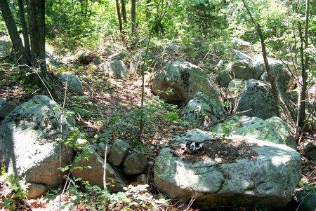
Source: http://myweb.northshore.edu/users/ccarlsen/poetry/gloucester/image_pages/moraine1.htm
Lesson 4: What Made This Landform? Handout
Plum Island
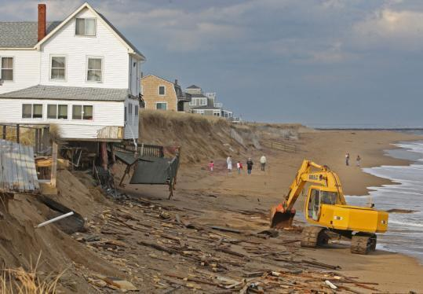
Source: http://www.boston.com/news/local/massachusetts/articles/2009/02/09/report_paints_dire_picture_for_plum_island/
Lesson 4: What Made This Landform? Handout
Arches National Park
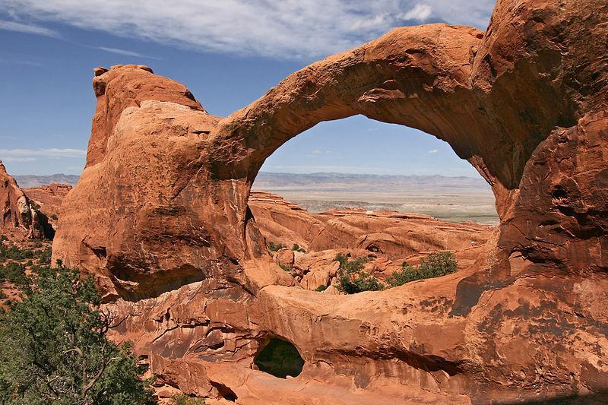
Source: http://en.wikipedia.org/wiki/File:Double-O-Arch_Arches_National_Park_2.jpg
Lesson 4: What Made This Landform? Handout
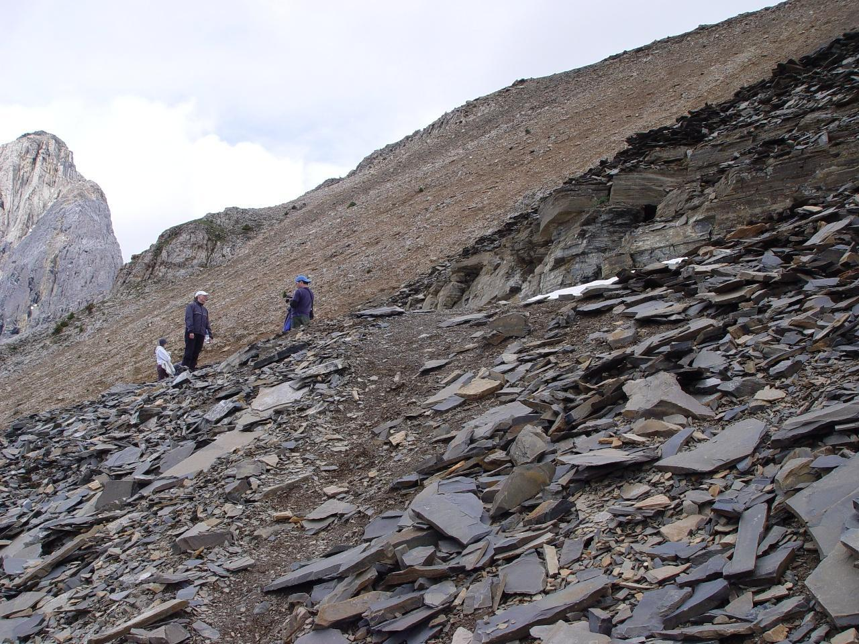
Source: http://geotripper.blogspot.com/2014/04/where-are-ten-most-incredible-places_1565.html
Curriculum Embedded Performance Assessment (CEPA): Roxbury Puddingstone
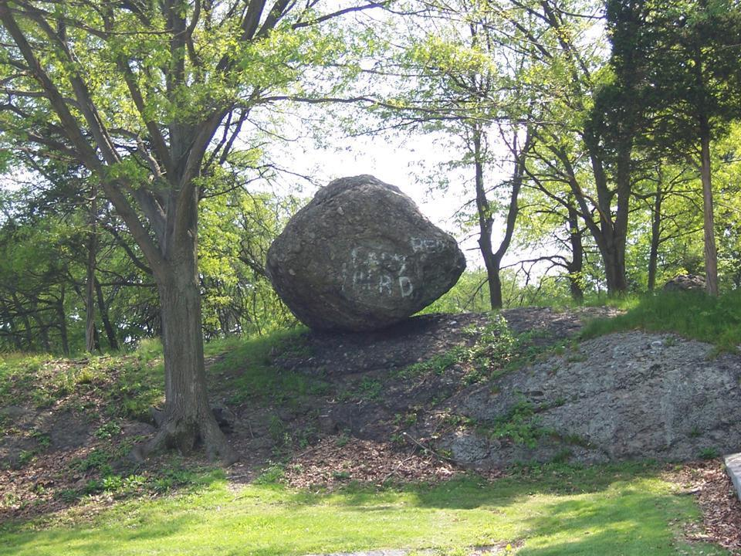
Source: http://www.franklinparkcoalition.org/about-franklin-park/places/99-steps-ellicott-arch/boulder/
Curriculum Embedded Performance Assessment (CEPA): Roxbury Puddingstone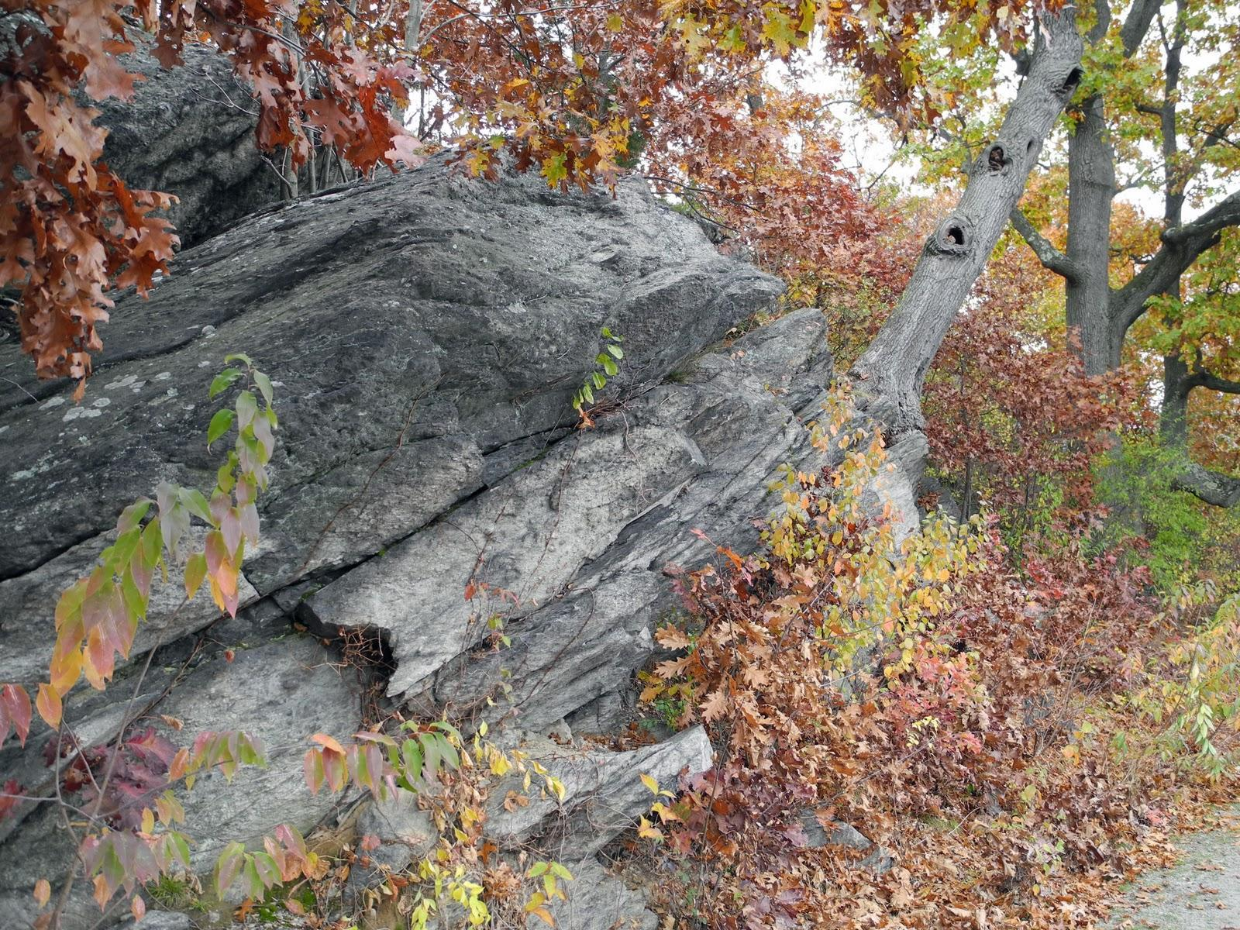
Curriculum Embedded Performance Assessment (CEPA): Roxbury Puddingstone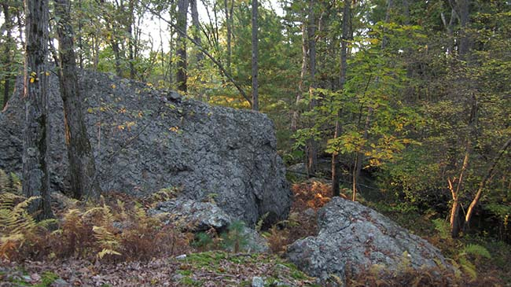
Source: http://www.newtonma.gov/gov/planning/conserv/area/

Curriculum Embedded Performance Assessment (CEPA): Grand Canyon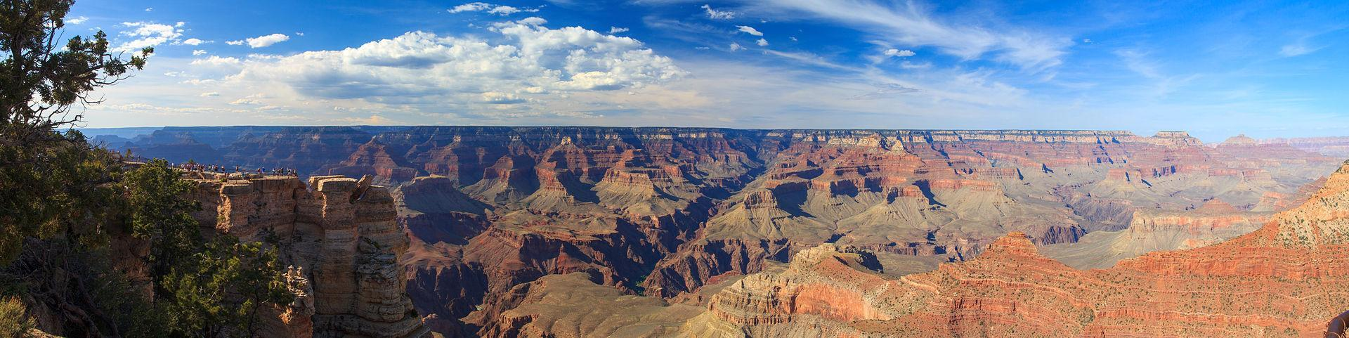
Source: http://en.wikipedia.org/wiki/Grand_Canyon#mediaviewer/File:Grand_Canyon_Panorama_2013.jpg

Curriculum Embedded Performance Assessment (CEPA): Grand Canyon
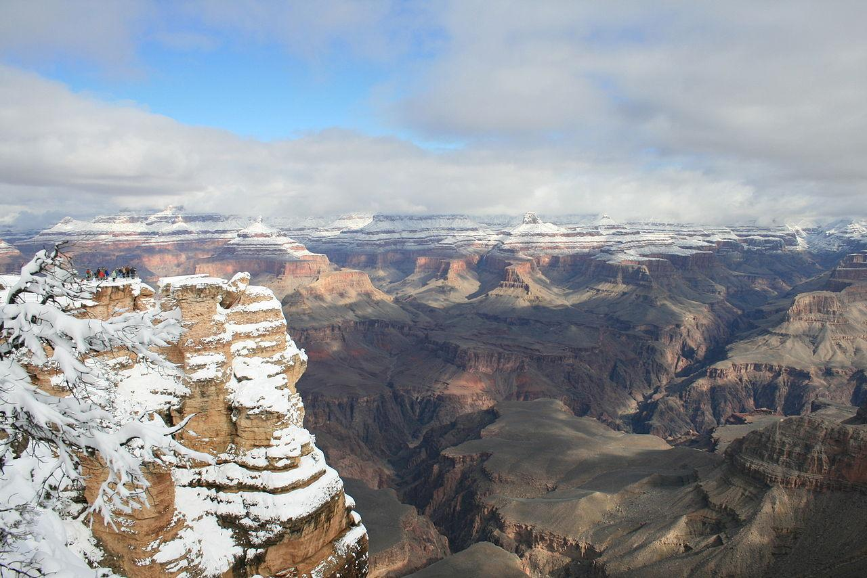
Source: http://en.wikipedia.org/wiki/Grand_Canyon#mediaviewer/File:GrandCanyonWinter2008.JPG
Curriculum Embedded Performance Assessment (CEPA): Grand Canyon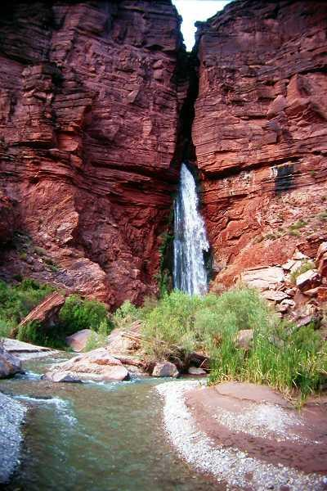 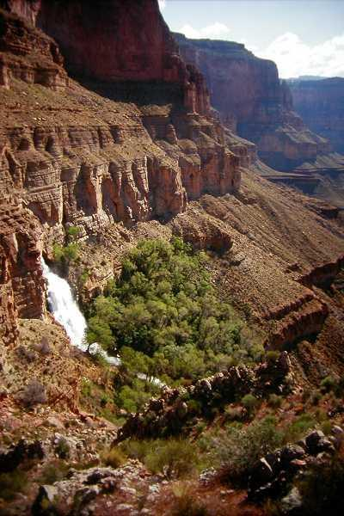
Source: http://www.bobspixels.com/kaibab.org/geology/gc_geol.htm
Lesson 1 additional resources:

Video Clips:
- Weathering: Ice Wedging Video from Teacher Tube http://www.teachertube.com/video/weathering-ice-wedging-31760
- Frost Wedge Animation from University of Kentucky College of Arts and Sciences: https://ees.as.uky.edu/sites/default/files/elearning/module07swf.swf (click arrows at top of page to Mechanical Weathering: Frost Wedging to find animation.)
- Weathering and erosion - Freeze thaw weathering video from You Tube: https://www.youtube.com/watch?v=_XnCTcjNpuc
- Erosion and Weathering for Kids: Causes and Differences from Make Me a Genius:
http://www.makemegenius.com/science-videos/grade_3/Weathering-and-Erosion-for-kids
- Study Jams-Weathering and Erosion from watchknowlearn.org: http://watchknowlearn.org/Video.aspx?VideoID=13256&CategoryID=2443

PBS Learning Media Slideshow about Erosion and Weathering
http://mass.pbslearningmedia.org/resource/ess05.sci.ess.earthsys.erosion/erosion-and-weathering/

Lesson 2 additional resources:

- Erosion Videos
  - Video About the Process of Erosion and Deposition in a River: http://mass.pbslearningmedia.org/resource/rr10.sci.earth.geol.eros/erosion/
  - Bill Nye Episode about Erosion: https://www.youtube.com/watch?v=0e3D2RB-bqI
- Animated Slideshow from University of Kentucky College of Arts and Sciences about how physical weathering breaks down rock: http://ees.as.uky.edu/sites/default/files/elearning/module07swf.swf
- Quick, interactive game about the different forces: http://www.kineticcity.com/mindgames/warper/

Lesson 3 additional resources:

- National Geographic site with images of various kinds of erosion—these are additional images that can be used for children to hypothesize about how they were formed. https://www.nationalgeographic.com/science/photos/weathering-erosion-gallery/

- Glacial erosion images and information
  - http://www.coolgeography.co.uk/GCSE/Year%2010/PhysicalWorld/Glacial%20processes/Glacier.jpg
  - http://geog-leics.blogspot.com/2012/07/glaciers.html (first photo)
  - http://ctinemarie.blogspot.com/2011/12/for-all-you-geologically-inclined.html (photos 7 and 8)
  - Glacialerratics: http://en.wikipedia.org/wiki/File:Angular_glacial_erratic_on_Lambert_Dome-750px.jpg

Lesson 4 additional resources:
Teacher note: Many more images of these landforms can be found with a quick Google search

- Old Man of the Mountain Images
  - http://www.newenglandtravelplanner.com/go/nh/white_mts/franconia_notch/old_man.html
  - http://www.thelivingmoon.com/43ancients/02files/Earth_Images_05a.html (scroll down page to Old Man in Mountain Section)

- Arches National Park Images
  - http://en.wikipedia.org/wiki/File:Double-O-Arch_Arches_National_Park_2.jpg
  - https://www.nationalgeographic.com/travel/national-parks/arches-photos/

- Plum Island Erosion Images
  - http://www.nytimes.com/2013/03/19/us/in-path-of-storms-plum-island-mass-weighs-its-options.html?_r=0
  - http://www.boston.com/news/local/massachusetts/articles/2009/02/09/report_paints_dire_picture_for_plum_island/
  - https://coastlinesproject.wordpress.com/2014/01/06/plum-island-areas-where-seawall-end-scour-has-created-potential-breach-areas/
- Dogtown in Gloucester Terminal Moraine Images
  - http://myweb.northshore.edu/users/ccarlsen/poetry/gloucester/image_pages/moraine1.htm
  - http://myweb.northshore.edu/users/ccarlsen/poetry/gloucester/image_pages/moraine2.htm
  - http://myweb.northshore.edu/users/ccarlsen/poetry/gloucester/image_pages/moraine3.htm

- Shell Fossil Landforms
  - Burgess Shale Formation:
    - http://www.earthmagazine.org/article/travels-geology-famous-fossils-and-spectacular-scenery-british-columbias-burgess-shale
    - http://geotripper.blogspot.com/2014/04/where-are-ten-most-incredible-places_1565.html
  - Shell Fossil Images in Coastal Southern Maine: https://www.maine.gov/dacf/mgs/explore/fossils/past/coral.htm
  - Various Shell Fossil Images: http://blogs.agu.org/mountainbeltway/files/2014/02/IMG_1808.jpg

Curriculum Embedded Performance Assessment (CEPA): Interpreting a Landscape
Additional Resources and Links:
Grand Canyon Images:
- http://sevennaturalwonders.org/the-original/grand-canyon/
- http://en.wikipedia.org/wiki/Grand_Canyon
- http://walkingconnection.com/holiday/arizona-grand-canyon-national-park-south-rim/

Roxbury Puddingstone Images:
- http://written-in-stone-seen-through-my-lens.blogspot.com/2011/03/architectural-geology-of-boston-roxbury_27.html
- http://www.statesymbolsusa.org/Massachusetts/rock_roxburypuddingstone.html

Grand Canyon links for students:
- National Park Service: http://www.nps.gov/grca/naturescience/naturalfeaturesandecosystems.htm
- Wikipedia: http://en.wikipedia.org/wiki/Grand_Canyon
- Geology of the Grand Canyon: http://www.bobspixels.com/kaibab.org/geology/gc_geol.htm
- Grand Canyon Association: https://www.grandcanyon.org/learn/canyon-facts/grand-canyon-geology

Roxbury Puddingstone links for students:
- Architectural Geology of Boston: The Roxbury Conglomerate (Puddingstone) Part 1& II - Quarries and Building Stone
  - http://written-in-stone-seen-through-my-lens.blogspot.com/2011/03/architectural-geology-of-boston-roxbury_27.html
  - http://written-in-stone-seen-through-my-lens.blogspot.com/2011/03/architectural-geology-of-boston-roxbury.html
- Wikipedia: http://en.wikipedia.org/wiki/Roxbury_Conglomerate
- Rockhounding New England: A Guide to 100 of the Region's Best Rockhounding Sites: https://books.google.com/books?id=j9jiCgAAQBAJ&printsec=frontcover&dq=%E2%97%8F%09Rockhounding+New+England:+A+Guide+to+100+of+the+Region's+Best+Rockhounding+Sites&hl=en&sa=X&ved=0ahUKEwihsJuk7eTbAhVIwVkKHQauA_8Q6AEIJzAA#v=onepage&q&f=false

