Plants Make Their Own Food
Life Science, Earth Science, and Physical Science, Grade 5
(Revised July 2018)
Standards addressed in unit:
5-ESS2-1. Use a model to describe the cycling of water through a watershed through evaporation, precipitation, absorption, surface runoff, and condensation. State Assessment Boundary: Transportation or explanations of mechanisms that drive the cycle are not expected in state assessment.
5-LS1-1. Ask testable questions about the process by which plants use air, water, and energy from sunlight to produce sugars and plant materials needed for growth and reproduction. State Assessment Boundary: The chemical formula or molecular details about the process of photosynthesis are not expected in state assessment.
5-PS3-1. Use a model to describe that the food animals digest (a) contains energy that was once energy from the Sun, and (b) provides energy and nutrients for life processes, including body repair, growth, motion, body warmth, and reproduction. Clarification Statement: Examples of models could include diagrams and flow charts. State Assessment Boundary: Details of cellular respiration, ATP, or molecular details of the process of photosynthesis or respiration are not expected in state assessment.

Using principles from Universal Design for Learning (UDL), this unit uses materials from the Concord Consortium to engage students in investigations about photosynthesis and plant growth. Students use the online environment to read a story, reflect on their understanding through writing, and use models and test variables. Students learn about where earth’s water comes from and goes to and produce and interpret data tables and graphs to show how a plant grows under different conditions. Students create a digital lab book where they collect snapshots of their investigations and activities and reflect on their understanding of concepts.

This Model Curriculum Unit is designed to illustrate effective curriculum that lead to expectations outlined in the 2016 Science and Technology/Engineering Curriculum Frameworks (www.doe.mass.edu/STEM/STE) as well as the MA Curriculum Frameworks for English Language Arts/Literacy and Mathematics. This unit includes lesson plans, a Curriculum Embedded Performance Assessment (CEPA), and related resources. In using this unit it is important to consider the variability of learners in your class and make adaptations as necessary.
Table of Contents

Unit Assumptions and Comments on Sequence 3
Unit Plan 6
Lesson 1: Pre-assessment and Introduction to Plants and Plant Growth 11
Lesson 2: How Plants Produce the Food We Eat 15
Lesson 3: Plants Role in the Water Cycle 21
Lesson 4: Interpreting and Producing Data Tables and Graphs 25
Curriculum Embedded Performance Assessment (CEPA) 28
Unit Resources: Handouts and Additional Instructional Materials/Resources/Tools 35

Unit Assumptions and Comments on Sequence

Assumed knowledge and skills that student should bring to the unit:
- Students will be able to construct an argument that plants have structures that support their survival, growth, behavior, and reproduction. Students should know that plants need water and light to grow. Students should know that plants have different structures that perform different functions (they are not expected to know details). Students have learned how to use a science notebook. Students have interpreted and analyzed data from simple tables and graphs.

Notes about the unit:
- In this unit, students are introduced to the concept of photosynthesis to the depth of how a plant acquires the materials it needs to provide for itself, grow, and store food for animals. It does not go deeply into identifying one of the main products of the process of photosynthesis, glucose, and in accordance with the standard for this grade level, 5-LS1-1, it does not go into its chemical equation.
- Although STE standard 5-ESS2-1 is addressed (in part), in this unit, it is not taught to its fullest intent or depth. We recommend that there be additional opportunities for students to fully learn the concepts embedded in this standard.
- Access to obtaining student and class data on the Concord Consortium website is limited. Therefore, teachers should not set up accounts for students until the unit is updated on the Concord Consortium website. Teachers (and students) can and should access the activities on the site, but the questions that follow in each of the sections, should not be completed online. Instead, these questions have been copied into handouts for the students to complete.
- This unit has online components for students to interact with, but it can also be adapted so that the teacher can use “paper and pencil” alternatives. Teachers may choose any of the following: each student has access to a computer to complete the unit; students can work in groups of 2-4 with each group having a computer; or a teacher may project the website to the class.
- Before implementing this unit, teachers should:
  - Become familiar with the scope and parts of this unit. Teachers should access and review the Universal Design for Learning (UDL) Beginning and Intermediate Plants Unit at http://udl.portal.concord.org/activities/. (This unit will have its own pop up window in Java.) Teachers should click on icons in the Java Plants Beginning Unit to become familiar with the following sections: Pre-Test, Story, Modeling and Post-Test. Teachers should click on icons in the Java Plants Intermediate Unit to become familiar with the following section: Math and Introduction.
  - Sign up on the website so that they view the Teacher Resources. The Teacher Guide for this unit located at http://udl.concord.org/share/teacher-guides/TG_Plants-Beginning-2010-final.pdf.
- In addition, we also recommend that teachers:
  - Collect seeds and plants to show the class (Lessons 1 and 3)
  - Have each student use a ½ inch 3-ring binder serve as their science notebook. This will allow students to keep track of the handouts for this unit.
  - Plan to build Biome in a Baggie days before you begin this unit so it will be ready to show with students during lesson 3. Review the video Biome in a Baggie for directions on how to build one. (http://mass.pbslearningmedia.org/resource/tdc02.sci.life.stru.baggiezoom/biome-in-a-baggie/).
- Throughout the unit, notes to the teacher are either noted as such or written in parentheses, and distinguished with red font.
- All handouts are located at the end of the unit.
- You may need to establish an account with PBSLearningMedia (http://mass.pbslearningmedia.org/) to access the resources in this unit. It is free and enables you access to other PBSLearningMedia resources.
- See the Additional Instructional Materials/Resources/Tools (page 33) section at the end of this unit for resources that provide background information and support the teaching of this unit
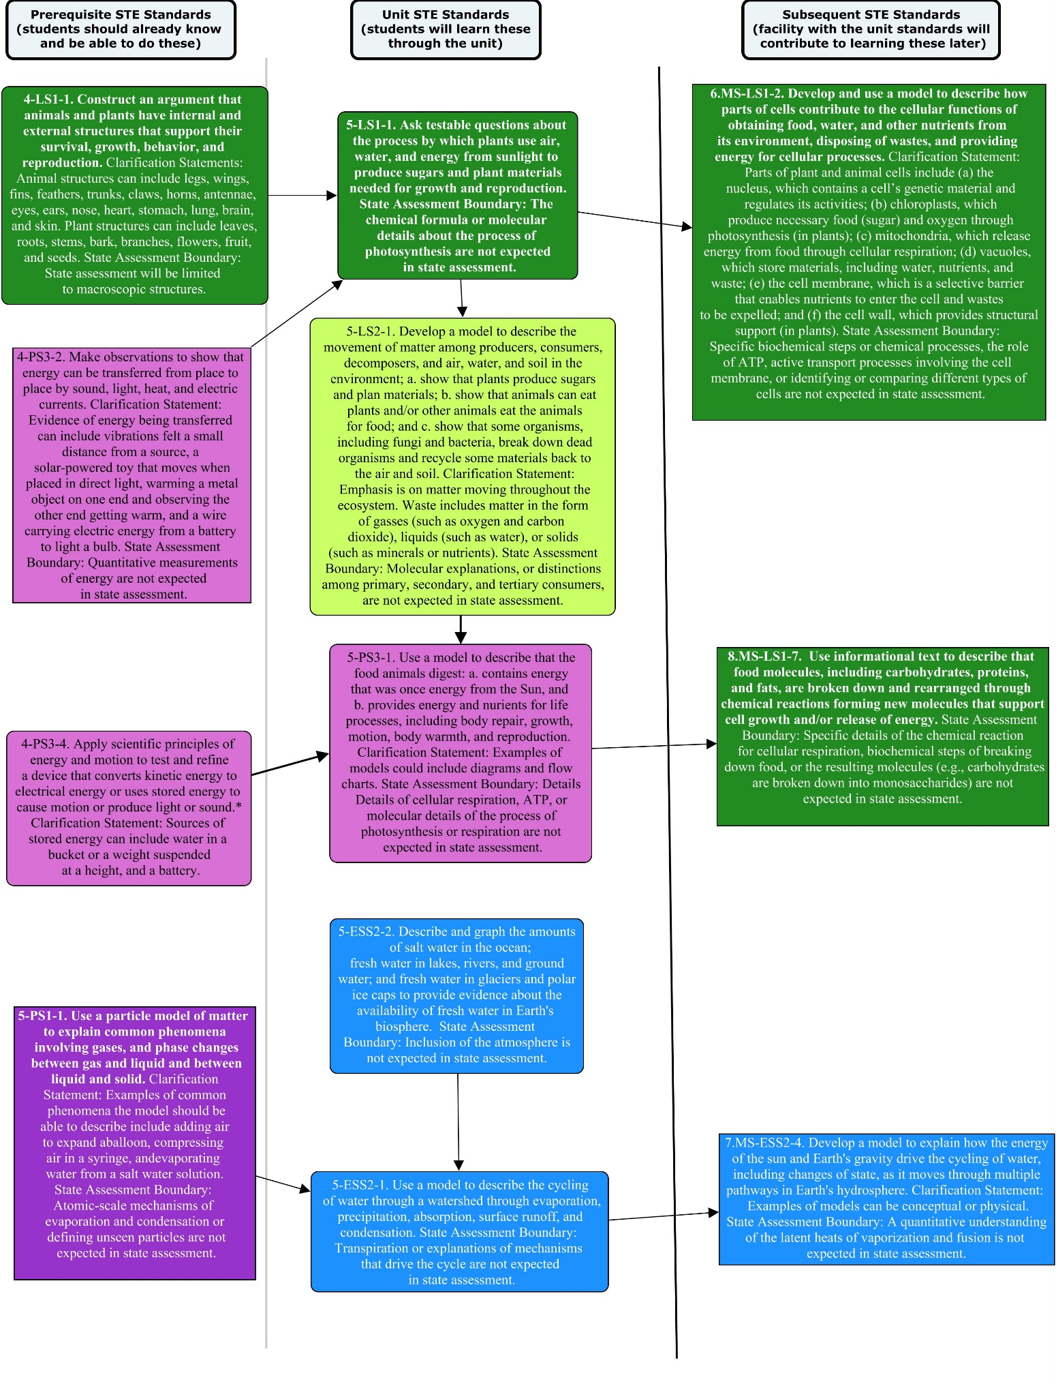

Unit Plan

Stage 1 Desired Results
ESTABLISHED GOALS G  Science and Technology/Engineering:  5-ESS2-1. Use a model to describe the cycling of water through a watershed through evaporation, precipitation, absorption, surface runoff, and condensation. State Assessment Boundary: Transportation or explanations of mechanisms that drive the cycle are not expected in state assessment.  5-LS1-1. Ask testable questions about the process by which plants use air, water, and energy from sunlight to produce sugars and plant materials needed for growth and reproduction. State Assessment Boundary: The chemical formula or molecular details about the process of photosynthesis are not expected in state assessment.  5-PS3-1. Use a model to describe that the food animals digest (a) contains energy that was once energy from the Sun, and (b) provides energy and nutrients for life processes, including body repair, growth, motion, body warmth, and reproduction. Clarification Statement: Examples of models could include diagrams and flow charts. State Assessment Boundary: Details of cellular respiration, ATP, or molecular details of the process of photosynthesis or respiration are not expected in state assessment.  English Language Arts and Literacy:  CCSS.ELA-Literacy.W.5.2. Write informative/explanatory texts to examine a topic and convey ideas clearly.  CCSS.ELA-Literacy.SL.5.4. Report on a topic or text or present an opinion, sequencing ideas logically and using appropriate facts and relevant, descriptive details to support main ideas or themes; speak clearly at an understandable pace.  Mathematics:  CCSS.Math.Content.5.G.A.2. Represent real-world and mathematical problems by graphing points in the first quadrant of the coordinate plane, and interpret coordinate values of points in the context of the situation. | Transfer
Students will be able to independently use their learning to…
- Engage in sustained, complex and successful scientific inquiry.
- Use appropriate evidence and reasoning to develop scientific claims and engage in discussions of scientific and technical topics. T
 | Meaning
 | UNDERSTANDINGS U  Students will understand that…  - The materials that make up a plant come mostly from carbon dioxide in the air and from water, not from the soil.  - Plants get the materials they need for growth and reproduction mostly through a process called photosynthesis.  - Photosynthesis requires light energy (from the Sun) for a part of air (carbon dioxide) and water to combine to form sugar (glucose) and oxygen.  - The sugars can be immediately used or stored for growth or later use, such as flower and seed production.  - There is a relationship between environmental conditions and plant growth.  - The energy and materials that animals need for their bodies come from plants and can be traced back to the sun.  - Models can use symbols to represent parts and processes in scientific contexts. | ESSENTIAL QUESTIONS Q  - How does a small seed turn into a large plant?  - How do plants get the material and energy required for growth?
 | Acquisition
 | Students will know…  K  - Leaves have parts within them that perform photosynthesis.  - Carbon dioxide is taken in by leaves and water is taken in by roots.  - Air (carbon dioxide) and water recombine inside the plant to form sugar (glucose).  - Sugar (glucose) is used by the plant as energy, or converted into other substances (such as starch) for storing energy, or converted into other substances (such as cellulose) for structures inside cells.  - Plants get the water they need as water cycles through the Earth’s systems (the geosphere (solid earth), the hydrosphere (the earth’s waters), and atmosphere (air surrounding the earth), and the biosphere (where plants and animals live) through the processes of evaporation, precipitation, condensation, transpiration, and runoff. | Students will be skilled at… S  - Determining the meaning of symbols used in a specific scientific model.  - Using models to build conceptual understanding.  - Supporting their explanation using evidence from informational texts (data, graphs, texts, etc.)  - Analyzing plant growth using data tables and graphs.  - Drawing conclusions and defending their claims using data.
Stage 2 - Evidence
Evaluative Criteria | Assessment Evidence
See CEPA Rubric | CURRICULUM EMBEDDED PERFORMANCE ASSESSMENT (PERFORMANCE TASKS) PT  Goal: Create a model for a new exhibit at Boston’s Children’s Museum that shows the connections between plants, animals, and their surroundings. The challenge is to develop a model that shows how plants get the materials they need through the cycling of water on Earth and the process of photosynthesis to grow and store food-energy, and how animals acquire that food-energy. Your display should clearly show what is needed for photosynthesis to occur, why it is needed and what the products of photosynthesis are. You will also need to describe what happens to these materials.  Role: Students are participating in a model-building challenge. Students will present their model to the class.  Audience: Boston Children’s Museum staff and visitors to the Boston Children’s Museum. Visitors are mostly families with young children.  Situation: The Boston Children’s Museum has challenged fifth grade students to help them design a new exhibit. The museum wants to find the most accurate and visually appealing display that highlights the connections between plants, animals, and their surroundings to the visitors.  Product and Purpose: Students will create a model (2D or 3D) that shows how plants acquire the water (through the cycling of water on Earth) and other materials they need to grow and store food-energy for animals.
OTHER EVIDENCE: OE
Pre-assessment
Science notebooks with responses to posed questions and notes on observations
Computer-based post assessment
Interpreting and Producing Data Tables and Graphs handout
Class discussions
Homework- Food-o-Meter questions

Stage 3 – Learning Plan
Summary of Key Learning Events and Instruction
Lesson 1: Pre-assessment and Introduction to Plants and Plant Growth
In this lesson, the teacher introduces the unit to the students. Students come up with their own questions about how plants make food. Then they will take a pre-test to gauge their understanding of the basic functions of plant structures and what plants need to grow. Students will also read a story about how plants grow and be asked questions about the story. This lesson is an introduction to the unit and the questions should be used as formative tools. (90 minutes or 2 X 45-minute sessions)

Lesson 2: How Plants Produce the Food We Eat
In this lesson, students examine a model to determine how models in science help us understand phenomena and that models have limitations. In this lesson, students compare seeds to their corresponding plants to continue to build on their understanding of how plants grow. Students make predictions and engage with a computer model (Food-O-Meter) to show how varying exposure to water, sunlight, and carbon dioxide affect a plant’s growth. Students view a short photosynthesis video; discuss the limitations and benefits of using models; and follow with an interactive PBS video to understand Energy Flow. Students learn that the food animals (including humans) eat for the energy they need include plants or can be traced back to plants and ultimately the Sun. (90 minutes or 2 X 45-minute sessions)

Lesson 3: Plants Role in the Water Cycle
In this lesson, students learn about where Earth’s water comes from and goes to. They watch a video in which a plant that was grown in a sealed, self-contained system called a biome gets the water it needs to sustain its growth, partially demonstrating the cycling of water on Earth.
(50 minutes)

Lesson 4: Interpreting and Producing Data Tables and Graphs
In this lesson, students will produce and interpret data tables and graphs to show how a plant grows under different conditions. Students will use the Lesson 4 Handout which is based on the Concord Consortium’s UDL Intermediate Plants Unit. (Note: The handout is not the same as the UDL Unit.). (45 minutes)

Curriculum Embedded Performance Assessment
Students will work independently to complete the Curriculum Embedded Performance Assessment (CEPA) for this unit. Students will participate in a mock competition by the Boston Children’s Museum to develop a model for a new exhibit that shows the connections between plants, animals, and their surroundings. Each model must show how plants get the materials they need through the cycling of water on earth and the process of photosynthesis to grow and store food-energy, and how animals acquire that food-energy. Informative descriptions must accompany the model. The CEPA is the summative assessment for the unit. (180 minutes or 4 X 45 minute sessions)

Adapted from Understanding by Design 2.0 © 2011 Grant Wiggins and Jay McTighe Used with Permission

Lesson 1: Pre-assessment and Introduction to Plants and Plant Growth

Brief Overview of Lesson: In this lesson, the teacher introduces the unit to the students. Students come up with their own questions about how plants make food. Then they will take a pre-test to gauge their understanding of the basic functions of plant structures and what plants need to grow. Students will also read a story about how plants grow and be asked questions about the story. This lesson is an introduction to the unit and the questions should be used as formative tools.

Prior Knowledge Required:
- 1-LS1-1. Use evidence to explain that (a) different animals use their body parts and senses in different ways to see, hear, grasp objects, protect themselves, move from place to place, and seek, find, and take in food, water, and air, and (b) plants have roots, stems, leaves, flowers, and fruits that are used to take in water, air, and other nutrients, and produce food for the plant. [Clarification Statement: Descriptions are not expected to include mechanisms such as the process of photosynthesis.]
- 4-LS1-1: Construct an argument that animals and plants have internal and external structures that support their survival, growth, behavior, and reproduction. [Clarification Statements: Animal structures can include legs, wings, fins, feathers, trunks, claws, horns, antennae, eyes, ears, nose, heart, stomach, lung, brain, and skin. Plant structures can include leaves, roots, stems, bark, branches, flowers, fruits, and seeds.] [State Assessment Boundary: State assessment will be limited to macroscopic structures.]

Estimated Time: 90 minutes

Resources for Lesson:
- Chart paper and markers
- Computer(s) for each student, group of students, or teacher - loaded with technical requirements and UDL Beginning Plant Unit.
- Access the UDL Beginning Plant Unit on the Concord Consortium site http://udl.portal.concord.org/activities/.
- Handouts: Pre-assessment, A Plant Story (http://udl.concord.org/share/teacher-guides/Plants34_v7.pdf), and questions related to A Plant Story
- Science notebooks for each student
Standard(s)/Unit Goal(s) to be addressed in this lesson:
- 5-LS1-1. Ask testable questions about the process by which plants use air, water, and energy from sunlight to produce sugars and plant materials needed for growth and reproduction. State Assessment Boundary: The chemical formula or molecular details about the process of photosynthesis are not expected in state assessment.
- CCSS.ELA-Literacy.W.5.2. Write informative/explanatory texts to examine a topic and convey ideas clearly.

Essential Question(s) addressed in this lesson:
- How does such a small seed turn into a much larger plant?
- How do plants get the material and energy required for growth?

Objective:
Students will be able to…
- use evidence from a module to explain that the materials that make up a plant come mostly from carbon dioxide in the air and from water, not from the soil.
- Make observations and ask questions about how plants use materials to grow.

Targeted Academic Language:

Scientific Language | Academic Language | Other Language for this Lesson
fertilizer | Function | Radish
light energy | Transported | mounds
carbon dioxide | Label | sprouting
sugar | Describe | x-ray
oxygen | Model
 | Symbol

What students should know and be able to do before starting this lesson:
- Use evidence to explain that plants have roots, stems, leaves, flowers, and fruits that are used to take in nutrients, water, and air, produce food (sugar), and make new plants.
- Construct an argument that plants have structures that support their survival, growth, behavior, and reproduction.

Anticipated Student Preconceptions/Misconceptions
- Students may assume that plants get their materials from soil. They may have difficulty grasping the concept that the materials comes from the water and air.

Instructional Materials/Resources/Tools
- Chart paper and markers
- Computer(s) for each student, group of students, or teacher - loaded with technical requirements and UDL Beginning Plant Unit.
- Access the UDL Beginning Plant Unit on the Concord Consortium site http://udl.portal.concord.org/activities/.
- Handouts: Pre-test, A Plant Story (http://udl.concord.org/share/teacher-guides/Plants34_v7.pdf), and questions related to A Plant Story
- Science notebooks for each student

Instructional Tips/Strategies/Notes for Teacher
- Show students several different types of seeds (e.g., acorn, sunflower, fruit, vegetable) so they are familiar with what a plant starts out as. Also show them house plants or plants outside to show students what the seeds can become.

Assessment
- Formative assessment questions during lesson.

Lesson Details

Lesson Opening (suggested time: 15 minutes):
Introduce the unit and explain what students will be learning about plants. Introduce the essential questions and post them on chart paper. After explaining what they will be learning, ask students to come up with questions that they would want answered during the unit. Keep this list of questions and refer to it at the beginning of each unit to see if the questions are being answered.

During Lesson
Activity 1: Pre-test (suggested time: 30 minutes):
- Have students work individually or in pairs and answer the pre-test questions using Lesson 1: Pre-Test handout at the end of this unit. (Questions can also be viewed online).

Activity 2: Plant Story (suggested time: 30 minutes)
- Have students read the Plant Story*. (This can be done as a class or individually. The story can be read on the computer or can be printed out. If using the computer set students up with computers and have them open the Concord Consortium UDL for Intermediate Plants Unit. http://udl.portal.concord.org/activities/)
* Story goes beyond the limits of the standards for grade 5 (introduces vocabulary such as stomata, chloroplast and hydrogen.)
- Project the sunflower video from the Introduction section of the Intermediate Plants Unit. The video shows 24 hours in the life of a sunflower. Students watch how the leaves and the flowers follow the movement of the sun.
- Ask students to work in pairs and answer the questions at the end of the story. Tell them they will be collected and looked at by the teacher (but they will not be graded). (The story and questions can either be distributed as handouts or viewed online.)

Closing Lesson (suggested time: 15 minutes): Ask students what they noticed and wondered during the sunflower story. Collect their observations on the board or on a piece of chart paper. (The wonderings students have are the questions used to guide the instruction of this unit.)

Formative assessment: The list of questions generated by students will help guide instruction for the unit; save the list of student observations and wonderings so that you can revisit them. The pre-test and questions from the Plant Story will also serve as formative assessment tools.

Preview outcomes for the next lesson:
Share a brief overview of Lesson 2 with students.

Lesson 2: How Plants Produce the Food We Eat

Brief Overview of Lesson: Students examine a model to determine how models in science help us understand phenomena and that models have limitations. In this lesson, students compare seeds to their corresponding plants to continue to build on their understanding of how plants grow. Students make predictions and engage with a computer model (Food-O-Meter) to show how varying exposure to water, sunlight, and carbon dioxide affect a plant’s growth. Students view a short photosynthesis video; discuss the limitations and benefits of using models; and follow with an interactive PBS video to understand Energy Flow. Students learn that the food animals (including humans) eat for the energy they need include plants or can be traced back to plants and ultimately the Sun.

Prior Knowledge Required:
- 1-LS1-1. Use evidence to explain that (a) different animals use their body parts and senses in different ways to see, hear, grasp objects, protect themselves, move from place to place, and seek, find, and take in food, water, and air, and (b) plants have roots, stems, leaves, flowers, and fruits that are used to take in water, air, and other nutrients, and produce food for the plant. Clarification Statement: Descriptions are not expected to include mechanisms such as the process of photosynthesis.
- 4-LS1-1: Construct an argument that animals and plants have internal and external structures that support their survival, growth, behavior, and reproduction. Clarification Statements: Animal structures can include legs, wings, fins, feathers, trunks, claws, horns, antennae, eyes, ears, nose, heart, stomach, lung, brain, and skin. Plant structures can include leaves, roots, stems, bark, branches, flowers, fruits, and seeds. State Assessment Boundary: State assessment will be limited to macroscopic structures.
- Concepts learned in Lesson 1 of this unit.
Estimated Time: 90 minutes
Resources for Lesson:
- Computer(s) for each student, group of students, or teacher - loaded with technical requirements and UDL Beginning Plant Unit.
- Access the UDL Beginning Plant Unit on the Concord Consortium site http://udl.portal.concord.org/activities/, the Illuminating Photosynthesis model: http://mass.pbslearningmedia.org/resource/tdc02.sci.life.stru.methusweb/illuminating-photosynthesis/, and the Food-O-Meter interactive: http://authoring.concord.org/sequences/56.
- An earth globe
- Science notebooks
- Handout: Food-o-Meter: What do plants need to stay alive? (All handouts are located at the end of the unit.)
For background information and instructional support:
- Next Generation Science Standards’ description of the science and engineering practices, APPENDIX F – Science and Engineering Practices in NGSS, http://nextgenscience.org/sites/ngss/files/Appendix%20F%20%20Science%20and%20Engineering%20Practices%20in%20the%20NGSS%20-%20FINAL%20060513.pdf. See page 6 on Developing and Using Models.
- Photosynthesis Explained http://youtu.be/JJxZH_Y5D4s*
* Video goes beyond the limits of the standards for grade 5 (introduces equation for photosynthesis.

What students should know and be able to do before starting this lesson:
- Use evidence to explain that plants have roots, stems, leaves, flowers, and fruits that are used to take in nutrients, water, and air, produce food (sugar), and make new plants.
- Construct an argument that plants have structures that support their survival, growth, behavior, and reproduction.

Anticipated Student Preconceptions/Misconceptions
Students may think that:
- Plants get their mass from soil. They may have difficulty grasping the concept that the mass comes from water and air.
- Plants get food from their roots and the soil.
- Minerals in the soil, water and/or the soil provide food for plants
- All plants store their food in their leaves. Leaves are the only place where food is stored.

Standard(s)/Unit Goal(s) to be addressed in this lesson:
- 5-LS1-1. Ask testable questions about the process by which plants use air, water, and energy from sunlight to produce sugars and plant materials needed for growth and reproduction. [State Assessment Boundary: The chemical formula or molecular details about the process of photosynthesis are not expected in state assessment.]
- 5-PS3-1. Use a model to describe that the food animals digest (a) contains energy that was once energy from the Sun, and (b) provides energy and nutrients for life processes, including body repair, growth, motion, body warmth, and reproduction. [Clarification Statement: Examples of models could include diagrams and flow charts.] [State Assessment Boundary: Details of cellular respiration, ATP, or molecular details of the process of photosynthesis or respiration are not expected in state assessment.]

Essential Question(s) addressed in this lesson:
- How does such a small seed turn into a much larger plant?
- How do plants get the material and energy required for growth?

Objectives
Students will be able to…
- Determine the meaning of symbols used in a model about photosynthesis and plant growth
- Use observations from models and simulations to construct an explanation of how small seeds turn into larger plants, and how plants get the materials and energy required for plant growth

Targeted Academic Language

Scientific Language | Academic Language | Other Language for this Lesson
photosynthesis | function | half a billionth (0.0000005%)
light energy | transported | one-tenth (10%)
calories | label
vaporized | describe
molecule | model
 | symbol

What students should know and be able to do before starting this lesson:
- Use evidence to explain that plants have roots, stems, leaves, flowers, and fruits that are used to take in nutrients, water, and air, produce food (sugar), and make new plants.
- Construct an argument that plants have structures that support their survival, growth, behavior, and reproduction.
- Concepts learned in Lesson 1 of this unit.

Anticipated Student Preconceptions/Misconceptions
Students may think that:
- Plants get their mass from soil. They may have difficulty grasping the concept that the mass comes from the water and air.
- Plants get food from their roots and the soil.
- Minerals in the soil, water and/or the soil provide food for plants
- All plants store their food in their leaves. Leaves are the only place where food is stored.

Instructional Materials/Resources/Tools
- Computer(s) for each student, group of students, or teacher - loaded with technical requirements and UDL Beginning Plant Unit.
- Access the UDL Beginning Plant Unit on the Concord Consortium site http://udl.portal.concord.org/activities/, the Illuminating Photosynthesis model: http://mass.pbslearningmedia.org/resource/tdc02.sci.life.stru.methusweb/illuminating-photosynthesis/, and the Food-O-Meter interactive: http://authoring.concord.org/sequences/56.
- An Earth globe
- Science notebooks
- Handout: Food-o-Meter: What do plants need to stay alive?
For background information and instructional support:
- Next Generation Science Standards’ description of the science and engineering practices, APPENDIX F – Science and Engineering Practices in NGSS, http://nextgenscience.org/sites/ngss/files/Appendix%20F%20%20Science%20and%20Engineering%20Practices%20in%20the%20NGSS%20-%20FINAL%20060513.pdf. See page 6 on Developing and Using Models.
- Photosynthesis Explained http://youtu.be/JJxZH_Y5D4s*
* Video goes beyond the limits of the standards for grade 5 (introduces equation for photosynthesis.)

Instructional Tips/ Strategies/Notes for Teacher
- Review the posted list of student questions generated from Lesson 1 and note which items will be addressed in this lesson.

Assessment
- Formative: Discussion questions on modeling; follow up questions for the Plant Food-O-Meter activity. Questions can be handed in for a grade.

Lesson Details

Opening Lesson: (suggested time: 20 minutes)
Models: Engage students in the following display and discussion about models and their limitations.
(Possibly give probe: Is It a Model? Uncovering Student Ideas in Science (Volume 4) - 25 NEW Formative Assessment Probes by Page Keeley and Joyce Tugel (2009)).
- Ask students, “What is a scientific model?” (This is brainstorming exercise to see what students know (or think they know) about models/modeling. It is okay if there are some wrong or inappropriate responses.)
- Holding the Earth Globe, ask students, “What is this a model of?” (Planet Earth)
- Ask and discuss, “What does this model represent well?” (Continents, shape of the earth, oceans, mountain ranges, equator, relative size, etc)
- Ask and discuss, “What does this model not represent?” (Size, place in space, individual states, small bodies of water) Ask, “Why?”
- Ask and discuss, “How does one know what is displayed on this model?” (Everything (or most everything) is labeled. There are also symbols to represent or identify things. Explain what the symbols mean and how to interpret them.)
- Ask and discuss, “Do all models look the same? Why or why not?” “What are some other types of models?” (See Instructional Materials/Resources/Tools for resource on modeling.)
- Ask and discuss, “What are some of the benefits and limitations of this model or models in general?” (See Instructional Materials/Resources/Tools for resource on modeling.)
- Revisit the question “What is a scientific model?” and discuss how students now define a model or modeling.
- Explain to students that we will be exploring a computer model that will demonstrate what happens inside a leaf, this model will be an animation (not the real object) and we will be able to select different variables to change that will affect the model.

During Lesson:
Part A. From Seed to Plant: Amassing Mass (suggested time: 10 minutes)
- Show students a picture or an actual seed (for a bean, grass, corn, herbs, nut, etc.) and its corresponding plant/tree (and in some cases, fruit, bark, etc.), and write the following questions on the board: How does a seed get the materials it needs to grow into a plant come from? Where do the materials that make up a tree trunk come from?
- Have students write their explanations/responses in their science notebook.
- Have students then turn to a partner to discuss their responses or discuss students’ responses as a whole class.
(Note to teacher: Students’ responses will reveal their preconceptions and possible misconceptions. Do not correct students’ responses at this point. You will revisit these questions later.)

Part B. Photosynthesis (suggested time: 15 minutes)
- Let students know that they will now be interacting with a computer model that simulates the process by which plants acquire the materials they need to grow.
- Use the Illuminating Photosynthesis: http://mass.pbslearningmedia.org/resource/tdc02.sci.life.stru.methusweb/illuminating-photosynthesis/ model to demonstrate how plants take in sunlight, the air we breathe out (carbon dioxide), and water, and releases the air we breathe in (in part oxygen). (Note to teacher: If possible, allow students to interact with this model on their own. Or, you may display this model from your computer to the whole class.)
  - Launch the program.
  - Click on “The Cycle” tab.
  - Follow the instructions on the interactive.
  - Explain to students what is happening in the interactive model.
  - Use the Discussion question at the bottom of the page to guide the students.
- Discuss the benefits, limitations, and need for using a model such as this.

Part C. The Food-o-Meter: What do Plants Need to Stay Alive? (suggested time: 20 minutes)
In this activity, students will use a computer model of a growing plant, called the Food-o-Meter. It will show the effect of water, sunlight, and carbon dioxide on the health of the plant. (Note to teacher: If possible, allow students to interact with this model on their own. Or, you may display this model from your computer to the whole class.)
  - Introduce this activity to students and explain its purpose.
  - Click on Food-O-Meter link, http://authoring.concord.org/sequences/56.
  - Click on module 2 (Food-O-Meter: What plants need to…).
  - Have students write responses to Questions 1, 2, and 3 in section 2 (Engage I) in their science notebooks. Have students interact with sections 3–7 (Engage II and III, and Explore I, II, and III). They are not to go beyond section 7! The questions in sections 8 and 9 (Explain and Elaborate) are for homework. (Questions are provided in handout section, What do plants need to stay alive?)

Part D. Food/Energy for and from Plants and the Animals that Eat It (suggested time: 15 minutes)
In this activity, the teacher walks students through an interactive cartoon which describes the process by which energy from the sun is captured by plants and then passed on to humans and other animals through the foods they eat. There are questions for students to answer throughout the cartoon.
  - Introduce this activity to students and explain its purpose.
  - To access the cartoon, go to PBS Learning Media Energy Flow online visual (http://mass.pbslearningmedia.org/asset/tdc02_int_energyflow/)
  - As you go through the cartoon with students, discuss what is happening.

Closing Lesson: (suggested time: 10 minutes)
- Revisit the essential questions. Have students respond to these questions in light of what they have learned in this lesson.
- Review the posted list of student responses, questions, and ideas generated from Lesson 1 and have students answer/edit/add to any item that have been addressed in this lesson. Remind students to use evidence from their observations and interactions to support your explanation.
- Homework: Complete the handout with questions from the Food-O-Meter activity.

Formative assessments:
- Discussion questions, Food-o-Meter worksheet, written responses in science notebook, and homework.

Preview outcomes for the next lesson:
- Share a brief overview of Lesson 3 with students.

Lesson 3: Plants Role in the Water Cycle

Brief Overview of Lesson: In this lesson, students learn about where earth’s water comes from and goes to. They watch a video in which a plant that was grown in a sealed, self-contained system called a biome gets the water it needs to sustain its growth, partially demonstrating the cycling of water on earth.

Prior Knowledge Required:
- 1-LS1-1. Use evidence to explain that (a) different animals use their body parts and senses in different ways to see, hear, grasp objects, protect themselves, move from place to place, and seek, find, and take in food, water, and air, and (b) plants have roots, stems, leaves, flowers, and fruits that are used to take in water, air, and other nutrients, and produce food for the plant. Clarification Statement: Descriptions are not expected to include mechanisms such as the process of photosynthesis.
- 4-LS1-1: Construct an argument that animals and plants have internal and external structures that support their survival, growth, behavior, and reproduction. Clarification Statements: Animal structures can include legs, wings, fins, feathers, trunks, claws, horns, antennae, eyes, ears, nose, heart, stomach, lung, brain, and skin. Plant structures can include leaves, roots, stems, bark, branches, flowers, fruits, and seeds. State Assessment Boundary: State assessment will be limited to macroscopic structures.
- Concepts learned in Lessons 1 and 2 of this unit.

Estimated Time: 50 minutes

Resources for Lesson:
- Handout: The Hydrologic Cycle http://www.state.nj.us/drbc/library/documents/water_cycle.pdf
- Poster Paper
- Science notebooks
- Background information:
  - Summary of the Water Cycle, U.S. Geological Survey, http://water.usgs.gov/edu/watercyclesummary.html
  - Thirstin’s Water Cycle (cartoon), US Environmental Protection Agency, http://www.epa.gov/safewater/kids/flash/flash_watercycle.html
- World Biomes, Kids do Ecology, http://kids.nceas.ucsb.edu/biomes/
- A teacher-designed biome (like the one in the PBSLearningMedia video) for students to see in person. (This is suggested but not required.)

Standard(s)/Unit Goal(s) to be addressed in this lesson:
- 5-ESS2-1. Use a model to describe the cycling of water through a watershed through evaporation, precipitation, absorption, surface runoff, and condensation. State Assessment Boundary: Transportation or explanations of mechanisms that drive the cycle are not expected in state assessment.
- 5-LS1-1. Ask testable questions about the process by which plants use air, water, and energy from sunlight to produce sugars and plant materials needed for growth and reproduction. State Assessment Boundary: The chemical formula or molecular details about the process of photosynthesis are not expected in state assessment.

Essential Question(s) addressed in this lesson:
- How does such a small seed turn into a much larger plant?
- How do plants get the material and energy required for growth?

Objectives:
Students will be able to…
- Evaluate a model of a biome to determine its strengths and limitations
- Revise an explanation of where plants obtain water from using evidence from investigations

Targeted Academic Language:
Scientific Language |  | Academic Language | Other Language for this Lesson
geosphere | runoff |  | Cycle
hydrosphere | System |  | system
atmosphere | Biome
biosphere | transpiration
evaporation | condensation
precipitation

What students should know and be able to do before starting this lesson:
- Use evidence to explain that plants have roots, stems, leaves, flowers, and fruits that are used to take in nutrients, water, and air, produce food (sugar), and make new plants.
- Construct an argument that plants have structures that support their survival, growth, behavior, and reproduction.
- Concepts learned in Lessons 1 and 2 of this unit.

Anticipated Student Preconceptions/Misconceptions:
- Students may think that the water plants use to grow only comes from a pipe or from rain.
- Students may think that once water goes into the ground/soil is only either taken in by plants or just stays there.
- Students may think that water can be created once it is used up.
- Students may think that water that comes from the sky (in the form of rain, snow, etc.) originated in outer space.

Instructional Materials/Resources/Tools
- Handout: The Hydrologic Cycle http://www.state.nj.us/drbc/library/documents/water_cycle.pdf
- Poster Paper
- Science notebooks
- Background information:
  - Summary of the Water Cycle, US Environmental Protection Agency, http://water.usgs.gov/edu/watercyclesummary.html
  - Thirstin’s Water Cycle (cartoon), US Environmental Protection Agency, http://www.epa.gov/safewater/kids/flash/flash_watercycle.html
- World Biomes, Kids do Ecology, http://kids.nceas.ucsb.edu/biomes/
- A teacher-designed biome (like the one in the PBSLearningMedia video) for students to see in person. (This is suggested but not required.)

Instructional Tips/Strategies/Notes for Teacher
- You may need to establish an account with PBSLearningMedia (http://mass.pbslearningmedia.org/) to view the video in this lesson. It is free and enables you access to other PBSLearningMedia resources.

Assessment
- Formative: Discussion questions.

Lesson Details

Lesson Opening: (suggested time: 15 minutes)
      - Homework review: As a class, review the questions assigned for homework in Lesson 2 and students’ responses. Make corrections wherever necessary.

      - Preconceptions about the water cycle:
- Post the following question on the board, “Where does the water plants need to grow come from?”
- Ask students to write a brief response to this question in their science notebooks.
- Discuss their responses as a whole class. Record their responses on poster paper that will stay posted for the remainder of this lesson.
Note to teacher: Students’ answers may be limited to a few ways by which they have seen water accessed. For example, they may think that the water that waters plants only comes from a pipe (to and through a hose or to a water pot), or through rain. Challenge the students’ thinking by asking where the water they have identified comes from, and then where that water comes from and so on. Do no correct incorrect responses at this time. You will revisit this question and their responses at the end of the lesson.
- Let students know that they will be learning about where Earth’s water comes from and goes to. They will also observe a plant that was grown in a sealed, self-contained system called a biome, gets the water it needs to sustain its growth, partially demonstrating the cycling of water on Earth.

During Lesson:
A. A Model of the Earth’s Water Cycle (suggested time: 10 minutes)
1. Distribute the handout The Hydrologic Cycle (http://www.state.nj.us/drbc/library/documents/water_cycle.pdf). Project the image as well for the whole class to see and for the teacher to reference.
2. Using the handout as a reference, review the process of the hydrologic cycle with students.
3. Identify the: geosphere, biosphere, hydrosphere, and atmosphere. Write their definitions on the board for students to copy into their science notebooks. Also define the terms used to represent the processes that are a part of the Hydrologic Cycle. (Note to teacher: For the purposes of this unit, earth’s systems and the actual terms used to represent the processes that are a part of the Hydrologic Cycle are not important. Therefore, define but do not emphasize them or students’ remembering them. Do emphasize, however, where plants fit into this cycle.)
4. Discuss the benefits and limitations of this model of the hydrologic/water cycle.

B. Biome in a Baggie (suggested time: 20 minutes)
1. Introduce this video and its purpose.
- Show the video Biome in a Baggie (http://mass.pbslearningmedia.org/resource/tdc02.sci.life.stru.baggiezoom/biome-in-a-baggie/).
- Pose and discuss with students the discussion questions posted at the bottom on the video’s website.
- (Optional – if available) Share your personally designed Biome in a Baggie with students to see up close.

Lesson Closing: (suggested time: 5 minutes)
- As a class, revisit the lesson opening question – “Where does the water plants need to grow come from?” and review students’ responses. Ask students if their ideas have changed according to the evidence they saw in today’s lesson. Have students make corrections where there are mistakes or omissions.

Formative assessment:
- Discussion questions:
  - Is this a good model of a biome?
  - What are its strengths? What are its weaknesses?

Preview outcomes for the next lesson:
- Share a brief overview of Lesson 4 with students.

Lesson 4: Interpreting and Producing Data Tables and Graphs
Brief Overview of Lesson: Students will use the Lesson 4 handout which is based on the Concord Consortium’s UDL Intermediate Plants Unit. (Note: The handout is not the same as the UDL Unit.) Students will produce and interpret data tables and graphs to show how a plant grows under different conditions.

Prior Knowledge Required:
- Students are expected to know how to interpret data tables and plot data points on graphs.
- Students are expected to know the general effects of watering and sunlight on plants.
- Concepts learned in Lessons 1, 2, and 3 of this unit.

Estimated Time: 45 minutes

Resources for Lesson:
- Chart paper and markers
- Handout: Student data tables and graphs worksheet and Teacher answer key
- Science notebooks

Standard(s)/Unit Goal(s) to be addressed in this lesson:
- 5-LS1-1. Ask testable questions about the process by which plants use air, water, and energy from sunlight to produce sugars and plant materials needed for growth and reproduction. State Assessment Boundary: The chemical formula or molecular details about the process of photosynthesis are not expected in state assessment.
- CCSS.Math.Content.5.G.A.2. Represent real-world and mathematical problems by graphing points in the first quadrant of the coordinate plane, and interpret coordinate values of points in the context of the situation.

Essential Question(s) addressed in this lesson:
- How does a small seed turn into such a large plant?
- How do plants get the material and energy required for growth?

Objectives:
Students will be able to…
- Construct an explanation using data from an investigation
- Create and use data tables and graphs to support explanations

Targeted Academic Language

Scientific and Math Language | Academic Language | Other Language for this Lesson
photosynthesis | Conditions | ivy
line plots | Shriveled | vine
centimeters | Reasoning
graphs | Effect
data points | predict/prediction
 | Correspond

What students should know and be able to do before starting this lesson:
- Students are expected to know how to interpret data tables and plot data points on graphs.
- Students are expected to know the general effects of watering and sunlight on plants.
- Concepts learned in Lessons 1, 2, and 3 of this unit.

Anticipated Student Preconceptions/Misconceptions:
- Students may have difficulty producing and interpreting tables and graphs.
- Students may have difficulty using appropriate data.
- Students may think that plants will die immediately without water or sunlight.

Instructional Materials/Resources/Tools:
- Chart paper and markers
- Handout: data tables and graphs
- Science notebooks

Instructional Tips/ Strategies/Notes for Teacher:
- As questions and issues on the chart paper are addressed throughout the lesson, be sure to call attention to them and have students edit and add information.
- The teacher may want to help students by graphing Plant 1 as an example so the students understand the expectations.

Assessment
There are both formative and interim assessment tools in this lesson. Teachers can use the questions, data table, and graphs in both ways, depending on the expectations of the class. It is suggested, at a minimum, that the questions on page 1 of the handout, the first data table on page 3, and the first graph on page 4 be used as formative assessment tools. It is suggested that page 5 be used as an interim assessment. This can be a homework assignment that can be graded.

Lesson Details

Lesson Opening: (suggested time: 5 minutes)
Tell students they will be examining how water and sunlight affect plant growth. Address any relevant questions or comments on chart paper from Lesson 1 and add any questions or information, as necessary. Ask them what they have already learned about photosynthesis and tell them they are going to apply their knowledge and their math skills to real data. They will be making their own predictions, discussing them with the classmates and figuring out if the data supports their predictions.

During Lesson: (suggested time: 30 minutes)
- Pass out the Data Tables and Graphs worksheet to each student and ask them to complete it. (Note to teacher: You can allow students to work individually or in groups of 2 or more to complete this worksheet. Students should add the worksheet to their science notebooks when completed.)
- As a class, review the questions and data.

Closing Lesson:
As a class, review the questions and data. Have students make corrections where there are mistakes or omissions.

Formative assessment:
There are both formative and interim assessment tools in this lesson. Teachers can use the questions, data table, and graphs in both ways, depending on the expectations of the class. It is suggested, at a minimum, that the questions on page 1 of the handout, the first data table on page 3, and the first graph on page 4 be used as formative assessment tools. It is suggested that page 5 be used as an interim assessment. This can be a homework assignment that can be graded.

Preview outcomes for the next lesson:
Share a brief overview of CEPA with students.

Curriculum Embedded Performance Assessment (CEPA)
Plants Make Their Own Food
Teacher Instructions
Brief Overview of Lesson: Students will work independently to complete the Curriculum Embedded Performance Assessment (CEPA) for this unit. Students will participate in a mock competition by the Boston Children’s Museum to develop a model for a new exhibit that shows the connections between plants, animals, and their surroundings. Each model must show how plants get the materials they need through the cycling of water on earth and the process of photosynthesis to grow and store food-energy, and how animals acquire that food-energy. Informative descriptions must accompany the model. The CEPA is the summative assessment for the unit.

Prior Knowledge Required:
- Concepts and skills learned in Lessons 1 – 4 of this unit.

Estimated Time: 4×45-minute sessions

Resources for Lesson (list resources and materials):
- Smart board or document camera or projector
- Computers for each student
- Science notebooks
- Plants Make Their Own Food CEPA - directions sheet
- For Students: Plants make Their Own Food CEPA Rubric
- Suggested Building Materials:

Large paper | Fabric
Pictures of plants, leaves, roots, trees, sun, water, flowers etc. | Markers
Colored pencils | Glue
Modeling clay | Scissors
Toothpicks | Colored paper

Standard(s)/Unit Goal(s) to be addressed in this lesson:
- 5-ESS2-1. Use a model to describe the cycling of water through a watershed through evaporation, precipitation, absorption, surface runoff, and condensation. State Assessment Boundary: Transportation or explanations of mechanisms that drive the cycle are not expected in state assessment.
- 5-LS1-1. Ask testable questions about the process by which plants use air, water, and energy from sunlight to produce sugars and plant materials needed for growth and reproduction. State Assessment Boundary: The chemical formula or molecular details about the process of photosynthesis are not expected in state assessment.
- 5-PS3-1. Use a model to describe that the food animals digest (a) contains energy that was once energy from the Sun, and (b) provides energy and nutrients for life processes, including body repair, growth, motion, body warmth, and reproduction. Clarification Statement: Examples of models could include diagrams and flow charts. State Assessment Boundary: Details of cellular respiration, ATP, or molecular details of the process of photosynthesis or respiration are not expected in state assessment.
- CCSS.ELA-Literacy. CCSS.ELA-Literacy. W.5.2. Write informative/explanatory texts to examine a topic and convey ideas clearly.
- CCSS.ELA-Literacy.SL.5.4. Report on a topic or text or present an opinion, sequencing ideas logically and using appropriate facts and relevant, descriptive details to support main ideas or themes; speak clearly at an understandable pace.

Instructional Tips/ Strategies/Notes for Teacher:
- Have building materials and reading/internet resources readily available in several stations around room.
- Have students refer back to their science notebooks for additional information.
- Optional: Have students create a drawing of their model first before designing.

Goal: Create a model for a new exhibit at Boston’s Children’s Museum that shows the connections between plants, animals, and their surroundings. The challenge is to develop a model that shows how plants get the materials they need through the cycling of water on Earth and the process of photosynthesis to grow and store food-energy, and how animals acquire that food-energy. Your display should clearly show what is needed for photosynthesis to occur, why it is needed and what the products of photosynthesis are. You will also need to describe what happens to these materials.

Role: Students are participating in a model-building challenge.

Audience: Boston Children’s Museum staff and visitors to the Boston Children’s Museum. Visitors are mostly families with young children. Students will present their models to the class.

Situation: The Boston Children’s Museum has challenged fifth grade students to help them design a new exhibit. The museum wants to find the most accurate and visually appealing display that highlights the connections between plants, animals, and their surroundings to the visitors.

Product and Purpose: Students will create a model (2D or 3D) that shows how plants acquire the water (through the cycling of water on Earth) and other materials they need to grow and store food-energy for animals. This display will also show animals acquiring the food-energy they need.

Standards and Criteria for Success: See accompanying rubric

Curriculum Embedded Performance Assessment (CEPA)
Plants Make Their Own Food
Student Instructions

Goal: The Boston Children’s Museum is opening a new exhibit about plants, animals, and their surroundings and they want input from students like you. The challenge is to develop a model that shows how plants get the materials they need through the cycling of water on earth and the process of photosynthesis to grow and store food-energy, and how animals acquire that food-energy. Your display should clearly show what is needed for photosynthesis to occur and why it is needed. Your model must introduce the public to key scientific vocabulary and include informative descriptions.
Role: You will be participating in a model-building challenge.
Audience: Boston Children’s Museum staff and visitors to the Boston Children’s Museum. Visitors are mostly families with young children. You will present your model to the class.
Situation: The Boston Children’s Museum has challenged fifth grade students to help them design a new exhibit. The museum wants to find the most accurate and visually appealing display that highlights the connections between plants, animals, and their surroundings to the visitors.
Product and Purpose: You will create a model (2D or 3D) that shows how plants acquire the water (through the cycling of water on Earth) and other materials they need to grow and store food-energy for animals. This display will also show animals acquiring the food-energy they need.
Standards and Criteria for Success: See rubric for details.
Directions: Now that you have learned all about photosynthesis and the water cycle, you will develop a model that is a visual representation of these processes. You will also write a summary of the model to describe your model to museum visitors.
- Create a model using one of the following media:
- 2D or 3D digital animation
- 2D diagram or drawing
- 3D model/ possible mediums could be paper, fabric, clay
Be sure to include any necessary keys to symbols you use in your model.
- Your model must represent the following scientific concepts:
  - Where do plants get the materials they need for growth and reproduction?
  - What is needed for photosynthesis to occur and why?
  - How water cycles on earth, and where plants fit into the cycle.
  - How the food and energy animals need can be traced back to plants and the sun.

- Write a description for your model that will be presented to the class. Your descriptions should be informative and use scientific vocabulary that help museum visitors understand the science behind your model. The descriptions should include the following sections (see bullet points below): and should be approximately a paragraph long for each explanation.
  - Where do plants get the materials they need for growth and reproduction?
  - What is needed for photosynthesis to occur and why?
  - How water cycles on earth, and where plants fit into the cycle.
  - How the food and energy animals need can be traced back to plants and the sun.

For Students: Plants Make Their Own Food CEPA Rubric

Name: _____________________________________ Date: _____________________
 | Exceeds Expectations  4 | Meets Expectations  3 | Developing  2 | Does Not Meet Expectations  1
Model
Model clearly illustrates where plants get the materials needed for growth and reproduction. | Display clearly shows the materials and, their source, needed for plants to grow and reproduce. | Display mostly shows the materials and, their source, needed for plants to grow and reproduce. | Display is missing some of the major materials and, their source, needed for plants to grow and reproduce. | Display incorrectly shows the materials and, their source, needed for plants to grow and reproduce.
Model clearly illustrates how plants get their materials needed for growth and reproduction. | Display clearly illustrates how plants get their materials needed for growth and reproduction. | Display mostly illustrates how plants get their materials needed for growth and reproduction. | Display is missing pieces that illustrate how plants get their materials needed for growth and reproduction. | Display incorrectly illustrates how plants get their materials needed for growth and reproduction.
Model clearly illustrates how water cycles on earth, and where plants fit into the cycle. | Water cycle is clearly represented accurately and model includes plants role in cycle. | Water cycle representation is mostly correct and model includes plants role in cycle. | Water cycle is mostly modeled correctly. Did not demonstrate plants role in water cycle. | Water cycle is not represented correctly and/or plants role in water cycle in model.
Model clearly illustrates how the food and energy animals need can be traced back to plants and the sun. | Display clearly illustrates how the food and energy animals need can be traced back to plants and the sun. | Display mostly illustrates how the food and energy animals need can be traced back to plants and the sun. | Display is missing pieces that illustrate how the food and energy animals need can be traced back to plants and the sun. | Display incorrectly illustrates how the food and energy animals need can be traced back to plants and the sun.
Model Description
All parts of the model are clearly labeled and keys to symbols used are included. | All parts clearly labeled and keys are included | All parts labeled and keys are mostly included. | Missing parts to model. Missing some labels and keys. | Many parts are missing from model. Missing many labels and keys.
Writing: Uses grade appropriate scientific and academic language and clearly expresses the science behind the model (includes scientific vocabulary) | Words are clear, precise, and accurate. All terms used correctly and in context. | Words are mostly clear, precise, and accurate. Most of the terms are used correctly and in context. | Two or more missing terms. Words are mostly clear, precise, and/or accurate. Most of the terms are used correctly and in context. | Words are not clear, precise, and/or accurate. Terms are not used correctly or in context.
Speaking: Topic is presented in a logical sequence, includes facts, and speaks clearly at an understandable pace. | Topic is presented in a logical sequence, includes facts, and speaks clearly at an understandable pace. | Topic is mostly presented in a logical sequence, includes facts, and speaks clearly at an understandable pace. | Topic is presented in mostly logical sequence, includes facts, and speaks at a mostly understandable pace. | Topic is not presented in a logical sequence, does not include facts, and speaks at a non-understandable pace.

Total: _______________________________ Score: ______________________________

Unit Resources: Handouts and Additional Instructional Materials/Resources/Tools

Lesson 1: Pre-assessment handout, A Plant Story (http://udl.concord.org/share/teacher-guides/Plants34_v7.pdf), and questions related to A Plant Story

Lesson 2: The Food-o-Meter: What do plants need to stay alive? handout

Lesson 3: Diagram of The Hydrologic Cycle from the Delaware Basin Commission: http://www.state.nj.us/drbc/library/documents/water_cycle.pdf

Lesson 4:

Students will use the Lesson 4 Handout which is based on the Concord Consortium’s UDL Intermediate Plants Unit. (Note: The handout is not the same as the UDL Unit.) Students will produce and interpret data tables and graphs to show how a plant grows under different conditions.

- Data Tables and Graphs student worksheet

- Teacher answer key for graphs and tables

Additional Instructional Materials/Resources/Tools

- Annenberg Learner (http://www.learner.org/workshops/privuniv/pup02.html), Workshop Two: Private Universe Project in Science: Why are some ideas so difficult?
Photosynthesis is among the most widely taught of all concepts in biology. Why, then, do many people have difficulty grasping the central idea of photosynthesis-that most of the substance of plants comes from the air?

- MIT Blossoms (https://blossoms.mit.edu/videos/lessons/roots_shoots_and_wood), Lesson video: Roots, Shoots, and Wood, Taught by Kathleen Vandiver

- AAAS Science Assessment (http://assessment.aaas.org/topics/ME#/) – Topic: Matter and Energy in Living Systems – Includes: Sub-Ideas, Assessment Items, and Misconceptions related to this topic.

- Concord Consortium UDL Beginning Plants Unit Teacher Guide: http://udl.concord.org/share/teacher-guides/TG_Plants-Beginning-2010-final.pdf. (The Concord Consortium Teacher Guide is a slightly different unit than this unit but uses the same online components.)

Lesson 1: Pre-Assessment
(from Concord Consortium’s Online UDL Beginning Plants Unit)

Name________________________________________________ Date________________________
Directions: Answer the following questions. Be prepared discuss your answers with your classmates.
1. Rebecca moved into a new house. She wants to grow plants in different areas of her garden.
a) Rebecca knows that plants need light to grow. Why do plants need light to grow?
_______________________________________________________________________________________________
_______________________________________________________________________________________________
_______________________________________________________________________________________________
b) Name one other thing plants need to grow well.
______________________________________________________________________________________________

2. What is the function of a plant’s leaves?
- To take in water
- To protect roots from the Sun
- To take in sunlight and carbon dioxide
- To attract insects

3. What is a function of a plant’s roots?
- To take in water
- To keep the plant cool
- To take in oxygen and carbon dioxide
- To attract worms

4. A girl has an idea that green plants need sand in the soil for healthy growth. In order to test her idea she uses two pots of plants. She sets up one pot of plants as shown.
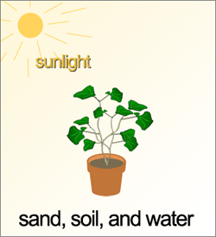

Which ONE of the following should she use for the second pot of plants?
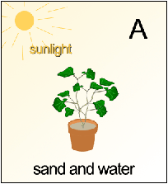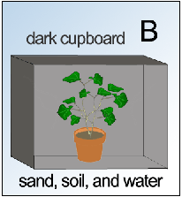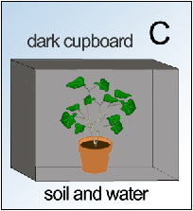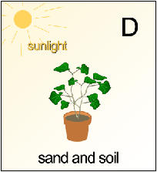

- Circle the letter for where each of the following processes takes place in a plant. (You may use the letters more than once.)
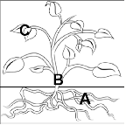
Water enters the plant. | Sunlight energy enters the plant. | Nutrients enter the plant. | Water is transported from the roots to the leaves.
A | A | A | A
B | B | B | B
C | C | C | C
6. Here is a graph of the number of healthy leaves on a plant for ten days. A student watered the plant each day at first, but then stopped. The plant had lots of sunlight.

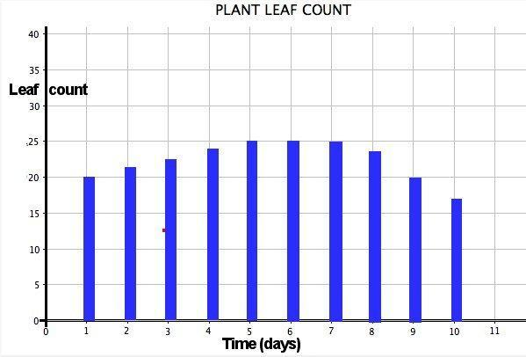

Answer the following questions about the graph.

a) What was the greatest number of healthy leaves?
- 15
- 20
- 25
- 30

b) On which day was the number of leaves unchanged?
- Day 3
- Day 6
- Day 9
Lesson 1: Plant Story Questions
(from Concord Consortium’s Online UDL Beginning Plants Unit)

Name_________________________________________________________ Date________________________

Describe something you learned from this story about growing plants.

______________________________________________________________________________________________________________________________________________________________________________________________________________________________________________________________________________________________________________________________________________________________________________

Draw a picture of a plant from the story. Label the parts of the plant and describe their functions.

Lesson 2: The Food-o-Meter:
What do plants need to stay alive?

Name_______________________________________________________ Date_______________________

Directions: Respond to the following questions reflecting on your observations in the Food-O-Meter activity. Include evidence from your observations in your responses.

- What happened to the plant when it was cloudy instead of sunny?

- What happened to the plant when it did not rain?

- What happened to the plant when there was less carbon dioxide in the air?

- What do plants need to stay alive?

- What does the plant produce when given enough water, sunlight, and carbon dioxide?

Lesson 3: Water Cycle
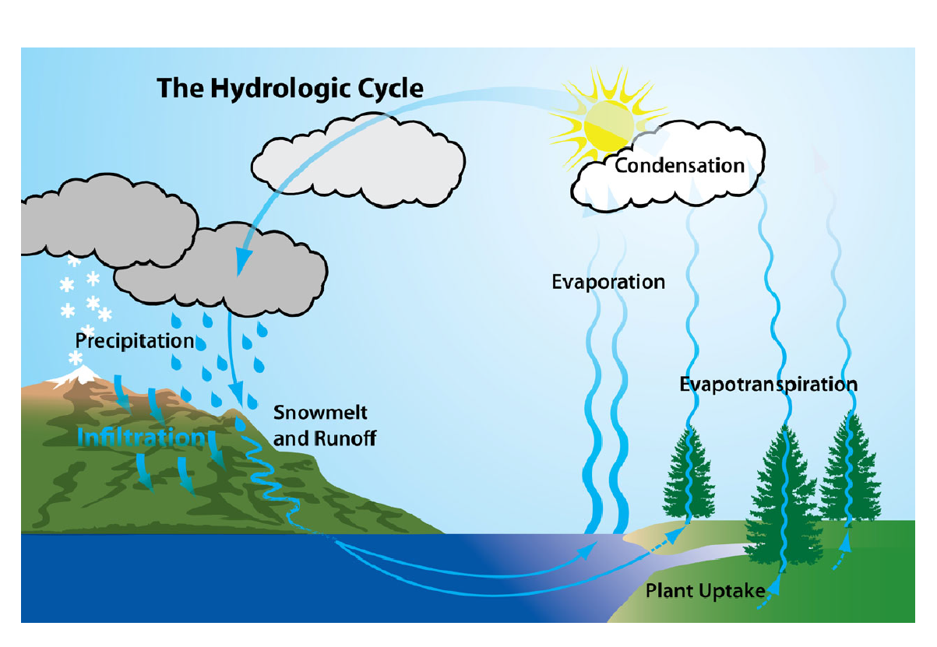
*Graphic from Delaware Basin Commission
http://www.state.nj.us/drbc/hydrological/

Lesson 4 Handout: Data Tables and Graphs
(adapted from the Concord Consortium’s Online UDL Intermediate Plants Unit)

Name: ______________________________________________________ Date_______________________

Directions: For this lesson, you will study data for the growth of plants under different conditions of light and water. You will interpret data from a table and produce and interpret line plots.

Read the information below and answer the questions that follow.

Natasha and Marc were having a discussion. They were convinced that plants -- sunflowers at least -- use sunlight and water to make food. But Marc still wondered what would happen to a plant if these things were taken away.

"I think it will shrivel up and die right away," remarked Natasha, thinking about how she felt if she missed breakfast because she was late for school.

"Well, I think the plant will just wait until the light and water come back again," argued Marc. "After all, when I go to sleep at night, I wake up hungry, but I'm not shriveled!"
"Well, maybe, but it certainly won't grow if it doesn't have light and water," Natasha insisted.

Predict what will happen to a plant if water and light are missing for 3-5 days?
____________________________________________________________________________________
_______________________________________________________________________________________________________________________________________________________________________

Using your knowledge of photosynthesis, why do you think this?
____________________________________________________________________________________________________________________________________________________________________________________________________________________________________________________________
We will now look at data collected when ivy plants were growing in different conditions to see if your predictions are correct or if they need to be modified.
How well do plants grow under different conditions?
Four ivy plants were observed over 7 days under different conditions. The data for each plant is shown below.
Ivy leaves and vine
Plant 1: lots of sunlight and only water added
Day | Length of Vine (cm) | Total number of leaves
1 | 27.3 | 18
2 | 28.6 | 18
3 | 29.2 | 20
4 | 29.8 | 21
5 | 30.5 | 24
6 | 31.1 | 25
7 | 31.8 | 28

Plant 2: lots of sunlight and no water added
Day | Length of Vine (cm) | Total number of leaves
1 | 29.0 | 20
2 | 30.2 | 22
3 | 31.8 | 23
4 | 32.3 | 23
5 | 33.6 | 20
6 | 33.2 | 19
7 | 32.7 | 17

Plant 3: no sunlight and only water added
Day | Length of Vine (cm) | Total number of leaves
1 | 31.0 | 18
2 | 31.5 | 18
3 | 31.8 | 18
4 | 31.3 | 18
5 | 31.0 | 18
6 | 31.0 | 18
7 | 30.5 | 18

Plant 4: no sunlight and no water added
Day | Length of Vine (cm) | Total number of leaves
1 | 28.3 | 22
2 | 28.3 | 22
3 | 28.3 | 22
4 | 28.3 | 20
5 | 28.3 | 19
6 | 28.3 | 16
7 | 28.3 | 16

Directions: Using the data tables, answer the following questions.

For each plant, what is the change in the number of leaves from day 1 to day 7? Explain or show your reasoning for how you got your numbers.
 | Change in Number of Leaves | Reasoning
Plant 1
Plant 2
Plant 3
Plant 4

For each plant, how much did the length of the vine change from day 1 to day 7? Explain or show your reasoning for how you got your numbers.
 | Change in Length of Vine | Reasoning
Plant 1
Plant 2
Plant 3
Plant 4

Based on the first table, which plant had the most change in the number of leaves? Which plant had the least change?

Based on the first table, which plant had the most change in the length of the vine? Which plant had the least change?

You should discuss your answers with your classmates before moving to the next section.

Graphing - We will now compare the four plants using graphs.

For each plant, plot the number of new leaves for each day on the graph below. Use different colored pencils to represent each plant. Connect the data points that were plotted by drawing a line for each plant. Use the same colored pencil that you used to make the data points. Be sure to label the color that corresponds (or goes with) each plant. Check with your teacher to make sure you are using the correct data to make the graph.
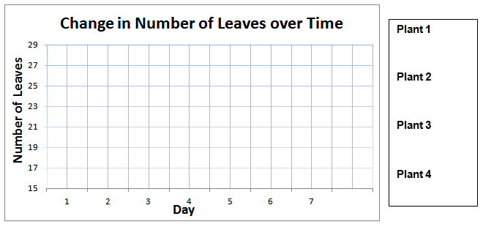
For each plant, graph the length of the vine for each day on the graph below. Use different colored pencils to represent each plant. Connect the data points that were plotted by drawing a line for each plant. Use the same colored pencil that you used to make the data points. Be sure to label the color that corresponds (or goes with) each plant. Check with your teacher to make sure you are using the correct data to make the graph.
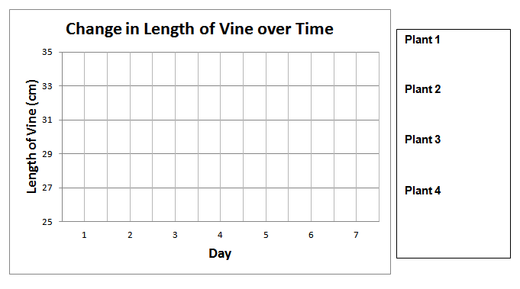

Using the graphs you produced, answer the following questions.

Which condition was the best for plant growth? Explain your reasoning using data from both graphs.
________________________________________________________________________________________________________________________________________________________________________

Which had a larger effect on the plants, having no sun or having no water added? Explain your reasoning using data from both graphs.
________________________________________________________________________________________________________________________________________________________________________

Summary Questions

Do the results from the investigation support the prediction you made on page 1? Why or why not? Be sure to use both evidence from the investigation and your knowledge of photosynthesis to support your answer.
________________________________________________________________________________________________________________________________________________________________________________________________________________________________________________________________________________________________________________________________________________

What is one benefit of using a data table instead of a graph?
____________________________________________________________________________________________________________________________________________________________________________________________________________________________________________________________

What is one benefit of using a graph instead of a data table?
____________________________________________________________________________________________________________________________________________________________________________________________________________________________________________________________
Teacher Answer Key
Using the data tables, answer the following questions.
For each plant, what is the change in the number of leaves from day 1 to day 7? Explain or show your reasoning for how you got your numbers.
 | Change in Number of Leaves | Reasoning
Plant 1 | +10 | 28-18=10
Plant 2 | -3 | 17-20=-3* *Note: may want to discuss how number goes up to 23, but then back down again.
Plant 3 | 0 | 18-18=0
Plant 4 | -6 | 16-22=-6
For each plant, how much did the length of the vine change from day 1 to day 7? Include units in your answer. Explain or show your reasoning for how you got your numbers.
 | Change in Length of Vine | Reasoning
Plant 1 | +4.5 cm | 31.8cm-27.3cm=4.5cm
Plant 2 | +3.7 cm | 32.7cm-29cm=3.7cm
Plant 3 | -0.5 cm | 30.5cm-31.0cm=-0.5cm
Plant 4 | 0 | 28.3cm-28.3cm=0

Based on the first table, which plant had the most change in the number of leaves? Which plant had the least change?
_Plant 1 had the most change and plant 4 had the least change. Discuss these numbers with the class and ask how they knew this.
Based on the first table, which plant had the most change in the length of the vine? Which plant had the least change?
Again, plant 1 had the most change and plant 4 had the least change. Discuss these numbers with the class and ask how they knew this.
You should discuss your answers with your classmates before moving to the next section.
Graphing Answers
For each plant, plot the number of new leaves for each day on the graph below. Use different colored pencils to represent each plant. Connect the data points that were plotted by drawing a line for each plant. Use the same colored pencil that you used to make the data points. Be sure to label the color that corresponds (or goes with) each plant. Check with your teacher to make sure you are using the correct data to make the graph.
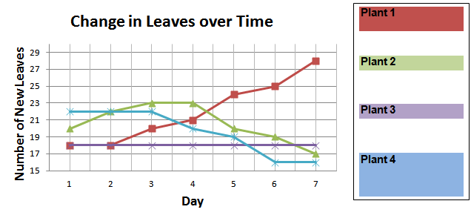
For each plant, graph the length of the vine for each day on the graph below. Use different colored pencils to represent each plant. Connect the data points that were plotted by drawing a line for each plant. Use the same colored pencil that you used to make the data points. Be sure to label the color that corresponds (or goes with) each plant. Check with your teacher to make sure you are using the correct data to make the graph.
