Differential Survival of Organisms
Life Science Grade 7
(Revised July 2018)
Standards addressed in unit:
7. MS-LS2-1. Analyze and interpret data to provide evidence for the effects of periods of abundant and scarce resources on the growth of organisms and the size of populations in an ecosystem.
7. MS-LS2-4. Analyze data to provide evidence that disruptions (natural or human-made) to any physical or biological component of an ecosystem can lead to shifts in all its populations. Clarification Statement: Focus should be on ecosystems characteristics varying over time, including disruptions such as hurricanes, floods, wildfires, oil spills, and construction.
7.MS-LS2-5. Evaluate competing design solutions for protecting an ecosystem. Discuss benefits and limitations of each design.* Clarification Statements: Examples of design solutions could include water, land, and species protection, and the prevention of soil erosion. Examples of design solution constraints could include scientific, economic, and social considerations.

In this unit, students examine how changes in the environment due to biotic and abiotic factors, as well as human activity, influence differential survival and reproduction within a population of given species. Students examine data on how human activities affect the rate of change in an environment. Students also predict the factors that can cause significant changes to the distribution of organisms. They end the unit researching and presenting solutions to protecting an ecosystem.

This Model Curriculum Unit is designed to illustrate effective curriculum that lead to expectations outlined in the 2016 Science and Technology/Engineering Curriculum Frameworks (www.doe.mass.edu/STEM/STE) as well as the MA Curriculum Frameworks for English Language Arts/Literacy and Mathematics. This unit includes lesson plans, a Curriculum Embedded Performance Assessment (CEPA), and related resources. In using this unit it is important to consider the variability of learners in your class and make adaptations as necessary.

Table of Contents

Unit Assumptions and Comments on Sequence 3
Unit Plan 6
Lesson 1: Where and Why of Species Distribution 10
Lesson 2: Natural Factors and Human Activities Change Environments 17
Lesson 3: Human Activities, Natural Factors, and Differential Survival 23
Lesson 4: Independent Research Project - Protecting the Piping Plover 29
Curriculum Embedded Performance Assessment (CEPA) 36
Unit Resources: Additional Instructional Materials/Resources/Tools 39

Unit Assumptions and Comments on Sequence

Sequence
In this unit students explore the differential survival of groups of organisms. After examining the changes to the environment that can result from abiotic and biotic factors, as well as human activities and practices, students study how each of these factors influences the differential survival of groups of organisms. Students use the knowledge they gain to further explore through case studies how human activities affect both the rates of change in an environment and the differential survival of groups of organisms in that environment.

Assumptions

Before starting this unit, students should have a basic understanding of:
- Food web dynamics
- Ecosystem structure
- Predator-prey relationships
Students should also have the following skills:
- Reading and summarizing scientific text and diagrams
- Reading basic graphs and diagrams

Notes about the unit:
- Throughout the unit, notes to the teacher are either noted as such or written in parentheses and distinguished with italics.
- See Unit Resources: Additional Instructional Materials/Resources/Tools section at the end of this unit for resources that provide additional background information and support the teaching of this unit.
- A list of handouts are located at the end of the unit in the Unit Resources section. Due to large file sizes, handouts are split up by lesson and will need to be downloaded separately from the DESE website.

See the strand map, page five, for an overview of the science standards that precede this unit and how the standards learned in this unit contribute to students learning in later grades.

Source and Credits
This curriculum is based largely upon the California Education and the Environment Initiative (EEI) Curriculum, which was developed by the State of California and copyrighted 2010. The California Department of Resources Recycling and Recovery (CalRecycle) granted permission to the State of Massachusetts to use select content from the EEI Curriculum in this publication. This unit is modified from the EEI high school unit Differential Survival of Organisms developed by the State of California, and Lesson 4 is modified from the Pennsylvania, Department of Conservation and Natural Resources, Bureau of State Parks. The original Differential Survival of Organisms unit, along with other EEI curriculum units and resources, may be accessed and downloaded free-of-charge on the EEI webpage http://www.californiaeei.org/Curriculum/.
The complete write up for Lesson 4 is found at the Pennsylvania, Department of Conservation and Natural Resources, Bureau of State Parks website http://www.trecpi.org/pdfs/greatlakespipingplover.pdf or http://www.dcnr.state.pa.us/learn/index.htm.

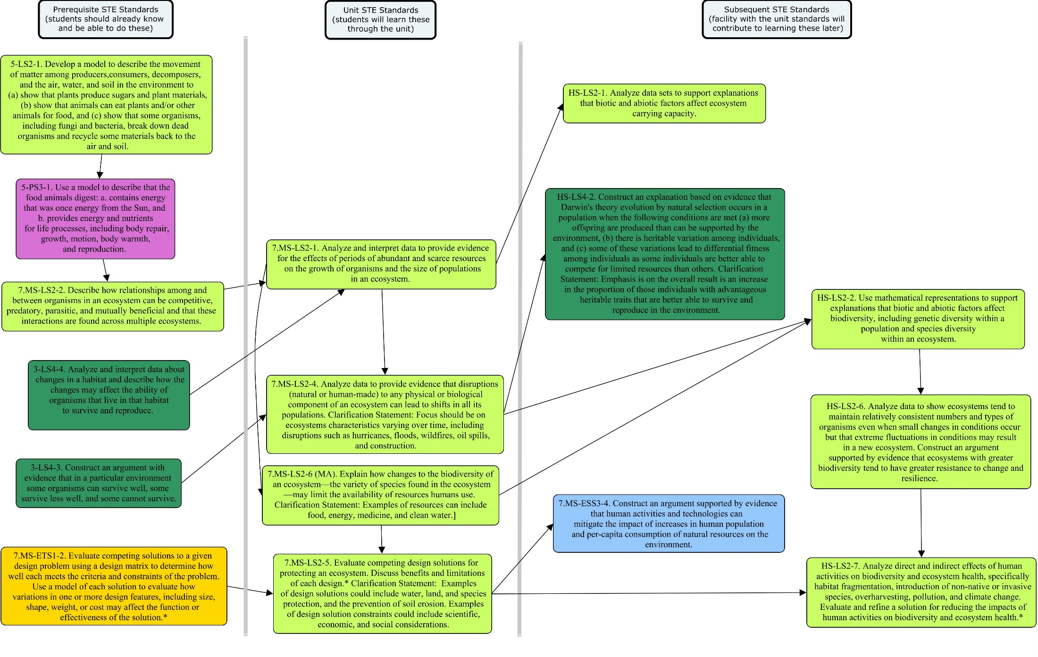

Unit Plan
Stage 1 Desired Results
ESTABLISHED GOALS G  Science & Technology/Engineering  7. MS-LS2-1. Analyze and interpret data to provide evidence for the effects of periods of abundant and scarce resources on the growth of organisms and the size of populations in an ecosystem.  7. MS-LS2-4. Analyze data to provide evidence that disruptions (natural or human-made) to any physical or biological component of an ecosystem can lead to shifts in all its populations. Clarification Statement: Focus should be on ecosystems characteristics varying over time, including disruptions such as hurricanes, floods, wildfires, oil spills, and construction.  7.MS-LS2-5. Evaluate competing design solutions for protecting an ecosystem. Discuss benefits and limitations of each design.* Clarification Statements: Examples of design solutions could include water, land, and species protection, and the prevention of soil erosion. Examples of design solution constraints could include scientific, economic, and social considerations.  ELA/Literacy Standards  WHST.6-8. 1. Write arguments focused on discipline-specific content.  WHST.6-8. 9 Draw evidence from informational texts to support analysis, interpretation, reflection, and research. | Transfer
Students will be able to independently use their learning to…
Make personal and civic decisions that respect how living systems maintain balance and stability, minimizing impact on factors that disturb stability. T
 | Meaning
 | UNDERSTANDINGS U  Students will understand that…  - Complex sets of interactions in ecosystems maintain relatively consistent numbers and types of organisms.  - Extreme fluctuations in conditions or the size of any population, however, can challenge the functioning of ecosystems in terms of resources and habitat availability.  - Disruptions to any physical or biological component of an ecosystem can lead to shifts in populations.  - Humans play a unique role in sustaining biodiversity.  - Humans design different solutions for protecting an ecosystem.  - To gather textual evidence to support an  analysis of scientific and technical texts.  - Claims must be supported by accurate and relevant evidence and connected by logical reasoning. | ESSENTIAL QUESTIONS Q  - How does the abundance of resources influence the size of populations in an ecosystem?  - How do natural or human disruptions impact populations and distributions of organisms?  - How do humans influence the extinction of species?
 | Acquisition
 | Students will know… K  - What abiotic, biotic, and human factors influence populations within an ecosystem.  - What type of environmental factors influence changes in populations of plants and animals.  - Shifting environmental conditions may lead to differential survival of organisms.  - Factors that might threaten the survival of an entire species.  - The natural factors that can influence the survival of groups of organisms.  - Distributions of populations of organisms change constantly.  - Different types of design solutions for protecting an ecosystem. | Students will be skilled at… S  - Interpreting timelines, graphs, maps, and data.  - Analyzing relationships between components of an ecosystem.  - Creating a concept map from a scientific document.  - Analyzing concept maps.  - Extracting evidence from informational text for analysis and discussion.  - Summarizing readings to share with peers.  - Analyzing data to support explanations.  - Communicating research to their peers.  - Evaluating solutions to complex real-world problems.  - Making and evaluating claims based on evidence (connected by reasoning) in writing (argument writing) and orally.
Stage 2 - Evidence
Evaluative Criteria | Assessment Evidence
See CEPA rubric. | CURRICULUM EMBEDDED PERFORMANCE ASSESSMENT (PERFORMANCE TASKS) PT  Goal: Students will learn about the Great Barrier Reef and explain factors that have contributed to environmental changes. They will then evaluate the different design solutions for protecting an ecosystem from the crown-of-thorns sea stars on the Great Barrier Reef. They will present in small groups their recommendation for the best solution (including the benefits and limitations) to the class.  Role: Students are biologists hired by the town conservation committee.  Audience: Town conservation committee  Situation: The town has become aware of potential problems along the reef. They have asked students to research the reef and the environmental changes and then choose a solution for controlling the crown-of-thorns sea star on the Great Barrier Reef. The students will then present an argument to the committee for the best solution using evidence to explain why the benefits outweigh the limitations.  Product Performance and Purpose: Students conduct independent research and then work in small groups to prepare an argument for the town conservation committee in favor of a particular solution. Students will have the opportunity to engage in argument from evidence.
OTHER EVIDENCE: OE Lesson 1: Effects of Natural Factors on Differential Selection
- Analysis and Discussion of California Connections: A Second Chance for Sea Otters Article
- Small and Whole Group Discussions: Interaction between kelp and sea otters and the factors affecting their distribution. Sea surface temperatures at upwelling locations and whether or not kelp would be found at upwellings. What does distribution mean? How is distribution a measurable result of differential survival? The relationship between natural factors and the survival of organisms.
- Effects of Natural Factors on Differential Selection Worksheet

Lesson 2: Natural Factors and Human Activities Change Environments
- Analysis and Discussion: Coastal Wetland Changes Article
- Group Analysis of coastal wetland diagram
- Coastal Wetland Changes worksheet

Lesson 3: Human Activities, Natural Factors, and Differential Survival
- Analysis and Discussion: Past and current distribution of sea otters, What human activities influenced sea otter survival?
- Sea Otters and Human Activities worksheet

Lesson 4: Independent Research Project-Protecting the Piping Plover
- Part 1: Analysis and Discussion (small group and whole group): Great Lakes Piping Plover Fact Sheet & Recovery Action Plan worksheet
- Part 2: Independent Research project: Students will research and create a project that evaluates two different plans that have been implemented to protect piping plovers in the United States. Students will be presented with a rubric to follow. They will then present their findings to the class.

Stage 3 – Learning Plan
Summary of Key Learning Events and Instruction

Lesson 1: Where and Why of Species Distribution (50-minute instructional period)
Students read about the “rediscovery” of sea otters off the California coast. They compare physical parameters of oceans along the east and west coasts of North America. They relate these parameters to the distribution of kelp and explore how this directly affects the distribution and differential survival of sea otters.

Lesson 2: Natural Factors and Human Activities Change Environments (50-minute instructional period)
Students examine and discuss relationships among various components of an ocean ecosystem. They read information about a coastal wetland ecosystem, examine an ocean ecosystem concept map, and use this information to create a coastal wetland ecosystem map including both natural and human-related factors. They discuss how these factors can change the coastal wetland ecosystem.

Lesson 3: Human Activities, Natural Factors, and Differential Survival (50-minute instructional period)
Students view maps to compare the historical and current distribution and differential survival of sea otters throughout its range. They explore how human activities can affect sea otter survival and participate in class discussions and analyze effects through written responses.

Lesson 4: Independent Research Project-Protecting the Piping Plover (2 x 50-minute instructional periods)
Students read about piping plovers in the Great Lakes area. They determine why the Great Lakes piping plover is endangered, develop a recovery plan outline and determine management techniques necessary for its survival. In the second part of the lesson students evaluate protection plans that have been implemented to save piping plovers and create a report that describes the success of these plans and the importance in saving this species.

CEPA: Case Study of Differential Survival of Organisms (2 x 50-minute instructional periods)
Students read a case study about the Great Barrier Reef and use data to explain factors that have contributed to environmental changes. Students then research solutions to the crown-of-thorns sea star problem and make recommendations for managing the reef ecosystem.

Adapted from Understanding by Design 2.0 © 2011 Grant Wiggins and Jay McTighe Used with Permission

Lesson 1: Where and Why of Species Distribution

Brief Overview of Lesson: Students read about the “rediscovery” of sea otters off the California coast. They compare physical parameters of oceans along the east and west coasts of North America. They relate these parameters to the distribution of kelp and explore how this directly affects the distribution and differential survival of sea otters.
Prior Knowledge Required:
Students should know about:
- Changes in ecosystems resulting from changes in abiotic and biotic factors, including human activity.
- The roles of producers and consumers in a food web.

Students should be able to:
- Interpret maps and charts

Estimated Time: 50-minute instructional period
Resources for Lesson:
- A-V Equipment:
- projection system, screen
- Class Supplies:
- chart paper
- colored markers
- pencils or pens
- tape or thumbtacks
- writing paper
- Handouts (All handouts are located at the end of the unit.):
- California Connections: A Second Chance for Sea Otters Article
- Key Unit Vocabulary
- Effects of Natural Factors on Differential Selection Worksheet
- Physical Parameters Data Chart
- Visual Aids (can be projected or printed out in color)
- Sea Surface Temperatures—North America
- Ocean Nitrates—North America
- Ocean Phosphates—North America
- Pacific Ocean Upwellings
- Kelp Forests
- Historical Distribution of Sea Otters

Standard(s) to be addressed in this lesson:
- 7.MS-LS2-1: Analyze and interpret data to provide evidence for the effects of periods of abundant and scarce resources on the growth of organisms and the size of populations in an ecosystem.
- WHST.6-8. 9 Draw evidence from informational texts to support analysis, reflection, and research.

Essential Question(s) addressed in this lesson:
- How does the abundance of resources influence the size of populations in an ecosystem?

Objectives:
Students will be able to…
- Describe the relationship between kelp forests in the Northern Pacific Ocean and sea otters.
- Provide evidence for how the complex sets of interactions in ocean ecosystems maintain relatively consistent numbers and types of organisms.
- Draw evidence from informational texts to support their analysis and discussion.

Language Objectives:
Students will be able to…
- Read informational text in order to identify and select evidence and orally discuss the interactions in ocean ecosystems using that evidence.

Targeted Academic Language
- Content specific: barrier to dispersal, bathymetry, differential survival, distribution, kelp, subspecies, upwelling, nitrates, phosphates
- Academic specific: brainstorm, discuss, glossary, predict, construct, abundant, scant, resources, relationships, interactions

Anticipated Student Preconceptions/Misconceptions
- Varying the population size of a species may not affect an ecosystem because some organisms are not important.
- Ecosystems are not a functioning whole but simply a collection of organisms.

Instructional Materials/Resources/Tools
- See ‘Resources for Lesson (list resources and materials)’ above.

Instructional Tips/Strategies/Suggestions for Teacher
- It may be useful to pre-assess students to determine prior knowledge of this content and vocabulary.
- Create Physical Parameters Data Chart on chart paper before class or have ready to project (sample provided in handouts and in lesson details) ahead of time.
- Post the Physical Parameters Data Chart in a location visible to all students and accessible during the lesson.
- The teacher may want to explicitly discuss the idea of maps as miniature representations of real data.
- Depending on student knowledge, teacher may have to teach how to present a claim and use evidence to support their claim. This will give the students the skills needed to describe how the sea otter distribution will be effected and give evidence to explain why this change will happen.

Assessment
- Gauge student understanding based on class discussion and answers to Effects of Natural Factors on Differential Selection worksheet questions.

Lesson Details:
Step 1:
- Students read California Connections: A Second Chance for Sea Otters article. Distribute the key unit vocabulary handout to introduce new words to students as appropriate. After students finish reading this section, ask them to turn to a class partner and quickly discuss the “gist” of what they’ve read (explain to students that the “gist” of something is a basic summary, what the reading is mainly about). Ask for a few student volunteers to share their ideas, and model for students how to write a “gist” statement in the margin of the text. Explain to students that notes in the margin of a text are called “text annotations” and it’s a technique that readers often use. Explain that they will need to use this information to answer the discussion questions. The class discussion should focus on the connection between kelp, sea urchins, and sea otters and the factors affecting their distribution.
- Additional Information for class discussion: Remind students that kelp is large brown algae that photosynthesizes. Mention that kelp is one of the largest species of algae and can grow several meters in length. After reading the story, facilitate a discussion about environmental factors that influence the distribution and survival of kelp and sea otters. Ask students:
  - Why is kelp an important ecosystem component for sea otters? (It is the food source for sea urchins, the preferred prey of the otters.)
  - Which environmental factors discussed earlier affect the distribution and survival of kelp? (Sunlight, ocean temperature, nutrient availability, rocky substrate of the ocean floor)
  - Which environmental factors discussed affect the distribution of sea otters? (Temperature, food resources [quantity of sea urchins], distribution of kelp)
Optional: If students are finding difficulty visualizing a kelp forest, show video from PBS Learning Media: http://www.pbslearningmedia.org/resource/kqed07.sci.life.eco.kelp/kelp-forest/
Step 2:
- Students review the physical parameters (temperature, nitrates, and phosphates) handouts. (Optional to project them). Discuss an ideal kelp habitat and determine where they would expect to find kelp and sea otters. Emphasize how the habitat features relate to the distribution of kelp. Call students’ attention to the Physical Parameters Data Chart Handout. Have students make a copy of the chart in their notebook or handout predesigned chart to fill in during the discussion. Discuss the ideal habitat for kelp and complete the first column of the chart as a class. Tell students to record their answers on their own chart. (Teacher Note: Sample Answers for Physical Parameters Data Chart are provided below)

- Additional Information for class discussion:
- Sea Surface Temperatures—North America and ask the students, “What differences do you see between the temperatures on the East and West Coasts?” (Sea surface temperatures are colder on the West Coast than on the East Coast.)
- Ocean Nitrates—North America and ask the students, “What differences do you see between the level of nitrates on the East and West Coasts?” (Nitrate levels on the West Coast are slightly higher than on the East Coast.)
- Ocean Phosphates—North America and ask the students, “What differences do you see between the level of phosphates on the East and West Coasts?” (Phosphate levels on the West Coast are higher than on the East Coast

- Ask students, “Where might you expect to find kelp populations based on the maps we have examined?” Revisit the maps as needed to emphasize how these habitat features relate to the distribution of kelp. (Kelp habitat features match those off the West Coast of North America. Kelp is not found on the East Coast. Its habitat stretches from central California north to Alaska.) Ask students, “In what kinds of habitats would you expect to find sea otters?” (Sea otters rely on kelp for shelter and as a food source for sea urchins, a main prey of sea otters. Therefore, they are found where kelp forests are found.)

Physical Parameters Data Chart- Teacher Answer Key
Characteristic | Ideal Kelp Habitat | East Coast | West Coast
Sea Surface Temperature | Cool | Warmer temperatures | Colder temperatures
Nitrates | Plentiful | Low | Slightly higher than East Coast
Phosphates | Plentiful | Low | Slightly higher than East Coast

Step 3:
- Explain about upwellings to students. (Teacher Note: Additional time may be needed to be sure that students understand the concept of upwellings. Optional: Show a video or animation of the process. Links to videos and animations found below or in Additional Instructional Materials/Resources/Tools)
  - Exploring Earth: http://www.classzone.com/books/earth_science/terc/content/visualizations/es2405/es2405page01.cfm
  - Green Sea Upwelling: http://www.greenseaupwelling.com/Upwelling.html
- Discuss sea surface temperatures at upwelling locations and whether or not kelp would be found at upwellings. Project Pacific Ocean Upwellings or pass out handout and discuss the locations of the upwellings. Project Sea Surface Temperatures and discuss the sea surface temperatures of the waters at the upwelling locations. Ask the students, “Do you think kelp is found wherever there are upwellings? Why or why not?” (Upwellings provide important nutrients for kelp and are likely to be correlated with kelp distribution. However, based on the maps, the southernmost upwellings appear to be too warm for kelp, or may not provide enough nutrients. The reading suggests that sea otters are not located south of Los Angeles, so perhaps kelp is not located there as well.)

Step 4:
- Discuss the term distribution and that distribution is a measurable result of differential survival. Ask students what differential survival means and how it is observed.
- To facilitate this discussion, ask the students:
  - What might happen to the distribution of a species if local environmental conditions change slightly (for example if, in a forest, there is slightly less rainfall than normal in a particular month)? (If the change is minor, all the organisms might survive.)
  - What might happen to the distribution of a species if local environmental conditions change to a greater extent
(for example if, in a forest, there is a drought that lasts all summer)? (Some of the organisms might not survive while others would.)
  - What might happen to the distribution of a species if local environmental conditions change drastically (for example if, in a forest, there is a drought that lasts for 10 years)? (A species might go extinct locally or more widely. Other species might thrive in this new environment with less competition.)
  - What do you think the term “differential survival” might mean?” If necessary, clarify that differential survival refers to differences between the rates of survival of some individuals in a group, such as a population or species.
  - How would you expect to be able to observe differential survival? (Might see that the distribution of groups of organisms has changed.)
Step 5:
- After reading California Connections: A Second Chance for Sea Otters, reviewing physical parameters and visual aids students have describe the relationship between kelp forests in the Northern Pacific Ocean and sea otters. Have students break up into small groups. Write the following discussion questions on the board and have them discuss in groups and record their answers.
  - Discussion questions:
  - Based on your reading of California Connections: A Second Chance for Sea Otters, what habitats support the survival of sea otters?” (Sea otters live and feed in kelp forests.)
  - Using the Kelp Forests. Ask the students to summarize where the major kelp forests are located. (In the northern Pacific Ocean along North America and north Asia)
  - Using the Historical Distribution of Sea Otters. Ask the students to summarize the historical distribution of sea otters. (In the northern Pacific Ocean along North America and north Asia)
  - Referring back to California Connections: A Second Chance for Sea Otters, ask students to describe the relationship between the kelp forests in the northern Pacific Ocean and sea otters. (Sea otters only live in regions of the Pacific Ocean along North America and north Asia where there are kelp forests because the kelp is the home to the otters’ principal food source, sea urchins.) Discuss the relationship between natural factors and the differential survival of organisms using the following questions:
    - Does the global distribution of kelp and sea otters match? Why or why not? (Sea otters live in most places that kelp lives in the Pacific Ocean. Sea otters evolved after the formation of the continents, so sea otters have never had access to the Atlantic Ocean.)
    - Some scientists think that climate change may affect kelp forests, reducing their populations. How would such a change affect other species? (Sea otter populations would drop, as would the populations of many other marine organisms that rely on the kelp forest habitat for food and shelter.)
    - If sea otters are threatened again by human activities as they were a century ago, what other species might be affected? (This would lead to the differential survival of species. Sea otter prey, such as the sea urchin, would thrive. This could harm kelp forests, since urchins eat kelp. This in turn could reduce populations of organisms that rely on kelp forests for food and shelter.)

Step 6
- Gather students back together for group discussion and go over answers. Have students explain their answers in writing including their claim and evidence. (Teacher Note: Depending on student knowledge, teacher may have to teach how to present a claim and use evidence to support their claim. This will give the students the skills needed to describe how the sea otter distribution will be effected and give evidence to explain why this change will happen. )
- Students complete Effects of Natural Factors on Differential Selection handout in class or for homework.

Sample Answers for Effects of Natural Factors on Differential Selection handout
- Fewer sea otters would survive because there would be less habitat for their principal food source. This would lead to a decrease in the distribution of sea otters.
- An increase in sea surface temperature might result in fewer upwellings, thus lower nutrient levels and less kelp, fewer sea urchins, and fewer otters. As kelp distribution decreased, so too would sea otter distribution.
- Because the growth of kelp depends on the availability of nutrients, there would be less kelp, therefore fewer sea urchins, and as a result, fewer sea otters. As kelp distribution changed, so too would otter distribution.

Lesson 2: Natural Factors and Human Activities Change Environments

Brief Overview of Lesson: Students examine and discuss relationships among various components of an ocean ecosystem. They read information about a coastal wetland ecosystem, examine an ocean ecosystem concept map, and use this information to create a coastal wetland ecosystem map including both natural and human-related factors. They discuss how these factors can change the coastal wetland ecosystem.

Prior Knowledge Required:
Students should know about:
- Abiotic and biotic factors that affect ecosystems.

Students should know how:
- Human activities can directly and indirectly affect the environment.
- The roles of producers and consumers are related in a food web.

Estimated Time: 50-minute instructional period
Resources for Lesson:
- A-V Equipment
- projection system, screen
- Class Supplies:
- chart paper
- colored markers
- crayons or colored pencils
- drawing paper
- pencils or pens
- rulers
- tape or thumbtacks

- Handouts (All handouts are located at the end of the unit.):
  - Coastal Wetland Background Information
  - Coastal Wetland Changes Worksheet
  - Ocean Systems Diagram (can be printed or projected)

Standard(s) to be addressed in this lesson:
- 7.MS-LS2-4: Analyze data to provide evidence that disruptions (natural or human-made) to any physical or biological component of an ecosystem can lead to shifts in all its populations. Clarification Statement: Focus should be on ecosystems characteristics varying over time, including disruptions such as hurricanes, floods, wildfires, oil spills, and construction.
- WHST.6-8. 9 Draw evidence from informational texts to support analysis, reflection, and research.

Essential Question(s) addressed in this lesson:
- How do natural or human disruptions impact populations and distributions of organisms?
- How do humans influence the extinction of species?

Objectives:
Students will be able to…
- Identify and describe abiotic, biotic and human factors that influence the coastal wetland environment, including both beneficial and detrimental.
- Analyze data to explain human and natural factors that influence the rates at which environments change.
- Summarize textual information in a flow chart.

Language Objectives
- Read informational text in order to write relationships in a flow chart

Targeted Academic Language
- Content specific: coastal wetlands, abiotic, biotic, watershed, runoff, salinity, nutrients, fluctuations, terrestrial, aquatic

Anticipated Student Preconceptions/Misconceptions
- Ecosystems change little over time.

Instructional Materials/Resources/Tools
- See ‘Resources for Lesson (list resources and materials)’ above.

Instructional Tips/Strategies/Suggestions for Teacher
- Depending on student prior knowledge, more time may be needed to be spent on explaining how to interpret a concept map.

Assessment
- Gauge student understanding based on class discussion, group work and answers to Coastal Wetland Changes worksheet questions.

Lesson Details:
Step 1:
- Students examine the Ocean Systems Diagram Handout. Teacher demonstrates how to interpret the diagram. Students first identify each part of the diagram as biotic, abiotic or human factors. Have them label items on chart with a “B” (biotic), “A” (abiotic) or “H” (human influences). Individually or in a group have students interpret the diagram and describe how water temperature, nutrient levels in the water, climate and fisheries management affect species composition of an ocean ecosystem in addition to the growth rates of plants and animals. Create a group list of the answers on the board and have students record their answers individually.
  - Background Information for teacher:
    - abiotic (Nutrients, ocean currents, water temperature, substrate type, and climate)
    - biotic (Species composition, predator-prey relationships)
    - human influences? (Water pollution, pollution controls, fishing practices, fisheries management, marine sanctuaries)water temperature (Water temperature affects plant and animal growth rates and the species that can live in an area.)
    - nutrient levels in the water(Nutrient levels affect plant and animal growth rates and species composition.)
    - climate (Climate affects plant and animal growth rates and species composition.)
    - fisheries management (Fisheries management affects the populations of fish species and the long-term health of
the fishery.)

Step 2:
- Students will read Coastal Wetland Background Information. As they are reading, have students identify and record abiotic and biotic factors that influence the ecosystem on the Coastal Wetland Changes worksheet question 1. (Teacher Note: A sample answer key is provided below.) After students finish reading this section, ask them to turn to a class partner and quickly discuss what they identified as abiotic and biotic factors from their reading. Ask for a few student volunteers to share their ideas. Explain that they will need to use this information to answer the discussion questions.
- Discuss the students’ responses and suggest additional factors students may have overlooked.

Step 3:
- Distribute chart paper and crayons or colored pencils to each group. Instruct groups to create a “coastal wetland ecosystem diagram,” (similar to the visual aid of the Ocean Systems Diagram) that includes the abiotic and biotic natural factors they listed in Step 1. Students will be able to identify four natural factors that can change coastal wetland ecosystems and discuss in groups.
- Have each student copy the group coastal wetland ecosystem diagram below question 2 on Coastal Wetland Changes worksheet. Have students walk around or present their diagrams and observe each other’s diagrams to see how different groups approached the task.

Step 4:
- Students will identify human activities that can influence the coastal wetland environment, including both beneficial and detrimental (ex. Pollution can increase the amount of nutrients available in an environment, resulting in an increase in the abundance of some species and a decrease in others). Instruct the students to complete the table for question 4 on Coastal Wetland Changes.

Step 5
- Summarize the discussion of “connections” by reminding students that natural systems proceed through cycles that humans depend upon, benefit from, and can alter.
- Collect worksheet for assessment.

Sample answer key to Coastal Wetland Changes worksheet
- Identify five abiotic and five biotic factors that can affect a coastal wetland ecosystem.

Abiotic Factors | Biotic Factors
Temperature, Tidal Movement, Rainfall, Nutrients, Salinity | Primary Producers, Consumers, Predators, Prey, Migratory Birds

- Record the information from your group system chart in the space below. Include at least four biotic factors and four abiotic factors. Draw arrows between the factors that you think might affect each other to create as many connections as possible. Include a minimum of four connections.

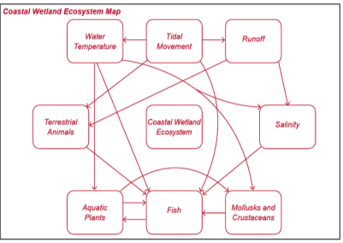

- Describe how two biotic and two abiotic natural factors can change this coastal wetland ecosystem.
How Natural Factors Cause Change:
Abiotic: More rain fall decreases the salinity in a wetland. Salinity affects which plants grow best in the wetland.
Abiotic: Tidal flow determines the amount of sediment that is deposited or carried away from coastal wetland. Sediment deposition in turn affects the wetland's substrate (soil type).
Biotic: A change in the abundance of wetland plants will influence the abundance of mollusks, crustaceans and fish.
Biotic: or the number of bat rays that eat mollusks and crustaceans will affect their population in the wetland.

- Identify four human activities that can influence this environment. Include examples of both beneficial and detrimental influences.

Human Activities
Activity | How Activity Influences the Environment
Alteration of Water sources | alters the regular flow of water, affecting sediment transport. Can also include the removal of habitat important to common wetland species, such as birds.
water pollution | changes in the habitat, making it undesirable for aquatic life and birds
regulation of pollution | prevents contamination of habitats, keeping then functioning for wetland species.
Habitat restoration | restores wetland habitat, allowing for recovery of aquatic species and birds

Lesson 3: Human Activities, Natural Factors, and Differential Survival

Brief Overview of Lesson: Students view maps to compare the historical and current distribution and differential survival of sea otters throughout its range. They explore how human activities can affect sea otter survival and participate in class discussions and analyze effects through written responses.
Prior Knowledge Required:
Students should know about:
- Food web dynamics

Students should know how:
- Read and summarize scientific text and diagrams
- Interpret graphs

Estimated Time: 50-minute instructional period

Resources for Lesson:
- A-V Equipment
- projection system, screen
- Class Supplies:
- pencils or pens
- Handouts:
  - Sea Otters and Human Activities worksheet
- Visual Aids: (can be projected or printed out in color)
- Refer back to Lesson 1 handouts for Kelp Forests and Historical Distribution of Sea Otters visuals
- Current Sea Otter Distribution
- Effects of Human Activities on Sea Otters

Standard(s) to be addressed in this lesson:
- 7.MS-LS2-1: Analyze and interpret data to provide evidence for the effects of periods of abundant and scarce resources on the growth of organisms and the size of populations in an ecosystem.
- 7.MS-LS2-4: Analyze data to provide evidence that disruptions (natural or human-made) to any physical or biological component of an ecosystem can lead to shifts in all its populations. Clarification Statement: Focus should be on ecosystems characteristics varying over time, including disruptions such as hurricanes, floods, wildfires, oil spills, and construction.

Essential Question(s) addressed in this lesson:
- How do natural or human disruptions impact populations and distributions of organisms?
- How do humans influence the extinction of species?

Objectives:
Students will be able to…
- Identify the natural and human factors that can influence the differential survival of groups of organisms.
- Describe the natural and human factors that can influence the rates at which environments change.
- Analyze data to provide evidence of human activities that have influenced the differential survival of groups of organisms.

Language Objectives
- Orally discuss observations of sea otters and write explanations of evidence for human impact.

Targeted Academic Language
- Content specific: contaminant, life span, mortality rate, population dynamics, adaptation
- Academic specific: detrimental, neutral, degradation, diminish, legislation

What students should know and be able to do before starting this lesson:
- See ‘Prerequisite Knowledge Required’ above.

Anticipated Student Preconceptions/Misconceptions
- Varying the population size of a species may not affect an ecosystem because some organisms are not important.

Instructional Materials/Resources/Tools
- See ‘Resources for Lesson (list resources and materials)’ above.

Instructional Tips/Strategies/Suggestions for Teacher
- Refer back to Lesson 1 handouts for Kelp Forests and Historical Distribution of Sea Otters visuals.
- Mortality pie graph and historical distribution of sea otters map from the student worksheet may be need to be projected in color to help students answer the questions more accurately.

Assessment
- Students will provide examples of human activities that can influence the differential survival of group of organism. Students will demonstrate the information they have learned by providing written responses to questions. A sample answer key for Sea Otter and Human Activities are provided.

Lesson Details:
Step 1:
- Review or show the Kelp Forest video from PBS Learning Media: http://www.pbslearningmedia.org/resource/kqed07.sci.life.eco.kelp/kelp-forest/
- Explain that although the local distribution of kelp forests has changed over the last 50 years, the overall range of the ecosystem has remained unchanged.
Step 2:
- Project or handout copies of Historical Distribution of Sea Otters & Current Sea Otter Distributions visuals.
- Divide the class into groups of 4. Ask students to discuss the past and current distribution of sea otters’ handouts.
  - “What changes in geographical distribution of sea otters do you observe?” (Sea otter range is no longer contiguous along the coasts; the range does not cover as large an area as it did historically; sea otters now live along the Central Coast of California from Santa Cruz to Santa Barbara but previously were found much further south.)
- Pass out Sea Otters and Human Activities Worksheet. Discuss changes in sea otter distribution. Students record their observations for question 1.

Step 3:
- Students read Part 1 of Sea Otters and Human Activity handout in groups. Answer questions 2 to 7:
- Why is the sea otters’ thick fur important for survival?
- What happens when the fur is soiled or clumped?
- Why is a healthy kelp forest essential to sea otter survival?
- How long do sea otters live?
- When can a female sea otter reproduce?
- How many pups can a female sea otter produce in a year?
- If the average age of sea otters decreased, what would happen to the sea otter population?
- Discuss the students’ responses to the questions.

Step 4:
- Students read Part 2 of Sea Otters and Human Activity handout in groups. Suggest that events in the list can be put into categories of ways humans influence species survival. Ask students to discuss in their groups what categories of activities have influenced the survival of sea otters (e.g., hunting, pollution, trauma from bomb testing, legislation). Have groups volunteer to share their categories with the class.
- Discuss in groups what activities influenced sea otter survival. Have groups share activities with the class.
- Review Differential Survival
  - In 1989 and 1995, what human activities caused thousands of sea otters to die?
  - How can human activities affect the sea otter’s thick fur and diminish its insulating quality?
  - What happens to sea otters if human activities decrease the distribution or productivity of the kelp forest ecosystem?
  - What is the cause of almost half of the sea otter deaths off the coast of California since 2001?
  - In what ways can human activity affect how long sea otters live?
- Answer questions 8 to 12 in Sea Otters and Human Activity worksheet.

Step 5:
- Show or project Effects of Human Activities on Sea Otters. Point out 4 examples of human activities that could have an effect on sea otters. Ask students to determine whether each activity would have a beneficial, detrimental, or neutral effect on sea otter survival. Record responses in Effects on the Survival of Sea Otters.
- Return to the discussion of the meaning of differential selection. Ask students to consider each activity and suggest an adaption that the sea otters might develop that would allow certain individuals to survive the effects of these human activities. Add their ideas to “Adaptations That Might Increase Sea Otter Survival”

Step 6:
- Answer questions 13 to 15 in Sea Otters and Human Activities.
- Collect worksheets for assessment.

Answer Key and Sample Answers from Sea Otters and Human Activities worksheet
- The sea otter range used to stretch from Mexico to Alaska; now it has large gaps in it. As a result, the otter distribution does not cover as much area as it once did. Otters no longer live as far south as they once did along the coast of North America or along the coast of northern Japan. Otters now live along the Central California coast from Santa Cruz to Santa Barbara.
- This thick fur provides insulation from the cold water. Unlike other ocean-dwelling mammals the otter does not have a layer of blubber to keep it warm.
- If the fur becomes soiled or clumped, it makes it difficult for the otters to maintain body temperature.
- Sea otters consume an average of nine pounds of food per day; kelp forest provides the food required by the sea otter; if sea otters do not have sufficient food they cannot maintain their fast metabolism and stay warm.
- Female sea otters live between 15 and 20 years; males live 10 to 15 years.
- Females become sexually mature (able to reproduce) between three and five years of age. Females usually have one pup per year.
- It too would decrease, because some sea otters would not live to reach sexually maturity, and thus would not reproduce.
- The Exxon Valdez disaster and pollution from runoff
- Water pollution can diminish the sea otter’s ability to groom itself, thus exposing it to the cold water and increasing the chance that it will become diseased.
- Since the kelp forest provides the food required by sea otters, a decrease in the distribution or productivity of the kelp forest will decrease the amount of food available; if the sea otters do not have sufficient food, they cannot maintain their fast metabolism and stay warm.
- Disease from parasites found in cat and opossum feces
- Trauma and disease from human pollutants can reduce the life span of sea otters. Legislation protecting sea otters from hunting and pollution can increase their life span.
- Pollution that contains parasites reduces sea otter survival rates.
- Human developments often destroy wetlands, replacing the feeding and resting grounds for migrating birds with golf courses for people.

Answer Key and Sample Answers from Effects of Human Activities on Sea Otters Chart
Human Activity | Effects on the Survival of Sea Otters | Adaptations That Might Increase Sea Otter Survival
Habitat degradation | Detrimental | Digestive tract adapted to accommodate and obtain nutrition from organisms that live in the degraded habitat.
Water pollution | Detrimental | Fur that does not become soiled or clumped when it comes in contact with oil and parasites.
Boating (Trauma from human activity) | Detrimental | Increased speed and maneuverability  to avoid humans and trauma from  human activities.
Legislation | Beneficial | n/a

Lesson 4: Independent Research Project - Protecting the Piping Plover

Brief Overview of Lesson: Students read about piping plovers in the Great Lakes area. They determine why the Great Lakes piping plover is endangered, develop a recovery plan outline and determine management techniques necessary for its survival. In the second part of the lesson students evaluate protection plans that have been implemented to save piping plovers and create a report that describes the success of these plans and the importance in saving this species.

Prior Knowledge Required:
Students should know about:
- threatened and endangered species
- food webs dynamics
- changes in ecosystems resulting from changes in abiotic and biotic factors, including human activity

Students should know how:
- Read and summarize scientific text and diagrams
- Interpret graphs

Estimated Time: 2 x 50-minute instructional periods

Resources for Lesson:
- A-V Equipment
- projection system, screen, computers with internet access for research
- Class Supplies:
  - markers, flip chart
- Handouts:
  - Activity A:
      - Great Lakes Piping Plover Fact Sheet
      - Recovery Action Plan worksheet
      - Image of a piping plover
      - Map of Presque Isle State Park showing the Gull Point Special Management Area
- Activity B:
      - Student Instruction sheet
      - Rubric

Standard(s)/Unit Goal(s) to be addressed in this lesson:
- 7.MS-LS2-1. Analyze and interpret data to provide evidence for the effects of periods of abundant and scarce resources on the growth of organisms and the size of populations in an ecosystem.
- 7.MS-LS2-4. Analyze data to provide evidence that disruptions (natural or human-made) to any physical or biological component of an ecosystem can lead to shifts in all its populations. Clarification Statement: Focus should be on ecosystems characteristics varying over time, including disruptions such as hurricanes, floods, wildfires, oil spills, and construction.
- 7.MS-LS2-5. Evaluate competing design solutions for protecting an ecosystem. Discuss benefits and limitations of each design.* Clarification Statement: Examples of design solutions could include water, land, and species protection, and the prevention of soil erosion. Examples of design solution constraints could include scientific, economic, and social considerations.
- WHST.6-8. 1. Write arguments focused on discipline-specific content.

Essential Question(s) addressed in this lesson:
- How does the abundance of resources influence the size of populations in an ecosystem?
- How do natural or human disruptions impact populations and distributions of organisms?
- How do humans influence the extinction of species?

Objectives:
Students will be able to…
- Identify the natural factors that can influence the differential survival of groups of organisms and the rates at which environments change.
- Describe human activities that can influence the rates at which environments change.
- Analyze data to provide evidence of human activities that have influenced the differential survival of groups of organisms.
- Compare different design solutions for protecting an ecosystem.

Language Objectives
- Write arguments focused on evaluating design solutions for protecting an ecosystem.

Targeted Academic Language
- Content specific: adaptation, breeding season, brood, captive rearing, display, disturbance, endangered, fledge, management, migration, precocial, predation, recreation, shorebird, territory
- Academic specific: extirpated, exclosure

What students should know and be able to do before starting this lesson:
- See ‘Prerequisite Knowledge Required’ above.

Anticipated Student Preconceptions/Misconceptions
- Species have always gone extinct. There is no need to worry about them right now.
- Losing a species will not affect humans.
- There’s nothing I can do to protect the Earth’s biodiversity.

Instructional Materials/Resources/Tools
- See ‘Resources for Lesson (list resources and materials)’ above.

Instructional Tips/Strategies/Suggestions for Teacher
- This lesson was modified from the Pennsylvania, Department of Conservation and Natural Resources, Bureau of State Parks. The link to the full lesson can be found in the sources and credits section of unit.
- Additional background information for teacher and/or to share with students is located in unit resources section.
- For information on constructing explanations:” Designing Science Inquiry: Claim + Evidence + Reasoning = Explanation,” Edutopia, http://www.edutopia.org/blog/science-inquiry-claim-evidence-reasoning-eric-brunsell
- Additional background information on engaging students in the science practice of argumentation can be found in the NSTA article, “Engaging Students in the Scientific Practices of Explanation and Argumentation Understanding: A Framework for K–12 Science Education” By Brian J. Reiser, Leema K. Berland, and Lisa Kenyon,
http://nstahosted.org/pdfs/ngss/resources/201204_Framework-ReiserBerlandKenyon.pdf
- Part B of the lesson can be assigned as homework or started in class and completed as homework.
- An optional assessment strategy is to use a gallery walk. Students display their work around the room to create stations. Each group is given some sticky notes to use during the gallery walk. When they get to a station, the group should read and discuss the issue being presented. After discussion, the group must leave comments on the issue (on sticky-notes) and come to a consensus on how they feel about the issue.

Assessment
- Activity A: Gauge student understanding based on class discussion and answers to Recovery Action Plan worksheet.
- Activity B: Students will research and create a project that evaluates two different plans that have been implemented to protect piping plovers in the United States. After investigating the success (or failure) of these plans, they must present pros and cons of these plans. Students will be presented with a rubric to follow. They will then present their findings to the class.
Optional: Students could complete a peer assessment on each project after each presentation.
Optional: In lieu of formal presentations, students could display their research in a “gallery walk” format.

Lesson Details:
Activity A: Great Lakes Piping Plover- Recovery Plan
Step 1:
- Explain to the students that they will be studying an endangered species, the Great Lakes piping plover. Ask for a definition of an endangered species. Explain that there are lists for both federally endangered and state endangered species. Tell the students that the Great Lakes piping plover was listed as federally endangered in 1985. Explain to the students that in Pennsylvania the Great Lakes piping plover is extirpated which means that it is no longer found breeding in Pennsylvania. Show the students an image of a piping plover.
      - Optional: U.S. Fish & Wildlife Service has developed a slide show of piping plover pictures that can be shown to students. http://www.fws.gov/northeast/pipingplover/slideshow/index.html
      - Optional: The PA department of Conservation and Natural Resources has information and a short video of the park for students to view. http://www.dcnr.state.pa.us/stateparks/findapark/presqueisle/presqieisle-introduction/index.htm
- Pass out the Great Lakes Piping Plover Fact Sheet. Ask the students to read the fact sheet to learn more about the Great Lakes piping plover. While students are reading have them identify unfamiliar vocabulary and make notes or highlight the main points within the article.

Step 2:
- When the students have finished reading the fact sheet, divide the students into small groups. Ask them to think about what actions are needed in order for the Great Lakes piping plover to recover and be removed from the Endangered Species List. Have each group make a list of their ideas and give reasons why the Great Lakes piping plover is endangered.
- Each group shares out reasons and record their answers on a flip chart.

Step 3:
- Review the list with the students. Explain that this is the beginning of a recovery plan for an endangered species. When a species is placed on the Endangered Species List the U.S. Fish and Wildlife Service (FWS) it is required to write a recovery plan that will protect the species, its current habitat, and habitat for future generations.
- Give each group the Recovery Action Plan handout. Tell the students that they should review the list of “Actions Needed for Recovery” on the flip chart. Explain that they should select five actions that they think are most important to the recovery of the Great Lakes piping plover. They should record their selected ideas in the actions needed section of the worksheet. The actions should be listed in order of importance from number 1 to 5 on the worksheet.
- Students should identify and record at least two tasks for each action that will help them accomplish it. The tasks should be listed in the space below each action.

Step 4
- After the groups have finished, explain that by completing the worksheet they have developed a basic recovery plan. Have the groups present their recovery plans to the rest of the students. Record actions on a flip chart. End with a group discussion after groups have finished presenting.
      - Discussion questions:
        - Which actions were included most often in the recovery plans?
        - Why are these actions ranked as most important?
        - Discuss some of the tasks the students identified as a way to accomplish the actions. Who should be responsible for implementing them?
Step 5
- Explain that Presque Isle State Park is required by the Fish & Wildlife Services to protect a portion of shoreline on Lake Erie that was in the past, and may be in the future, a breeding site for the Great Lakes piping plover. Show students a map of Presque Isle State Park that outlines Gull Point. Discuss the Park Resource Management Plan that addresses the issues regarding the piping plover. Explain some of the management practices that have taken place there.
      - Management plan can found at Pennsylvania Game Commission website: http://www.pgc.pa.gov/Wildlife/EndangeredandThreatened/Pages/PipingPlover.aspx
      - Optional Activity: Students are introduced to the piping plover and the threats to its survival through an activity that simulates 1) the feeding behavior of the piping plover, and 2) factors that disturb both feeding and nesting of this threatened species. This activity is designed to get students actively thinking about the piping plover's needs and the things that are threatening this bird's survival. Developed by U.S. Fish & Wildlife Service. http://www.fws.gov/northeast/pipingplover/lessonplan/index.html

Activity B: Independent Research Project
Step 1:
- Explain to students that a new pair of piping plovers were recently found nesting at a nearby beach. They will need to evaluate two different plans that have been implemented to protect piping plovers in the United States. After investigating the success (or failure) of these plans, they must present pros and cons of each.
  - Teacher Background Information: There are three separate breeding populations of piping plovers: the Northern Great Plains population, the Great Lakes population, and the Atlantic Coast population. Of these three populations, only the Great Lakes population is listed as endangered. The other two populations are listed as threatened. In the Great Lakes watershed, piping plovers formerly nested throughout much of the north-central United States and south-central Canada on beaches in Illinois, Indiana, Michigan, Minnesota, Ohio, Pennsylvania, New York, Wisconsin, and in Ontario, Canada.
- Plans for Students to Review:
  - U.S. Fish & Wildlife Service Recovery Plan for the Great Lakes Piping Plover: http://www.fws.gov/northeast/nyfo/es/GLplover03.pdf
  - U.S. Fish & Wildlife Service Recovery Plan for the Atlantic Coast Piping Plover: http://www.fws.gov/northeast/pipingplover/recovery.html
  - U.S. Fish & Wildlife Service Recovery Plan for the Northern Great Plains Piping Plover: http://www.fws.gov/mountain-prairie/species/birds/pipingplover/

Step 2:
- Hand out Student Instruction Worksheet and Rubric. Give students time to review rubric.
- Explain to students they will need to write and present a scientific argument to determine which plan would be the best solution for helping the piping plovers.
- Explain the elements of scientific argument to the students.
  - Teacher Background Information: Argumentation is a process for reaching agreements about explanations and design solutions. Argument is a process based on evidence and reasoning that leads to explanations acceptable by the scientific community and design solutions acceptable by the engineering community. Explain to the students that they are expected to use argumentation to listen to, compare, and evaluate competing ideas and methods based on their merits. Scientists and engineers engage in argumentation when investigating a phenomenon or testing a design solution.
- Model examples for students. Remind students that a claim is a statement or conclusion that answers a question based on evidence. Scientists always need to make sure that relevant and sufficient evidence is provided to support a claim. They also provide their reasoning (the big scientific idea or principle that connects the claim and evidence). For example, let’s look at this photograph of a seal (show images and/or videos of a seals from arkive.org). The question is: Why can seals survive in Arctic waters? What do we notice about seals from this image that might help them survive in a cold ocean habitat? Chart student responses. What claim(s) might we be able to make based on this evidence? [Claim: Seals can live in Arctic waters because they have adaptations for the environment. Example evidence: Their flippers allow them to swim through the water to catch food. The seal’s body is streamlined for swimming. Their fur helps keep them warm.] What big idea allows us to connect the claim and evidence? [Adaptations are characteristics that allow an animal to survive in its environment. Getting food and staying warm are both necessary for an animal to live.]

Step 3:
- Have students research independently. Teacher Note: Research can be assigned as homework or started in class and then completed as homework.

Step 4:
- Have students present their findings to the class.
  - Optional: Students could complete a peer assessment on each project after each presentation.
  - Optional: In lieu of formal presentations, student could display their research in a “gallery walk” format.

Curriculum Embedded Performance Assessment (CEPA):
Case Study of Differential Survival of Organisms

Brief Overview of Lesson: Students read a case study about the Great Barrier Reef and use data to explain factors that have contributed to environmental changes. Students then research solutions to the crown-of-thorns sea star problem and make recommendations for managing the reef ecosystem.

Prior Knowledge and Skills Required: Students are familiar with understanding changes in ecosystems that result from changes in abiotic and biotic factors, including human activity. They should be skilled at interpreting timelines, graphs, maps, and data and analyzing relationships between components of an ecosystem. They are able to access and use the internet to research management plans. They are able to work in groups.

Estimated Time: 2 x 50 minutes instructional periods

Resources for Lesson:
- Computers with internet access for research
- pencils or pens
- Handouts
  - Instructions for Students
  - Case Study: Great Barrier Reef, Australia Student Worksheet
  - Case Study: Great Barrier Reef, Australia Information Handout
  - Rubric for Presentation

Standard(s) to be assessed:
- MS-LS2-4. Analyze data to provide evidence that disruptions (natural or human-made) to any physical or biological component of an ecosystem can lead to shifts in all its populations. Clarification Statement: Focus should be on ecosystems characteristics varying over time, including disruptions such as hurricanes, floods, wildfires, oil spills, and construction.
- MS-LS2-5. Evaluate competing design solutions for protecting an ecosystem. Discuss benefits and limitations of each design.* Clarification Statement: Examples of design solutions could include water, land, and species protection, and the prevention of soil erosion. Examples of design solution constraints could include scientific, economic, and social considerations.
- WHST.6-8. 1. Write arguments focused on discipline-specific content.

Explanation of CEPA:
Goal: Students will learn about the Great Barrier Reef and explain factors that have contributed to environmental changes. They will then evaluate the different design solutions for protecting an ecosystem from the crown-of-thorns sea stars on the Great Barrier Reef. They will present in small groups their recommendation for the best solution (including the benefits and limitations) to the class.

Role: Students are biologists hired by the town conservation committee.

Audience: Town conservation committee

Situation: The town has become aware of potential problems along the reef. They have asked students to research the reef and the environmental changes and then choose a solution for controlling the crown-of-thorns sea star on the Great Barrier Reef. The students will then present an argument to the committee on the best solution by using evidence to explain why the benefits outweigh the limitations.

Product Performance and Purpose: Students conduct independent research and then work in small groups to prepare an argument for the town conservation committee in favor of a particular solution. Students will have the opportunity to engage in argument from evidence. A rubric is provided to assess research and presentation.

Information for Teachers:
- Students will work both in groups and individually.

Individual Work
- Students will read the Case Study: Great Barrier Reef, Australia Information Handout and use the internet to research management strategies for the reef.
- They will use what they have learned to complete the individual piece of the Case Study: Great Barrier Reef, Australia worksheet.

Group Work
- Students will work in small groups.
- Groups will discuss their internet research and make a table displaying a summary of their findings.
- Groups will evaluate the benefits and limitations of each solution.
- Groups will identify the most effective solution for managing the crown-of-thorns sea star.
- Groups will defend their reasoning to the audience.

Unit Resources: Additional Instructional Materials/Resources/Tools

Lesson 1 Handouts:
- California Connections: A Second Chance for Sea Otters Article
- Key Unit Vocabulary
- Effects of Natural Factors on Differential Selection Worksheet
- Visual Aids (can be projected or printed out in color)
- Sea Surface Temperatures—North America
- Ocean Nitrates—North America
- Ocean Phosphates—North America
- Pacific Ocean Upwellings
- Kelp Forests
- Historical Distribution of Sea Otters

Lesson 2 Handouts:
- Coastal Wetland Background Information
- Coastal Wetland Changes Worksheet
- Ocean Systems Diagram (can be printed or projected)
Lesson 3 Handouts:
- Sea Otters and Human Activities worksheet
- Visual Aids: (can be projected or printed out in color)
- Refer back to Lesson 1 handouts for Kelp Forests and Historical Distribution of Sea Otters
- Current Sea Otter Distribution
- Effects of Human Activities on Sea Otters

Lesson 4 Handouts:
- Activity A:
    - Picture of a piping plover
    - Great Lakes Piping Plover Fact Sheet
    - Recovery Action Plan worksheet
    - Map of Presque Isle State Park showing the Gull Point Special Management Area
- Activity B:
    - Student Instruction sheet
    - Rubric

CEPA Handouts:
- Instructions for Students
- Case Study: Great Barrier Reef, Australia Student Worksheet
- Case Study: Great Barrier Reef, Australia Information Handout
- Rubric for Presentation

Additional Instructional Materials/Resources/Tools
- Under Standing Evolution, Natural Selection: http://evolution.berkeley.edu/evolibrary/article/evo_25
- Woods Hole Oceanographic Institute, Oceans Institute: http://www.whoi.edu/main/ocean-institutes
- Woods Hole Oceanographic Institute, k-12 Resources: http://www.whoi.edu/main/k-12-students-and-teachers
- PBS, Empty Oceans, Empty Nets: http://www.pbs.org/emptyoceans/eoen/
- Habitat Media: http://www.habitatmedia.org/
- Kelp forest video from PBS Learning Media: http://www.teachersdomain.org/resource/kqed07.sci.life.eco.kelp
- Upwelling Videos Exploring Earth: http://www.classzone.com/books/earth_science/terc/content/visualizations/es2405/es2405page01.cfm
- Green Sea Upwelling: http://www.greenseaupwelling.com/Upwelling.html

Additional background information and websites for information about piping plovers:

Endangered Species Act- In 1973 Congress passed the Endangered Species Act (ESA) after recognizing that many of the nation’s plants and animals were in danger of becoming extinct. The purpose of the ESA is to conserve the ecosystems upon which endangered and threatened species depend and to conserve and recover listed species. Under the law, species may be listed as either “endangered” or “threatened.” Endangered means that a species is in danger of becoming extinct and threatened means a species is likely to become endangered within the foreseeable future. All species of plants and animals are eligible for listing except for pest insects.

The ESA is administered by the Interior Department’s U.S. Fish and Wildlife Service (FWS) and the National Oceanic and Atmospheric Administration (NOAA)-Fisheries. The FWS has primary responsibility for terrestrial and freshwater organisms, while the NOAA-Fisheries’ responsibilities are mainly marine species. Species are listed on the basis of the best scientific and commercial data available. Listings are made solely on the basis of a species’ biological status and threats to its existence. The FWS decides all listings using sound science peer review to ensure the accuracy of the best available data.

The law’s ultimate goal is to recover species populations, so they no longer need protection under the ESA. ESA—Recovery Plans The law requires that recovery plans be developed which describe the steps needed to restore a species to health. Appropriate public and private agencies and institutions and other qualified persons assist in the development and implementation of recovery plans. Involvement of the public and interested stakeholders is also encouraged. Many environmental variables need to be taken into account when developing and implementing a recovery plan. Biologists must consider how the recovered species will affect the other inhabitants in the ecosystem. Is there enough genetic diversity for long-term population sustainability? Why did the species decline in the first place? What changes/events/regulations have taken place that will enable the species to recover?

Societal variables are also an important part of a recovery plan. For example, what is society’s tolerance for living with the species? How do people affect the species? Historically, how have people viewed and valued the species?

ESA—Critical Habitat Critical habitat for listed species is also designated under the law. It includes geographic areas on which are found physical or biological features essential to the conservation of the species and which may require special management considerations or protection. Critical habitat may include areas not occupied by the species at the time of listing, but which are essential to the conservation of the species.

Great Lakes Piping Plover
The piping plover (Charadrius melodus), named for its melodic mating call, is a small, pale-colored North American shorebird. Its light, sand-colored plumage blends in well with the sandy beach, its primary habitat. Plumage and leg color help distinguish this bird from other plover species. During the breeding season the legs are bright orange and the short, stout bill is orange with a black tip. There are two single dark bands, one around the neck and one across the forehead between the eyes. Chicks have speckled gray, buff, and brown down, black beaks, paleorange legs, and a white collar around the neck. Juveniles resemble wintering adults and obtain their adult plumage the spring after they fledge.

There are three separate breeding populations of piping plovers: the Northern Great Plains population, the Great Lakes population, and the Atlantic Coast population. Of these three populations, only the Great Lakes population is listed as endangered. The other two populations are listed as threatened. In the Great Lakes watershed, piping plovers formerly nested throughout much of the north-central United States and south-central Canada on beaches in Illinois, Indiana, Michigan, Minnesota, Ohio, Pennsylvania, New York, Wisconsin, and in Ontario, Canada.

During pre-settlement of the Great Lakes region, piping plover populations may have been as high as 492 to 682 breeding pairs. Since industrial development, urbanization, and increased recreational pressures have occurred, the population has declined drastically. By 1977, the Great Lakes breeding population had decreased to 31 nesting pairs and by 1985 when the piping plover was placed on the Endangered Species List the population consisted of only 17 breeding pairs. In addition, the breeding areas had been reduced from eight states to only portions of Michigan.

Since the Great Lakes piping plover has been listed as endangered, the population increased to 31 pairs in 1999 and their breeding range increased to include one site in Wisconsin. This population increase has been aided by support from federal, state, tribal, and private conservation actions. Activities such as habitat surveys, beach restoration, public education, habitat protection and enhancement, and the protection of nests from predators and disturbance have all contributed to the improving status of the Great Lakes piping plover.

Presque Isle State Park and the Piping Plover
The last known nesting piping plovers in Pennsylvania were found in the late 1940’s or early 1950’s on Presque Isle. Today the habitat still remains suitable for the piping plover, but human pressure on the peninsula has increased and is one of the reasons they have not nested there in decades.

In April of 1994, a Special Management Area was designated on the eastern tip of Gull Point, which is the most critical habitat for nesting and migrating shorebirds on Presque Isle. This area encompasses approximately 67 acres and 3.7 miles of shoreline. The area is closed to all public use from April 1 through November 30, including all land and water access, hiking, and beaching of boats. Boats are not permitted to moor within 100 feet of the shoreline.

Presque Isle State Park has developed a Park Resource Management Plan for the critical habitat designation of the piping plover. It includes: where the critical habitat is located, piping plover general information, rules and regulations regarding the piping plover, guidelines for monitoring, and an action/recovery plan. During the spring of 2005, three piping plovers were spotted on the beaches at Presque Isle. They did not stay to nest, but monitoring has increased in the hopes that piping plovers may be returning to the peninsula.

Source: PA department of Conservation and Natural Resources
Additional Resources:
- United States Fish and Wildlife Service Endangered Species Recovery Plan Action Status: http://ecos.fws.gov/roar/pub/planImplementationStatus.action?documentId=1000797&entityId=131 - Website describes many different plans that have been implemented to increase the populations of various endangered species, including the Piping Plover.
- United States Fish and Wildlife Service Report:
  - http://www.fws.gov/northeast/endangered/pdf/piping_plover_five_year_review_and_summary.pdf - Highly detailed report on the status of piping plovers living in the United States including the threats to the species, conservation efforts that have been implemented, and the success of those efforts. This document is quite long, but it is a great resource to pull data from for students to analyze.
  - Piping Plover - Great Lakes Population- Critical Habitat Questions and Answers http://www.fws.gov/midwest/endangered/pipingplover/qandas.html

Lesson 1: A Second Chance for Sea Otters Article
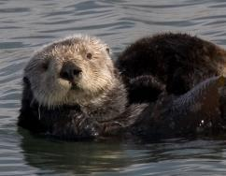
Source: Wikipedia http://upload.wikimedia.org/wikipedia/commons/1/15/Sea_otter_cropped.jpg
One spring morning in 1938, Howard Granville Sharpe gazed at the ocean through his telescope. Sharpe lived 13 miles south of Carmel, California, at the edge of a rocky cliff overlooking the sea. On this particular morning he glanced over the plentiful kelp beds close to shore. Something caught Sharpe’s eye: It floated lazily on its back, covered with long strands of kelp. Was it a small seal or sea lion? Sharpe did not think it was either.
Sharpe called the California Department of Fish and Game. Commissioners there insisted the animal he saw was a seal or sea lion, but Sharpe protested; he knew what a sea lion looked like, and this creature did not match up with the animals in his pictures. For one thing, the animal was smaller and had beautiful, thick fur. Soon Sharpe located more of these creatures with his telescope; when he looked closer, he saw that they had white furry faces. They look “like muskrats,” Sharpe said. As it turned out, Sharpe had “rediscovered” the lost member of the Mustelidae family, the southern sea otter (Enhydra lutris nereis), that until that point was thought to be extinct.

Range of the Otter
There are 13 species of otters in the world; only one of these species lives in a marine environment. Enhydra lutris consists of three subspecies. Sea otters only live in regions of the Pacific Ocean along North America and north Asia. The playful E. l. lutris lives near the Kuril Islands stretching from Japan to Russia; E. l. kenyoni lives throughout the Aleutian chain, the Alaska Peninsula, British Columbia, and Washington; and E. l. nereis lives along the western coast of North America, from Monterey Bay National Marine Sanctuary to a point just below Point Conception near Santa Barbara. One population persists on San Nicolas Island off the coast of Los Angeles and is currently the southern-most geographic extent. At times, a few southern sea otters have been spotted as far south as Baja California.

Changing Population
Historians estimate that 150,000 to 300,000 sea otters occupied the world’s oceans before hunters started killing these animals for their beautiful pelts in 1741. By the early 1900s, 1,000 to 2,000 otters remained, only 50 of which lived off the coast of Central California. Land managers passed the International Fur Seal Treaty of 1911 to protect fur seals, but it ended up protecting several other fur-bearing species, including sea otters. The treaty was the first international law enacted for wildlife conservation, and it effectively stopped the slaughter of certain marine mammals for their valuable fur.

Since 1911, otter populations have increased, though not without setbacks. When disease and environmental factors affected otters and other marine mammals in the early 1970s, lawmakers passed the Marine Mammal Protection Act to protect and replenish otter, seal, and sea lion populations. Today more than 100,000 sea otters occupy 75% of their original habitat. In the northern Pacific Ocean, sea ice limits the otters’ distribution. In California, where winters are warm, the location and condition of the kelp beds where otters forage for food determine the otter’s distribution and rates of survival.

Adaptations for a Cold Ocean
Sea otters can grow up to five feet long, and weigh up to 100 pounds. They have wide, cream-colored heads with small eyes and thick, glossy coats that range in color from dark brown to black. Otters use their webbed hind feet to propel themselves through water at a slow pace on their backs. When threatened, otters flip onto their stomachs and swim away.

Otters dive for food, foraging for sea urchins, sea stars,
crabs, abalone, and mussels. They roll on their backs, place a small rock on their stomachs, and use their five-fingered paws to smash sea urchins against the rock. Otters are the only marine mammals to use such tools. If you concentrate while walking along the shore or sitting quietly in a boat, you can sometimes hear the clicking of shells on rock above the sound of the waves.

In addition to eating and sleeping, sea otters spend large amounts of time grooming their luxurious fur. The pelts, valued by hunters since the 1700s, allow the otters to survive in cold water. One square inch of an otter’s coat contains approximately 1 million hairs. That is 10 times the number of hairs on a human head! Because otters have no extra fat on their bodies, they rely heavily on having healthy coats to keep them warm.

The Kelp Forest

When resting, otters often wrap themselves in long strands of kelp, which keep them from drifting away. Scientists identify sea otters as a “keystone” species, because the presence or absence of these animals affects the size and health of rich kelp forest ecosystems. Without otters to feed on sea urchins, the hungry urchins can devour entire kelp forests and create an urchin-dominated community.

Ocean temperature, light, nutrient availability, competition, and the condition of the rocky substrate (ocean bottom) all affect the abundance of kelp, the home of sea urchins, the otter’s preferred food supply. The health of the kelp forest also depends on a process called upwelling, in which winds create currents that bring up nutrient-rich water from the bottom of the ocean. When certain naturally derived nutrients, such as nitrates and phosphates, are plentiful, the abundance of kelp increases, providing food for the sea urchins to thrive. Weather patterns, such as El Niño, warm the water and disrupt the process of upwelling, which in turn affects marine organisms that depend on coastal productivity. An invasive species of kelp called Undaria spp., which is growing along the California coast and is sold as wakame seaweed, competes with the kelp, reducing its abundance. These changes to kelp forests affect the populations of the marine organisms that live there, including organisms that the sea otter depends upon for its diet.

Threats to the Otter
Today oil presents one of the greatest threats to the survival of sea otters. Oil spills leave slicks that float on the surface of the water and coat sea otters with a sticky film that mats their fur and destroys the protective warmth of their coats. If an otter’s core body temperature drops a few degrees below normal, it can be fatal, especially in northern waters where the water temperature is much colder than in California.

The southern sea otter in central California faces a unique set of challenges. California otters often must compete with commercial fishermen for food. They are also more threatened by the effects of pollution than otters in the less-polluted northeastern Pacific. For these reasons the southern sea otter is listed as “threatened” under the Endangered Species Act.

Since their rediscovery by Sharpe in 1938, the number of southern sea otters off California’s coast has increased, though not as rapidly as in Washington or Alaska. California otters still have a high mortality rate. As otter populations increase, they deplete populations of sea urchins, abalone, and large crabs. Without a steady supply of regular prey, the otters turn to filter-feeding mussels, clams, and worms, all of which contain high levels of bacteria, viruses, parasites, and contaminants. Large predators, such as great white sharks and killer whales, also threaten otter survival.

At the beginning of the 21st century, 2,692 otters lived off the coast of central California. The engaging sea otter has become a symbol of how environmental pressures can affect interdependent marine communities. Despite a small decline in the otter’s population between 2005 and 2006, the trend for the last few years has been slightly upward. As Howard Granville Sharpe wrote in 1938, “Nature’s immutable law was: ‘once extinct, always extinct.’” Sharpe understood nature, but he still could not figure out how the otter eluded him until that historic spring morning!

Lesson 1: Effects on Natural Factors on Differential Selection
A Second Chance for Sea Otters

Name____________________________________________ Date________________________

Instructions: For questions 1 to 3, describe how the distribution of the sea otters in the northern Pacific Ocean would be affected by changes to the following environmental conditions. Explain why this change in distribution would occur. Complete the tasks in the spaces provided.

- A decrease in the distribution of kelp around the Pacific Ocean basin:

- An increase in sea surface temperature in the Pacific Ocean basin:

- A drastic decrease in the nutrients (nitrates and phosphates) in the Pacific Ocean basin:

- The graph below shows the fluctuations seen in the amount of kelp in kelp forests from 1970 – 1990 in kilograms/meter². (Questions on following page.)
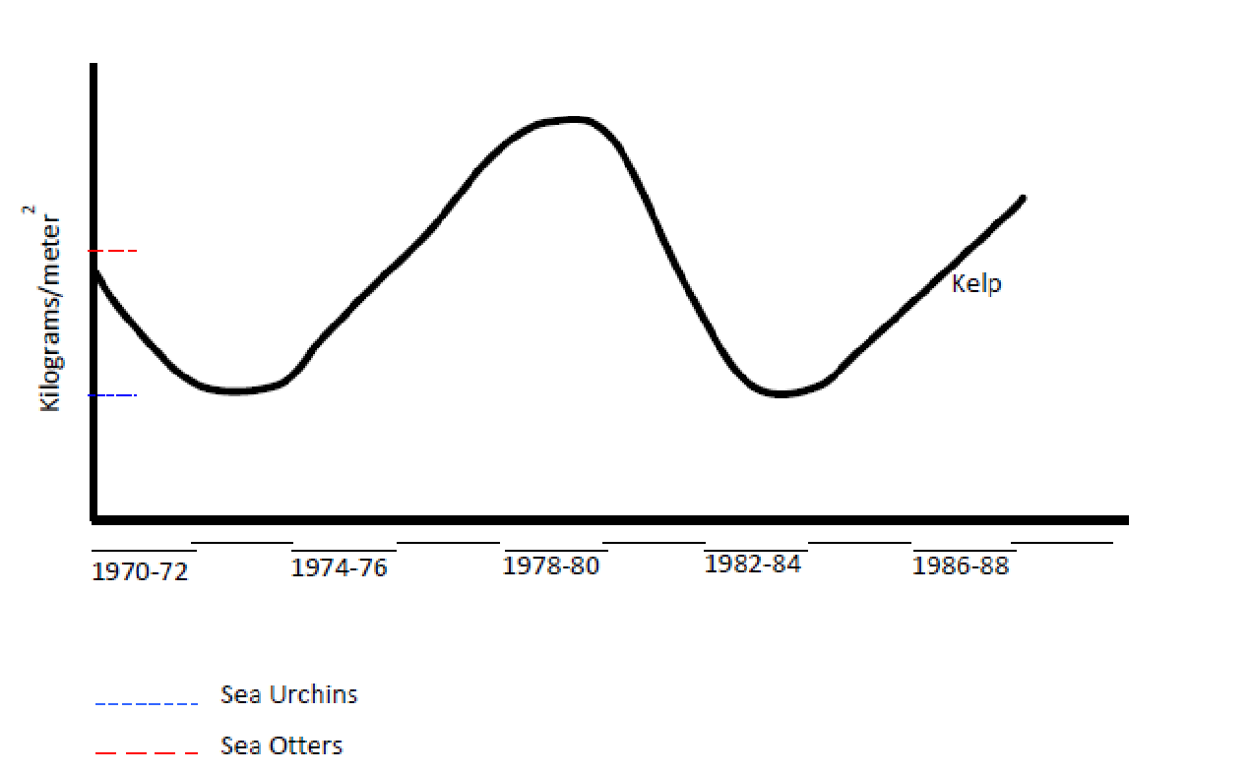
During this time frame, there were two strong El Niño events. (Remember that during El Niño years, the water is warmer than in non-El Niño years.) Given the kelp data below, predict when these two strong El Niño events occurred. Explain why you made this choice.

On the same graph, sketch the fluctuations you expect to see for both the sea urchin and otter populations as a result of El Niño. Explain how your knowledge of the relationships between sea otters, sea urchins, and kelp helped you to draw your graph.

Lesson 1 Handout: Key Unit Vocabulary

Barrier to dispersal: A geographical, environmental, or physical boundary that limits where organisms can disperse.

Bathymetry: The measurement of depths in a large body of water, such as the ocean.

Differential survival: Differences in survival rates of organisms resulting from variations in the genetic, physical, or behavioral traits that they possess.

Distribution: The geographic area inhabited by a species.

Kelp: Large brown algae that grow primarily in shallow ocean water in temperate and arctic regions.

Subspecies: A group of organisms within a species that has distinct characteristics resulting from geographical or physical isolation from other populations of their species.

Upwelling: The wind-driven movement of cold, usually nutrient-rich water from ocean depths to the surface.

Lesson 1: Physical Parameters Data Chart

Characteristic | Ideal Kelp Habitat | East Coast | West Coast
Sea Surface Temperature

Nitrates

Phosphates

Lesson 1: Sea Surface Temperature
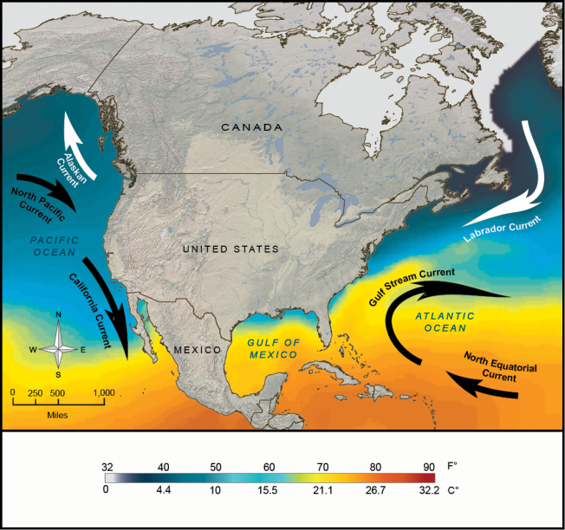

Lesson 1: Ocean Nitrates

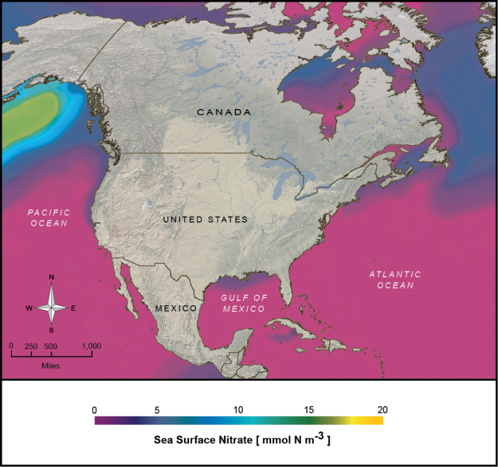

Lesson 1: Ocean Phosphates
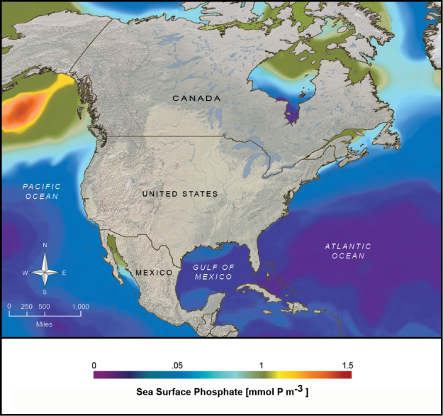

Lesson 1: Pacific Ocean Upwellings
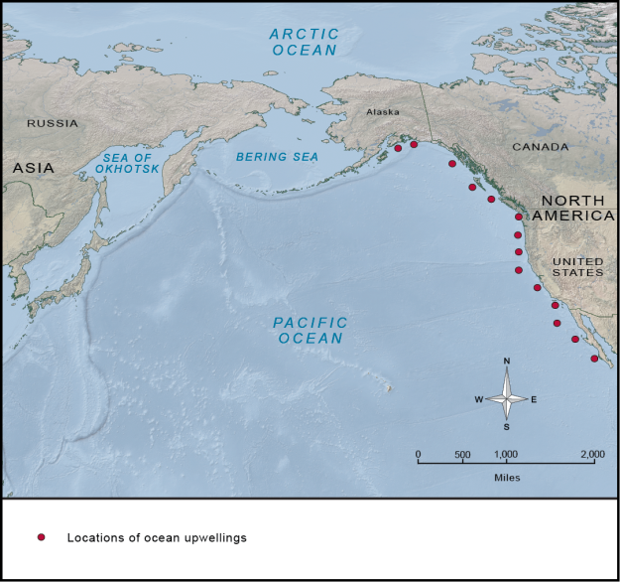

Lesson 1 & 3: Kelp Forests
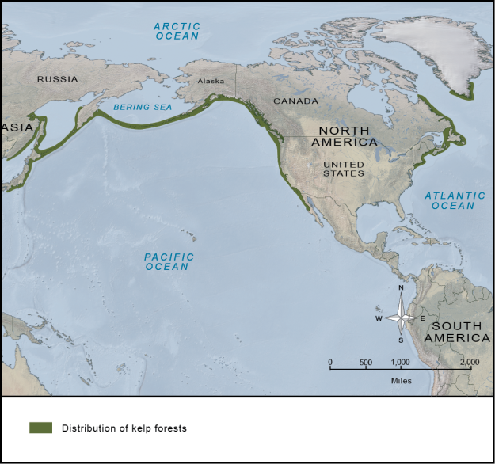

Lesson 1 & 3: Historical Distribution of Sea Otters
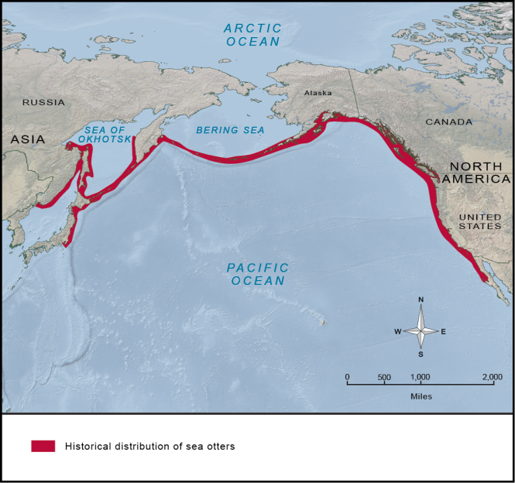

Lesson 2: Coastal Wetland Background Information
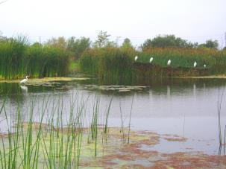
Source: Southern California Wetlands Recovery Project http://scwrp.org/wp-content/uploads/2013/08/IMG_6351.jpg
Coastal wetlands connect the watersheds of coastal areas with the ocean. Water moves through this ecosystem dynamically; both the inflow and outflow of rainfall runoff and tidal movement from the ocean affect this environment. Fluctuations in runoff and tidal movement can increase or decrease the salinity of water in wetlands; for example, an influx of rainfall decreases the salinity of water in wetlands, while tidal movement brings in salty water from the ocean. The movement of water from both sources also affects the amount of nutrients in the water. In California, tidal movement, which brings in cold ocean waters, strongly affects the temperature of water in wetlands.

Water movement also affects coastal wetland substrates. Runoff carries sediment into wetlands, where it settles out and deposits onto the wetland floor. Tidal flow carries some sediment out to the ocean, where it settles onto the ocean floor or gets transported to other areas.

Coastal wetlands support diverse aquatic plants and animals, as well as terrestrial vertebrates. The level of nutrients here strongly affects primary producers. Some, like pickleweed, are adapted to high salinity in the water. Animals depend on these plants for food and shelter. For example, the larvae of brine flies eat decaying vegetation in the water, and as adults these flies serve as food for many bird species. The muddy waters of wetlands provide an ideal habitat for animals like bat rays, which flap their fins to move the silt and expose their prey of mollusks, crustaceans, and small fish along the sandy bottom. Burrowing animals, such as worms, depend on the muddy substrate, while dragonfly larvae need shallow water to grow into adults.

In California, human activities have reduced the total area of wetlands, including coastal wetlands, mudflats, and salt marshes, by 97%. Development and water diversion especially affect wetland areas. Real estate developers prize coastal locations, and purchase and fill them in with dirt and sediment so they can build up residential and commercial projects. The development or expansion of airports in Santa Barbara, Los Angeles, San Francisco, and San Diego all involved the filling in of coastal wetlands.

Water diversion, like development, also leads to the filling in of wetlands. In natural conditions, flowing water transports sediment from wetlands to the ocean. Decreased water flow as a result of diversion allows sediment to build up within a wetland and eventually in the waterways that flow to the wetland.

Pollution frequently contaminates water flow in local watersheds. Wetlands typically filter water moving off the land; if, however, the contaminant load is too great, the concentration of the pollutants may affect burrowing animals and other aquatic species.

As more and more people recognize the importance of wetlands as a habitat for migrating aquatic bird species and for the ecosystem services they provide, they are making greater efforts to restore many wetland regions. California has protected its remaining wetlands and begun habitat restoration programs in several areas where the wetlands have been substantially changed by human activities. The introduction of stronger regulations restricting terrestrial pollution has also decreased the number of contaminants that reaches wetlands.

Lesson 2: Coastal Wetland Changes Worksheet

Name: ____________________________________________________ Date: ___________________________

- Identify five abiotic and five biotic factors that can affect a coastal wetland ecosystem.

Abiotic Factors | Biotic Factors

- Record the information from your group system chart in the space below. Include at least four biotic factors and four abiotic factors. Draw arrows between the factors that you think might affect each other to create as many connections as possible. Include a minimum of four connections.

- Describe how two biotic and two abiotic natural factors can change this coastal wetland ecosystem.
How Natural Factors Cause Change
Abiotic:

Abiotic:

Biotic:

Biotic:

- Identify four human activities that can influence this environment. Include examples of both beneficial and detrimental influences.

Human Activities
Activity | How Activity Influences the Environment

Lesson 2: Ocean System Diagram
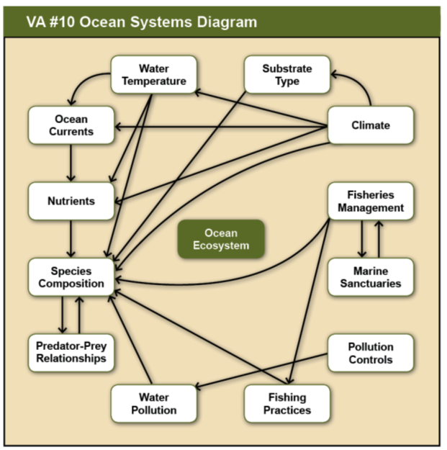

Lesson 3: Sea Otters and Human Activities
Name: _________________________________________________ Date: __________________________

Directions: Read information below and answer questions at the end.

Part 1:
Appearance
The sea otter (Enhydra lutris), belongs to the family Mustelidae and is closely related to the weasel. Like other members of this family, the otter has thick fur with approximately 1 million hairs per square inch. This thick fur insulates the otter from the cold waters of its habitat. Unlike other marine mammals the otter does not have a layer of blubber to keep it warm. This animal spends a good portion of its day grooming because soiled or clumped fur makes it difficult to maintain body temperature. Marine biologists consider a lack of grooming in sea otters to be a sign of disease.

Habitat
The sea otter prefers to spend its time in the nearshore habitat of kelp forests. It usually lives in waters shallower than 131 feet (40 meters). Studies on the food webs of kelp forests show that this animal plays a major role in the biodiversity of this habitat. For this reason, scientists identify the otters as a keystone species of the kelp forest.

Feeding
The sea otter has a fast metabolism that helps it stay warm. The average otter consumes nine pounds of food per day, the equivalent of 20 to 25% of its body weight. That is the equivalent of a human who weighs 150 pounds eating 30 pounds of food per day! The otter consumes a variety of invertebrates, such as urchins, clams, mussels, oysters, octopi, and sea stars.

Life Span and Reproduction
Female sea otters live between 15 and 20 years; males live only 10 to 15 years. Females become sexually mature (able to reproduce) between three and five years of age, while males reach sexual maturity slightly later, at five to six years. Females usually give birth to one pup per year.

Part 2: Population Dynamics

1700–1900s Extensive hunting of sea otters occurs.
Early 1900s Otters hunted almost to extinction. An estimated 1,000 otters remain in Alaska.
1911 International Fur Seal Treaty of 1911 established to protect fur seals.
1938 A population of 50 sea otters spotted off of Central California coast near Big Sur.
1971 Atomic bomb testing off Amchitka Island in Alaska kills thousands of otters.
1972 Marine Mammal Protection Act becomes law.
1973 Endangered Species Act becomes law.
1977 California group of sea otters classified as a subspecies and placed under
protection of the Endangered Species Act.
1980s Legislation enacted to reduce the number of sea otters that drown in gillnets (a form of fishing net).
1989 Thousands of sea otters die in the Exxon Valdez disaster off the coast of Alaska. This was one of the largest oil spills in U.S. history.
1995 California population of otters declines; new research indicates pollution from
runoff is partly to blame.
2004 Forty percent of sea otter deaths off the coast of California since 2001 are
attributed to two parasites: Toxoplasma gondii (from cat feces) and Sarcocystis neurona (from opossum feces).
2007 California legislation enacted a law that requires warning labels on cat litter packages to help diminish transfer of parasites to sea otters.

Sea Otter Population Changes Over Time
Year | British Columbia | Russia | Alaska | Washington | California
1900 | Estimated 1,000–2,000 otters worldwide
2004 | 2,700 | 13,000 | 75,000 | 800 | 2,000*

* Current population is descended from the original 50 individuals off the coast of Big Sur.

Historical Changes in Sea Otter Distribution

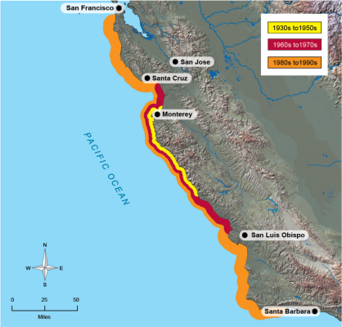
Mortality

Many factors contribute to mortality in sea otters. Occasionally bald eagles and white sharks eat otter pups; in Alaska killer whales feed on otters when their regular food sources of seals and sea lions are not readily available. Trauma caused by boats or gunshots also contributes to otter mortality; however, disease caused by a combination of parasites and infection appears to be the main cause of death of sea otters today. Scientists have identified two main parasites in sea otters. These parasites are Toxoplasma gondii (spread through cat feces) and Sarcocystis neurona (from opossum feces). Contaminants in coastal runoff, such as polychlorinated biphenyls (PCBs) also poison sea otters and can compromise their immune systems, making them susceptible to disease.

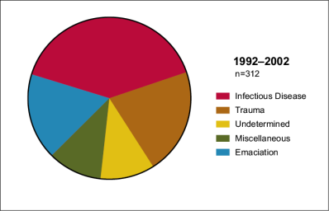
Source: http://www.nwhc.usgs.gov/publications/fact_sheets/pdfs/SeaOtter2005.pdf

Name: ______________________________________________ Date: _________________________

Instructions: Use the information in Part 1 of Sea Otters and Human Activities to answer the following questions in the spaces provided.

1. Describe the geographical changes that have taken place in the distribution of sea otters over time.

2. Why is the sea otter’s thick fur important to its survival?

3. What happens when the fur is soiled or clumped?

4. Why is a healthy kelp forest essential to the sea otter’s survival?

5. How long do sea otters live?

6. When can a female sea otter reproduce? How many pups does a female produce a year?

7. If the average age of sea otters decreased, what would happen to the sea otter population?

Instructions: Use information in Part 2 of Sea Otters and Human Activities to answer the following questions in the spaces provided.

8. In 1989 and 1995, what human activities caused thousands of sea otters to die?

9. How can human activity affect the sea otter’s thick fur and diminish its insulating qualities?

10. What happens to sea otters if human activities decrease the distribution or productivity of the kelp forest ecosystem?

11. What is the cause of almost half of the sea otter deaths off the coast of California since 2001?

12. In what ways can human activity affect how long sea otters live?

Instructions: Consider what you have learned about adaptations, sea otters, human activities, and differential survival and complete the following tasks in the spaces provided.

13. Give one example of a way that human activities might affect the sea otter’s habitat and chances for survival.

14. Give one example of another organism and some human activities that might affect this organism.

Lesson 3: Current Sea Otter Distribution
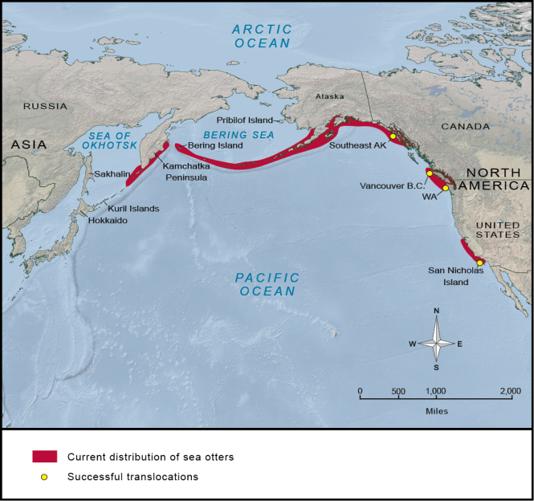

Lesson 3: Effects of Human Activities on Sea Otters
Human Activity | Effects on the Survival of Sea Otters | Adaptations that might Increase Sea Otter Survival
Habitat degradation
Water pollution
Boating (trauma from human activity)
Legislation

Lesson 4: Great Lakes Piping Plover Fact Sheet

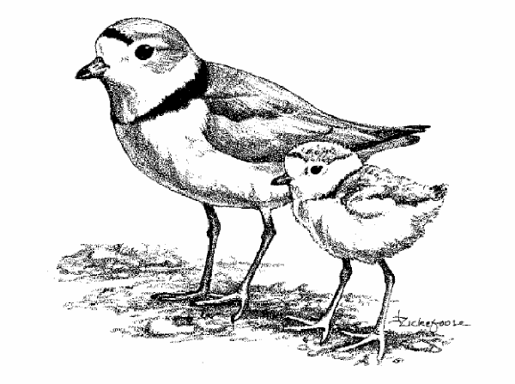
Piping Plover (Charadrius moldus)
The Great Lakes piping plover is a shorebird that inhabits beaches on the Great Lakes during the breeding season from April through September. It migrates south to beaches along the Atlantic Coast and the Gulf of Mexico where it winters from October through March. This bird was federally listed as an endangered species under the Endangered Species Act in 1985 by the U.S. Fish and Wildlife Service.
There are three separate breeding populations of piping plovers: the Northern Great Plains population, the Great Lakes population, and the Atlantic Coast population. Of these three populations, only the Great Lakes population is listed as endangered. The other two populations are listed as threatened.
In the Great Lakes watershed, piping plovers formerly nested throughout much of the north-central United States and south central Canada on beaches in Illinois, Indiana, Michigan, Minnesota, Ohio, Pennsylvania, New York, Wisconsin, and in Ontario, Canada. Currently they are limited to Michigan and, recently, at one site in northern Wisconsin.

Appearance: A small, stocky shorebird that has a sand-colored upper body and a white underside. During the breeding season the legs are bright orange and the short, stout bill is orange with a black tip. There are two single dark bands, one around the neck and one across the forehead between the eyes. In winter, the bill turns black, the legs fade to pale orange, and the black plumage bands on the head and neck are lost. As adults, they weigh 43-63 grams (1.5-2.5 ounces) and are 17-18 centimeters (6-7 inches) long.

Food: The piping plover’s diet consists of crustaceans, insects, marine worms, and mollusks. They feed by pecking for invertebrates that are one centimeter or less below the surface of moist or wet sand, mud, or fine shell. Their diet is basically the same in their breeding and wintering habitats although they spend more time foraging for food in the winter.

Habitat: During the breeding season, piping plovers select open, sparsely vegetated sandy beaches. Habitat features include, but are not limited to: space for population growth, and normal behavior; food, water, air, light, minerals, or other physiological requirements; shelter or cover; sites for breeding, reproduction, and rearing of offspring; and protection from disturbances and predators.

Winter habitats include beaches, mud flats, sand flats, algal flats, and washover passes (areas where breaks in the sand dunes result in an inlet). Individual plovers tend to return to the same wintering sites year after year. Wintering plovers rely on a diversity of habitat patches and move throughout the patches depending on weather and tidal conditions.

Courtship: Piping plovers spend about 3-4 months a year on their breeding grounds. Birds begin arriving in the Great Lakes region in April, and most nests are initiated by mid to late May.
Courtship behavior includes aerial displays, digging of several nest scrapes, and a ritualized stone-tossing display.

Nesting: Nest sites are dry, sandy areas where there is cobble and gravel, driftwood and patches of beach grass. Nests consist of shallow depressions in the sand approximately 6 cm. (2.3 in.) in diameter and 2 cm. (0.8 in.) deep, usually lined with light colored pebbles (gravel) and shell fragments. Beach width has been shown to influence nest site selection. Great Lakes piping plovers prefer wide areas of beach. Nest territories are actively defended by both adults. Females lay an egg approximately every other day; clutches are complete at three or four eggs. Both sexes share incubation duties that last 25-31 days. Eggs hatch from May to late July in Great Lakes nesting sites. Young plovers can walk almost as soon as they hatch, but remain vulnerable to predation and disturbance for another 21-30 days until they are able to fly and leave their parents. Cover provided by small patches of vegetation and beach debris are critical for protection. Both eggs and young are the color of sand which helps to camouflage them from predators.

Reasons for Being Endangered: Increasing habitat loss, human disturbance and recreational pressure, predation, and contaminants are the main reasons for decline of piping plovers and continue to be the primary threats to its recovery. The extirpation of piping plovers from areas they formerly occupied has been associated with shoreline development that permanently converted shorelines to another type of land use or recreational uses that altered the physical nature of beaches.

Predators are a cause of nest failure and are suspected in the majority of disappearances of unfledged chicks. Actual and potential predators include herring gulls, ring-billed gulls, merlins, peregrine falcons, great horned owls, snowy owls, American crows, raccoon, ground squirrels, striped skunk, and domestic cats and dogs. Human developments near beaches attract increased numbers of predators, such as skunks and raccoons.

Use of motorized vehicles on beaches threatens both wintering and breeding piping plovers. Vehicles have crushed eggs and killed adults and chicks, may degrade the quality substrate, and deter piping plovers from nesting. Other motorized vehicles, such as boats or jet skis, may also be a disturbance if they are too close to beaches.

Beach walking, bike riding, kite flying, fireworks, bonfires, horseback riding, kayaking, windsurfing, camping, and close-up photography are among many non-motorized activities that disturb piping plovers and disrupt normal behavior patterns. High pedestrian use may deter piping plovers from using nesting habitat. Pedestrians accompanied by pets present an even greater disturbance, as dogs frequently chase and attempt to capture adults and chicks. Repeated flushing of birds from their nests exposes eggs to potentially lethal extremes in temperature.

Contaminants have sub-lethal as well as lethal effects on birds. Sub-lethal effects may include behavioral impairment, deformities, and impaired reproduction. Piping plover may accumulate contaminants from point sources and non-point sources at breeding, migratory stop-over, and wintering sites.

Critical Habitat: The U.S. Fish and Wildlife Service designated critical habitat pertaining to the piping plover in the Great Lakes region on May 7, 2001. Similar habitat was designated in eight southern states along the coastline in the piping plovers wintering areas. Critical habitat designation identifies habitat areas that provide essential needs of the species and seeks to protect habitat to meet the recovery criteria. These areas do not necessarily have to be occupied by the species at the time of designation. This means that areas must be identified which will allow for the protection of the current population, and any population increases that may be required to achieve recovery. Designation does not, however, signify that areas outside of designation are unimportant or may be required for recovery.

Gull Point Natural Area in Presque Isle State Park was designated as critical habitat for nesting and migrating shorebirds in April of 1994. This area encompasses 6.0 km. (3.7 mi.) of Lake Erie shoreline and 67 acres on the outermost eastern point of the peninsula. It includes foraging areas for transient piping plovers and areas that were historically used for nesting.

Presque Isle State Park: On April 26, 2005 a piping plover was discovered on the sand flats at the junction of Region 2 and 3 near the east end of Gull Point in the Special Management Area at Presque Isle State Park. This plover was seen daily, from Region 3 on the northeast side of Gull Point, to the small sand spit at the south end of Region 2 at Gull Point until April 28, 2005. This individual bird did not have any leg bands.

On May 10, 2005 another piping plover was discovered again on the sand flats at the junction of Region 2 and 3 at Gull Point. This bird had a medium to dark blue colored band above a service band on its right leg. This banded bird was observed daily through May 12 and was not seen again until May 17. The plover was seen more frequently on the northeast side of Region 3 at Gull Point along the outer beach and among the beach grass on a sand dune nearby.

A third individual was sighted on May 28, 2005 also on the sand flats at the junction of Region 2 and 3. This was a third individual based upon the description of the breast band, which was broken in the middle. The previous two piping plovers had solid breast bands. The observer was not able to determine whether this bird was banded.

None of the birds observed showed any signs of territorial or breeding behavior while they were present. Prior to these sightings, the last piping plovers seen on Presque Isle was on May 8, 1977 when three birds were seen together.

Source: Commonwealth of Pennsylvania, Department of Conservation and Natural Resources, Bureau of State Parks

Lesson 4: Recovery Action Plan

Name: _____________________________________________________ Date: ________________________
Directions: Select 5 ideas from the flip chart list that you think are most important to the recovery of the piping plover. List them below in order of importance. Below each action, list at least two tasks that can be taken to accomplish the action.
When you are selecting actions and defining the tasks, consider the following:
- It is essential to prevent extinction of the population in the foreseeable future.
- It is necessary to prevent a decline in habitat quality and quantity.
- It is necessary to create an increasing trend toward recovery of the population.

Actions Needed:
Action #1:

Task:

Task:

Action #2:

Task:

Task:

Action #3:

Task:

Task:

Action #4:

Task:

Task:

Action #5:

Task:

Task:

Lesson 4: Piping Plover Image
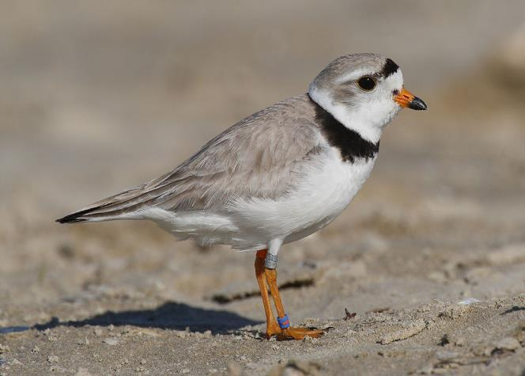
Source: Wikipedia: http://en.wikipedia.org/wiki/Piping_plover

Lesson 4: Piping Plovers
Map of Presque Isle State Park showing the Gull Point Special Management Area
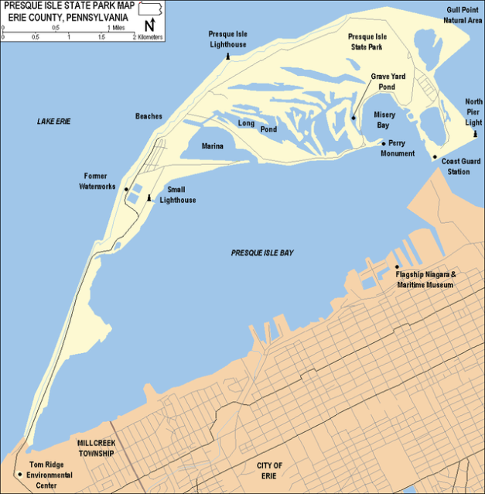
Source: Wikipedia: http://en.wikipedia.org/wiki/Presque_Isle_State_Park

Lesson 4: Independent Research Project: Piping Plover
Student Instructions

Directions: You are an intern for the Environmental Protection Agency (EPA). Your job is to evaluate two different plans that have been implemented to protect piping plovers in the United States. After investigating the success (or failure) of these plans, you must present pros and cons of these plans to the class. Following this, you must make your own plan to protect these birds. Review Rubric for grading guidelines.

Your Research Project can be in the form of:
  - essay
  - pamphlet
  - poster
  - digital presentation
  - video
  - podcast

The information compiled for your review should include:
Content Criteria:
- An overview of why piping plovers are considered endangered.
- What are the natural (abiotic and biotic) threats to the piping plover?
- What are the human threats to the piping plover?
- A food web of the piping plover’s ecosystem.
  - Include at least three organisms a piping plover eats and at least three organisms that depend on piping plovers for their food.
- An explanation of why the extinction of piping plovers would impact the whole ecosystem.
- A description of two plans used to protect the piping plovers including:
  - What is the plan?
  - Explain the benefits and limitations for each solution.
  - Did this plan increase the population of piping plovers in that area?
  - How much did it cost to implement this plan?
  - Who ensures that this plan is followed?
- Your suggestion and recommendations to protect the recently found pair of piping plovers. Explain the benefits and limitations for each solution.

Form Criteria:
- Provide evidence to support your claims with logical reasoning.
- All sources should be cited correctly.
- There should be no grammatical, spelling or punctuation errors.

Piping Plover Websites for Student Research
Plans for Students to Review:
  - U.S. Fish & Wildlife Service Recovery Plan for the Great Lakes Piping Plover: http://www.fws.gov/northeast/nyfo/es/GLplover03.pdf
  - U.S. Fish & Wildlife Service Recovery Plan for the Atlantic Coast Piping Plover: http://www.fws.gov/northeast/pipingplover/recovery.html
  - U.S. Fish & Wildlife Service Recovery Plan for the Northern Great Plains Piping Plover:
http://www.fws.gov/mountain-prairie/species/birds/pipingplover/
Additional Websites:
- Audubon: Interactive Map: A Year in the Life of a Piping Plover:
http://web4.audubon.org/plover/
- U.S. Fish and Wildlife Service: Piping Plover site for the Atlantic Coast Population: http://www.fws.gov/northeast/pipingplover/
- U.S. Fish and Wildlife Service: Atlantic Piping Plover Fact sheet: http://www.fws.gov/northeast/pipingplover/pdf/plover.pdf
- Encyclopedia of Life: Piping Plovers: http://eol.org/pages/1049343/overview
- (IUCN) International Union for Conservation of Nature and Natural Resources http://www.iucnredlist.org/details/summary/22693811/0
- U.S. Fish and Wildlife Service Species Profile of the three populations of Piping Plover in North America:
https://ecos.fws.gov/ecp0/profile/speciesProfile?spcode=B079

Lesson 4: Independent Research Report: Piping Plovers

Name ___________________________________________________________
 |  | Exceeds Expectations | Meets Expectations | Approaches Expectations | Does Not Meet Expectations
Content | An overview of why piping plovers are considered endangered is clearly stated (including the natural and human threats to piping plover) and evidence provided. | 4 | 3 | 2 | 1
 | A food web of the piping plover’s ecosystem that includes at least three organisms a piping plover eats and at least three organisms that depend on piping plovers for their food. | 4 | 3 | 2 | 1
 | Provides an explanation of why the extinction of the piping plover would impact the entire ecosystem. | 4 | 3 | 2 | 1
 | Compares different solutions to protecting the piping plover. The benefits and limitations of each solution are discussed. Explains why benefits outweigh the limitations for this solution compared to the other solutions. | 4 | 3 | 2 | 1
 | Presents a recommendation for a new plan that provides evidence to support the claims with logical reasoning, using accurate and credible sources. | 4 | 3 | 2 | 1
Mechanics | No grammatical, spelling or punctuation errors. | 4 | 3 | 2 | 1
Organization | Information is very organized and clearly articulates the pros and cons of issue. | 4 | 3 | 2 | 1
Presentation | Clearly and effectively structured. Student speaks clearly and addresses the audience. The flow of the presentation is orderly and the sequence of evidence supports their claim. | 4 | 3 | 2 | 1
 | Uses appropriate academic language and clearly expresses ideas. | 4 | 3 | 2 | 1
Score ________________________
CEPA: Case Study: Great Barrier Reef, Australia
Student Instructions

Performance Task: You will read the Case Study: Great Barrier Reef, Australia Information Handout and use the internet to research management strategies for the reef.
After you have finished reading, complete the individual piece of the Case Study: Great Barrier Reef, Australia worksheet questions 1-4. You will then work in groups to evaluate different design solutions for protecting an ecosystem and discuss benefits and limitations of each design based on your species. Your group will present your findings including the benefits and limitations of each solution to the class.

Goal: Your goal is to learn about the Great Barrier Reef and explain factors that have contributed to environmental changes providing evidence to support your claims with logical reasoning . You will then evaluate the different design solutions for protecting an ecosystem from the crown-of-thorns sea stars on the Great Barrier Reef. You will evaluate multiple solutions for controlling the species and present in small groups your recommendation for the best solution (including the benefits and limitations) to the class.

Role: You are biologists hired by the town conservation committee.

Audience: Town conservation committee (class)

Situation: The town has become aware of potential problems along the reef. They have asked you to research the reef and the environmental changes and then choose a solution for controlling the crown-of-thorns sea star on the Great Barrier Reef. You will then present an argument to the committee (class) why your solution is the best option by using evidence to explain why the benefits outweigh the limitations.

Product Performance and Purpose: Prepare a scientific argument for the town conservation committee in favor of a particular solution. Present this solution in front of the committee that includes your reasoning, evidence and credible sources. You will have the opportunity to engage with the audience. Be prepared to answer their questions.

Individual Work Directions:
- Read the Case Study: Great Barrier Reef, Australia Information Handout and use the internet to research management strategies for the reef.
- After you have finished your research, complete questions 1-4 of the Case Study: Great Barrier Reef, Australia worksheet.

Group Work Directions:
Part 1:
- Discuss your findings from your individual research with your small group.
- Answer question 5 on your worksheet.
- Brainstorm with your group recommendations the different solutions for managing the crown-of-thorns sea star (including the benefits and limitations)
- Work with your group to complete the table (question 5) with the following information:
  - Write down your solutions for managing the crown-of-thorns sea star.
  - Determine if each solution is appropriate and reasonable and write yes or no in the second column.
  - For each of the solutions you identified as appropriate, list the benefits of the solution in column three and the limitations in column five.
  - Assign a value from 1-5 for each benefit, where 1 = not beneficial and 5 = very beneficial.
  - Assign a value from 1-5 for each limitation, where 1 = minimal cost and 5 = high cost.

Part 2:
- After completing the table, work with your group to identify the most effective solution.
- Create a presentation that clearly states your claim and gives evidence to support your claim. See rubric for expectations.
- Present your presentation to the committee (class). Be prepared to defend your reasoning to the audience.

CEPA: Case Study: Great Barrier Reef, Australia
Information Handout
Introduction
The Great Barrier Reef along northeastern Australia supports more than 300 species of reef-building or hard corals. Light, water clarity (how clear the water is), and temperature all help determine where reef-building coral grows. The corals occupy a band between 30ºN and 30ºS latitude and grow in shallow regions of the tropical and subtropical western Atlantic and Indo-Pacific oceans. Coral reefs form highly diverse habitats that provide sanctuary to hundreds of species of fish and invertebrates. Sixty-five percent of marine fish live in or near coral reefs because this habitat provides shelter and food. A few organisms, including various marine snails, fish, and sea stars, prey on coral. The most aggressive predator on hard corals is the crown-of-thorns sea star.

Changes in water clarity, sea surface temperatures, and water quality resulting from the runoff of nitrates have led to declines in the amount of hard coral in the Great Barrier Reef.

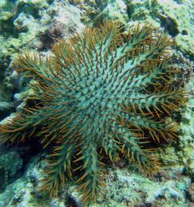
Crown-of-thorns sea star
Photo: NOAA Photo Library
Key Species
The crown-of-thorns sea star belongs to the phylum Echinodermata, which also includes sea urchins and sea cucumbers. Temperature and coral (a food resource) limit the distribution of this sea star. The crown-of-thorns sea star has a planktonic (microscopic, free-living) larval stage in which its larvae move along with the currents. Many larvae die off in this stage, especially when their food source of phytoplankton (plant-like plankton) is low. The amount of phytoplankton available depends on the level of nutrients in the water. An increase in nutrients leads to an increase in phytoplankton (referred to as a “bloom”) and thus an increase in the survival rate of the crown-of-thorns sea star larvae. More larvae mean more adult sea stars on the Great Barrier Reef.

Habitat Data
- Phytoplankton concentrations have increased along coastal regions.
- Nutrient levels along the eastern coast of Australia have increased in areas adjacent to where major rivers drain into the ocean.
- Nutrient levels along the coast are higher during rainy seasons, when more water from rivers runs into the ocean.
- The survival of crown-of-thorn larvae increases during the wet season.
- Ocean currents along the eastern coast of Australia run from north to south.
- In eastern Australia, agriculture has increased over the past several decades:
- In the past 10 years, native vegetation has been replaced with crops planted for agriculture.
- The use of fertilizers is unregulated in the Australian agricultural industry.
- Fertilizers contain nutrients (nitrates and phosphates) that flow into rivers as runoff from farms.
- The banks of the major rivers along agricultural regions have been altered for irrigation, increasing the amount of runoff that flows into rivers.
- The size of the region where outbreaks of crown-of-thorns sea stars occur has increased over the past 10 years.
- Coral bleaching, or die-off, along the Great Barrier Reef has increased over the past 25 years.
Source: Australian Institute of Marine Science, www.aims.gov.au

Crown-of-Thorns Starfish Outbreaks Graph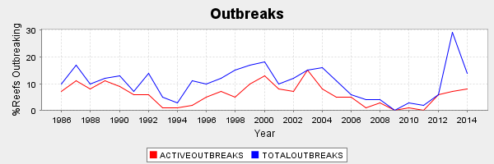

http://data.aims.gov.au/waCOTSPage/cotspage.jsp

Years When More Than 20% of Reefs Experienced Outbreaks (Between 1993–2003)

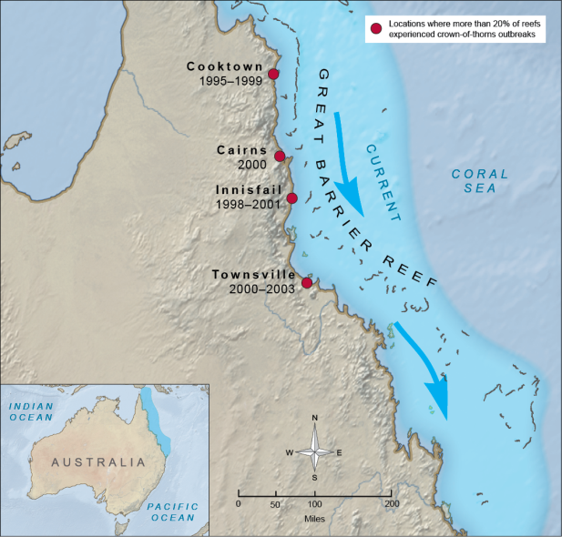

Scientist’s Observations: Great Barrier Reef, Australia

Most of the time few crown-of-thorns sea stars populate healthy coral reefs because most of this organism’s larvae die off instead of growing into adult sea stars. Outbreaks of crown-of-thorns sea stars have increased on Australian reefs due to a recent increase in larval survival. Larvae usually die because the phytoplankton, their favorite food, is often scarce. The recent increases in crown-of-thorn larval survival probably result from an increase in phytoplankton (microscopic plants). Scientists often use measurements of chlorophyll levels to calculate phytoplankton density. Some researchers have reported increased chlorophyll levels near crown-of-thorns sea star outbreaks. The researchers attribute the increase in phytoplankton to an increase in nutrient concentrations; for example, more phytoplankton grow when more nutrients are available in the water.

Researchers have also recorded a recent increase in nitrates in certain areas around the reefs. Agriculture, which often uses nitrate-containing fertilizers, is a common contributor of nitrates to water supplies. Surveys of land use along the main river near the reef areas containing increased phytoplankton indicate that brush has been cleared there for agriculture. Clearing and conversion of the land to agricultural production has resulted in the increased use of nitrates in the form of fertilizers. Without the roots of brush plants to hold the soil in place and protect it from rainfall, increased runoff from agriculture has resulted in higher levels of nutrients in the water. Consequently, phytoplankton continue to bloom, leading to an increase in crown-of-thorn sea stars.

Visit the following the websites to learn more about the management of the reef:
- Australian Government, Great Barrier Reef Marine Park Authority:
  - Management Strategy: http://www.gbrmpa.gov.au/about-the-reef/animals/crown-of-thorns-starfish/what-is-the-short-term-strategy
  - Crown -of-thorns sea star: http://www.gbrmpa.gov.au/about-the-reef/animals/crown-of-thorns-starfish

- Reef Resilience, Crown -of-thorns sea star:
http://www.reefresilience.org/coral-reefs/stressors/predator-outbreaks/crown-of-thorns-starfish/

- CRC -Reef Research Centre
http://rrrc.org.au/wp-content/uploads/2014/11/RRRC-COTS-IPM-Strategy-Factsheet2.pdf

CEPA: Case Study: Great Barrier Reef, Australia
Student Worksheet
Name: __________________________________________________ Date: ______________________
Directions: Use the information provided in Case Study: Great Barrier Reef, Australia handout and additional websites to complete the following chart and answer the questions below.
- Individual Work
Changes to the Environment | Cause: Natural Factor or Human Activity | Effects on Species

- Recommendations for Management of crown-of-thorns sea star. What are some of the benefits and limitations of each solution?

- Identify and describe the effects natural and human factors that have affected the survival of the population of coral in the Great Barrier Reef.

- What would be the long-term effects if a large population of crown-of-thorns sea stars continues to eat the coral? What adaptations might allow coral to survive and avoid local extinction?

Group Work
- Work with your group to complete the table with the following information:
  - Write down your solutions for managing the crown-of-thorns sea star.
  - Determine if each solution is appropriate and reasonable and write yes or no in the second column.
  - For each of the solutions you identified as appropriate, list the benefits of the solution in column three and the limitations in column five.
  - Assign a value from 1-5 for each benefit, where 1 = not beneficial and 5 = very beneficial.
  - Assign a value from 1-5 for each limitation, where 1 = minimal cost and 5 = high cost

Solutions | Can this solution work for your invasive species? (yes/no) | Benefits | Total Points | Limitations/Costs | Total Points

CEPA: Case Study: Great Barrier Reef, Australia Rubric
Name _____________________________________________________
 | Exceeds Expectations (4) | Meets Expectations (3) | Approaches Expectations (2) | Does Not Meet Expectations(1)
Content:  MS-LS2-5. Evaluate competing design solutions for protecting an ecosystem. Discuss benefits and limitations of each design.* | Benefits and limitations of each solution are discussed. Uses evidence and explains in detail with evidence why the benefits outweigh the limitations for this solution compared to the other solutions for protecting the Great Barrier Reef.  Makes connections between the background research and the benefits and limitations. | Benefits and limitations of each solution are discussed. Uses evidence to explain why the benefits outweigh the limitations for this solution compared to the other solutions for protecting the Great Barrier Reef.  Makes connections between the background research and the benefits and limitations. | Benefits and limitations of each solution are somewhat discussed. Uses little evidence to explain why the benefits outweigh the limitations for this solution compared to the other solutions for protecting the Great Barrier Reef.  Makes incomplete connections between the background research and the benefits and limitations. | Benefits and limitations of each solution are not discussed. Uses little evidence to explain why the benefits outweigh the limitations for this solution compared to the other solutions for protecting the Great Barrier Reef.  Makes incomplete or does not make any connections between the background research and the benefits and limitations.
Content:  MS-LS2-4. Analyze data to provide evidence that disruptions (natural or human-made) to any physical or biological component of an ecosystem can lead to shifts in all its populations. | Identifies and describes in detail (using data and evidence) how coral reef populations have been affected (both nautal and human-made) by crown-of-thorn sea stars. Describes the long-term effects to the ecosystem. | Identifies and describes (using data and evidence) how coral reef populations have been affected (both nautal and human-made) by crown-of-thorn sea stars. Describes the long-term effects to the ecosystem. | Identifies and/or describes (using data and evidence) how coral reef populations have been affected (nautal and/or human-made) by crown-of-thorn sea stars. Gives incomplete description of the long-term effects to the ecosystem. | Does not identify and/or describe (using data and evidence) how coral reef populations have been affected (nautal and/or human-made) by crown-of-thorn sea stars. Gives incomplete or no description of the long-term effects to the ecosystem.
Science Content and Vocabulary  The writer demonstrates an understanding of the topic and uses scientific vocabulary appropriately | Demonstrates a deep, sophisticated understanding of the topic and use advanced scientific vocabulary appropriately and accurately throughout the argument | Demonstrates a deep understanding of the topic and use scientific vocabulary appropriately and accurately throughout the argument | Demonstrates a fairly accurate understanding of the topic and use scientific vocabulary appropriately and accurately in some places in the argument | Does not demonstrate an understanding of the topic and does not use scientific vocabulary appropriately or accurately in the argument
ELA/Literacy:  WHST.6-8. 1. Write arguments focused on discipline-specific content. | The reasoning demonstrates understanding that is beyond grade level expectations.  A clear arguable claim is made about best solutions for managing crown-of-thorn sea stars.  Relevant and sufficient evidence is provided from accurate, reliable sources to support the claim(s) and counterclaims.  Logical reasoning is provided to link the claim and the evidence. | A clear arguable claim is made about best solutions for managing crown-of-thorn sea stars.  Relevant and sufficient evidence is provided from accurate, reliable sources to support the claim(s) and counterclaims.  Logical reasoning is provided to link the claim and the evidence. | An incomplete or unclear claim is made about best solutions for managing crown-of-thorn sea stars.  Provides relevant, but insufficient evidence to support the claim(s) and counterclaims.  Most of the evidence is from accurate, reliable sources.  Provides weak reasoning to link the claim and evidence. | Does not make a claim or the claim is not relevant to the best solutions for managing crown-of-thorn sea stars.  Does not provide evidence to support the claim or only provides evidence that is not relevant or is unreliable.  Does not provide logical reasoning to connect the claim and evidence, or provides inappropriate reasoning.
Presentation Structure and Flow | Clearly and effectively structured. Students take turns speaking; they speak clearly, and address the audience. The flow of the presentation is orderly and the sequence of evidence supports their claim. | Clearly and mostly effectively structured. Students mostly take turns speaking; they address the audience. The flow of the presentation is orderly and the sequence of evidence supports their claim. | Presentation is not clearly structured. Students mostly take turns speaking; they address the audience. The flow of the presentation is out of order and the sequence of evidence supports their claim. | Presentation is not clearly structured. Students do not take turns speaking; they address the audience. The flow of the presentation is out of order and the sequence of evidence does not support their claim.

Score ________________________

