Thermal Energy Design Challenges
Technology/Engineering & Physical Science, Grade 7 (Revised July 2018)
Standards addressed in this unit:
7.MS-ETS1-2. Evaluate competing solutions to a given design problem using a decision matrix to determine how well each meets the criteria and constraints for the problem. Use a model of each solution to evaluate how variations in one or more design features, including size, shape weight, or cost, may affect the function or effectiveness of the solution.*
7.MS-ETS1-4. Generate and analyze data from iterative testing and modification of a proposed object, tool, or process to optimize the object, tool, or process for its intended purpose.*
7.MS-ETS1-7(MA). Construct a prototype of a solution to given design problem.*
7.MS-PS3-3. Apply scientific principles of energy and heat transfer to design, construct, and test a device to minimize or maximize thermal energy transfer.* Clarification Statement: Examples of devices could include an insulated box, a solar cooker, and a vacuum flask. State Assessment Boundary: Accounting for specific heat or calculations of the total amount of thermal energy transferred is not expected in state assessment.

Students work together to build, test, and refine both models and prototypes of solutions to several design challenges that utilize principles of heat transfer. Students develop increasingly sophisticated understandings of engineering design, including the development of models and prototypes, the evaluation of competing design solutions, the impact of changing design features, and the iterative testing based on data analysis, all in the context of applying principles of thermal energy transfer. Students learn how to keep careful records, write technical text, and communicate their designs and process.

This Model Curriculum Unit is designed to illustrate effective curriculum that lead to expectations outlined in the 2016 Science and Technology/Engineering Curriculum Frameworks (www.doe.mass.edu/STEM/STE) as well as the MA Curriculum Frameworks for English Language Arts/Literacy and Mathematics. This unit includes lesson plans, a Curriculum Embedded Performance Assessment (CEPA), and related resources. In using this unit it is important to consider the variability of learners in your class and make adaptations as necessary.

This document was prepared by the Massachusetts Department of Elementary and Secondary Education. Mitchell D. Chester, Ed.D., Commissioner

The Massachusetts Department of Elementary and Secondary Education, an affirmative action employer, is committed to ensuring that all of its programs and facilities are accessible to all members of the public. We do not discriminate on the basis of age color, disability, national origin, race, religion, sex, or sexual orientation.

© 2015 Massachusetts Department of Elementary and Secondary Education (ESE). ESE grants permission to use the material it has created under the terms of the Creative Commons Attribution-NonCommercial-ShareAlike 3.0 Unported License. Additionally, the unit may also contain other third party material used with permission of the copyright holder. Please see Image and Text Credits for specific information regarding third copyrights.

Image and Text Credits:
Page 8: Source: Design Squad TM / WGBH Educational Foundation.
Page 46: Box Cooker and Parabolic Cooker images: From HowStuffWorks.com, 2009, © 2009 HowStuffWorks.com. All rights reserved. Used by permission and protected by the Copyright Laws of the United States. The printing, copying, redistribution, or retransmission of the Content without express written permission is prohibited.
Page 46: Solar Cooker image. Courtesy Solar Cooker at Cantina West.
Page 49: Micron: Source: http://images.thecarconnection.com/lrg/micron-urban-electric-car-2011-geneva-motor-show_100343158_l.jpg
Page 50: Lamborghini Huracan scale model: Courtesy MR COLLECTION MODELS S.r.l.
Page 50: Lamborghini Huracan Prototype: http://www.lambocars.com/huracan/; and http://www.lambocars.com/lambonews/lamborghini_huracan_scale_model_in_the_making.html
Page 52: Simple Water Heater: Source: http://www.reuk.co.uk/Simple-Solar-Water-Heating.htm
Page 53: Concentrated Water Heater: Source: http://www.reuk.co.uk/Build-a-Concentrated-Solar-Water-Heater.htm.
Page 54: Flat Plate Collector Solar Water Heater: Source: http://www.reuk.co.uk/DIY-Solar-Water-Heating-Prototype.htm
Page 55: Geothermal Heat Pump 1: Source: http://www.diymanager.com/green/Companies/energyinstallations/groundheatpumps/index.php

[continued on following page]
The contents of this Model Curriculum Unit were developed under a grant from the U.S. Department of Education. However, those contents do not necessarily represent the policy of the U.S. Department of Education, and you should not assume endorsement by the Federal Government.
Massachusetts Department of Elementary and Secondary Education, 75 Pleasant St, Malden, MA 02148-4906. Phone 781-338-3300, TTY: N.E.T. Relay 800-439-2370, www.doe.mass.edu

Table of Contents

Unit Assumptions and Comments on Sequence 5
Overview of Engineering Design 9
Unit Plan 10
Lesson 1: Solar Oven Design Challenge: Pre-assessment and Documentation of an Engineering Process 14
Lesson 2: Models and Prototypes 20
Lesson 3: Lunar Hot Water Heater Challenge: Design Evaluation and Prototyping 29
Lesson 4: Lunar Hot Water Heater Challenge: Iterative Testing and Redesign 37
Curriculum Embedded Performance Assessment (CEPA): Space Suit Design Challenge 43
Unit Resources 47

Unit Assumptions and Comments on Sequence
This unit should follow a unit or units that address Standards 7.MS-PS3-4 and 7.MS-PS3-6, the Basics of Energy Transfer, as well as other pre-requisite knowledge outlined below, particularly the understanding of engineering design in earlier grades. This unit contributes to later applications of engineering design in grade 7, in the context of ecosystems, and to high school engineering design units. See the strand map on the next page.
Pre-Requisite Knowledge:
- 3.3-5-ETS1-2. Generate several possible solutions to a given design problem. Compare each solution based on how well each is likely to meet the criteria and constraints of the design problem.* Clarification Statement: Examples of design problems can include adapting a switch on a toy for children that have a motor coordination disability, designing a way to clear or collect debris or trash from a storm drain, or creating safe moveable playground equipment for a new recess game.
- 4.3-5-ETS1-3. Plan and carry out tests of one or more design features of a given model or prototype in which variables are controlled and failure points are considered to identify which features need to be improved. Apply the results of tests to redesign a model or prototype.* Clarification Statement: Examples of design features can include materials, size, shape, and weight.
- 4.3-5-ETS1-5(MA). Evaluate relevant design features that must be considered in building a model or prototype of a solution to a given design problem.*
- 6. MS-ETS1 -5(MA). Create visual representations of solutions to a design problem. Accurately interpret and apply scale and proportion to visual representations.* Clarification Statements: Examples of visual representations can include sketches, scaled drawings, and orthographic projections. Examples of scale can include ¼’’ = 1’0’’ and 1 cm = 1 m.
- 6.MS-ETS2-1(MA). Analyze and compare properties of metals, plastics, wood and ceramics, including flexibility, ductility, hardness, thermal conductivity, electrical conductivity, and melting point.
- 6.MS-ETS2-2(MA). Given a design task, select appropriate materials based on specific properties needed in the construction of a solution. Clarification Statement: Examples of materials can include metals, plastics, wood, and ceramics.
- 6.MS-ETS2-3(MA). Choose and safely use appropriate measuring tools, hand tools, fasteners and common hand-held power tools used to construct a prototype.* Clarification Statements: Examples of measuring tools include a tape measure, a meter stick, and a ruler. Examples of hand tools include a hammer, a screwdriver, a wrench and pliers. Examples of fasteners include nails, screws, nuts and bolts, staples, glue, and tape. Examples of common power tools include jigsaw, drill, and sander.
- 7.MS-PS3-4. Conduct an investigation to determine the relationships among the energy transferred, how well the type of matter retains or radiates heat, the mass, and the change in the average kinetic energy of the particles as measured by the temperature of the sample. State Assessment Boundary: Calculations of specific heat or the total amount of thermal energy transferred are not expected in state assessment.
- 7.MS-PS3-6(MA). Use a model to explain how thermal energy is transferred out of hotter regions or objects and into colder ones by convection, conduction and radiation.
- Students should be familiar with using a science journal/engineering notebook to record ideas, sketches, claims, evidence, data, analysis and conclusions.

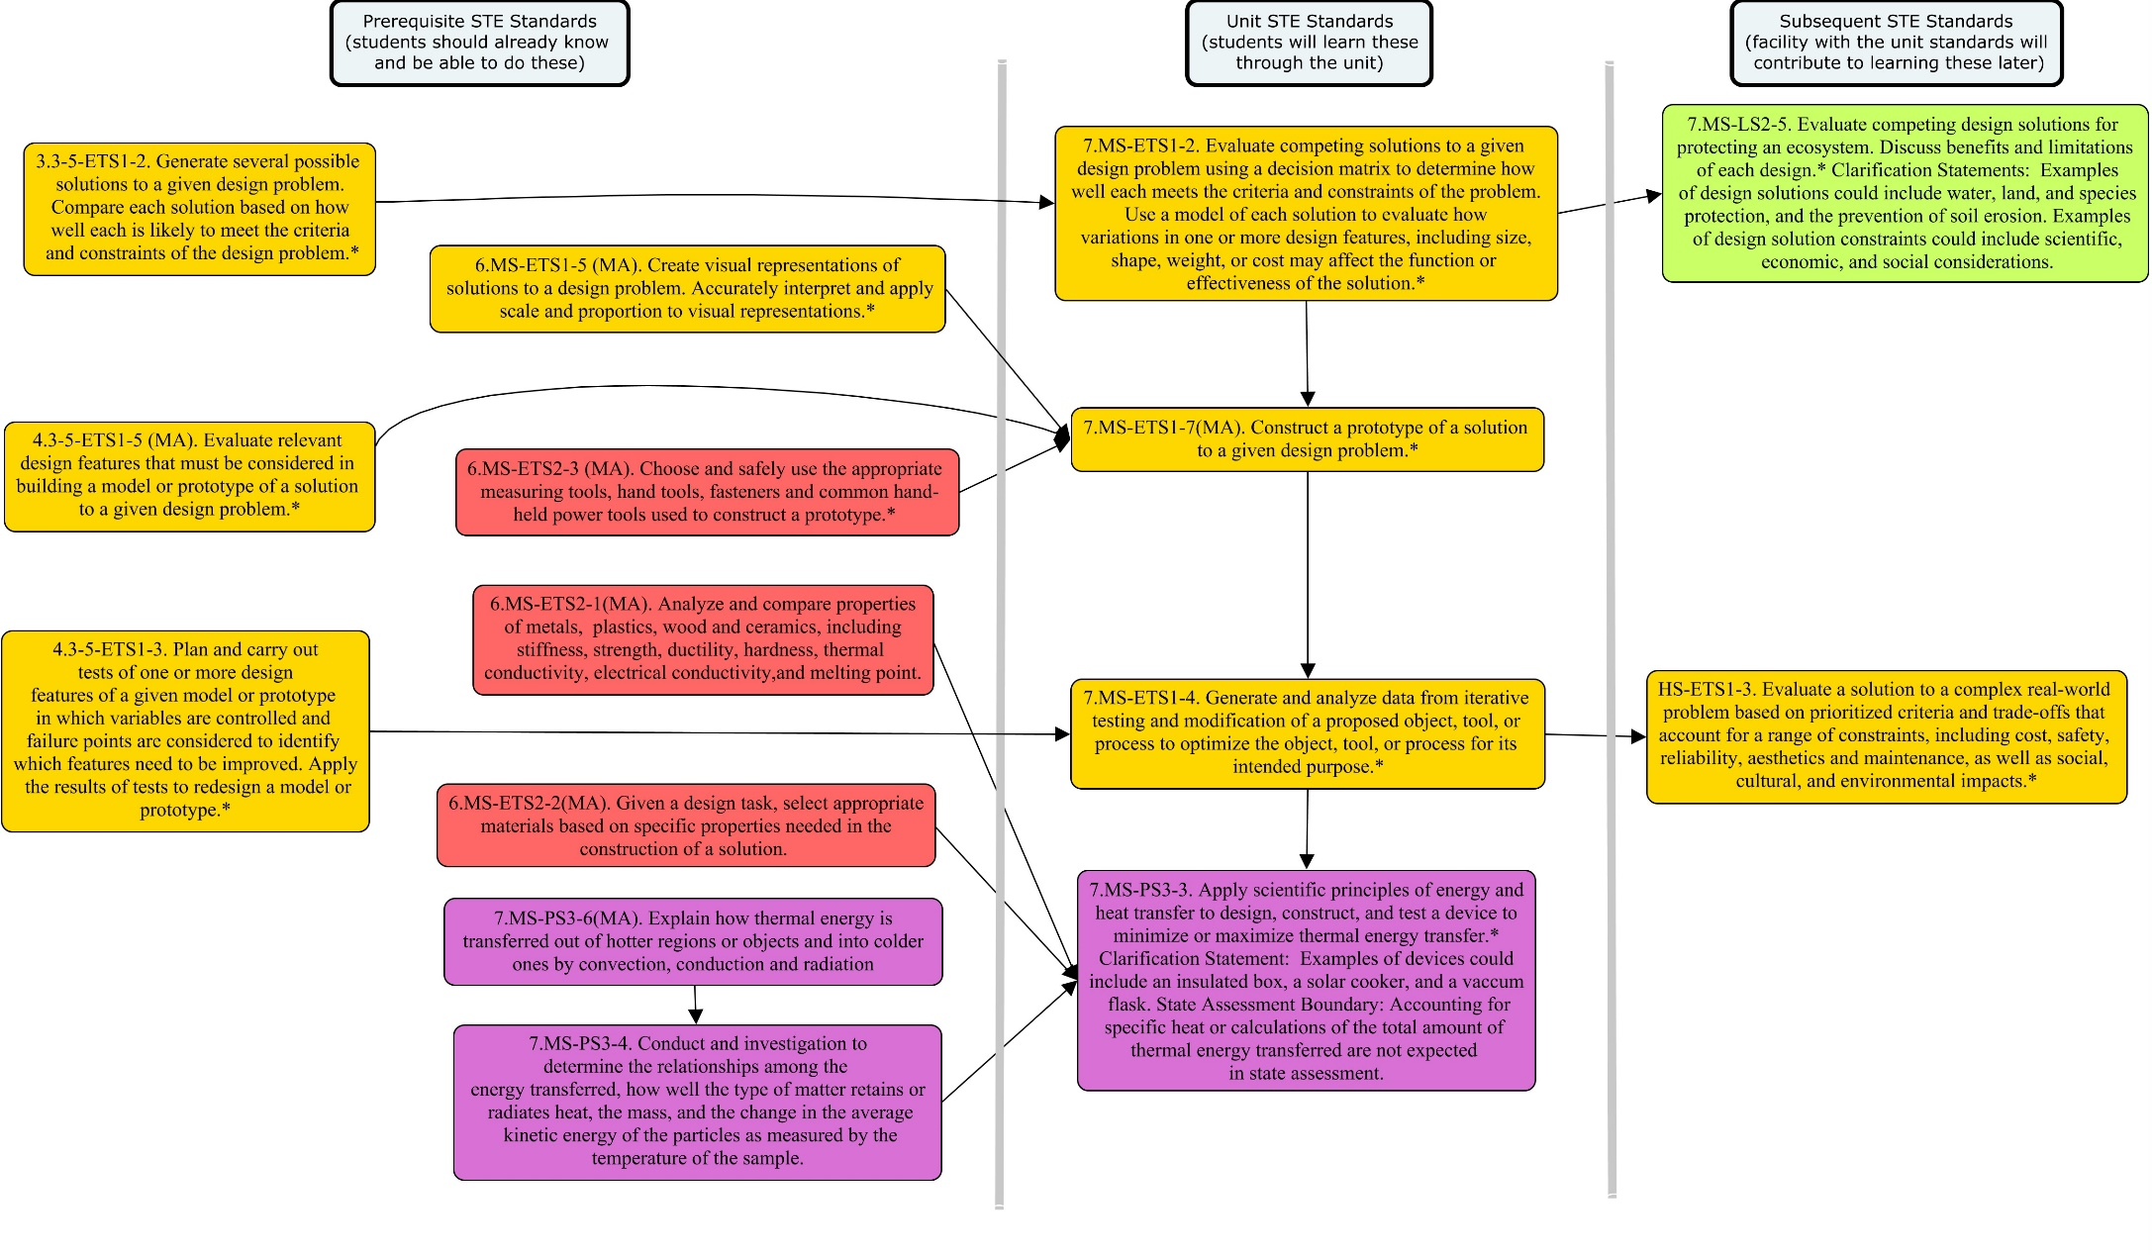

Throughout the unit, notes to the teacher are listed in the section, Instructional Tips/Strategies/Suggestions for Teacher. All handouts are located in Unit Resources at the end of the unit.

This unit makes use of several strategies and methodologies throughout:
- Design Challenges
Design challenges are a way to engage students in a relevant context that allows them to use a design process to solve a problem and apply their skills and knowledge. As students work through a challenge, they will see that the steps of engineering design encourage them to think creatively to solve a problem. Each challenge begins with an overview describing the context and goals. Design challenges should give students opportunities to collaborate and innovate as they create unique solutions. Reflection is a key part to any design challenge; students should be encouraged to identify the science concepts applied in their work, explain and rationalize their design choices, and reflect on how a design process encourages them to think creatively to design an effective product.

- Engineering Notebook
An engineering notebook is an important part of any research or engineering project. Used properly, the notebook contains a detailed and permanent account of every step of the project, from the initial brainstorming to the final data analysis and research report. Many projects require a number of steps and multiple trials. By recording the steps of the procedure, observations, and any questions that arise during the process, students create a record of the project that documents precisely what was done, when, and why. With a complete record of the project, students can look back if a question arises or if they decide to pursue a related project. Similarly, writing down the product design ideas, engineering challenges, and product testing data helps keep track of all of their ideas, what has been tested, and how well a particular design performed.

- Exit Ticket
At the end of class, students write on note cards or slips of paper one of the following: an important idea they learned, a question they have, a prediction about what will come next, or a thought about the lesson for the day. Alternatively, have students sumit such a response at the start of the next day either based on the learning from the day before or the previous night’s homework. These quick writes can be used to assess students’ knowledge or to make decisions about next teaching steps or points that need clarifying. Moreover, this reflection helps students focus as they enter the classroom and/or solidifies learning before they leave.

Exit Ticket Procedure:
- For 2–3 minutes at the end of class, or at the start of the next one, have students jot responses to the reading or lesson on 3 x 5 note cards.
- Keep the response options simple–“One thing you learned and one question you have.” If you have taught particular thinking strategies, such as connecting, summarizing, inferring, ask students to use them.
- A variation is known as 3-2-1: Have students write three of something, two of something, then one of something. For example, students might explain three things they learned, two areas in which they are confused, and one thing about which they would like to know more or one way the topic can be applied. The criteria for listing items is contingent upon the teacher and the requirements of the lesson, but it’s important to make the category for three items easier than the category for listing one item.
- Don’t let the cards become a grading burden. Glance over them for a quick assessment and to help you with planning for next learning needs. These are simply quick writes, not final drafts.
- After studying the “deck” you might pick-out a few typical/unique/thought-provoking cards to spark discussion.
- Cards could be typed up, maybe nameless, to share with the whole group to help with summarizing, synthesizing, or looking for important ideas. It is a good idea to let students know ahead of time as they may put more effort into the write-up. When typing, go ahead and edit for spelling and grammar.

Overview of Engineering Design
Modified from On the Moon, by Design Squad and NASA (http://www.nasa.gov/pdf/308966main_On_the_Moon.pdf ).
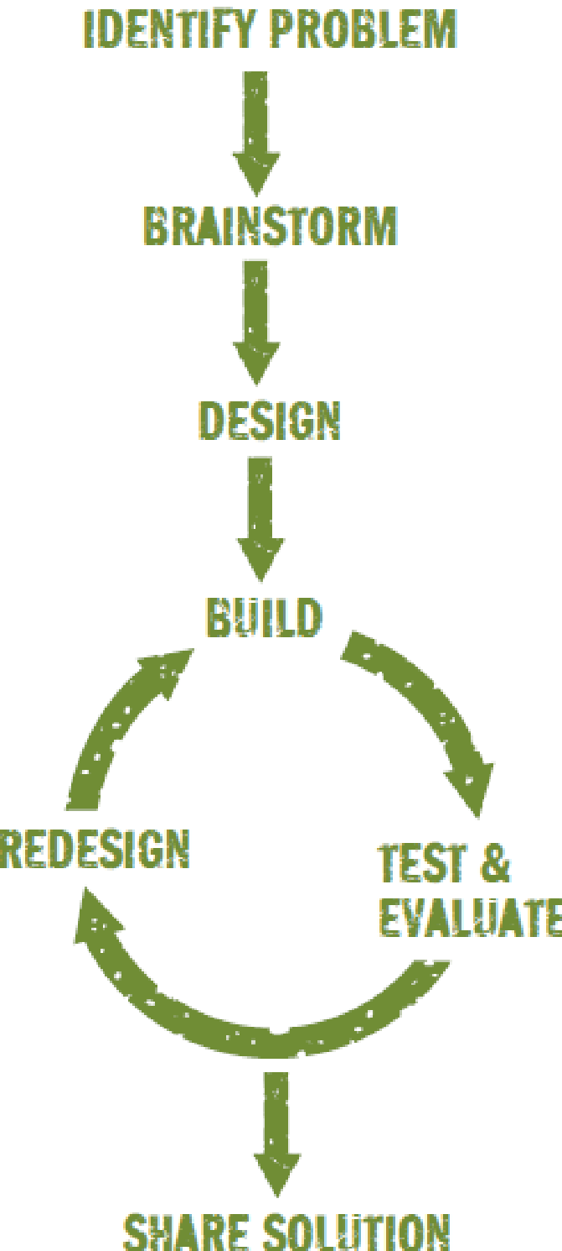
When NASA engineers try to solve a problem, their initial ideas rarely work out perfectly. Like all engineers, they try different ideas, learn from mistakes, and try again. A series of steps engineers use to arrive at a solution is called a design process. As students work through a challenge, use questions such as the ones below to talk about their work and tie what they are doing to components of a design process.
Brainstorming
- At this stage, all ideas are welcome, and criticism is not allowed.
- What are some different ways to start tackling today’s challenge?
Designing
- Talk through the brainstormed ideas. What’s really possible given your time, tools, and materials?
- What specific goal are you trying to achieve, and how will you know if you’ve been successful?
- What are some problems you’ll need to solve as you build your project?
- What are the design criteria and constraints that need to be met?
Building, Testing, Evaluating, and Redesigning
- Does your design meet the goal set out in the challenge?
- Why do you have to test something a few times before getting it to work the way you want?
- What can you learn from looking at other students’ projects and discussing them?
Sharing Solutions
- What were the different steps you had to do to get your project to work the way you wanted?
- What do you think is the best feature of your design? Why?
- What are some things everyone’s designs have in common?
- If you had more time, how could you improve your design?

Unit Plan
Stage 1 Desired Results
ESTABLISHED GOALS G  7.MS-ETS1-2. Evaluate competing solutions to a given design problem using a decision matrix to determine how well each meets the criteria and constraints for the problem. Use a model of each solution to evaluate how variations in one or more design features, including size, shape weight, or cost, may affect the function or effectiveness of the solution.*  7.MS-ETS1-4. Generate and analyze data from iterative testing and modification of a proposed object, tool, or process to optimize the object, tool, or process for its intended purpose.*  7.MS-ETS1-7(MA). Construct a prototype of a solution to given design problem.*  7.MS-PS3-3. Apply scientific principles of energy and heat transfer to design, construct, and test a device to minimize or maximize thermal energy transfer.* Clarification Statement: Examples of devices could include an insulated box, a solar cooker, and a vacuum flask. State Assessment Boundary: Accounting for specific heat or calculations of the total amount of thermal energy transferred is not expected in state assessment.  ELA/Literacy  6-8 WHST2. Write informative / explanatory texts, including narration of historical events, scientific procedures/experiments, or technical processes.  b. Develop the topic with relevant, well-chosen facts, definitions, concrete details, quotations, or other information and examples.  d. Use precise language and domain-specific vocabulary to inform about or explain the topic. | Transfer
Students will be able to independently use their learning to… T
Use principles of the physical world to assess designed products and systems based on social needs and wants.
 | Meaning
 | UNDERSTANDINGS U  Students will understand that…  - Engineering design is a collaborative and iterative process that can be used to solve real world problems.  - Engineers have to evaluate and consider constraints, tradeoffs and criteria when designing solutions.  - Engineering design decisions are based on testing, gathering and analyzing data and making modifications.  - Engineers communicate in writing using concrete details and precise language.  - Scientific principles of energy and heat transfer can be applied to minimize or maximize thermal energy transfer. | ESSENTIAL QUESTIONS Q  - How can you minimize or maximize thermal energy transfer to an object?  - How do we evaluate a design solution to see if it is effective?  - How do we develop the best possible design for our problem?
 | Acquisition
 | Students will know… K  - That a prototype or model is tested to determine how well the design meets the criteria and constraints.  - Successful designs are evaluated based upon specific criteria.  - Multiple trials are necessary to maximize the effectiveness of design.  - Differences between models and prototypes, their relative benefits and limitations when evaluating solutions.  - A claim about the effectiveness of a design solution requires evidence from testing or modeling.  - Transfer of thermal energy can be manipulated and used for particular purposes through design.  - Qualities of effective technical writing. | Students will be skilled at… S  - Collecting, recording and analyzing related and relevant data from their designs and iterative tests.  - Evaluating how variations in design options affect the effectiveness of design solutions.  - Evaluating multiple solutions for a design problem using a systemic process.  - Applying the scientific concepts of heat transfer to fulfill a design problem  - Giving specific design feedback both verbal and written.  - Designing, building and testing models and prototypes.  - Using test data to drive design improvements to solutions of a given challenge.  - Documenting the scientific concepts, test data and design processes used to a design solution through quality technical writing.
Stage 2 - Evidence
Evaluative Criteria | Assessment Evidence
(See CEPA rubric) | CURRICULUM EMBEDDED PERFORMANCE ASSESSMENT (CEPA) (PERFORMANCE TASKS) PT  Space Suit Design Challenge  Students are team leaders on a NASA project trying to design and build a space suit for astronauts going to the moon. Students will create a model of something to wear in a super cold environment that maintains a constant temperature. The final products are the model, as well as the Engineering Notebook that includes recording sheets, tested models, and any other artifacts students think are necessary. The Engineering Notebook should include a brief text that describes how their design evolved through at least three stages: beginning, intermediate, and final.
OTHER EVIDENCE: OE
Formative assessments
Engineering notebook – (teacher generated rubric)
-structure (reflection questions, data table/graph)
-labeled sketches of original design and modifications
-recording of results of experiments
- model of the water heater/ class compare and contrast models and graph data
- Evidence to establish different designs
Exit Tickets
Stage 3 – Learning Plan
Summary of Key Learning Events and Instruction
Lesson 1: Solar Oven Design Challenge: Pre-assessment and Documentation of an Engineering Process (One 60-minute class)
Students conduct an engineering design challenge to design and build a solar oven as a pre-assessment of engineering design and thermal energy transfer. Additionally, students document their process and building skills for writing technical texts.

Lesson 2: Models and Prototypes (Two 60-minute classes)
This lesson focuses on models and prototypes, their differences and similarities, and their relative benefits and limitations when designing and evaluating different solutions. Students review a number of different models and prototypes relevant to a range of problems. Students then review a few models that emphasize thermal energy transfer concepts to identify possible designs for a lunar hot water heater challenge. They evaluate several of the models to consider the benefits and limitations of each.

Lesson 3: Lunar Hot Water Heater Challenge: Design Evaluation and Prototyping (Two 60-minute classes)
Students use provided models as a basis to develop possible designs for a solar hot water heater for use on the Moon. They evaluate each then build a prototype of their best design solution. Students document their process and reasoning to develop their technical writing skills, including the use of evidence and reasoning in making claims and design decisions.

Lesson 4: Lunar Hot Water Heater Challenge: Iterative Testing and Redesign (Two 60-minute classes)
This lesson focuses on iterative testing and redesign of the prototypes to optimize the use of thermal energy principles. Students use their test results to improve their solar hot water heater to better meet design criteria and constraints. They make and document evidence-based claims about the effectiveness of their design and their redesign decisions.

CEPA: Space Suit Design Challenge (Two 60-minute classes)
Students construct a space suit that minimizes heat transfer for the Moon. Students use a capped flask with a thermometer to simulate a space suit and use materials to minimize its heat transfer. They use a Quality Assurance Form (QAF) to evaluate their model and a classmate’s model.

Understanding by Design®. © 2012 Grant Wiggins and Jay McTighe. Used with permission.

Lesson 1: Solar Oven Design Challenge: Pre-assessment and Documentation of an Engineering Process

Brief Overview of Lesson: Students conduct an engineering design challenge to design and build a solar oven as a pre-assessment of engineering design and thermal energy transfer. Additionally, students document their process and building skills for writing technical texts.

Prior Knowledge Required:
- See ‘What students should know and be able to do before starting this lesson’ section below

Estimated Time: One 60-minute class
Resources for Lesson:
- Chart paper
- Pre-assessment
- Solar Oven Design Challenge
- Solar Oven Engineering Guide
- Student Engineering Notebooks (or Science Journals)
- Design challenge materials (see below)

Standard(s)/Unit Goal(s) to be addressed in this lesson:
- 7.MS-PS3-3. Apply scientific principles of energy and heat transfer to design, construct, and test a device to minimize or maximize thermal energy transfer.* Clarification Statement: Examples of devices could include an insulated box, a solar cooker, and a vacuum flask. State Assessment Boundary: Accounting for specific heat or calculations of the total amount of thermal energy transferred is not expected in state assessment.

- 6-8 WHST 2. Write informative / explanatory texts, including narration of historical events, scientific procedures/experiments, or technical processes. b.) Develop the topic with relevant, well-chosen facts, definitions, concrete details, quotations, or other information and examples. d.) Use precise language and domain-specific vocabulary to inform about or explain the topic.

Essential Question addressed in this lesson:
- How can you minimize or maximize thermal energy transfer to an object?

Objectives:
- Students will be able to pre-assess their understanding of engineering design and thermal energy transfer concepts.
- Students will be able to apply thermal energy transfer concepts to a design challenge.
- Students will be able to write technical text using precise language and concrete details to document a design process.

Language Objectives:
- Orally discuss design ideas in small groups
- Write a reflection of their design experience in their engineering notebook

Targeted Academic Language:
- Thermal Energy
- Convection
- Conduction
- Radiation

What students should know and be able to do before starting this lesson:
- Basic process of engineering design
  - Select appropriate materials based on specific properties needed in the construction of a solution.
  - Build a basic design using everyday materials.
- Basic concepts of thermal energy transfer by convection, conduction and radiation.
- Read a thermometer, record and graph data.
- Use a science journal/engineering notebook to record ideas, sketches, claims, evidence, data, analysis and conclusions.

Anticipated Student Preconceptions/Misconceptions:
- Students may believe that only things that are warm or hot have thermal energy.
- Students may believe that heat only travels upward (heat rises).
- Students may believe cold is transferred from one object to another.
- Students may believe that design is coming up with good ideas, and that’s all. They may not realize, or forget about, the rest of an engineering design process – how to realize these ideas and evaluate them.
- Students may focus only on the function or the structure of a design and have difficulty moving between them in a constructive manner.
- Students may believe that design is a linear, step-by-step process, while ignoring iterative cycles, revisiting past decisions, and evaluating alternatives.
- Students may believe that there is only one “right answer” to a design challenge.

Instructional Materials/Resources/Tools:
- See ‘Resources for Lesson’ above.
- Design Challenge Materials (per team or station)
  - Thermometer
  - Timer
  - Cardboard box
  - Aluminum pan
  - Aluminum foil
  - Black construction paper
  - Plastic wrap big enough to cover the box (or Plexiglass - optional)
  - Gooseneck lamp with 100 W bulb (optional if using sunlight)
  - Oven mitts
  - S‘mores fixings (graham crackers, marshmallows and chocolate)

Instructional Tips/Strategies/Suggestions for Teacher:
- Assign teams of 3-4 students. Arrange the class so the teams of 3-4 students can work together at one workstation.
- During the challenge, students/teams may ask questions and help each other, but in the end, each team must create its own oven.
- As students engage in the challenge, actively check and monitor for understanding of both engineering design and energy transfer concepts.
- Continually encourage and model good documentation in the notebook: precise language, specific vocabulary, well-chosen facts, concrete details and examples. Support students in checking and refining their writing of their process. Actively encourage revision of their writing so that they develop a clear technical description of their process. Other students should be able to read their process and be able to follow it. Not every student will have the same process as it depends on how they go about their design and testing.
- If there is time, students may make minor adjustments and/or retest their oven, documenting design changes and testing results each time.
- Review the engineering notebook after the class; use your review to inform any adjustments to the rest of the lessons in the unit.
- Designate a space to store the teams’ solar ovens at the end of the class.
- Solar oven build directions can be found at: http://climatekids.nasa.gov/smores/. See additional resources in the Unit Resources section.
- Technical writing is a concise, informative, analytical, and primarily STEM-based style of writing that helps convey ideas, processes, analysis, and more. For more on technical writing, see page 22.

Assessment:
- During the lesson, assess students’ ability to complete an engineering design process and apply their knowledge of thermal energy transfer. Review their notebook entries for understanding of each as well as the quality of their technical writing. Particularly focus on their responses to the research questions, documentation of their design decisions and rationales, and reflection questions.

Lesson Details:
Lesson Opening: 10 minutes
- Give a few examples of where principles of thermal energy transfer are used in our lives and how important their application is for us. Ask students to consider/brainstorm thoughts about the Essential Question: How can you minimize or maximize thermal energy transfer to an object? Consider how it might be different if we were trying to cook on the Moon rather than here on Earth. Record responses to the Essential Question and Moon considerations on chart paper.
- Hand out a formative assessment, “What does the Design Engineering process include?” or “Create a graphic illustration/drawing of the Design Engineering process.” Give students five minutes to complete. Collect and review.

During the Lesson: 40 minutes
10 minutes:
- Hand out the Solar Oven Design Challenge and the Solar Oven Engineering Guide. Read the Design Challenge Introduction (Can we cook while on the Moon?) as a class. Review the challenge, including the criteria and constraints:
- It must have a “footprint” of no more than 40 cm x 40 cm.
- In 10 minutes, the temperature inside the box must increase by 10˚ C.
- You may use any available materials to line the bottom and inside of box.
- Your food may not touch the bottom of the oven directly.
- Documentation is a critical component of today’s design challenge. Remind students that the success of their solar oven is just one aspect of today’s lesson; what we are most interested in today is how and why they make their design decisions and that they document their process and results. Have students use the Solar Oven Engineering Guide to write their problem statement and criteria in their Engineering Notebook. Ask if there are any questions about the task.
- Review the Research section and ask students to write responses to questions #1-3 in their Engineering Notebook. Emphasize the use of specific vocabulary and examples. Work with students to set up the Design Log to record their process and Data Table to record their test results in their Engineering Notebook. These can be copied and glued or taped into their notebooks to save time, if needed.
15 minutes:
- Tell students they will be designing, building, and testing a solar oven using only the materials provided. They will have 15 minutes to use whatever resources they have. Read the ‘Design and Build’ section aloud. Emphasize that as they go through the process of designing and building their team’s solar oven, they each document their design process by noting key design decisions and the reason each choice was made. These are recorded on the two-column table in their Engineering Notebook (see the Design Process section). Encourage use of precise language and labeled images.
- Before students can test their oven, review the documentation of their process for clarity, completeness, inclusion of reasons for design decisions, and use of precise language, e.g. specific vocabulary, well-chosen facts, concrete details and examples. Ask for revision or refinement if it is not sufficiently done to be completed before testing can be conducted.
15 minutes:
- Once the oven is built and design decisions documented, students should place a S‘more and the thermometer in the box and close the plastic wrap lid. Place the box in front of the gooseneck lamp with the 100W bulb or set it in direct sunlight – they may have to tilt the box so that there are no shadows inside. Students record their data and observations in their notebook. Encourage use of precise language and labels. Students should use oven mitts when moving the lid or removing items from the solar oven once exposed to the sun or gooseneck lamp.
- When testing is done, each group cleans up their materials and stores their oven.
- Each group then reflects on the success or failure of their design and considers different ways to make their design better. Refer them to the reflection questions in the “Ideas for Redesign” section. They need to document their reflections and redesign ideas in their notebooks; however, they will not have time to actually do the redesign and retest.
Lesson Closing: 10 minutes
- Review features of the students’ Engineering Notebook; highlight a few examples of high-quality technical writing, including the use of precise vocabulary, features of sketches, and documentation of process steps with reasons for particular decisions.
- Students hand in their Engineering Notebook.

Lesson 2: Models and Prototypes
Brief Overview of Lesson: This lesson focuses on models and prototypes, their differences and similarities, and their relative benefits and limitations when designing and evaluating different solutions. Students review a number of different models and prototypes relevant to a range of problems. Students then review a few models that emphasize thermal energy transfer concepts to identify possible designs for a lunar hot water heater challenge. They evaluate several of the models to consider the benefits and limitations of each.
Prior Knowledge Required:
- See ‘What students should know and be able to do before starting this lesson’ section below

Estimated Time: Two 60-minute classes
Resources for Lesson:
- Student Engineering Notebook
- Chart paper
- Examples of Models and Prototypes handout
- Hot Water Heater Design Features, Benefits and Limitations Handout
- Internet connection and projector (optional)
- Exit Tickets
  - Day 1 - What is the key difference between a model and a prototype?
  - Day 2 - Record two key differences between a model and a prototype.

Standard(s)/Unit Goal(s) to be addressed in this lesson:
- 7.MS-ETS 1-2. Evaluate competing solutions to a given design problem using a decision matrix to determine how well each meets the criteria and constraints for the problem. Use a model of each solution to evaluate how variations in one or more design features, including size, shape weight, or cost, may affect the function or effectiveness of the solution.*
- 7.MS-ETS1-7(MA) Construct a prototype of a solution to given design problem.*

Essential Question(s) addressed in this lesson:
- How do we evaluate a design solution to see if it is effective?

Objectives:
- Students will be able to identify models and prototypes and describe their relative benefits and limitations when evaluating solutions.
- Students will be able to evaluate hot water heater designs that model thermal energy transfer processes.

Language Objectives
- Listen to student examples of technical writing and share observations orally.
- Write observed differences between models and prototypes.
- Orally discuss the design problem in small groups and orally share main ideas with the whole group.

Targeted Academic Language
- Model
- Prototype
- Function
- Scale
- Predictions
- Testing

What students should know and be able to do before starting this lesson:
- Be able to create visual representations of solutions to a design problem. (6.MS-ETS1-5(MA))
- Be able to explain how thermal energy is transferred out of hotter regions or objects and into colder ones by convection, conduction and radiation. (6.MS-PS3- 6(MA))
- Use a science journal/Engineering Notebook to record ideas, sketches, claims, evidence, data, analysis and conclusions

Anticipated Student Preconceptions/Misconceptions:
- Students may believe that models and prototypes are the same thing.
- Students may believe that models or prototypes are just smaller versions of the real thing or are the first build of any design.
- Students may believe that models and prototypes are always a three-dimensional object. Therefore, pictures, diagrams, graphs, written descriptions, abstract mathematical equations, conceptual models, software programs, etc. are not models or prototypes.
- Students may believe that only physical objects can be modeled or prototyped, or that events and processes cannot be modeled or prototyped.
- Students may believe that design is coming up with good ideas, and that’s all. They may not realize or forget about, the rest of an engineering design process, and how to realize these ideas and evaluate them.
- Students may focus only on the function or the structure of a design and have difficulty moving between them in a constructive manner.
- Students may believe that design is a linear, step-by-step process, while ignoring iterative cycles, revisiting past decisions, and evaluating alternatives.
- Students may believe that there is only one “right answer” to a design challenge.
- Students may believe that only things that are warm or hot have thermal energy.
- Students may believe that heat only travels upward (heat rises).
- Students may believe that objects that keep things warm, e.g., sweaters, mittens, blankets, are sources of heat.
- Students may believe that objects that readily become warm, conductors of heat, do not readily become cold.
- Students may believe that gases do not have any thermal energy because gases do not have mass, are not matter, or are much too dispersed to be a source of energy.

Instructional Materials/Resources/Tools:
- See ‘Resources for Lesson’ above.

Instructional Tips/Strategies/Suggestions for Teacher
- Review the Engineering Notebooks from Day 1 to identify a few notebooks that illustrate quality technical writing for the first activity. Also, review them for misconceptions and readiness regarding prerequisite knowledge and skills. Plan for any adjustments to subsequent lessons, or additional activities or remediation, as needed.
- Any model(s) and prototype(s) can be used as examples in this lesson. Adding relevant examples is encouraged. There is, however, a lot of confusion and inconsistency in how these labels are used, so try to ensure any examples chosen illustrate characteristics listed in the tables showing key features and/or benefits and limitations of each (see Day 1 lesson details). You may find a few that are dynamic, i.e. that can be manipulated, which can be a useful addition to the static models presented in the example handout. Project each for the whole class to see (optional).

Assessment:
- Formative Assessment: use an “Exit Ticket” as a formative assessment to help evaluate student understanding at the moment. Question: What is the key difference between a model and a prototype? The best answered exit slips can be read the next day and the teacher can use questioning to recheck students that did not understand.

Lesson Details:
Day 1: Benefits and limitations of models and prototypes: 60 minutes
Lesson Opening: 15 minutes
Facilitated Discussion
- Remind students that a key aspect of yesterday’s lesson was documenting their thinking and work. Read aloud a couple of passages from a few selected Engineering Notebooks that model quality technical writing. Students actively listen and then share thinking about what features make those good examples of technical writing. Chart observations about good technical writing on chart paper titled “What We Notice About Good Technical Writing.”
Sample
What We Notice About Good Technical Writing
Includes clearly state purpose
Constraints and criteria are clear
Uses precise vocabulary and language
Sketches of work/design clearly illustrate plans
Drawings or sketches are labeled
Explanations of each decision are included
Notes and explanations include details
Things that did not work are described with a possible reason included
Specific examples are provided

- State the essential question from yesterday: How can you minimize or maximize thermal energy transfer to an object? As a whole class, briefly review the thermal energy transfer processes at work in the solar oven to ensure that those concepts are explicit to all. Record and/or illustrate these on chart paper.
During the Lesson
Modeling vs. Prototyping: 40 minutes
10 minutes:
- Review exit tickets and share the essential question: How do we evaluate a design solution to see if it is effective? A key strategy to evaluate a design solution is to model the principles underlying a design, or to model the design itself, and to build a small-scale version of a design to ‘try it out.’ Explain that for just about every product we use, or process that has been designed, both a model and a prototype was likely developed and tested before the product was built. Today’s lesson focuses on what a model and prototype are and why these are so important. Ask students to report out examples of models or prototypes they have heard of. Record on chart paper. Do not address accuracy or correctness at this point.
20 minutes:
- Share several models and prototypes: use ‘Example of Models and Prototypes’ handout located in Unit Resources. Ask the students to brainstorm out loud how models and prototypes represent the real object. Record and categorize four models and four prototypes. Review examples. Do one together, then in small groups and share. Task: summarize key features of each. Record on charts (see Lesson 2: Examples of Models and Prototypes). Use the questions: How is a model similar to its final product; how is a prototype similar to its final product?
- Remind students that a model is a representation of a design or the principles a design needs to account for, and a prototype is a large scale version of a design that allows for testing the performance of multiple functions. Check that the group charts include key features from the sample below:

Sample

Model | Prototype
- Only a few functions of the end product are present  - Generally small scale, can be graphical or visual  - Early design built to test and evaluate a particular design function (or small set of functions)  - Often made of materials different from those to be used in the final product  - Can be used to make predictions about performance | - All or most functions of the end product are present  - Can be full scale  - Built after the modeling phase  - Built to test and evaluate all or most the functions of the end product  - Includes many materials that will be used in the final product  - Can be used to test performance of the design (at least those functions the prototype is built to include)

10 minutes:
- Mini-lesson: Overview of common benefits and limitation of models and prototypes. Use examples to illustrate as you build and review the table:
Sample
Model | Prototype
Benefits:  - Fast to build  - Limited functionality  - Evaluate one function or just a few functions – easier to optimize  - Used to make predictions about performance  Limitations:  - Not the actual size  - Other functions do not work  - Cannot directly test performance of functions | Benefits:  - Large scale (up to life size)  - Fully or mostly functional  - Basis for production  - Used to test performance of multiple functions  Limitations:  - Longer/more expensive to build  - Test whole system – harder to optimize

Lesson Closing: 5 minutes
- Provide students with an “Exit Ticket” to complete and turn in as they leave. Record two key differences between a model and a prototype. Use as a formative assessment to help evaluate student understanding at this point in the lesson. The best answered exit slips can be read the next day and the teacher can use questioning to recheck students that did not understand.
Homework: Find another example of a model and a prototype. Justify why each it is either a model or a prototype.
Day 2: Review models: 60 minutes
Lesson Opening: 10 minutes
- To continue our consideration of the advantages and limitations of models and prototypes, it will help to have a particular context or design challenge to work on, so we’ll be starting a multiple-day project on building a prototype of a hot water heater for use on the Moon. Discuss how NASA needs thermal energy to heat buildings that can protect astronauts from the moon’s frigid temperatures—temperatures that are nearly twice as cold as Antarctica. One way to heat a building is to use the sun. Some places near the moon’s poles get nearly constant sunshine that can be used to heat water that can then be used to heat buildings. Another way could be by using a heat exchanger – absorbing thermal energy from another place, such as the ground, to heat water. Today we will review several models of hot water heating systems, both solar and heat exchanger systems.
During the Lesson: 40 minutes
- Define and discuss the Identify Problem Phase. Engineers clearly explain the problem/challenge by defining the purpose, constraints, criteria, and development specifications/limitation. The purpose identifies the problem and introduces the context of the design challenge. The engineer clearly relates the constraints, criteria and development specifications/limitations. For a design to be successful, it must solve the problem, meet the constraints and criteria of the design and be developed within specifications/limitations. In this phase, the engineer defines what a successful solution is, how to select the best design options, and how the solutions are to be evaluated.
  - Ask the students: “What is a successful design?” Answers may vary but should sum up to, ‘For a design to be successful it must solve the problem, meet the constraints and criteria of the design and be developed within specifications/limitations.’
  - Ask the students: “How do you pick the best design?” Answers may vary but should sum up to, ‘For a design to be the best it must BEST solve the problem, meet the constraints and criteria of the design and be developed within specifications/limitations.’

- Introduce today’s task. Students review different models of both solar and geothermal heat exchange designs to heat water. As they engage in this they need to attend to thermal energy transfer concepts and features of the models. By reviewing these models for different features, benefits and limitations, they will also develop ideas for the design of their lunar hot water heater. Look at number six if help is needed finding sources. Remind them to write their thoughts and ideas about heat transfer with supporting evidence in their Engineering Notebook.

- Distribute and review the ‘Hot Water Heater Design Benefits and Limitations’ handout.

- Discuss the Problem:
- What is the purpose of the design? ‘Heat a small and large amount of water.’
- What are the constraints or criteria? ‘Heat enough water to shower or wash dishes and heat a house or garage.’
- What are the development specifications/limitations? ‘Situation 1 must be simple enough to be built by the average person.’
- Ask the students: “What is a successful design?” Answers may vary but should sum up to, ‘For a design to be successful it must solve the problem, meet the constraints and criteria of the design and be developed within specifications/limitations.’
- Ask the students: “How do you pick the best design?” Answers may vary but should sum up to, ‘For a design to be the best it must BEST solve the problem, meet the constraints and criteria of the design and be developed within specifications/limitations.’

- Remind students to provide supporting evidence.
Design Resources:
  - Simple Hot Water Heater provides information on insulation and absorption: http://www.reuk.co.uk/Simple-Solar-Water-Heating.htm
  - Building a concentrated Solar Water Heater (use of reflectors): http://www.reuk.co.uk/Build-a-Concentrated-Solar-Water-Heater.htm
  - Solar Hot Water Heater provides information on position and insulation: http://www.builditsolar.com/Experimental/StockTank/SolarStockTankProto.htm
  - Water container that helps heat transfer: http://www.wired.com/2014/07/a-jet-engineer-designs-a-saucepan-that-heats-up-super-fast/
  - Geothermal Heat Pump 1: http://www.diymanager.com/green/Companies/energyinstallations/groundheatpumps/index.php
  - Geothermal Heat Pump 2: http://pecva.org/index.php/our-mission/energy-solutions/distributed-clean-generation/615-geothermal

- Have the students work in their design teams to share and compare information, especially the underlying energy concepts and design features of the solution; return to benefits and limitations of models.

- Document and evaluate the models. Record the particular features that are highlighted in each model, as well as the limitations and benefits of each model based on which functions or features are included. Remind students to write their thoughts and ideas with supporting evidence.

- Return to the whole class setting to share one or two promising models and have the whole-class document the features, limitations and benefits of each.

Lesson Closing: 10 minutes
- Restate the Essential Question: How do we evaluate a design solution to see if it is effective? Ask students to state some responses. Record on chart paper. Answers may vary but should sum up to ‘For a design to be successful it must solve the problem, meet the constraints and criteria of the design and be developed within specifications/limitations.’ AND, ‘For a design to be the best it must BEST solve the problem, meet the constraints and criteria of the design and be developed within specifications/limitations.’

- Using the charts from yesterday’s lesson, review the differences between models and prototypes, drawing on several of the examples from the two days to highlight the differences.

- Preview the next class in which students will use the models of hot water heaters to aid their brainstorming and design of a solar hot water heater for use on the Moon.
Homework: Research conditions on the Moon. Be ready to share three conditions that may impact how we design a solar hot water heater for use on the Moon. Include why that lunar condition may be important. The following sources of information about conditions on the Moon can be shared:
- Temperature of the Moon compared to Earth: http://www.universetoday.com/19623/temperature-of-the-moon/
- Atmosphere and weather on the Moon video (3:12 minutes): http://www.pbslearningmedia.org/resource/ess05.sci.ess.eiu.extemp/extreme-temperatures-on-the-moon/
- NASA Fact Sheet: http://nssdc.gsfc.nasa.gov/planetary/factsheet/moonfact.html

Lesson 3: Lunar Hot Water Heater Challenge: Design Evaluation and Prototyping

Brief Overview of Lesson: Students use provided models as a basis to develop possible designs for a solar hot water heater for use on the Moon. They evaluate each then build a prototype of their best design solution. Students document their process and reasoning to develop their technical writing skills, including the use of evidence and reasoning in making claims and design decisions.
Prior Knowledge Required:
- See ‘What students should know and be able to do before starting this lesson’ section below

Estimated Time: Two 60-minute classes

Resources for Lesson:
- Lunar Hot Water Heater Design Challenge
- Chart paper
- Student Engineering Notebooks
- Thermal Energy Design Challenge Rubric
- Materials for Design Challenge (see below)

Standard(s)/Unit Goal(s) to be addressed in this lesson:
- 7.MS-ETS 1-2. Evaluate competing solutions to a given design problem using a decision matrix to determine how well each meets the criteria and constraints for the problem. Use a model of each solution to evaluate how variations in one or more design features, including size, shape weight, or cost, may affect the function or effectiveness of the solution.*
- 7.MS-ETS1-7(MA). Construct a prototype of a solution to given design problem.*
- 7.MS-PS3-3. Apply scientific principles of energy and heat transfer to design, construct, and test a device to minimize or maximize thermal energy transfer.* Clarification Statement: Examples of devices could include an insulated box, a solar cooker, and a vacuum flask. State Assessment Boundary: Accounting for specific heat or calculations of the total amount of thermal energy transferred is not expected in state assessment.

- 6-8 WHST 2. Write informative / explanatory texts, including narration of historical events, scientific procedures/experiments, or technical processes. b.) Develop the topic with relevant, well-chosen facts, definitions, concrete details, quotations, or other information and examples. d.) Use precise language and domain-specific vocabulary to inform about or explain the topic.

Essential Questions addressed in this lesson:
- How can you minimize or maximize thermal energy transfer to an object?
- How do we evaluate a design solution to see if it is effective?
- How do we develop the best possible design for our problem?

Objectives:
- Students will be able to apply thermal energy transfer concepts to a design challenge.
- Students will be able to evaluate hot water heater designs that model thermal energy transfer processes.
- Students will be able to design and build a prototype.

Language Objectives:
- Write technical text using precise language and concrete details to document a design process.
- Orally discuss design ideas in small groups.

Targeted Academic Language:
- None

What students should know and be able to do before starting this lesson:
- Analyze and compare properties of metals, plastics, wood and ceramics, including stiffness, strength, ductility, hardness, thermal conductivity, electrical conductivity, and melting point. 6.MS-ETS2-1(MA).
- Given a design task, be able to select appropriate materials based on specific properties needed in the construction of a solution. 6.MS-ETS2-2 (MA).
- Choose and safely use appropriate measuring tools, hand tools, fasteners and common hand-held power tools used to construct a prototype.* 6. MS-ETS2-3(MA)
- Be able to explain how thermal energy is transferred out of hotter regions or objects and into colder ones by convection, conduction and radiation. 7.MS-PS3- 6(MA)
- Be familiar with using a science journal/Engineering Notebook to record ideas, sketches, claims, evidence, data, analysis and conclusions
- Use basic tools safely to build a simple prototype.

Anticipated Student Preconceptions/Misconceptions:
- Students may believe that design is coming up with good ideas, and that’s all. They may not realize or forget about the rest of an engineering design process – how to realize these ideas and evaluate them.
- Students may focus only on the very high level (function) or the very low level (structure), and have difficulty moving between them in a constructive manner.
- Students may believe that design is a linear, step-by-step process, ignoring iterative cycles, revisiting past decisions, and evaluating alternatives.
- Students may believe that there is only one “right answer” to a design challenge.
- Students may believe that only things that are warm or hot have thermal energy.
- Students may believe that objects that keep things warm, e.g., sweaters, mittens, blankets, are sources of heat.
- Students may believe that objects that readily become warm, i.e. conductors of heat, do not readily become cold.
- Students may believe that one side of the Moon is always dark; that the Moon does not rotate; or that the Moon’s day is 24 hours just like Earth’s.
- Students may believe that there is a smaller atmosphere on the Moon, or that the Moon has weather just like Earth.
- Students may believe that there is no gravity on the Moon.

Instructional Materials/Resources/Tools
- See ‘Resources for Lesson’ above.
- For solar hot water heater, per team:
  - Aluminum foil
  - Large sheet of cardboard (11 x 17 inches/28 x 43 cm)
  - Gooseneck lamp with a 100-watt light bulb (or sunlight)
  - Black marker
  - Colored paper (mostly black)
  - Two paper cups (medium-sized)
  - Three feet (0.9 m) clear plastic tubing with outside diameter: 1/4 inch or 6 mm
  - Pitcher of water
  - Ruler
  - Scissors
  - Straws
  - Duct tape
  - Stopwatch or clock with a second hand
  - Indoor-outdoor digital thermometer that can read tenths of a degree or a temperature probe.

Instructional Tips/Strategies/Suggestions for Teacher
Prepare ahead of time:
- Read the Challenge Sheet and lessons to become familiar with the activity.
- Gather the materials listed on the Challenge Sheet.
- Build a sample hot water heater – optional but encouraged when running this the first time.
- Decide where to store students’ hot water heaters for each team.
- Decide whether you will use natural sunlight or a lamp as a radiation source.
- Add solar oven materials to allow for variation in design options. These materials do not have to be given to each team.
- Update/edit the Lunar Hot Water Heater design Challenge Worksheet’s ‘Build Material List’ to reflect actual materials available, as it may differ from the list above, for the class to use for their design and build.

Teacher Note: Classroom Management Tips
- Assigning group roles can help with classroom management, e.g. student timekeepers can keep groups moving to complete projects on time.
- Have one or two team members remind their team to complete their Engineering Notebook entries.
- If there are not enough lamp stations: the teacher may have one group member “take a number” so the groups know when it’s their turn. Groups can work on their notebook entries while waiting.
- Emphasize safety when building. Carefully monitor and make students responsible for monitoring as well.
- Teacher may use a pump to create a closed loop system; not required

Possible Extensions for the Lesson:
- The teacher can allow students to continue to improve their hot water heater designs outside of class.
- The teacher can set up a visit from an engineer (perhaps use Skype) to learn how she/he uses an engineering design process to do their work and/or to discuss thermal energy transfer in different applications.
- Movies may be used in the classroom to illustrate and discuss engineering design process in the real world, such as the Futures Channel (http://thefutureschannel.com/), Collaboration Between Design and Engineering or Underground Engineering.
- Use concepts below to grade students on their Engineering Notebook and scientific inquiry:
  - Articulation of how thermal concepts were applied
  - Thoroughness of the students’ designs
  - Involvement in discussions and cooperative teamwork
  - Quality of experimental data
  - Graphs / Drawings
  - Re-design improvements
  - Written responses to questions

Lesson Details:
Day 1: Use models to predict performance and develop a potential solution: 60 minutes
Lesson Opening: 15 minutes
- Distribute the Lunar Hot Water Design Challenge Handout and introduce the context. Read the introduction and challenge together: to design and build a lunar hot water heater to achieve the biggest temperature change possible for a quart of water in 10 minutes. Pose the first Essential Question, How can you minimize or maximize thermal energy transfer to an object? Refer to prior brainstorms on poster paper in room to remind students of how those concepts may apply to this challenge.

- Ask students to share what they know about thermal characteristics of the Moon from their homework. Record on chart paper. Discuss as a class how this might inform the design of possible solutions to the challenge.

- Review phases of an engineering design process and work with students to set up their Engineering Notebook. Have the students record all criteria and constraints in their notebooks, including a research section, and a table for documenting their design process and decision rationales (refer to the model found in Solar Oven Design challenge from Day 1). Some components can be printed and glued or taped into their notebook to save time if needed. Students will set up the data tables and leave space for evaluation and redesign claims for Lesson 4.

During the Lesson: 40 minutes
15 minutes (Model Evaluation - Prediction)
- Preview the rubric so all students know what will be valued in their work.

- To start, you will evaluate the potential of several different models that you have already worked with for use in a solar hot water heater on the Moon. Relate this to the Essential Questions, particularly: How do we evaluate a design solution to see if it is effective? And How do we develop the best possible design for our problem?

- Using the “Research” Section, students are given four models (teacher decides which ones). Students decide on two to review and make predictions about the effectiveness of each for this particular challenge. Evaluate each possibility re: criteria and constraints; document in notebook. Guiding question: Is this a design model that we think will work well for our solar hot water heater on the Moon?

- Make sure to write and record at least one prediction for each model reviewed. For each prediction, include any evidence and reasoning you used in making the prediction. Document in your notebook.

10 minutes (Mini-Lesson)
- Mini-lesson: The key point: Engineers support their claims about the predicted performance of a design with specific evidence, clearly explaining how the evidence supports the claim (their reasoning). Suggested activities for this time may include:
- Students turn and talk with partners about their predictions made so far; share their evidence and reasoning.
- Teacher and students brainstorm different types of evidence that can support claims in a prediction about the effectiveness of the models.
- Teacher and students discuss and critique how well the evidence is explained.
- Choose a couple of claims from student work so far and have students revise the claims or add evidence and/or reasoning.
- Write a couple of claims as a whole class based on the use of, or predictions from, the models in the design challenge context (on the Moon). Use claims-evidence-reasoning format.

15 minutes (Model Evaluation and Design)
- Students choose one model that will be the basis of their design. Document why choosing that one – what design features are likely to heat the water the most (specify energy transfer mechanisms being used in the design) to meet the criteria and constraints. Respond to the research questions in the Research section, including possible impact of conditions on the Moon on predicted performance. Record in notebook, use precise language and fully support predictions as discussed in the mini-lesson.
- Using the “Design and Build” section, students should develop a design solution using the model they have chosen. There are many details that need to be decided on; they should document their design decisions, rationales and provide labeled illustrations where appropriate. The design is very likely to change as they work on it.

Lesson Closing: 5 minutes
- Students hand in their Engineering Notebook for review prior to construction of their prototype. Review their notebook before allowing construction of their prototype to begin. Provide feedback and ask for revisions/refinement as needed, to be completed before building begins.

- Provide students with an “Exit Ticket” to complete and turn in as they leave. Share your best prediction (or claim) from the work you have done so far; make sure it is supported with evidence and reasoning. Use as a formative assessment to help evaluate student understanding of engineering design and construction of claims at the moment. The best answered exit slips can be read the next day and the teacher can use questioning to recheck students that did not understand.

Day 2: Build a prototype of one design (each team) 60 minutes
Lesson Opening: 5 minutes
- Share several examples of well-constructed claims from yesterday’s exit tickets. Provide context for today which is for student teams to build their prototype.

- Emphasize safety when building their prototype. Carefully monitor and make students responsible for monitoring as well.
During the Lesson: 45 minutes
- If students need more time to complete a design(s) or enhance their documentation, they can use some time to do that.

- The majority of the time today should be for teams to construct their solar hot water heater design. Remind them to record their process and document any challenges or changes they make as they work. There often are design decisions made when constructing a prototype that were not anticipated when developing a model or initial design solution. Students should include claims about predictions, specific vocabulary, labeled diagrams, and reasons for design decisions.

- If any group is ready before the end of the class, have them set up their notebooks to document their test results and redesign decisions (see Lesson 4 for details). A few may also have time to run a trial. Record temperatures by time (see Lesson 4 for details).
Lesson Closing: 10 minutes
- Return to the Essential Questions, particularly: How do we evaluate a design solution to see if it is effective? And How do we develop the best possible design for our problem? Briefly discuss as a class how the use of a model contributed to their design, whether that made them more effective in the design process, whether that is likely to have made their prototypes more effective in meeting the criteria and constraints, and how so.

- Provide overview of how the testing and redesign process will go over the next few days.

Lesson 4: Lunar Hot Water Heater Challenge: Iterative Testing and Redesign

Brief Overview of Lesson: This lesson focuses on iterative testing and redesign of the prototypes to optimize the use of thermal energy principles. Students use their test results to improve their solar hot water heater and better meet design criteria and constraints. They make and document evidence-based claims about the effectiveness of their design and their redesign decisions.

Prior Knowledge Required:
- See ‘What students should know and be able to do before starting this lesson’ section below

Estimated Time: Two 60-minute classes
Resources for Lesson:
- Lunar Hot Water Heater Design Challenge
- Student Engineering Notebooks
- Computer and projector
- Thermal Energy Design Challenge Rubric

Standard(s)/Unit Goal(s) to be addressed in this lesson:
- 7.MS-ETS1-4. Generate and analyze data from iterative testing and modification of a proposed object, tool, or process to optimize the object, tool, or process for its intended purpose.*
- 7.MS-ETS1-7(MA). Construct a prototype of a solution to given design problem.*
- 7.MS-PS3-3. Apply scientific principles of energy and heat transfer to design, construct, and test a device to minimize or maximize thermal energy transfer.* Clarification Statement: Examples of devices could include an insulated box, a solar cooker, and a vacuum flask. State Assessment Boundary: Accounting for specific heat or calculations of the total amount of thermal energy transferred is not expected in state assessment.

Essential Question(s) addressed in this lesson:
- How can you minimize or maximize thermal energy transfer to an object?
- How do we develop the best possible design for our problem?

Objectives:
- Students will be able to apply thermal energy transfer concepts to a design challenge.
- Students will be able to design and build a prototype.
- Students will be able to describe the need for iterative testing in making a claim about the effectiveness of a solution and for redesigning for an optimal solution.

Language Objectives:
- Write data from observations.
- Orally discuss design ideas in small groups.
- Record in writing any design changes and the reason for the change.

Targeted Academic Language:
- Absorption
- Insulation
- Transfer

What students should know and be able to do before starting this lesson:
- How does a water heater work?

Anticipated Student Preconceptions/Misconceptions:
- When running multiple tests, students may change more than one variable, making claims or fair comparisons difficult.
- Students may believe that design is coming up with good ideas, and that is all. They may not realize, or forget about, the rest of an engineering design process – how to realize these ideas and evaluate them.
- Students may focus only on the very high level (function) or the very low level (structure) and have difficulty moving between both in a constructive manner.
- Students may believe that design is a linear, step-by-step process, ignoring iterative cycles, revisiting past decisions, and evaluating alternatives.

Instructional Materials/Resources/Tools:
- See ‘Resources for Lesson’ above.

Instructional Tips/Strategies/Suggestions for Teacher:
- During independent writing, students continue to draft, revise, and edit notebook entries. Support quality technical writing by continuing to model and provide feedback.
Prepare ahead of time
- Read the Challenge Sheet and lessons to become familiar with the activity.
- Gather the materials on the Challenge Sheet.
Assessment
Use the Engineering Notebook, and reflection questions as formative assessment of students knowledge and skills.

Lesson Details:
Day 1: Testing and redesign of prototype: 60 minutes

Lesson Opening: 15 minutes
- Remind/review essential questions.

- Students watch the Optimizing Solution video (7.57 minutes): https://www.youtube.com/watch?v=SlubyxbJx84&feature=player_embedded. In this video Paul Andersen explains how engineers optimize the design solution. After a number of solutions have been identified engineers will test each of them against a given set of criteria. They will trade-off different phenomenon to arrive at a best solution.

- Follow up (short) reflection/discussion: “What are the key points to take away from the video?”

- Mini-lesson: Engineers refer directly to the data (tables, sketches, trials etc.) and include specific data when writing their test results and ideas for redesign (optimization). Have students look at their Engineering Notebooks and identify specific data they plan to include when documenting their tests and writing their ideas for redesign. Have students set up data tables and space for evaluation/ideas for redesign in their Notebooks. Some components can be printed then glued or taped into their Notebooks to save time if needed.
During the Lesson: 40 minutes
Test and redesign prototype
- If students haven’t run a trial yet, do so. Record data and observations of test results, what works, and what may be improved in the design. See the “Test, Evaluate, and Redesign” section of the handout.

- Encourage each team to improve their hot water heater design to maximize the temperature increase of the water in their next trial, to increase the thermal energy transfer and reduce energy loss. Remind the students to use their previous knowledge of thermal energy transfer, their ‘improvement ideas’ from the solar oven design, their current testing data, research, and the responses to the last exit ticket to maximize the thermal energy transfer to the water.

- Remind students to document the changes they make to maximize thermal energy transfer (heat absorption) and include an explanation or claim of the effect of the change using precise vocabulary and data in their Engineering Notebook.

- Redesign and run as many trials as they have time for. The number of trials and actual results are not as important as their engagement in a systemic process to test and redesign, their application of thermal energy principles, and their documentation.
Lesson Closing: 5 minutes
- Clean up.

Day 2: Share and compare design features and results: 60 minutes
Lesson Opening: 20 minutes
Collaborating and Discussing in Teams
- A key point of this lesson is to reflect on the process that students engaged in to design and optimize their solar hot water heaters, consider the impact of evaluating a series of models to make predictions and inform their design, and how a prototype allowed them to test the performance of the hot water heater. Key to a facilitated debrief is that engineers share feedback with peers about their design.

- Discuss: Engineers clearly explain how their design fulfilled the intended function of the design, criteria and constraints.

- Redistribute team members so that half of each team from the prior day are now paired up with half of the members of another team (so two designs are now represented in each group). Allow each team to present their process and key design decisions to answer the guiding question: How did you select which design was the ‘best’ solution to the problem? Encourage the use of their Engineering Notebooks as they present to the other team members. Encourage and note the use of precise language, evidence and reasoning to support claims and references to thermal energy principles.

- Briefly have each group share out to the whole class some key differences they noted in process or design.

During the Lesson: 30 minutes
Reflection/Debrief
- Working independently for approximately 10 to15 minutes, ask each student to answer the Reflection questions from the Design Challenge handout. They can also review their Engineering Notebook to ensure that all components of the design process are well documented and as thorough as possible. Have students review their Engineering Notebooks to ensure they:
  - Described the changes they made to increase the thermal energy transfer (absorption, insulation, etc) using precise vocabulary words
  - Documented their claims and rationales about the design changes effect on temperature based on their data.
  - Included labeled illustrations or diagrams.

- Working with their original design teams, for 10 to 15 minutes, ask students to share and discuss their independent responses to the Reflection questions. The intent of the group discussion is to round out and further develop their responses to the Reflection questions.

Lesson Closing: 10 minutes
- As a whole group, review the concept of optimization and how that played out in this design challenge and how the use of models and prototypes contributed to their design. Briefly review the benefits and limitations of models and prototypes and link these concepts to the Essential Question: “How do we develop the best possible design for our problem?”

- Remind students of the What We Notice About Good Technical Writing list developed at the beginning of the unit.

- Have students turn in their Engineering Notebooks and review using the What We Notice About Good Technical Writing list.
Homework: On both design challenges so far we have been working to maximize thermal energy transfer to increase the temperature in our designs. Your homework is to come up with ideas to minimize thermal energy transfer.

Curriculum Embedded Performance Assessment (CEPA): Space Suit Design Challenge

Brief Overview: Students are team leaders on a NASA project to design and build a space suit for astronauts going to the moon. Each suit will be tested and then redesigned to prototype the new design. As team leaders, evaluations on each space suit must be done based on the quality of their evaluations, tests, data analysis, application of thermal energy transfer concepts, articulation of the redesign and prototyping and technical writing.

Anticipated time: Two 60-minutes blocks

Materials:
- Space Suit Design Challenge sheet (one per student)
- CEPA Rubric (one per student)
- Space Suit Design Challenge Recommendation (one per student)
- Student Engineering Notebooks
- 3-4 models for the design challenge for students to evaluate and enough for one-third of the class to each have one
- Testing equipment
  - Thermometer
- Materials for redesign:
  - Saran wrap
  - Felt
  - Black garden cloth
  - Styrofoam packing peanuts
  - Cotton balls
  - Construction paper – various colors
  - Cloth – fleece, nylon, cotton, knit, shiny/reflective
  - Cardboard
  - Other teacher supplied material as available
  - Plastic baggie – one per student
  - Flask assembly – flask, rubber stopper, and thermometer
  - Black markers
  - Scissors, one per student
  - Tape, one per student
  - Several large rectangular containers for ice bath
  - Ice
  - Stopwatch or clock with a second hand
Prepare ahead of time:
- Read the Challenge Sheet and leader notes to become familiar with the activity.
- Gather the materials listed on the challenge sheet.
- Create a Team A (reduced conduction) and Team B (reduced radiation, increased conduction)
Instructional Notes:
- Tell students this challenge is a performance assessment and they will work individually.
- Give the students enough time to construct, test, and redesign their solutions. Remind them to record their design(s) and data.
Explanation of CEPA:
Students design and build a space suit that can maintain constant temperature by using the Design Cycle. While doing this, they write all information and data in their Engineering Notebooks.

Procedure:

Day 1: Design Challenge
- Tell students how NASA uses space suits to keep body temperatures constant on the moon. To survive long stays on the moon, astronauts need these suits to protect them from the moon’s frigid temperatures—temperatures that are nearly twice as cold as Antarctica.
- Review the engineering design process and introduce the specific space suit challenge goals on the student handout, Space Suit Design Challenge.

- Discuss the design problem with the students. Use the student handouts to guide class discussion. Decide on constraints and development specifications/limitations, such as size, mass limits, and the time and interval used to measure the temperature.

- Tell students this challenge is a performance assessment.

- Share the CEPA Rubric for assessing the students’ work. Explain the CEPA requirements.

Day 2: Evaluation
- Pass out the Quality Assurance (QA) Form for the space suit and inform the students that they will put on their inspector hats again and evaluate the models.

- If there were any additional constraints, criteria, or development specifications/limitations they would be entered in the blank rows of the QA form.

- Have the students complete one QA form for their own design and then move on to the other model. The teacher may select which models they inspect, or the students may self-select.

- Pass out the Space Suit Design Challenge Recommendation sheet and have students complete.

- When they are done, students should turn in the recommendation, their QA forms and their Engineering Notebook.
Possible Extension to Lesson:
Students can build the prototype of their revised model using the materials listed above. They can then test their prototype using an ice bath. All construction and testing must be recorded in their Engineering Notebook.

Assessment
- Use the CEPA Rubric as a summative assessment for the unit.
- Review both the evaluation of models/student recommendations, as well as their Engineering Notebook for evidence of their process: prototyping, redesigning, testing, and data analysis.
- Students with special needs may use diagrams with labels and sentences, or oral explanations to support design modifications rather than longer written summaries. The assessment information can inform teacher instruction for the following school year.
- A QA Inspection is part of the CEPA – students evaluate other models/notebooks and provide peer review and feedback on model design or notebook entries (one class session).

Unit Resources
Lesson 1:
- Solar Oven Design Challenge Handout
- Solar Oven Engineering Notebook Guide
- Solar oven build directions for the teacher: http://climatekids.nasa.gov/smores/
- Additional Resources:
  - Optional Design Challenge introduction “Living on the Moon“ video: http://svs.gsfc.nasa.gov/goto?10515
  - Building a solar oven: http://www.nasa.gov/offices/education/programs/national/summer/education_resources/engineering_grades7-9/E_solar-oven.html
  - Solar radiation mathematically speaking: http://www.nasa.gov/audience/foreducators/topnav/materials/listbytype/Solar_Math.html
  - Earth’s energy budget poster: https://science-edu.larc.nasa.gov/energy_budget/pdf/ERB-poster-combined-update-3.2014.pdf
  - Cooking Cookies with Solar Power: In this video segment adapted from ZOOM, the cast tests two homemade solar cookers to determine which one can cook a "s'more" faster, http://mass.pbslearningmedia.org/resource/phy03.sci.phys.mfe.zsolar/cooking-cookies-with-solar-power/.
  - Design Process: http://pbskids.org/designsquad/parentseducators/workshop/welcome.html
- Engineering Notebook screen shots: http://mreclass.weebly.com/engineering-notebook.html
- Engineering Notebook lesson guidelines: http://www.madisonschools.net/userfiles/680/Classes/23234/Notes-Engineering%20Notebook%20Guide%202.pdf

Lesson 2:
- Examples of Models and Prototypes
- Hot Water Heater Design Features, Benefits and Limitations handout
- Additional Resources:
  - Engineering Design Process Review: http://mass.pbslearningmedia.org/resource/adptech12.sci.engin.design.idsprocess/the-design-process/ In this interactive video, featuring video segments excerpted from DESIGN SQUAD, teams of students work through each of the five steps of the design process: 1) identify the problem; 2) brainstorm; 3) design; 4) build, test, evaluate, and redesign; and 5) share solutions.
  - Thermal Energy Transfer Review 1: http://mass.pbslearningmedia.org/asset/lsps07_int_heattransfer/ Review of radiation, convection, and conduction, includes insulators and conductor.
  - Thermal Energy Transfer Review 2: Alternate video option with a lower reading requirement - Heat Transfer: Conduction, Convection, Radiation: http://www.wisc-online.com/Objects/heattransfer In this animated activity, learners explore three major methods of heat transfer (includes conductors and insulators) and practice identifying each.
  - Optimizing Solution Video: https://www.youtube.com/watch?v=SlubyxbJx84&feature=player_embedded
  - Video of a real world application of the engineering design process: http://mass.pbslearningmedia.org/resource/phy03.sci.engin.design.desprocess/what-is-the-design-process/ This video segment, adapted from Thinking Big, Building Small, demonstrates each part of the engineering design process in the context of building skyscrapers.

Lesson 3/4:
- Lunar Hot Water Heater Design Challenge
- Thermal Energy Design Challenge Rubric
- Additional Resources:
  - MYP Design Cycle on Always Learning and on TEWM
  - NASA solar heater design challenge sheet
  - Solar Cookers International: Pasteurization
  - Practical Action: http://answers.practicalaction.org/our-resources/item/serpentine-solar-water-heating-guidelines-for-fabrication
  - Solar Water Heating Article: https://www.nytimes.com/2014/09/04/business/energy-environment/interest-in-solar-water-heating-spreads-globally.html
  - Solar Panels in Developing Countries: http://files.udc.edu/docs/cere/Solar%20Power%20and%20Sustainability%20in%20Developing%20Countries.pdf
  - Solar Energy Background Info and Readings for Students
  - The Futures Channel,: Educational Videos and Activities - 2-5 minute videos that focus on STEM issues and examples.
    - Interactive Sites:
    - Compares convection, conduction, and radiation: http://energy.concord.org/energy2d/compare-convection-conduction-radiation.html
    - Compare Heat Transfer by Conduction of Different materials: In this interactive gizmo, connect a hot water beaker to a cold water beaker with various conducting bars, then watch the temperature of the beakers change. http://www.explorelearning.com/index.cfm?method=cResource.dspDetail&Resourc ...
    - Compares Heat Transfer of Different materials and color: http://www.glencoe.com/sites/common_assets/science/virtual_labs/E16/E16.html
    - Compares Heat Transfer by radiation based on position: http://energy.concord.org/energy2d/viewfactor.html
    - Interactive heat transfer Simulations for Everyone: http://energy.concord.org/energy2d/
  - Optimizing Solution video (7.57 minutes): https://www.youtube.com/watch?v=SlubyxbJx84&feature=player_embedded.

- Background Information: Design challenge adapted from www.anl.gov and www.nasa.gov
CEPA:
Space Suit Design Challenge
Space Suit Design Challenge Recommendation
Thermal Energy Design Challenge Rubric

Lesson 1: Solar Oven Design Challenge

The Challenge: Can we cook while on the Moon?
While we might have to bring just about everything with us when we establish a habitat on the Moon, one thing we won’t need is solar energy. There may be no atmosphere, no climate and no weather on the Moon, but all that means is it DOES make it an ideal place to collect solar energy. The majority of the Moon is exposed to sunlight constantly, except briefly during a rare lunar eclipse. If that energy could be harnessed, we could use it to power almost everything in our habitat, including that most important device that helps us cook our food: an oven!

Your mission is to build a solar oven to cook your own S’mores using a cardboard box and a few simple materials. Your solar oven must meet the following criteria and constraints:

Criteria | Constraints
In 10 minutes, the temperature inside the box must increase by 10˚ C. | It must have a “footprint” of no more than 40 cm x 40 cm.
Meet constraints | You may use any available materials to line the bottom and inside of box.
Use solar radiation | Your food may not touch the bottom of the oven directly.

Research
Below is a graph showing data that demonstrates the efficiency of three different solar oven designs: a plain box, a box with a black bottom, and a box with aluminum foil and a black bottom.
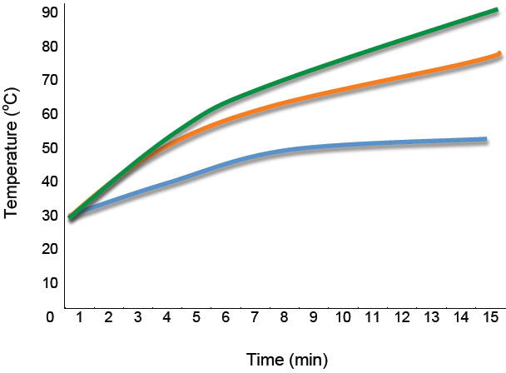
Using the graph above and what you know about transfer of thermal energy, write your thoughts about the following questions in your Engineering Notebook:
- Which line (a. blue, b. orange or c. green) do you think represents the solar oven that is just an empty box? Why?
- Which line do you think represents the solar oven with aluminum foil and a black bottom? Why?
- What purpose do you think aluminum foil serves?

Design and Build
Using what you know about thermal energy transfer, design a simple solar oven that meets the criteria and constraints. You can use any of the following materials:
- Thermometer
- Timer
- Cardboard box
- Aluminum pan
- Aluminum foil
- Black construction paper
- Plastic wrap big enough to cover the box (or Plexiglass - optional)
- Gooseneck lamp with 100 W bulb (optional if using sunlight)
- Oven mitts
- S‘mores fixings (graham crackers, marshmallows and chocolate)

Using the materials provided, build your solar oven based on your design. As your team works together, record the following in your Engineering Notebook:
- Record the design decisions you made and why you are using a simple two-column table (see the Engineering Notebook Guide). This can include a sketch with labels.

You have 15 minutes to design and build your solar oven. Remember the criteria and constraints for the design! Ask your teacher to check your Engineering Notebook before beginning a test.

Test, Evaluate, and Redesign
- Set up your data table in your Engineering Notebook (see the Engineering Notebook Guide).
- Take your oven to the designated place for testing (see your teacher).
- Place the S’more in the oven. Close the lid and begin your test. Record the starting temperature of the oven. Record the temperature and observations of the S’more every (1) minute for 10 minutes. Make sure to use oven mitts when lifting the lid or manipulating anything inside the oven!
Clean up
Return your oven and materials and clean up any remaining materials at your work station.

Ideas for Redesign
Using the results of your test and what you know about transfer of thermal energy, respond to the following questions in your Engineering Notebook:
- Did your oven design successfully meet all the criteria and constraints? Why or why not?
- Explain how your solar oven worked to use solar energy to heat up the inside of the oven and cook the S’mores.
- What could you have done to make your solar oven work better? How could you have increased thermal energy transfer in your oven?
- What did you learn from this design challenge that might be useful in building a solar oven for use on the Moon?
Lesson 1: Solar Oven Engineering Notebook Guide

Your Engineering Notebook should include the following sections:

Problem Statement
What is the problem you are trying to solve?
What are the criteria and constraints that must be met?

Research
Record responses to questions #1-3 about the graph.

Design Process
Design Log: As you create your oven, keep a running list of the design decisions you made based on questions about how to build a lid to choosing when and which materials to use. Be sure to include why you made each decision. For example, “We chose black paper because this will absorb more light.”
Design decision | Reason for decision

Test Results
Set up your data table in your Engineering Notebook.
Time (min) | Temperature ˚C | Observations
0:00
1:00
2:00
3:00
4:00
5:00
6:00
7:00
8:00
9:00
10:00

Ideas for Redesign
Record your responses to the reflection questions and ideas for changes in your design.

Name_____________________________

Lesson 2: Examples of Models and Prototypes

Answering the questions below can provide evidence to whether an example is a model or prototype. By understanding the cases in which these attributes are found, it will become apparent whether the example is a model or prototype.
- Fast/easy to build (Y/N)?
- Small scale or large scale?
- Few functions or many functions?
- Uses final materials (Y/N)?
- Graphical/physical or an actual product?

Lesson 2: Examples of Models and Prototypes
Model:
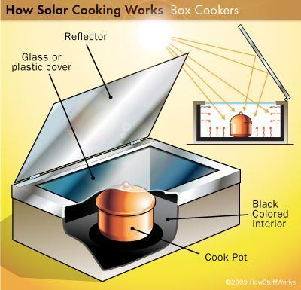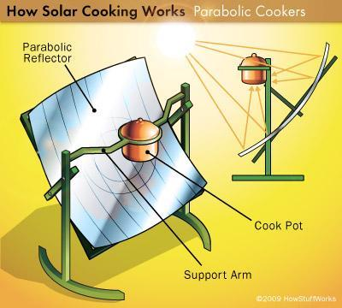
Source:
How Stuff Works http://science.howstuffworks.com/environmental/green-science/solar-cooking1.htm
http://www.idigmygarden.com/forums/showthread.php?t=1025&page=5
Prototypes:
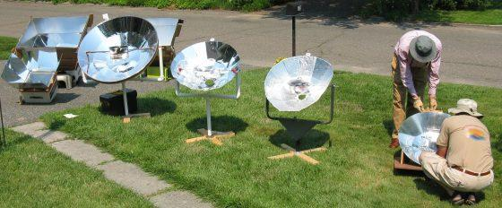
- Source: Solar Cooker Comparison: http://www.solarcooker-at-cantinawest.com/buildingasolarcooker.html
- Reflective Solar Ovens: http://sunnycooker.webs.com/
Lesson 2: Example of Models and Prototypes

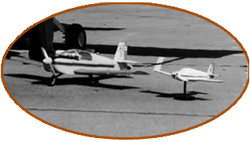
In a classic NASA study, tests were conducted with, right to left: a spin tunnel model, a radio-controlled model, and the full-scale aircraft. Langley test pilot Jim Patton, center, and researchers Jim Bowman, left, and Todd Burk.

Source: https://www.nasa.gov/pdf/601262main_ModelingFlight-ebook.pdf
Lesson 2: Example of Models and Prototypes
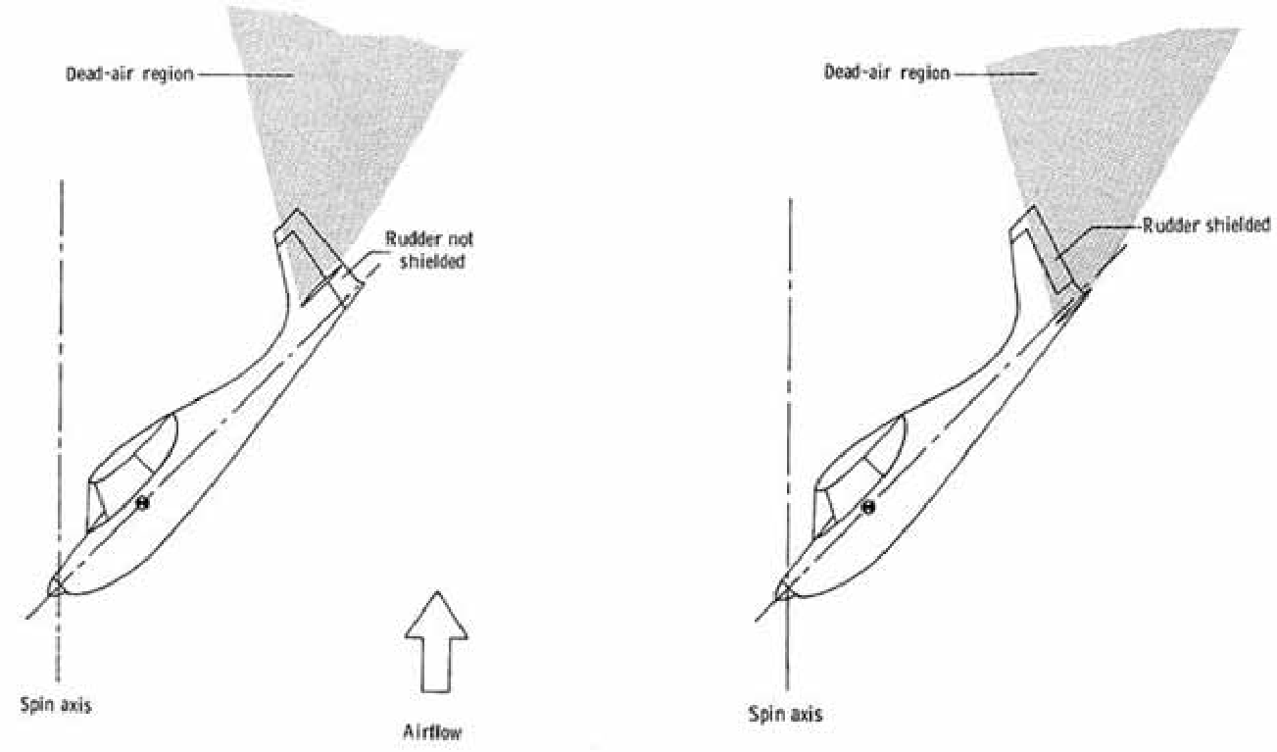
Model of the geometric properties of the tail surfaces of aircraft were major factors in the derivation of the NASA–developed, tail-damping power factor parameter. The aircraft on the left is likely to have a better tail design for spinning because the rudder will not be shielded by the wake of the horizontal tail and side area is available beneath the horizontal to counter any spin the plane may experience in a rapid descent.
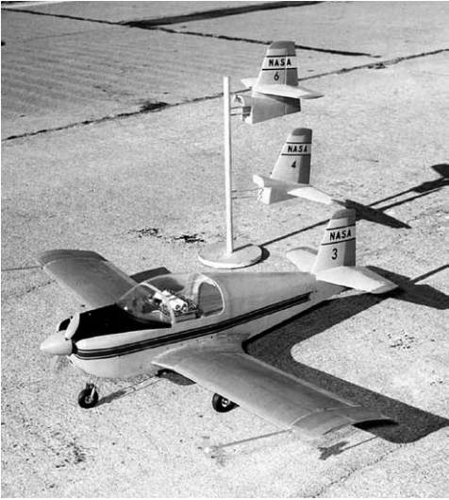
The NASA General-Aviation Spin Research Program of the 1970s included extensive correlation studies of results obtained with spin tunnel tests, radio-controlled model tests, and airplane flight tests. Many key parameters were studied, including the effects of tail configuration, as shown, for the low-wing research model.

Lesson 2: Examples of Models and Prototypes
Micron
Model
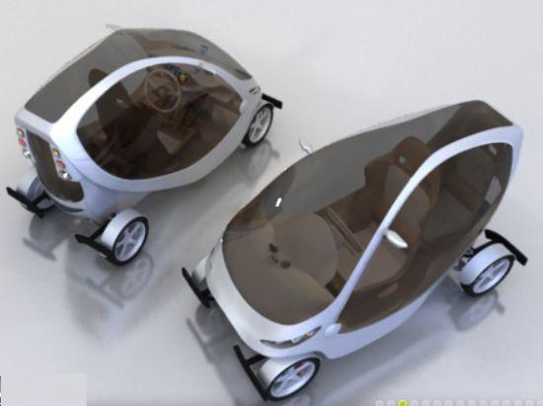
http://www.ecofriend.com/wp-content/uploads/2012/07/exide_2_mgCj7_5638.jpg
Prototype
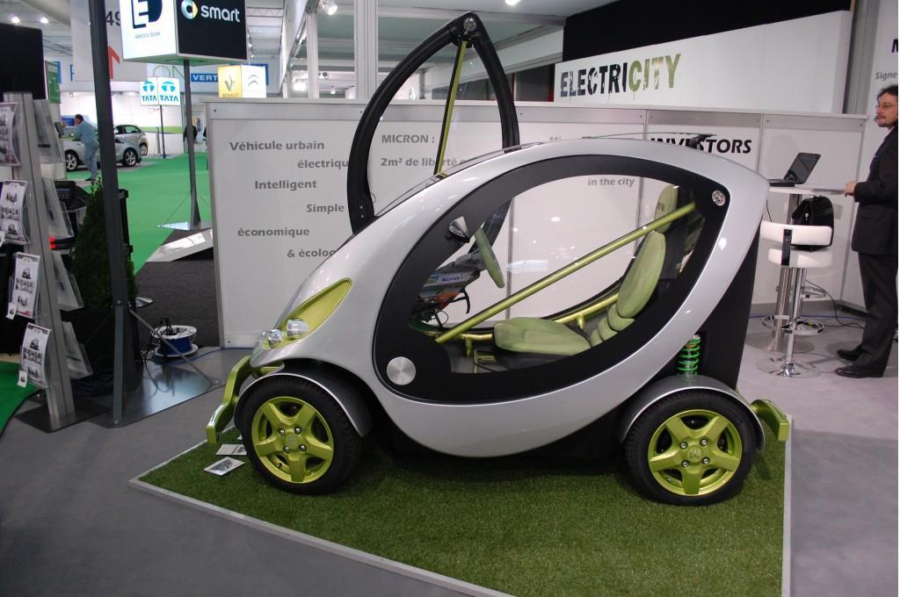
http://images.thecarconnection.com/lrg/micron-urban-electric-car-2011-geneva-motor-show_100343158_l.jpg
Lesson 2: Examples of Models and Prototypes
Lamborghini Huracan: http://www.lambocars.com/huracan/
http://www.lambocars.com/lambonews/lamborghini_huracan_scale_model_in_the_making.html
Scale Model
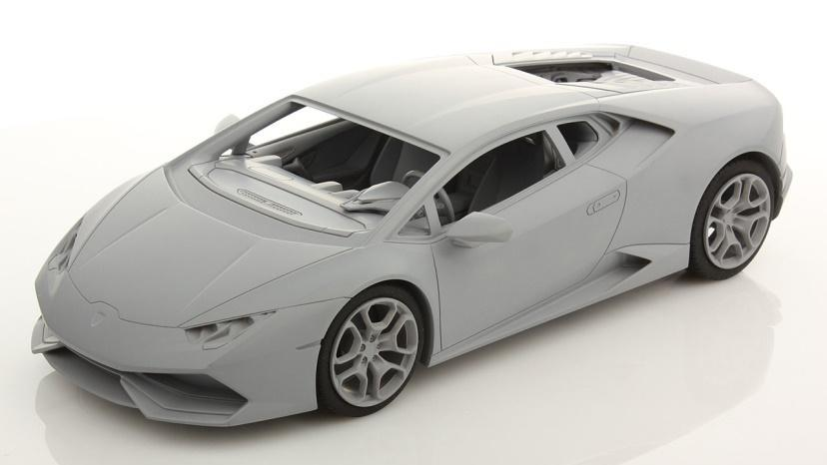
Lamborghini Huracan
1/18 scale car from:
http://www.lambocars.com/images/lambonews/1/mr_collection_huracan_1.html

Prototype
The new Lamborghini Huracán during winter testing. Note the wheels on this prototype. They put on tape to hide the design.
http://www.lambocars.com/images/huracan/1/huracan_test_mule_5.html

Lesson 2: Hot Water Heater Design Benefits and Limitations
Review and compare models for two situations:
- Small volume with occasional application such as showering or washing dishes.
Hot water is needed for showering and washing dishes while on extended camping trips. The heating system should be portable, inexpensive, and easy to set up at the camp site. System should be successfully built by the average person (not an electrician or construction worker).

- Large volume and constant supply such as heating a house or garage in winter. Heating system is needed to heat a house during the winter. The heating system should keep the house warm and heat water for use in the house. System should be economical, dependable and run continuously.

Purpose:

- ________________________________________________________________________________________________________________________________________________________________________________________________
- ________________________________________________________________________________________________________________________________________________________________________________________________

Constraints or Criteria:

- ________________________________________________________________________________________________________________________________________________________________________________________________
- ________________________________________________________________________________________________________________________________________________________________________________________________

Development Specifications or Limitations:

- ________________________________________________________________________________________________________________________________________________________________________________________________
- ________________________________________________________________________________________________________________________________________________________________________________________________

Recommendation for Water Heater with Evidence: _______________________________________________________________________________________________________________________________________________________________________________________________________________________________________

Simple Hot Water Heater: http://www.reuk.co.uk/Simple-Solar-Water-Heating.htm

Features:
- No Pump
- Heats up a five-gallon bucket of water to well over 40 degrees Celsius
- Pond liner which is both waterproof and an excellent solar absorber
- Insulated and kept sheltered from the wind so that heat is not wasted

Benefits | Limitations

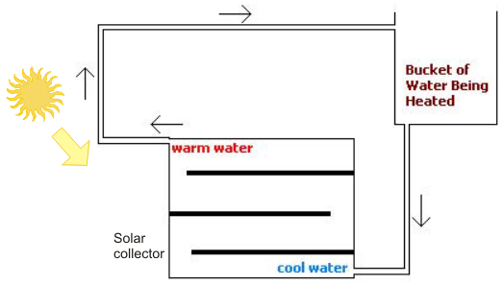

Which thermal energy principles are being used?
_____________________________________________________________________________________________________________________________________________________________________________________________________________________________________________________________________________________________________________________________________________________________________________________________________________________________________________________________________________________________________________________________________________
Concentrated Solar Water Heater: http://www.reuk.co.uk/Build-a-Concentrated-Solar-Water-Heater.htm

Features:
- Small pump
- Reflection: use of mirrors or other reflective surfaces to concentrate the Sun's rays magnifying and focusing the solar radiation
- Copper pipes – high melting point and good conductors
- Parabolic trough which focuses all of the sunlight
- Painting the pipe with matte black paint will maximize heat absorption

Benefits | Limitations

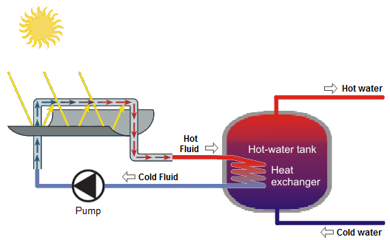
Which thermal energy principles are being used?
_____________________________________________________________________________________________________________________________________________________________________________________________________________________________________________________________________________________________________________________________________________________________________________________________________________________________________________________________________________________________________________________________________________

Flat Plate Collector Solar Water Heater: http://www.reuk.co.uk/DIY-Solar-Water-Heating-Prototype.htm

Features:
- Driven using a 12V car windscreen washer pump
- Copper pipes for the flat plate collector helps with heat conduction
- Lined with aluminum sheeting, helps with heat conduction
- Heat sink compound was used between the copper and aluminum to help heat conduction
- Heat sink and pipes were painted with heat resistant black paint to maximize heat absorption
- Heavily insulated in layers

Benefits | Limitations
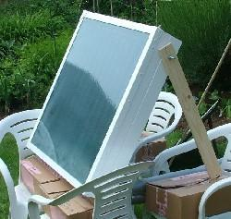
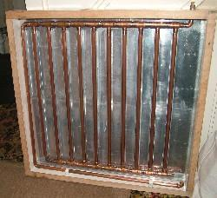

➔

Which thermal energy principles are being used?
_____________________________________________________________________________________________________________________________________________________________________________________________________________________________________________________________________________________________________________________________________________________________________________________________________________________________________________________________________________________________________________________________________________
Geothermal Heat Pump 1: http://www.diymanager.com/green/Companies/energyinstallations/groundheatpumps/index.php

Features:
- The ground absorbs the Sun’s heat and has a relatively constant temperature of 10-16 ̊ C.
- Geothermal systems utilize the warmth from the ground to heat hot water, radiators or under-floor heating
- The fluid in the geothermal pipes absorbs the renewable heat from the ground, through conduction, as it is moved through the circuit of pipes to a heat exchanger and compressor within the heat pump

Benefits | Limitations
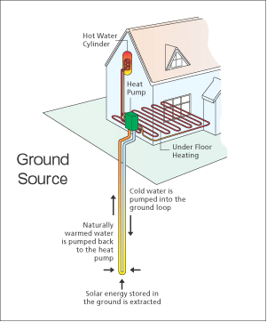

Which thermal energy principles are being used?
_____________________________________________________________________________________________________________________________________________________________________________________________________________________________________________________________________________________________________________________________________________________________________________________________________________________________________________________________________________________________________________________________________________
Geothermal Heat Pump2: http://pecva.org/index.php/our-mission/energy-solutions/distributed-clean-generation/615-geothermal

Features:
- The water absorbs the Sun’s heat and has a relatively constant temperature
- Geothermal systems utilize the warmth from the water to heat water, radiators or under floor heating
- The fluid in the geothermal pipes absorbs the renewable heat from the water through conduction, as it is moved through the circuit of pipes to a heat exchanger and compressor within the heat pump
- Heat transfer coils are put in a body of water at least eight feet below the surface

Benefits | Limitations
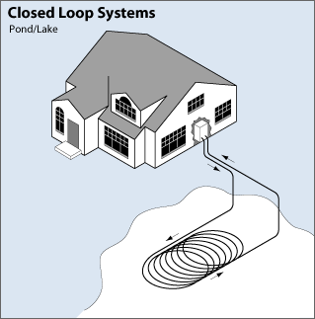

Which thermal energy principles are being used?
_____________________________________________________________________________________________________________________________________________________________________________________________________________________________________________________________________________________________________________________________________________________________________________________________________________________________________________________________________________________________________________________________________________
Recommendations:

Which Design Model best solves Problem number 1? Support your answer with evidence.
__________________________________________________________________________________________________________________________________________________________________________________________________________________________________________________________________________________________________________________________________________________________________________________________________________________________________________________________________________________________________________

Which Design Model best solves Problem number 2? Support your answer with evidence.
__________________________________________________________________________________________________________________________________________________________________________________________________________________________________________________________________________________________________________________________________________________________________________________________________________________________________________________________________________________________________________
Lesson 2: Hot Water Heater Design Benefits and Limitations –
ANSWER KEY

Review and compare models for two situations:
- Small volume with occasional application such as showering or washing dishes. Hot water is needed for showering and washing dishes while on extended camping trips. The heating system should be portable, inexpensive, and easy to set up at the camp site. System should be successfully built by the average person (not an electrician or construction worker).

- Large volume and constant supply such as heating a house or garage in winter. Heating system is needed to heat a house during the winter. The heating system should keep the house warm and heat water for use in the house. System should be economical, dependable and run continuously.

Purpose:

- Heat a small volume of water with occasional application, such as showering, or washing dishes
- Heat a large volume of water with a continual supply such as heating a barn or garage in winter

Constraints or criteria:

- Should be portable, inexpensive, and easy to set up at the camp site.
- Should keep the house warm and heat water for use in the house. Should economical, dependable and run continuously.

Development Specifications or Limitations:

- System should be successfully built by the average person.

Simple Hot Water Heater discusses insulation and absorption: http://www.reuk.co.uk/Simple-Solar-Water-Heating.htm
Features:
- No Pump
- Heats up a five gallon bucket of water to well over 40 degrees Celsius
- Pond liner which is both waterproof and an excellent solar absorber
- Insulated and kept sheltered from the wind so that heat is not wasted

Benefits | Limitation
No power needed (passive system) | Five-gallon bucket capacity
Simple to build (few hours)
Inexpensive to build

Concentrated Solar Water Heater (use of reflectors): http://www.reuk.co.uk/Build-a-Concentrated-Solar-Water-Heater.htm
Features:
- Small pump
- Reflection: use of mirrors or other reflective surfaces to concentrate the Sun's rays - magnifying and focusing the solar radiation
- Copper pipes – high melting point and good conductors
- Parabolic trough which focuses all of the sunlight
- Painting the pipe with matte black paint will maximize heat absorption

Benefits | Limitation
More efficient | more complicated to construct
Expandable capacity | more expensive
 | Requires power (active system)
 | The heat transfer liquid my leak
 | Cannot use cheaper plastic pipes they will melt.

Flat Plate Collector Solar Water Heater: http://www.reuk.co.uk/DIY-Solar-Water-Heating-Prototype.htm
Features:
- driven using a 12V car windscreen washer pump
- copper pipes for the flat plate collector helps with heat conduction
- lined with aluminum sheeting, helps with heat conduction
- Heat sink compound was used between the copper and aluminum to help heat conduction
- heat sink and pipes was painted with heat resistant black paint to maximize heat absorption
- heavily insulated in layers
Benefits | Limitation
15 liter bucket of water | Requires power (active system)
Heated from 16 to 41 degrees Celsius (hot bath temperature) in just over one hour without insulation | more complicated to construct (24 hours)
 | more expensive

Geothermal Heat Pump 1: http://www.diymanager.com/green/Companies/energyinstallations/groundheatpumps/index.php
Features:
- The ground absorbs the Sun’s heat and has a relatively constant temperature of 10-16 ̊ C
- Geothermal systems utilize the warmth from the ground to heat hot water, radiators or under-floor heating
- The fluid in the geothermal pipes absorbs the renewable heat from the ground, through conduction, as it is moved through the circuit of pipes to a heat exchanger and compressor within the heat pump

Benefits | Limitations
A possible reduction of 75% CO2 | Requires power (active system)
provides hot water system, radiator, and/or floor heating | Very complicated to install and equipment purchase required
 | Expensive: Costs $10,600 to $19,700
 | Refrigerants are used in ground source heat pump systems. These are toxic, flammable and have a high global warning potential.

Geothermal Heat Pump 2: http://www.geothermaldesigns.net/hybrid_geothermal.html
Features:
- The water absorbs the Sun’s heat and has a relatively constant temperature.
- Geothermal systems utilize the warmth from the water to
heat water, radiators or under floor heating
- The fluid in the geothermal pipes absorbs the renewable heat from the water, through conduction, as it is moved through the circuit of pipes to a heat exchanger and compressor within the heat pump
- Heat transfer coils are put in a body of water at least eight
feet below the surface

Benefits | Limitations
Simple to design | Requires power (active system)
Cheaper to install than ground source geothermal loops | Equipment purchase required
Provides hot water system, radiator, and/or floor heating | Refrigerants are used in ground source heat pump systems. These are toxic, flammable and have a high global warning potential.

Lesson 2: Hot Water Heater Design Benefits and Limitations – ANSWER KEY

Review and compare models for 2 situations:
- Small volume with occasional application such as showering or washing dishes; hot water is needed for showering and washing dishes while on extended camping trips. The heating system should be portable, inexpensive, and easy to set up at the camp site. System should be successfully built by the average person (not an electrician or construction worker).

- Large volume and constant supply such as heating a house or garage in winter. Heating system is needed to heat a house during the winter. The heating system should keep the house warm and heat water for use in the house. System should be economical, dependable and run continuously.

Purpose:

- Heat a small volume of water with occasional application such as showering, or washing dishes;
- Heat a large volume of water with a continual supply such as heating a barn or garage in winter

Constraints or criteria:

- Should be portable, inexpensive, and easy to set up at the camp site.
- Should keep the house warm and heat water for use in the house. Should economical, dependable and run continuously.

Development Specifications or Limitations:

- System should be successfully built by the average person

Lesson 3: Lunar Hot Water Heater Design Challenge
Colder than Antarctica? Welcome to the Moon! To survive on the Moon, astronauts will need buildings that can protect them from temperatures as low as –250˚ Fahrenheit (–157˚ Celsius). One way to heat these buildings is to use sunlight to heat water and pump it through the rooms.
The Challenge
To design and to prototype the most effective solar hot water heater possible for use on the Moon. The hot water heater needs to function effectively given the extreme conditions on the Moon.

Criteria:
- Minimum temperature change of 10º C for a quart of water in 10 minutes
- Meets constraints listed below
- Uses solar radiation as the sole energy source (a lightbulb will be used for Earth testing)

Constraints:
- Size (has to fit on a rocket)
- Limited to solar designs (rather than others such as heat exchanger) as astronauts have to be able to set it up on the surface (rather than dig into the surface)
- Water will be used for testing on Earth; for Moon trials another liquid has to be substituted that will not freeze during dark periods
- Limited to materials provided (allows for compatibility with other materials and products used on the Moon by the astronauts)

Research
- Use four models already introduced: solar oven, solar cooker (parabolic reflector), two solar models from prior lesson
- Make predictions about the effectiveness of two of those models. Record predictions, including evidence and reasoning. Choose one as a basis for your own design. Guiding question: Is this a design model that we think well work will for our solar hot water heater on the Moon?
- Respond to questions in your Engineering Notebook:
  - Why did you choose the two models to evaluate (or why not the other two)? Why did you choose the one particular model to base your design on?
  - How might conditions on the Moon impact or change its effectiveness/performance?

Explain
What is the value of using a model to evaluate potential designs?
Where is radiation, convection, and conduction at work in this model?
How does the model account for absorption, insulation, storage, etc.?

Design and Build
Now that you have chosen a model to use as a basis of your design, now you must turn this model into an actual design that can later be built and tested. Many decisions need to be made to complete your design. Think about the impact of each decision on the function of the hot water heater. For example:
- What color should you make the tube and background? How will the color impact absorption and heat transfer?
- How fast do you want water to flow through the tube? How will that impact the temperature and volume of what you can produce?
- Does the position of the water relative to other parts of the hot water heater affect water temperature?
- As you work, document your decisions and rationale. Include diagrams or illustrations (with labels) that will help you construct a prototype of the design.

The following materials are available to you: (ADD to list for both active systems and solar oven option(s)).
For water heater, per team:
- Aluminum foil
- Large sheet of cardboard (11 x 17 inches/28 x 43 cm)
- Gooseneck lamp with a 100 W floodlight light bulb (optional if using sunlight)
- Black marker
- Colored paper
- Two paper cups (medium-sized)
- Three feet (0.9 m) clear plastic tubing with outside diameter: 1/4 inch or 6 mm
- Pitcher of water
- Ruler
- Scissors
- Straws
- Duct tape
- Stopwatch or clock with a second hand
- Digital thermometer or temperature probe

Test, Evaluate, and Redesign
Test
- Put your heater in strong sunlight or eight inches (20 cm) below the lamp (SAFETY NOTE: Keep water away from the outlet, lamp, and bulb).
- Measure and record the temperature of the water in the pitcher in your Engineering Notebook.
- Pour water from the pitcher into the supply cup.
- Record the temperature of the water as it comes out of the lower end of the tube, in your Engineering Notebook.
- Record the temperature change from start to end.

Evaluate
- What worked, what did not work (or not as well as predicted)?
- How do you know?

Redesign
- Can you get an even bigger temperature change? Or more volume in the same time? Engineers test a design and improve it based on what they learn. Some possible considerations:
  - Help the water absorb more heat—Add materials above, below, or around the tube to focus more heat energy on the water. Also think how you can use color to help heat the water.
  - Slow the flow—The longer the water stays in the light, the more it will heat up. Figure out how to make the water flow slowly through the tube.
  - Increase the exposure—A longer tube can help water stay in the light for a longer time. Tape two tubes together.
  - Reduce energy loss—A loss of heat once absorbed reduces the effectiveness of your heater.
- Document any changes you make, including your rationale for why each change was made, in your Engineering Notebook.
- Reflection
- ADD questions to respond to in Engineering Notebook; attend to writing
  - Give two examples of how a small change in your design (maybe a change in size, length, color, placement, etc.) impacted the effectiveness of your design.
  - Is your prototype ready to go to the Moon to be tested? How might actual conditions on the Moon change the effectiveness or performance of your prototype?
  - How does your design account for thermal energy principles (radiation, conduction, convection, absorption, insolation, etc.) ?
  - Describe the benefits and limitations of the each of the components of this design challenge: the model you chose, the design you developed based on the model, and your prototype.
  - What single change in the design led to the biggest improvement in the performance of your design?
Clean up
- Return your oven and materials and clean up any remaining materials at your work station.

Source: This design challenge is edited from materials produced by NASA and Design Squad
(http://www.nasa.gov/pdf/308966main_On_the_Moon.pdf Feel the heat)

Thermal Energy Design Challenge Rubric
 | Category | Partial/Incomplete |  | Meets/Proficient | Excellent
Research: review of models, predictions |  |  | Reasonable predictions are made for one or two models; reasoning and evidence may be partially missing or not fully relevant | Reasonable predictions are made for two models; relevant reasoning and evidence provided |  | Reasonable predictions are made for more than two models; relevant reasoning and evidence provided
Design: documentation of design decisions; application of concepts; attention to criteria and constraints |  |  | Demonstrates partially correct application of some thermal energy principles; rationales for key design decisions may be partially articulated or only provided for some decisions; design may not meet some criteria and constraints | Demonstrates appropriate application of thermal energy principles; rationales for key design decisions articulated; design likely to meet criteria and constraints |  | Demonstrates excellent application and explanation of thermal energy principles; conveys how specific design decisions affect the function of efficiency; design likely to meet criteria and constraints
 | Build: documentation of prototype | Prototype meets the task criteria to a limited extent; documentation is weak |  | Prototype contains all pertinent elements and meets task criteria; documentation of process is adequate | Prototype contains all pertinent elements and meets task criteria and constraints; documentation of process detailed and thorough
 | Test and Evaluate: tests of performance | Testing and evaluation processes are inadequate to collect useful data |  | Testing and evaluation processes are adequate to collect data to refine the design solution | Testing and evaluation processes are innovative and relevant to redesign
 | Redesign: evidence used to justify changes; final prototype meets task criteria | Refinement based on testing and data evaluation is not evident or not logical; the final solution is missing more than one of the criteria or constraints |  | Refinements made based on testing and data evaluation are evident and logical; the solution meets all but one of the criteria or constraints | Significant improvement in the design is made based on testing and data evaluation; the solution meets all of the criteria and constraints criteria
 | Reflection: on application of standards | Reflection demonstrates partial understanding of: thermal energy principles, value of models and prototypes, and/or redesign process |  | Reflection demonstrates reasonable understanding of: thermal energy principles, value of models and prototypes, and redesign process | Reflection demonstrates thorough understanding of: thermal energy principles, value of models and prototypes, and redesign process

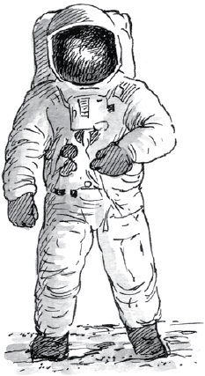
Space Suit Design Challenge
What Shall I Wear?
Ever have trouble deciding what to wear? Try packing for the Moon! On the Moon, daily temperatures can fluctuate about 500° Fahrenheit (260° Celsius). It can get up to 250° F (121° C) during the day, and at night, it can drop to –250° F (–157° C). Earth’s blanket of air—the atmosphere—keeps us at a comfortable average temperature of 60° F (16° C). But the Moon has no atmosphere to hold heat. Better bring a well-insulated space suit when you visit!
We Challenge You To…
Design and build a space suit that can maintain a constant temperature.
- Use the Design Cycle.
- Use your Engineering Notebook
- Complete three Quality Assurance Inspections
- Select and recommend the best design solution
Figure 1: Buzz Aldrin wore a million dollar space suit designed to protect him from the Moon’s extreme hot and cold temperatures.
Functions
Change in Temperature
Size
Flexibility
Criteria
Keep Warmth in
Small and Flexible as possible
The Chief NASA engineer is asking you to design a space suit that maintains a constant temperature – minimizing thermal energy transfer. You will simulate this scenario by insulating a closed flask/beaker with a thermometer that will be placed in an ice bath to test and record temperature change. You must use at least 2 different materials in your design; the suit must fit in a baggie (determined by size of flask/beaker) and encase the flask completely to be placed in an ice bath for testing. The designed suit should maintain a constant temperature for as long as possible.
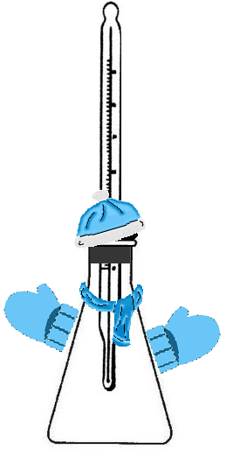
Presentation to the Chief NASA Engineer Functions:
- Your Engineering Notebook
  - Problem Identification
  - Concrete details (drawings, data tables) and scientifically appropriate language that describes how their design evolved
  - Modifications to your model based on data
- The design model that you tested
Design Challenge Recommendation – you will select and recommend the best design solution. Support your recommendation with evidence.
Team A: Insulate, Insulate, Insulate (Bulky)
Team B: Foil then Insulate (Flexible)

Space Suit Design Challenge: Quality Assurance Form

Name: ______________________________________

Directions: Use your Space Suit Design Challenge handout to check and see if the team’s design meets the criteria and functions for their suit.

In what ways does this design MEET the criteria and functions?
__________________________________________________
__________________________________________________
__________________________________________________
__________________________________________________
__________________________________________________

In what ways could this design IMPROVE how it meets the criteria and functions?
____________________________________________________________________________
____________________________________________________________________________
____________________________________________________________________________
____________________________________________________________________________
Provide advice to help the design team redesign their model:
____________________________________________________________________________
____________________________________________________________________________
____________________________________________________________________________
____________________________________________________________________________
____________________________________________________________________________

Space Suit Design Challenge Final Recommendation

Name: ______________________________________

Which design is the best solution for the challenge?
__________________________________________________

Why? Support your claim.
__________________________________________________
__________________________________________________
__________________________________________________
__________________________________________________
__________________________________________________
____________________________________________________________________________
____________________________________________________________________________
Provide advice to help the design team redesign their model:
____________________________________________________________________________
____________________________________________________________________________
____________________________________________________________________________
____________________________________________________________________________
____________________________________________________________________________
Provide advice to help the design team build a prototype:
____________________________________________________________________________
____________________________________________________________________________
____________________________________________________________________________
____________________________________________________________________________
____________________________________________________________________________

Space Suit Design Rubric
 | Category |  | Partial/Incomplete |  | Meets/Proficient |  | Excellent
Design - Applied understanding of insulator/conductor, radiation, convection, and conduction |  | Demonstrates partially correct application of some thermal energy principles; rationales for key design decisions may be partially articulated or only provided for some decisions; design may not meet some criteria and constraints |  | Demonstrates appropriate application of thermal energy principles; rationales for key design decisions articulated; design likely to meet criteria and constraints |  | Demonstrates excellent application and explanation of thermal energy principles; conveys how specific design decisions affect the function of efficiency; design meets criteria and constraints
 | Evaluate (using constraints, and criteria) |  | Evaluation process is inadequate to collect design data.  The solution is missing more than one of the required constraints, criteria, or development specifications/limitations listed in the design brief |  | Evaluation process is adequate for collecting design data to refining the design solution.  The solution meets all but one of the required constraint, criteria, or development specifications/limitations listed in the design brief. |  | Evaluation processes are innovative.  The solution meets all of the required constraint, criteria, or development specifications/limitations listed in the design brief.
 | Application of Thermal Energy Transfer Concepts |  | Incorporates knowledge of thermal energy transfer concepts in a limited extent |  | Incorporates knowledge of thermal energy transfer concepts adequately |  | Incorporates knowledge of thermal energy transfer in insightful ways
 | Advice for Redesign |  | Refinement evaluation is not evident or not logical. |  | Refinements made based on evaluation. |  | Significant improvement in the design is made based on evaluation.
 | Advice for Building Prototype |  | Design proposal is inadequate and lacking pertinent information  Model/Prototype meets the task criteria to a limited extent |  | Design proposal is adequate, containing all pertinent elements.  Model/Prototype meets the task criteria |  | Design proposal is accurate and comprehensive.  Model/Prototype meets the task criteria in insightful ways
 | Recommendation |  | Recommendation based on constraint, criteria, and development specification/limitations is not evident |  | Recommendation based on constraint, criteria, and development specification/limitations; Some supporting evidence |  | Recommendation based on constraint, criteria, and development specification/limitations; extensive supporting evidence on how the solution best meets the challenge

http://www.sciencebuddies.org/science-fair-projects/project_laboratory_notebook.shtml?from=Blog
Expeditionary Learning materials, http://elschools.org

