Massachusetts Department of

Elementary and Secondary Education

Grants Management

75 Pleasant Street, Malden, Massachusetts 02148-4906 Telephone: (781) 338-6595 TTY: N.E.T. Relay 1-800-439-2370

Grants Management April Update

- April Payment Request window is now available
- Monthly Update – new look and feel!
- Multi-Year: May 1st – May 14th!
- Grant Amendments
- FY2019 ISAs to State Entities Including Colleges
- Changes to Award / Payment Notices
- Final Reports (FR1)
- User Request Form / EdGrants Webinars
- Requesting Funds Reminders & FAQs

April Payment Request is now available

This is a courtesy reminder that the April Payment Request window is open now through April 30th. This window is open for all approved FY2019 grants as well as FY2018 Multi-Year grants that are currently in year 2 with balances left to draw down. (FY2018 Multi-Year grants* are only Fund Codes: 140, 141, 180, 186, 305, 309, 240).

*Grantees with FY18 year two balances should be using those balances for FY19 expenditures before charging FY19 expenses to the new FY19 award. If you need to amend your FY18 grant to accommodate these charges, please be sure to contact your program liaison to request an amendment for you to complete in EdGrants.

To request grant funds, log into EdGrants with your DESE provided user name and password. If you are new to EdGrants, please review the Requesting Funds Reminders & FAQs. Don’t have a login? Please review the http://www.doe.mass.edu/grants/edgrants/user-security-controls.html information which explains how to get connected.

Locked out of EdGrants? Grants Management staff periodically checks and unlocks those who are locked out throughout the day. If you continue to find that you are locked out, please call the Grants Management main line at 781-338-6595 for assistance.
BACK TO THE TOP

Monthly Update – new look and feel!

Beginning next month, the Grants Management May Update will have a new look and feel! We are transitioning over to MailChimp, which is used by other offices within DESE to communicate information out to our constituency. Next month, you will see a more formatted email update, but it will contain the same helpful information regarding the EdGrants fiscal year and items of interest as it always does. Grants Management will continue to post the monthly update for reference on the grants website under Grants Notifications and Alerts. Previously posted monthly updates are always available in the Grants News Archives.

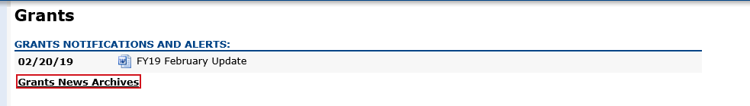
Multi-Year: May 1st – May 14th!
Start prepping now for Multi-Year! Not sure how much to move? Move some small amount to get the extended end date on your grant. The beauty of the multi-year feature is that it does not have to be exact! Simply roll some funds into Year 2 to extend the end date of your grant and apply the grant funds back to whenever they are needed within the award period.

May 1, 2019 – May 14, 2019, the multi-year form will be available in EdGrants in the Submissions menu for all grant funds codes that have the multi-year option.
FY2019 grant fund codes that have the multi-year feature available in EdGrants:
- 140 (Title II-A)
- 180 / 186 (Title III)
- 218* (High-Quality Instruction – Summer Planning)
- 240 (Special Ed)
- 262 (Early Childhood Special Ed)
- 305 (Title I)
- 309 (Title IV)

As long some small amount is moved using the multi-year form in EdGrants, any unclaimed balances left in year 1 will roll into Year 2 automatically. If nothing is moved, you could be opening yourself up to a break in service should you decide you need the extended end date after the fact. It is always better to move some small amount to be covered for the extended end date. You will have access to draw any moved funds on 7/1, and those funds can be applied back to services through 6/30 if necessary.

*Fund Code 218 – High-Quality Instruction – Summer Planning grantees should use the multi-year feature to receive an 8/31/2019 end date on this state-funded grant. This is not available for the 24-month grant period as the other multi-year grants are.

Please register for http://www.doe.mass.edu/Grants/edgrants.html for more info and review the How to Complete Multi-Year / FAQs user guide.

BACK TO THE TOP
Grant Amendments

It’s good to have a practice of assessing grant spending on a quarterly basis to determine if you need to request an amendment.

Amendments are Required When:
- there is any significant change in program objectives; or
- there is any increase or decrease in the total amount of the grant; or
- an increase in a line of the budget exceeds $100 or 10% of the line (whichever is greater) or exceeds $10,000.
Amendments should be submitted at least thirty (30) days prior to the desired change and must be submitted thirty (30) days before the conclusion of the project. The maximum number of amendments to any grant may not exceed three (excepting any required by the Department). Exceptions to this limit may be allowed. The EdGrants Front Office User Guide: Amending the Application Submission has detailed instructions as to how to how to amend your grant submission in EdGrants.

FY2019 ISAs to State Entities Including Colleges

Amending your ISA

We are more than halfway through the state’s fiscal year. This is a good time to assess spending and determine if an amendment to your EdGrants submission or your ISA (or both) is needed. Information regarding how to amend was sent out to all ISA contacts in mid-January.

Fringe Information
The fringe rate for those receiving state grants is 1.73% of AA and CC payroll (D09). Federal/trust accounts are 36.62% of AA payroll and 1.73% of CC payroll (D09). Please review the approved rates with the MA Comptroller’s Office. If you are required to contribute to D08, please add that separately on the ISA. We have been and will continue to will reach out and work with you to complete this process.

Please note that you can find the proposed FY20 rate on the MA Comptroller’s and you can also check back for the rate is approved. We will also notify you about the rate changes for FY20 once approved.

If you have any questions regarding amending your ISA, please contact your Grants Management liaison.
BACK TO THE TOP

Changes to Award / Payment Notices

The Office of Management and Budget (OMB) requires all pass-through entities (DESE) to provide additional information to sub-recipients regarding their federal awards. You will now see this information at the bottom of the payment notice, with a link to the Federal Awards letters as provided by USED.
BACK TO THE TOP

Filing Final Financial Reports (FR1)

FY2018 Final Reports should have already been submitted in EdGrants for grant ending 6/30/2018 or 8/31/2018. If an Applicant has not submitted an FR-1 for an FY2018 grant, please do so ASAP. GM staff may have to make the report available to you since the timeframe has expired.

Please make sure that all expenses have been accounted for and bills reconciled before you file a Final Report. If no FY2018 final report is available for a particular project in the Submissions menu, please email EdGrants@doe.mass.edu and include the project number in the email. You can also call the main grants line at 781-338-6595, again please have the project number ready.

Please note: There is a known glitch with the FY2018 final report form in EdGrants. If the line item is overspent by a small amount, it throws the “Balance Unexpended” and the percentage columns off. We are working to correct this error. In the meantime, you can submit the final report; the “Cash Balance” section at the bottom of the report form does calculate correctly.

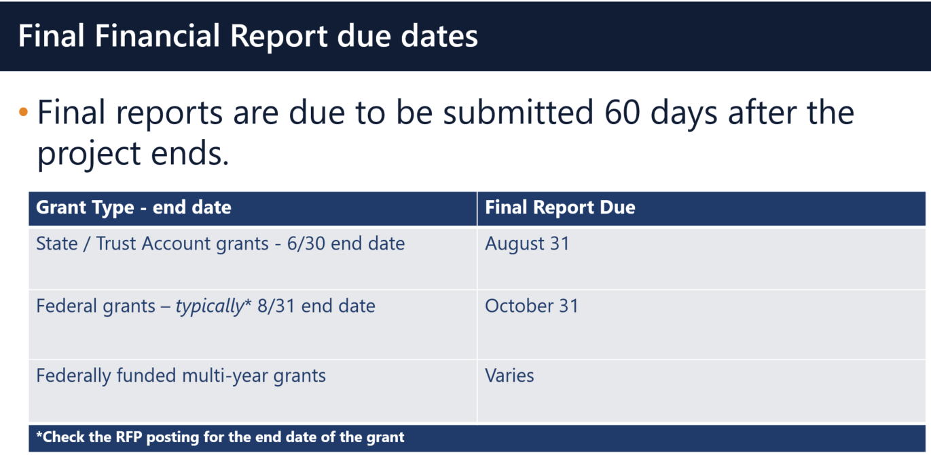

Multi-Year grants: DESE expects that Applicants will spend down their funds in full and not return money as FY2018 multi-year grants now have an end date of 6/30/2019 as long as you filed a multi-year form in May or left a Year 1 balance unclaimed which rolled into Year 2.

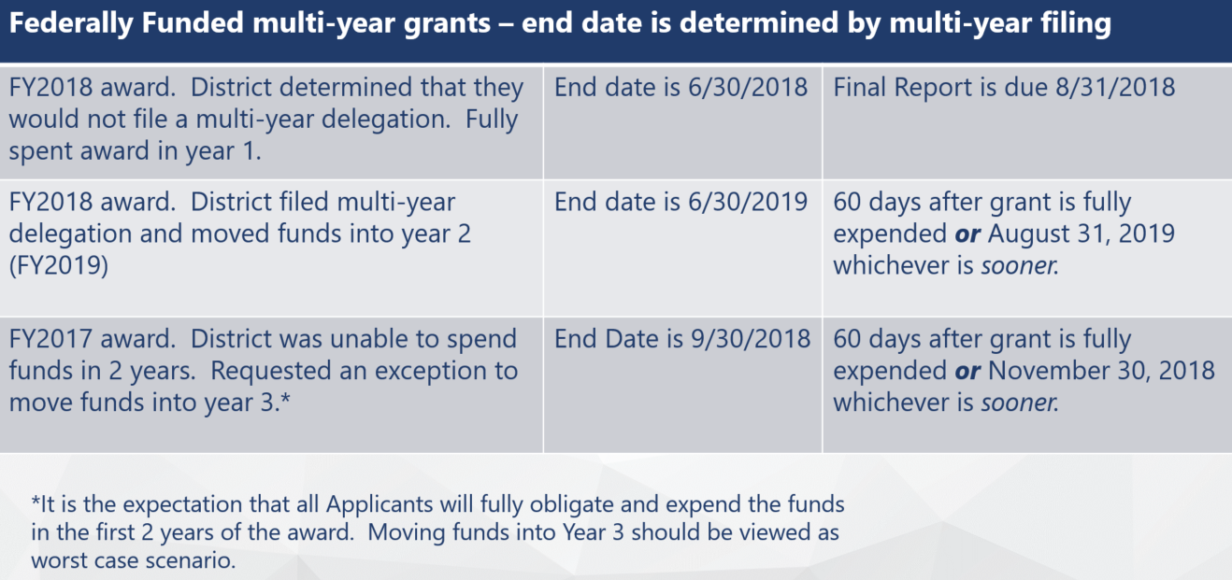

Applicants should use FY2018 Year 2 grant funds up before charging FY2019 grants.

DESE expects that before you try to file a final report, fiscal and programmatic staff will coordinate to ensure all funds have been expended appropriately and agree on the total amounts.
BACK TO THE TOP

User Request Form / EdGrants Webinars
DESE requires a user request form be submitted for all new users and edits to existing users. Please review http://www.doe.mass.edu/grants/edgrants/user-security-controls.html for more information and a copy of the Front Office User Request Form.

EdGrants Front Office user webinars are available with ongoing sessions being added as needed. Please click here to review the sessions offered and to register.
BACK TO THE TOP

Requesting Funds Reminders & FAQs

Sherriff / State Agency Departments / Colleges who receive grant funds (all fund codes) directly through MMARS accounts via ISAs do NOT need to request grant funds using EdGrants.
-----
Funds can only be requested if your grant has been programmatically approved, processed and an automatic Initial Payment has been issued by DESE.

http://www.doe.mass.edu/Grants/edgrants.html
http://www.doe.mass.edu/Grants/edgrants.html
http://www.doe.mass.edu/Grants/edgrants.html
http://www.doe.mass.edu/Grants/edgrants.html

http://www.doe.mass.edu/grants/edgrants/requesting-funds.docx outlines step by step how to make your payment request as well as how to view your Project Record Card.

Please find all EdGrants user documents here.
BACK TO THE TOP

_ _ _ _ _

If you need assistance, please contact Grants Management at 781-338-6595 or email EdGrants@doe.mass.edu. Please reference your grant project number or fund code and Applicant number (LEA Code) when you call and/or email.

Thank you,
Grants Management

