Massachusetts Department of

Elementary and Secondary Education

Grants Management

75 Pleasant Street, Malden, Massachusetts 02148-4906 Telephone: (781) 338-6595 TTY: N.E.T. Relay 1-800-439-2370

Grants Management May Update

- May Payment Request window is now available
- Monthly Update – new look and feel!
- Multi-Year is now closed!
- Grant Amendments
- FY2019 ISAs to State Entities Including Colleges
- Changes to Award / Payment Notices
- Final Reports (FR1)
- User Request Form / EdGrants Webinars
- Requesting Funds Reminders & FAQs

May Payment Request is now available

This is a courtesy reminder that the May Payment Request window is open now through May 31st. This window is open for all approved FY2019 grants as well as FY2018 Multi-Year grants that are currently in year 2 with balances left to draw down. (FY2018 Multi-Year grants* are only Fund Codes: 140, 141, 180, 186, 305, 309, 240).

*Grantees with FY18 year two balances should be using those balances for FY19 expenditures before charging FY19 expenses to the new FY19 award. If you need to amend your grant(s) to accommodate these charges, please be sure to contact your program liaison to request an amendment for you to complete in EdGrants.

To request grant funds, log into EdGrants with your DESE provided user name and password. If you are new to EdGrants, please review the Requesting Funds Reminders & FAQs. Don’t have a login? Please review the http://www.doe.mass.edu/grants/edgrants/user-security-controls.html information which explains how to get connected.

Locked out of EdGrants? Grants Management staff periodically checks and unlocks those who are locked out throughout the day. If you continue to find that you are locked out, please call the Grants Management main line at 781-338-6595 for assistance.
BACK TO THE TOP

Monthly Update – new look and feel!

The Grants Management Updates have transitioned over to MailChimp, which is used by other offices within DESE to communicate information out to our constituency. This new formatting contains the same helpful information regarding the EdGrants fiscal year and items of interest as it always does. Grants Management will continue to post the monthly update for reference on the grants website under Grants Notifications and Alerts. Previously posted monthly updates are always available in the Grants News Archives.

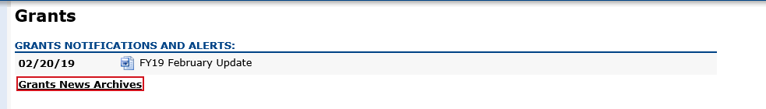
Multi-Year is now closed!
The final chance to submit any Multi-Year requests in EdGrants was May 14, 2019.
The only FY2019 grant fund codes that have multi-year available in EdGrants are:
- 140 (Title II-A)
- 180 / 186 (Title III)
- 218* (High-Quality Instruction – Summer Planning)
- 240 (Special Ed)
- 262 (Early Childhood Special Ed)
- 305 (Title I)
- 309 (Title IV)

If the multi-year delegation form was not submitted in EdGrants, or if $0 was moved into Year 2, the grant end date is 6/30/2019. If multi-year was submitted moving any funds into Year 2, the grant end date is now 6/30/2020.

Unclaimed balances left in year 1 will roll into Year 2 automatically in September.

*Fund Code 218 – High-Quality Instruction – Summer Planning grantees have a grant end date of 8/31/2019, provided a multi-year delegation form was submitted moving some funds into Year 2. This grant is not available for the 24-month grant period as the other multi-year grants are.
BACK TO THE TOP
Grant Amendments

It’s good to have a practice of assessing grant spending on a quarterly basis to determine if you need to request an amendment.

Amendments are Required When:
- there is any significant change in program objectives; or
- there is any increase or decrease in the total amount of the grant; or
- an increase in a line of the budget exceeds $100 or 10% of the line (whichever is greater) or exceeds $10,000.
Amendments should be submitted at least thirty (30) days prior to the desired change and must be submitted thirty (30) days before the conclusion of the project. The maximum number of amendments to any grant may not exceed three (excepting any required by the Department). Exceptions to this limit may be allowed. The EdGrants Front Office User Guide: Amending the Application Submission has detailed instructions as to how to how to amend your grant submission in EdGrants.

FY2019 ISAs to State Entities Including Colleges

Amending your ISA
Information regarding how to amend was sent out to all ISA contacts in mid-January. All FY2019 state funded ISAs can no longer be amended as the deadline to do so has passed.

FY2019 federally funded ISAs may still be amended if needed, but please assess your expenditures and make the request for any changes as soon as possible.

Fringe Information
The fringe rate for those receiving state grants is 1.73% of AA and CC payroll (D09). Federal/trust accounts are 36.62% of AA payroll and 1.73% of CC payroll (D09). Please review the approved rates with the MA Comptroller’s Office. If you are required to contribute to D08, please add that separately on the ISA.

Please note that you can find the proposed FY20 rate on the MA Comptroller’s and you can also check back for the rate is approved. We will also notify you about the rate changes for FY20 once approved.

If you have any questions regarding amending your ISA, please contact your Grants Management liaison.
BACK TO THE TOP

Changes to Award / Payment Notices

The Office of Management and Budget (OMB) requires all pass-through entities (DESE) to provide additional information to sub-recipients regarding their federal awards. You will now see this information at the bottom of the payment notice, with a link to the Federal Awards letters as provided by USED.
BACK TO THE TOP

Filing Final Financial Reports (FR1)

FY2018 Final Reports should have already been submitted in EdGrants for grant ending 6/30/2018 or 8/31/2018. If an Applicant has not submitted an FR-1 for an FY2018 grant, please do so ASAP.

Please make sure that all expenses have been accounted for and reconciled before you file a Final Report. If no FY2018 final report is available for a particular grant project in the Submissions menu, please email EdGrants@doe.mass.edu and include the project number in the email. You can also call the main grants line at 781-338-6595, again please have the project number ready.

Please note: There is a known glitch with the final report form in EdGrants. If the line item is overspent by a small amount, it throws the “Balance Unexpended” and the percentage columns off. We are working to correct this error. In the meantime, you can submit the final report; the “Cash Balance” section at the bottom of the report form does calculate correctly.

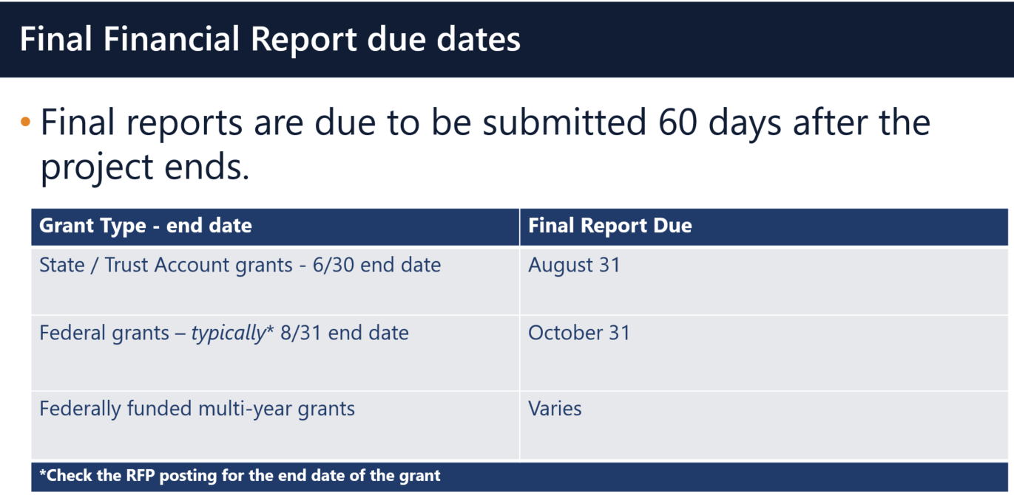

Multi-Year grants: DESE expects that Applicants will spend down their funds in full and not return money now that the multi-year feature is available in EdGrants for specific grant fund codes.

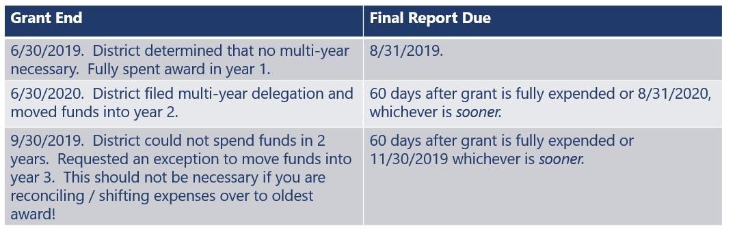

Applicants should finish expending FY2018 Year 2 grant funds. Shift expenses from FY2019 to FY2018 and amend if/as needed.

DESE expects that before you try to file a final report, district fiscal and programmatic staff will coordinate to ensure all funds have been expended appropriately and agree on the total amounts.
BACK TO THE TOP

User Request Form / EdGrants Webinars
DESE requires a user request form be submitted for all new users and edits to existing users. Please review http://www.doe.mass.edu/grants/edgrants/user-security-controls.html for more information and a copy of the Front Office User Request Form.

EdGrants Front Office user webinars are available with ongoing sessions being added as needed. Please click here to review the sessions offered and to register.
BACK TO THE TOP

Requesting Funds Reminders & FAQs

Sherriff / State Agency Departments / Colleges who receive grant funds (all fund codes) directly through MMARS accounts via ISAs do NOT need to request grant funds using EdGrants.
-----
Funds can only be requested if your grant has been programmatically approved, processed and an automatic Initial Payment has been issued by DESE.

http://www.doe.mass.edu/Grants/edgrants.html
http://www.doe.mass.edu/Grants/edgrants.html
http://www.doe.mass.edu/Grants/edgrants.html
http://www.doe.mass.edu/Grants/edgrants.html

http://www.doe.mass.edu/grants/edgrants/requesting-funds.docx outlines step by step how to make your payment request as well as how to view your Project Record Card.

Please find all EdGrants user documents here.
BACK TO THE TOP

_ _ _ _ _

If you need assistance, please contact Grants Management at 781-338-6595 or email EdGrants@doe.mass.edu. Please reference your grant project number or fund code and Applicant number (LEA Code) when you call and/or email.

Thank you,
Grants Management

