Massachusetts Department of

Elementary and Secondary Education

Grants Management

75 Pleasant Street, Malden, Massachusetts 02148-4906 Telephone: (781) 338-6595 TTY: N.E.T. Relay 1-800-439-2370

Grants Management September Update

- September Payment Request window is now available
- FY2020 EdGrants Front Office User Certification – Action Required
- FY2020 Initial Payments
- FY2020 Federal Grant Assurances
- Monthly Updates posted on the Grants Management website
- Federal/Entitlement Multi-Year Grants
- Grant Amendments
- Changes to Community College ISA process
- Final Reports (FR1)
- User Request Form / EdGrants Webinars
- Requesting Funds Reminders & FAQs

September Payment Request window is now available

This is a courtesy reminder that the September Payment Request window is open now through September 30th.

This includes any FY2020 grants where an initial payment has been received, as well as any FY2019 Year 2 and FY2018 Year 3 grants.

Unclaimed 2019 Year 1/ 2018 Year 2 balances are being rolled now and will be available to draw in the October payment request window.

To request grant funds, log into EdGrants with your DESE provided user name and password. If you are new to EdGrants, please review the Requesting Funds Reminders & FAQs. Don’t have a login? Please review the http://www.doe.mass.edu/grants/edgrants/user-security-controls.html information which explains how to get connected.

Locked out of EdGrants? Grants Management staff periodically checks and unlocks those who are locked out throughout the day. If you continue to find that you are locked out, please call the Grants Management main line at 781-338-6595 for assistance.
BACK TO THE TOP

FY2020 EdGrants Front Office User Certification – Action Required

On September 13th Grants Management sent out an email reading the FY2020 EdGrants Front Office User Certification. Please, business managers or financial administrators, review EdGrants users for your Applicant/LEA and return the form as described in the email. Very soon, this information will be posted on the grants site under Grants Notifications and Alerts.
FY2020 Initial Payments

Once grants management receives a programmatically approved grant from the program unit administering the grant, an encumbrance is set up via EdGrants and MMARS (the state’s accounting system). When that encumbrance clears MMARS to final status, we can issue an initial payment in the amount of 10% of the budgeted amount of the grant. In order to ensure smooth initial payment, we ask that grantees hold off on requesting line item amendments to make budget changes until October. Amending your grant can delay encumbrance setup and initial payment release.
BACK TO THE TOP

FY2020 Federal Grant Assurances

The FY2020 Federal Grant Assurances document can be found on Resource Allocation Strategy and Planning (RASP) as well as under the Required Forms section of the FY2020 Title I (FC: 305) RFP posting. Grant Assurances must be uploaded with the district’s Title I application which is a change in the past method of submission. Please contact the RASP unit at federalgrantprograms@doe.mass.edu or call 781-338-6230 with any questions regarding the FY2020 Federal Grant Assurances.

Monthly Updates

These Grants Management Updates are posted each month on the grants website under Grants Notifications and Alerts. Previously posted monthly updates are always available in the Grants News Archives.
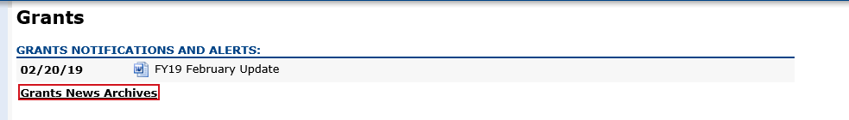
BACK TO THE TOP
Federal/Entitlement Multi-Year grants
The purpose of the multi-year grants in EdGrants is to allow continuous spending of funds resulting in no grant returns.

FY2019 Award: If the multi-year delegation form was not submitted in EdGrants, if $0 was moved into Year 2, and/or no unclaimed funds were left to roll, the grant end date was 6/30/2019. Final Reports should be filed.

If multi-year was submitted moving funds into Year 2, the grant end date is now 6/30/2020.
No Final Report is expected until funds are fully drawn down and reconciled.

Unclaimed balances left in year 1 are in the process of being rolled and the grant end date is being extended to 6/30/2020. These rolled funds will be available to draw in the October payment request window, as we need September to complete the manual rolls.

FY2018 Award: Very few FY2018 Multi-Year 2-3 delegation forms were submitted in EdGrants requesting that a year 3 be added (FY2020). This is good news as Year 3 should be viewed as an exception and only utilized if the alternative would be returning grant funds.

If the multi-year delegation form was not submitted in EdGrants, if $0 was moved into Year 3, and/or no unclaimed funds were left to roll, the grant end date was 6/30/2019. Final Reports should be filed.

DESE expects that applicants will assess expenditures and shift FY19/FY20 charges over to the FY18 award where necessary and appropriate. In some cases, this will require an amendment to the FY18 or FY19/FY20 grant budgets.

If multi-year was submitted moving funds into Year 3, the grant end date is now 9/30/2019.
No Final Report is expected until funds are fully drawn down and reconciled.

Unclaimed balances left in year 2 are in the process of being rolled and the grant end date is being extended to 9/30/2019. These rolled funds should be available to draw in this current window as well as the October payment request window.
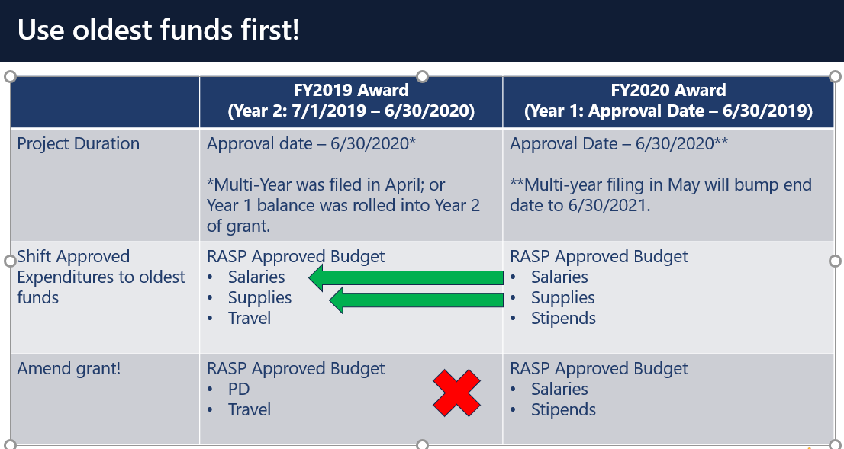

If you’d like to request an amendment, please contact your federal grants group liaison.

BACK TO THE TOP

Grant Amendments

In order to ensure a smooth start to FY2020, we ask that grantees hold off on requesting line item amendments on FY2020 grants until October. Amending your grant right after you submit it in EdGrants can delay encumbrance setup and initial payment release.

BACK TO THE TOP

Changes to Community College ISA Process

After some discussion with the Comptroller’s Office, we are happy to announce that for FY20 grants, state community colleges no longer will be required to setup BGCS / BGCNs on MMARS to access grant funds. As in years past, ISA paperwork will still be required and maintained on file here at DESE, but EdGrants should be used to draw down grant funds. Colleges are still required to do the monthly reporting in MMARS for grant funds.

Approved FY20 Fringe Rates for Correctional Facilities
Fringe Rate on State grants is 2.43% of AA and CC payroll (D09).
Fringe Rate on Federal/trust accounts is 37.91% of AA payroll and 2.43% of CC payroll

Approved FY20 Fringe Rates for State Colleges/ Universities
Fringe Rate on State/Federal/trust accounts is 37.91% of AA payroll and 2.43% of CC payroll

You can also view that on the MA Comptrollers. We will also notify you about the rate changes for FY20 once approved.

We will set up ISA webinars for the colleges soon and you’ll find those http://www.doe.mass.edu/grants/edgrants (keep checking back) if you questions, and you need help right away with something give us a call on the main line at 781-338-6595; please have the project number ready.

Thank you for your patience and time during this past year as we sorted this out.

BACK TO THE TOP

Filing Final Financial Reports (FR1)

Final Reports should not be submitted until all expenses have been accounted for and reconciled.

FY2019 Final Reports will be available in EdGrants the day after the grant project duration ends.
- FY2019 grants that end 6/30/2019 were available as of 7/1/2019.
- FY2019 grant that end 8/31/2019 were available as of 9/1/2019.

If you do not see an FY2019 final report available for a specific grant project in the Submissions menu, please email EdGrants@doe.mass.edu and include the project number in the email. You can also call the main grants line at 781-338-6595; please have the project number ready.

Please note there are a couple of known glitches with the final report form in EdGrants:
- If the line item is overspent by a small amount that is within the allowable thresholds, it throws the “Balance Unexpended” and the percentage columns off. We are working to correct this error. In the meantime, you can submit the final report; the “Cash Balance” section at the bottom of the report form does calculate correctly.
- If your Final Report shows a balance to return less than $1, you do not need to return the funds.

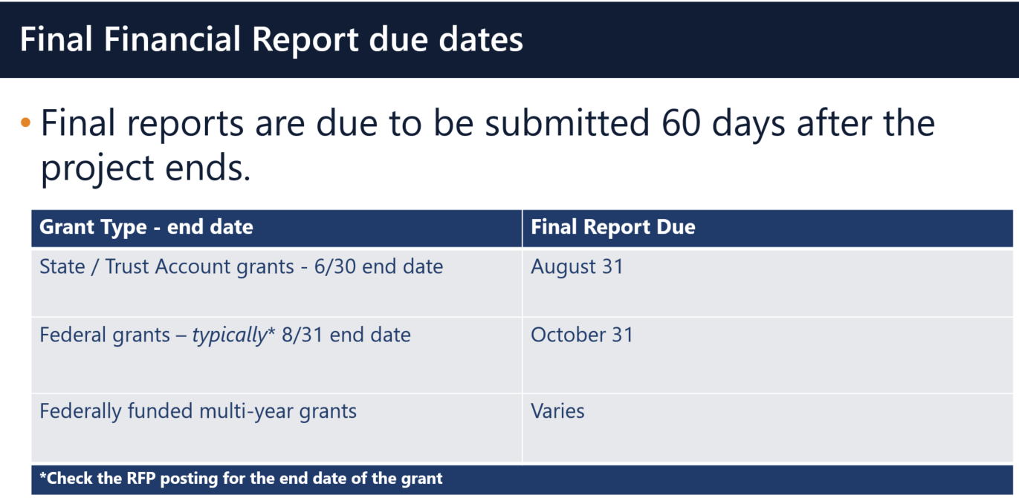

Multi-Year grants: DESE expects that Applicants will spend down their funds in full and not return money now that the multi-year feature is available in EdGrants for specific grant fund codes.

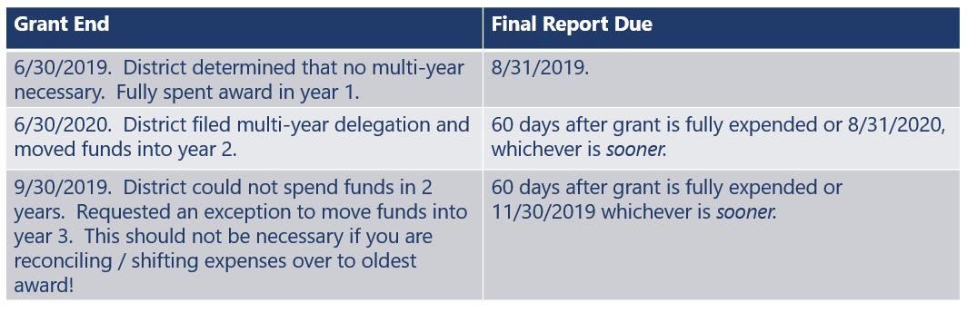

DESE expects that before you try to file a final report, district fiscal and programmatic staff will coordinate to ensure all funds have been expended appropriately and agree on the award total.
BACK TO THE TOP

User Request Form / EdGrants Webinars
DESE requires a user request form be submitted for all new users and edits to existing users. Please review http://www.doe.mass.edu/grants/edgrants/user-security-controls.html for more information and a copy of the Front Office User Request Form.

EdGrants Front Office user webinars will be available with ongoing sessions being added as needed. Please click here to review the sessions offered and to register.
BACK TO THE TOP

Requesting Funds Reminders & FAQs

Sherriff / State Agency Departments who receive grant funds (all fund codes) directly through MMARS accounts via ISAs do NOT need to request grant funds using EdGrants.
-----
Funds can only be requested if your grant has been programmatically approved, processed and an automatic Initial Payment has been issued by DESE.

http://www.doe.mass.edu/grants/edgrants
http://www.doe.mass.edu/grants/edgrants
http://www.doe.mass.edu/grants/edgrants
http://www.doe.mass.edu/grants/edgrants

http://www.doe.mass.edu/grants/edgrants/requesting-funds.docx outlines step by step how to make your payment request as well as how to view your Project Record Card.

Please find all EdGrants user documents here.
BACK TO THE TOP

_ _ _ _ _

If you need assistance, please contact Grants Management at 781-338-6595 or email EdGrants@doe.mass.edu. Please reference your grant project number or fund code and Applicant number (LEA Code) when you call and/or email.

Thank you,
Grants Management

