*****Massachusetts Department of***

***Elementary and Secondary Education***

***Grants Management***

### 75 Pleasant Street, Malden, Massachusetts 02148-4906 Telephone: (781) 338-6595 TTY: N.E.T. Relay 1-800-439-2370

***Grants Management April Update***

These updates are also posted on the [Grants Management Website](https://www.doe.mass.edu/Grants/)

* April Payment Request Window is open
* FY2021 Multi-Year Delegation
* FY2019 and FY2020 Multi-Year Grant Balances
* Vendor Web
* FY2020 Final Financial Reports (FR1) – past due
* FY2021 Grants and the Part I signatures
* Community College / Sherriff’s Department ISAs
* EdGrants Users
* Requesting Funds Reminders & FAQs

**April Payment Request Window is Open**

This is a courtesy reminder that the April Payment Request window is open through April 30, 2021.

This includes any FY2021 grants where an initial payment has been received, as well as Multi-Year grants for FY2020 Year 2 (use Year 2 form) and FY2019 Year 3.

**A note regarding FY2019 Year 3 request forms: The FY2019 Year 3 payment request window has some glitches. If you are unable to draw funds that are shown in the available grant balance but do not show in the Current Available to draw section, please email** [**EdGrants@mass.gov**](mailto:EdGrants@mass.gov)**. It will take us time to get through the emails, so your patience is appreciated.**

To request grant funds, log into [EdGrants](https://edgrants.eoe.mass.edu/grantium/frontOffice.jsf) with your DESE provided user name and password. If you are new to EdGrants, please review the Requesting Funds Reminders & FAQs. Don’t have a login? Please review the [User Security Controls](https://www.doe.mass.edu/grants/edgrants/user-security-controls.html) information which explains how to get connected.

Locked out of EdGrants? Grants Management staff periodically checks and unlocks those who are locked out throughout the day. If you continue to find that you are locked out, please call the Grants Management main line at 781-338-6595 for assistance.

BACK TO THE TOP

**FY2021 Multi-Year Delegation**

**Just as we did last year, DESE is going to submit multi-year delegation forms for all grantees with balances left of over $5,000 to activate the extended period of availability.**

|  |  |
| --- | --- |
| **Active Multi-Year Grant Programs** | **Federal Award Year** |
| Title I (FC: 305) | FY2020 & FY2021 |
| Title II-A (FC: 140) | FY2020 & FY2021 |
| Title III (FC: 180 and 186) | FY2020 & FY2021 |
| Title IV (FC: 309) | FY2020 & FY2021 |
| IDEA (FC: 240) | FY2020 & FY2021 |
| Early Childhood Special Ed (FC: 262) | FY2020 & FY2021 |
| ESSER I (FC: 113) | FY2020 & FY2021 |
| ESSER II (FC: 115) | FY2020 & FY2021 |

**ACTION ITEM: By MAY 5th**

Applicants that **DO NOT** want us to roll any funds into FY2022, because all funds will be obligated by June 30, 2021 must email [Jennifer.M.Ahern@mass.gov](mailto:Jennifer.M.Ahern@mass.gov) asap and no later than May 5th. Otherwise, for those with an unclaimed balance of over $5,000, we will move $100 into FY2022.

**ACTION ITEM: MAY 1st through May 7th**

Applicants that **would like to file their own** multi-year delegation moving more than $100 over to FY2022 may do so May 1, 2021 through May 7, 2021. Grantees will be able to draw these funds down starting in the July Year 2 payment request window (FY2021 awards) and/or the July Year 3 payment request window (FY2020 awards). Otherwise, for those with an unclaimed balance of over $5,000, we will move $100 into FY2022.

**THE MULTI-YEAR DELEGATION ONLY PERTAINS TO THE GRANT FUND CODES LISTED IN THE ABOVE CHART.**

BACK TO THE TOP

**FY2019 and FY2020 Multi-Year Grant Balances:**

**Unclaimed grant balances for FY2019 and FY2020 awards should be obligated and expended first. The FY2019 Year 3 and FY2020 Year 2 request window is open. DESE expects that these balances will be drawn in full as soon as possible. Please contact your** [**RASP liaison**](https://www.doe.mass.edu/federalgrants/liaisons.xlsx) **if you have questions regarding IDEA funds (FC 240) and the pro-share set aside.**

Federal Grants covered by the Tydings provision have an obligation period that covers approximately 27 months. FY2019 awards that originally would have expired September 30, 2020 were extended due to the COVID pandemic.

|  |  |  |
| --- | --- | --- |
| **Grant Program** | **Federal Award Year** | **Current End Date** |
| Title I (FC: 305) | FY2019 & FY2020 | 6/30/2021 |
| Title II-A (FC: 140) | FY2019 & FY2020 | 6/30/2021 |
| Title III (FC: 180 and 186) | FY2019 & FY2020 | 6/30/2021 |
| Title IV (FC: 309) | FY2019 & FY2020 | 6/30/2021 |
| IDEA (FC: 240) | FY2019 & FY2020 | 6/30/2021 |
| Early Childhood Special Ed (FC: 262) | FY2019 & FY2020 | 6/30/2021 |
| Civics Teaching and Learning (FC: 589)* | FY2020 | 6/30/2021 |

*FC: 589 is a state trust funded grant, not a federal award.

If all funds have been drawn for FY2019 or FY2020 multi-year grants, outstanding invoices have been reconciled/paid and all goods and services received, a final report (FR-1) should be filed in EdGrants ASAP.

BACK TO THE TOP

**Vendor Web**

Confused about payments? Not sure if you received a payment? Applicants can locate information regarding any payments received by DESE (and any other state agency) by logging in to the MA Comptroller’s [Vendor Web](https://massfinance.state.ma.us/VendorWeb/vendor.asp) site. This link includes a job aid on how to use Vendor Web.

BACK TO THE TOP

**FY2020 Final Financial Reports (FR-1) – past due**

All grantees must file a Final Financial Report (FR-1) in EdGrants to close out the grants. Final Reports are available in EdGrants the day after the grant project duration ends.

* FY2020 grants that ended 6/30/2020 were available 7/1/2020 and were due 8/31/2020 – these FR-1s should now be complete*
* FY2020 grants that ended 8/31/2020 are available (since 9/1/2020) and were due 10/31/2020 - these FR-1s should now be complete**
* For Multi-Year grants with balances, please do not file your FR-1 until you have drawn down and reconciled all funds spent and all expected invoices.
* Please DO NOT return unspent funds less than $1.

*FY19 and FY20 **multi-year** grants with unclaimed balances are due to be filed 60 days after final draw down. See Due Dates Chart below.

If you do not see a final report available for a specific grant project in the Submissions menu, please email [EdGrants@mass.gov](mailto:EdGrants@mass.gov) and ***include the project number in the email.*** You can also call the main grants line at 781-338-6595; please have the project number ready.

**Please note there are a couple of known glitches with the final report form in EdGrants:**

* If the line item is overspent by a small amount that is within the allowable thresholds, it throws the “Balance Unexpended” and the percentage columns off. We are working to correct this error. In the meantime, you can submit the final report; the “Cash Balance” section at the bottom of the report form does calculate correctly.
* **If your Final Report shows a balance to return less than $1, you do not need to return the funds.**

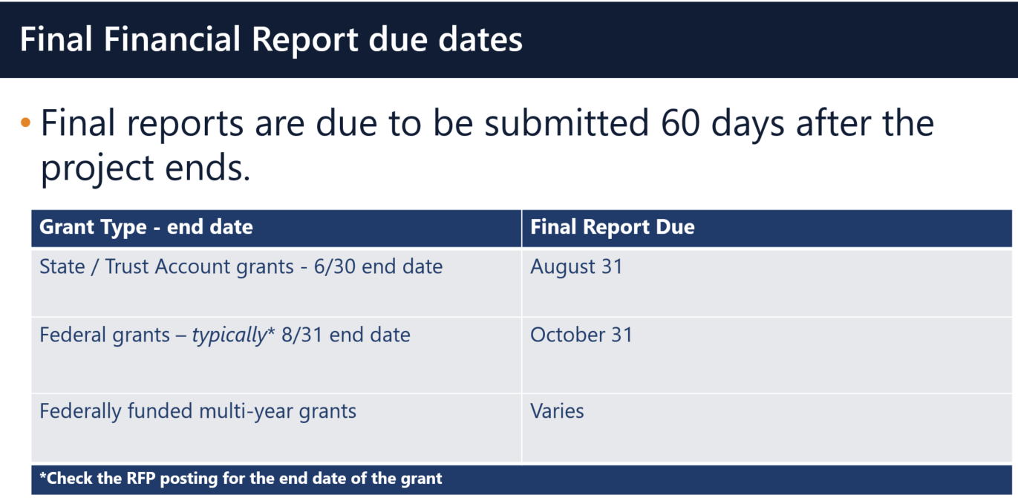

**Multi-Year grants:** DESE expects that Applicants will spend down their funds in full and not return money now that the multi-year feature is available in EdGrants for specific grant fund codes.

**DESE expects that before you try to file a final report, district fiscal and programmatic staff will coordinate to ensure all funds have been expended appropriately and agree on the award total.**

BACK TO THE TOP

**FY2021 Grants and the Part I signatures**

Per our fiscal oversight agency, the Massachusetts state Comptroller’s office (CTR), the original signature requirement has not been waived and we cannot accept an electronic signature on the Part I documents.  A grant is a type of contract.  Please see below the standard language for all signed contracts.

**Authorizing Signature for Contractor/Date**: The Authorized Contractor Signatory must (in their own handwriting and in ink) sign AND enter the date the Contract is signed. See section above under “Anticipated Contract Start Date”. Acceptance of payment by the Contractor shall waive any right of the Contractor to claim the Contract/Amendment is not valid and the Contractor may not void the Contract**. Rubber stamps, typed or other images are not acceptable**. Proof of Contractor signature authorization on a **Contractor Authorized Signatory Listing** may be required by the Department if not already on file. **Electronic or digital signatures are not authorized at this time.**

**Contractor Name /Title:** The Contractor Authorized Signatory’s name and title must appear legibly as it appears on the **Contractor Authorized Signatory Listing**.

Screen Shot of Contractor Terms and Conditions.


This form is published and issued jointly by the Executive Office for Administration and Finance (ANF), the Office of the State Comptroller (CTR), and the Operational Services Division (OSD) for use by all commonwealth Departments for New Grants/Contracts and Grant/Contract Agreements or Renewals.  The policies, procedures, and legal references outlines therein, have been incorporated by reference in the Office of the Comptroller regulations, [815 CMR 2.00: Grants and Subsidies](https://www.mass.gov/files/documents/2017/11/01/815cmr2.pdf).

While we maintain these forms on file in the Department as a master service agreement between the Department (state) and the grantee, part of our agreement with CTR is to collect and maintain a Part I, which serves as a contract form for *each individual grant program*, to determine date of signature and contracted (grant award) amount on file and as such is treated as a contract form falling under the same regulations as above.

The Comptroller’s office is piloting the use of electronic signatures but we as a Department have not been authorized at this time to accept anything other than originals or scanned uploads of the original Part Is for each program grant.

To assist getting the Part I signed and uploaded properly for FY2021 grants we have put together the following options as an assist to our grantees:

* Email the PART I to the authorized signatory and have them scan and email it back to upload into the EdGrants Application Submission.
* Have the authorized signatory sign, upload the enter grant into EdGrants with all docs forward from the applicant’s program personnel.  (Some districts already operate this way.)
* Obtain an email from the authorized signatory authorizing the grant applicant to sign during this time and scan and upload the Part I with applicant’s signature; send the authorizing email to the proper program unit overseeing the grant. They should forward the email to Grants Management once they approve the grant in EdGrants.  (We do not want these emails until we have the grant to process, please).
* Convert the signed document to PDF using an iPhone or Android:
  + iPhone users can take a picture of the signed Part I and convert it to a PDF: https://www.igeeksblog.com/how-to-convert-photos-to-pdf-on-iphone-ipad/.
  + Android  users to take a picture of the signed Part I and convert to a PDF using [Google Drive, or](https://www.androidpolice.com/2020/05/28/create-convert-pdf-phone-camera-android-free/) [Microsoft Office Lens](https://www.androidpolice.com/2020/05/28/create-convert-pdf-phone-camera-android-free/).

BACK TO THE TOP

**Community College / Sherriff’s Department ISAs**

The [EdGrants: User Guides, Information and Training](https://www.doe.mass.edu/grants/edgrants.html) section of the Grants Management website has been updated to include tools and information regarding Interdepartmental Services Agreement (ISA) process.

*Fringe Rates for Correctional Facilities:*

**Approved** FY21 Fringe Rate on **State** grants is 1.94% of AA and CC payroll (D09).   
Fringe Rate on **Federal**/**trust accounts** is 38.32% of AA payroll and 1.32% of CC payroll

**Proposed** FY22 Fringe Rate on **State** grants is 1.97% of AA and CC payroll (D09).   
Fringe Rate on **Federal**/**trust accounts** is 39.5% of AA payroll and 1.97% of CC payroll

*Fringe Rates for State Colleges/ Universities****:***

**Approved** FY21 Fringe Rates on **State/Federal/trust accounts** is 38.32% AA payroll and 1.94% of CC payroll

**Proposed** FY22 Fringe Rates on **State/Federal/trust accounts** is 39.5% AA payroll and 1.97% of CC payroll

The state sets these rates, not the Department. Rates and charge backs can be reviewed at [MA Comptrollers](https://www.macomptroller.org/fiscal-year-updates).

Please see FY2020 Final Financial Report (FR-1) due dates which have passed. All grantees must file an FR-1 in EdGrants to close out their grants.

BACK TO THE TOP

**EdGrants Users**

DESE requires a user request form be submitted for all new users and edits to existing users. Please review [EdGrants: User Security Controls](https://www.doe.mass.edu/grants/edgrants/user-security-controls.html) for more information and a copy of the Front Office User Request Form.

It is the Applicant/LEAs responsibility to update user access as needed, including deactivating user access no longer needed.

BACK TO THE TOP

**Requesting Funds Reminders & FAQs**

*Sherriff / State Agency Departments* who receive grant funds (all fund codes) directly through MMARS accounts via ISAs do NOT need to request grant funds using EdGrants.

-----

Payment Request windows will only be available once your grant has been programmatically approved, processed and an automatic **Initial Payment** has been issued by DESE.

If you cannot see a Project Record Card or a Payment Request available during the draw-down window, it is likely because your grant has not yet finished processing and an initial payment has not yet been sent.

**[How to check the Project Record Card to view payments and payment notices](http://www.doe.mass.edu/grants/edgrants/requesting-funds.docx)**

[**How to Request Funds**](http://www.doe.mass.edu/grants/edgrants/requesting-funds.docx)

Please find all EdGrants user documents [here](http://www.doe.mass.edu/Grants/edgrants.html).

BACK TO THE TOP

If you need assistance, please contact Grants Management at 781-338-6595 or email [EdGrants@mass.gov](mailto:EdGrants@mass.gov). **Please reference your grant project number or fund code and Applicant number (LEA Code) when you call and/or email.**

**Due to high volume, it can take up to a week for response.**

Thank you,

Grants Management