*****Massachusetts Department of***

***Elementary and Secondary Education***

***Grants Management***

### 75 Pleasant Street, Malden, Massachusetts 02148-4906 Telephone: (781) 338-6595 TTY: N.E.T. Relay 1-800-439-2370

***Grants Management July Update***

* FY2021 Grant Start Dates: Required Forms for Grant Applicants - Time Sensitive Action Required
* July is the FINAL FY2020 Payment Request window
* FY2021 Grants and the Part I signatures
* Important Changes due to COVID-19: FY20 Multi-Year Delegation – updated 6/24/2020
* FY2020 Close / FY2021 Open Info
* Monthly Updates posted on the Grants Management website
* Community College / Sherriff’s Department ISAs
* Final Financial Reports (FR1)
* DESE Communication Survey
* EdGrants User Access Request
* Requesting Funds Reminders & FAQs

**FY2021 Grant Start Dates:** **Required Forms for FY2021 Grant Applicants - Time Sensitive Action Required**

All documents must be signed and in place for your entity prior to DESE being able to issue any FY2021 funds. This will impact FY2021 start dates if we have not received a signed dated form prior to 7/1/2020.

In October 2019, Grants Management notified all applicant lead agencies regarding state requirements needed before FY21 grants can be issued. DESE is still missing documentation from about one-third of the applicants. [Click here to review the memo and required forms.](http://www.doe.mass.edu/news/news.aspx?id=25747)

Please review the [Missing Standard Contract Forms](http://www.doe.mass.edu/grants/2021/missing-standard-contract-list.xlsx) list to determine if your entity needs to send in the required forms. Not having this documentation on file means we cannot issue any FY21 grants to the effected applicants until it is received. This can impact grant start dates. This list will be updated online weekly as we get responses.

If you are **not** on the list, it means we have all the documentation needed.

A reminder that DESE is “opting in” for the notary on the CASL form, but we realize that during this time it may be difficult to obtain a notary seal. ***We can accept CASL forms without the notary, temporarily, provided it accompanies a signed original Standard Contract Form.*** The notary can be sent in later when access to such things becomes available. If able to obtain the notary seal now, please do so. The CASL form is used any time pertinent secure information is changed in the applicant’s vendor profile setup, such as bank account information, so it is important that we have the CASL form with a notary seal and sign off when possible.

**July is the FINAL Payment Request window - now available**

This is a courtesy reminder that the July Payment Request window is open through July 31, 2020.

**This is the FINAL FY2020 payment request window, including grants that end 8/31/2020.**

To request grant funds, log into [EdGrants](https://edgrants.eoe.mass.edu/grantium/frontOffice.jsf) with your DESE provided user name and password. If you are new to EdGrants, please review the Requesting Funds Reminders & FAQs. Don’t have a login? Please review the [User Security Controls](http://www.doe.mass.edu/news/news.aspx?id=24371) information which explains how to get connected.

Locked out of EdGrants? Grants Management staff periodically checks and unlocks those who are locked out throughout the day. If you continue to find that you are locked out, please call the Grants Management main line at 781-338-6595 for assistance.

BACK TO THE TOP

**FY2021 Grants and the Part I signatures**

Per our fiscal oversight agency, the Massachusetts state Comptroller’s office (CTR), the original signature requirement has not been waived and we cannot accept an electronic signature on the Part I documents.  A grant is a type of contract.  Please see below the standard language for all signed contracts.

**Authorizing Signature for Contractor/Date**: The Authorized Contractor Signatory must (in their own handwriting and in ink) sign AND enter the date the Contract is signed. See section above under “Anticipated Contract Start Date”. Acceptance of payment by the Contractor shall waive any right of the Contractor to claim the Contract/Amendment is not valid and the Contractor may not void the Contract**. Rubber stamps, typed or other images are not acceptable**. Proof of Contractor signature authorization on a **Contractor Authorized Signatory Listing** may be required by the Department if not already on file. **Electronic or digital signatures are not authorized at this time.**

**Contractor Name /Title:** The Contractor Authorized Signatory’s name and title must appear legibly as it appears on the **Contractor Authorized Signatory Listing**.

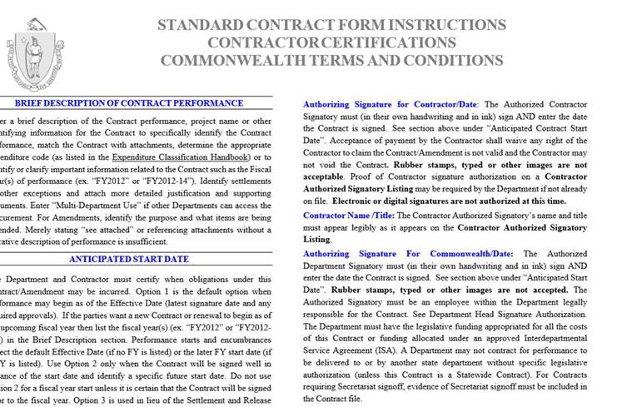

This form is published and issued jointly by the Executive Office for Administration and Finance (ANF), the Office of the State Comptroller (CTR), and the Operational Services Division (OSD) for use by all commonwealth Departments for New Grants/Contracts and Grant/Contract Agreements or Renewals.  The policies, procedures, and legal references outlines therein, have been incorporated by reference in the Office of the Comptroller regulations, [815 CMR 2.00: Grants and Subsidies](https://www.mass.gov/files/documents/2017/11/01/815cmr2.pdf).

While we maintain these forms on file in the Department as a master service agreement between the Department (state) and the grantee, part of our agreement with CTR is to collect and maintain a Part I, which serves as a contract form for *each individual grant program*, to determine date of signature and contracted (grant award) amount on file and as such is treated as a contract form falling under the same regulations as above.

The Comptroller’s office is piloting the use of electronic signatures but we as a Department have not been authorized at this time to accept anything other than originals or scanned uploads of the original Part Is for each program grant.

To assist getting the Part I signed and uploaded properly for FY2021 grants we have put together the following options as an assist to our grantees:

* Email the PART I to the authorized signatory and have them scan and email it back to upload into the EdGrants Application Submission.
* Have the authorized signatory sign, upload the enter grant into EdGrants with all docs forward from the applicant’s program personnel.  (Some districts already operate this way.)
* Obtain an email from the authorized signatory authorizing the grant applicant to sign during this time and scan and upload the Part I with applicant’s signature; send the authorizing email to the proper program unit overseeing the grant. They should forward the email to Grants Management once they approve the grant in EdGrants.  (We do not want these emails until we have the grant to process, please).
* Convert the signed document to PDF using an iPhone or Android:
  + iPhone users can take a picture of the signed [Part I and convert it to a PDF](https://www.igeeksblog.com/how-to-convert-photos-to-pdf-on-iphone-ipad/).
  + Android  users to take a picture of the signed Part I and convert to a PDF using [Google Drive, or](https://www.androidpolice.com/2020/05/28/create-convert-pdf-phone-camera-android-free/) [Microsoft Office Lens](https://www.androidpolice.com/2020/05/28/create-convert-pdf-phone-camera-android-free/).

**Important Changes due to COVID-19: FY20 Multi-Year Delegation**

Due to the ongoing COVID-19 pandemic, and related school closures which may impact the ability to spend down funds in both FY2019 Year 2 and FY2020 Year 1 entitlement grants, **DESE has submitted and processed Multi-year Delegation forms on behalf of Applicants with balances remaining over $100. Applicants do not need to take any action to obtain the multi-year extension from FY2020 to FY2021.**

These are the **only** grants with Multi-Year provision getting extended by DESE:

|  |  |
| --- | --- |
| **Grant Program** | **Federal Award Year** |
| Title I (FC: 305) | FY2019 & FY2020 |
| Title I Part D (FC: 306/307)** | FY2019 & FY2020 |
| Title II-A (FC: 140) | FY2019 & FY2020 |
| Title III (FC: 180 and 186) | FY2019 & FY2020 |
| Title IV (FC: 309) | FY2019 & FY2020 |
| IDEA (FC: 240) | FY2019 & FY2020 |
| Early Childhood Special Ed (FC: 262) | FY2019 & FY2020 |
| Civics Teaching and Learning (FC: 589)* | FY2020 |

** Funds extended through an ISA. Communication to impacted grantees has gone out please contact: [jennyfer.cabral@mass.gov](mailto:Jennyfer.cabral@mass.gov) for questions regarding your ISA.

This has extended the end date for both FY2019 and FY2020 grants as follows:

*6/24/2020: Please note DESE was notified by USED that the FY2019 IDEA related grants have also been granted an extension beyond 9/30/2020. See update below.*

|  |  |  |
| --- | --- | --- |
| **Grant Program** | **Federal Award Year** | **New End Date** |
| Title I (FC: 305) | FY2019 & FY2020 | 6/30/2021 |
| Title I Part D (FC: 306/307) | FY2019 & FY2020 | 6/30/2021 |
| Title II-A (FC: 140) | FY2019 & FY2020 | 6/30/2021 |
| Title III (FC: 180 and 186) | FY2019 & FY2020 | 6/30/2021 |
| Title IV (FC: 309) | FY2019 & FY2020 | 6/30/2021 |
| IDEA (FC: 240) | FY2019 & FY2020 | 6/30/2021 |
| Early Childhood Special Ed (FC: 262) | FY2019 & FY2020 | 6/30/2021 |
| Civics Teaching and Learning (FC: 589) | FY2020 | 6/30/2021 |

Other DESE discretionary grant programs, do NOT utilize the multi-year feature in EdGrants.

BACK TO THE TOP

**FY2020 Close / FY2021 Open Info**

**FY2020: The FINAL July payment request window for all FY2020 grants (that are not multi-year) is open now through July 31st. This includes state grants as well as federally funded grants with an 8/31/2020 end date.**

|  |  |  |
| --- | --- | --- |
| **Grant Type** | **Award Year** | **Payment Request Window** |
| State / Federal / Trust – All Fund Codes*  **This includes Federal grants ending 8/31/2019**  *except multi-year fund codes | 2020 | July 20th – July 31st  **Final** opportunity to request funds including grants that end 8/31/2019. |
| **FY2019 and FY2020 Multi-Year Payment Request Windows** | | |
| Fund Codes: 305 (Title I), 140 (Title II-A), 180 & 186 (Title III), 309 (Title IV), 240 (IDEA), 262 (Early Childhood Special Ed) and 589 (Civics Teaching and Learning) | | |

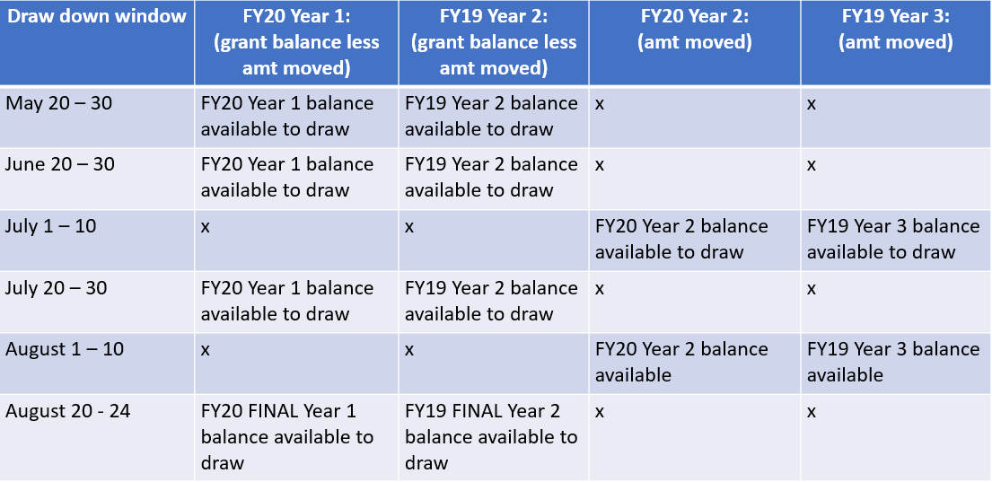

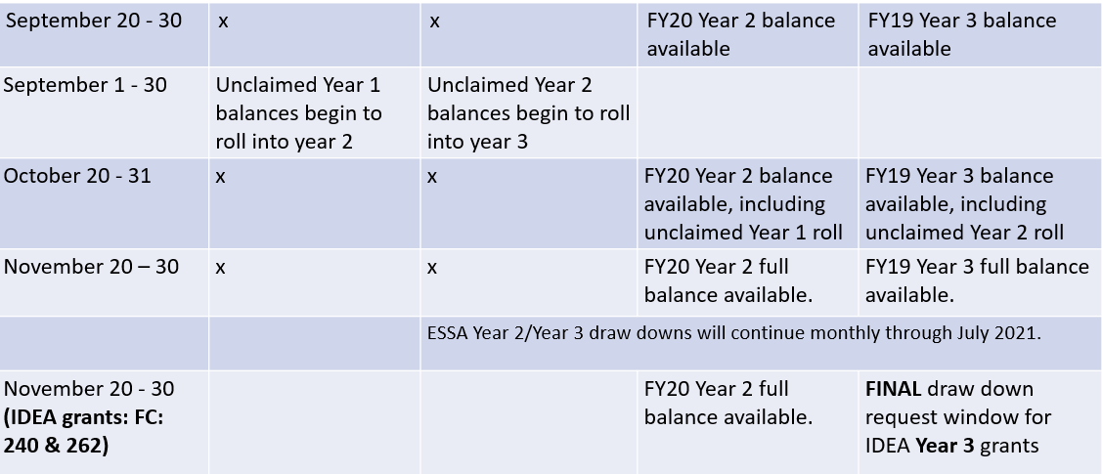

FY2021:Payment Request windows will not be available until the grant has been programmatically approved, processed and an automatic **Initial Payment** has been issued by DESE.

Once grants management receives a programmatically approved grant from the program unit administering the grant, an encumbrance is set up on MMARS (the state’s accounting system) via EdGrants.

When the encumbrance clears MMARS to final status, DESE will issue an automatic initial payment in the amount of 10% of the budgeted amount of the grant. **To ensure smooth initial payment, we ask that grantees hold off on requesting budget line item amendments until October. Amending your grant can delay encumbrance setup and initial payment release.**

BACK TO THE TOP

**Monthly Updates**

These Grants Management Updates are posted each month on the [grants website](http://www.doe.mass.edu/Grants/) under **Grants Notifications and Alerts**. Previously posted monthly updates are always available in the **Grants News Archives.**

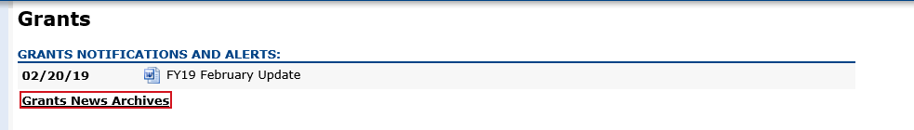

BACK TO THE TOP

**Community College / Sherriff’s Department ISAs**

*Fringe Rates for Correctional Facilities:***Approved** FY20 Fringe Rate on **State** grants is 2.43% of AA and CC payroll (D09).   
Fringe Rate on **Federal**/**trust accounts** is 37.91% of AA payroll and 2.43% of CC payroll

**Proposed** FY21 Fringe Rate on **State** grants is 1.85% of AA and CC payroll (D09).   
Fringe Rate on **Federal**/**trust accounts** is 38.88% of AA payroll and 1.85% of CC payroll  
  
*Fringe Rates for State Colleges/ Universities****:***

**Approved** FY20 Fringe Rate on **State/Federal/trust accounts** is 37.91% of AA payroll and 2.43% of CC payroll  
**Proposed** FY21 Fringe Rates on **State/Federal/trust accounts** is 38.88% AA payroll and 1.85% of CC payroll

The state sets these rates, not the Department. Rates and charge backs can be reviewed at [MA Comptrollers](https://www.macomptroller.org/fiscal-year-updates). We will also notify you about the rate changes for FY21 once approved.

Please do not forget to file a Final Financial Report (FR-1) for any grant funds issued.

BACK TO THE TOP

**Filing Final Financial Reports (FR-1)**

Final Financial Reports should not be submitted until all expenses have been accounted for and reconciled.

FY2020 Final Reports will be available the day after the grant project duration ends.

* FY2020 grants that end 6/30/2020 will be available 7/1/2020 and are due 8/31/2020
* FY2020 grants that end 8/31/2020 will be available 9/1/2020 and are due 10/31/2020
* Please do not file your FR-1 until you have drawn down and reconciled all funds spent and all expected invoices.

FY2019 Final Reports should be submitted by now. The exception being FY2019 multi-year grants still active with funds available to draw down and obligate. See due date chart below for more info.

If you do not see a final report available for a specific grant project in the Submissions menu, please email [EdGrants@doe.mass.edu](mailto:EdGrants@doe.mass.edu) and ***include the project number in the email.*** You can also call the main grants line at 781-338-6595; please have the project number ready.

**Please note there are a couple of known glitches with the final report form in EdGrants:**

* If the line item is overspent by a small amount that is within the allowable thresholds, it throws the “Balance Unexpended” and the percentage columns off. We are working to correct this error. In the meantime, you can submit the final report; the “Cash Balance” section at the bottom of the report form does calculate correctly.
* **If your Final Report shows a balance to return less than $1, you do not need to return the funds.**

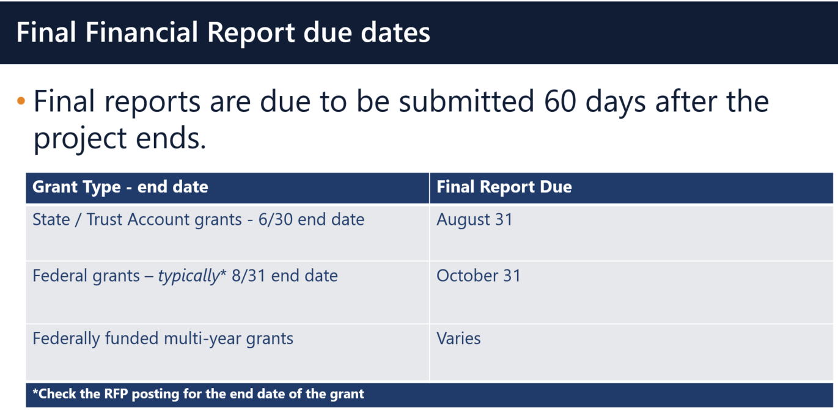

**Multi-Year grants:** DESE expects that Applicants will spend down their funds in full and not return money now that the multi-year feature is available in EdGrants for specific grant fund codes.

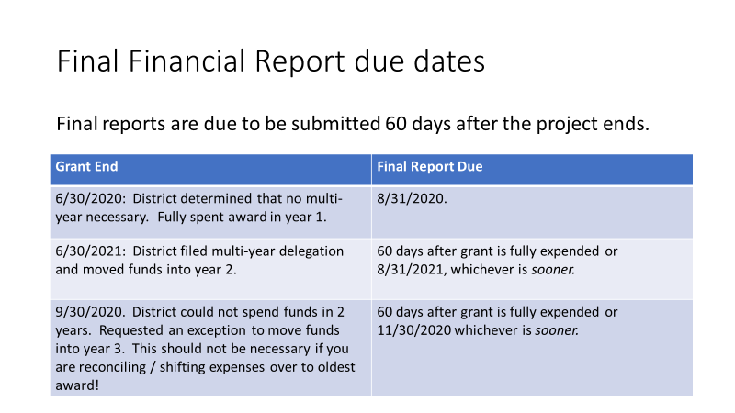

**DESE expects that before you try to file a final report, district fiscal and programmatic staff will coordinate to ensure all funds have been expended appropriately and agree on the award total.**

BACK TO THE TOP

**DESE Communication Survey**

Clear communication is essential to bring us together and plan for a safe future. DESE is continuously working to improve communication with all those involved in and impacted by our public schools. Please take this [two-minute survey](http://www.surveygizmo.com/s3/3335041/ESE-Communication) to help inform our communication efforts. Thank you!

**EdGrants User Access Request**

DESE requires a user request form be submitted for all new users and edits to existing users. Please review [EdGrants: User Security Controls](http://www.doe.mass.edu/news/news.aspx?id=24371) for more information and a copy of the Front Office User Request Form.

BACK TO THE TOP

**Requesting Funds Reminders & FAQs**

*Sherriff / State Agency Departments* who receive grant funds (all fund codes) directly through MMARS accounts via ISAs do NOT need to request grant funds using EdGrants.

-----

Payment Request windows will only be available once your grant has been programmatically approved, processed and an automatic **Initial Payment** has been issued by DESE.

If you cannot see a Project Record Card or a Payment Request available during the draw-down window, it is likely because your grant has not yet finished processing and an initial payment has not yet been sent.

**[How to check the Project Record Card to view payments and payment notices](http://www.doe.mass.edu/grants/edgrants/requesting-funds.docx)**

[**How to Request Funds**](http://www.doe.mass.edu/grants/edgrants/requesting-funds.docx)

Please find all EdGrants user documents [here](http://www.doe.mass.edu/Grants/edgrants.html).

BACK TO THE TOP

If you need assistance, please contact Grants Management at 781-338-6595 or email [EdGrants@doe.mass.edu](mailto:EdGrants@doe.mass.edu). **Please reference your grant project number or fund code and Applicant number (LEA Code) when you call and/or email.**

Thank you,

Grants Management