Massachusetts Department of

Elementary and Secondary Education

Grants Management

75 Pleasant Street, Malden, Massachusetts 02148-4906 Telephone: (781) 338-6595 TTY: N.E.T. Relay 1-800-439-2370

Grants Management June Update
These updates are also posted on the Grants Management Website

- June Payment Request Window is open
- FY2021 Final Payment Request Windows
- FY2021 Multi-Year Delegation
- FY2019, FY2020 and FY2021 Multi-Year Draw Down Windows
- FY2019 and FY2020 Multi-Year Grant Balances
- Vendor Web
- Final Financial Reports (FR1)
- Community College / Sherriff’s Department ISAs
- EdGrants Users
- Requesting Funds Reminders & FAQs

June Payment Request Window is Open

This is a courtesy reminder that the June Payment Request window is open through June 30, 2021.

There is one more payment window for all FY21 grants: July 20 – 31.
FY22 summer grants will follow the normal payment window schedule.

This includes any FY2021 grants where an initial payment has been received, as well as Multi-Year grants for FY2020 Year 2 (use Year 2 form) and FY2019 Year 3.

A note regarding FY2019 Year 3 request forms: The FY2019 Year 3 payment request window has some glitches. If you are unable to draw funds that are shown in the available grant balance but do not show in the Current Available to draw section, please email EdGrants@mass.gov. It will take us time to get through the emails, so your patience is appreciated.

To request grant funds, log into EdGrants with your DESE provided user name and password. If you are new to EdGrants, please review the Requesting Funds Reminders & FAQs. Don’t have a login? Please review the User Security Controls information which explains how to get connected.

Locked out of EdGrants? Grants Management staff periodically checks and unlocks those who are locked out throughout the day. If you continue to find that you are locked out, please call the Grants Management main line at 781-338-6595 for assistance.
BACK TO THE TOP

Final FY2021 Payment Request Windows

Grant Type | Award Year | Payment Request Window
State / Federal / Trust – All Fund Codes*  This includes Federal grants ending 8/31/2021  *except multi-year fund codes | 2021 | July 20th – July 31st  Final opportunity to request funds including grants that end 8/31/2021.
BACK TO THE TOP

FY2021 Multi-Year Delegation

Multi-Year is now closed. DESE has rolled funds for applicant as described in the FY2021 Multi-Year Information memo.

If multi-year was not filed but you do need the extended grant end date of 6/30/2022, leave funds unclaimed in FY21 and the balances will be rolled into FY22 for you in September, available to draw down in October payment window. These funds can be applied back to expenditures as of the original start date of the grant if needed.

If multi-year was done but you did not need it, you should be able to claim/draw down the funds moved as of July 1st, and you can apply those funds back to expenditures prior to 6/30 if needed.

Currently, the only grants eligible for this multi-year submission/feature in EdGrants are the following fund codes.* All other grant funds do not have multi-year capabilities and the final drawn down window is July 20 – 31st.

Grant Program
Title I (Fund Code: 305)
Title II-A (Fund Code: 140)
Title III (Fund Code: 180 and 186)
Title IV (Fund Code: 309)
IDEA (Fund Code: 240)
Early Childhood Special Ed (Fund Code: 262)
*FY20-FY22 Emergency/COVID related entitlement funding - Fund Codes: 113, 115 and ESSER III Fund Code TBD. Also, Fund Code: 589 (trust funded, not federal) FY22 will have access to multi-year in May of 2022.

BACK TO THE TOP

FY2019, FY2020 and FY2021 Multi-Year Draw Down Windows

Once Multi-Year occurs, the grant award amount is now split between 1, 2 or 3 fiscal years depending on award year of the grant. All expenditures can be charged back to the start date on the grant, regardless of what amount was moved or remained because the grant start date has not changed, only the end date has been extended.

However, the movement of funds does impact access to draw down the grant funds from Year 1 or Year 2 or Year 3. The window dates depend on which award you are drawing from.
Grant Original Award Year | Balances | Available Payment Request Windows
FY2021 | Year 1 | May 20 - 30 | June 20 - 30 | July 20 - 31 | Aug 20 – 24*
 | Year 2 (funds moved) | X | X | July 1 - 10 | Aug 1 - 10
FY2020 | Year 2 | May 20 - 30 | June 20 - 30 | July 20 - 31 | Aug 20 – 24
 | Year 3 (funds moved) | X | X | July 1 - 10 | Aug 1 - 10
FY2019 | Year 3 | May 20 - 30 | June 20 - 30 | July 20 - 31 | Aug 20 – 24
 | Year 4** | TBD – likely one October Window to draw final balance.

*The August window for the outgoing FY is shortened so that DESE can ensure all payments clear by the Comptroller’s Accounts Payable deadline for FY2021 payments. ONLY MULTI-YEAR GRANTS HAVE ACCESS TO THE AUGUST WINDOW. All other grants final window is July 20 – 31, even those that end 8/31.
**DESE expects that most grantees will fully expend the oldest award first, shift expenditures over as needed to use up and spend down FY2019 awards. For those who require funds to be rolled into Year 4 of this grant, DESE will roll balances in September and you will have access to draw these funds in October. The end date on FY2019 year 4 is 9/30/2021 so all obligations must be incurred by that time.
BACK TO THE TOP

FY2019 and FY2020 Multi-Year Grant Balances:

Unclaimed grant balances for FY2019 and FY2020 awards should be obligated and expended first. The FY2019 Year 3 and FY2020 Year 2 request window is open. DESE expects that these balances will be drawn in full as soon as possible. Please contact your RASP liaison if you have questions regarding IDEA funds (FC 240) and the pro-share set aside.

Federal Grants covered by the Tydings provision have an obligation period that covers approximately 27 months. FY2019 awards that originally would have expired September 30, 2020 were extended due to the COVID pandemic.

If all funds have been drawn for FY2019 or FY2020 multi-year grants, outstanding invoices have been reconciled/paid and all goods and services received, a final report (FR-1) should be filed in EdGrants ASAP.
BACK TO THE TOP

Vendor Web

Confused about payments? Not sure if you received a payment? Applicants can locate information regarding any payments received by DESE (and any other state agency) by logging in to the MA Comptroller’s Vendor Web site. This link includes a job aid on how to use Vendor Web.

BACK TO THE TOP
Final Financial Reports (FR-1)

Final Reports are available in EdGrants the day after the grant project duration ends.

- All grants Final Report is due 60 days after the project end date of the grant.
  - June 30th end grants FR-1 is available in EdGrants on 7/1 and due by 8/31st.
  - August 31st end grants FR-1 is available in EdGrants on 9/1 and due by October 31st.
- Multi-Year grants: Final Report is due 60 days after final draw down OR 60 days after the obligation end date of the grant whichever comes sooner.
- Multi-Year grants with balances should claim and expend all funds, reconcile invoices and file FR-1. You should not ever need to return multi-year grant funds because of the length of time in which you have to expend them.
- Please DO NOT return unspent funds less than $1.

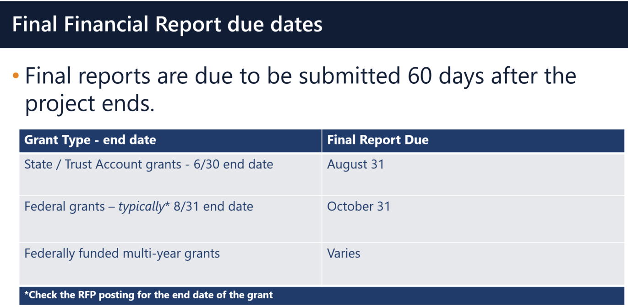

If you do not see a final report available for a specific grant project in the Submissions menu, please email EdGrants@mass.gov and include the project number in the email. You can also call the main grants line at 781-338-6595; please have the project number ready.

Please note there are a couple of known glitches with the final report form in EdGrants:
- If the line item is overspent by a small amount that is within the allowable thresholds, it throws the “Balance Unexpended” and the percentage columns off. We are working to correct this error. In the meantime, you can submit the final report; the “Cash Balance” section at the bottom of the report form does calculate correctly.
- If your Final Report shows a balance to return less than $1, you do not need to return the funds.

Multi-Year grants: DESE expects that Applicants will spend down their funds in full and not return money now that the multi-year feature is available in EdGrants for specific grant fund codes.

DESE expects that before you try to file a final report, district fiscal and programmatic staff will coordinate to ensure all funds have been expended appropriately and agree on the award total.

BACK TO THE TOP

Community College / Sherriff’s Department ISAs

The EdGrants: User Guides, Information and Training section of the Grants Management website has been updated to include tools and information regarding Interdepartmental Services Agreement (ISA) process.

Fringe Rates for Correctional Facilities:
Approved FY21 Fringe Rate on State grants is 1.94% of AA and CC payroll (D09).
Fringe Rate on Federal/trust accounts is 38.32% of AA payroll and 1.32% of CC payroll

Proposed FY22 Fringe Rate on State grants is 1.97% of AA and CC payroll (D09).
Fringe Rate on Federal/trust accounts is 39.5% of AA payroll and 1.97% of CC payroll
Fringe Rates for State Colleges/ Universities:
Approved FY21 Fringe Rates on State/Federal/trust accounts is 38.32% AA payroll and 1.94% of CC payroll

Proposed FY22 Fringe Rates on State/Federal/trust accounts is 39.5% AA payroll and 1.97% of CC payroll

The state sets these rates, not the Department. Rates and charge backs can be reviewed at MA Comptrollers.

Please see FY2020 Final Financial Report (FR-1) due dates which have passed. All grantees must file an FR-1 in EdGrants to close out their grants.

BACK TO THE TOP

EdGrants Users
DESE requires a user request form be submitted for all new users and edits to existing users. Please review EdGrants: User Security Controls for more information and a copy of the Front Office User Request Form.

It is the Applicant/LEAs responsibility to update user access as needed, including deactivating user access no longer needed.

BACK TO THE TOP

Requesting Funds Reminders & FAQs

Sherriff / State Agency Departments who receive grant funds (all fund codes) directly through MMARS accounts via ISAs do NOT need to request grant funds using EdGrants.
-----
Payment Request windows will only be available once your grant has been programmatically approved, processed and an automatic Initial Payment has been issued by DESE.

If you cannot see a Project Record Card or a Payment Request available during the draw-down window, it is likely because your grant has not yet finished processing and an initial payment has not yet been sent.

How to check the Project Record Card to view payments and payment notices
How to Request Funds
Please find all EdGrants user documents here.
BACK TO THE TOP

If you need assistance, please contact Grants Management at 781-338-6595 or email EdGrants@mass.gov. Please reference your grant project number or fund code and Applicant number (LEA Code) when you call and/or email.

Due to high volume, it can take up to a week for response.

Thank you,
Grants Management

