Massachusetts Department of

Elementary and Secondary Education

Grants Management

75 Pleasant Street, Malden, Massachusetts 02148-4906 Telephone: (781) 338-6595 TTY: N.E.T. Relay 1-800-439-2370
Action Needed: Expiring Awards Unclaimed Funds

Unclaimed Balances for Multi-Year Grants Expiring 9/30/2022

FY2020 ESSA (Titles I - IV), ESSER (FC: 113) and FY2021 ESSA (Titles I-V), IDEA (240 & 262) and ESSER (FC: 113 ) grants expire on 9/30/2022.

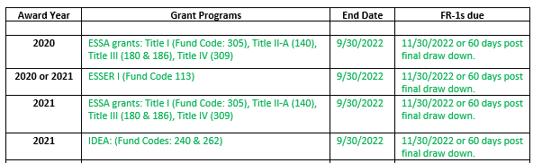

DESE has posted two reports showing unclaimed balances: one for FY2020 and one for FY2021.

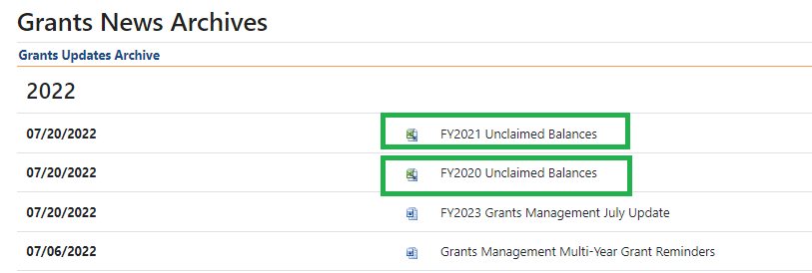

Districts/Entities can filter on the “Recipient” column by entity name to see all unclaimed balances for that Fiscal Year Report.

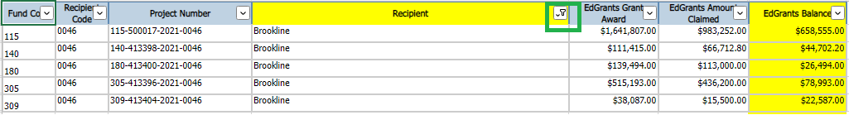
Please review both reports to ensure you are aware of all balances about the expire.
Please note there are many grants with $100 or $200 balances because DESE would have filed multi-year on your behalf during COVID for these grants to extend them.

Please draw these funds as soon as possible and apply obligations incurred within the grant period to use up this funding before drawing down from newer award balances on these grants. If funds are not claimed, DESE will end up reverting funds to the Federal government which could impact future MA allocations.

Please utilize Year 3 request forms to claim FY2020 grant balances. Please utilize Year 2 request forms to claim FY2021 grant balances. If there are issues filing a request, please contact Jennifer Ahern ASAP at Jennifer.M.Ahern@mass.gov.

If the district/entity is not listed on the reports, no action is needed at this time. This email goes out to a list serve so if this message does not apply to your entity, ignore it.

Multi-Year Payment Request Windows (FY22, FY21 and FY20 awards)
These windows only apply to multi-year fund codes. All other grants final payment request window is 7/20/22 – 7/31/2022.
Award Year | Balances | Available Payment Request Windows Post Multi-Year
FY2022 | Currently in Year 1 | July 20 - 31 | Aug 20 – 24* | Sept: Year 1 unclaimed balances transferred to Year 2
 | Year 2 (funds moved via Multi-Year Submission) | July 1 - 10 | Aug 1 - 10 | Sept 20 - 30 | October 20 – 31 (windows cont. each month 20th – last day)
FY2021 | Currently in Year 2 | July 20 - 31 | Aug 20 – 24* | Sept: Year 2 unclaimed balances transferred to Year 3.
 | Year 3 (funds moved via Multi-Year Submission) | July 1 - 10 | Aug 1 - 10 | Sept 20 - 30 | Oct 20 – 31* FINAL WINDOW
FY2020 | Currently in Year 3 | July 20 - 31 | Aug 20 – 24* | Year 3 unclaimed balances will transfer to Year 4 | Oct 20 – 31* FINAL WINDOW
*Year 4 (ESSA: Fund Codes 305, 140, 180/186, 309) and ESSER: Fund Code 113 |  | There is no Year 4 multi-year form. FY2020 awards should continue to draw down using Year 3 form. Unclaimed balances will roll into Year 4 in September and there will be a final request window in October (20 – 31) to claim funds. The obligation end date on these grants is 9/30/2022.
*The August 20-24 window is ONLY available to Multi-Year. JULY is the final window for all other grants.

Please let us know asap if there are issues drawing down final balances. Please do not wait until the last two days of the payment request window as DESE response time will be slower because of the volume of calls and emails received.

