*****Massachusetts Department of***

***Elementary and Secondary Education***

***Grants Management***

### 75 Pleasant Street, Malden, Massachusetts 02148-4906 Telephone: (781) 338-6595 TTY: N.E.T. Relay 1-800-439-2370

***Grants Management July Update***

* July is the FINAL FY2021 Payment Request window
* FY2021 Close Info: Final Draw down windows and Filing Final Financial Reports (FR-1)
* FY2022 Open Info: Initial Payments and Part I signatures
* Important Changes due to COVID-19: FY21 Multi-Year Delegation
* Community College / Sherriff’s Department ISAs
* EdGrants User Access Request
* Requesting Funds Reminders & FAQs

**July is the FINAL Payment Request window - now available**

This is a courtesy reminder that the July Payment Request window is open through July 31, 2021.

**This is the FINAL FY2021 payment request window, for any Funding Opportunities that begin “DESE - FY21” in EdGrants. This includes FY2021 grants that end 8/31/2021.**

**FY2022 Summer grants (DESE – FY22 in the Funding Opportunity Name) will have additional windows, despite the 8/31/2021 end date.**

To request grant funds, log into [EdGrants](https://edgrants.eoe.mass.edu/grantium/frontOffice.jsf) with your DESE provided user name and password. If you are new to EdGrants, please review the Requesting Funds Reminders & FAQs. Don’t have a login? Please review the [User Security Controls](http://www.doe.mass.edu/news/news.aspx?id=24371) information which explains how to get connected.

Locked out of EdGrants? Grants Management staff periodically checks and unlocks those who are locked out throughout the day. If you continue to find that you are locked out, please call the Grants Management main line at 781-338-6595 for assistance.

BACK TO THE TOP

**FY2021 Close Info: Final Draw down windows and Filing Final Financial Reports (FR-1)**

*Final FY2021 Drawdown window is now.*

The FINAL July payment request window for all FY2021 grants is open now through July 31st.

If the Funding Opportunity Name in EdGrants starts with DESE FY21 – this is your final request window.

|  |  |  |
| --- | --- | --- |
| **Grant Type** | **Award Year** | **Payment Request Window** |
| State / Federal / Trust – All Fund Codes*  **This includes Federal grants ending 8/31/2021**  *except multi-year fund codes | 2021 | July 20th – July 31st  **Final** opportunity to request funds including grants that end 8/31/2021. |

*FY2019, FY2020 and FY2021 Multi-Year Draw Down Windows*

*Please see Multi-Year section of this memo to verify which grant fund codes are considered multi-year.*

Once Multi-Year occurs, the grant award ***amount*** is now split between 1, 2 or 3 fiscal years depending on award year of the grant. **All expenditures can be charged back to the start date on the grant, regardless of what amount was moved or remained because the grant start date has not changed, only the end date has been extended.**

However, the movement of funds does impact access to draw down the grant funds from Year 1 or Year 2 or Year 3. The window dates depend on which award you are drawing from.

|  |  |  |  |  |  |
| --- | --- | --- | --- | --- | --- |
| **Grant Original Award Year** | **Balances** | **Available Payment Request Windows** | | | |
| FY2021 | Year 1 | May 20 - 30 | June 20 - 30 | July 20 - 31 | Aug 20 – 24* |
|  | Year 2 (funds moved) | X | X | July 1 - 10 | Aug 1 - 10 |
| FY2020 | Year 2 | May 20 - 30 | June 20 - 30 | July 20 - 31 | Aug 20 – 24 |
|  | Year 3 (funds moved) | X | X | July 1 - 10 | Aug 1 - 10 |
| FY2019 | Year 3 | May 20 - 30 | June 20 - 30 | July 20 - 31 | Aug 20 – 24 |
|  | Year 4** | TBD – likely one October Window to draw final balance. | | | |

*The August window for the outgoing FY is shortened so that DESE can ensure all payments clear by the Comptroller’s Accounts Payable deadline for FY2021 payments. **ONLY MULTI-YEAR GRANTS HAVE ACCESS TO THE AUGUST WINDOW.** **All other grants final window is July 20 – 31, even those that end 8/31.**

**DESE expects that most grantees will fully expend the oldest award first, shift expenditures over as needed to use up and spend down FY2019 awards. For those who require funds to be rolled into Year 4 of this grant, DESE will roll balances in September and you will have access to draw these funds in October. The end date on FY2019 year 4 is 9/30/2021 so all obligations must be incurred by that time.

FY2021:Payment Request windows will not be available until the grant has been programmatically approved, processed and an automatic **Initial Payment** has been issued by DESE.

*Filing Final Financial Reports (FR-1) for FY2021*

Final Financial Reports should not be submitted until all expenses have been accounted for and reconciled.

FY2021 Final Reports will be available the day after the grant project duration ends.

* FY2021 grants that ended 6/30/2021 are available now and are due 8/31/2021.
* FY2021 grants that end 8/31/2021 will be available 9/1/2021 and are due 10/31/2021
* Please make sure you have claimed all funds expended and reconciled all payments before you file.
* Please do not return unexpended funds less than $1, even though the report prompts you to.
* Please mail in a copy of the FR-1 along with a check for each grant where you are returning unexpended funds. Please do not consolidate return checks.

If you do not see a final report available for a specific grant project in the Submissions menu, please email [EdGrants@doe.mass.edu](mailto:EdGrants@doe.mass.edu) and ***include the project number in the email.*** You can also call the main grants line at 781-338-6595; please have the project number ready.

**Please note there are a couple of known glitches with the final report form in EdGrants:**

* If the line item is overspent by a small amount that is within the allowable thresholds, it throws the “Balance Unexpended” and the percentage columns off. We are working to correct this error. In the meantime, you can submit the final report; the “Cash Balance” section at the bottom of the report form does calculate correctly.
* **If your Final Report shows a balance to return less than $1, you do not need to return the funds.**

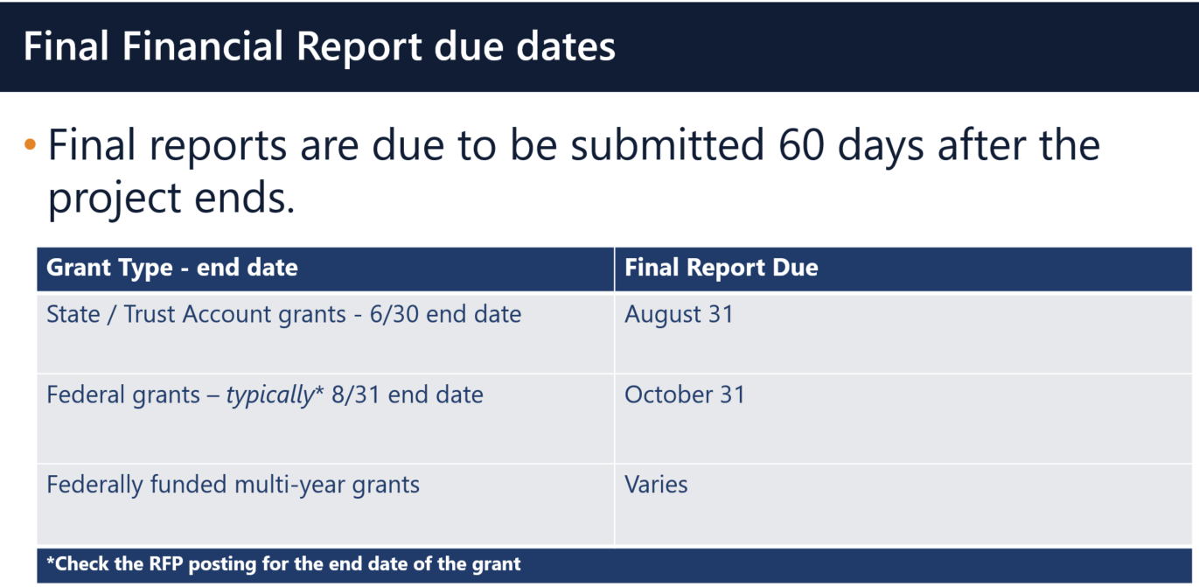

**Multi-Year grants:** DESE expects that Applicants will spend down their funds in full and not return money now that the multi-year feature is available in EdGrants for specific grant fund codes.

**DESE expects that before you try to file a final report, district fiscal and programmatic staff will coordinate to ensure all funds have been expended appropriately and agree on the award total.**

BACK TO THE TOP

**FY2022 Open Info: Initial Payments and Part I signatures**

*Initial grant setup and payment*

Once grants management receives a programmatically approved grant from the program unit administering the grant, an encumbrance is set up on MMARS (the state’s accounting system) via EdGrants.

When the encumbrance clears MMARS to final status, DESE will issue an automatic initial payment in the amount of 10% of the budgeted amount of the grant. **To ensure smooth initial payment, we ask that grantees hold off on requesting budget line item amendments until they receive an initial payment. Amending your grant can delay encumbrance setup and initial payment release.**

*FY2022 Grants and the Part I signatures*

We have recently received notification that electronic signatures can be accepted for procurement documents, but there are some caveats to this.

Based on what has been determined this is how we can handle the Part I documents uploaded into EdGrants with each grant submission:

* A scan of an original signature uploaded or a picture of the original signature inserted into the document is still fine (the old way)
* An electronically signed document using Adobe or Docusign which is a true electronic signature, and not just cursive characters typed into the document.

True electronic signature (see digital stamp): - acceptable

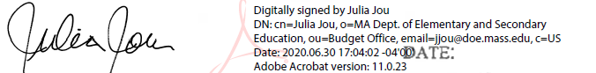

Original signature scanned into PDF and inserted into the document: - acceptable

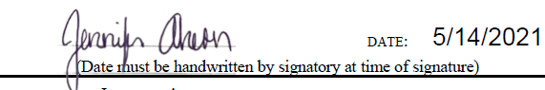

Inserted/Typed in cursive font signature (no digital stamp): - not acceptable*

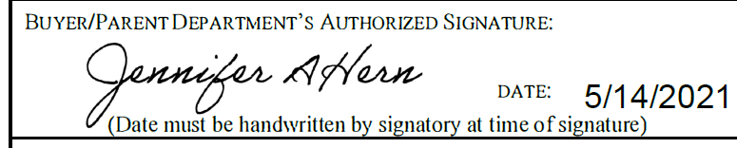

An electronic sign that is not clear or is inserted/typed using DocuSign or Adobe will be sent back to include the proper signature.

A reminder that there are ways to scan and upload original signatures using iphones and android tools:

* Convert the signed document to PDF using an iPhone or Android:
  + iPhone users can take a picture of the signed [Part I and convert it to a PDF](https://www.igeeksblog.com/how-to-convert-photos-to-pdf-on-iphone-ipad/).
  + Android  users to take a picture of the signed Part I and convert to a PDF using [Google Drive, or](https://www.androidpolice.com/2020/05/28/create-convert-pdf-phone-camera-android-free/) [Microsoft Office Lens](https://www.androidpolice.com/2020/05/28/create-convert-pdf-phone-camera-android-free/).

BACK TO THE TOP

**Important Changes due to COVID-19: FY21 Multi-Year Delegation**

**DESE has processed Multi-year Delegation forms on behalf of Applicants with balances remaining over $5,000 on their FY2020 and FY2021 as of the May 1 – 10th multi-year delegation window. Grantees who files their own multi-year delegation forms have also been processed. The grant end dates have been extended for these grants. Please review the** **multi-year draw down windows** **to see when you can access Year 1 final balances, Year 2 and Year 3 funds (if applicable).**

These are the **only** grants with Multi-Year provision extended by DESE:

|  |  |
| --- | --- |
| **Grant Program** | **Federal Award Year** |
| Title I (FC: 305) | FY2020 & FY2021 |
| Title I Part D (FC: 306/307)** | FY2020 & FY2021 |
| Title II-A (FC: 140) | FY2020 & FY2021 |
| Title III (FC: 180 and 186) | FY2020 & FY2021 |
| Title IV (FC: 309) | FY2020 & FY2021 |
| IDEA (FC: 240) | FY2020 & FY2021 |
| Early Childhood Special Ed (FC: 262) | FY2020 & FY2021 |

** Funds extended through an ISA. Communication to impacted grantees has gone out please contact: [jennyfer.cabral@mass.gov](mailto:Jennyfer.cabral@mass.gov) for questions regarding your ISA.

|  |  |  |
| --- | --- | --- |
| **Grant Program** | **Federal Award Year** | **New End Date** |
| Title I (FC: 305) | FY2020 | 9/30/2021 (Year 3) |
| Title I (FC: 305) | FY2021 | 6/30/2022 (Year 2) |
| Title I Part D (FC: 306/307) | FY2020 | 9/30/2021 (Year 3) |
| Title I Part D (FC: 306/307) | FY2021 | 6/30/2022 (Year 2) |
| Title II-A (FC: 140) | FY2020 | 9/30/2021 (Year 3) |
| Title II-A (FC: 140) | FY2021 | 6/30/2022 (Year 2) |
| Title III (FC: 180 and 186) | FY2020 | 9/30/2021 (Year 3) |
| Title III (FC: 180 and 186) | FY2021 | 6/30/2022 (Year 2) |
| Title IV (FC: 309) | FY2020 | 9/30/2021 (Year 3) |
| Title IV (FC: 309) | FY2021 | 6/30/2022 (Year 2) |
| IDEA (FC: 240) | FY2020 | 9/30/2021 (Year 3) |
| IDEA (FC: 240) | FY2021 | 6/30/2022 (Year 2) |
| Early Childhood Special Ed (FC: 262) | FY2020 | 9/30/2021 (Year 3) |
| Early Childhood Special Ed (FC: 262) | FY2021 | 6/30/2022 (Year 2) |

Other DESE discretionary grant programs, do NOT utilize the multi-year feature in EdGrants.

BACK TO THE TOP

**Monthly Updates**

These Grants Management Updates are posted each month on the [grants website](http://www.doe.mass.edu/Grants/) under **Grants Notifications and Alerts**. Previously posted monthly updates are always available in the **Grants News Archives.**

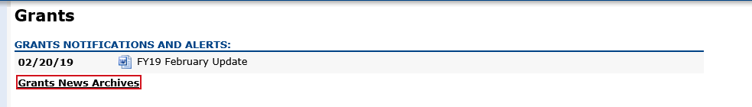

BACK TO THE TOP

**Community College / Sherriff’s Department ISAs**

The [EdGrants: User Guides, Information and Training](https://urldefense.com/v3/__https:/mass.us14.list-manage.com/track/click?u=d8f37d1a90dacd97f207f0b4a&id=7a2d749d42&e=7ae5d0f287__;!!CUhgQOZqV7M!0P6jd6pMMYHte3bJcl1f-5PXPPV_cchx1vF-pNbnJBP3sX8jpF0TiR0-4CLzQ4UKAw$) section of the Grants Management website has been updated to include tools and information regarding Interdepartmental Services Agreement (ISA) process.  
   
*Fringe Rates for Correctional Facilities:*  
  
**Approved** FY21 Fringe Rate on **State** grants is 1.94% of AA and CC payroll (D09).   
Fringe Rate on **Federal**/**trust accounts** is 38.32% of AA payroll and 1.32% of CC payroll  
   
**Proposed** FY22 Fringe Rate on **State** grants is 1.97% of AA and CC payroll (D09).   
Fringe Rate on **Federal**/**trust accounts** is 39.5% of AA payroll and 1.97% of CC payroll  
  
*Fringe Rates for State Colleges/ Universities:*  
  
**Approved** FY21 Fringe Rates on **State/Federal/trust accounts** is 38.32% AA payroll and 1.94% of CC payroll  
   
**Proposed** FY22 Fringe Rates on **State/Federal/trust accounts** is 39.5% AA payroll and 1.97% of CC payroll  
   
The state sets these rates, not the Department.  Rates and charge backs can be reviewed at [MA Comptrollers](https://urldefense.com/v3/__https:/mass.us14.list-manage.com/track/click?u=d8f37d1a90dacd97f207f0b4a&id=3255f74726&e=7ae5d0f287__;!!CUhgQOZqV7M!0P6jd6pMMYHte3bJcl1f-5PXPPV_cchx1vF-pNbnJBP3sX8jpF0TiR0-4CJihjgHug$).     
   
Please see FY2020 Final Financial Report (FR-1) due dates which have passed.  All grantees must file an FR-1 in EdGrants to close out their grants.

BACK TO THE TOP

**EdGrants User Access Request**

DESE requires a user request form be submitted for all new users and edits to existing users. Please review [EdGrants: User Security Controls](http://www.doe.mass.edu/news/news.aspx?id=24371) for more information and a copy of the Front Office User Request Form.

BACK TO THE TOP

**Requesting Funds Reminders & FAQs**

*Sherriff / State Agency Departments* who receive grant funds (all fund codes) directly through MMARS accounts via ISAs do NOT need to request grant funds using EdGrants.

-----

Payment Request windows will only be available once your grant has been programmatically approved, processed and an automatic **Initial Payment** has been issued by DESE.

If you cannot see a Project Record Card or a Payment Request available during the draw-down window, it is likely because your grant has not yet finished processing and an initial payment has not yet been sent.

**[How to check the Project Record Card to view payments and payment notices](http://www.doe.mass.edu/grants/edgrants/requesting-funds.docx)**

[**How to Request Funds**](http://www.doe.mass.edu/grants/edgrants/requesting-funds.docx)

Please find all EdGrants user documents [here](http://www.doe.mass.edu/Grants/edgrants.html).

BACK TO THE TOP

If you need assistance, please contact Grants Management at 781-338-6595 or email [EdGrants@doe.mass.edu](mailto:EdGrants@doe.mass.edu). **Please reference your grant project number or fund code and Applicant number (LEA Code) when you call and/or email.**

Thank you,

Grants Management