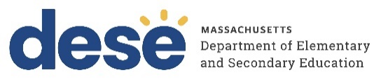

FC215 Genocide Education Grant: Questions and Answers
Updated November 17, 2022

- If applying for both FY23 and FY24, is the maximum award amount spread across both fiscal years?
A: Yes. For example, if your LEA is applying for $60,000, that amount would be spread across both FY23 and FY24. The LEA would not receive an additional $60,000 in the second fiscal year.

- Can LEAs apply for the grant for FY24 without applying for FY23?
A: No. For this grant cycle, LEAs may apply for funds for FY23 only or may spread their funds across FY23 and FY24. The intention of this option is to allow districts more time to use the FY23 funds, given that the application deadline is already well into the 2022-23 school year.

- If applying for FY23 and FY24, do the Part I signature pages constitute separate grants or one multi-year grant?
A: They constitute separate grants. In Part II (Budget), please indicate in the FY23 and FY24 tabs the amount of funds that you intend to use in each fiscal year.

- Can LEAs apply as a group and consolidate their funding?
A: Yes. If you are applying as a group, please indicate the LEAs that are included in the “LEA Name” field of the Part III form. In this case, the maximum award amount is determined based on the total number of students across all LEAs.

- Are funds for substitute teachers allowable?
A: Yes. LEAs may budget for substitute teachers so that staff can participate in PD, curriculum writing, or other grant activities.

- Are the funds disbursed through the grant state funds?
A: Yes, they are state funds.

- Is there a preferred format for the vendor scope of work?
A: There is no preferred format. Please submit in whatever format is most convenient.

