
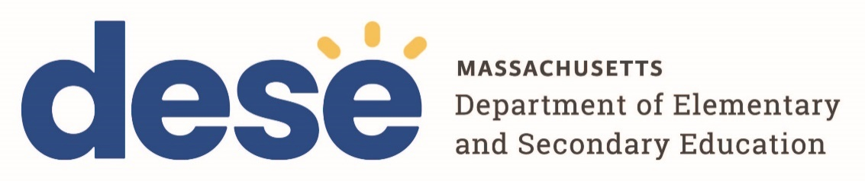
135 Santilli Highway, Everett, MA 02149 | 781.338.3000 | TTY: N.E.T. Relay (800).439.2370

Questions and Answers

DESE FY 2026 FC 0213 Grant

COMMBUYS Document #: BD-26-1026-DOE02-DOE01-121639

Support Implementing of Updated Regulations Regarding Time-Out Practices

Question #1- Would an approved special education school be eligible for the time
out grant as an out of district placement?

Answer #1- Yes. Any Massachusetts public school district, public school, collaborative, approved special education program, or charter district/school that currently employs the use of time out strategies is eligible to apply.

Question #2- Is there a PDF or Word version of the RFP we can use to prep the materials before we submit in GEMS?

Answer #2- No. Yet, if the team requires a separate copy to work on the grant beforehand, they may copy/paste the narrative questions from GEMS into a word or PDF document.

Question #3- Are districts, collaboratives, charter schools and approved special education schools who received funds under grant FC 0213 Strategies to Reduce or Eliminate the Use of Time-Out Rooms in 2024 still eligible to apply for this current grant?

Answer #3- Yes.

Question #4- I was wondering if the 0213 grant funds can be used to pay for de-
escalation training for our staff to help reduce the need for quiet rooms?

Answer #4- Yes. Funds can be used for High Quality Professional Development, Implementation of Restorative Practices and Behavioral Support Teams capacity and empowerment to implement individualized culturally and linguistically sustaining interventions for students.

Question #5- I am working on our application for this grant, and we will definitely seek some funds to continue our investment in Collaborative Problem Solving. Is it permissible to also use some of the funds for the creation of additional sensory spaces as an alternative to time-out? This does not seem to be listed as an acceptable use or prohibited use of funds.

Answer # 5- No. Funds cannot be used to add additional physical spaces or upgrades. The following are not allowable costs:food and refreshments, indirect costs, advertising, maintenance/repairs.

