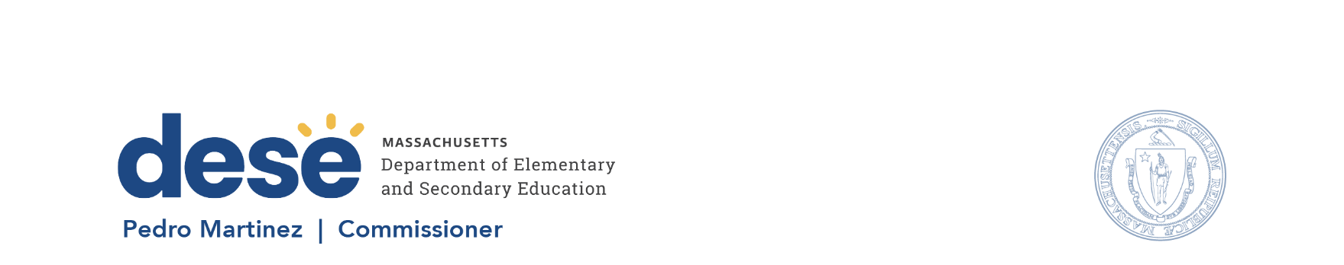

135 Santilli Hwy, Everett MA 02149 Voice: (781) 388-3000 TTY: 1-800-439-2370 www.doe.mass.edu

April 15, 2026
Dear Applicant:
I am pleased to release the 2027 Adult Education in Correctional Institutions Continuation grant. With this RFP, the Department will continue to fund Adult Education in Correctional Institutions (AECIs) across the Commonwealth to provide adult education services to Massachusetts students in the carceral system who seek a high school credential (HiSET/GED) and/or need to improve literacy or numeracy skills to succeed in the workforce.
The Adult and Community Learning Services (ACLS) Unit at the Department of Elementary and Secondary Education (DESE) envisions a future where every adult in Massachusetts has the knowledge, skills, and support they need to lead the life they aspire to live.
With this RFP, ACLS is looking to continue the partnership with adult education programs in correctional facilities to ensure that all students have access to quality instruction, advising, job training, and career pathways that are culturally responsive. ACLS sets high expectations and provides support to achieve them, promotes flexible options for learning that honor the diversity of students and advance equity and inclusion, fosters collaborations that enhance student success in employment and higher education, and holds ourselves and our providers accountable for results.
The Massachusetts adult education system serves as an on-ramp to the workforce development system, enabling individuals not yet ready to participate in that system with opportunities to advance students to career pathways and employment in jobs that pay family-sustaining wages and opportunities that would be otherwise out of their reach. This RFP is one of many continuation RFPs that are being released by the Department to offer comprehensive adult education system access in Massachusetts in FY27.
Sincerely,
Wyvonne Stevens-Carter
Wyvonne Stevens-Carter
DESE Associate Commissioner, State Director of Adult Education

