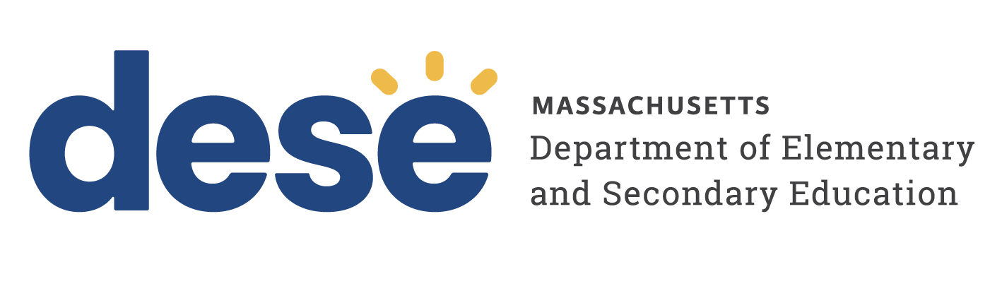

FY27 Indirect Cost Certification Statement

Date:

Department of Elementary and Secondary Education
Center of Administration and Finance
Attn: Audit & Compliance Unit
135 Santilli Highway
Everett, MA 02149-1962

Dear Audit & Compliance Unit:

This is to certify that to the best of my knowledge and belief:

- All indirect costs recovered are allowable in accordance with the requirements of EDGAR and the Uniform Grant Guidance.

- The indirect costs recovered with DESE grant funds will not include any costs which are unallowable under Uniform Grant Guidance 2 CFR Part 200 Subpart E cost principles such as (without limitation: advertising and public relations cost, contributions and donations, entertainment costs, fines and penalties, lobbying costs, bad debts, or defense of fraud proceedings; and EDGAR 34 CFR Part 76.563-569 such as (without limitation, rent other than for organizational wide administration space, depreciation, and executive leadership)

- All costs included in the indirect cost rate are properly allocable to Federal agreements on the basis of beneficial or causal relationship between the expenses incurred and the agreements to which they are allocated in accordance with applicable requirements and are properly recorded in our accounting records.

I declare under penalty of perjury that the statements herein are true and correct.

Organization: ____________________________________________

Signature and Date: _____________________________________________

Name of Official and Title: _______________________________________

