# DESE logoInter-State Agreement (ISA) for State Agency and LEAs: Fiscal Reference Guide

This fiscal reference guide is designed to support state agency staff in effectively managing fiscal requirements,

responsibilities, and best practices to ensure compliance with DESE and CTR regulations.

## GEM$ Application Workflow and Approval Requirements:

* Grant applicants use the GEM$ grants management system to apply for DESE administered grant funds in Massachusetts.
* Each grant application is required to go through a series of approval phases before the grant is final and approved.
* The GEM$ workflow is based on the grant type in the system: *Non-Competitive types* or *Competitive.*
* LEA is responsible for submitting the grant through the LEA level steps to move the grant along in the workflow.
* The DESE grant contact listed on the RFP reviews/approves the application at the DESE Program Approval phase.
* Interdepartmental Service Agreement (ISA) is initiated, reviewed and approved at the DESE Fiscal Budget Approval phase.

**Workflow and Approval - Requirements**

**Regardless of the type of workflow, the following requirements must be observed:**

*Failure to follow these requirements will result in return of your funding application and possibly delay availability of funding.*

* The actual Superintendent/Chief Executive/Head of Agency should be approving each funding application as the last LEA step in the workflow.
* In no case should the same person be submitting/approving a funding application in all LEA roles.
* Every instance of a funding application going through a workflow in GEM$ (whether it be a correction or revision/amendment), must have at least two different people submitting/approving for the LEA.
* If a surrogate is needed because the actual Superintendent/Chief Executive is not available such that a grant will be unreasonably delayed, that surrogate must be listed as an authorized signatory on the LEA’s current CASL form that has been submitted to DESE (see exception, noted above (*) for Community Colleges and other state entities with an ISA with DESE).

Please visit the “DESE Resources” tab in GEM$ for additional information regarding [GEM$ Application Workflows](https://mass.egrantsmanagement.com/DocumentLibrary/Default.aspx?ccipSessionKey=638862982000685942) and [GEM$ User Role - Guidance and Forms](https://mass.egrantsmanagement.com/DocumentLibrary/Default.aspx?ccipSessionKey=638760117264477570).

### The Interdepartmental Service Agreement (ISA):

The Interdepartmental Service Agreement (ISA) Form is issued by the Office of the Comptroller (CTR) pursuant to 815 CMR 6.00. The ISA Form is the “Contract” that documents the business agreement (joint venture) between two Commonwealth departments within the Executive, Judicial, and Legislative Branches of government.

The ISA documentation is required for State Agencies as part of the application process and authorizes the grant funding. One ISA document per grant fund code being applied to is required. The grant cannot be DESE fiscal approved without a signed and executed ISA.

State and Community Colleges: GEM$ is where the grant application and approval process exists, where the ISA record is attached, and where the grantees claim reimbursement on grant expenditures, and where the grant closeout process exists (FER). CTR requires DESE to maintain the signed (both parties) executed ISA document with the grant as backup to the authorized grant.

State Agencies (such as DYS or county Sherriff Departments – true ISAs): GEM$ is where the grant application and approval process exists, where the ISA record is attached but the funding is transferred to MMARS based on the ISA object classes in the ISA document (which is based on the budget tags). *These ISAs are considered true ISAs because MMARS is the mechanism for the grantee to obtain access to the funding.* State agencies do not use GEM$ to claim reimbursement on grant expenditure as the funding is deposited directly through MMARS. The grant closeout process is in GEM$ (FER). FER filings should align with the budget as well as the ISA object classes and be true and correct to what we see on MMARS.

For more information on completing the ISA form for true ISAs, please see the [ISA Instructions](https://public.powerdms.com/MAComptroller/documents/2918141) and [CTR ISA Policy](https://www.macomptroller.org/announcement/updated-interdepartmental-service-agreement-isa-policy-and-form/) for guidance. Please note, true ISA approval may add 4 to 6 weeks to grant approval process. Keeping this in mind, it is important to plan ahead and submit your completed application in a timely fashion.

#### ISA and GEM$ process:

1. Once the application is moved to the DESE Program Approved step of the workflow in GEM$, information is sent to Grants Management for review.
2. The Grants Management (GM) office reviews the ISA budget information submitted on the application.
3. From information submitted on the ISA section/budget tags entered, an ISA document will be generated by Grants Management.
4. The ISA document will then be uploaded into GEM$ as part of the grant file for the applicant to sign.
5. Grants Management will send an alert through GEM$ signaling to the grantee that the ISA is ready for review & signature.
   1. To find the ISA document GM has prepared based on the approved budget, click into the grant, Sections>History log.

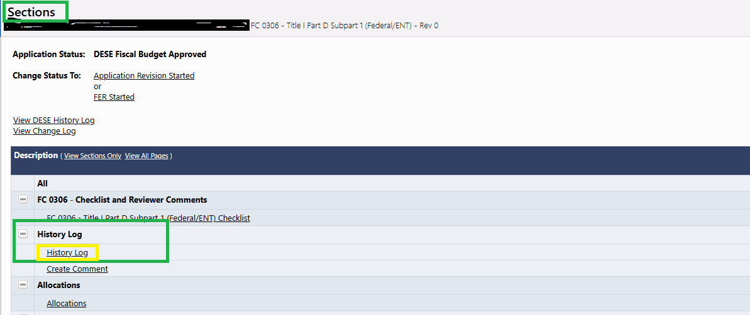

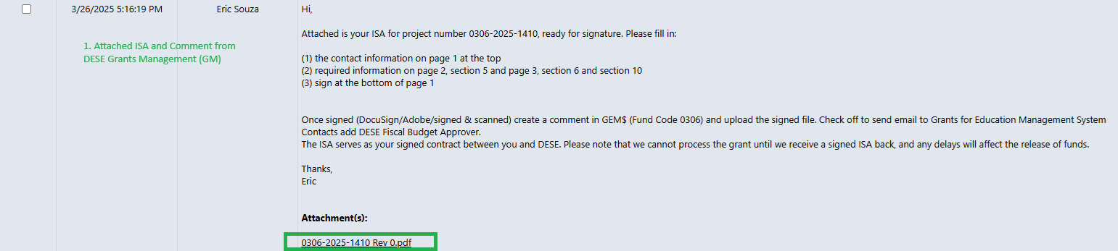

1. Fill out all applicable parts of Attachment A in the ISA form before signing. DESE will auto populate this space where applicable but we do need you to fill in descriptors as outlined in the boxes on the form (i.e., Subcontractors line box #5)

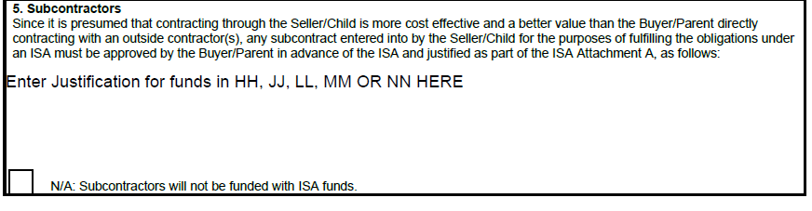

1. Once reviewed and signed by the applicant, the signed ISA should be uploaded to the grant file by the applicant.
   1. To do this, go to Sections>Create Comment
   2. Once signed ISA is uploaded to the grant file by the applicant, Grants Management will receive a notification from GEM$.

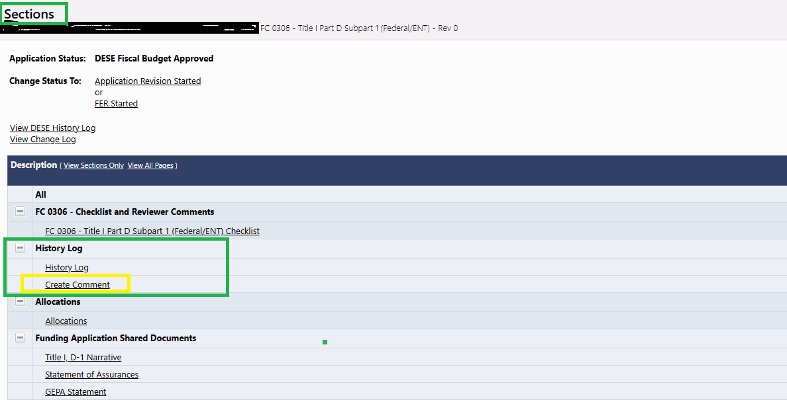

1. Next, for state agencies (true ISAs only) the DESE budget office signs and processes the BGCN (MMARS document to establish fiscal year total ceiling for federal/trust ISAs) and BGRG (MMARS document to establish federal program code total (including all budget years covered by the ISA) documentsin [MMARS](https://public.powerdms.com/MAComptroller/documents/1779234) and sends the ISA to Comptroller’s Office for final approval. Once Office of the Comptroller (CTR) approves the ISA documents in MMARS, this fully executed ISA will then be attached to the GEM$ application file. Grants Management will notify you through GEM$ of final approval.

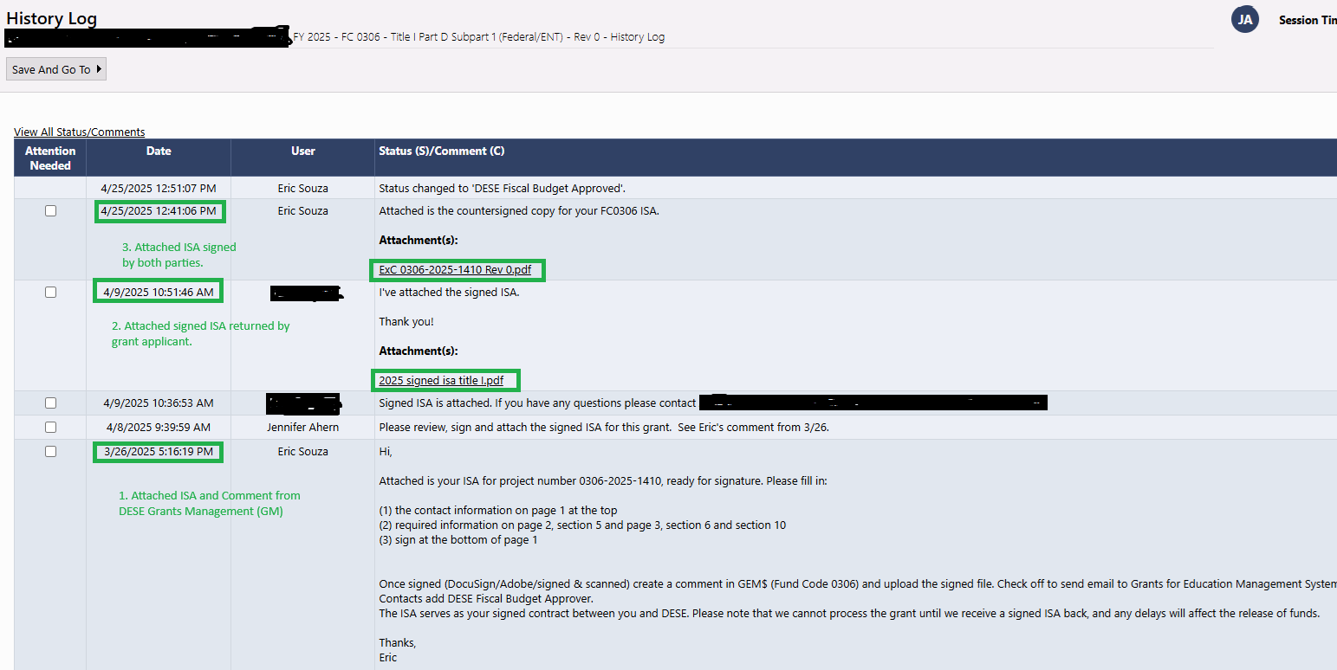

1. The grant will then be moved through the DESE fiscal approved step in GEM$.
2. Since the ISA process is layered and travels through many different DESE offices, it is imperative to get the signed ISA attached/uploaded as soon as possible so the setup can be completed timely, and applicants have access to their grant funding.

##### Application Revisions:

If an applicant wants to revise any of the budget/categories a revision can be completed which will kick off the entire process again. To initiate the process of amending your ISA, you will want to change the status of your application in GEM$ to “Application Revision Started” to make changes to the “ISA Budget Details” and/or budget pages. Revisions must be submitted 30-days prior to need and final revisions submitted 30-days prior to grant/ISA end date. The revision will go through the entire ISA process described above.

###### Requesting Grant Reimbursement:

**State and Community Colleges:** Grant funds can be claimed on a reimbursement method via GEM$. Please reference the [Reimbursement request Training Module](https://mass.egrantsmanagement.com/DocumentLibrary/ViewDocument.aspx?DocumentKey=15&inline=true) for details information on drawing down funds.

**State Agencies (such as DYS or county Sherriff Departments):** All funds are transferred to the grantee via the ISA/MMARS setup process, so grantees are responsible for processing all eligible expenses in MMARS.

ISA Closeout (State Agencies only):  
If an ISA ended in the previous fiscal year (ending on 6/30):

* ISA amendment is not needed – the remaining balance will be pulled back.

If ISA ends in the current fiscal year (ending on 9/30)

* Confirm that you have sufficient uncommitted estimated receipts in the current fiscal year and that all related fringe and indirect costs have been charged on the grant by Office of the Comptroller (CTR).
* Send ISA amendment to return unspent funds back to DESE.

Final Expenditure Report (FER):

At the conclusion of grant activities, grant recipients must submit a Final Expenditure Report (FER) to the Department, accounting for the expenditure on funds received. Please reference [Instructions for Submitting Final Financial Reports](https://www.doe.mass.edu/grants/edgrants/fr1-instructions.docx) for additional details.

Final expenditures are required to be submitted 90-days after the grant program/ISA end. Final grant application revisions should be submitted 30-days prior to ISA/grant end date so that by the time the FER is due, revisions are processed and FER can be filed with no issues.

Resources:

* [EdGrants & GEM$: User Guides, Information and Trainings](https://www.doe.mass.edu/grants/edgrants.html)
* [ISA Process and Timelines for ISAs on MMARS](https://view.officeapps.live.com/op/view.aspx?src=https%3A%2F%2Fwww.doe.mass.edu%2Fgrants%2Fedgrants%2Fisa-mmars-timeline.docx&wdOrigin=BROWSELINK)
* [MA Expenditure Classification Handbook](https://www.macomptroller.org/expenditure-classification-handbook/)
* [ISA Revisions](https://www.doe.mass.edu/grants/isa-revisions.docx)
* [Federal Grants Cost Allocation](https://www.macomptroller.org/federal-grants-and-cost-allocation/)
* [GEM$ Revisions, Reimbursements and Reporting](https://mass.egrantsmanagement.com/DocumentLibrary/ViewDocument.aspx?DocumentKey=17685&inline=true)
* [Office of the Comptroller – State Finance Trainings](https://www.macomptroller.org/announcement/state-finance-training-for-new-finance-and-budget-employees/)

*For questions regarding the ISA documentation and Fiscal matters please contact the Grants Management Office at 781-338-6595 or email* [*EdGrants@mass.gov*](mailto:EdGrants@mass.gov)*.*