Multi-Year FAQ and How To
Which Federal Grants are Eligible for Multi-Year?
What is Multi-Year?
Is Filing Multi-Year required?
How to file Multi-Year Delegation Form
Error Messages
Applicants who move $0 into the next FY
What if Multi-Year is filed, but more should have been moved?
What if Multi-Year form is not filed, but funds are needed in next FY?
Post Multi-Year Payment Request Windows
Which Federal Grants are Eligible for Multi-Year?
Award Year | Grant Programs | End Date | FR-1s due
2022 | ESSER II (Fund Code 115) | 9/30/2023 | 11/30/2023 or 60 days post final draw down, whichever comes first.
2022 | ESSA grants: Title I (Fund Code: 305), Title II-A (140), Title III (180 & 186), Title IV (309) | 9/30/2023 | 11/30/2023 or 60 days post final draw down, whichever comes first.
2022 | IDEA: (Fund Codes: 240 & 262) | 9/30/2023 | 11/30/2023 or 60 days post final draw down, whichever comes first.
2022 | ARP IDEA grants: ARP IDEA (Fund Code 252) & ARP IDEA Early Childhood (Fund Code 264) | 9/30/2023 | 11/30/2023 or 60 days post final draw down, whichever comes first.
2022 | ESSER III (Fund Code 119) | 9/30/2024 | 11/30/2024 or 60 days post final draw down, whichever comes first.
2022 | ARP Homeless Children & Youth I (Fund Code 301) | 8/31/2024 | 10/31/2024 or 60 days post final draw down.
2022 | ARP Homeless Children & Youth II (Fund Code 302) | 8/31/2024 | 10/31/2024 or 60 days post final draw down.
2023 | ESSA grants: Title I (Fund Code: 305), Title II-A (140), Title III (180 & 186), Title IV (309) | 9/30/2024 | 11/30/2024 or 60 days post final draw down, whichever comes first.
2023 | IDEA: (Fund Codes: 240 & 262) | 9/30/2024 | 11/30/2024 or 60 days post final draw down, whichever comes first.

Back to Top
What is Multi-Year?
Most federal grants funded through the United States Department of Education (USED) contain a provision known as the Tydings Amendment. This means the funds are awarded to states for use within a 27-month period. The intent of this provision is to give the grantees (states) and sub-grantees (LEAs) enough time to administer effective programs and minimize the amount of funds returned to the federal government.
For most DESE federal entitlement grants, the EdGrants system was designed with multi-year functionality to more effectively administer Tydings grants. In the past, grantees would have to close their grant and re-apply for the balance. Now, the same grant is simply extended into the next Fiscal Year (FY) and can continue along with payment request windows and the ability to amend line items as needed.
The multi-year delegation form does two things:
- It extends the end date on the grant award
- It moves some funds into the next FY so that re-applying for unclaimed balances is not needed

Back to Top
How to file Multi-Year Delegation Form
Multi-year will be available each May 1st for submission. Refer to the current FY Multi-Year info for timelines and deadlines.
Log in to EdGrants Front Office
Go to Submissions on the left-hand navigation menu
Filter on the grant project you intend to complete Multi-Year for by selecting the Applicant Project Name in the drop-down menu.
Starting on May 1st, you will see the Multi-Year Delegation form in the Submissions menu.
Open the Multi-Year form by clicking on the orange folder.
Note the amount of funds you have left to draw. Of that remaining balance, enter how much you would like to keep in the current FY in the Additional Funds Needed through 6/30 field. Click Save.
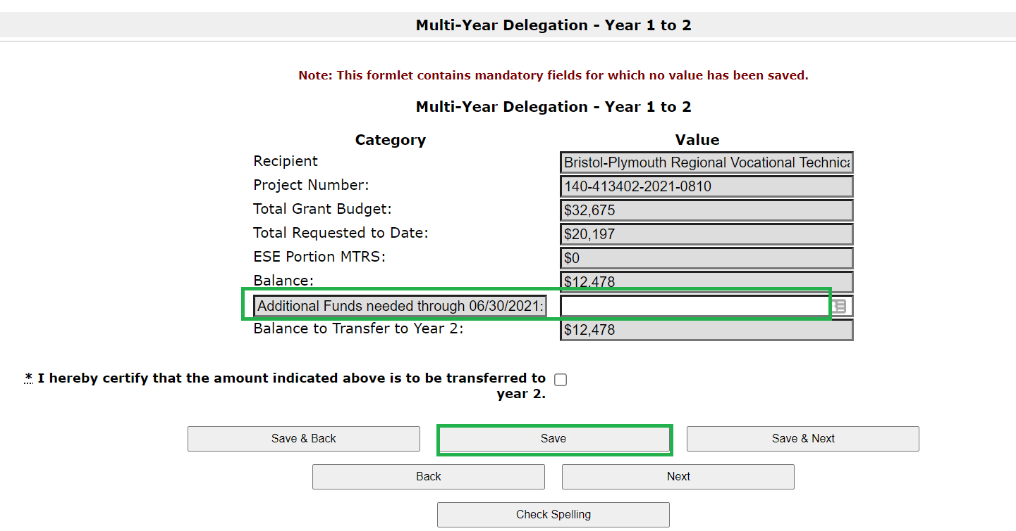

Once Saved, the Balance to Transfer to Year 2 (or 3, depending on award year) will change to equal the Balance on the grant less the amount electing to keep through 6/30.
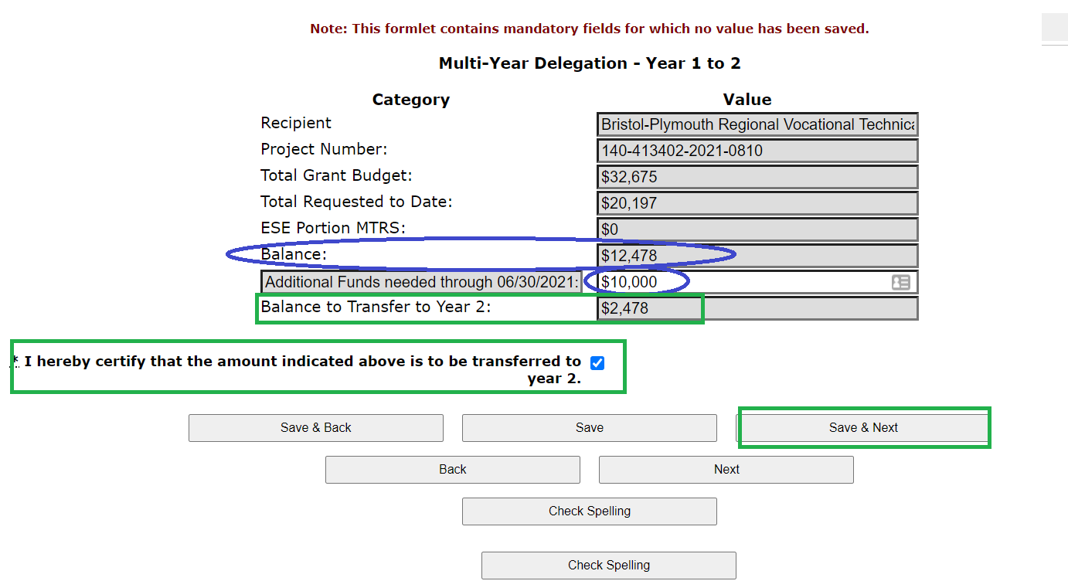

Review to ensure the form accurately reflects the amount you are leaving through 6/30 and moving to next FY is accurate.
Click the Certification box* and click Save & Next.
Make sure to click SUBMIT on the Submission Summary page, or the request will not be recorded.
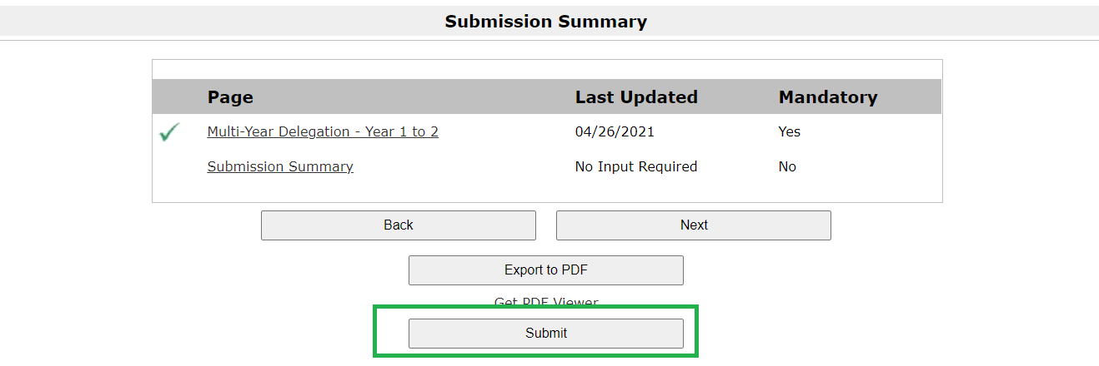

Once submitted, it will bring you back to the submissions menu and it will display the date and time stamp of your submission. If you do not see a date and time stamp, go back into the form by clicking the orange folder open, and hit submit.
If you file a multi-year form, it cannot be amended once submitted. Funds moved will be available to draw using the next FY payment windows starting on 7/1.
*Please note, the grant awards moving funding into Year 3, the certification box is mis-labeled to say “… transferred to Year 2.” This is a typo and it is asking for certification regarding the Year 3 multi-year roll.
Back to Top
Is Filing multi-year required?
No. If you anticipate spending 100% of the grant funding in FY2023 there is no need to file a multi-year delegation form.
Funds not moved into FY24 will continue to be available to draw through August (8/20-8/24).
If balances remain unclaimed after the August window, DESE will roll them automatically in September, and they will be available to draw in the October window (10/20-10/31). The grant award end date will be extended at this time. Expenditures can be applied back to the summer months, if needed, since the original start date on the grant remains the same.
Districts that have some high spending planned over summer may not want to wait until October to get access to the funds, so should move it by the multi-year submission due date.
Back to Top

Error Messages
The Multi-year delegation form will prevent submission when the applicant is trying to move more into Year 2 (or Year 3) than is available to draw on the grant. If an error message appears, please check to make sure the numbers entered are accurate.
Back to Top
Applicants who move $0 into the next FY
If an applicant realizes too late that it should have moved some funds and extended the grant, we will roll unclaimed balances in September and extend your grant end date at that time. Funds must be left unclaimed for DESE to roll them in September. We cannot roll funds that you have already drawn down.
Grantees that file FR-1 to close the grant that attempt to return funds before the federal award end date on the grant will be told to keep the funds and continue to spend them down. The purpose of multi-year is to prevent grant fund returns. Please consider this as you make decisions regarding multi-year.
Back to Top
What if Multi-Year is filed, but more should have been moved?
Leave funds unclaimed. Unclaimed balances left in the current FY, will roll into the next FY in September, and will be available to draw down in October.
For example, a grantee has a $10,000 balance left to claim.
They submit a multi-year form moving $2,000 into the next FY.
They now have $8,000 left to claim in current FY. ($10,000 - $2,000 moved = $8,000)
They only claim $7,000 of the $8,000. $1,000 will roll into the next FY in September.
They will have access to draw the $2,000 they moved via multi-year form starting 7/1. The additional $1,000 will be available to draw in the October payment window. $1,000 will be added to whatever balance is remaining at that time (moved – drawn to date + unclaimed).
We cannot roll funds that you have already drawn down.
Back to Top
What if multi-year form is not filed, but funds are needed in next FY?
Leave funds unclaimed. We will roll the unclaimed balances into the next FY and extend the end date of the grant in September. These funds rolled not using multi-year delegation form will not be able to be drawn down until October.
For example, a grantee has a $10,000 balance left to claim.
They do not file / submit a multi-year form moving funding into the next FY.
They claim $8,000 in current FY, leaving a balance of $2,000 unclaimed after the final 8/20 – 8/24 multi-year draw down window.
In September, DESE will analyze balances left unclaimed and roll them into the next FY on behalf of the grantee. Grantee will be able to access the $2,000 balance in October (10/20 – 10/31). Grantee can apply these funds back to summer expenditures, as the roll in September extends the end date of the grant and does not change the original start date of the grant.
Back to Top
Post Multi-Year Payment Request Windows
Once Multi-Year occurs, the grant award amount is now split between Year 1 and Year 2 (or Year 2 and Year 3). All expenditures can be charged back to the start date on the grant, regardless of what amount was moved or remained; the grant start date has not changed, the end date has been extended.
The multi-year delegation does impact when applicants can access or draw down the grant funds from Year 1, Year 2 or Year 3. The window dates depend on which award is being drawn.
Award Year | Balances | Available Payment Request Windows Post Multi-Year
FY2023 | Year 1 | May 20 - 30 | June 20 - 30 | July 20 - 31 | Aug 20 – 24*
 | Year 2 (funds moved) | X | X | July 1 – 10 | Aug 1 - 10
FY2022 | Year 2 | May 20 - 30 | June 20 - 30 | July 20 - 31 | Aug 20 – 24*
 | Year 3 (funds moved) | X | X | July 1 - 10 | Aug 1 - 10

*This window is only available for multi-year grants. The August window for the outgoing FY is shortened so that DESE can ensure all payments clear by the Comptroller’s Accounts Payable deadline for FY2021 payments. All other grants final window is July 20 – 31, even for grant that end 8/31.
DESE expects that grantees will shift expenditures as needed to fully expend the oldest award first.
Back to Top

