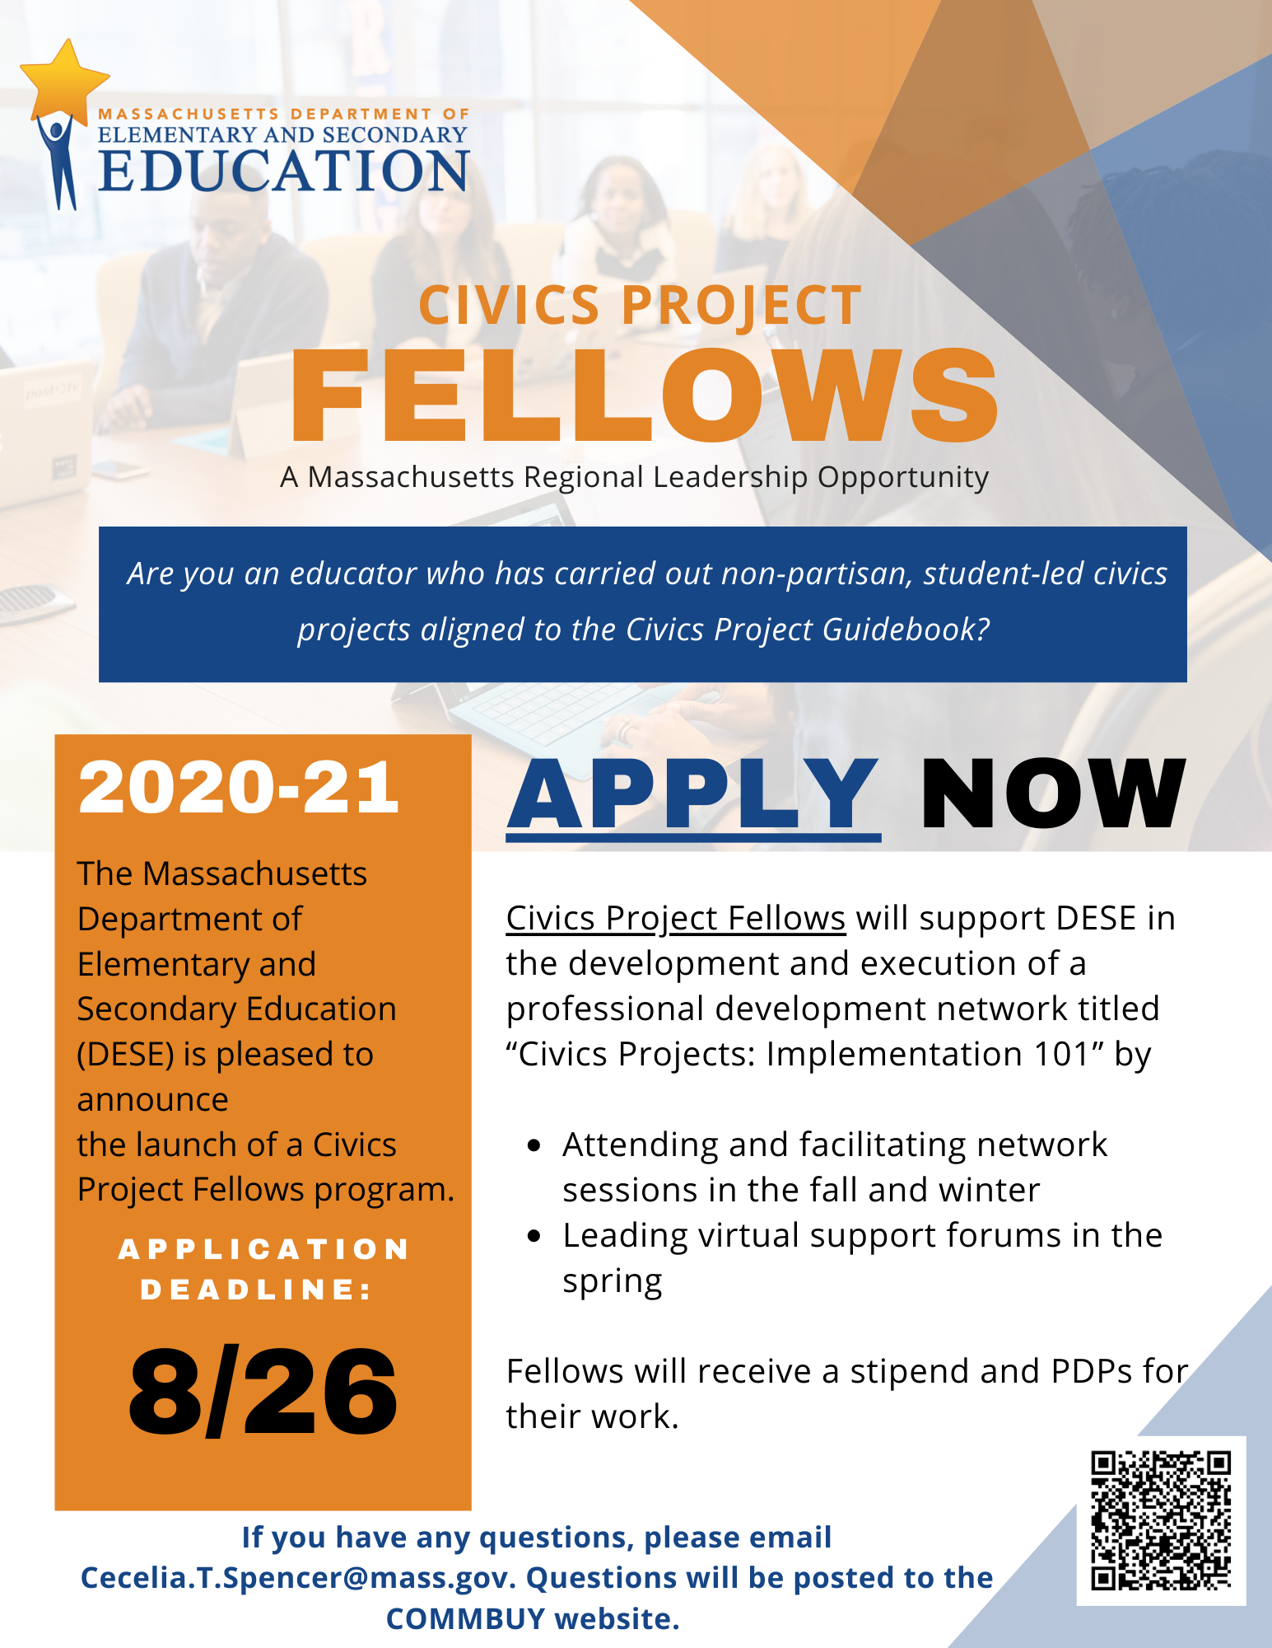
Civics Project Fellows:
Purpose: To support Massachusetts educators to implement the new student-led, non-partisan Civics Projects outlined in the Civics Project Guidebook and required by Chapter 296 An Act to promote and enhance civic engagement.
Background: The Civics Projects Fellows will support DESE in the development and execution of a professional development network titled “Civics Projects: Implementation 101” to help participants understand the characteristics of high-quality, aligned student-led civics projects and plan for project implementation. Participants in the “Civics Projects: Implementation 101” will attend one virtual regional meeting in the fall and one virtual regional meeting in the winter, with optional virtual support forums throughout the year to share implementation successes/challenges. The Civics Project Guidebook will be the anchoring resource for all learning.
The Civics Projects Fellows will provide feedback on the development of the network materials and provide support during the network sessions throughout the 2020-21 school year. Each Fellow will attend and help facilitate two 2.5-hour virtual regional network meetings of the “Civics Projects: Implementation 101” during the fall of 2020; attend and help facilitate one to two 2.5-hour virtual regional network meetings during the winter of 2020; and help plan and lead one 2-hour virtual support forum during the spring of 2021. Civics Project Fellows will also contribute to additional DESE-developed instructional resources related to the civics projects.
Civics Projects Fellows will attend and help facilitate two of the following virtual meetings of Session 1 meeting and one of Session 2 meetings of the “Civics Projects: Implementation 101” in the following Massachusetts regions:
Session 1 meetings are scheduled to take place between virtually 10/14/20-10/30/20. Session 2 meetings are scheduled to take place virtually between 11/23/20 and 12/11/20.

Summary of Fellows Role:
- Lead: Fellows will lead specific portions of Session 1 and Session 2 of “Civics Projects: Implementation 101” in 2020, as well as plan and lead one virtual support forum in the Spring of 2021. Fellows may choose to tailor their portions of the events to best utilize their expertise and address the needs of their regions.
- Encourage: Fellows will foster buy-in and build credibility at the network meetings by speaking to the value and outcomes of student-led, non-partisan civics projects. Fellows will serve as the point person for the region’s educators when content/project-specific questions arise. Fellows will raise awareness of the projects with community organizations local to their region.
- Advise: Working closely with DESE, Fellows will provide feedback on the content of the “Civics Projects: Implementation 101” professional development series as well as other instructional materials related to civics.

Civics Projects Fellows Responsibilities:
- Attend a one-hour norming meeting the week of 9/21/20-9/25/20.
- Attend and help facilitate (with DESE as lead) two 2.5-hour professional development sessions (Session 1 of Civics Projects: Implementation 101) in their respective regions, taking place between 10/14/20-10/30/20.
- Attend and help facilitate (with DESE as lead) one to two 2.5-hour professional development sessions (Session 2 of Civics Project: Implementation 101), taking place between 11/23/20 and 12/11/20.
- Plan and facilitate (with Fellows as lead) one 2-hour virtual support forum during the spring of 2021.
- Participate in four virtual DESE-led afternoon (4:30pm-6pm) Fellows meetings during the 2020-2021 school year in October 2020, November 2020, January 2021, and June 2021.
- Provide targeted feedback on DESE produced materials related to the network and other civics projects materials (4-5 hours over the course of the 2020-21 school year).
- Participate in informal check-ins/communications with DESE as needed.
- Make contact and share informational materials with five community organizations in their region regarding the student-led, non-partisan civics projects.
- Answer questions from educator participants during the “Civics Project: Implementation 101” series and as they arise during implementation.

Civics Fellows Anticipated Schedule 2020-2021
Month | Responsibilities
August -September  2020 | DESE:  - Select Fellows and assigns regional meeting responsibilities.  - Design materials for the Civics Projects: Implementation 101 professional development series.  Fellows:  - Commit to regional meeting responsibilities and provide feedback on materials for Civics Projects: Implementation 101.  - Complete pre-work for and participate in virtual norming meeting with DESE to review and discuss the program overview (week of 9/21-9/24).
October 2020 | DESE:  - Lead regional Session 1 meetings of the Civics Projects: Implementation 101 network.  Fellows:  - Attend preparation meeting for Session 1 of the Civics Projects: Implementation 101 network (week of 10/5-10/9).  - Attend and help facilitate 1-2 meetings of Session 1 of the of the Civics Projects Implementation 101 network (10/14/20-10/30/20).
November-December 2020 | DESE:  - Lead regional Session 2 meetings of the Civics Projects: Implementation 101 network.  Fellows:  - Attend preparation meeting for Session 2 of the Civics Projects: Implementation 101 network (week of 11/9-11/13).  - Attend and help facilitate one to two virtual meetings of Session 2 of the of the Civics Projects Implementation 101 network (11/23/20- 12/11/20).
February-May 2021 | DESE:  - Schedule and manage outreach, registration, and logistics for four to six virtual support forums.  Fellows:  - Plan and lead one Virtual Support Forum for educators in the Civics Projects: Implementation 101 and other educators leading projects across the state.  - Make contact and share informational materials with five community organizations in their region regarding the student-led, non-partisan civics projects.
June 2021 | DESE and Fellows  - Attend closing meeting to discuss progress, challenges, and feedback on program.  - Complete summative reflections of their experience participating in the Civics Projects Fellows.

Compensation
Fellows will receive a stipend of $1,250 for time. Expected time commitment is 22-25 hours over the course of the school year, with an accompanying 25 Professional Development Points.

For information on the application process, preferred qualifications and to apply, click the link HERE.

Applications are due August 26 by 5:00 PM EST and can be submitted to the link posted above.

