CAP: Research Notes

This document is intended to help you stay focused while researching your chosen issue. You will see that each aspect of your research has been broken down into three research questions, with a “general information” section for facts that are helpful but don’t fit neatly into one of the research questions. The three research questions that you will be addressing during this part of the project are:
- What is the issue?
- Why is it an issue?
- What are people/organizations doing about it?

It is important that you keep careful track of where you get your information from throughout this process. Please use the box below to capture your sources and your information:

Copy & Paste me every time you find a NEW source!

⇩ ⇩ ⇩ ⇩ ⇩ ⇩

Source: *
This is a reliable source because...
Information:
●
*Great resource for citing sources: MLA Style Citation Examples (B.D. Owens Library) Web page Citation:
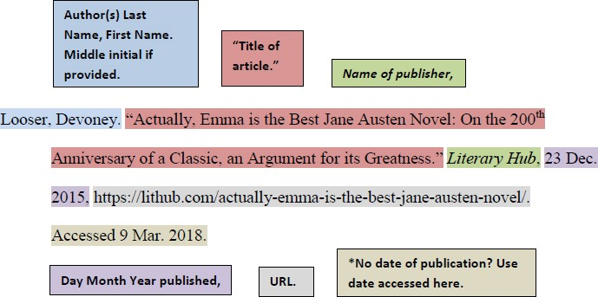

Research Question 1: What is the issue?
Questions to consider while researching this section
  - What does your issue look like in real life?
  - Where is this issue most prominent?
  - What are the facts of this issue?
  - What are some important terms associated with this issue?

Source:
This is a reliable source because...
Information:
●

Research Question 2: Why is it an issue?
Questions to consider while researching this section
  - What has happened?
  - What is the extent of the problem?
  - Why should we be concerned?
  - Who is affected? How are they affected?
  - What are the repercussions of this problem?

Source:
This is a reliable source because...
Information:
●

Research Question 3: What are people/organizations doing about it?
Questions to consider while researching this section
  - Who has worked to address this issue in the past?
  - What have they done?
  - When addressing the issue, which level did they target (local, state, national, global)?
  - What challenges did they encounter?
  - What successes did they have?
  - What lessons did they provide to future generations of activists?

Source:
This is a reliable source because...
Information:
●

Any other general helpful information

Source:
This is a reliable source because...
Information:
●

Reflect on research:
- How many DIFFERENT sources did you consult while researching?

- How do you know that you are DONE researching?

- What questions remain?

