Stage 4: Develop an Action Plan
CAP, Day 5 of 11: Locating Allies and Determining Actions

My issue is

Background to Build Meaning: So far, we have selected an issue that interests us and our communities (Stage 2), researched the root causes and effects of the issue (Stage 3A), determined ways in which community groups on a local, state, and national level are working to make change (Stage 3B), and researched what our government is doing to reduce the effects of the issue (Stage 3C). Throughout this process, we’ve thought about ways we might make systemic change, and we’ve studied the ways others have and continue to make change to help us and members of our community. Let’s keep it going! You’re doing very well, and we’re proud of your efforts. Reach out, anytime.

Today’s GOAL: Meet with other 8th graders who share similar values to help brainstorm ways we might take action to make systemic change together.

Key to Support Today’s Work
Directions
Examples
Your Thinking/Notes

Locate Your Issue on Library Tables.  Begin Task 1 Below.  You have 3 Tasks to complete in  20 minutes. | 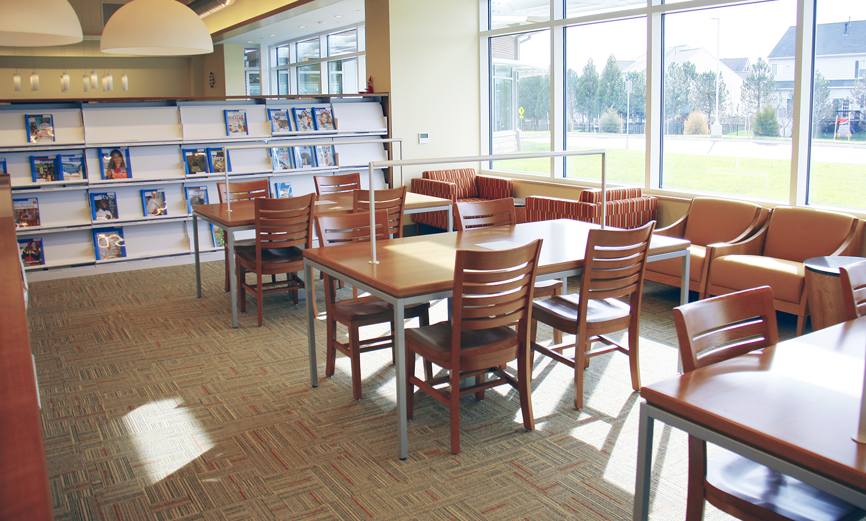

Step 1: Introduce yourself. Share your name, the issue that you’ve been studying, and why you’re interested in it.
5 minute TIMER
My name is Jennifer. I want to help families who struggle with food insecurity in Western Mass. For example, 1 in 4 children are food insecure.
My name is
The issue that I’m interested in is because

Step 2: Write peers’ names and issues with hopes of making connections. Remember that we are looking for allies, people whom we can support and will support us. It doesn’t have to be the exact issue, but something that you see as being connected. 5 minute TIMER

Equal rights for women connects with reproductive rights. Raising the minimum wage connects to food security.

Student Name and Email | Issue | How It Connects to My Issue

Step3: Brainstorm Collective Action: How might we take action to attack the root cause and reduce the effects of my issue? 10 minute TIMER
Dream big with your ideas. All ideas are great ideas!

Actions that Already Exist that you can Join | Actions that You can Model off of Others’ Action | Actions that You Can Create (local, state, or national)
Walk for Hunger on 5/5/22; With letter writing persuade Congress to increase federal minimum wage | Food Drive at ARMS OR Brown Bag for Kids | Present free breakfast for all students to School Committee

Today’s Reflection
D  A  T  E | Write a peer’s idea for an action that you’d like to try. | Focus and Effort in Reaching  Today’s Goal: Meet with other 8th graders who share similar interests and values to brainstorm ways you might take action to make systemic change together. | Questions/Comments for Teachers
Focus: ____/5
Effort:____/5

