Civics Action Project (Unit 5)
Your Playlist
Directions:
This Playlist is designed to help you to complete the tasks needed to develop and implement your class’ Civics Action Project. You will be given class time on Fridays to complete most tasks but some will involve work done outside of school. When necessary, consecutive days will be added to work on your project.

Important Dates to Remember: Due Date:
- Tasks #1-3 Initial Topic Research January 7-28
- Task #4 Initial Topic Research Presentations February 4-18
- Tasks #5-6 Further Research & Progress Meetings March 4-25
- Task #7 Developing an Action Plan April 1-May 6
- Task #8 Taking Action May 6-June 10
- Task #9 Reflection Tuesday, 6/14/2022

Activity | Directions | Notes | Date Completed
1) Examine Self & Civic Identity | - Read the Civic Action Overview on Google Classroom. |  | Suggested due date: 1/7  Date Completed:
2) Identifying an Issue | Initial Topic Research Part I  - Students will identify possible projects and research them.  - Begin Brainstorming Issues of Concern  - Have classes make an Google Form Assessment of “Issues that Concern Them” |  | Due Date: 1/7
3) Identifying an Issue: Research | Student Research  Students will research a specific topic.  - Students will develop a Google Slide Presentation to present to the class.  - This will count as a test grade. (see Initial Research Project Rubric) |  | Due Date: 1/7-1/28
4)Identifying an Issue: Research Presentation | Presentation of Possible Issue  - Students will present to the class.  - Students will be prepared to answer questions  - Students will choose which projects should be researched further. (Students will assist each other with this task.)  . |  | Due date: 2/4-2/18
5) Identifying an Issue: Further Research | Further Research on Possible Topics  - The class will choose either one project or a few to explore more deeply.  - All students will assist with this research.  - Second Presentation of new information.  - Class votes on Civic Actions Project |  | Due date: 3/4
6) Researching & Investigating: Defined Issue | Civics Action Plan-Progress Meetings  - All students will be involved in researching their class’ chosen project.  - Each class will decide when to hold “Project Meetings.”  - They should meet quickly at the beginning and end of each class.  - The meetings will employ “Robert’s Rules of Procedure.”  - Students will choose roles for the project.  - Participation will be graded. (Participation Rubric) |  | Suggested due date: 3/4-3/25  Date Completed:
7) Developing an Action Plan | How will you achieve effective change?  - Identify targets  - Identify agents of change  - Develop feasible Action Plan  - Develop indicators when goals have been achieved  - Identify effective strategies  - Identify tactics to achieve Plan |  | Suggested due date: 4/1-5/6  Date Completed:
8) Taking Action  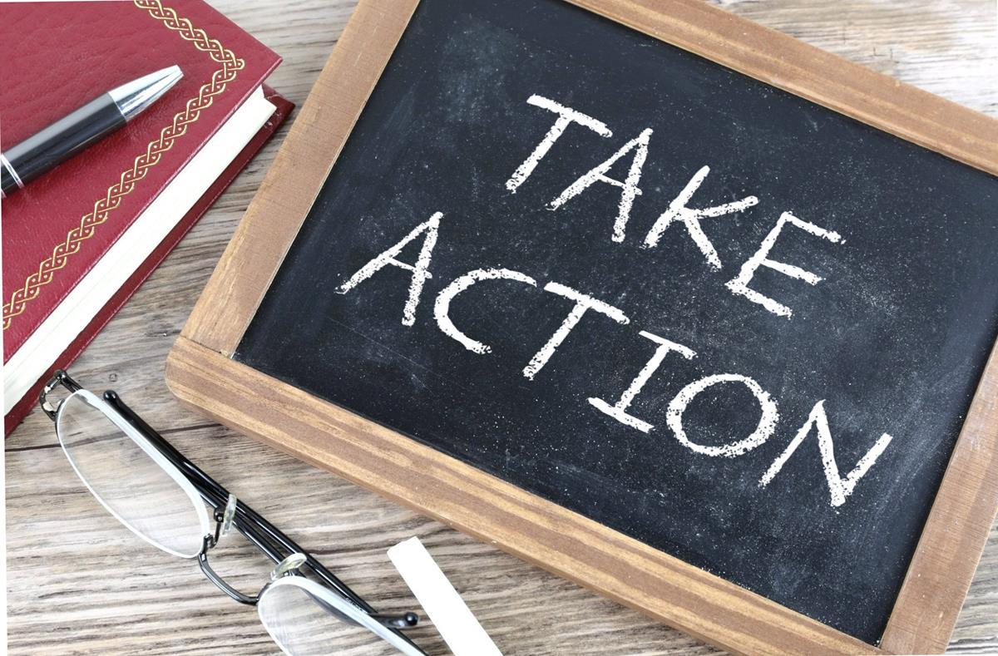 | What are you going to do?  - Interact with agents of change  - Monitor Plan  - Meet often to review strategies  - Consider alternatives to your plan of action  - Evaluate Progress |  | Suggested due date: 5/6-6/10  Date Completed:
9) Reflection on Civics Action Project  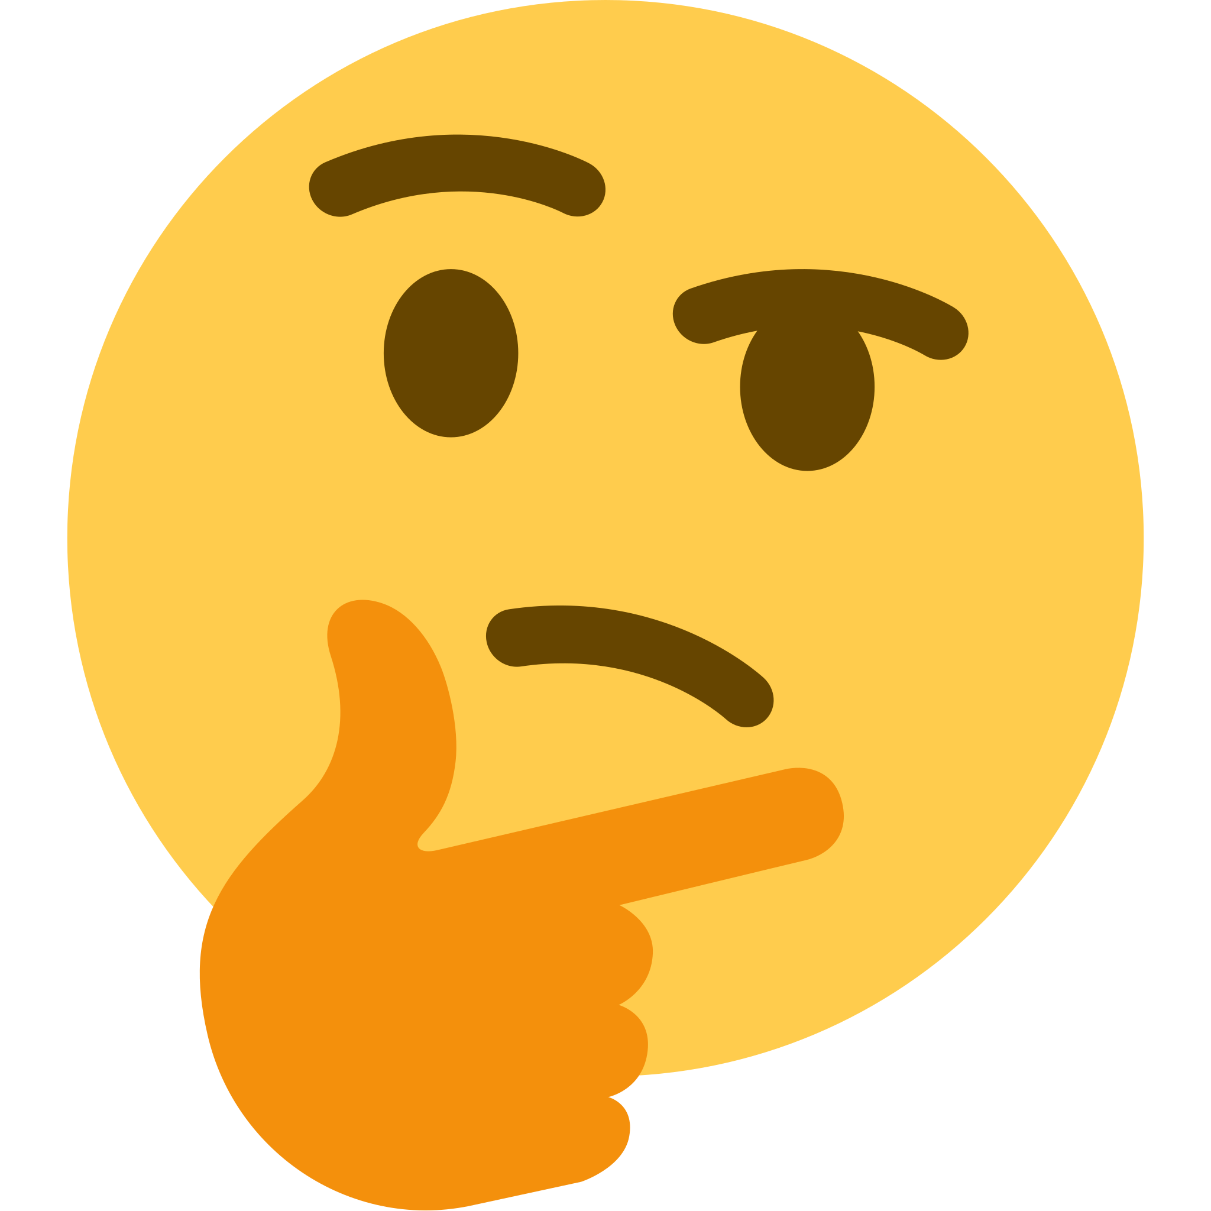 | Reflecting & Showcasing  - Assess the outcome of your Civic Action Project.  - Assess your role in the Civic Action Project.  - This will count as a Quiz grade. (Reflection Rubric) |  | Suggested due date: 6/14  Date Completed:

Bibliography
"Using Playlists to Differentiate Instruction." Cult of Pedagogy. September 24, 2018. https://www.cultofpedagogy.com/student-playlists-differentiation/.

