Unit 5: Activism Project
How to create change!
This notebook belongs to:

Table of Contents
- Project Instructions
Part 1: Research
- Brainstorming Topics
- Narrowing
- How to Research Notes
- Researching the Topic
- Paraphrasing Notes
- Creating an Informational Slideshow Instructions
Part 2: Activism
- Forms of Activism
- Creating Change Instructions
Part 3: Publish
- How to Publish Instructions

Packet Total: /35

Make sure to submit the project on Google Classroom! That is a separate grade from the notes in this packet.

Project Instructions

Directions: Over the next few weeks, you will be investigating, arguing, and trying to create change on an issue of your choosing. You can work with up to two other people. Each part will be graded independently. Notice how the work builds on each other, so it’s important to stay on top of the tasks so you don’t fall behind.

What will be submitted:
❏ This packet (aka notes)
❏ A powerpoint of research
❏ A form of activism
❏ A website that publishes your work

Part 1: Research
- Pick and narrow down a research topic
- Research a topic
- Create informational slideshow about a topic
Part 2: Activism
- Create one form of activism about your topic
- Send or share the form of activism to gather support
Part 3: Publish
- Create website with the slideshow, creation, a survey, and sources!
- Look through other people’s projects to show support!

Part 1: Research
What is Activism?

Brainstorming Activism Topics
Directions: Choose a topic of your own. Brainstorm what areas could be changed about that topic. If you’re stuck, use the list below!
schools health sports equality racism science/tech LGBTQ+ environment animals COVID Social Media mental health
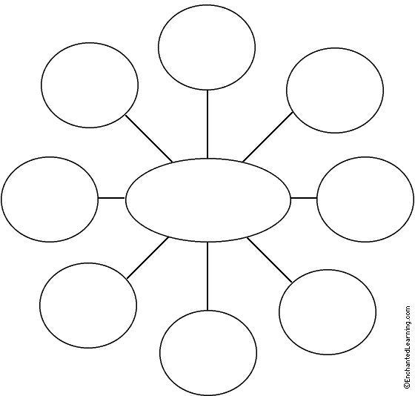

Narrowing Down your Research Topic

Your Broad Topic: (Ex. civil rights, i-Ready, environments, etc.)

+ When does this happen? (during school, a sports games, etc.)

+ Where this takes place (ex. School, United States, Massachusetts)

+ The change wanted (reduce homework, incorporate more food options)

+ Who can make this change? (parents, senators, principals, teachers, etc)

Put it all together! This is your new, narrow topic.
(ex. The Superintendent of Haverhill Public Schools should ban plastic water bottles this year for all the schools in the district).

How to Research Notes

Google Tip | Example | What does it do?
“ “ | “We hold these truths to be self evident”
OR | Climate change OR global warming
- | apple -fruit
site: | site:history.com sloths
Best sites to look for:

Query | Keywords
Is climate change affecting water levels? | “Climate change” +water
What steps do I take to get a driver’s license?
What are the admission requirements for Boston University?

Research the Topic

A credible source should have:
- A .gov .org, .edu ending
- An author(s) listed
- Their sources listed
- Both sides of an argument/opinion

Find 3 different credible sources. If you are working in a group, every person should still contribute 3 DIFFERENT sources.

From each source, ﬁnd 3 different facts, statistics, or opinions that help answer the four guiding questions.

Guiding Questions:
★ What is your topic?
★ Who does your topic affect?
★ Why is your topic a problem?
★ What are some possible solutions?

Source 1 of 3
Website name:
Website Link:
Article Name:
Info #1
Fact, Statistic, or Opinion that answers a guiding question
Info #2
Fact, Statistic, or Opinion that answers a guiding question
Info #3
Fact, Statistic, or Opinion that answers a guiding question

Source 2 of 3
Website name:
Website Link:
Article Name:
Info #1
Fact, Statistic, or Opinion that answers a guiding question
Info #2
Fact, Statistic, or Opinion that answers a guiding question
Info #3
Fact, Statistic, or Opinion that answers a guiding question

Source 3 of 3
Website name:
Website Link:
Article Name:
Info #1
Fact, Statistic, or Opinion that answers a guiding question
Info #2
Fact, Statistic, or Opinion that answers a guiding question
Info #3
Fact, Statistic, or Opinion that answers a guiding question

Paraphrasing Notes
What does it mean to paraphrase?

Five steps to Paraphrase
1.
2.
3.
4.
5.

Tips to Paraphrase

Original Sentences | Paraphrase
Willy Wonka was famous for his delicious candy. Both children and adults loved to eat it. | Willy Wonka was known throughout the world because people enjoyed eating the tasty candy he made.
Last summer, my dog ran away for several days. It wasn’t until a neighbor saw him that we were able to catch him.
New York City is an engaging and exciting city that tourists love to visit.

Informational Slideshow Instructions

Compile all the information together into an informational slideshow on Google Slides. It should have at least 6 slides (4 informational ones per person). If any slideshow contains copy/pasted sentences, the whole slideshow will get a 0.
Paraphrase it! An example is on Google Classroom. Submit when you are done!

★ Slide 1: Cover slide.
★ Slide 2: What is your topic?
★ Slide 3: Who does your topic affect?
★ Slide 4: Why is your topic a problem?
★ Slide 5: What are some possible solutions?
★ Slide 6: Sources used
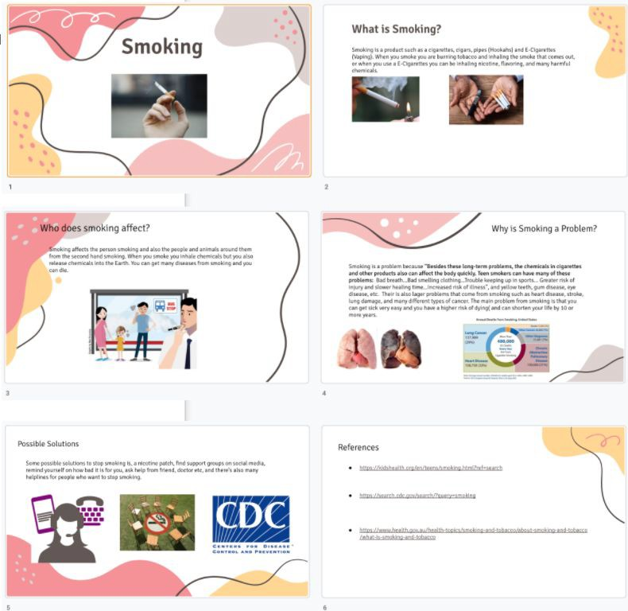

Part 2: Activism
Main forms of Activism
Type of Activism | Deﬁnition | What is an example?
Letter Writing Campaign
Petition
Protest
Boycott
Social Media Campaign
Civil Disobedience
Public Service Announcement
Write an Essay

Creating Change Instructions
The most important piece of this project is being an activist and trying to create change. Choose one of the main forms of activism and work to accomplish it.
You should submit evidence of your activism to Google Classroom when you are done. This could be anything from pictures of a peaceful protest or pictures of letters that were sent to a senator.

No matter what form of activism you’re taking on, Yyur creation should include three things:
★ Background information about the issue
★ Who the issue impacts
★ What should be done about the issue

Examples of ﬁnished work (Read them on Google Classroom)

Letter
A student wrote a letter to School Committee to change a policy.

Petition
A petition was created and shared on change.org to stop a harmful disability narrative in an advertisement.

Public Service Announcement

A video was created and shared on social media to show harmful impacts of smoking.

Essay
A student wrote a persuasive essay (similar to a letter) and submitted it to a local newspaper for publishing.

Part 3: Publish the Work

Your last step is to get the word out about your issue by creating a website OR poster. Your published piece should include 4 things:

Informational Slideshow
★ Insert the slideshow you created about the topic.

Creation (letter, petition, essay, or PSA)
★ Insert the creation you made
★ If there’s a petition, include the link so people can sign!
★ If there’s a letter, include any responses you may have gotten.

Survey
★ Create an include a Google Survey
★ Ask audience 3-4 questions:
  - What they learned
  - Their feelings on this topic
  - If they would be willing to support your stance for your cause
  - If they have ideas on how to make a change for your cause

Sources
★ Insert every source you used throughout the project
Sample Website (link on Google Classroom)

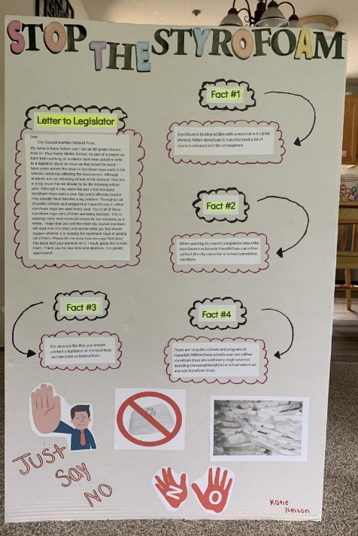Sample Poster (Image on Google Classroom)

