Date Assigned: | Topics for the Action Civics Response Log  If you can’t write on a log sheet, send me your answer as a Schoology DM.
Wednesday March 11 (this is the last one!) | For the January 29 Response Log, I collected many answers like the ones in the blue box below.  You may use those ideas to answer 1 or both of these questions:  How well has your class been working in these 5 areas to actually make a difference?  OR  Do you predict that your class will achieve its Policy Goal before the school year ends?  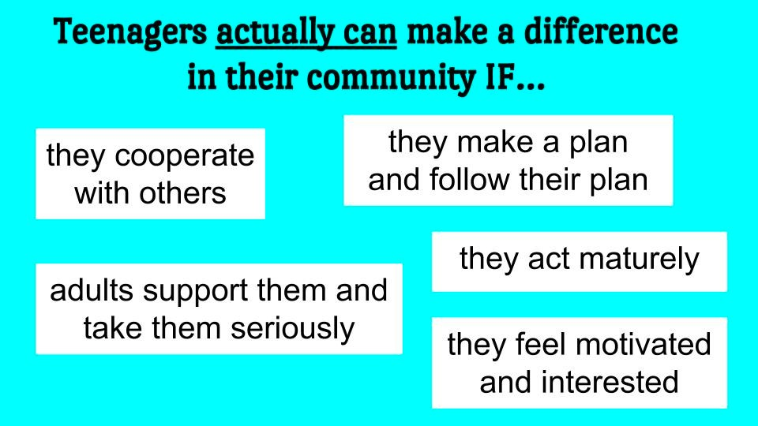
Tuesday March 10 | Of course there is a lot of concern around the world about the COVID-19 virus, and what the government of each city, state, and country should do about it  What do you believe would be “going too far”?  (In other words, what is the limit of government action for people’s health?)

Monday March 9 | Today’s topic is inspired by the “graveyard” of presidential candidates who have dropped out.  People are always telling you to “Persevere!” … “Never quit!” … “Keep trying!” ... How can someone know `when it is the right time to give up for the common good?
Friday March 6 | OPTIONAL (ignoring this topic will not count against your Response Log grade)  How do you feel about the “tyrannical” decisions I announced in class today AND the way that I announced them?
Thurs March 5 | Almost every minute of this week’s classes have been whole-class discussions  of your group’s Action Civics project (plus a little time about the presidential primaries). Mr Swan has been running the discussion, calling on hands, typing into the GoogleDoc, writing and revising the questions, assigning you into pairs for the homework, etc.  Has this strategy been BETTER or WORSE than trying the same work in small-groups?  Please be honest!!
Wed March 4 | What have you done since Wednesday’s class to find answers to your assigned question(s) OR to think about the information/ideas that were shared in class?  (open your section’s folder on my Schoology page to find your assigned questions)
Tuesday March 3 | What have you done since Tuesday’s class to find answers to your assigned question(s) OR to think about the information/ideas that were shared in class?
Monday March 2  [sections 1, 2,  4] | What have you done to find answers to your assigned question(s)?

Monday March 2  [section 3] | Some students in every class act like leaders, even if it won’t raise their grade. Why do you think they do it anyway?
Wed Feb 26 | There is a famous quotation: “Democracy is the worst form of government except for all those other forms that have been tried.”  Based on your recent experience with democracy in this Action Civics project (and/or your opinions about current events like the presidential primary process), do you agree with that statement? Why or why not?
Tues Feb 25 | Should we make new Action Civics Committees for the next steps of the hourglass?  If so, then why? … and what should each committee do?  If not, then why not? … and how should we divide the work instead?
Thurs Feb 13 | How do you feel about what your class decided for “Decision Day” on Thursday?  (If you plan to attempt the “totally get it” writing task, this log entry is a good chance for a first draft.)
Wed Feb 12 | SAME TOPIC AS YESTERDAY!!  Do you expect the class will choose your topic? Why or why not?  (I expect you to base your answers on what you saw & heard during Sharing Day. If you were absent from class, then you are excused from this log.)
Tues Feb 11 | Do you expect the class will choose your topic? Why or why not? (Reminder: The voting will happen in Thursday’s class on a GoogleForm. You can vote to approve more than one Focus Issue -- not just the one your committee worked on!)
Fri Feb 7 | Who has been inspiring other students in your committee  AND/OR working to keep others involved & included with the groupwork?  If nobody is doing that in your committee: Would that be helpful for your group?

Thurs Feb 6 | Right after President Trump finished his State of the Union speech on Tuesday, the Democratic leader of the House of Representatives (Nancy Pelosi) picked up her copy of his speech and ripped it in half.  Do you support “the rip”? Was this OK?  If you’re not sure, what information do you need to help make your decision?
Wed Feb 5 | Describe your first day of working with your Action Civics Committee! (optional: Add an emoji to help illustrate your feelings, but your response should still be mostly written in sentences)  If you were absent from Wednesday’s class, you are excused from this topic BUT you should check your “shared with me” GoogleDocs to see what your group did today.
Tues Feb 4 FOR SECTION 3  AND 4 | Was Julie’s story inspiring?  Can your class do something better with this project?
Mon Feb 3 FOR SECTION 1  AND 2 | Read this article or watch the video about an 8th grader’s food pantry THEN answer the question: Was that a successful Action Civics project?
Fri Jan 31 | How do you feel about what we are going to do in class next week?  (scroll down to see the green slide that I showed on Friday)
Thur Jan 30 | Answer all questions on the “Easiest Quiz of All Time” [read the directions 1st!] THEN  Read the sentence that appears below the score box (it starts with “Before”) THEN

Write about that sentence & about your experience with the “Easiest Quiz of All Time”.
(like questions you got right or wrong, and why the quiz has that name!)
Wed Jan 29 | Can teenagers actually make a difference in their community?  Or are you too young & foolish & immature & powerless to be effective?
Tue Jan 28 | What are some community issues that need improvement in Newton? RECOMMENDED: Talk to family members for ideas AND/OR think about your recent experiences with school AND/OR look around your neighborhood.
Mon Jan 27 | Listen to the first 2 minutes of the song “Hourglass” by A Perfect Circle...  ...and write a full paragraph about whatever you think this song is about. HINT: There is definitely a civics connection!

Action Civics Committees!!
Size: between 3 and 6 students
Structure: 1 chair and 1 vice-chair (elected within the group) with power to
assign roles to others, manage votes and discussions, veto ideas
Job:
- learn more about your Community Issue (research local news articles, talk to people affected by it, find groups already working on it...)
- narrow down to a Focus Issue
- identify a systemic Root Cause
- prepare to persuade the rest of the class to agree with you!

