Name: Date:

**I: Identity & Belonging:** Who am I? What is MY story?

DO NOW BRAINSTORM: Every one of us has a story. We’re all unique individuals who are shaped by many different factors & experiences. Beyond physical appearance, what makes you unique?

# Brainstorm around the following questions:

* What makes a person unique?
* What does a person’s “story” mean?
* When you think of describing yourself to others, telling your story, what type of information would be important to include?

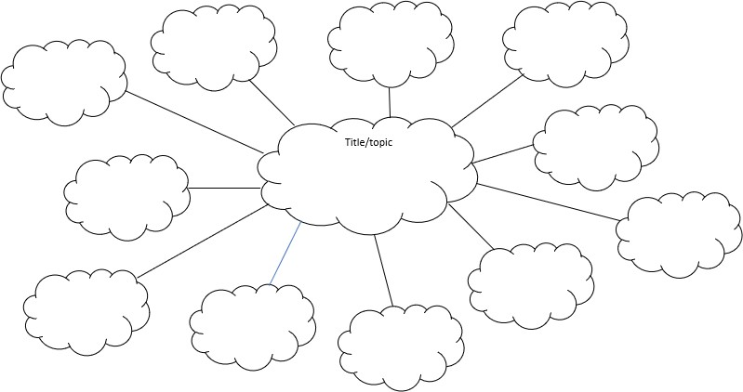

**TURN & TALK:** Consider how your individual story (identity) is connected to your various communities or groups. The communities you belong to are related to your interests, your activities, where you live, and what you care deeply about such as your family, school, sports team, place of worship, clubs, etc.

Turn & Talk with your partner or group about the following questions. Jot down your ideas and select a person to share out:

* + What is a community?
  + Can you belong to more than one community?
  + How do these communities help to shape you?

**Notes:**

**YOUR UNIQUE PORTRAIT**

1. On the next page, use words or short phrases inside the person to describe what makes you unique as an individual.
2. Next, think about the different groups or communities you belong to which shape your self-identity. Write them in the space outside the person.

**CRITICAL THINKING:** As you work, think about how these different groups or communities help to shape your identity. Be prepared to discuss your unique portrait with our class when you finish. As you share your story with us, use the portrait to help organize your story. You might find the following questions helpful in guiding your conversation:

* + What did you include in your portrait (inside the person)? Why did you choose them?
  + How does belonging to certain communities (outside the person) help to shape your unique identity?
  + What are some obstacles or challenges you face as an individual or as part of a larger community?
  + What similarities/differences do you have with others in your group?
  + Are you surprised by those similarities/differences? Why or why not?
  + How do your unique history and experiences, both good and bad, shape who you are and who you want to be?



# EXIT TICKET REFLECTION:

1. What did you learn about yourself from your self-portrait?
2. How do you think group membership (or being a member of various communities) impacts who we are & our individual stories?
3. What is your biggest take-away from this experience today?