How to Use the Civics Project Data Dashboard

The Civics Project Data Dashboard is designed to provide district leaders with their own student-led civics project data for grades 8 and high school, making it easier to:
- Track civics project completion over time and compare district data with statewide trends.
- Identify opportunities to improve data quality and better understand student access across schools and grade levels.
- Support local conversations about expanding access to meaningful, high-quality civic learning experiences.
The dashboard is available in Edwin for designated school and district staff. For help accessing and using Edwin, see the Getting Started in Edwin page.
Explore a version of the dashboard with simulated sample data.

Overview and Navigation

The Civics Project Data Dashboard has three pages:
- Home: Basic information about the dashboard, the civics project, and data included throughout the dashboard.
- Lookback Participation: Shows how many grade 12 students participated in the civics projects, looking back to earlier grades.
- Grade-Level Breakdown: Shows how many students in each grade participated in the civics projects, with options to look back to earlier grades or view a snapshot of the current grade.
Navigate between the three pages by clicking the tabs at the bottom of the dashboard.
The top-left corner of each page of the dashboard shows the Teaching for Civic Empowerment logo. Click it to go to the Civics homepage.
The top-right corner of each page of the dashboard shows a pink hand icon. Hover over the icon for more information on each page.

Users may click links in the dashboard, which appear as underlined blue text. Links will appear in teal once clicked.

Uses can also navigate the dashboard using a screen reader. See the Consume Power BI Reports by Using Accessibility Features page on Microsoft’s website for more information.
For more information and screenshots specific to each page of the dashboard, navigate to the corresponding section in this document.

Home Page

The Home tab acts as a landing page for the dashboard. It gives an overview of how to use the dashboard, examples of lookback and snapshot data, and informational text and links relating to the civics project.
Hovering over the pink hand icon on this page shows information about the source of data included throughout the dashboard. It also shows which students are included in the numerator and denominator for lookback and snapshot calculations.

Lookback Participation Page

The Lookback Participation tab shows three tachometer (“gauge”) charts, representing the percentage of 12th grade students in the selected year who participated in a civics project. The dark orange section represents 0-25% participation. The light orange section represents 25-75% participation. The blue section represents 75-100% participation.
The needle shows the percentage for the selected school or district. The black line shows the state average for comparison.
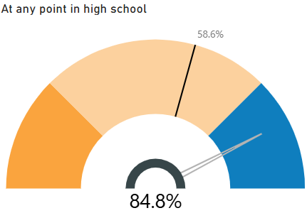
Each chart on this tab has a corresponding data table below, showing the numerators, denominators, and percentages for the selected school or district.
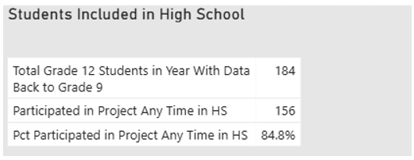
To filter the charts and tables, select the year and school(s) from the dropdown menus. Click anywhere in a dropdown menu to open the list of options, then scroll in the list to find the desired option. Click to select and filter the visuals on the page.
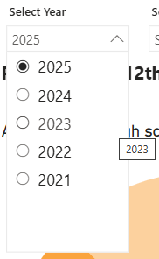

Grade-Level Breakdown Page

The Grade-Level Breakdown tab shows two bar charts, each of which has two views: 12th Grade Lookback and Current Grade Snapshot.
The first chart includes all grade 12 students, including students who may have transferred from another school. The second chart only includes grade 12 students who attended the selected school in each grade 9-12.
Both charts show the percentage of students participating in a civics project by grade. The Grade 8 bar represents the percentage of students participating in the grade 8 civics project, while the other bars represent students participating in the high school civics project. The gray line shows the state average for comparison.

Use the pill buttons to switch between the 12th Grade Lookback and Current Grade Snapshot views. The button is light blue when selected and white when unselected.
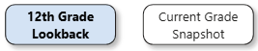

The 12th Grade Lookback view shows how many grade 12 students participated in the civics projects while they were in each grade, looking back to those students’ experiences in earlier grades. For example, the grade 10 bar in the chart below shows the percentage of 2025’s grade 12 students who participated in a civics project in grade 10 – likely in 2023, or whichever school year that student completed grade 10.
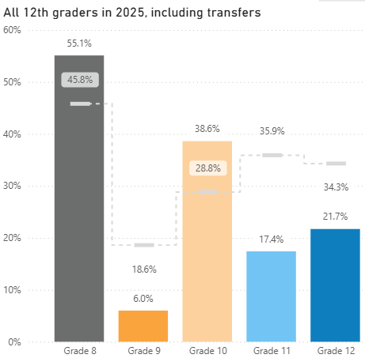

The Current Grade Snapshot view shows how many grade 12 students participated in the civics projects during the selected school year. For example, the grade 10 bar in the chart below shows the percentage of 2025’s grade 10 students who participated in a civics project in 2025.

Each chart on this tab has a corresponding data table to the right, showing the number of students participating in the project by grade as well as the total number of high school students.
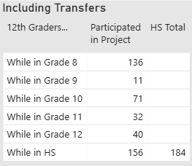
To filter the charts and tables, select the year and school(s) from the dropdown menus. Click anywhere in a dropdown menu to open the list of options, then scroll in the list to find the desired option. Click to select and filter the visuals on the page.

