
Student Work Review Tool
DESE Instructional Planning and Observation Tools Collection

Guiding Question
What ideas and concepts did students learn deeply?

This Tool Helps Educators
Apply an equity lens to
- Assess students’ progress, strengths, and opportunities for growth based on grade-level content, language, and practice standards.
- Reflect on and shift instructional practice to support access, growth, and achievement of all learners.
- Determine action steps to support grade-level student learning.

This tool is best used within an ongoing cycle of instructional planning: unit unpacking, lesson internalization, and student work review. You can find a facilitator’s companion in the Planning Tools Guidance.

Student Work Review Tool: Every Day and Deep Dive Versions
The Student Work Review Tool includes two versions: Every Day and Deep Dive. While it may not be practical to run the complete “deep dive” after every lesson, teachers can use the “every day” version to support their day-to-day reflection of student work as part of effective educator practice to cultivate deeper learning for all students.

Every Day Student Work Reflection

Reflection Questions | Considerations
- What are the expectations for the grade-level student work? | Review the content and language objectives for this lesson.  - What grade-level content standards and practices did this lesson target?  - Review the exemplar and rubric/criteria for success to ensure that you are assessing student work against grade-level standards and practices.
- To what extent did students meet the grade-level learning goals? | Review the student work and sort by the highest level of understanding to the lowest as aligned to the rubric/criteria for success.  - Did every student meet the objectives for this lesson and task? If not, identify the highest leverage gap(s) in student work. What trends, including both strengths and areas for growth, do I see?  - Where is there evidence of student learning and understanding aligned to the objective and grade-level standard(s) of the lesson?  - How does grade-level student learning and understanding vary across student groups?
- What must I shift in my instructional practice to address specific areas of student learning growth? | Reflect on the impact of your instruction and facilitation on learning for all students.  - How did my instruction contribute to trends – strengths and areas for growth – observed in the student work?  - To what extent did my instruction leverage students’ dynamic funds of knowledge – based on their cultures lived experiences, and linguistic resources – to draw and build upon for learning?  - To what extent did the learning task provide opportunities for students to think critically about the content and resources of the lesson and engage in learning that values and leverages their own identities?  Plan action steps.  - How will I address the highest leverage gap(s)?  - What shifts will I make to my instruction to deepen student learning in upcoming lessons to support progress towards meeting grade-level unit standards and goals?  - How will I communicate progress and action steps to students?

Student Work Review Team Deep Dive

Through the five-step process outlined, teacher teams can use the “Team Deep Dive” to collaboratively review student work and plan for shared shifts in instruction to advance student learning at scale, through shared and consistent practices and strategies.

Please refer to the Planning Tools Guidance for preparation required to engage with the Team Deep Dive version of the tool.

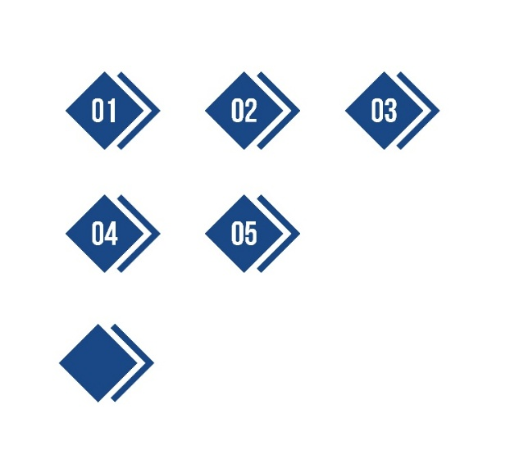Step 1: Pause and Check
We all approach student work with expectations about what students can or cannot yet do, emotions, and prior knowledge and assumptions.
Review Question | Reflection and Discussion
What are my biases or blind spots so I can mitigate them when reviewing student work? | Reflect on your own implicit biases and assumptions.  - To what extent do I believe that every student is capable of meeting grade-level standards and expectations?  - Is my bar or expectation for what students can do the same for every student?  - To what extent do I believe my instruction and facilitation of lessons impact student learning, both successes and areas for growth?  - When I see gaps in student learning, to what extent do I want to make the task easier versus identifying supports, scaffolds, and changes in pedagogy that would support all students to demonstrate mastery of grade-level work?  Discuss biases as a team.  - Where have we identified potential biases or blind spots?  - How can we hold each other accountable in setting and maintaining high expectations for every student?  - How can we hold each other accountable to reflect on the role our instruction plays in every student’s learning?

Step 2: Anchor in the Purpose and Goals of the Unit
Review Question | Reflection and Discussion
What are grade-level learning goals and expectations for student work for this unit? | Set the context for the student work.  - Provide information about:  - The sequence of learning within the unit.  - Objectives, as well as the grade-level aligned content, English language development (WIDA), and practices.  - The lesson, task, exemplars, and rubric/criteria for success for the team to reference. Work to ensure that the team is assessing student work against grade-level standards and practices.  - Any scaffolds provided to students for this specific work.  Individually review the student work.  - Read the student work and sort by level of performance as measured by the rubric and/or criteria of success. Be prepared to provide rationale for your sort.  - Note: Remember students may share ideas in a variety of ways. Focus only on the features of students’ responses that are articulated in the rubric / criteria for success.  - Highlight or note where you see evidence of grade-level understanding of content, skills, and English language development (WIDA).

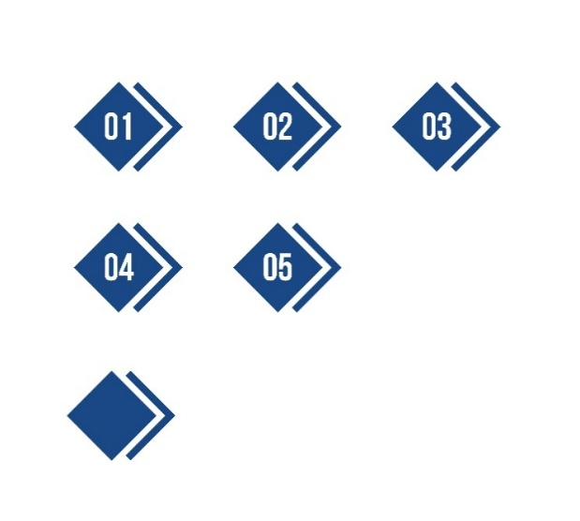Step 3: Analyze Student Work
Review Question | Reflection and Discussion
To what extent did students meet the learning goals of the lesson? | As a team, analyze student work with an asset-based lens and discuss trends.  - How did you sort the student work and why? Each team member should provide evidence for why they put the work in that order.  - Did every student meet the grade-level objective for this lesson and task? If not, identify and align on the highest leverage gap(s) in student work.  - What strengths and areas for growth do we see across student work, aligned to the rubric/criteria for success and standards-aligned exemplars?  - How does student learning and understanding vary across student groups? Note: Student identities may need to be shared to answer this question.  Compare trends to other evidence and data.  - How do these trends from student work compare to student feedback, standardized assessment data, and other data collected?  - How does the evidence collected from student work reflect learning goals identified for students with disabilities, English learners, and/or advanced learners?

Step 4: Reflect on Instruction
Review Question | Reflection and Discussion
What must we shift in our instructional practice to address specific areas of student learning growth at scale? | As a team, discuss the impact of our instruction and learning for all students.  - What specific aspect of prior instruction could have contributed to any gaps or variation we saw?  - How did our use (or non-use) of scaffolds specifically impact students’ thinking and learning?

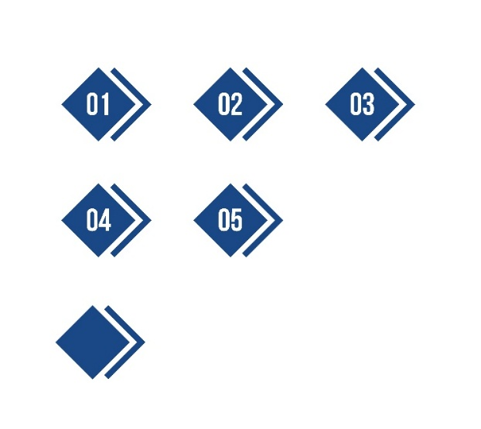Step 5: Plan for Actions and Communication
Review Question | Reflection and Discussion
What high-leverage actions do we commit to take as a team, and how will they be communicated? | Determine high-leverage instructional practice(s) to address specific areas for growth.  As needed, reference the Classroom Observation Tool or the Deeper Learning Guidance Tool in determining next steps in instructional practice.  - What shifts must we make to our instruction to support student learning growth in the areas we have identified and to reduce disparate outcomes? Consider specific instructional practices or routines that will deepen student learning in upcoming lessons.  - What will these shifts / actions look like in an upcoming lesson?  - How will we know that these actions are successful in improving learning for all students?  - How will we provide specific, timely, and asset-based feedback to students?  Determine how you will revise the lesson for future years.  - What must be added and/or removed from the lesson to support students to build knowledge, skills, and language development, to ensure all students meet the grade-level learning goals of the student work task?  - What aspects of the task itself might need to be revised?  - Consider the extent to which the lesson and task provided opportunities for students to think critically about the content and resources of the lesson and engage in learning that values and leverages their own identities: For example, to what extent does the task support:  - Variation in responses and answers (i.e., use of different pathways, ideas, strategies, or representations)?  - Students planning and/or revising their work?  - Original thinking and/or the creation of something authentic to the discipline?  - Students leveraging their own identities to make sense of and complete the task?  - Opportunities for students to reflect on their process and/or their learning?  - What areas of the rubric or criteria for success might need to be revised?  Develop consensus for how you will communicate feedback and progress to students, colleagues, and families (as applicable), and follow through.

