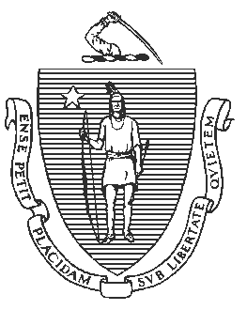
Jeffrey C. Riley
Commissioner

June 30, 2021

Massachusetts Department of Elementary and Secondary Education

75 Pleasant Street, Malden, Massachusetts 02148-4906 Telephone: (781) 338-3000 TTY: N.E.T. Relay 1-800-439-2370

Anthony Soto
c/o Holyoke Public Schools 57 Suffolk Street
Holyoke, MA 01040 Dear Mr. Soto:
Pursuant to M.G.L. c. 69, § 1J and 1K and 603 CMR 2.00, I have appointed you as the receiver for the Holyoke Public Schools and William G. Morgan School, effective July 1, 2021.

The authority of the Holyoke Public Schools School Committee to establish policies for the district; to make employment decisions; to approve budget transfers, encumbrances, and expenditures; to enter into any contracts; and to take any other action will remain suspended for the duration of the receivership. Under state law, the receiver exercises all the powers of the superintendent and the school committee.

Please feel free to contact Senior Associate Commissioner Russell Johnston (Russell.Johnston@mass.gov) if you need any additional information.

Thank you, and I look forward to working with you on behalf of the Holyoke Public Schools. Sincerely,
SIGNED BY COMMISSIONER RILEY

Jeffrey C. Riley
Commissioner of Elementary and Secondary Education

Cc: Acting Mayor Terrence Murphy, Chair, Holyoke Public Schools School Committee Russell Johnston, Department of Elementary and Secondary Education

