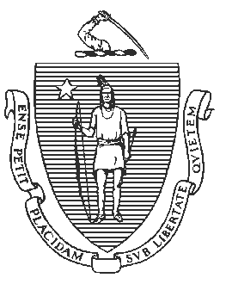
Jeffrey C. Riley
Commissioner

By email August 2, 2021

Massachusetts Department of Elementary and Secondary Education

75 Pleasant Street, Malden, Massachusetts 02148-4906 Telephone: (781) 338-3000 TTY: N.E.T. Relay 1-800-439-2370

Anthony Soto
Receiver, Holyoke Public Schools 57 Suffolk Street
Holyoke, MA 01040 Dear Anthony Soto:
I am writing to update you on the status of the turnaround plan for Morgan Full Service Community School (Morgan).

On June 22, 2021, the Board of Elementary and Secondary Education adopted an amendment to 603 CMR 2.00: Accountability and Assistance for School Districts and Schools. The amendment allows the Department of Elementary and Secondary Education (Department) to refrain from issuing new accountability determinations for districts and schools for school year 2020-2021.
Instead of issuing new accountability determinations in fall 2021, the Department will use each district’s and school’s most recent accountability determination (from 2019), to ensure that they continue to receive support as needed. As a result, and consistent with 603 CMR 2.06 (6) (a), Morgan will remain in chronically underperforming status and the turnaround plan will remain in effect.

Sincerely,

Jeffrey C. Riley
Commissioner of Elementary and Secondary Education

Cc: Steve Moguel, Morgan Full Service Community School
Russell Johnston, Department of Elementary and Secondary Education Lauren Woo, Department of Elementary and Secondary Education

