Amendment to the John Avery Parker Turnaround Plan, pages 48-51

II. PROFESSIONAL COMPENSATION SYSTEM
As part of the Turnaround Plan, the Receiver and Parker school leaders will continue to utilize the revised compensation system with the following components.
The basic principles of the plan are the following:

- Provides competitive compensation for teachers
- Rewards teachers for excellent performance and effectiveness
- Provides a career path for teachers to grow professionally without leaving the classroom
- Provides opportunities to reward teachers for their contributions to student growth
The new professional compensation system will be implemented for professional employees in the John Avery Parker Elementary School and will include a teacher career ladder containing five tiers—Novice, Developing, Career, Advanced, and Expert—that will compensate teachers commensurate with their development and impact on students. It is envisioned that student outcomes will improve by creating a professional compensation system that will attract new high-potential teachers and retain our best performers and leaders.

The Commissioner’s designee for the John Avery Parker Elementary School may include student performance measures in the evaluation of teachers’ performance and determination of teachers’ compensation.

CAREER LADDER
Definitions:

Novice teachers are typically first-year teachers entering teaching directly from college.

Developing teachers are early career educators, typically with one to two years of experience. There are two levels within the Developing tier.

Career teachers have been recognized as excellent educators. Career teachers serve as role models to less-experienced educators, and proactively drive their own professional growth.

Advanced teachers are outstanding educators who serve as schoolwide models of excellence. Advanced teachers have at least five years of experience and possess deep expertise in their craft.

Expert teachers are exceptional educators who serve as schoolwide and districtwide models of excellence. Expert teachers have at least five years of experience, possess deep expertise in their craft, and are capable of elevating the practice of already-gifted educators. Expert teachers will assume additional roles and responsibilities to support the school’s and district’s improvement.

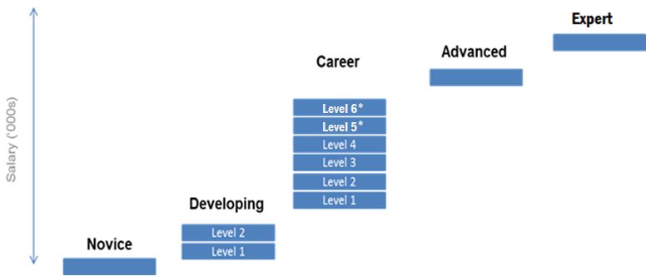
*Effective beginning in school year 2023-24, Career Levels V and VI are added to the career ladder.

Transition to the Career Ladder
Effective July 1, 2014, each New Bedford Public Schools teacher assigned to the John Avery Parker Elementary School was placed on one of the Levels based on such teacher’s performance as determined by the Commissioner’s designee. Teachers newly hired and assigned to the John Avery Parker Elementary School will be placed on one of the Levels as determined by the Commissioner’s designee:

The career ladder schedule is modified for school years 2022-23 and 2023-24 and beyond as follows:
Career Level | School Year 22-23 Compensation Level | School Year 23-24  and Beyond Compensation Level
Novice | $52,000 | $52,000
Developing Level I | $55,000 | $55,000
Developing Level II | $59,000 | $59,000
Career Level I | $63,000 | $63,000
Career Level II | $66,500 | $66,500
Career Level III | $70,000 | $70,000
Career Level IV | $75,000 | $75,000
Career Level V* | N/A | $80,000
Career Level VI* | N/A | $85,000
*Effective beginning in school year 2023-24, Career Levels V and VI are added to the career ladder.
Beginning in school year 2023-24, the annual base salary for an “Advanced” teacher will be $90,000 (increased from the previous level of $81,500 in school year 2022-23). A teacher designated as an Advanced teacher, whose total compensation exceeds $90,000 at the time of designation ($81,500 in school year 2022-23), will receive an additional one-time payment of $2,000 added to their annual base salary ($1,500 in school year 2022-23). The annual base salary for an “Expert” teacher will be $95,000 (increased from the previous level of $89,000 in school year 2022-23). Teachers selected for this position will receive a stipend differential based on their annual base salary in order to reach the Expert level of compensation. These stipend compensation amounts shall be included in base pay, or otherwise considered as part of the teacher’s annualized salary, for retirement purposes.

Beginning in school year 2023-24, a Career VI teacher who has been employed as a Career VI teacher for at least one school year and who receives an end-of-year overall evaluation rating of “proficient” or “exemplary,” with “proficient” or better ratings on all four standards shall receive an additional $2,000 added to their base salary annually ($1,500 in school year 2022-23).

Beginning in school year 2023-24, an Advanced teacher who has been employed as an Advanced teacher for at least one school year and who receives an end-of-year overall evaluation rating of “proficient” or “exemplary,” with “proficient” or better ratings on all four standards shall receive an additional $2,000 added to their base salary annually ($1,500 in school year 2022-23).

The salary schedule will continue to be reviewed and may be adjusted periodically by the Commissioner’s designee to reflect market conditions.

Advancement on the Career Ladder
A Novice teacher shall advance to Developing I and a Developing I teacher shall advance to Developing II annually provided that the teacher does not receive an end-of year overall evaluation rating of “unsatisfactory” and provided that such teacher’s employment is renewed.

A Developing II teacher shall advance to Career I and all Career level teachers shall advance a level annually provided that an end-of-year overall evaluation rating of “proficient” or “exemplary” is received, with “proficient” or better ratings on all four standards. It is expected that educator evaluation ratings and student performance data will be major components of the teacher’s evaluation. A teacher with an end-of-year overall rating of “proficient” who has achieved less than “proficient” ratings in the third and fourth standards may still advance to the next level with the recommendation of the school principal and the approval of the Commissioner’s designee.

A teacher may advance on the salary scale more rapidly than described at the discretion of the Commissioner’s designee.

Novice, Developing, Career, and Advanced teachers who continue in employment at the John Avery Parker Elementary School shall not have their salary reduced based on their performance evaluation.

Consistent with the School Turnaround Plan, based on past experience and performance, a newly hired teacher may be placed above the Novice level at the discretion of the Commissioner’s designee.

The categories of Advanced and Expert teachers will be established effective July 1, 2014. The roles, expectations, and selection criteria for Advanced and Expert teachers will be determined by the Commissioner’s designee.

A teacher who has attained the status of Career III or a higher level and received “proficient” or “exemplary” overall end-of-year ratings the previous two years can apply to become an Advanced teacher through a cumulative career portfolio, including demonstrated success in attaining specific student growth benchmarks as determined by the Commissioner’s designee.

A teacher who has attained the status of Career III or a higher level and received “exemplary” overall end-of-year ratings the previous two years can apply to become an Expert teacher through a cumulative career portfolio with demonstrated success in attaining specific student growth benchmarks as determined by the Commissioner’s designee. The portfolio may include 1) student growth data over time; 2) endorsements from peers, parents, students, and administrators; 3) and evidence of effective instruction.

In addition to teacher advancement as outlined above, the Commissioner’s designee may provide additional compensation to a bargaining unit member if she determines that such payment is necessary to better serve the needs of the students. Such compensation may include payment to teachers who possess additional certifications not required by their current positions, and/or for performing additional duties, etc.

