 | Official Transcripts/Degree Conferral – An Overview
Verifying that the transcript is official:
When reviewing a transcript to verify that it is official, a licensure evaluator must be able to see the Registrar’s signature. Note: transcripts sent directly to the applicant from eSCRIP-SAFE (or any other provider of electronic transcripts) that lack a Registrar’s signature, are not considered official transcripts for the purpose of licensure. See example below.
Example of transcript sent directly to student from eSCRIP-SAFE without Registrar’s signature. | 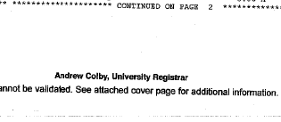  eSCRIP-SAFE transcript lacking Registrar’s signature
Examples of transcripts bearing legible Registrar signatures. | 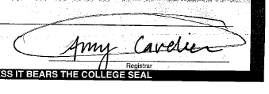 | 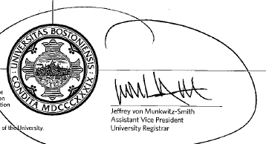
Verifying degree conferral:
Along with verifying that a transcript is official a licensure evaluator may also need to verify conferral of a degree (verification of Bachelor or Master’s degree). To verify conferral of a degree the transcript must note degree conferred as well as conferral date. See examples below.
Examples of transcript indicating degree conferred and conferral date. | 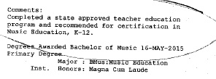 | 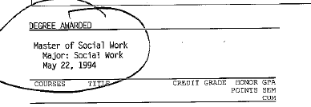
For guidance on how to upload documents into your ELAR account, please refer to the How to Upload Documents to ELAR: A Step-by-Step Guide which can be found on the Office of Educator Licensure’s website (https://www.doe.mass.edu/licensure/). Click on the Forms, Guidelines, and Regulation’s link in the Licensure Requirements module on the main page:
