Submitting an Updated Application for an Additional Review in ELAR

The guide is intended to assist an applicant in moving an application from a pending to a pending review status. Please note that a pending status means that the Office of Educator Licensure has reviewed the application and notified the applicant of what requirements must be satisfied to obtain the license. An application in pending review means that new information is on file to be reviewed by the Office of Educator Licensure.

1. 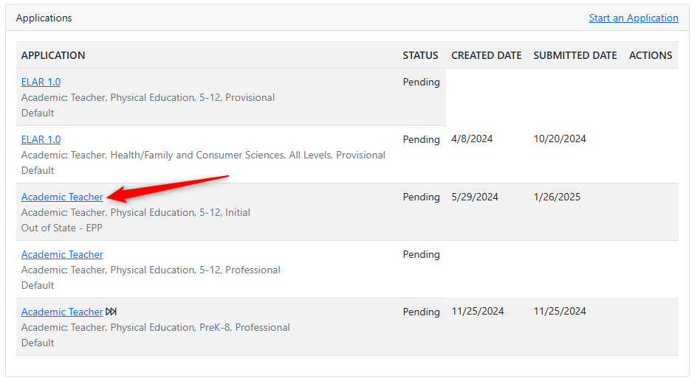Open the application that was marked ***Pending*** by clicking on the application. These will be shown on your ***Dashboard***.

Once you are in the application, an update must be made to one of the elements in order for you to be able to request an updated evaluation for the application. If no changes are made to any elements, the application will not be evaluated again.

1. 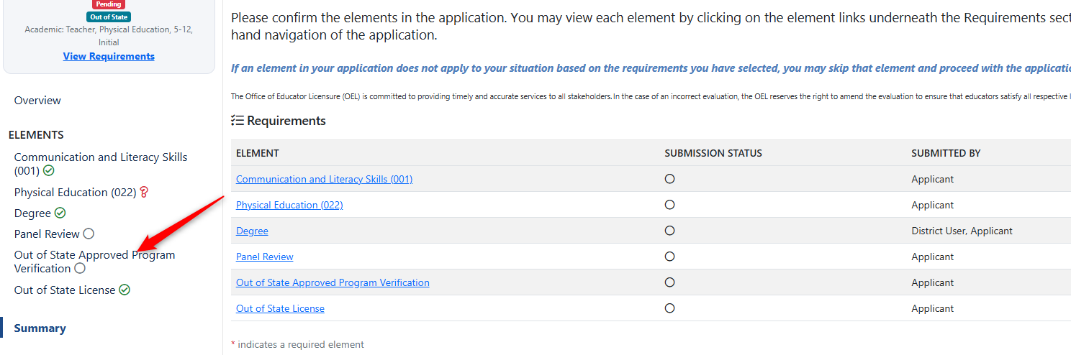Click to open any element on your application that may need to be addressed or updated.
2. Once the element is open, add any additional information or documents to meet the requirements.
3. 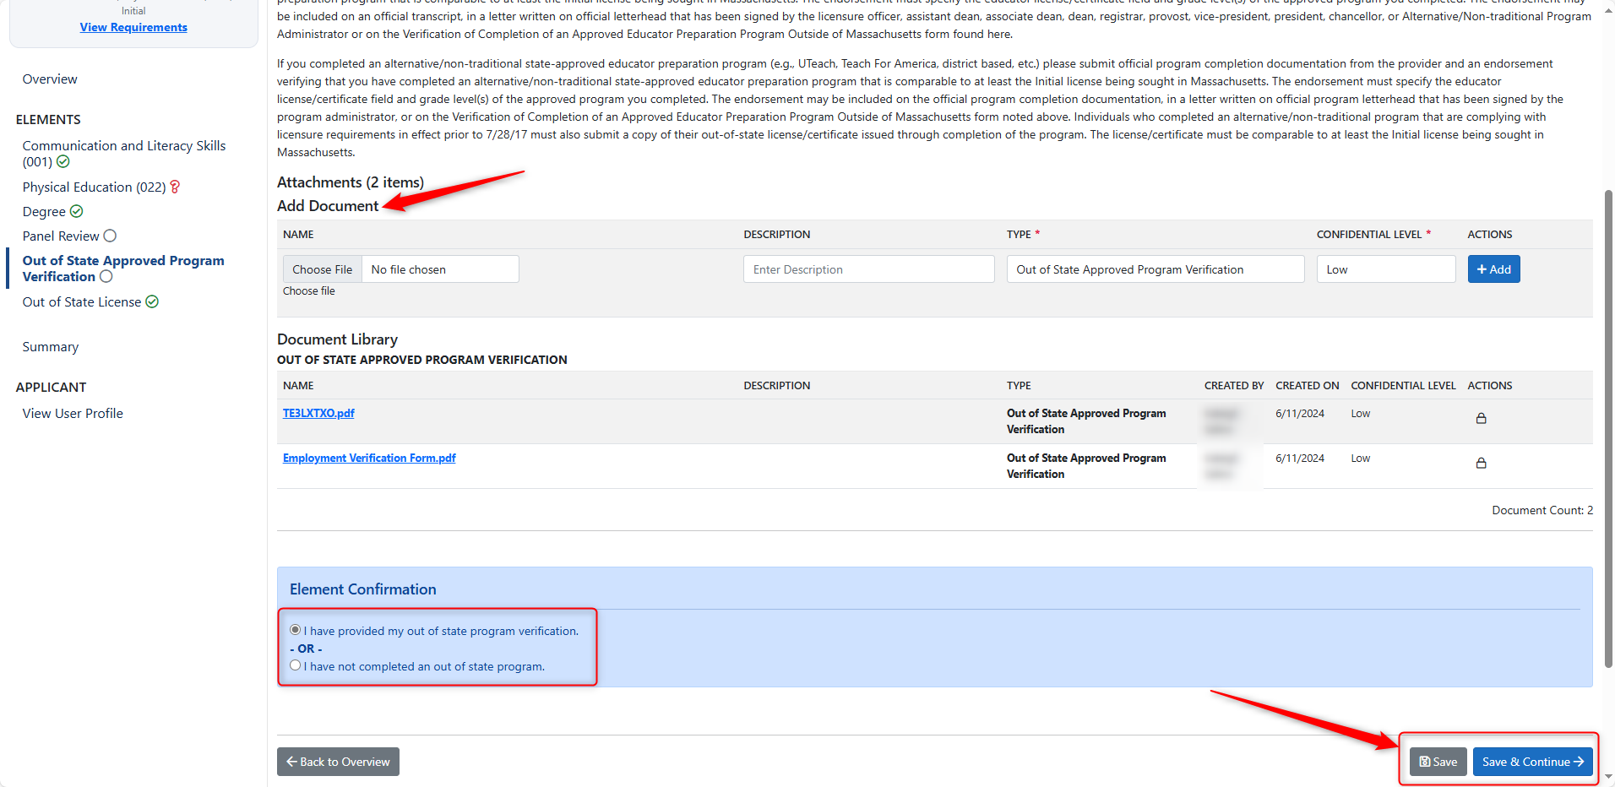Then make a selection in the blue Element Confirmation box at the bottom of the element before Saving.   
     
     
   Note: If information was added to your profile or application externally, from a transcript or assessment score, for example, you may not need to add any information to the application. In that case, you may still confirm and save any element on your application, which indicates that an update has been made, so the application may be reviewed again.

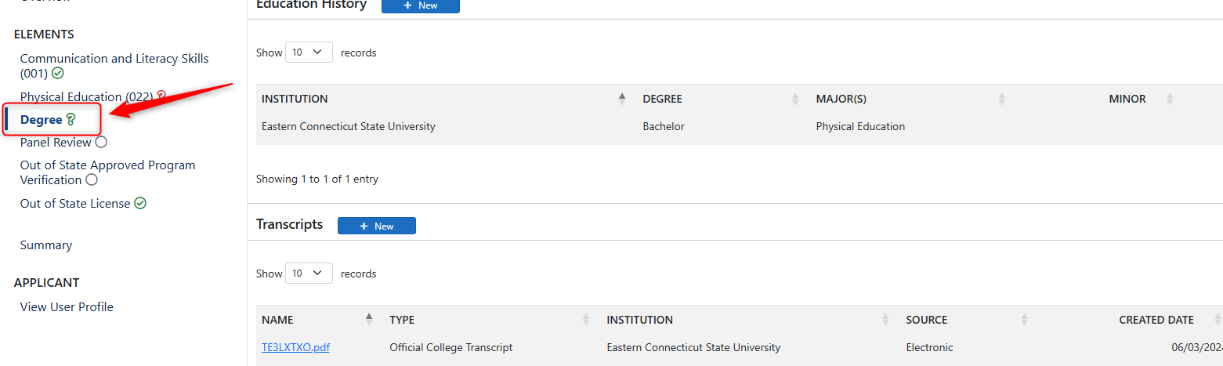For example, navigate to the ***Degree*** element from this example, and open it.

1. Scroll to the bottom of the element, check the Element Confirmation checkbox, then Save.

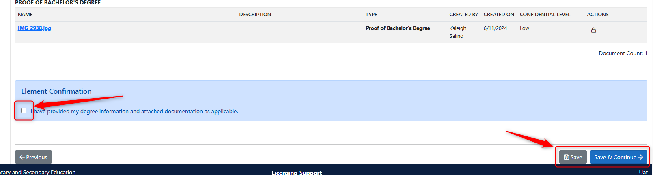

1. 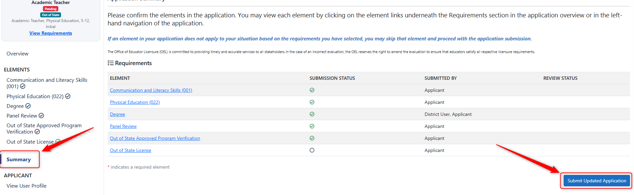Once an update has been made to an element of the Pending application, navigate to the ***Summary*** page. In the lower right corner of the Summary, you will see a new ***Submit Updated Application*** button. Click this when you are ready to submit your application again for review.

The application that was updated will now show ***Pending Review*** status and is ready for an additional evaluation. Repeat this process for other Pending applications as needed.

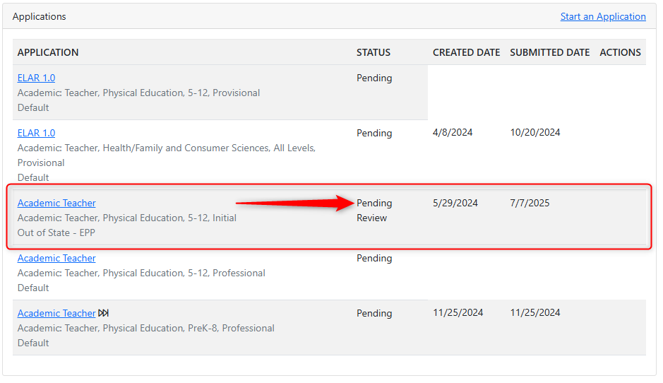

If after step one, you do not see any of the elements/requirements shown in step two and instead you see a “Legacy element”, you should contact the Licensure Office at 781-338-6600 for assistance in getting your status changed to pending review. Please note that a change should be made if documents were recently uploaded to your account or MTEL scores were received or an electronic endorsement from a sponsoring organization was submitted.

