How to Apply for the
Emergency-Extension

Welcome to this advisory on how to apply for an Emergency-Extension. This advisory is designed to assist those that have an emergency license in one of the following fields:
- Teacher of Students with Moderate Disabilities
- Teacher of Students with Severe Disabilities
- Teacher of the Deaf and Hard of Hearing (ASL/TC)
- Teacher of the Deaf and Hard of Hearing (Oral/Aural)
- Teacher of the Visually Impaired
- English as a Second Language (ESL)
Emergency licenses that have been granted in the above six license areas are valid through June 30, 2022 and are not subject to the automatic one-year extension announced by the Commissioner. Individuals with an emergency license in these fields are eligible to apply for a no-cost extension of their emergency license, and an extension to June 30, 2023 will be given to those that demonstrate appropriate subject matter knowledge in the field.
Application Process
Once you have indicated from the main ELAR Welcome Page that you would like to apply for a new license, which is the first choice in the list of options, you will be presented with an overview of the application process and the five steps to submitting an application.
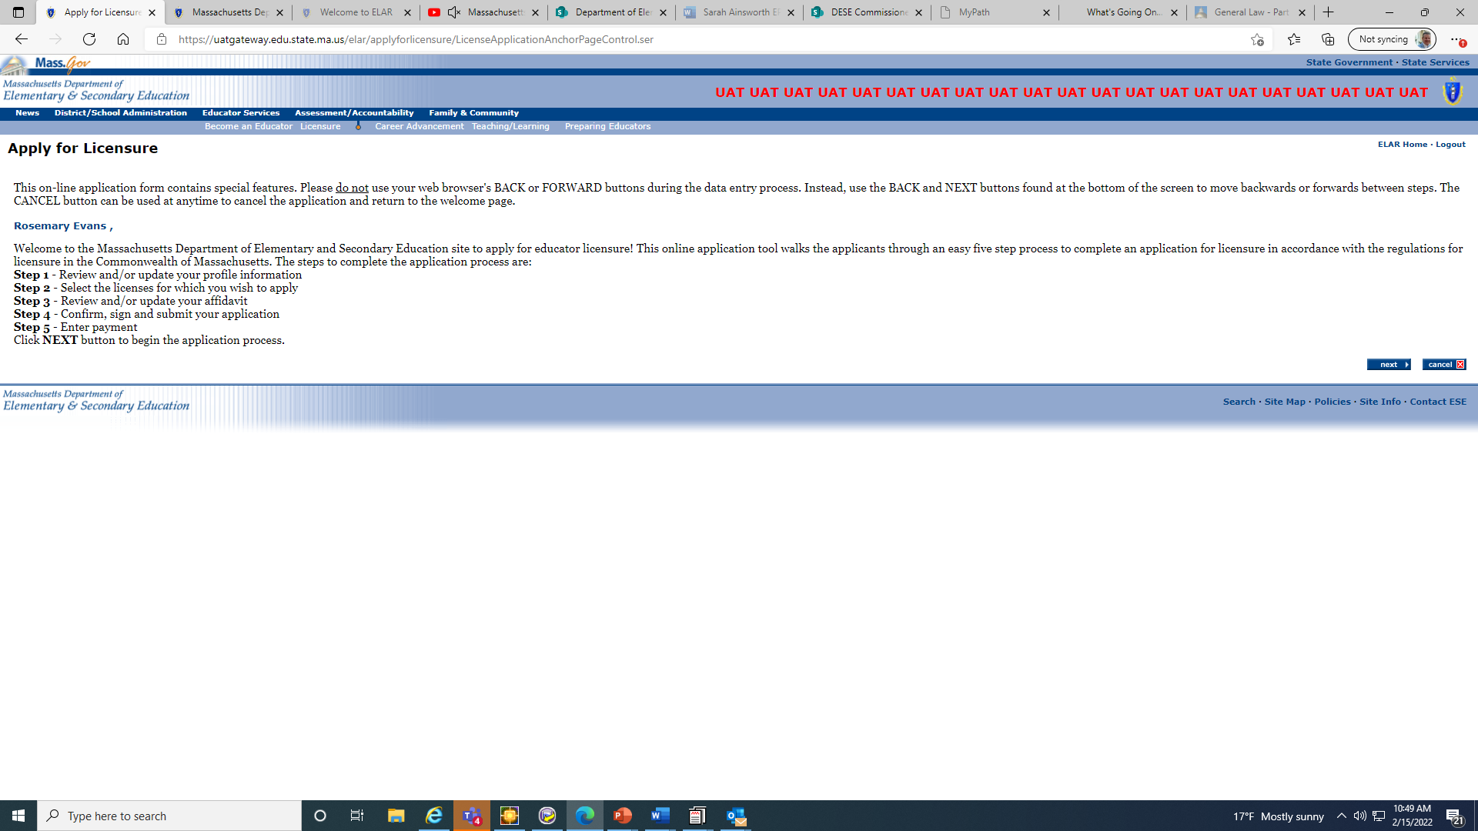
In step 1, you will have the opportunity to review information in your profile and update certain information. For example, you can update your address, update your email, or phone number, enter additional education information.
In step 2, select the Field as Academic Teacher, and then select the content area that you would like to apply for, such as English as a Second Language, select the grade level of the license and for Type, select Emergency-Extension.
Once you have selected the license you would like to apply for the Emergency-Extension, select the add button. You will be presented the requirements to obtain the extension, select the path that best suits your situation and select next (see image 2).
At this point, you would be able to select other licenses you would like to apply for, including other Emergency-Extensions, if applicable. Once you have selected all the licenses you would like to apply for, select the next button in the lower right corner.
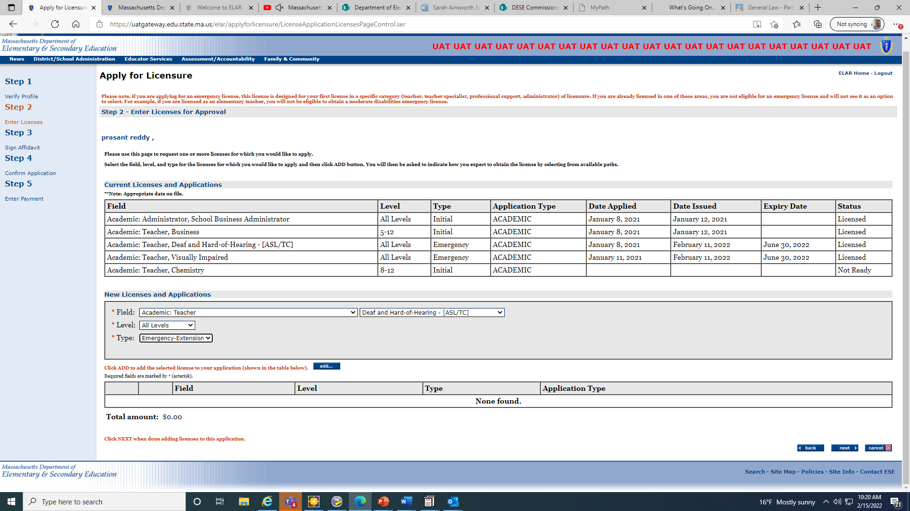

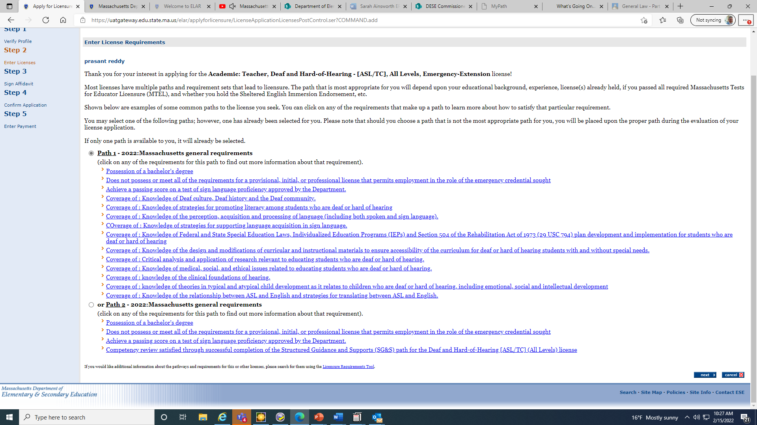
During step 2, you will be presented with the requirements to obtain the Emergency-Extension. Select the path that best suits your needs and select the next button in the lower right corner of the page.

In step 3, you will review the affidavit questions and respond appropriately. When ready, sign the affidavit by selecting the sign button in the lower right corner.
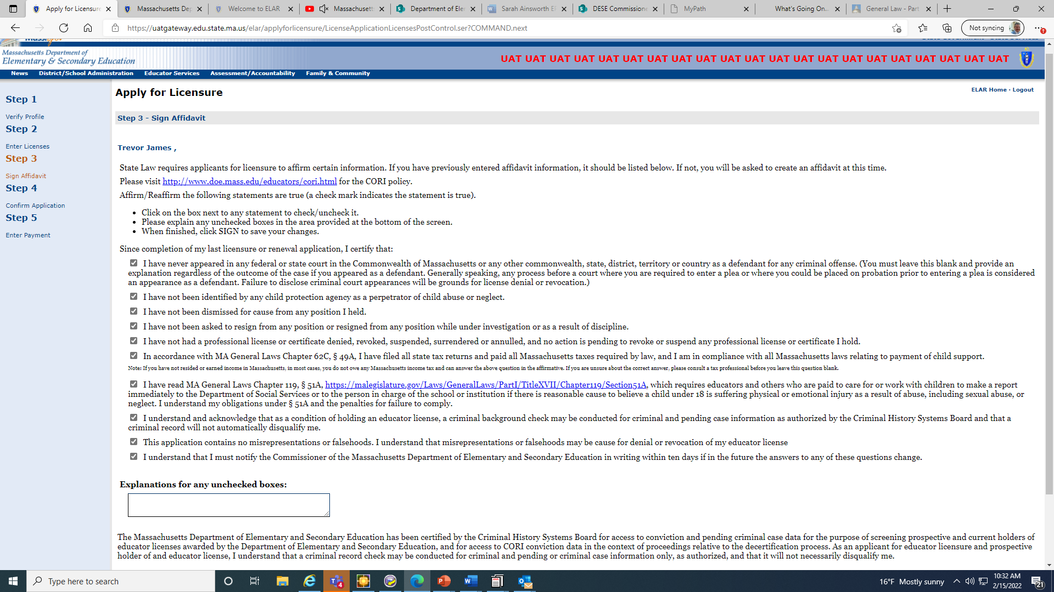

In step 4, you will confirm what you are applying for by signing. In the lower right corner.
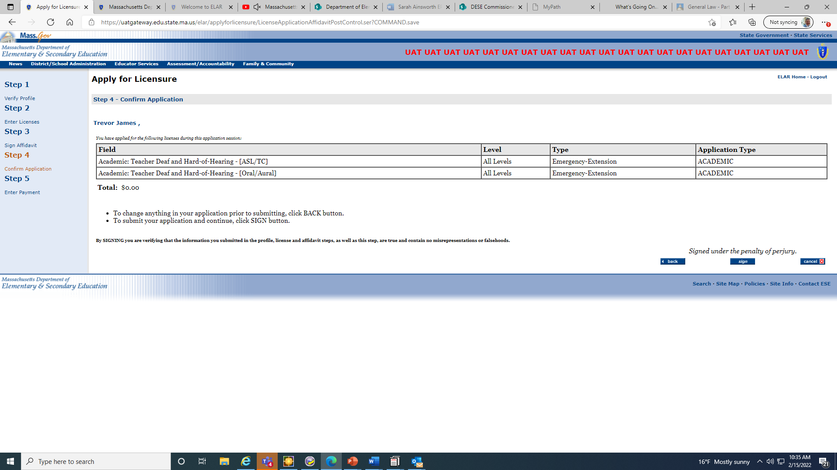

Step 5 payment. If you are only applying for the Emergency-Extension, since there is no cost, a fee will not need to be submitted. By selecting done, you will have completed the application. From the main ELAR welcome page, you can select the “Check application/license status and history” option and you will see that your Emergency-Extension application is listed as “Ready for Review.”
Your application will be evaluated by a member of the Licensure Office, and you will either be granted the Emergency-Extension, or you will see that your status has become “Pending.” A pending status means that correspondence will be sent to you via that email you have listed in ELAR with details about the remaining requirements to obtain the Emergency-Extension. If you did not receive the email, you can check your junk folder in your email and you can also view your correspondence history (accessible via your ELAR main menu). Please note that most correspondence in ELAR does not get sent out in “real time” and is generated in a nightly routine.
If you have applied for an Emergency-Extension for English as a Second Language, please note that your MTEL scores are automatically submitted to your ELAR account. If you have applied for an Emergency-Extension for one of the special education licenses you likely will need to submit documents to verify the competencies. For your convenience, you can upload documents directly to your ELAR account.
