Provisional License Validity Period Guidelines:
How much time do I have left on my license?

Office of Educator Licensure
Licensure Call Center: 781-338-6600
Hours: Monday-Friday 9am-1pm & 2pm-5pm.
Walk-in Welcome Center Service Counter
Hours: Monday-Friday
8:45am - 4:45pm

Background:
On June 27, 2017 the Board of Elementary and Secondary Education voted to approve some changes to the academic licensure regulations. These changes included changing the name of the Preliminary license to Provisional. Another significant change was made to the validity period of the license. It limits the time someone can be employed under any combination of Provisional teacher licenses held, to no more than five years in total.

The change in the validity period takes place as of July 1, 2019 and these guidelines are designed to help educators and school districts to understand the validity period of the Provisional license, particularly for those educators that hold multiple Provisional licenses and are employed under the license(s) prior to July 1, 2019.

Educators with multiple Provisional licenses will only be eligible for five years of employment in total, regardless of how many Provisional licenses held. Educators with multiple Provisional licenses will no longer be able to be employed under one Provisional license for five years and then switch to a different Provisional license and continue employment under a Provisional license.

Educators holding only one Provisional license had no change made to the validity period of the license as it remains valid for five years of employment.

What constitutes employment under a license?
The Department considers employment under a license to mean in the role of the license and in a position for which the license is legally required for employment. As a result, employment in a school such as a private parochial school would not count as time worked under your Provisional license. In addition, typical day-to-day employment as a temporary substitute teacher would not be considered as employment under the license. However, employment as substitute teacher for greater than 90 consecutive school days in the same instructional role would be considered as employment under the license.

In a case where an educator begins the school year employed under a waiver linked to a Provisional license but later in the school year was issued the Provisional license, the time working under the license would start from the date the license was issued. For example, if the teacher is employed for the whole school year as a full time tenth grade chemistry teacher and worked under a waiver linked to a Provisional Chemistry (8-12) license for the first three months of the school year (let’s assume that equals the full-time equivalent (FTE) of .3 of a school year) prior to obtaining their Provisional Chemistry (8-12) license, then the educator would have only used .7 of a year of employment under the license.

Employment used under a Provisional license that was less than a full school year or less than full time is based on the specific FTE of the position for the applicable time period of employment.

Scenarios:
- Possess multiple Provisional licenses and employed prior to 7/1/19
- Possess multiple Provisional licenses and not employed prior to 7/1/19
- Possess one Provisional license and employed prior to 7/1/19
- Possess one Provisional license and not employed prior to 7/1/19
- Possession of a Provisional license and employed prior to 7/1/19 and obtains an additional Provisional license on/after 7/1/19
- Possession of a Provisional license but not employed prior to 7/1/19 and obtains an additional Provisional license on/after 7/1/19

Employment Scenarios
Please note that in all of the examples provided, the employment is full-time. In instances in which employment is less than full-time, the time should be calculated based on the full-time equivalency (FTE) for that period of employment. For example, two part time years of .6 FTE would be equal to 1.2 years of employment.
Possess multiple Provisional licenses and employed prior to 7/1/19
- Thomas possesses Provisional licenses in mathematics at the (8-12) and (5-8) grade levels that were obtained on August 5, 2013. He first began teaching under his Mathematics (8-12) license in the 2015-16 school year as a high school math teacher. As of July 1, 2019 Thomas has been employed under the Provisional Mathematics (8-12) license for four years and he would now have a combined total of five years remaining under his Mathematics (8-12) and Mathematics (5-8) licenses. However, he would have no more than one year of employment remaining under his mathematics 8-12 license.
If Thomas remained employed under his Mathematics (8-12) license, he would need to earn the Initial license prior to beginning his sixth year of employment. At the end of one additional year of employment under his Mathematics (8-12) license, he could be employed for up to four years under his mathematics (5-8) license.
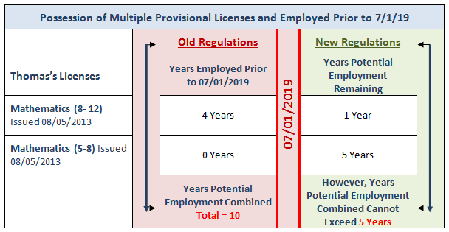
- Susan possesses an Elementary, Early Childhood and Moderate Disabilities (PreK-8) Provisional license. The Elementary and Moderate Disabilities (PreK-8) licenses were issued on July 10, 2016 and the Early Childhood license was issued on January 19, 2017. Susan is hired as a Moderate Disabilities teacher and works under that Provisional license during the 2016-17 and 2017-18 school years (Susan is not employed in the 2018-19 school year). As of July 1, 2019, Susan could be employed for no more than a combined total of five years under her Provisional licenses; however, she would have no more three years of employment remaining under her Moderate Disabilities (PreK-8) license.
For example, if Susan remains employed under her Moderate Disabilities (PreK-8) license during the 2019-20 and 2020-21 school years, she will have accumulated four years of employment under her Moderate Disabilities (PreK-8) license and would have one year of employment remaining under that license. However, she could be employed under her Elementary or Early Childhood licenses for a combined total of three years.
- Evan holds a Provisional Biology (8-12) license issued in 2012 and a Provisional Chemistry (8-12) license issued in 2017. He was employed under the Biology license for five years (2012-2017) and then was employed under the Chemistry license for the 2017-18 and 2018-19 school years. As of July 1, 2019, Evan has three years of employment remaining under his Chemistry (8-12) Provisional license since he has been employed under it for two years and was already employed for five years under the Biology license.
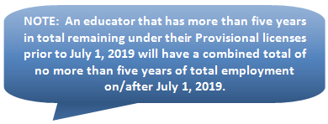

Possess multiple Provisional licenses and not employed prior to 7/1/19
- Amy obtained Provisional licenses in Visual Art at the (PreK-8) and (5-12) grade levels, on April 5, 2008. As of July 1, 2019 Amy returned to the Commonwealth after having lived in Georgia for the last 10 years. Amy was never employed under either of her Provisional Visual Art licenses in a Massachusetts public school; therefore the licenses are still valid. However, the Visual Arts (PreK-8) and (5-12) licenses are now valid for a combined total of five years of employment.
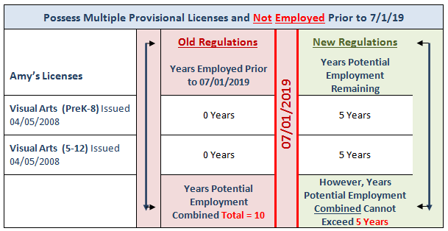
- Derrick has a Provisional Health/Family Consumer Science (All) levels license that was issued on August 12, 2016 and Provisional Physical Education licenses at the (PreK-8) and (5-12) grade levels that were issued on March 6, 2018. Derrick has been teaching in a Massachusetts private school where licensure is not required by law for employment purposes. Therefore, he was not employed under any of his licenses during this time period. In August of 2020 Derrick is hired by a Massachusetts public school district and will begin employment under his Physical Education (5-12) Provisional license. Derrick will have a total of five years of employment to move from his Provisional license to Initial. For example, if Derrick is employed for five years under his Physical Education (5-12) license, he will not be able to switch his employment into Health/Family Consumer science or Physical Education (PreK-8) and continue employment under a Provisional license.
Possess one Provisional license and employed prior to 7/1/19
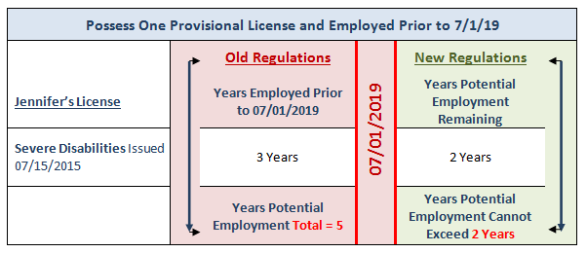
- Jennifer possesses a Provisional Severe Disabilities license and as of July 1, 2019, she has been employed under that license for three years. Jennifer has two years of employment remaining under her Provisional license.

- Leonard obtained a Provisional Business (5-12) license that was issued on July 20, 2017 and as of July 1, 2019 will have one year of employment under his Provisional license. As of July 1, 2019, Leonard will have four years of employment remaining under his Provisional Business (5-12) license.
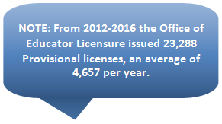

Possess one Provisional license and not employed prior to 7/1/19
- Barbara obtained a Provisional Foreign Language [Spanish] 5-12 license that was issued in 2006 but has not been employed under the license in Massachusetts. In June of 2020 she calls the Licensure Office to inquire about the validity of her license and the requirements to advance to an Initial license. Barbara is surprised to learn that since she has not been employed in a Massachusetts public school as a Spanish teacher; her Provisional license is still valid for five years of employment.
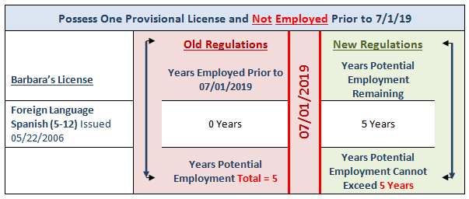
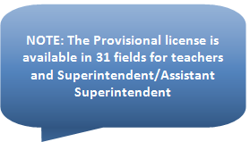
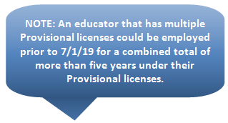
Possession of a Provisional license and employment prior to 7/1/19 and obtains an additional Provisional license after 7/1/19
- George possesses a Provisional license in History at the (5-8) and (8-12) grade levels and as of July 1, 2019 he has been employed for five years under his History (5-8) license and two years under his History (8-12) license. George continued to be employed under the History (8-12) license in the 2019-2020 school year, and obtained a new Provisional Social Science (5-12) license after July 1, 2019. George will now have a combined total of four years of employment remaining under his Provisional licenses and has two years of employment remaining under his Provisional History (8-12) license. Obtaining a fourth Provisional license after July 1, 2019 in this instance will not provide George with additional total years of employment.
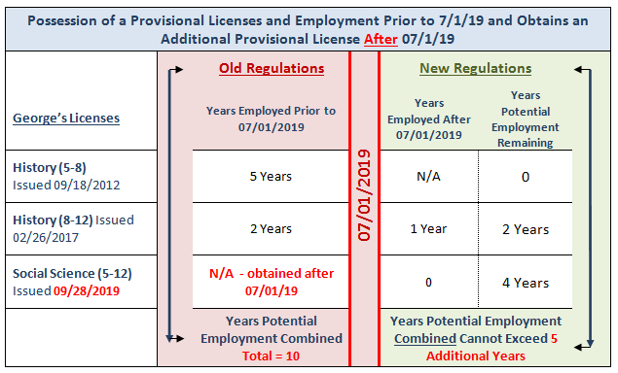
- Roberta has been employed under her General Science (5-8) Provisional license for two years prior to July 1, 2019 and in March of 2021 she obtains a new Provisional Middle School: Mathematics/Science (5-8) license. As of July 1, 2019, Roberta has been employed under her Provisional General Science (5-8) license for two years; she will now have a combined total of five years of full-time employment remaining under any combination of her Provisional licenses but only has three years of employment remaining under her General Science (5-8) license.
- Manuel obtained his Provisional English as a Second Language (ESL) license at the (PreK-6) and (5-12) grade levels in 2011. Manuel started his employment in the 2012-13 school-year and worked for five years under his ESL (PreK-6) license and then began working under his ESL (5-12) license in 2018-19. During the 2020-21 school year Manuel passes the Middle School: Humanities MTEL exam and obtains a new Middle School: Humanities (5-8) license. However, during the 2020-21 school year, Manuel completed his third year of employment under his Provisional ESL (5-12) license. Therefore, Manuel will have a combined total of three years of employment remaining under his ESL (5-12) and Middle School: Humanities licenses but only two years of employment remaining under his Provisional ESL (5-12) license.
Possession of a Provisional license but no employment prior to 7/1/19 and obtains an additional Provisional license after 7/1/19
- Yvonne possesses a Provisional Library license that was issued in 2018 and in November of 2019 she was issued a Provisional Early Childhood (PreK-2) license. Yvonne has not been employed under either license in a Massachusetts public school. When Yvonne does become employed under one of her Provisional licenses, either as a Library or Early Childhood teacher, she will have five years of employment available to her under any combination of her Provisional licenses and will need to obtain an Initial license prior to beginning her sixth year of employment as a teacher.
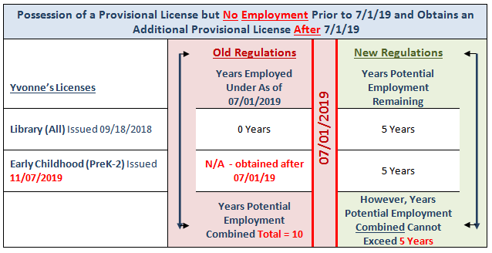
- After graduating with a Bachelor’s degree in 2017, Paul passed the necessary MTEL exams and received Provisional licenses in English and Foreign Language [French]. Both licenses were issued at the 5-12 grade level. Paul did not seek employment as a teacher but in January of 2020 Paul obtained a History 5-12 Provisional license and will actively search for his first teaching job for the 2020-21 school year. Despite having a Provisional license in three areas, Paul will be eligible for a combined total of five years of employment under his Provisional licenses. For example, Paul could be employed for two years as a high school English teacher, two years as a high school French teacher and one year as a high school History teacher.

Please contact the Office of Educator Licensure if you have any questions regarding the validity of a Provisional license.

Office of Educator Licensure
Licensure Call Center: 781-338-6600
Hours: Monday-Friday 9am-1pm & 2pm-5pm.

Walk-in Welcome Center Service Counter
Hours: Monday-Friday
8:45am - 4:45pm

