

**APPLYING FOR A WAIVER**

District users can request waivers for licensure applications with the following status: submitted, pending review, & not ready.

1. Log-in as a district user, navigate to District Tab.
2. Click on Person Search, look up the educator. Click on the educator’s name to go to Educator Profile.
3. Click on Applications on the left column.
4. Make a new application.

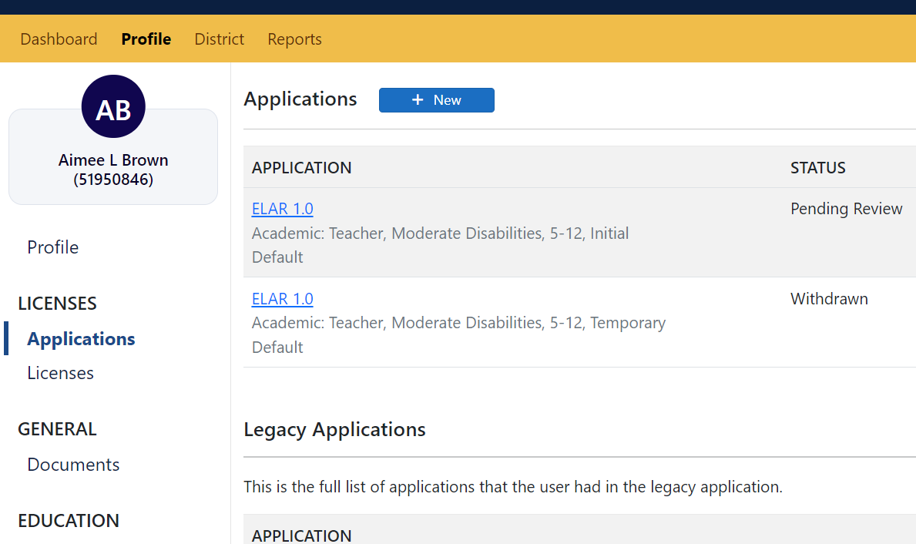

1. The applications eligible for waiver will populate in the dropdown menu. Choose the application that needs a waiver and the district for which the waiver is being applied.

First Image: Applicant's name and MEPID is displayed.
Drop-down menu is used to select credential and district requesting the waiver.

1. Click on Next and Submit the application.

Second Image: Applicant's name and MEPID 
Two drop-down menus to select credential and district name.

1. Once submitted, the user is directed to District Waiver Overview

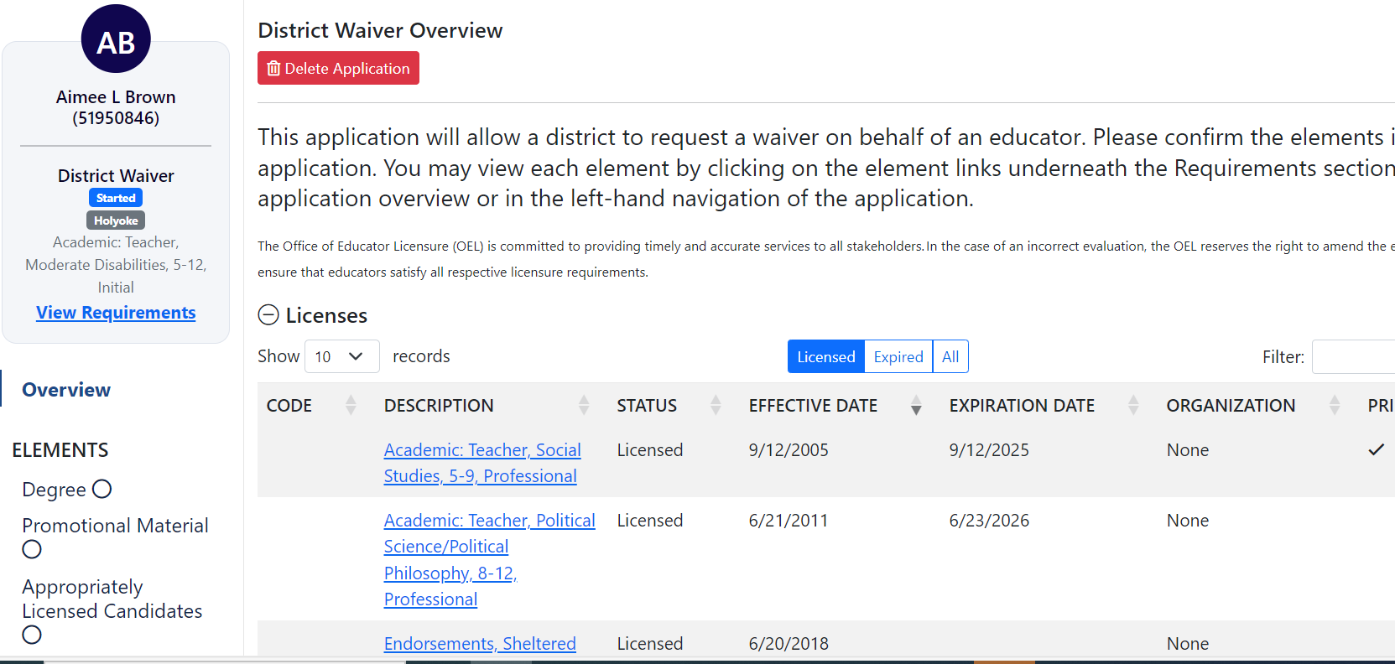

1. Within “Applications” of the user, the District waiver is available, but is not in submitted status.

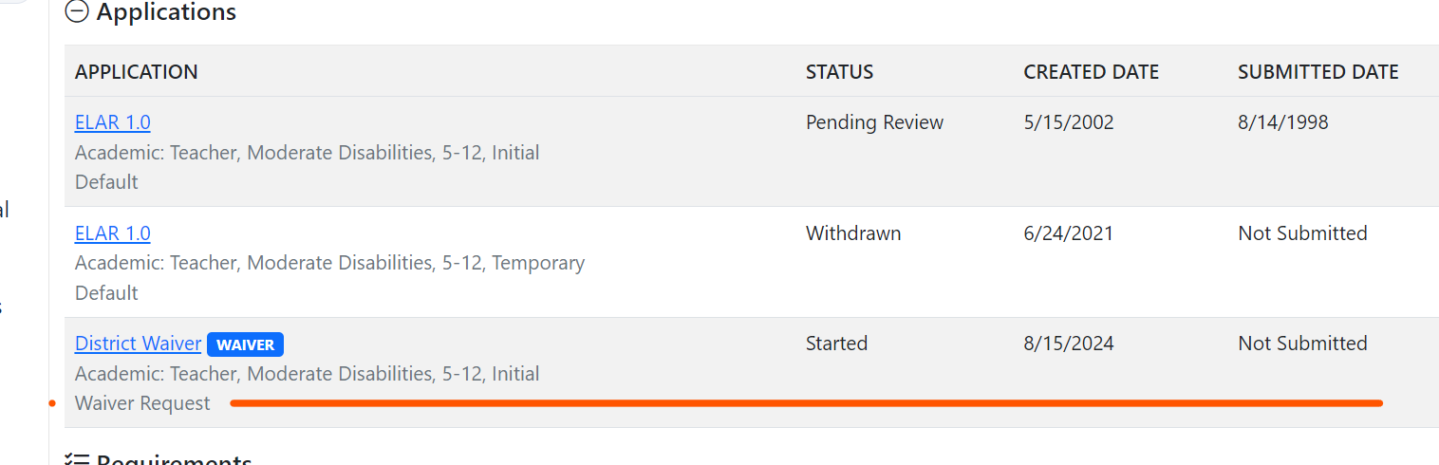

1. Click on the district waiver application to open it.

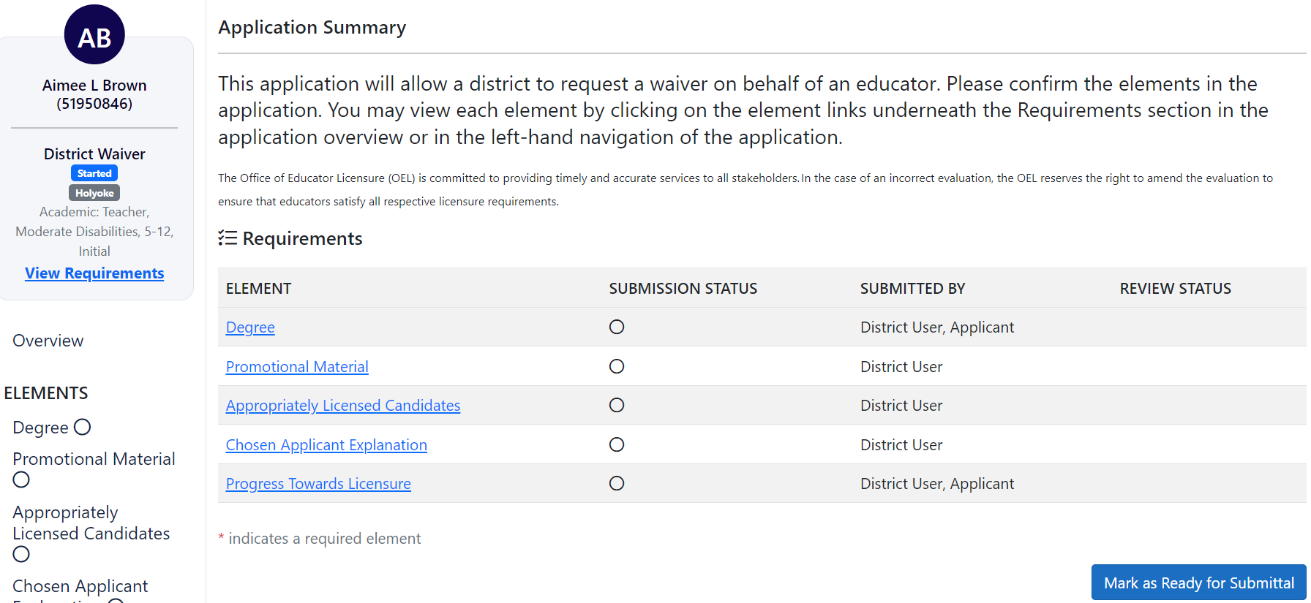

1. Complete the element confirmations including the school year connected to the waiver request and mark the application ready for submittal

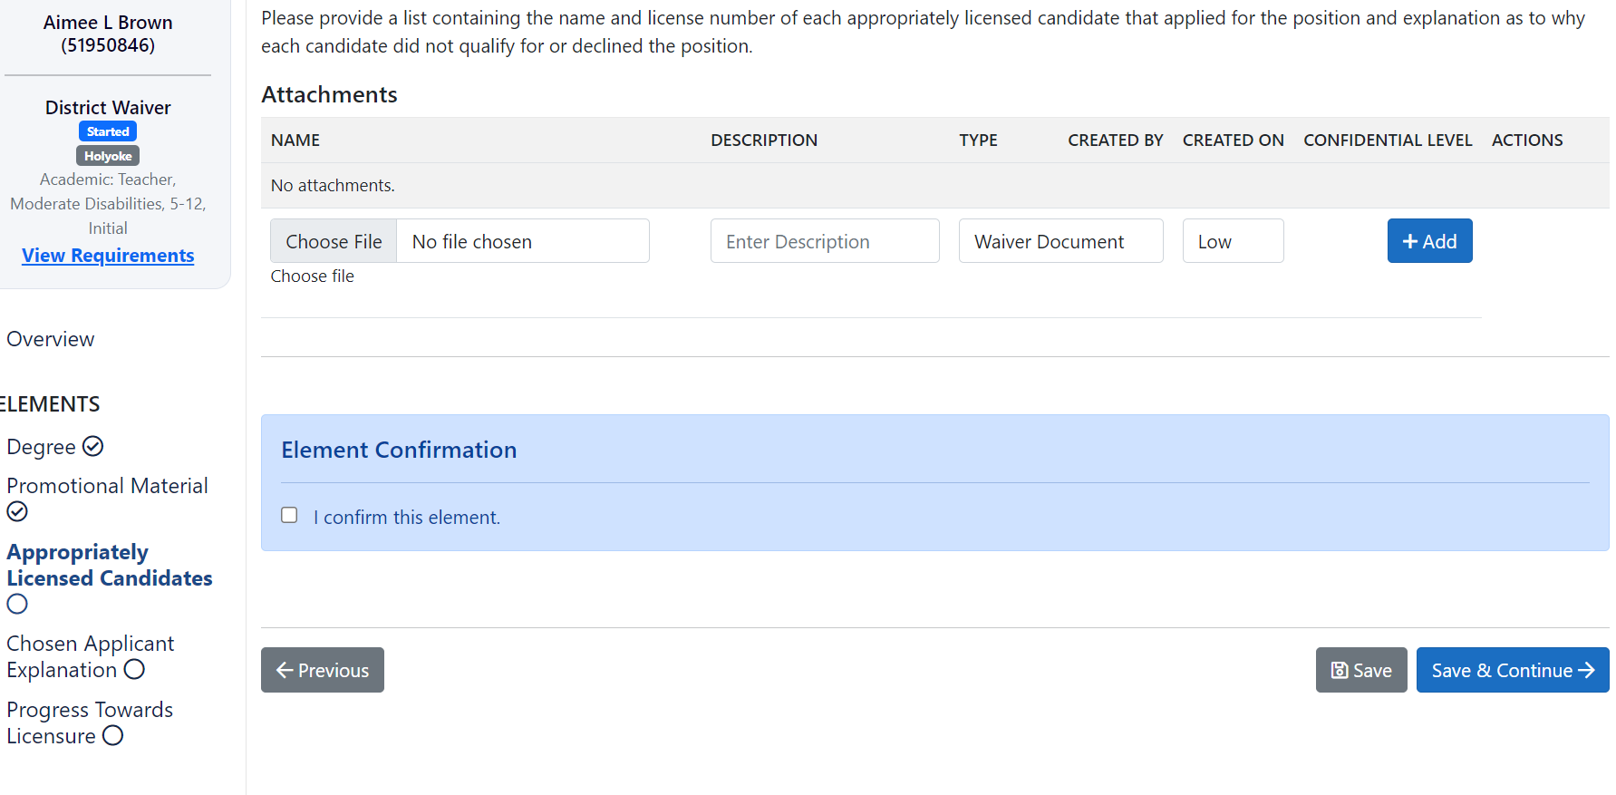

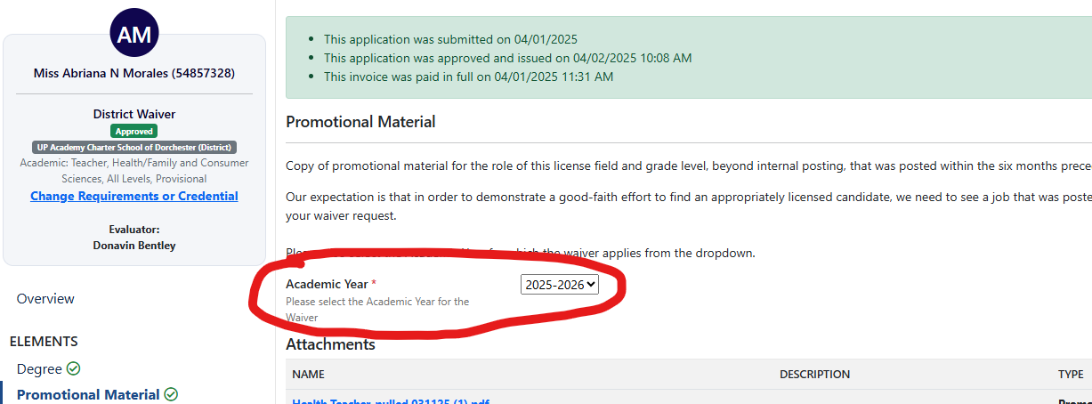

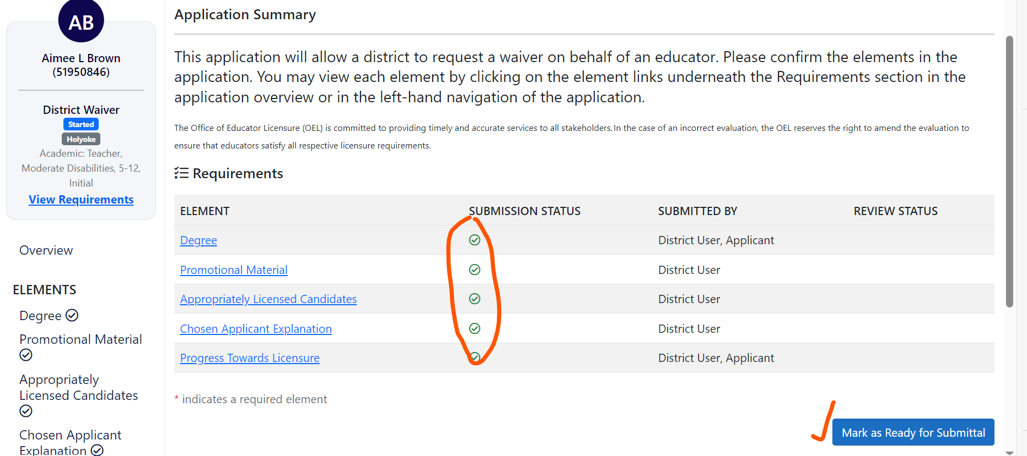

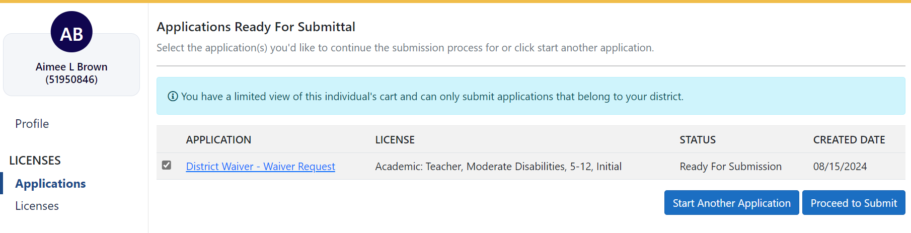

1. After “Proceed to Submit,” the district waiver application shows up in the application list with Status: Submitted.

