What are Student Growth Percentiles (SGPs), and how are they usually calculated?

Student Growth Percentiles (SGPs) provide a measure of the degree to which a student’s achievement has changed from the prior year(s) to the current year, in comparison to other students in the same grade who performed similarly in the past. SGPs use students’ current and prior scores to assign an SGP that ranges from 1 to 99. Students who have a current year’s score and a prior year’s score—and have met the consecutive grade requirement—are issued an SGP.
Figure 1: 2019 SGP Distribution

In prior years, student growth percentiles (SGPs) were calculated by comparing students’ current-year score to that of students with similar scores in their cohort. Each year, the cohort group changed (depending on the performance of the current year population), which resulted in a state average SGP of about 50. Since the average SGP per grade and subject is 50, the distribution is flat and 20% of students score in each SGP growth category, from very low growth to very high growth, as shown in Figure 1.
How did the pandemic affect our method for calculating SGPs?
The pandemic functioned as an academic headwind for most students, slowing their educational progress and growth. The decreased educational progress and growth yielded lower 2021 academic attainment, and this was a significant departure from the typical achievement and growth patterns in prior years. Score changes between 2019 to 2021 were much larger than those seen between 2018 and 2019, and all the changes showed declines in grades 3-8.
Figure 2: Example of Baselined Growth

To accurately reflect the extent to which educational progress and growth slowed during the pandemic, DESE adopted a slightly different method for calculating SGPs in 2021: baseline SGPs. In this method, a historical peer group represents a “baseline” from which current progress can be measured over time.
The baseline SGPs are reported on the same scale as the 2019 results, allowing for comparisons between SGPs in 2021 to SGPs in prior years. Because student growth slowed due to the pandemic, the baseline MCAS SGPs in 2021 show higher percentages of students in the lower growth categories, as shown in Figure 2.

The baseline method provides a more sensitive and realistic measure of student growth when a systemic event, such as the Covid-19 pandemic, has a significant, widespread impact on student performance and progress, as shown in the figures below.
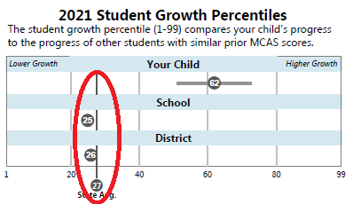
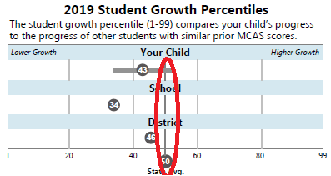

DESE made the decision to report growth using the baseline model after consultation with a number of experts and stakeholders, including the MCAS technical advisory committee as well as experts at the Center for Assessment.

