ACCESS for ELLs

2020 Statewide Results
January 2021

Massachusetts Department of Elementary and Secondary Education
75 Pleasant Street, Malden, MA 02148
Phone 781-338-3000 TTY: N.E.T. Relay 800-439-2370
www.doe.mass.edu

This document was prepared by the
Massachusetts Department of Elementary and Secondary Education
Jeffrey C. Riley
Commissioner

The Massachusetts Department of Elementary and Secondary Education, an affirmative action employer, is committed to ensuring that all of its programs and facilities are accessible to all members of the public.
We do not discriminate on the basis of age, color, disability, gender identity, national origin, race, religion,
sex, or sexual orientation.
Inquiries regarding the Department’s compliance with Title IX and other civil rights laws may be directed to the
Human Resources Director, 75 Pleasant St., Malden, MA 02148 781-338-6105.

© 2021 Massachusetts Department of Elementary and Secondary Education
Permission is hereby granted to copy any or all parts of this document for non-commercial educational purposes. Please credit the “Massachusetts Department of Elementary and Secondary Education.”

Massachusetts Department of Elementary and Secondary Education
75 Pleasant Street, Malden, MA 02148-4906
Phone 781-338-3000 TTY: N.E.T. Relay 800-439-2370
http://www.doe.mass.edu/

Table of Contents

Executive Summary 1
I. Background 3
II. Summary of the Statewide ACCESS for ELLs Results 6
Student Participation 6
Student Achievement 6
Composite Proficiency Levels 10
Results of the 2020 Alternate ACCESS 12

III. REPORTING ELEMENTS…………………………………………………………………………………….. 13
IV. ACCESS Results for EL Students from the State’s Highest Incidence First-Language Groups 21
Appendix A. Performance Definitions for the ACCESS Levels of English Language Proficiency 26
Appendix B. Alternate ACCESS Performance Definitions 28
Appendix C. Additional Clarification of Future Progress Targets and Difficulty Indices 29

Executive Summary
The ACCESS for ELLs (ACCESS) is an assessment of English language proficiency administered through the WIDA consortium to students who have been reported to the Massachusetts Department of Elementary and Secondary Education (the “Department”) as English learners (ELs). The ACCESS assesses student achievement of the WIDA English Language Development Standards in reading, writing, listening, and speaking and is administered to all publicly funded English learners (ELs) in grades K−12. In addition, the Alternate ACCESS for ELLs (Alternate ACCESS) is administered to EL students in grades 1−12 who have significant cognitive disabilities and are unable to take the regular ACCESS tests. The ACCESS is available in paper-based and online versions for grades 1−12 (kindergarten tests are available on paper only, as is the Alternate ACCESS).

Massachusetts joined the WIDA consortium in May 2012 and has administered the ACCESS tests since the 2012–2013 school year. Over the past three years, Massachusetts has transitioned from paper-based to online ACCESS testing and in 2020, 97.4 percent of ELs in grades 1-12 took the ACCESS test online.

Participation Rates
In 2020, 98,196 EL students in Massachusetts who were enrolled in grades K–12 participated in the ACCESS tests, including 1,585 students who participated in the Alternate ACCESS. The overall participation rate was 98.2 percent, 0.1 percentage points higher than in 2019 (98.1 percent). Absent students totaled 1,809, slightly lower than in 2019 (1,853). Overall participation rates are shown beginning on page 6.
Overall Achievement
Achievement results are shown in detail beginning on page 6. The combined percentage of students attaining the highest levels on the ACCESS tests (i.e., Level 4.2 through Level 6) in 2020 (18.7 percent) was three percentage points lower than that in 2019 (21.7 percent). 2020 was the third consecutive year showing a decrease. In 2017, the percent of students achieving Level 4.2 through Level 6 was 22.4 percent.
New Reporting Requirements
Since 2019, this State Report was revised to include new reporting elements described in Title III of the federal Every Student Succeeds Act (ESSA) and in the Language Opportunities for Our Kids (LOOK) Act, a 2017 state law. The five required reporting elements described in ESSA are summarized below and described in detail beginning on page 13 of this report.

- Reporting Element #1: The number and percent of ELs making progress toward achieving English language proficiency in the aggregate and disaggregated for EL students with disabilities (EL SWD). A student who is making progress is on track to attain English proficiency (i.e., achieve overall level of 4.2) within six years.
  - 48.9 percent of Massachusetts EL students made progress in 2020; among students with disabilities, 28.8 percent made progress in 2020.
- Reporting Element #2: The number and percent of ELs attaining English language proficiency as determined by their ACCESS test scores (overall level of 4.2 and literacy level of 3.9).
  - 16.5 percent of students attained English proficiency in 2020; 19.6 percent of students attained English proficiency in 2019.
- Reporting Element #3: The number and percent of ELs who exit English learner status based on their attainment of English language proficiency
  - 75.4 percent of students who attained English proficiency exited EL status in 2020, compared with 69.7 percent of students who attained English proficiency and exited EL status in 2019.
- Reporting Element #4: The number and percent of former ELs (FELs) meeting challenging state academic standards on the Massachusetts Comprehensive Assessment System (MCAS)
- Not available in 2020, as MCAS was cancelled due to school closures during the COVID-19 pandemic.
- Reporting Element #5: The number and percent of ELs who have not attained English language proficiency within six years of initial classification as an EL (i.e., within five years plus a baseline year, or six years)
  - In 2020, 15.5 percent of ELs had not met proficiency after six years, compared to 14.9 percent in 2019.

I. Background
This report summarizes the results of 98,196 EL students in Massachusetts who participated in the 2020 ACCESS and the Alternate ACCESS tests, which were developed by the WIDA consortium and are intended to measure the English language proficiency of EL students in 40 consortium member states, territories, and federal agencies.

ACCESS tests measure how well EL students have met the English Language Development (ELD) Standards developed by the WIDA consortium. Massachusetts adopted the WIDA standards because they describe English language development in four areas, called domains (listening, reading, speaking, and writing); academic literacy in four subjects, plus social and instructional language; and because the WIDA standards are aligned with the Massachusetts Curriculum Frameworks. Only students who participate in all four domains or who are assigned scores in missing domains (according to rules described here) receive overall scores. Students participate in tests designed for specific grade-level clusters as follows:

ACCESS Tests
Format | Grade-Level Cluster Tests
Online | 1, 2-3, 4-5, 6-8, 9-12
Paper | K, 1, 2, 3, 4-5, 6-8, 9-12; and Alternate ACCESS in grades 1-12

In 2016, WIDA introduced a new, more rigorous computer-based test. Schools in Massachusetts were given a choice to administer either computer- or paper-based tests, with the expectation that the state would transition virtually all EL students to computer-based testing for the 2020 test administration. Paper-based tests remain available for use as an accommodation due to a disability, or for a first-year EL who lacks familiarity with or the ability to use a computer.

For online testing, the listening and reading tests are adaptive, with students directed to questions of equal, lesser, or greater difficulty depending on how they responded to a previous cluster of questions. Based on listening and reading results, students are routed to the appropriately tiered speaking and writing tests. For paper-based testing, students in grades 1-12 take either Tier A or B/C of the designated grade-cluster test, depending on their level of English language proficiency.

Students taking the ACCESS test receive scaled scores between 100−600 overall, in each domain, and several composite scores. Proficiency level scores are reported as a whole number followed by a decimal (e.g., Level 3.4), indicating the student’s overall language proficiency level, and the relative position within the proficiency level of the student’s scaled score, rounded to the nearest tenth. English proficiency is reported in one of six English language proficiency levels: 1-Entering, 2-Emerging, 3-Developing, 4-Expanding, 5-Bridging, and 6-Reaching (see Appendix A).

Assessment subscores are also reported using the same scaled scores and proficiency levels in the four domains of listening, speaking, reading, and writing; and reported as composite scores in the following combined areas:
- Overall composite score combining all four domain scores
- Oral Language composite score, combining scores from listening and speaking
- Literacy composite score, combining scaled scores from reading and writing
- Comprehension composite score, combining scaled scores from listening and reading.

Standard Setting on ACCESS 2.0 Tests
In 2016, the WIDA consortium reset proficiency standards on its new ACCESS for ELLs 2.0 assessment. The standards on ACCESS 2.0 are more rigorous than the standards on ACCESS 1.0, meaning that a higher level of achievement on the new test is required to earn the same proficiency level as on the ACCESS 1.0 tests, which were phased out after 2015. The new standards were applied to ACCESS scores for the first time in 2017. Resetting the proficiency standards was intended by WIDA to ensure that EL students were well-prepared to meet the rigor of the new College and Career Ready Standards in place in many WIDA member states. However, the resetting of standards had the effect of greatly reducing the number of students who qualified under the previous ACCESS 1.0 criteria to exit EL status. Massachusetts subsequently elected to revise its criteria for eligibility to exit EL status to a level that was judged to be comparable to the exit criteria on the previous score scale, as described below.
Reclassification of EL students
Prior to 2017, the criteria used to exit students from EL status had been the attainment of an overall score of Level 5.0. Based on 2017 results using the ACCESS 2.0 revised score scale, the Department recommended instead that districts consider exiting students from EL status when they meet the following criteria, based on the likelihood that they will be able to perform standards-based classroom work in English:
- An overall Level of 4.2; and
- A composite literacy Level of 3.9

As before, the Department also recommended the use of other relevant data before exiting a student from EL status, including:
  - student scores on locally administered reading, language, and other academic assessments
  - written observations and the recommendations of classroom teachers
  - student’s classroom work and academic grades
  - student’s performance on MCAS tests.

Validating the New Exit Criteria − A Comparability Study
The Student Assessment office conducted a study to determine the comparability of ACCESS 1.0 and ACCESS 2.0 proficiency standards, specifically in terms of the overall ACCESS 2.0 test scores and the composite literacy scores. Three distinct methods were used to identify the equivalent proficiency level for an overall Level of 5.0 and literacy Level of 4.5 on the ACCESS 1.0 scale converted to the ACCESS 2.0 scale. The results of the three methods yielded similar results, described below.
- Equipercentile linking, which compared the scores of students on both tests at each percentile rank; e.g., the scores for an EL student in the 15th percentile were calculated on both the 2015 ACCESS 1.0 (old scale) and 2017 ACCESS 2.0 (new scale);
- The WIDA Score Lookup Calculator, which converts a given score on the ACCESS 1.0 scale to a score on the ACCESS 2.0 scale. We used this method to determine comparable scores on the new scale for students who previously took ACCESS 1.0;
- Comparing the percentage of students attaining Level 5.0 on ACCESS 1.0 with the score attained by the same percentage of students on ACCESS 2.0.
All three methods yielded equivalent overall scores of Level 4.2 with a literacy composite score of 3.9 on the new ACCESS 2.0 scale.

Alternate ACCESS

The Alternate ACCESS was administered in Massachusetts to EL students with significant cognitive disabilities. The Alternate ACCESS is given in grades 1–12 to students whose disabilities prevent participation in the ACCESS general assessment, and is recommended for students who participate in the state’s academic alternate assessment, the MCAS-Alt. It is administered individually by trained and certified educators in four grade-level clusters: Grades 1–2, 3–5, 6–8, and 9–12. Students are assessed in the four domains of reading, writing, listening, and speaking. Results are reported at six proficiency levels (Levels A1, A2, A3, P1, P2, and P3; see Appendix B for descriptors for each proficiency level), and on a numerical scale from 900 to 960. In all, 1,585 Massachusetts students in grades 1-12 participated in the Alternate ACCESS test during the five-week January–February 2020 testing window.

II. Summary of the Statewide ACCESS for ELLs Results

Student Participation
In 2020, 98,196 EL students in Massachusetts who were enrolled in grades K–12 completed the ACCESS tests, including 1,585 students who participated in the Alternate ACCESS, an overall participation rate of 98.2 percent, 0.1 percentage points higher than in 2019. Absent students totaled 1,809. In 2020, 85,451 or 97.4 percent of students in grades 1–12 took online ACCESS tests (rather than paper-based tests) compared with 97 percent taking online ACCESS in 2019.

Participation numbers and participation rates in the 2019 and 2020 ACCESS and Alternate ACCESS are summarized below in Table 1. “Participation” means that a student participated in all four sections of the ACCESS or Alternate ACCESS test―reading, writing, listening, and speaking. Table 1 summarizes participation by grade cluster and years of enrollment in Massachusetts. Participation rates were highest in lower grades and slowly declined as grade levels increased. Participation rates were lowest in grades 9−12.

Table 1. Participation by Grade Cluster and Years of Enrollment in MA (2019 and 2020)

Grade cluster
Year | Years in MA | K |  | 1-2 |  | 3-5 |  | 6-8 |  | 9-12 |  | Grand Total
 |  | Part.  # | Part. % | Part.  # | Part. % | Part.  # | Part. % | Part.  # | Part. % | Part.  # | Part. % | Part.  # | Part. %
2019 | First Year | 10,648 | 99 | 2,601 | 99 | 2,933 | 100 | 2,598 | 99 | 3,747 | 99 | 22,527 | 99
 | Second Year | 378 | 98 | 10,806 | 99 | 2,780 | 99 | 2,456 | 100 | 3,591 | 97 | 20,011 | 99
 | Third Year | 1 | - | 8,596 | 99 | 2,679 | 99 | 2,026 | 99 | 3,318 | 96 | 16,620 | 99
 | Fourth Year |  |  | 707 | 99 | 7,550 | 99 | 1,363 | 98 | 2,059 | 96 | 11,679 | 98
 | Fifth Year |  |  | 1 | - | 5,876 | 99 | 941 | 99 | 1,220 | 94 | 8,038 | 98
 | Sixth+ Year |  |  |  |  | 4,307 | 99 | 6,948 | 98 | 5,170 | 89 | 16,425 | 95
 | Total | 11,027 | 99 | 22,711 | 99 | 26,125 | 99 | 16,332 | 98 | 19,105 | 95 | 95,300 | 98
2020 | First Year | 10,912 | 99 | 3,033 | 100 | 3,609 | 100 | 3,180 | 100 | 4,712 | 99 | 25,446 | 99
 | Second Year | 364 | 99 | 10,843 | 99 | 2,589 | 99 | 2,170 | 99 | 3,423 | 98 | 19,389 | 99
 | Third Year |  |  | 8,975 | 99 | 2,516 | 99 | 1,975 | 99 | 2,774 | 96 | 16,240 | 99
 | Fourth Year |  |  | 665 | 99 | 7,815 | 99 | 1,610 | 99 | 2,495 | 96 | 12,585 | 98
 | Fifth Year |  |  | 1 | - | 5,830 | 99 | 1,027 | 98 | 1,420 | 95 | 8,278 | 98
 | Sixth+ Year |  |  |  |  | 3,711 | 98 | 6,868 | 98 | 5,679 | 90 | 16,258 | 95
 | Total | 11,276 | 99 | 23,517 | 99 | 26,070 | 99 | 16,830 | 99 | 20,503 | 95 | 98,196 | 98

Student Achievement
Table 2 summarizes overall ACCESS proficiency level results including the number of students tested, and percent of students scoring at each ACCESS proficiency level, disaggregated by grade cluster and years of enrollment in Massachusetts. Results for students who took the Alternate ACCESS are summarized in Table 5.

Table 2. Proficiency Level
by Grade Cluster and Years of Enrollment in MA (2020)

Grade Cluster | Years in MA | # Tested | % Level 1 | % Level 2 | % Level 3 | % Level 4 | % Level 5 | % Level 6
K | First Year | 10,912 | 57 | 18 | 15 | 9 | 1 | 0
 | Second Year | 364 | 45 | 27 | 18 | 11 | 1 | 0
 | Total | 11,276 | 56 | 19 | 15 | 9 | 1 | 0
1-2 | First Year | 3,017 | 47 | 26 | 19 | 7 | 1 | 0
 | Second Year | 10,653 | 8 | 31 | 47 | 11 | 2 | 0
 | Third Year | 8,847 | 4 | 18 | 48 | 27 | 3 | 0
 | Fourth Year | 654 | 5 | 22 | 53 | 18 | 1 | 0
 | Fifth Year | 1 | - | - | - | - | - | -
 | Total | 23,172 | 12 | 25 | 44 | 17 | 2 | 0
3-5 | First Year | 3,592 | 46 | 21 | 17 | 11 | 4 | 1
 | Second Year | 2,563 | 12 | 20 | 33 | 25 | 8 | 2
 | Third Year | 2,476 | 5 | 13 | 36 | 36 | 9 | 1
 | Fourth Year | 7,680 | 2 | 11 | 43 | 38 | 6 | 1
 | Fifth Year | 5,711 | 1 | 6 | 32 | 47 | 12 | 2
 | Sixth+ Year | 3,599 | 1 | 6 | 35 | 43 | 12 | 1
 | Total | 25,621 | 9 | 12 | 34 | 35 | 9 | 1
6-8 | First Year | 3,165 | 47 | 23 | 18 | 9 | 3 | 0
 | Second Year | 2,143 | 19 | 29 | 31 | 16 | 4 | 1
 | Third Year | 1,941 | 9 | 27 | 43 | 18 | 2 | 0
 | Fourth Year | 1,585 | 5 | 22 | 49 | 22 | 2 | 0
 | Fifth Year | 1,007 | 3 | 22 | 49 | 24 | 2 | 0
 | Sixth+ Year | 6,621 | 3 | 20 | 53 | 22 | 2 | 0
 | Total | 16,462 | 14 | 23 | 42 | 19 | 2 | 0
9-12 | First Year | 4,696 | 46 | 25 | 18 | 9 | 2 | 0
 | Second Year | 3,395 | 22 | 29 | 32 | 14 | 2 | 0
 | Third Year | 2,742 | 13 | 28 | 42 | 14 | 2 | 0
 | Fourth Year | 2,473 | 11 | 26 | 47 | 15 | 2 | 0
 | Fifth Year | 1,394 | 8 | 25 | 50 | 16 | 2 | 0
 | Sixth+ Year | 5,380 | 5 | 20 | 55 | 19 | 1 | 0
 | Total | 20,080 | 20 | 25 | 40 | 14 | 2 | 0
Grand Total |  | 96,611 | 18 | 20 | 37 | 21 | 4 | 0

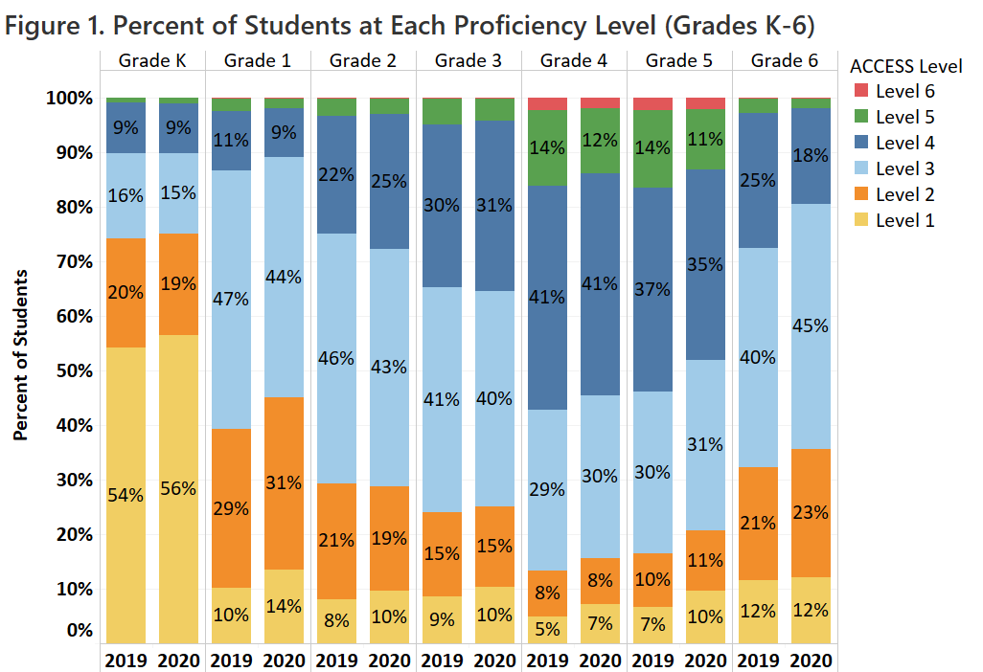

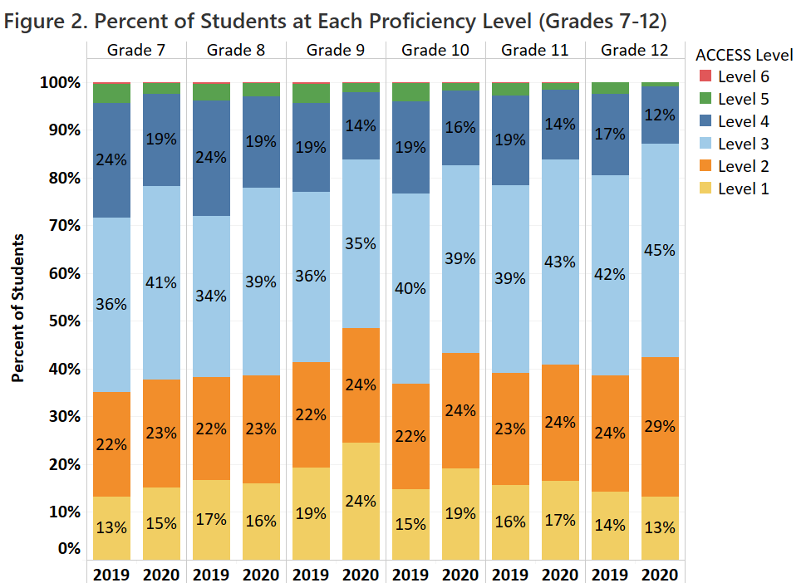
Table 3 shows the comparative percentage of ELs who attained English proficiency as indicated by an ACCESS score of Level 4.2. The percentage of students attaining scores indicating their attainment of English proficiency (i.e., between Level 4.2 and Level 6) in 2020 (18.7 percent) was three percentage points lower than the percentage in 2019 (21.7 percent).

Table 3. Students Who Attained Above or Below Level 4.2 by Grade (2019 and 2020)

Grade | 2019 |  | 2020
 | Below 4.2 | 4.2 or Above | Below 4.2 | 4.2 or Above
K | 92.8% | 7.2% | 92.7% | 7.3%
1 | 89.8% | 10.2% | 91.7% | 8.3%
2 | 81.1% | 18.9% | 79.2% | 20.8%
3 | 74.1% | 25.9% | 74.4% | 25.6%
4 | 51.9% | 48.1% | 54.7% | 45.3%
5 | 54.7% | 45.3% | 60.3% | 39.7%
6 | 80.1% | 19.9% | 86.9% | 13.1%
7 | 78.8% | 21.2% | 85.0% | 15.0%
8 | 79.0% | 21.0% | 83.6% | 16.4%
9 | 81.9% | 18.1% | 88.1% | 11.9%
10 | 82.6% | 17.4% | 87.6% | 12.4%
11 | 84.7% | 15.3% | 89.7% | 10.3%
12 | 86.5% | 13.5% | 91.7% | 8.3%
Total | 78.3% | 21.7% | 81.3% | 18.7%

Composite Proficiency Levels
In addition to receiving a composite overall ACCESS proficiency level score, students receive three additional composite scores: oral language, comprehension, and literacy. Composite scores are derived from a combination of weighted scaled scores in the four language domains as follows:
- Overall―combining the four domain scores, as follows: listening (15 percent), speaking (15 percent), reading (35 percent), and writing (35 percent)
- Oral Language―combining equally weighted scaled scores for listening and speaking (50 percent each)
- Comprehension―combining scaled scores for listening (30 percent) and reading (70 percent)
- Literacy―combining equally weighted scaled scores for reading (50 percent) and writing (50 percent)

Average proficiency levels for the Oral Language, Comprehension, and Literacy composite scales are presented below, by grade cluster and years in Massachusetts, in Table 4.

Table 4. Average Composite Proficiency Level
by Grade Cluster and Years of Enrollment in MA (2020)

Grade Cluster | Years in MA | # Included | Average Oral Level | Average Comprehension Level | Average Literacy Level
K | First Year | 10,912 | 3.9 | 2.3 | 1.8
 | Second Year | 364 | 4.3 | 2.6 | 1.9
 | Total | 11,276 | 3.9 | 2.3 | 1.8
1-2 | First Year | 3,017 | 2.7 | 3.0 | 2.4
 | Second Year | 10,653 | 3.9 | 4.1 | 2.8
 | Third Year | 8,847 | 3.8 | 4.3 | 3.4
 | Fourth Year | 654 | 3.7 | 4.0 | 3.3
 | Fifth Year | 1 | - | - | -
 | Total | 23,172 | 3.7 | 4.0 | 3.0
3-5 | First Year | 3,592 | 2.7 | 3.0 | 2.6
 | Second Year | 2,563 | 3.8 | 4.0 | 3.4
 | Third Year | 2,476 | 4.2 | 4.5 | 3.6
 | Fourth Year | 7,680 | 4.1 | 4.5 | 3.7
 | Fifth Year | 5,711 | 4.7 | 5.0 | 3.9
 | Sixth+ Year | 3,599 | 4.6 | 4.8 | 3.9
 | Total | 25,621 | 4.1 | 4.4 | 3.6
6-8 | First Year | 3,165 | 2.8 | 2.9 | 2.4
 | Second Year | 2,143 | 3.5 | 3.4 | 2.9
 | Third Year | 1,941 | 3.7 | 3.7 | 3.1
 | Fourth Year | 1,585 | 3.9 | 3.9 | 3.2
 | Fifth Year | 1,007 | 4.0 | 3.9 | 3.2
 | Sixth+ Year | 6,621 | 4.0 | 3.9 | 3.2
 | Total | 16,462 | 3.6 | 3.6 | 3.0
9-12 | First Year | 4,696 | 2.5 | 2.9 | 2.6
 | Second Year | 3,395 | 2.9 | 3.3 | 3.0
 | Third Year | 2,742 | 3.1 | 3.5 | 3.1
 | Fourth Year | 2,473 | 3.2 | 3.6 | 3.2
 | Fifth Year | 1,394 | 3.2 | 3.7 | 3.3
 | Sixth+ Year | 5,380 | 3.4 | 3.9 | 3.4
 | Total | 20,080 | 3.0 | 3.4 | 3.1
Grand Total |  | 96,611 | 3.7 | 3.7 | 3.0

Results of the 2020 Alternate ACCESS
The Alternate ACCESS assessment was first administered in 2014 to EL students with significant cognitive disabilities. The Alternate ACCESS results are reported at six proficiency levels: A1-Initiating, A2-Exploring, A3-Engaging, P1-Entering, P2-Emerging, and P3-Developing (for Writing only), and on a numerical scale from 900 to 960. See Appendix B for the performance definitions of the Alternate ACCESS proficiency levels.

The statewide participation rate for students who took the Alternate ACCESS was 97 percent for 2020, which was one percentage point lower than the Alternate ACCESS participation rate of 98 percent in 2019.

Alternate ACCESS proficiency levels are shown by grade level in Table 5.

Table 5. Alternate ACCESS Proficiency Level by Grade (2020)

Grade | # Tested | A1 | A2 | A3 | P1 | P2
1 | 196 | 20% | 11% | 32% | 23% | 13%
2 | 149 | 16% | 5% | 24% | 30% | 25%
3 | 153 | 12% | 8% | 26% | 25% | 29%
4 | 160 | 10% | 11% | 23% | 24% | 32%
5 | 136 | 11% | 7% | 21% | 24% | 38%
6 | 159 | 16% | 8% | 14% | 26% | 36%
7 | 113 | 9% | 8% | 17% | 28% | 38%
8 | 96 | 10% | 4% | 13% | 32% | 41%
9 | 115 | 10% | 6% | 15% | 29% | 40%
10 | 91 | 10% | 11% | 8% | 38% | 33%
11 | 103 | 11% | 10% | 20% | 21% | 38%
12 | 114 | 18% | 4% | 13% | 16% | 49%
Grand Total | 1,585 | 13% | 8% | 20% | 26% | 33%

III. Reporting Elements
New requirements for reporting the proficiency and progress of ELs are outlined in Title III of the federal Every Student Succeeds Act (ESSA) and in the Language Opportunities for Our Kids Act (LOOK), a 2017 state law. Five required reporting elements found in ESSA are summarized below.
- Reporting Element #1: The number and percent of ELs making progress toward achieving English language proficiency, disaggregated for ELs with disabilities (EL SWD). A student who is making progress is on track to achieve English proficiency (i.e., for Reporting Element #1, overall Level 4.2 on ACCESS is considered English proficient) within six years.
- Reporting Element #2: The number and percent of ELs attaining English proficiency (i.e., for Reporting Element #2, overall Level 4.2 and composite literacy Level 3.9 on ACCESS is considered English proficient)
- Reporting Element #3: The number and percent of ELs exiting EL status based on their attainment of English proficiency
- Reporting Element #4: The number and percent of former ELs (FELs) meeting challenging state academic standards on the next-generation MCAS tests for English language arts (ELA), mathematics, and science and technology/engineering (STE) for each of the four years after such students are no longer receiving EL services, disaggregated for FELs with disabilities (FEL SWD)
- Reporting Element #5: The number and percent of ELs who have not attained English language proficiency within six years of initial classification as an EL (i.e., within five years after the first baseline year, or within six years), disaggregated for ELs with disabilities
This report has been updated to include results on the five reporting elements described above. Results for the five reporting elements are based on the overall state results on the ACCESS tests combined with results for students taking the Alternate ACCESS, and results of FEL students on the MCAS tests. Reporting on the five elements is intended to provide districts with important instructional feedback to promote and accelerate the achievement of EL and FEL students, and to provide a basis for additional oversight of EL programming by districts and the Department.
Reporting Element #1: EL Students Making Progress toward English Language Proficiency (disaggregated for students with and without disabilities)
In 2018, a method was established to indicate progress in learning English that provided the following information for each EL student:
- Future Progress Target representing the minimum ACCESS proficiency level score needed on the following year’s ACCESS test to remain on track to reach English proficiency (i.e., attain overall Level 4.2) within a total of six years in a Massachusetts school. Future progress targets are reported as an ACCESS proficiency level, ranging from Levels 1.0 to 4.2. Individual student targets are provided in the summer of each year. Further clarification of Future Progress Targets is provided in Appendix C.
- Difficulty Index showing an estimate of how difficult it will be to reach next year’s target, relative to the student’s current proficiency level. The difficulty index ranges from 1–99, with one being the lowest difficulty (i.e., least difficult to achieve the target) and 99 the highest (i.e., most difficult to achieve the target). Students with difficulty indices greater than 60 are considered to have a high difficulty index. Educators are directed to use the difficulty index as an indicator of which students may need additional instructional assistance in order to succeed. Further clarification of Difficulty Indices is provided in Appendix C.
- Student Growth Percentile for ACCESS (SGPA) indicating the amount of progress made by a student on the ACCESS test from one year to the next, relative to other EL students in the same grade who earned similar ACCESS scores the prior year. In general, SGPA indicates whether a student has made low, moderate, or high gains in their ACCESS test scores from one year to the next compared with other ELs in the same grade level who took the ACCESS test in two consecutive years. Like the difficulty index, the SGPA is a number from 1−99, with 40−59 representing average growth. Higher SGPA numbers (i.e., above 60) indicate more growth, and lower SGPA numbers (i.e., below 40) show less growth.
- Progress Indicator, either “Yes” or “No,” showing whether the student has met last year’s future progress target in the current year. Students who meet or exceed their future target for that year will be designated as having “made progress.” Students who do not meet their targets will not make progress for that year. Students taking the Alternate ACCESS will make progress if they increase the Alternate ACCESS achievement level in any subdomain by one level.
Table 6. Students Making Progress by Grade (2019 & 2020)

Grade | 2019 |  |  | 2020
 | % Making  Progress | # Making  Progress | # Included in Progress | % Making Progress | # Making Progress | # Included  in Progress
1 | 61.9% | 6,128 | 9,896 | 54.5% | 5,468 | 10,032
2 | 63.4% | 6,071 | 9,577 | 70.2% | 7,112 | 10,131
3 | 63.7% | 5,630 | 8,842 | 69.6% | 6,327 | 9,095
4 | 65.3% | 5,076 | 7,770 | 65.8% | 5,164 | 7,852
5 | 55.9% | 3,266 | 5,838 | 52.9% | 2,999 | 5,674
6 | 33.2% | 1,442 | 4,339 | 29.8% | 1,358 | 4,556
7 | 37.0% | 1,621 | 4,380 | 34.2% | 1,567 | 4,586
8 | 36.0% | 1,574 | 4,369 | 37.7% | 1,675 | 4,438
9 | 36.0% | 1,624 | 4,515 | 29.8% | 1,472 | 4,938
10 | 30.8% | 1,266 | 4,115 | 26.1% | 1,128 | 4,328
11 | 27.5% | 1,004 | 3,649 | 19.9% | 725 | 3,641
12 | 24.7% | 799 | 3,239 | 15.4% | 521 | 3,394
Total | 50.3% | 35,501 | 70,529 | 48.9% | 35,516 | 72,665

Across Massachusetts, 48.9 percent of EL students made progress in 2020 (as shown in Table 6). Approximately two-thirds of students in grades 2–4 made progress, while a third or fewer students made progress in grades 6–12. Among the students who have been enrolled in the state for six or more years (as shown in Table 7), only 16.7 percent made progress in middle school, and only 13.4 percent made progress in high school.

Table 7. Students Making Progress
by Grade Cluster and Years of Enrollment in MA (2019 and 2020)

Grade Cluster | Years in MA | 2019 |  | 2020
 |  | # included in Progress | % Making Progress | # included  in Progress | % Making Progress
1-2 | First Year | 197 | 55.8% | 326 | 76.7%
 | Second Year | 10,236 | 62.7% | 10,350 | 55.9%
 | Third Year | 8,342 | 63.8% | 8,831 | 69.9%
 | Fourth Year | 696 | 50.4% | 656 | 56.6%
 | Fifth Year | 2 | - | - | -
 | Total | 19,473 | 62.6% | 20,163 | 62.4%
3-5 | First Year | 75 | 61.3% | 533 | 93.4%
 | Second Year | 2,456 | 61.3% | 2,335 | 64.8%
 | Third Year | 2,581 | 64.4% | 2,458 | 65.3%
 | Fourth Year | 7,404 | 65.4% | 7,763 | 69.4%
 | Fifth Year | 5,775 | 65.3% | 5,816 | 64.5%
 | Sixth+ Year | 4,159 | 51.6% | 3,716 | 46.6%
 | Total | 22,450 | 62.2% | 22,621 | 64.1%
6-8 | First Year | 54 | 42.6% | 376 | 93.6%
 | Second Year | 2,199 | 53.8% | 1,951 | 60.6%
 | Third Year | 1,975 | 51.5% | 1,941 | 49.2%
 | Fourth Year | 1,336 | 44.8% | 1,587 | 41.7%
 | Fifth Year | 901 | 38.5% | 1,013 | 32.6%
 | Sixth+ Year | 6,623 | 22.1% | 6,712 | 16.7%
 | Total | 13,088 | 35.4% | 13,580 | 33.9%
9-12 | First Year | 110 | 22.7% | 497 | 82.1%
 | Second Year | 3,290 | 39.0% | 3,044 | 32.1%
 | Third Year | 3,357 | 39.5% | 2,783 | 29.0%
 | Fourth Year | 2,079 | 37.9% | 2,549 | 22.3%
 | Fifth Year | 1,239 | 31.6% | 1,437 | 19.7%
 | Sixth+ Year | 5,443 | 16.2% | 5,991 | 13.4%
 | Total | 15,518 | 30.2% | 16,301 | 23.6%
Grand Total |  | 70,529 | 50.3% | 72,665 | 48.9%

ESSA, Title III also requires reporting of progress results by disability status. Table 8 disaggregates the results by students with disabilities versus without disabilities. Overall, 55.6 percent of students without a disability made progress while only 28.8 percent of students with a disability made progress in 2020. In middle and high school, the rate of students with disabilities making progress was less than 15 percent.

Table 8. Students Making Progress
by Grade Cluster, Years of Enrollment in MA, and Disability Status (2020)

Grade Cluster | Years in MA | non-SWD |  | SWD |  | Total
 |  | # included in Progress | % Making Progress | # included in Progress | % Making Progress | # included in Progress | % Making Progress
1-2 | First Year | 302 | 80.1% | 24 | 33.3% | 326 | 76.7%
 | Second Year | 8,855 | 59.5% | 1,495 | 34.7% | 10,350 | 55.9%
 | Third Year | 6,994 | 75.2% | 1,837 | 50.0% | 8,831 | 69.9%
 | Fourth Year | 362 | 62.4% | 294 | 49.3% | 656 | 56.6%
 | Fifth Year | - | - | - | - | - | -
 | Total | 16,513 | 66.6% | 3,650 | 43.6% | 20,163 | 62.4%
3-5 | First Year | 521 | 94.4% | 12 | 50.0% | 533 | 93.4%
 | Second Year | 2,151 | 67.1% | 184 | 38.0% | 2,335 | 64.8%
 | Third Year | 1,984 | 71.7% | 474 | 38.8% | 2,458 | 65.3%
 | Fourth Year | 5,796 | 75.9% | 1,967 | 50.4% | 7,763 | 69.4%
 | Fifth Year | 3,851 | 75.4% | 1,965 | 43.2% | 5,816 | 64.5%
 | Sixth+ Year | 1,913 | 61.8% | 1,803 | 30.4% | 3,716 | 46.6%
 | Total | 16,216 | 73.0% | 6,405 | 41.3% | 22,621 | 64.1%
6-8 | First Year | 370 | 94.1% | 6 | 66.7% | 376 | 93.6%
 | Second Year | 1,821 | 62.4% | 130 | 35.4% | 1,951 | 60.6%
 | Third Year | 1,627 | 52.2% | 314 | 33.4% | 1,941 | 49.2%
 | Fourth Year | 1,303 | 45.0% | 284 | 26.1% | 1,587 | 41.7%
 | Fifth Year | 712 | 37.6% | 301 | 20.6% | 1,013 | 32.6%
 | Sixth+ Year | 3,245 | 25.0% | 3,467 | 8.9% | 6,712 | 16.7%
 | Total | 9,078 | 44.1% | 4,502 | 13.3% | 13,580 | 33.9%
9-12 | First Year | 486 | 83.1% | 11 | 36.4% | 497 | 82.1%
 | Second Year | 2,936 | 32.6% | 108 | 18.5% | 3,044 | 32.1%
 | Third Year | 2,554 | 29.7% | 229 | 21.4% | 2,783 | 29.0%
 | Fourth Year | 2,314 | 23.2% | 235 | 13.2% | 2,549 | 22.3%
 | Fifth Year | 1,186 | 22.1% | 251 | 8.4% | 1,437 | 19.7%
 | Sixth+ Year | 3,206 | 16.7% | 2,785 | 9.5% | 5,991 | 13.4%
 | Total | 12,682 | 27.3% | 3,619 | 10.7% | 16,301 | 23.6%
Grand Total |  | 54,489 | 55.6% | 18,176 | 28.8% | 72,665 | 48.9%

Reporting Element #2: EL Students Attaining English Language Proficiency
The method of identifying EL proficiency in 2020 is the same as it was in 2019. Students who obtained an overall score of Level 4.2 and a literacy composite score of Level 3.9 will be designated as having attained English language proficiency in Table 9. The overall proficiency rates shown in Table 9 indicate a decrease in attainment of approximately three percentage points (19.6 percent in 2019 and 16.5 percent in 2020).

Table 9. Students Attaining English Proficiency by Grade (2019 and 2020)

Grade | 2019 |  |  | 2020
 | % Proficient | # Proficient | # Included | % Proficient | # Proficient | # Included
K | 3.3% | 365 | 11,138 | 3.5% | 394 | 11,386
1 | 8.6% | 1,010 | 11,680 | 6.8% | 812 | 11,994
2 | 17.6% | 1,970 | 11,190 | 19.2% | 2,247 | 11,676
3 | 24.8% | 2,528 | 10,205 | 24.1% | 2,540 | 10,527
4 | 44.3% | 4,013 | 9,051 | 40.8% | 3,704 | 9,085
5 | 41.8% | 2,975 | 7,115 | 35.7% | 2,407 | 6,733
6 | 17.8% | 1,001 | 5,617 | 11.3% | 651 | 5,748
7 | 19.4% | 1,081 | 5,560 | 13.2% | 764 | 5,775
8 | 19.4% | 1,052 | 5,419 | 14.8% | 820 | 5,538
9 | 17.1% | 1,149 | 6,733 | 11.1% | 848 | 7,633
10 | 16.2% | 849 | 5,228 | 11.6% | 654 | 5,643
11 | 14.0% | 637 | 4,563 | 9.4% | 427 | 4,542
12 | 12.1% | 442 | 3,654 | 7.2% | 269 | 3,725
Total | 19.6% | 19,072 | 97,153 | 16.5% | 16,537 | 100,005

Table 10 indicates that the percent of students attaining proficiency is highest in grades 3−5 (32.8 percent in 2020 and 36.1 percent in 2019), but much lower (less than 20 percent) in other grade clusters in both years.

Table 10. Students Attaining English Proficiency
by Grade Cluster and Years of Enrollment in MA (2019 and 2020)

Grade Cluster | Years in MA | 2019 |  |  | 2020
 |  | % Proficient | # Proficient | #  Included |  | %  Proficient | #  Proficient | # Included
K | First Year | 3.3% | 352 | 10,751 |  | 3.4% | 380 | 11,019
 | Second Year | 3.4% | 13 | 386 |  | 3.8% | 14 | 367
 | Third Year | - | - | 1
 | Total | 3.3% | 365 | 11,138 |  | 3.5% | 394 | 11,386
1-2 | First Year | 7.3% | 192 | 2,620 |  | 5.6% | 172 | 3,046
 | Second Year | 10.3% | 1,119 | 10,884 |  | 8.7% | 951 | 10,913
 | Third Year | 18.5% | 1,598 | 8,650 |  | 20.5% | 1,857 | 9,041
 | Fourth Year | 9.9% | 71 | 714 |  | 11.8% | 79 | 669
 | Fifth Year | - | - | 2 |  | - | - | 1
 | Total | 13.0% | 2,980 | 22,870 |  | 12.9% | 3,059 | 23,670
3-5 | First Year | 16.3% | 480 | 2,940 |  | 12.8% | 463 | 3,621
 | Second Year | 26.6% | 745 | 2,796 |  | 26.0% | 678 | 2,607
 | Third Year | 35.0% | 945 | 2,699 |  | 33.9% | 861 | 2,540
 | Fourth Year | 31.7% | 2,416 | 7,628 |  | 31.0% | 2,450 | 7,900
 | Fifth Year | 47.9% | 2,851 | 5,946 |  | 44.9% | 2,650 | 5,898
 | Sixth+ Year | 47.7% | 2,079 | 4,362 |  | 41.0% | 1,549 | 3,779
 | Total | 36.1% | 9,516 | 26,371 |  | 32.8% | 8,651 | 26,345
6-8 | First Year | 14.2% | 371 | 2,613 |  | 9.8% | 312 | 3,190
 | Second Year | 15.5% | 383 | 2,468 |  | 14.7% | 321 | 2,185
 | Third Year | 19.9% | 407 | 2,048 |  | 13.6% | 271 | 1,990
 | Fourth Year | 21.8% | 302 | 1,388 |  | 14.9% | 243 | 1,631
 | Fifth Year | 22.1% | 211 | 954 |  | 15.5% | 162 | 1,046
 | Sixth+ Year | 20.5% | 1,460 | 7,125 |  | 13.2% | 926 | 7,019
 | Total | 18.9% | 3,134 | 16,596 |  | 13.1% | 2,235 | 17,061
9-12 | First Year | 13.7% | 520 | 3,791 |  | 8.2% | 389 | 4,766
 | Second Year | 16.2% | 598 | 3,689 |  | 11.5% | 404 | 3,507
 | Third Year | 15.5% | 534 | 3,440 |  | 10.3% | 296 | 2,876
 | Fourth Year | 16.0% | 342 | 2,141 |  | 10.3% | 268 | 2,603
 | Fifth Year | 17.8% | 230 | 1,293 |  | 11.1% | 166 | 1,489
 | Sixth+ Year | 14.6% | 853 | 5,824 |  | 10.7% | 675 | 6,302
 | Total | 15.2% | 3,077 | 20,178 |  | 10.2% | 2,198 | 21,543
Grand Total |  | 19.6% | 19,072 | 97,153 |  | 16.5% | 16,537 | 100,005

Reporting Element #3: EL Students Who Exited English Learner (EL) Status as a Result of Their Attainment of English Proficiency
This element reports the number and percent of students who exited EL status once they had attained English proficiency on the ACCESS tests. The number of students reaching proficiency in 2019 and 2020 is shown in the top row of each grade cluster shown in Table 11. The number of students exiting EL status by the fall of the following school year is shown in the second row of each grade cluster shown. The percent of EL students who attained proficiency and exited EL status by the following fall as a result of their attainment of proficiency is shown in row three of the grade cluster provided. The overall percent of proficient EL students who exited EL status after reaching proficiency was 69.7 percent in 2019 and 75.4 percent in 2020.
Table 11. Students Who Attained English Proficiency and Exited EL Status (2019 and 2020)

Grade Cluster |  | 2019* | 2020
K | Proficiency | 365 | 394
 | RE3 Exit | 175 | 174
 | % Attained and Exited | 47.9% | 44.2%
1-2 | Proficiency | 2,980 | 3,059
 | RE3 Exit | 2,044 | 2,173
 | % Attained and Exited | 68.6% | 71.0%
3-5 | Proficiency | 9,516 | 8,651
 | RE3 Exit | 6,645 | 6,775
 | % Attained and Exited | 69.8% | 78.3%
6-8 | Proficiency | 3,134 | 2,235
 | RE3 Exit | 2,119 | 1,616
 | % Attained and Exited | 67.6% | 72.3%
9-12 | Proficiency | 3,077 | 2,198
 | RE3 Exit | 2,313 | 1,733
 | % Attained and Exited | 75.2% | 78.8%
Grand Total | Proficiency | 19,072 | 16,537
 | RE3 Exit | 13,296 | 12,471
 | % Attained and Exited | 69.7% | 75.4%
*The 2019 Reporting Element 3 numbers in the current report are slightly different from those in the 2019 state report because more enrollment data were made available since the 2019 state report was released.
Reporting Element #4: Former ELs (FELs) Meeting Challenging State Academic Standards (disaggregated for students with and without disabilities)
Reporting Element #4 describes the number and percent of former English learners (FELs) who have met challenging state standards, as indicated by a score of Meeting Expectations or Exceeding Expectations on the next-generation MCAS tests. For this reporting element, FELs are considered to be students who exited EL status up to four years prior to taking the MCAS tests. Reporting Element #4 is also reported for FEL students with disabilities.

MCAS was not administered in spring 2020 due to school closure and test cancellation during the COVID-19 pandemic. Therefore, Tables 12 and 13 are not shown in this report.

Table 12. (not available for 2020)
Former ELs (FEL) and Never ELs Meeting Challenging State Academic Standards,
Disaggregated for FELs with Disabilities (FEL & SWD)
Grades 3–8

Table 13. (not available for 2020)
Former ELs (FELs) and Never ELs Meeting Challenging State Academic Standards,
Disaggregated for FELs with Disabilities (FEL & SWD)
Grade 10

Reporting Element #5: EL Students Who Have Not Attained English Proficiency within Six Years (disaggregated for students with and without disabilities)
ELs in Massachusetts are anticipated to reach proficiency on ACCESS tests within a total of six years after being classified as an English learner in a Massachusetts school (one baseline year, plus five years to demonstrate growth toward proficiency). ELs are considered to have attained English proficiency when they achieve ACCESS scores of at least Level 4.2 overall and Level 3.9 literacy composite.
As shown in Table 14, approximately 15 percent of all EL students did not reach proficiency in 2019 and 2020 within six years of entering a Massachusetts school. Students in grades K–4 are omitted in the table due to the reporting requirement that a student be enrolled in a Massachusetts school for at least six years. The percent of students with disabilities who are not attaining proficiency within six years is similar in both years (36.9 percent in 2019 and 38.3 percent in 2020). For students with disabilities in grades 6–12, the percent not attaining proficiency within six years is greater than 70 percent in both years.

Table 14. Students Not Attaining English Proficiency within Six Years
by Grade Cluster and Disability Status (2019 & 2020)

Grade Cluster |  | 2019 |  |  | 2020
 |  | non-SWD | SWD | Total | non-SWD | SWD | Total
3-5 | # Not Meeting | 943 | 1,479 | 2,422 | 928 | 1,487 | 2,415
 | % Not Meeting | 4.7% | 23.1% | 9.2% | 4.7% | 22.1% | 9.2%
 | # Included | 19,980 | 6,391 | 26,371 | 19,621 | 6,724 | 26,345
6-8 | # Not Meeting | 3,371 | 3,151 | 6,522 | 3,330 | 3,588 | 6,918
 | % Not Meeting | 27.6% | 72.2% | 39.3% | 27.1% | 75.1% | 40.5%
 | # Included | 12,231 | 4,365 | 16,596 | 12,283 | 4,778 | 17,061
9-12 | # Not Meeting | 2,999 | 2,560 | 5,559 | 3,245 | 2,956 | 6,201
 | % Not Meeting | 18.0% | 73.5% | 27.5% | 18.4% | 75.0% | 28.8%
 | # Included | 16,694 | 3,484 | 20,178 | 17,604 | 3,939 | 21,543
Grand Total* | # Not Meeting | 7,313 | 7,190 | 14,503 | 7,503 | 8,031 | 15,534
 | % Not Meeting | 9.4% | 36.9% | 14.9% | 9.5% | 38.3% | 15.5%
 | # Included | 77,647 | 19,506 | 97,153 | 79,026 | 20,979 | 100,005
* The Grand Total includes the count of students in grades K-4, but these students are not considered eligible to be included in the “meets” or “does not meet” proficiency status within six years due to the number of years they have been enrolled in school.

IV. ACCESS Results for EL Students from the State’s Highest Incidence First-Language Groups
Table 15 shows the number and percent of students in the highest incidence language groups enrolled in a Massachusetts school in 2019 and 2020. Spanish is the largest native language group with just under 55 percent of students, followed by Portuguese, the native language of just under 14 percent of the EL population.
Table 15. Enrollment by Highest-Incidence First (Native) Languages (2019 & 2020)

Language Spoken and Ranking by Enrollment # |  | 2019 |  | 2020
 |  | # of ELs | % of ELs | # of ELs | % of ELs
1 | Spanish | 52,906 | 54.1% | 54,103 | 53.8%
2 | Portuguese | 11,033 | 11.3% | 13,671 | 13.6%
3 | Other | 6,789 | 6.9% | 6,476 | 6.4%
4 | Cape Verdean | 4,263 | 4.4% | 4,237 | 4.2%
5 | Creole | 4,120 | 4.2% | 4,080 | 4.1%
6 | Chinese | 3,930 | 4.0% | 3,617 | 3.6%
7 | Arabic | 3,004 | 3.1% | 2,951 | 2.9%
8 | Vietnamese | 2,135 | 2.2% | 2,024 | 2.0%
9 | Khmer | 1,564 | 1.6% | 1,537 | 1.5%
10 | Russian | 1,233 | 1.3% | 1,235 | 1.2%
11 | French | 865 | 0.9% | 831 | 0.8%
12 | Twi | 683 | 0.7% | 702 | 0.7%
13 | Swahili | 585 | 0.6% | 587 | 0.6%
14 | Somali | 605 | 0.6% | 556 | 0.6%
15 | Nepali | 574 | 0.6% | 501 | 0.5%
16 | Japanese | 508 | 0.5% | 513 | 0.5%
17 | Albanian | 482 | 0.5% | 469 | 0.5%
18 | Korean | 401 | 0.4% | 405 | 0.4%
19 | Gujarati | 379 | 0.4% | 398 | 0.4%
20 | Telagu | 409 | 0.4% | 373 | 0.4%
21 | French Patois | 419 | 0.4% | 341 | 0.3%
22 | Hindi | 356 | 0.4% | 345 | 0.3%
23 | Urdu | 339 | 0.3% | 341 | 0.3%
24 | English | 285 | 0.3% | 282 | 0.3%
Total ELs |  | 97,867 | 100.0% | 100,575 | 100.0%

The ACCESS achievement, by proficiency level, of students speaking the ten highest-incidence languages is summarized in Table 16 and in Figures 3, 4, and 5.
Both Table 16 and Figure 3 show the percent of students scoring at each ACCESS level, by native language. The language group with the highest percentages of students in the highest proficiency levels is Chinese.

Table 16. Proficiency Level by the Ten Highest-Incidence Languages (2020)

Language Spoken | Level 6 | Level 5 | Level 4 | Level 3 | Level 2 | Level 1 | # Included
Spanish | 0.2% | 2.3% | 17.6% | 36.9% | 22.4% | 20.6% | 51,759
Portuguese | 0.4% | 3.4% | 18.9% | 30.5% | 20.6% | 26.2% | 13,332
Cape Verdean | 0.2% | 2.0% | 16.4% | 41.2% | 25.1% | 15.1% | 4,015
Creole | 0.1% | 2.4% | 21.6% | 46.3% | 19.8% | 9.8% | 3,859
Chinese | 2.2% | 12.1% | 31.6% | 31.4% | 12.4% | 10.3% | 3,515
Arabic | 0.4% | 4.7% | 25.0% | 38.9% | 18.1% | 12.9% | 2,835
Vietnamese | 0.9% | 5.8% | 28.7% | 36.9% | 16.1% | 11.6% | 1,932
Khmer | 0.4% | 5.4% | 27.5% | 39.2% | 18.1% | 9.4% | 1,511
Russian | 1.3% | 8.0% | 32.0% | 34.9% | 11.6% | 12.1% | 1,205
French | 1.0% | 8.8% | 28.5% | 38.6% | 15.2% | 7.9% | 808

Figure 3. Percent of Students at Each Proficiency Level for the Ten Highest-Incidence Languages

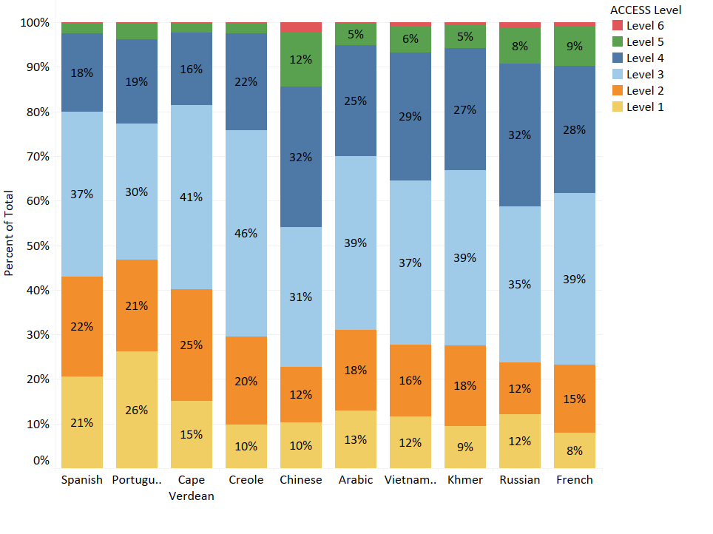
Figure 4 shows the average ACCESS proficiency level by grade cluster for the ten highest-incidence native languages. Figure 5 shows the average ACCESS proficiency level by native language and number of years in a Massachusetts school. For Figures 4 and 5, the width of the bar represents the percent of students with an economic disadvantage, as shown in the key.

Figure 4. Average Proficiency Level of the Ten Highest-Incidence Languages
by Grade Cluster, Bar Width Indicating % Economically Disadvantaged

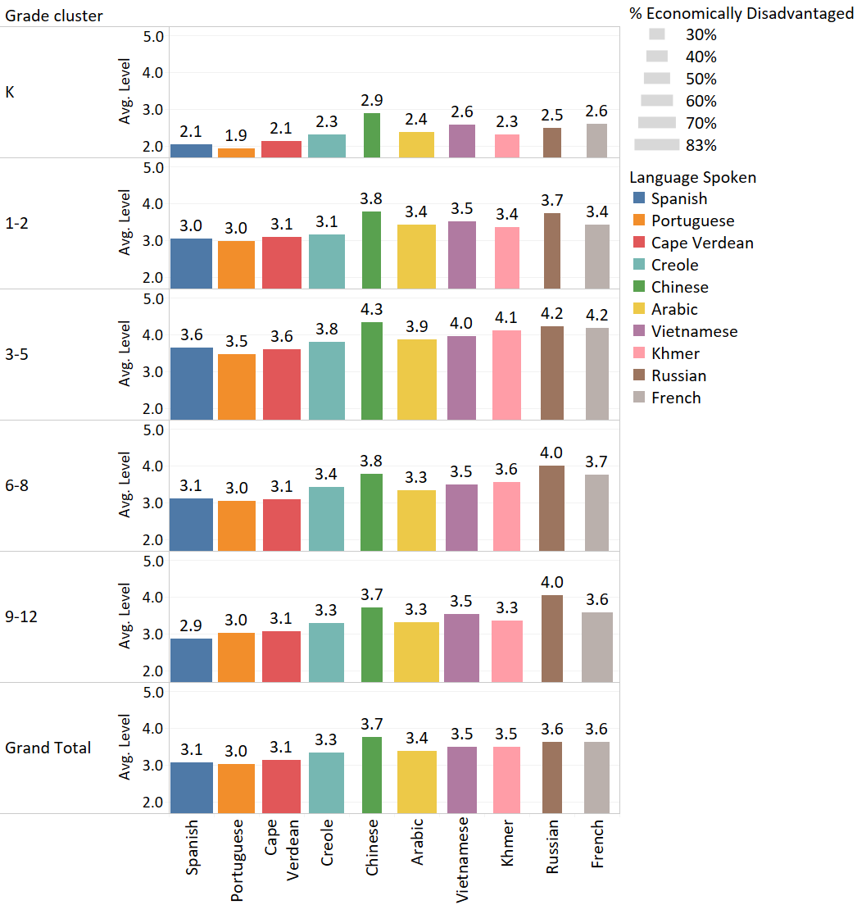
Figure 5. Average Proficiency Level of the Ten Highest-Incidence Languages
by Number of Years in MA, Bar Width Indicating % Economically Disadvantaged

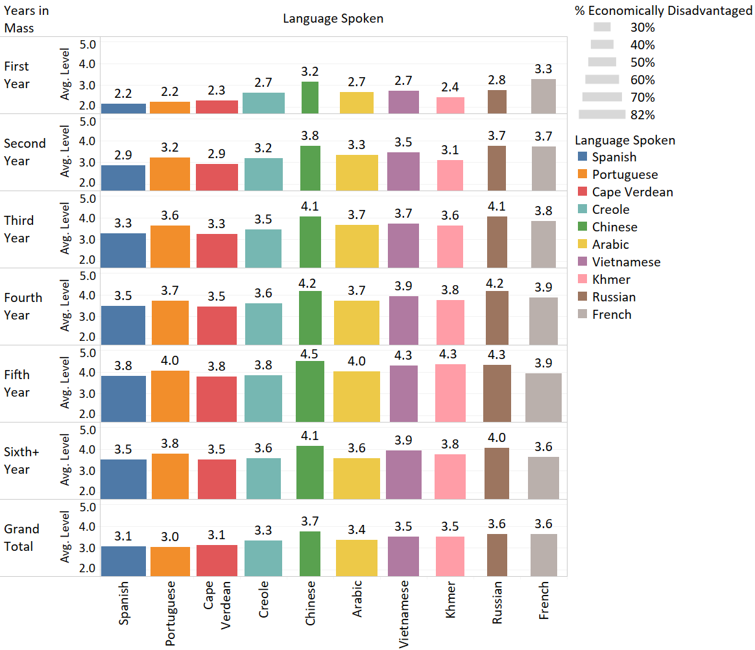

Appendix A. Performance Definitions for the ACCESS Levels of English Language Proficiency

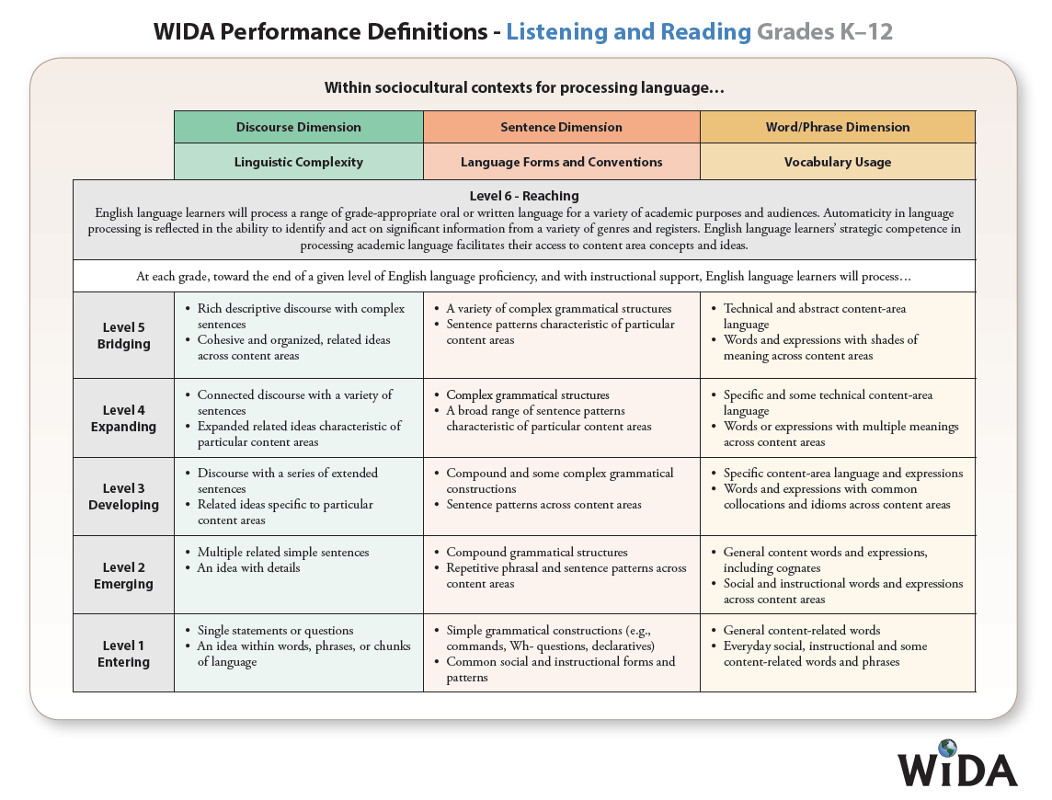
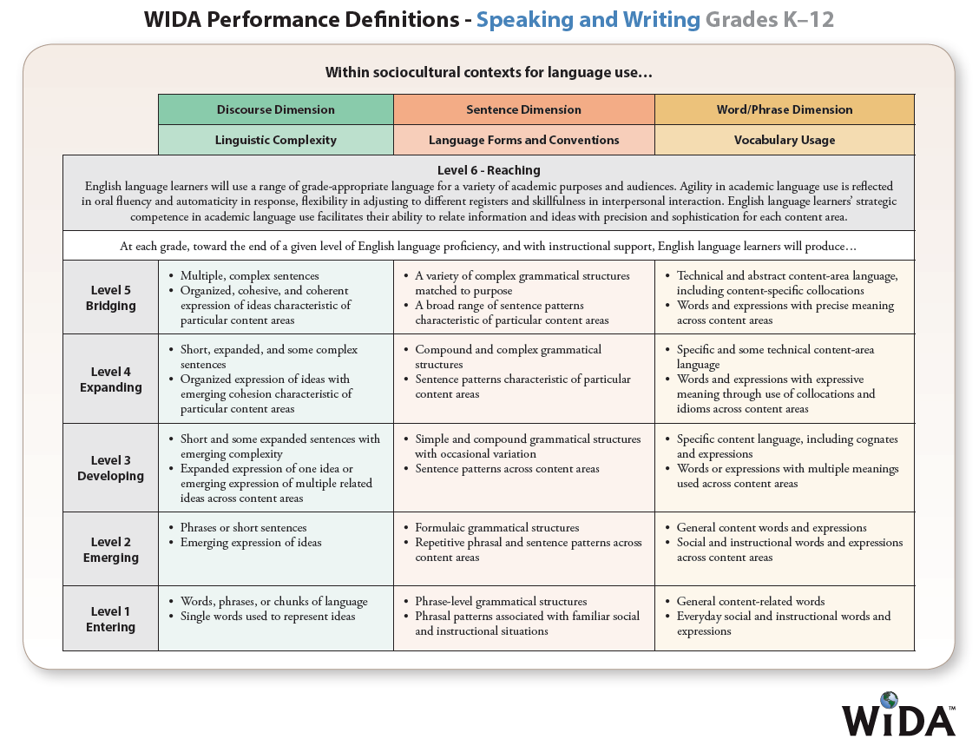

Appendix B. Alternate ACCESS Performance Definitions

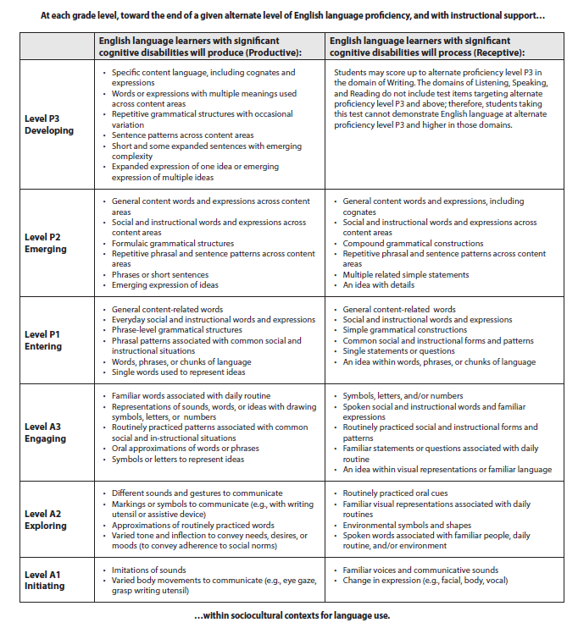

Appendix C. Additional Clarification of Future Progress Targets and Difficulty Indices

Graph C1 provides clarification of Future Progress Targets based on the following variables for ELs. Future Progress Targets for EL students in grade 6 are provided as an example:
- Future Progress Targets (2020)
- Difficulty Index for the Future Progress Targets
- Current ACCESS level
- Years enrolled in MA

In Graph C1, the ACCESS proficiency level is shown on the y-axis for each category of Years in MA. The 2020 Future Progress Target is displayed on the x-axis. The shading depicts the Difficulty Index from easiest (green) to moderate difficulty (yellow) to very difficult (red). The nonlinear growth trajectory observed in the actual student population is illustrated in the curved graph lines.

For EL students in their first year in a Massachusetts school, students who scored lowest on the ACCESS test will have the lowest targets, ranging from 1.9 to 2.0 for students scoring between 1.4 to 1.7 on the current year’s ACCESS test. As students’ current year ACCESS scores increase, their Future Progress Targets will also increase. Students who score above ACCESS level 2.0 will have targets that are higher than 2.9. The highest target assigned is 4.2 (Level 4.2 is considered English proficient), depicted by the straight vertical line in each graph panel. A similar growth trajectory is observed for students enrolled in MA for two years.

For students enrolled in MA for three and four years, the trajectories are shortened to denote the reduced time frame for attaining proficiency. For example, the lowest-scoring students enrolled for three years begin with Future Progress Targets of 2.4 (compared with a target of 1.9 for students enrolled in MA for fewer years). For the lowest-scoring students enrolled in MA for four years, the targets start at 2.8. The higher level of difficulty in meeting these targets is denoted by the orange shading, which is especially evident for lower-scoring students enrolled in MA for four and five years. For high-scoring students, the relative ease of reaching their targets is denoted by the green shading.

Graph C1: 2020 Grade 6 Students’ Future Targets Relative to Years in MA,
Current ACCESS Proficiency Level, and Difficulty Index

