|  |  |  |
| --- | --- | --- |
| DESE logo | | |
|  | ACCESS for ELLs  2021 Statewide Results |
|  |
|  | January 2022  Massachusetts Department of Elementary and Secondary Education  75 Pleasant Street, Malden, MA 02148  Phone 781-338-3000 TTY: N.E.T. Relay 800-439-2370  [www.doe.mass.edu](http://www.doe.mass.edu) |
| This document was prepared by the  Massachusetts Department of Elementary and Secondary Education  Jeffrey C. Riley  Commissioner  The Massachusetts Department of Elementary and Secondary Education, an affirmative action employer, is committed to ensuring that all of its programs and facilities are accessible to all members of the public.  We do not discriminate on the basis of age, color, disability, gender identity, national origin, race, religion,  sex, or sexual orientation.  Inquiries regarding the Department’s compliance with Title IX and other civil rights laws may be directed to the  Human Resources Director, 75 Pleasant St., Malden, MA 02148 781-338-6105.  © 2022 Massachusetts Department of Elementary and Secondary Education  Permission is hereby granted to copy any or all parts of this document for non-commercial educational purposes. Please credit the “Massachusetts Department of Elementary and Secondary Education.”  Massachusetts Department of Elementary and Secondary Education  75 Pleasant Street, Malden, MA 02148-4906  Phone 781-338-3000 TTY: N.E.T. Relay 800-439-2370  [http://www.doe.mass.edu/](http://www.doe.mass.edu/%20)  State Seal of Massachusetts | | |

**Table of Contents**

overview of 2021 participation and achievement 1

I. Background 4

II. Summary of 2021 ACCESS for ELLs Participation and achievement 5

Student Participation 5

Student Achievement 9

Composite Proficiency Levels 11

Comparison of ACCESS Scale Scores from 2020 to 2021 13

Results of the 2021 Alternate ACCESS 14

**III. REPORTING ELEMENTS……………………………………………………………………………………...15**

IV. ACCESS Results for EL Students from the State’s Highest Incidence First-Language Groups 29

Appendix A. Performance Definitions for the ACCESS Levels of English Language Proficiency 33

Appendix B. Alternate ACCESS Performance Definitions 35

Appendix C. Additional Clarification of Future Progress Targets and Difficulty Indices 36

APPENDIX D. HOW SGPAs WERE CALCULATED 38

# Overview of 2021 Participation and Achievement

The ACCESS for ELLs (ACCESS) is an assessment of English language proficiency administered through the WIDA consortium to students who have been reported to the Massachusetts Department of Elementary and Secondary Education (the “Department” or “DESE”) as English learners (ELs). The ACCESS assesses student achievement of the WIDA English Language Development Standards in reading, writing, listening, and speaking and is administered to all publicly funded ELs in grades K12. In addition, the Alternate ACCESS for ELLs (Alternate ACCESS) is administered to EL students in grades 112 who have significant cognitive disabilities and are unable to take the regular ACCESS tests, even when accommodations are provided.

In the 2020–2021 school year, the COVID-19 pandemic disrupted typical educational programming in Massachusetts schools, with most schools transitioning to a hybrid educational model that employed varying degrees of remote instruction and reducing the amount of in-person instruction. Two major objectives of this report are to shed light on the impact of the COVID-19 pandemic on English learners’ educational outcomes in the 2021 school year and to share historical trends. In consideration of the need to test as many English learners as possible in the 2020–2021 school year, the Commissioner extended the original five-week ACCESS for ELLs testing window to nineteen weeks until May 20, 2021.

**Participation Rates**

During the 2020–2021 school year, there was a significant decrease in Massachusetts ACCESS participation rates compared to prior years. In total, 69,847 (76 percent of ELs) who were enrolled in grades K–12 participated in all four domains of the ACCESS tests, including 999 students who participated in the Alternate ACCESS. This was an overall decrease of 22 percentage points from the previous year. Participation rates were especially low for students in high school; about 80 percent of EL students in grades K–8 participated in the ACCESS tests, whereas only 60 percent of students in grades 9–12 participated in the test.

Test participation was also significantly lower among students in urban districts, in which the majority of ELs are enrolled in school; 88 percent of students participated in ACCESS tests in non-urban districts versus only 68 percent in urban districts. Interpretations of ACCESS results this year should take into account the lower and uneven participation rates in urban and non-urban districts among different EL student subgroups. Many variables should be considered when making comparisons between the 2020–2021 test results with the prior years’ results, including 1) the unprecedented and extenuating circumstances of instruction and testing during the COVID-19 pandemic; 2) consideration of which students were and were *not* tested in 2021; and, 3) the overall percentage of students tested in a district.. For more information on participation, see page 7 of this report.

**Overall Achievement**

The ACCESS results reveal a downward trend in overall student proficiency and growth in 2020–2021 compared to 2019–2020. Achievement results, shown in detail in Table 5 (see page 11) indicate that the combined percentage of students attaining proficiency on the ACCESS tests (i.e., *Level 4.2* through *Level 6*) in 2021 (15.3 percent) was 3.4 percentage points lower than in 2020 (18.7 percent). While the pandemic appeared to have contributed to the decrease in 2021, overall achievement has declined in each year since 2017 when the percentage attaining proficiency was 22.4. The implication of these declines is that ELs will need significant support in classrooms and at home to accelerate English proficiency so that they are able to rebound to previous levels and take advantage of learning opportunities within both EL programs as well as in inclusive, general education settings.

**Reporting Requirements**

In 2019, this report has been revised to include reporting elements described in Title III of the federal *Every Student Succeeds Act* (ESSA) and in the *Language Opportunities for Our Kids* (LOOK) Act, a 2017 state law. The five required reporting elements described in ESSA are summarized below and described in detail beginning on page 15 of this report.

Due to lower participation rates in 2021, results that include all students are difficult to compare to past years. Therefore, 2021 results compared to prior years will be presented first, referencing all students **eligible** for testing (including students who were absent from the test) and second, referencing only **tested** students. The percentages for the tested students can be compared to prior years' results for tested students. For example, results across all grades for *attaining proficiency* (Reporting Element #2) appear as:

*2021 All eligible students*: 10.4%

*2021 All tested students:* 13.6%

*2020 All eligible students:* 16.5%

*2020 All tested students:* 16.8%

* Reporting Element #1: The number and percent of ELs making progress toward achieving English language proficiency in the aggregate and disaggregated for EL students with disabilities (EL SWD). A student who is making progress is on track to attain English proficiency (i.e., achieve an overall proficiency level of at least 4.2) within five years, plus one baseline year, or six years. In 2021, EL progress dropped significantly among *all* eligible students and dropped significantly even among *tested* students.
  + *2021 All eligible students:*
    - *All students:* 29.4% made progress.
    - *Students with disabilities:* 16.9% made progress.
  + *2021 All tested students:*
    - *All students:* 39.3% made progress
    - *Students with disabilities:* 23.6% made progress
  + *2020 All eligible students:* 
    - *All students:* 48.9% made progress
    - *Students with disabilities:* 28.8% made progress
  + *2020 All tested students:* 
    - *All students:* 49.9% made progress
    - *Students with disabilities:* 29.8% made progress
* Reporting Element #2: The number and percent of ELs attaining English language proficiency as determined by their ACCESS test scores (i.e., overall level at least 4.2 and literacy level 3.9).
  + *2021 All eligible students:* 10.4% attained proficiency
  + *2021 All tested students:* 13.6% attained proficiency
  + *2020 All eligible students:* 16.5% attained proficiency
  + *2020 All tested students:* 16.8% attained proficiency
* Reporting Element #3: The number and percent of ELs who exited English learner status based on their attainment of English language proficiency
  + *2021 students:* 73.9% of those who attained proficiency exited EL status
  + *2020 students:* 75.4% of those who attained proficiency exited EL status
* Reporting Element #4: The number and percent of former ELs (FELs) meeting challenging state academic standards on the Massachusetts Comprehensive Assessment System (MCAS) by performing in the *Meeting* *Expectations* or *Exceeding Expectations* MCAS achievement levels. Note that results disaggregated for FELs with disabilities are shown in Tables 15 and 16 on page 27.
  + *Grades 3-8 FELs in* *Meeting* *Expectations* or *Exceeding Expectations* *level:*
    - *ELA:* 41%
    - *Mathematics:* 28%
    - *Science and Technology/Engineering:* 31%
* *Grade 10 FELs* *in Meeting* *Expectations* or *Exceeding Expectations* *level:*
  + - *ELA:* 42%
    - *Mathematics:* 32%
    - *Science and Technology/Engineering:* Students in the class of 2023 were not required to take the STE test. Therefore, very few grade 10 students took the STE test in spring 2021.
* Reporting Element #5: The number and percent of ELs who have not attained English language proficiency within six years of initial classification as an EL (i.e., within five years plus a baseline year, or six years)
  + *2021 students:* 18.3% not attaining proficiency
  + *2020 students:* 15.5% not attaining proficiency

# I. Background

This report summarizes the results of 69,847 EL students in Massachusetts who participated in all four test domains of the 2021 ACCESS and Alternate ACCESS tests, which were developed by the WIDA consortium and are intended to measure the English language proficiency of EL students in 41 consortium member states, territories, and federal agencies. Massachusetts joined the WIDA consortium in May 2012 and has administered the ACCESS tests since the 2012–2013 school year.

The ACCESS tests are available in paper-based and online versions for grades 112. Kindergarten tests are available on paper only, as is the Alternate ACCESS. Large print and Braille formats of the ACCESS tests are also available only on paper. Of the students who participated in the ACCESS in 2021, 87.6 percent took the test online and 12.4 percent took the test on paper.

ACCESS tests measure how well EL students have met the *English Language Development (ELD) Standards* developed bythe WIDA consortium. The WIDA ELD Standards describe English language literacy in four academic subjects (English language arts, mathematics, social studies, and science), plus social and instructional language, in four separate domains (listening, reading, speaking, and writing). The WIDA ELD Standards are aligned with the *Massachusetts Curriculum Frameworks*. Massachusetts adopted the WIDA ELD standards in 2012. Only students who participate in all four domains, or those who are assigned scores in missing domains as described in the [Guide to Assigning Scores for Missing Domains on ACCESS for ELLs Tests (for English Learners with Disabilities)](https://www.doe.mass.edu/mcas/access/guide-assigning-scores.docx) receive overall scores. Students are required to participate in tests designed for the grade or grade-level cluster in which they are enrolled, as follows:

**ACCESS Tests**

| **Format** | **Grade-Level Cluster Tests** |
| --- | --- |
| Online | 1, 2-3, 4-5, 6-8, 9-12 |
| Paper | K, 1, 2, 3, 4-5, 6-8, 9-12; and Alternate ACCESS in grades 1-12 |

In 2016, WIDA introduced a new, computer-based test, with the expectation that the state would transition virtually all EL students to computer-based testing over a transition period. Paper-based testing is available for use as an accommodation for students with disabilities and for first-year ELs who lack familiarity with or the ability to use a computer.

For online testing, the listening and reading tests are adaptive, with students directed to questions of equal, lesser, or greater difficulty depending on how they responded to a previous cluster of questions. Based on listening and reading results, students are routed to the appropriately tiered speaking and writing tests. For paper-based testing, students in grades 1-12 take either Tier A or B/C of the designated grade-cluster test, as determined by their teachers, depending on their level of English language proficiency.

### Students taking the ACCESS test receive scaled scores between 100600 overall, in each domain, and several composite scores. Proficiency level scores are reported as a whole number followed by a decimal (e.g., Level 3.4), indicating the student’s overall language proficiency level, and the relative positionwithin the proficiency level of the student’s scaled score, rounded to the nearest tenth. English proficiency is reported in one of six English language proficiency levels: 1-Entering, 2-Emerging, 3-Developing, 4-Expanding, 5-Bridging, and 6-Reaching (see Appendix A).

### Composite scores are also reported using the same scaled scores and proficiency levels in the four domains of listening, speaking, reading, and writing; and reported in the following combined areas:

* Overall composite score combining all four domain scores
* Oral Language composite score, combining scores in listening and speaking
* Literacy composite score, combining scaled scores in reading and writing
* Comprehension composite score, combining scaled scores in listening and reading.

**Reclassification of EL students**

* + The minimum criteria districts use to exit students from EL status is an overall ACCESS score of Level 4.2 and a Literacy composite score of Level 3.9. The Department recommends that districts also consider other relevant data before exiting students from EL status, including the following:
    - student scores on locally administered reading, language, and other academic assessments
    - written observations and the recommendations of classroom teachers
    - student’s classroom work and academic grades
    - student’s achievement and growth on MCAS tests.

**Alternate ACCESS**

The Alternate ACCESS is administered to Massachusetts EL students with the most significant cognitive disabilities. The Alternate ACCESS is given to students in grades 1–12 whose disabilities prevent participation in the ACCESS general assessment, even with the use oif accommodations, and is recommended for students who also participate in the state’s academic alternate assessment, the MCAS-Alt (or who would be designated by their IEP teams to participate if the test were offered in their grade). It is administered individually by trained and certified educators in four grade-level clusters: Grades 1–2, 3–5, 6–8, and 9–12. Students are assessed in the four domains of reading, writing, listening, and speaking. Results are reported at six proficiency levels (Levels A1, A2, A3, P1, P2, and P3; see Appendix B for descriptors for each proficiency level), and on a numerical scale from 900 to 960. In all, 999 Massachusetts students in grades 1–12 participated in the Alternate ACCESS test in 2021.

**II. Summary of 2021 ACCESS for ELLs Participation and Achievement**

## 

## Student Participation

Despite extending the original five-week ACCESS testing window by an additional fourteen weeks, the 2021 ACCESS participation rate decreased significantly, with no remote testing option available. Table 1 below shows the ACCESS participation rates in districts with the highest numbers of enrolled EL students in 2021. Of the 17 districts with greater than 1,000 students, fourteen were urban districts.

**Table 1. Districts with Highest Numbers of EL Students including their ACCESS Participation Rates**

|  |  |  |  |  |  |
| --- | --- | --- | --- | --- | --- |
| Organization | Org Type | Rank | Total EL Students | Participated in ACCESS | Percent ACCESS Participation |
| State | -- |  | 92,375 | 69,850 | 76.3 |
| Boston | Urban | 1 | 12,617 | 7,381 | 59.1 |
| Worcester | Urban | 2 | 6,497 | 3,727 | 58.1 |
| Lynn | Urban | 3 | 4,874 | 3,964 | 82.6 |
| Lawrence | Urban | 4 | 4,482 | 3,574 | 80.2 |
| Brockton | Urban | 5 | 3,883 | 3,361 | 86.8 |
| Springfield | Urban | 6 | 3,599 | 1,591 | 45.3 |
| Lowell | Urban | 7 | 3,365 | 2,600 | 78.3 |
| New Bedford | Urban | 8 | 3,129 | 2,786 | 89.5 |
| Framingham | Non-Urban | 9 | 2,271 | 1,801 | 80 |
| Chelsea | Urban | 10 | 1,980 | 426 | 21.5 |
| Fall River | Urban | 11 | 1,767 | 1,493 | 85.4 |
| Everett | Urban | 12 | 1,760 | 964 | 55.3 |
| Revere | Urban | 13 | 1,705 | 1,530 | 90 |
| Quincy | Urban | 14 | 1,491 | 1,331 | 89.5 |
| Waltham | Non-Urban | 15 | 1,272 | 1,192 | 94.3 |
| Malden | Urban | 16 | 1,146 | 796 | 70.8 |
| Marlborough | Non-Urban | 17 | 1,101 | 1,009 | 92.3 |

Participation numbers and rates in the 2020 and 2021 ACCESS and Alternate ACCESS by grade cluster and years of enrollment in Massachusetts are summarized in Table 2 below. “Participation” means that a student participated in all four sections of the ACCESS or Alternate ACCESS test―reading, writing, listening, and speaking.

Overall ACCESS participation dropped substantially in 2021 compared to 2020, with participation rates much lower in high school than in grades K−8. In 2021, 69,847 EL students in Massachusetts enrolled in grades K–12 completed the ACCESS tests, including 999 students who participated in the Alternate ACCESS. This was an overall participation rate of 76 percent, which is 22 percentage points lower than in 2020. Absent students in 2021 totaled 21,686, compared to 1,809 absent students in the previous administration year. On average, 80 percent of EL students in grades K–8 participated in the test compared and only 60 percent of students in high school. The 2021 participation rates also decreased for each year a student was enrolled in Massachusetts, as shown in Table 2.

**Table 2. Participation by Grade Cluster and Years of Enrollment in MA (2020 and 2021)**

|  |  |  |  |  |  |  |  |  |  |  |  |  |  |
| --- | --- | --- | --- | --- | --- | --- | --- | --- | --- | --- | --- | --- | --- |
| **Grade cluster** | | | | | | | | | | | | | |
| **Year** | **Years in MA** | **K** | | **1-2** | | **3-5** | | **6-8** | | **9-12** | | **Grand Total** | |
| **Part.**  **#** | **Part. %** | **Part.**  **#** | **Part. %** | **Part.**  **#** | **Part. %** | **Part.**  **#** | **Part. %** | **Part.**  **#** | **Part. %** | **Part.**  **#** | **Part. %** |
| **2020** | **First Year** | 10,912 | 99 | 3,033 | 100 | 3,609 | 100 | 3,180 | 100 | 4,712 | 99 | 25,446 | 99 |
| **Second Year** | 364 | 99 | 10,843 | 99 | 2,589 | 99 | 2,170 | 99 | 3,423 | 98 | 19,389 | 99 |
| **Third Year** |  |  | 8,975 | 99 | 2,516 | 99 | 1,975 | 99 | 2,774 | 96 | 16,240 | 99 |
| **Fourth Year** |  |  | 665 | 99 | 7,815 | 99 | 1,610 | 99 | 2,495 | 96 | 12,585 | 98 |
| **Fifth Year** |  |  | 1 | - | 5,830 | 99 | 1,027 | 98 | 1,420 | 95 | 8,278 | 98 |
| **Sixth+ Year** |  |  |  |  | 3,711 | 98 | 6,868 | 98 | 5,679 | 90 | 16,258 | 95 |
| **Total** | **11,276** | **99** | **23,517** | **99** | **26,070** | **99** | **16,830** | **99** | **20,503** | **95** | **98,196** | **98** |
| **2021** | **First Year** | 8,140 | 82 | 1,153 | 93 | 1,164 | 93 | 1,046 | 95 | 1,168 | 88 | 12,671 | 85 |
| **Second Year** | 165 | 85 | 9,403 | 82 | 2,764 | 88 | 2,377 | 88 | 2,986 | 69 | 17,695 | 81 |
| **Third Year** |  |  | 7,266 | 80 | 1,896 | 83 | 1,487 | 84 | 1,869 | 66 | 12,518 | 79 |
| **Fourth Year** |  |  | 502 | 80 | 6,266 | 79 | 1,240 | 80 | 1,437 | 60 | 9,445 | 76 |
| **Fifth Year** |  |  | 1 | - | 4,529 | 77 | 990 | 79 | 1,028 | 55 | 6,548 | 73 |
| **Sixth+ Year** |  |  |  |  | 2,755 | 78 | 4,942 | 71 | 3,273 | 47 | 10,970 | 63 |
| **Total** | **8,305** | **82** | **18,325** | **82** | **19,374** | **81** | **12,082** | **79** | **11,761** | **60** | **69,847** | **76** |

Note: 97 percent of tested students in 2020 and 2021 took the online versus paper-based ACCESS for ELLs test. The Alternate ACCESS is only offered on paper.

Table 3 represents the changes in ACCESS participation rates between 2020 and 2021 by grade span. The participation rates decreased by 17-20 percentage points for students in grades K–8, and by 35 percentage points for students in grades 9–12.

**Table 3. Change in Percentage Points and ACCESS Participation Rates**

**by Grade Cluster between 2020, 2021**

|  |  |  |  |
| --- | --- | --- | --- |
|  | **Admin Year** | |  |
| **Grade Cluster** | **Participation Rate 2020** | **Participation Rate 2021** | **Change in Percentage Points** |
| **Kindergarten** | 99% | 82% | -17 |
| **Grades 1-2** | 99% | 82% | -18 |
| **Grades 3-5** | 99% | 81% | -18 |
| **Grades 6-8** | 99% | 79% | -20 |
| **Grades 9-12** | 95% | 60% | -35 |
| **TOTAL** | 98% | 76% | -22 |

There are also differences in the test sample characteristics across years and across districts between students who did and did *not* participate. Figure 1 shows that while there was an overall decline in ACCESS participation, participation rates were lower for students in urban districts, economically disadvantaged students, and students with disabilities when compared to their counterparts.

**Figure 1: 2021 ACCESS Participation Among Selected EL Student Demographic Categories**

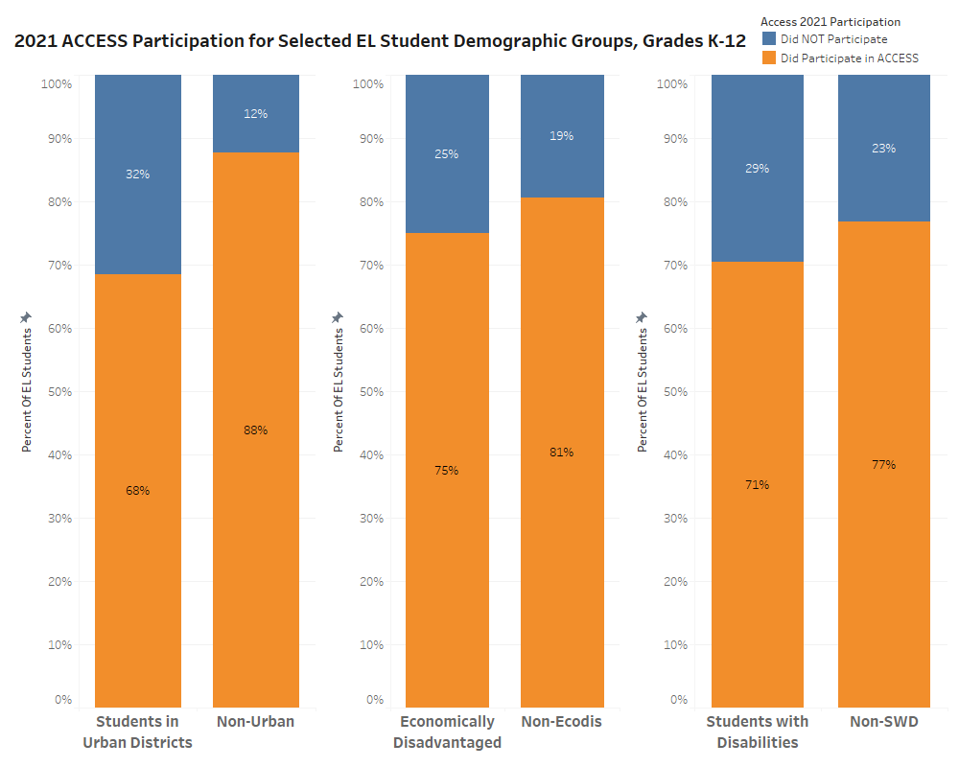

## Student Achievement

Table 4 summarizes overall ACCESS proficiency level results including the number of students tested, and percent of students scoring at each ACCESS proficiency level, disaggregated by grade cluster and years of enrollment in Massachusetts. Results for students who took the Alternate ACCESS are summarized in Table 6.

**Table 4. Proficiency Level**

**by Grade Cluster and Years of Enrollment in MA (2021)**

|  |  |  |  |  |  |  |  |  |
| --- | --- | --- | --- | --- | --- | --- | --- | --- |
| **Grade Cluster** | **Years in MA** | **# Tested** | **% Level 1** | **% Level 2** | **% Level 3** | **% Level 4** | **% Level 5** | **% Level 6** |
| **K** | First Year | 8,140 | 59 | 15 | 14 | 10 | 2 | 0 |
| Second Year | 165 | 58 | 20 | 15 | 5 | 2 | 0 |
| **Total** | **8,305** | 59 | 15 | 14 | 10 | 2 | 0 |
| **1-2** | First Year | 1,148 | 36 | 26 | 24 | 11 | 3 | 1 |
| Second Year | 9,283 | 15 | 35 | 36 | 11 | 3 | 0 |
| Third Year | 7,135 | 6 | 22 | 48 | 21 | 2 | 0 |
| Fourth Year | 495 | 5 | 32 | 51 | 11 | 1 | 0 |
| Fifth Year | 1 | -- | -- | -- | -- | -- | -- |
| **Total** | **18,062** | 12 | 29 | 41 | 15 | 3 | 0 |
| **3-5** | First Year | 1,159 | 38 | 17 | 24 | 16 | 4 | 2 |
| Second Year | 2,735 | 25 | 21 | 29 | 19 | 5 | 1 |
| Third Year | 1,877 | 8 | 18 | 40 | 28 | 5 | 1 |
| Fourth Year | 6,164 | 4 | 17 | 48 | 28 | 3 | 0 |
| Fifth Year | 4,433 | 3 | 9 | 41 | 38 | 7 | 1 |
| Sixth+ Year | 2,672 | 3 | 12 | 47 | 32 | 5 | 1 |
| **Total** | **19,040** | 9 | 15 | 41 | 29 | 5 | 1 |
| **6-8** | First Year | 1,043 | 42 | 22 | 22 | 10 | 3 | 1 |
| Second Year | 2,365 | 33 | 27 | 27 | 10 | 2 | 0 |
| Third Year | 1,473 | 14 | 29 | 39 | 15 | 3 | 0 |
| Fourth Year | 1,224 | 7 | 28 | 46 | 17 | 2 | 0 |
| Fifth Year | 976 | 5 | 23 | 53 | 17 | 2 | 0 |
| Sixth+ Year | 4,782 | 4 | 25 | 55 | 15 | 1 | 0 |
| **Total** | **11,863** | 15 | 26 | 44 | 14 | 2 | 0 |
| **9-12** | First Year | 1,163 | 35 | 28 | 24 | 10 | 3 | 0 |
| Second Year | 2,976 | 28 | 31 | 29 | 10 | 2 | 0 |
| Third Year | 1,855 | 17 | 31 | 39 | 12 | 2 | 0 |
| Fourth Year | 1,424 | 10 | 30 | 47 | 12 | 1 | 0 |
| Fifth Year | 1,017 | 7 | 25 | 52 | 15 | 1 | 0 |
| Sixth+ Year | 3,141 | 3 | 21 | 58 | 17 | 1 | 0 |
| **Total** | 11,576 | 16 | 27 | 42 | 13 | 2 | 0 |
| **Grand Total** | | **68,846** | **18** | **23** | **38** | **18** | **3** | **0** |

Figures 1 and 2 show the percent of students in each ACCESS proficiency level in 2020 and 2021, by grade. The percent of students at Level 4 decreased in 2021 in every grade except kindergarten, 1, 9, and 11.

**Figure 2: Percent of Students in each ACCESS Proficiency Level, Grades K-6**

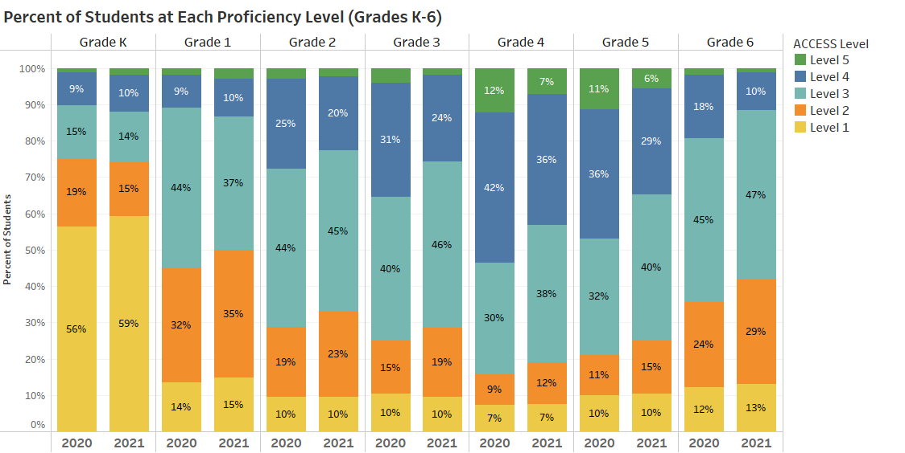

**Figure 3: Percent of Students in each ACCESS Proficiency Level, Grades 7-12**

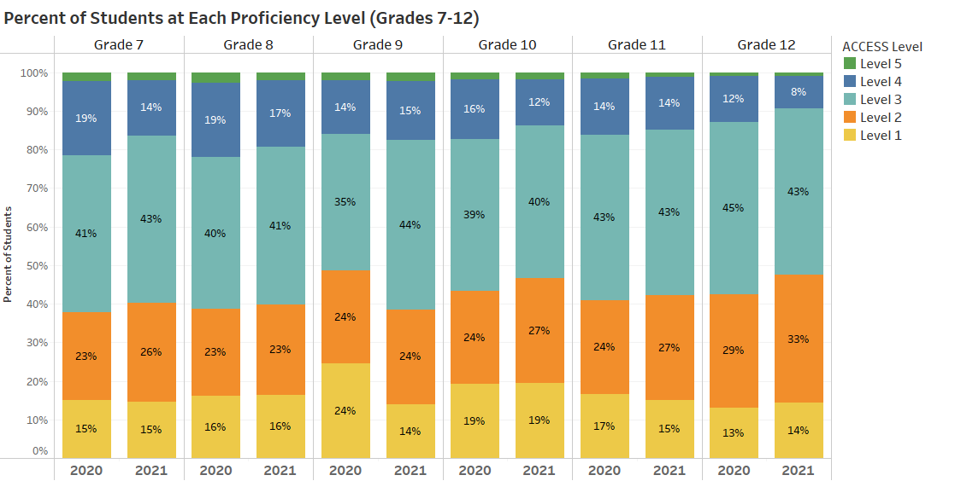

Table 5 shows the comparative percentage of ELs who attained English proficiency as indicated by an overall composite ACCESS score of Level 4.2 or higher. The percent of students attaining scores indicating their attainment of English proficiency (i.e., between *Level 4.2* and *Level 6 Overall*) in 2021 (15.3 percent) was 3.4 percentage points lower than the percentage in 2020 (18.7 percent), even accounting for lower participation rates in 2021. Declines in average proficiency scores were likely due to pandemic-related educational and social-emotional disruptions as well as reduced and uneven participation on the ACCESS test.

**Table 5.** **Students Who Attained Above or Below Level 4.2 by Grade (2020 and 2021)**

|  |  |  |  |  |
| --- | --- | --- | --- | --- |
| **Grade** | **2020** | | **2021** | |
| **Below 4.2** | **4.2 or Above** | **Below 4.2** | **4.2 or Above** |
| **K** | 92.7% | 7.3% | 91.1% | 8.9% |
| **1** | 91.7% | 8.3% | 89.3% | 10.7% |
| **2** | 79.2% | 20.8% | 83.7% | 16.3% |
| **3** | 74.4% | 25.6% | 82.7% | 17.3% |
| **4** | 54.7% | 45.3% | 66.1% | 33.9% |
| **5** | 60.3% | 39.7% | 72.7% | 27.3% |
| **6** | 86.9% | 13.1% | 92.2% | 7.8% |
| **7** | 85.0% | 15.0% | 87.6% | 12.4% |
| **8** | 83.6% | 16.3% | 86.6% | 13.4% |
| **9** | 88.1% | 11.9% | 87.3% | 12.7% |
| **10** | 87.6% | 12.4% | 90.1% | 9.9% |
| **11** | 89.7% | 10.3% | 90.4% | 9.6% |
| **12** | 91.7% | 8.3% | 94.2% | 5.8% |
| **Total** | **81.3%** | **18.7%** | **84.7%** | **15.3%** |

## 

## Composite Proficiency Levels

In addition to receiving a composite overall ACCESS proficiency level score, students receive three additional composite scores: oral language, comprehension, and literacy. Composite scores are derived from a combination of weighted scaled scores in the four language domains as follows:

* Overall―combining the four domain scores, as follows: listening (15 percent), speaking (15 percent), reading (35 percent), and writing (35 percent)
* Oral Language―combining equally weighted scaled scores for listening and speaking (50 percent each)
* Comprehension―combining scaled scores for listening (30 percent) and reading (70 percent)
* Literacy―combining equally weighted scaled scores for reading (50 percent) and writing (50 percent)

Average proficiency levels for the Oral Language, Comprehension, and Literacy composite scales are presented in Table 6, by grade cluster and years in Massachusetts. Comparisons between 2020 and 2021 are shown in Tables 7 and 8.

**Table 6. Average Composite Proficiency Level**

**by Grade Cluster and Years of Enrollment in MA (2021)**

|  |  |  |  |  |  |
| --- | --- | --- | --- | --- | --- |
| **Grade Cluster** | **Years in MA** | **# Included** | **Average Oral Level** | **Average Comprehension Level** | **Average Literacy Level** |
| **K** | First Year | 8,140 | 3.8 | 2.4 | 1.8 |
| Second Year | 165 | 4.1 | 2.3 | 1.7 |
| **Total** | 8,305 | 3.9 | 2.4 | 1.8 |
| **1-2** | First Year | 1,153 | 3.1 | 3.5 | 2.6 |
| Second Year | 9,403 | 3.7 | 4.0 | 2.7 |
| Third Year | 7,266 | 3.7 | 4.2 | 3.3 |
| Fourth Year | 502 | 3.4 | 3.8 | 3.0 |
| Fifth Year | 1 | -- | -- | -- |
| **Total** | 18,325 | 3.7 | 4.0 | 2.9 |
| **3-5** | First Year | 1,164 | 3.0 | 3.3 | 2.8 |
| Second Year | 2,764 | 3.4 | 3.5 | 3.0 |
| Third Year | 1,896 | 3.9 | 4.1 | 3.4 |
| Fourth Year | 6,266 | 3.8 | 4.1 | 3.5 |
| Fifth Year | 4,529 | 4.4 | 4.6 | 3.7 |
| Sixth+ Year | 2,755 | 4.2 | 4.4 | 3.6 |
| **Total** | 19,374 | 3.9 | 4.1 | 3.4 |
| **6-8** | First Year | 1,046 | 3.0 | 3.0 | 2.5 |
| Second Year | 2,377 | 3.1 | 3.1 | 2.6 |
| Third Year | 1,487 | 3.6 | 3.5 | 2.9 |
| Fourth Year | 1,240 | 3.8 | 3.7 | 3.0 |
| Fifth Year | 990 | 3.9 | 3.8 | 3.1 |
| Sixth+ Year | 4,942 | 3.8 | 3.6 | 3.1 |
| **Total** | 12,082 | 3.6 | 3.5 | 2.9 |
| **9-12** | First Year | 1,168 | 2.6 | 3.2 | 2.8 |
| Second Year | 2,986 | 2.7 | 3.2 | 2.9 |
| Third Year | 1,869 | 2.9 | 3.5 | 3.0 |
| Fourth Year | 1,437 | 3.1 | 3.6 | 3.2 |
| Fifth Year | 1,028 | 3.2 | 3.8 | 3.3 |
| Sixth+ Year | 3,273 | 3.4 | 4.0 | 3.4 |
| **Total** | 11,761 | 3.0 | 3.6 | 3.1 |
| **Grand Total** | | 69,847 | 3.6 | 3.7 | 3.0 |

**Comparison of ACCESS Scale Scores from 2020 to 2021**

Since many fewer EL students were tested in 2021 compared to 2020, it is important to note that interpretations of 2021 test scores should be made cautiously and only for those students who participated in testing. Inferences should not be generalized to the entire EL student population in Massachusetts, nor within a district, unless a comparable high percentage of students was tested in both 2020 and 2021. Nevertheless, it may be valuable to examine state results broadly by grade and domain to identify areas in which to provide increased support and intervention to specific students to compensate for the apparent overall declines in 2021 ACCESS test scores.

When comparing state results across years, it is also important to consider the characteristics of students who were *not* tested in 2021 due to factors resulting from the impact of the pandemic, including an increase in the use of remote instruction, but a lack of any remote ACCESS testing opportunities. Differential test participation across districts will affect cross-district comparisons, both within 2021 and between 2021 and earlier years. In addition, the future test scores of students untested in 2021 will likely be included in next year’s results which may further complicate comparisons between 2021 and future years. Tables 7 and 8 show the scale score differences ONLY for the tested populations in 2020 and 2021.

**Table 7. 2021 ACCESS Overall Scale Score Differences of Tested Students in Massachusetts**

**by Grade, Compared to 2020**

|  |  |
| --- | --- |
| **Grade** | **Average Overall Scale Score Difference 2020 to 2021** |
| 1 | -1 |
| 2 | -4 |
| 3 | -5 |
| 4 | -7 |
| 5 | -8 |
| 6 | -6 |
| 7 | -3 |
| 8 | -2 |
| 9 | +8 |
| 10 | -3 |
| 11 | -1 |
| 12 | -4 |

**Comparison of Individual Test Domain Scores in 2020 and 2021**

Table 8 indicates the average changes in each test domain from 2020 to 2021 among tested students. For all domains and grades/grade clusters:

* The greatest declinesoccurred in Speaking in grades 4−6 and in Writing in grades K−6.
* Increases occurred in grade 9 in all domains, in Reading in grades 1−2 and 10−12, and in Listening in grades 7 and 11.

**Table 8. Changes in ACCESS Test Domain Scores from 2020 to 2021**

**Among Tested Students**

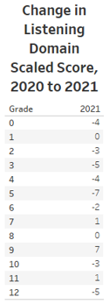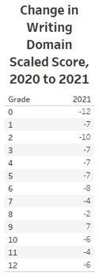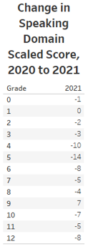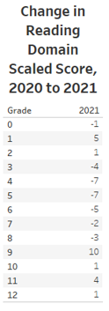

## Results of the 2021 Alternate ACCESS for ELLs

The Alternate ACCESS for ELLs assessment was first administered in 2014 to EL students with the most significant cognitive disabilities. The Alternate ACCESS results are reported at six proficiency levels: A1-Initiating, A2-Exploring, A3-Engaging, P1-Entering, P2-Emerging, and P3-Developing (for Writing only), and on a numerical scale from 900 to 960. See Appendix B for the performance definitions of the Alternate ACCESS proficiency levels.

Overall, 999 students participated in the 2021 Alternate ACCESS, compared with 1,585 students in 2020. The percentage of students in each Alternate ACCESS proficiency level is shown by grade in Table 9.

**Table 9. Percent of Students taking Alternate ACCESS in each Proficiency Level and Grade (2021)**

|  |  |  |  |  |  |  |
| --- | --- | --- | --- | --- | --- | --- |
| **Grade** | **# Tested** | **A1** | **A2** | **A3** | **P1** | **P2** |
| **1** | 115 | 21% | 10% | 30% | 23% | 15% |
| **2** | 147 | 14% | 10% | 21% | 33% | 22% |
| **3** | 119 | 11% | 8% | 25% | 39% | 17% |
| **4** | 112 | 11% | 6% | 14% | 29% | 39% |
| **5** | 102 | 7% | 13% | 19% | 28% | 33% |
| **6** | 76 | 8% | 5% | 22% | 30% | 34% |
| **7** | 79 | 11% | 8% | 18% | 18% | 46% |
| **8** | 64 | 2% | 5% | 27% | 23% | 44% |
| **9** | 35 | 14% | 23% | 6% | 31% | 26% |
| **10** | 60 | 3% | 8% | 23% | 30% | 35% |
| **11** | 36 | 8% | 8% | 25% | 22% | 36% |
| **12** | 54 | 11% | 11% | 19% | 19% | 41% |
| **Grand Total** | **999** | **11%** | **9%** | **21%** | **28%** | **30%** |

**III. Reporting Elements**

Requirements for reporting the proficiency and progress of ELs are outlined in Title III of the federal *Every Student Succeeds Act* (ESSA) and in the *Language Opportunities for Our Kids* *Act* (LOOK), a 2017 state law. The five reporting elements required by ESSA are summarized below.

* Reporting Element #1: The number and percent of ELs making progress toward achieving English language proficiency, disaggregated for ELs with disabilities (EL SWD). A student who is making progress is on track to achieve English proficiency (i.e., for Reporting Element #1, overall Level 4.2 on ACCESS is considered English proficient) within one baseline year plus 5 years, or a total of six years.
* Reporting Element #2: The number and percent of ELs attaining English proficiency (i.e., for Reporting Element #2, overall Level 4.2 and composite literacy Level 3.9 on ACCESS is considered English proficient)
* Reporting Element #3: The number and percent of ELs exiting EL status based on their attainment of English proficiency
* Reporting Element #4: The number and percent of former ELs (FELs) meeting challenging state academic standards on the next-generation MCAS tests for English language arts (ELA), mathematics, and science and technology/engineering (STE) for each of the four years after such students are no longer receiving EL services, disaggregated for FELs with disabilities (FELSWD)
* Reporting Element #5: The number and percent of ELs who have not attained English language proficiency within six years of initial classification as an EL (i.e., five years after the first baseline year), disaggregated for ELs with disabilities

This report includes the results based on the five reporting elements described above. Results for the five reporting elements are based on the overall state results on the ACCESS tests combined with results for students taking the Alternate ACCESS, as well as the results of FEL students on the MCAS tests. Reporting on the five elements is intended to provide districts with important instructional feedback to promote and accelerate the achievement of EL and FEL students, and to provide a basis for additional oversight of EL programming by districts and the Department.

**Reporting Element #1: EL Students Making Progress toward English Language Proficiency (disaggregated for students with and without disabilities)**

In 2018, a method was established to indicate progress in learning English that provided the following information for each EL student:

1. **Future Progress Target** representing the minimum ACCESS proficiency level score needed on the following year’s ACCESS test to remain on track to reach English proficiency (i.e., attain overall Level 4.2) within a total of six years in a Massachusetts school. Future progress targets are reported as an ACCESS proficiency level, ranging from Levels 1.0 to 4.2. Individual student targets are provided in the summer of each year. Further clarification of Future Progress Targets is provided in Appendix C.
2. **Difficulty Index** showing an estimate of how difficult it will be to reach next year’s target, relative to the student’s current proficiency level. The difficulty index ranges from 1–99, with one being the lowest difficulty (i.e., least difficult to achieve the target) and 99 the highest (i.e., most difficult to achieve the target). Students with difficulty indices greater than 60 are considered to have a high difficulty index. Educators are directed to use the difficulty index as an indicator of which students may need additional instructional assistance in order to succeed. Further clarification of Difficulty Indices is provided in Appendix C.
3. **Student Growth Percentile for ACCESS** **(SGPA)** indicates the amount of progress made by a student on the ACCESS test from one year to the next, relative to other EL students in the same grade who earned similar ACCESS scores the prior year. The SGPAs in 2021 are calculated using the same baseline and scale as those produced from 2017 to 2020. Further clarification of How SGPAs are Calculated, and modifications to the SGPA calculations process in 2021 as a result of pandemic-related disruptions, are provided in Appendix D.

SGPA indicates whether a student has made low, moderate, or high gains in their ACCESS test scores from one year to the next compared with other ELs in the same grade who took the ACCESS test in two consecutive years. Like the difficulty index, the SGPA is a number from 1-99, with 40-59 representing *average* growth. Higher SGPA numbers (i.e., above 60) indicate more growth and lower SGPA numbers (i.e., below 40) show less growth. In 2021, the average SGPAs by grade are below 50, indicating overall lower growth rates than in prior years among students who took the test.

1. **Progress Indicator**, either “Yes” or “No,” showing whether the student has met last year’s future progress target in the current year. Students who meet or exceed their future target for that year will be designated as having “made progress.” Students who do not meet their targets will not make progress for that year. Students taking the Alternate ACCESS will make progress if they increase the Alternate ACCESS achievement level in any domain by one level and do not lower their score in any other domain.

Students who were eligible to take the ACCESS test but did not participate because they were absent received a progress indicator of “0”. Given the substantially lower ACCESS participation rate in 2021, Table 10 indicates progress indicator data for *all* enrolled students in both 2020 and 2021, as well as for only those EL students who *tested* in 2021.

**Table 10. Students Making Progress by Grade**

**(All Students in 2020 and 2021, and Tested Students in 2021)**

|  |  |  |  |  |  |  |  |  |  |
| --- | --- | --- | --- | --- | --- | --- | --- | --- | --- |
|  | **2020 (All)** | | | **2021 (All)** | | | **2021 (Tested)** | | |
| **Grade** | **% Making Progress** | **# Making Progress** | **# Incl. in Progress** | **% Making Progress** | **# Making Progress** | **# Incl. in Progress** | **% Making Progress** | **# Making Progress** | **# Incl. in Progress** |
| **1** | 54.5% | 5,468 | 10,032 | 44.1% | 4,525 | 10,265 | 54.0% | 4,525 | 8,387 |
| **2** | 70.2% | 7,112 | 10,131 | 47.3% | 4,940 | 10,441 | 58.5% | 4,940 | 8,444 |
| **3** | 69.6% | 6,327 | 9,095 | 38.7% | 3,517 | 9,081 | 48.1% | 3,517 | 7,317 |
| **4** | 65.8% | 5,166 | 7,854 | 37.5% | 2,959 | 7,894 | 47.1% | 2,958 | 6,282 |
| **5** | 52.9% | 2,999 | 5,674 | 27.6% | 1,511 | 5,472 | 34.0% | 1,511 | 4,443 |
| **6** | 29.8% | 1,358 | 4,556 | 16.2% | 697 | 4,308 | 20.7% | 697 | 3,373 |
| **7** | 34.2% | 1,568 | 4,587 | 20.4% | 975 | 4,787 | 26.1% | 974 | 3,725 |
| **8** | 37.7% | 1,675 | 4,438 | 19.8% | 941 | 4,761 | 25.7% | 941 | 3,660 |
| **9** | 29.8% | 1,473 | 4,939 | 15.9% | 764 | 4,800 | 25.0% | 762 | 3,054 |
| **10** | 26.1% | 1,129 | 4,329 | 10.6% | 557 | 5,248 | 17.5% | 557 | 3,182 |
| **11** | 19.9% | 726 | 3,642 | 9.9% | 398 | 4,013 | 17.3% | 398 | 2,297 |
| **12** | 15.4% | 521 | 3,394 | 6.3% | 233 | 3,700 | 12.8% | 232 | 1,814 |
| **Total** | **48.9%** | **35,522** | **72,671** | **29.4%** | **22,017** | **74,770** | **39.3%** | **22,012** | **55,978** |

**Figure 4: Students Making Progress by Grade Span**

**(All Students in 2020 and 2021, and Tested Students in 2021)** 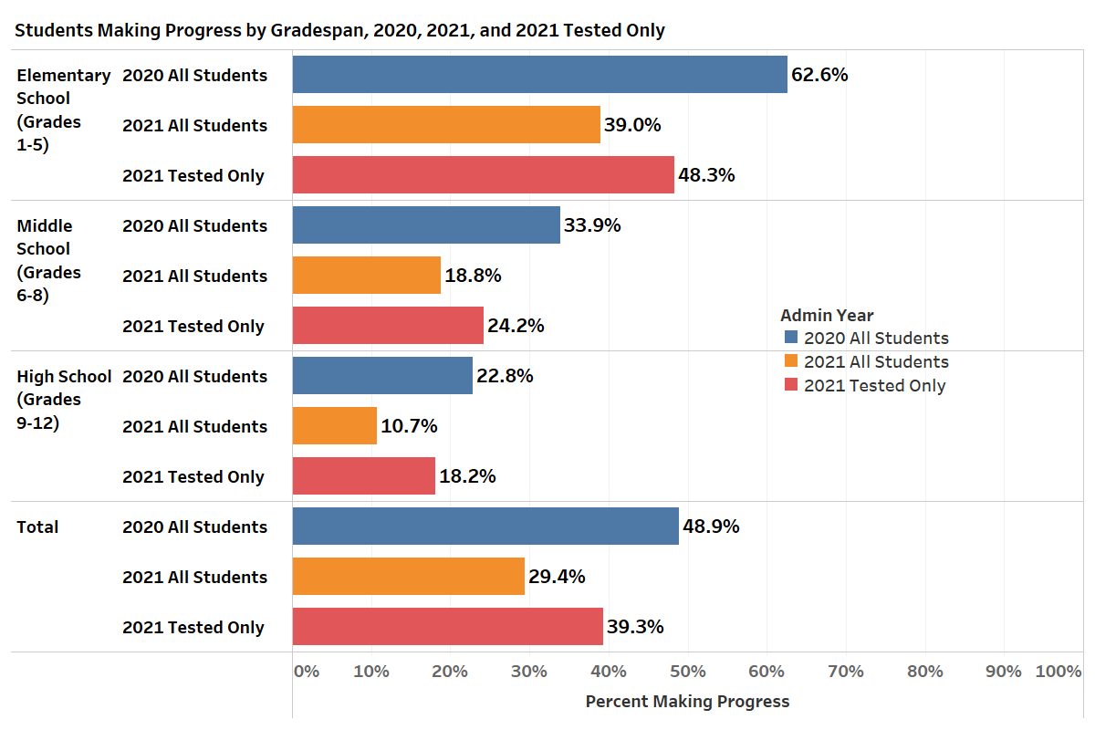

Across Massachusetts, 29.4 percent of all EL students made progress in 2021 (untested students are counted as “not making progress”), a decline of about 20 percentage points from 2020 when approximately 49% of all students made progress. Table 11 indicates that among the students who were tested in 2021, 39.3% made progress. The highest rates of progress in 2021 were in grades 1−4 in which approximately 37−47 percent of all students made progress, and between 47−58 percent of tested students made progress, compared with approximately 62−64 percent who made progress in 2020. Progress rates declined sharply for students in middle and high school in 2021

**Table 11. Students Making Progress**

**by Grade Cluster and Years of Enrollment in MA (2020 and 2021)**

|  |  |  |  |  |  |  |  |
| --- | --- | --- | --- | --- | --- | --- | --- |
| **Grade Cluster** | **Years in MA** | **2020 (All)** | | **2021 (All)** | | **2021 (Tested)** | |
| **# included in Progress** | **% Making Progress** | **# included in Progress** | **% Making Progress** | **# included in Progress** | **% Making Progress** |
| **1-2** | First Year | 326 | 76.7% | 210 | 75.7% | 204 | 77.9% |
| Second Year | 10,350 | 55.9% | 10,939 | 44.4% | 8,980 | 54.1% |
| Third Year | 8,831 | 69.9% | 8,939 | 47.4% | 7,154 | 59.3% |
| Fourth Year | 656 | 56.6% | 618 | 33.5% | 493 | 42.0% |
| **Total** | **20,163** | **62.4%** | **20,706** | **45.7%** | **16,831** | **56.2%** |
| **3-5** | First Year | 533 | 93.4% | 224 | 88.4% | 223 | 88.3% |
| Second Year | 2,335 | 64.8% | 2,913 | 39.3% | 2,562 | 44.7% |
| Third Year | 2,458 | 65.3% | 2,220 | 39.0% | 1,833 | 47.2% |
| Fourth Year | 7,763 | 69.4% | 7,797 | 37.8% | 6,191 | 47.6% |
| Fifth Year | 5,816 | 64.5% | 5,791 | 35.1% | 4,497 | 45.2% |
| Sixth+ Year | 3,716 | 46.6% | 3,502 | 22.8% | 2,736 | 29.2% |
| **Total** | **22,621** | **64.1%** | **22,447** | **35.6%** | **18,042** | **44.3%** |
| **6-8** | First Year | 376 | 93.6% | 140 | 85.7% | 139 | 86.3% |
| Second Year | 1,951 | 60.6% | 2,467 | 32.4% | 2,163 | 37.0% |
| Third Year | 1,941 | 49.2% | 1,729 | 30.7% | 1,459 | 36.4% |
| Fourth Year | 1,587 | 41.7% | 1,526 | 24.7% | 1,217 | 31.0% |
| Fifth Year | 1,013 | 32.6% | 1,227 | 19.7% | 974 | 24.8% |
| Sixth+ Year | 6,712 | 16.7% | 6,767 | 8.0% | 4,806 | 11.3% |
| **Total** | **13,580** | **33.9%** | **13,856** | **18.9%** | **10,758** | **24.3%** |
| **9-12** | First Year | 497 | 82.1% | 169 | 75.7% | 164 | 78.0% |
| Second Year | 3,044 | 32.1% | 3,957 | 14.1% | 2,746 | 20.3% |
| Third Year | 2,783 | 29.0% | 2,755 | 14.0% | 1,843 | 20.9% |
| Fourth Year | 2,549 | 22.3% | 2,340 | 11.8% | 1,401 | 19.7% |
| Fifth Year | 1,437 | 19.7% | 1,811 | 11.2% | 1,011 | 20.0% |
| Sixth+ Year | 5,991 | 13.4% | 6,729 | 6.0% | 3,182 | 12.6% |
| **Total** | **16,301** | **23.6%** | **17,761** | **11.0%** | **10,347** | **18.8%** |
| **Grand Total** | | **72,665** | **48.9%** | **74,770** | **29.4%** | **55,978** | **39.3%** |

Title III of ESSA also requires reporting of progress results by disability status. Table 12 (for all students) and Table 13 (only for tested students) disaggregate the 2021 results by disability status. Overall, 33.6 percent of *all* EL students without a disability made progress in 2021 while 16.9 percent of ELs with a disability made progress. Of *tested* students, 44.2 percent of students without a disability and 23.6 percent of students with a disability made progress (see Table 11). In 2020, 55.6 percent of EL students without a disability made progress and 28.8 percent of ELs with a disability made progress.

In middle and high school, the rate of *all* EL students with a disability making progress was 7.1 percent and 5 percent respectively, compared with approximately 25 percent and 13 percent respectively for all EL students without a disability. Among the *tested* middle school students without a disability, 30.9 percent made progress and 9.8 percent with a disability made progress. Among the tested high school EL students without a disability, 20.8 percent made progress and 10.2 percent of high school EL students with a disability made progress.

**Table 12. Students Making Progress in 2021**

**by Grade Cluster, Years of Enrollment in MA, and Disability Status (All Students)**

|  |  |  |  |  |  |  |  |
| --- | --- | --- | --- | --- | --- | --- | --- |
| **Grade Cluster** | **Years in MA** | **non-SWD** | | **SWD** | | **Total** | |
| **# included in Progress** | **% Making Progress** | **# included in Progress** | **% Making Progress** | **# included in Progress** | **% Making Progress** |
| **1-2** | First Year | 201 | 78.6% | 9 | - | 210 | 75.7% |
| Second Year | 9,350 | 47.0% | 1,589 | 29.0% | 10,939 | 44.4% |
| Third Year | 7,123 | 50.3% | 1,816 | 36.0% | 8,939 | 47.4% |
| Fourth Year | 345 | 36.2% | 273 | 30.0% | 618 | 33.5% |
| Fifth Year | - | - | - | - | - | - |
| **Total** | 17,019 | 48.6% | 3,687 | 32.5% | 20,706 | 45.7% |
| **3-5** | First Year | 217 | 88.5% | 7 | - | 224 | 88.4% |
| Second Year | 2,725 | 40.5% | 188 | 22.3% | 2,913 | 39.3% |
| Third Year | 1,920 | 41.6% | 300 | 22.0% | 2,220 | 39.0% |
| Fourth Year | 5,776 | 41.8% | 2,021 | 26.4% | 7,797 | 37.8% |
| Fifth Year | 3,739 | 40.7% | 2,052 | 25.0% | 5,791 | 35.1% |
| Sixth+ Year | 1,710 | 31.8% | 1,792 | 14.3% | 3,502 | 22.8% |
| **Total** | 16,087 | 40.8% | 6,360 | 22.3% | 22,447 | 35.6% |
| **6-8** | First Year | 135 | 86.7% | 5 | - | 140 | 85.7% |
| Second Year | 2,349 | 33.2% | 118 | 17.8% | 2,467 | 32.4% |
| Third Year | 1,569 | 31.8% | 160 | 20.0% | 1,729 | 30.7% |
| Fourth Year | 1,185 | 28.2% | 341 | 12.6% | 1,526 | 24.7% |
| Fifth Year | 911 | 22.0% | 316 | 13.3% | 1,227 | 19.7% |
| Sixth+ Year | 3,006 | 11.7% | 3,761 | 5.1% | 6,767 | 8.0% |
| **Total** | 9,155 | 24.9% | 4,701 | 7.1% | 13,856 | 18.9% |
| **9-12** | First Year | 168 | 76.2% | 1 | - | 169 | 75.7% |
| Second Year | 3,865 | 14.1% | 92 | 14.1% | 3,957 | 14.1% |
| Third Year | 2,607 | 14.0% | 148 | 14.2% | 2,755 | 14.0% |
| Fourth Year | 2,058 | 12.2% | 282 | 8.5% | 2,340 | 11.8% |
| Fifth Year | 1,563 | 12.0% | 248 | 5.6% | 1,811 | 11.2% |
| Sixth+ Year | 3,607 | 7.8% | 3,122 | 3.9% | 6,729 | 6.0% |
| **Total** | 13,868 | 12.7% | 3,893 | 5.0% | 17,761 | 11.0% |
| **Grand Total** | | **56,129** | **33.6%** | **18,641** | **16.9%** | **74,770** | **29.4%** |

**Table 13. Students Making Progress in 2021**

**by Grade Cluster, Years of Enrollment in MA, and Disability Status (Tested Students Only)**

|  |  |  |  |  |  |  |  |
| --- | --- | --- | --- | --- | --- | --- | --- |
| **Grade Cluster** | **Years in MA** | **non-SWD** | | **SWD** | | **Total** | |
| **# included in Progress** | **% Making Progress** | **# included in Progress** | **% Making Progress** | **# included in Progress** | **% Making Progress** |
| **1-2** | First Year | 196 | 80.6% | 8 | - | 204 | 77.9% |
| Second Year | 7,691 | 57.2% | 1,289 | 35.8% | 8,980 | 54.1% |
| Third Year | 5,704 | 62.9% | 1,450 | 45.0% | 7,154 | 59.3% |
| Fourth Year | 263 | 47.5% | 230 | 35.7% | 493 | 42.0% |
| Fifth Year | -- | -- | -- | -- | -- | -- |
| **Total** | **13,854** | **59.7%** | **2,977** | **40.2%** | **16,831** | **56.2%** |
| **3-5** | First Year | 217 | 88.5% | 6 | -- | 223 | 88.3% |
| Second Year | 2,395 | 46.1% | 167 | 25.1% | 2,562 | 44.7% |
| Third Year | 1,594 | 50.1% | 239 | 27.6% | 1,833 | 47.2% |
| Fourth Year | 4,565 | 52.8% | 1,626 | 32.8% | 6,191 | 47.6% |
| Fifth Year | 2,860 | 53.1% | 1,637 | 31.4% | 4,497 | 45.2% |
| Sixth+ Year | 1,345 | 40.4% | 1,391 | 18.4% | 2,736 | 29.2% |
| **Total** | **12,976** | **50.6%** | **5,066** | **28.0%** | **18,042** | **44.3%** |
| **6-8** | First Year | 134 | 87.3% | 5 | -- | 139 | 86.3% |
| Second Year | 2,060 | 37.8% | 103 | 20.4% | 2,163 | 37.0% |
| Third Year | 1,337 | 37.3% | 122 | 26.2% | 1,459 | 36.4% |
| Fourth Year | 959 | 34.8% | 258 | 16.7% | 1,217 | 31.0% |
| Fifth Year | 726 | 27.5% | 248 | 16.9% | 974 | 24.8% |
| Sixth+ Year | 2,155 | 16.3% | 2,651 | 7.2% | 4,806 | 11.3% |
| **Total** | **7,371** | **30.9%** | **3,387** | **9.8%** | **10,758** | **24.3%** |
| **9-12** | First Year | 163 | 78.5% | 1 | -- | 164 | 78.0% |
| Second Year | 2,682 | 20.3% | 64 | 20.3% | 2,746 | 20.3% |
| Third Year | 1,739 | 20.9% | 104 | 20.2% | 1,843 | 20.9% |
| Fourth Year | 1,235 | 20.4% | 166 | 14.5% | 1,401 | 19.7% |
| Fifth Year | 879 | 21.4% | 132 | 10.6% | 1,011 | 20.0% |
| Sixth+ Year | 1,760 | 16.0% | 1,422 | 8.4% | 3,182 | 12.6% |
| **Total** | **8,458** | **20.8%** | **1,889** | **10.2%** | **10,347** | **18.8%** |
| **Grand Total** | | **42,659** | **44.2%** | **13,319** | **23.6%** | **55,978** | **39.3%** |

**Reporting Element #2: EL Students Attaining English Language Proficiency**

Students who attained an overall score of at least Level4.2 and a literacy composite score of at least Level 3.9 were designated as having attained English language proficiency. Students who did not test were given a score of “0” and were considered not proficient. The overall rates of proficiency shown in Table 14 indicate a decrease in attainment of approximately six percentage points in 2021 compared to 2020 among all students (16.5 percent in 2020 compared with 10.4 percent in 2021) and a decrease of approximately three percentage points from 2020 to 2021 among students who tested in 2021 (16.5 percent proficient among tested students in 2020 and 13.6 percent proficient among tested students in 2021).

**Table 14. Students Attaining English Proficiency by Grade (2020 and 2021)**

|  |  |  |  |  |  |  |  |  |  |
| --- | --- | --- | --- | --- | --- | --- | --- | --- | --- |
| **Grade** | **2020 (All)** | | | **2021 (All)** | | | **2021 (Tested)** | | |
| **% Proficient** | **# Proficient** | **# Included** | **% Proficient** | **# Proficient** | **# Included** | **% Proficient** | **# Proficient** | **# Included** |
| **K** | 3.5% | 394 | 11,386 | 4.2% | 422 | 10,157 | 5.1% | 422 | 8,305 |
| **1** | 6.8% | 812 | 11,994 | 7.4% | 830 | 11,261 | 9.0% | 830 | 9,270 |
| **2** | 19.2% | 2,247 | 11,676 | 12.1% | 1,345 | 11,116 | 14.9% | 1,345 | 9,055 |
| **3** | 24.1% | 2,540 | 10,527 | 13.0% | 1,257 | 9,657 | 16.0% | 1,257 | 7,841 |
| **4** | 40.8% | 3,704 | 9,085 | 24.5% | 2,064 | 8,409 | 30.7% | 2,064 | 6,727 |
| **5** | 35.7% | 2,407 | 6,733 | 20.2% | 1,190 | 5,891 | 24.8% | 1,190 | 4,806 |
| **6** | 11.3% | 651 | 5,748 | 5.3% | 257 | 4,862 | 6.7% | 257 | 3,862 |
| **7** | 13.2% | 764 | 5,775 | 8.8% | 468 | 5,292 | 11.2% | 468 | 4,169 |
| **8** | 14.8% | 820 | 5,538 | 9.6% | 498 | 5,205 | 12.3% | 498 | 4,051 |
| **9** | 11.1% | 848 | 7,633 | 8.2% | 455 | 5,578 | 12.4% | 455 | 3,663 |
| **10** | 11.6% | 654 | 5,643 | 6.0% | 342 | 5,731 | 9.6% | 342 | 3,563 |
| **11** | 9.4% | 427 | 4,542 | 5.6% | 246 | 4,399 | 9.5% | 246 | 2,587 |
| **12** | 7.2% | 269 | 3,725 | 2.7% | 106 | 3,976 | 5.4% | 106 | 1,948 |
| **Total** | **16.5%** | **16,537** | **100,005** | **10.4%** | **9,480** | **91,534** | **13.6%** | **9,480** | **69,847** |

As shown in Figure 5 below, proficiency rates in 2021 are higher for elementary school students and lower for middle and high school students. In addition, in 2021, proficiency rates for *all* students included students who did not test and were considered “not proficient.” Therefore, the proficiency rates of tested students in 2021 is higher than for all students.

**Figure 5: EL Students Attaining Proficiency by Grade Span for All Students in 2020 and 2021, and Tested Students in 2021**

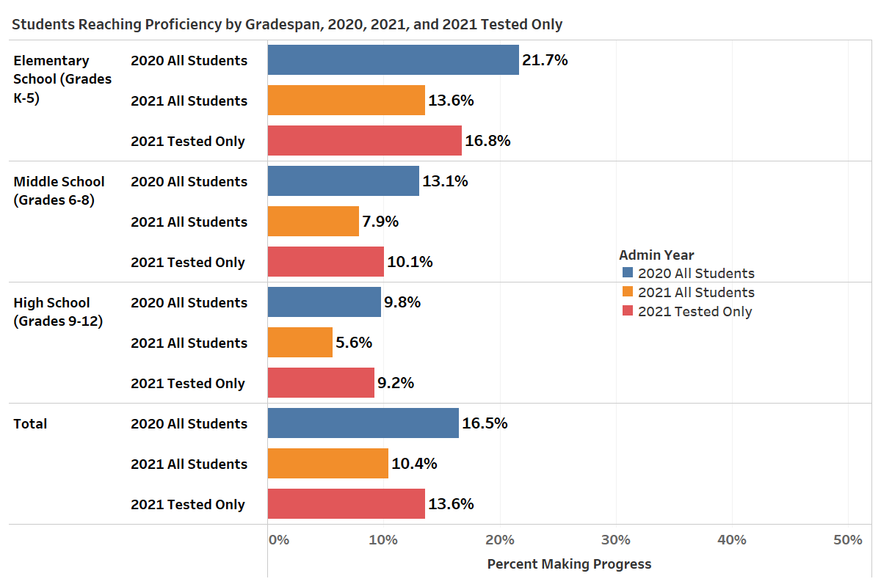

Table 15 indicates that the percent of students attaining proficiency is highest in grades 35 (18.8 percent for all students in 2021 and 23.3 percent for tested students), but much lower in other grade clusters. Students in grades 68 attained proficiency rates of 8percent for all students and 10.1 percent for tested students. Students in grades 912 attained a proficiency rate of 5.8 percent for all students and 9.8 percent for tested students.

**Table 15. Students Attaining English Proficiency by Grade Cluster and Years of Enrollment in MA**

**(All Students in 2020 and 2021, and Tested Students in 2021)**

|  |  |  |  |  |  |  |  |  |  |  |
| --- | --- | --- | --- | --- | --- | --- | --- | --- | --- | --- |
| **Grade** | **Years in MA** | **2020 (All)** | | | **2021 (All)** | | | **2021 (Tested)** | | |
| **% Proficient** | **# Proficient** | **# Included** | **% Proficient** | **# Proficient** | **# Included** | **% Proficient** | **# Proficient** | **# Included** |
| **K** | First Year | 3.4% | 380 | 11,019 | 4.2% | 415 | 9,964 | 5.1% | 415 | 8,140 |
| Second Year | 3.8% | 14 | 367 | 3.6% | 7 | 193 | 4.2% | 7 | 165 |
| Third Year | - | - | - | - | - | - | - | - | - |
| **Total** | **3.5%** | **394** | **11,386** | **4.2%** | **422** | **10,157** | **5.1%** | **422** | **8,305** |
| **1-2** | First Year | 5.6% | 172 | 3,046 | 9.5% | 118 | 1,247 | 10.2% | 118 | 1,153 |
| Second Year | 8.7% | 951 | 10,913 | 7.9% | 899 | 11,433 | 9.6% | 899 | 9,403 |
| Third Year | 20.5% | 1,857 | 9,041 | 12.4% | 1,125 | 9,068 | 15.5% | 1,125 | 7,266 |
| Fourth Year | 11.8% | 79 | 669 | 5.3% | 33 | 628 | 6.6% | 33 | 502 |
| Fifth Year | - | - | 1 | - | - | 1 | 0.0% | 0 | 1 |
| **Total** | **12.9%** | **3,059** | **23,670** | **9.7%** | **2,175** | **22,377** | **11.9%** | **2,175** | **18,325** |
| **3-5** | First Year | 12.8% | 463 | 3,621 | 14.8% | 186 | 1,253 | 16.0% | 186 | 1,164 |
| Second Year | 26.0% | 678 | 2,607 | 16.0% | 505 | 3,154 | 18.3% | 505 | 2,764 |
| Third Year | 33.9% | 861 | 2,540 | 19.7% | 450 | 2,290 | 23.7% | 450 | 1,896 |
| Fourth Year | 31.0% | 2,450 | 7,900 | 15.7% | 1,237 | 7,882 | 19.7% | 1,237 | 6,266 |
| Fifth Year | 44.9% | 2,650 | 5,898 | 24.5% | 1,432 | 5,847 | 31.6% | 1,432 | 4,529 |
| Sixth+ Year | 41.0% | 1,549 | 3,779 | 19.9% | 701 | 3,531 | 25.4% | 701 | 2,755 |
| **Total** | **32.8%** | **8,651** | **26,345** | **18.8%** | **4,511** | **23,957** | **23.3%** | **4,511** | **19,374** |
| **6-8** | First Year | 9.8% | 312 | 3,190 | 9.8% | 108 | 1,104 | 10.3% | 108 | 1,046 |
| Second Year | 14.7% | 321 | 2,185 | 8.5% | 230 | 2,716 | 9.7% | 230 | 2,377 |
| Third Year | 13.6% | 271 | 1,990 | 10.9% | 192 | 1,766 | 12.9% | 192 | 1,487 |
| Fourth Year | 14.9% | 243 | 1,631 | 9.6% | 150 | 1,558 | 12.1% | 150 | 1,240 |
| Fifth Year | 15.5% | 162 | 1,046 | 9.0% | 113 | 1,249 | 11.4% | 113 | 990 |
| Sixth+ Year | 13.2% | 926 | 7,019 | 6.2% | 430 | 6,966 | 8.7% | 430 | 4,942 |
| **Total** | **13.1%** | **2,235** | **17,061** | **8.0%** | **1,223** | **15,359** | **10.1%** | **1,223** | **12,082** |
| **9-12** | First Year | 8.2% | 389 | 4,766 | 9.2% | 123 | 1,333 | 10.5% | 123 | 1,168 |
| Second Year | 11.5% | 404 | 3,507 | 6.3% | 272 | 4,298 | 9.1% | 272 | 2,986 |
| Third Year | 10.3% | 296 | 2,876 | 5.9% | 166 | 2,816 | 8.9% | 166 | 1,869 |
| Fourth Year | 10.3% | 268 | 2,603 | 5.1% | 123 | 2,413 | 8.6% | 123 | 1,437 |
| Fifth Year | 11.1% | 166 | 1,489 | 5.8% | 108 | 1,855 | 10.5% | 108 | 1,028 |
| Sixth+ Year | 10.7% | 675 | 6,302 | 5.1% | 357 | 6,969 | 10.9% | 357 | 3,273 |
| **Total** | **10.2%** | **2,198** | **21,543** | **5.8%** | **1,149** | **19,684** | **9.8%** | **1,149** | **11,761** |
| **Grand Total** | | **16.5%** | **16,537** | **100,005** | **10.4%** | **9,480** | **91,534** | **13.6%** | **9,480** | **69,847** |

**Reporting Element #3: EL Students Who Exited English Learner (EL) Status as a Result of Their Attainment of English Proficiency**

This element reports the number and percent of students who exited EL status once they had attained English proficiency on the ACCESS tests, based on districts’ reporting of students in the October 2021 Student Information Management System (SIMS). The number of students reaching proficiency who exited EL status in 2019, 2020, and 2021 is shown in Table 16a. The overall percent of proficient EL students who exited EL status after reaching proficiency was 69.5 in 2019, 75.4 percent in 2020, and 73.9 percent in 2021.

**Table 16a. Students Who Attained English Proficiency and Exited EL Status (2019 to 2021)**

|  |  |  |  |  |
| --- | --- | --- | --- | --- |
| **Grade Cluster** |  | **Admin year** | | |
| 2019 | 2020 | 2021 |
| **K** | Number Proficient | 365 | 394 | 422 |
| RE3 Exit | 174 | 173 | 304 |
| Percent Proficient Who Exited | 47.7% | 43.9% | 72.0% |
| **1-2** | Number Proficient | 2,980 | 3,059 | 2,176 |
| RE3 Exit | 2,040 | 2,166 | 1,584 |
| Percent Proficient Who Exited | 68.5% | 70.8% | 72.8% |
| **3-5** | Number Proficient | 9516 | 8651 | 4511 |
| RE3 Exit | 6609 | 6751 | 3325 |
| Percent Proficient Who Exited | 69.5% | 78.0% | 73.7% |
| **6-8** | Number Proficient | 3,134 | 2,235 | 1,223 |
| RE3 Exit | 2,114 | 1,610 | 874 |
| Percent Proficient Who Exited | 67.5% | 72.0% | 71.5% |
| **9-12** | Number Proficient | 3077 | 2198 | 1149 |
| RE3 Exit | 2311 | 1726 | 908 |
| Percent Proficient Who Exited | 75.1% | 78.5% | 79.0% |
| **Grand Total** | Number Proficient | 19,072 | 16,537 | 9,481 |
| RE3 Exit | 13,248 | 12,426 | 6,995 |
| Percent Proficient Who Exited | 69.5% | 75.1% | 73.8% |
| A Note about RE 3: Each year RE3 is re-evaluated based on the most current FEL year. This results in a small increase in the numbers and percentages reported for the previous year(s). The method for calculating RE3 is consistent across years. | | | | |
|

Table 16b shows the number of students who were exited from EL status who attained English proficiency in the previous year as determined by their performance on the ACCESS test. In 2019 and 2020, 68 and 71 percent of students who were exited from EL status had attained proficiency the prior year, whereas in 2021, only 55 percent of enrolled FEL students had obtained proficiency in the prior year.

**Table 16b. FELs Who Attained English Proficiency in Prior Year**

**(Admin Year 2019 and 2020)**

|  |  |  |  |
| --- | --- | --- | --- |
|  | **FEL Year** | | |
| 2019 | 2020 | 2021 FEL |
| Number Proficient in Prior Year | 13,248 | 12,426 | 6,995 |
| Total FELs | 19,606 | 17,501 | 12,792 |
| Percent FELs Reached Proficient | 68% | 71% | 55% |

**Reporting Element #4: Former ELs (FELs) Meeting Challenging State Academic Standards (disaggregated for students with and without disabilities)**

Reporting Element #4 describes the number and percent of former English learners (FELs) and former English learners with disabilities (FELSWD) who met challenging state standards, as indicated by a score of *Meeting* *Expectations* or *Exceeding* *Expectations* on the next-generation MCAS tests. For this reporting element, FELs are considered to be students who exited EL status up to four years prior to taking the MCAS tests. Results for students who took grades 3−8 MCAS in ELA, mathematics, and science and technology/Engineering (STE) are reported in Table 17 and results for grade 10 ELA and mathematics are presented in Table 18. Results on the legacy high school STE MCAS tests were not included because students in the class of 2023 were not required to take the MCAS tests. MCAS participation among FELs was 96 percent in 2021 and participation among FELs with disabilities was 94 percent.

As shown in Table 17, 41 percent of FELs in grades 3−8 performed at *Meeting Expectations* or *Exceeding Expectations* in ELA, 28 percent performed at these levelsin mathematics, and 31 percent performed at these levels in STE. In all subjects and grade clusters, FELs who exited an EL program 4 years prior to taking the tests performed better than those who exited the program more recently. FELs did not perform as well in all three subjects as students who were never categorized as ELs in all tested grades. The gap in performance between FELs and students who were never ELs is significantly larger in grade 10 than in grades 3−8: The gap in grades 3−8 is 9 percentage points in mathematics, 10 percentage points in ELA, and 16 percentage points in STE. In grade 10, the gap is 25 percentage points in mathematics and 28 percentage points in ELA.

FELs with disabilities consistently performed below the level of FELs without disabilities. The percentage of FELs with disabilities meeting academic standards is about one third that of the overall FEL group across all three subjects in all tested grades. FELs with disabilities performed more comparably with “Never EL” students with disabilities, but “Never EL” students with disabilities had slightly higher average performance, with a difference ranging between one and six percentage points, except for grade 10 ELA where FELSWD performed 12 percentage points lower than “Never ELSWD” students.

**Table 15. Former ELs (FEL) and Never ELs Meeting Challenging State Academic Standards,**

**Disaggregated for FELs with Disabilities (FEL & SWD) in Grades 3–8 (2021)**

|  |  |  |  |  |  |  |  |  |  |  |
| --- | --- | --- | --- | --- | --- | --- | --- | --- | --- | --- |
| **Student Group** | **FEL Year** | **Grades  3-8  ELA  Tested #** | **Grades  3-8  ELA  E+M #** | **Grades  3-8  ELA  E+M %** | **Grades  3-8  Math  Tested #** | **Grades  3-8 Math  E+M #** | **Grades  3-8  Math  E+M %** | **Grades  5 & 8  STE Tested #** | **Grades  5 & 8  STE E+M #** | **Grades  5 & 8  STE E+M %** |
| **FEL** | 1 | 17,834 | 6,455 | 36% | 17,811 | 4,151 | 23% | 5,327 | 1,226 | 23% |
| **FEL** | 2 | 8,938 | 3,808 | 43% | 8,944 | 2,752 | 31% | 2,479 | 949 | 38% |
| **FEL** | 3 | 6,822 | 3,221 | 47% | 6,816 | 2,469 | 36% | 1,844 | 766 | 42% |
| **FEL** | 4 | 1,450 | 748 | 52% | 1,444 | 574 | 40% | 363 | 165 | 45% |
| **FEL** | **Total** | **35,044** | **14,232** | **41%** | **35,015** | **9,946** | **28%** | **10,013** | **3,106** | **31%** |
| **FEL & SWD** | 1 | 2,295 | 358 | 16% | 2,294 | 232 | 10% | 705 | 88 | 12% |
| **FEL & SWD** | 2 | 979 | 148 | 15% | 982 | 88 | 9% | 283 | 36 | 13% |
| **FEL & SWD** | 3 | 750 | 116 | 15% | 740 | 88 | 12% | 232 | 29 | 13% |
| **FEL & SWD** | 4 | 210 | 40 | 19% | 211 | 27 | 13% | 54 | 12 | 22% |
| **FEL & SWD** | **Total** | **42,34** | **662** | **16%** | **4,227** | **435** | **10%** | **1,274** | **165** | **13%** |
| **Never EL** | n/a | 313,881 | 159,817 | 51% | 313,574 | 115,951 | 37% | 95,361 | 44,467 | 47% |
| **Never EL & SWD** | n/a | 64,025 | 11,428 | 18% | 63,940 | 6,850 | 11% | 19,582 | 3,469 | 18% |

**Table 16. Former ELs (FELs) and Never ELs Meeting Challenging State Academic Standards,**

**Disaggregated for FELs with Disabilities (FEL & SWD) in Grade 10 (2021)**

|  |  |  |  |  |  |  |  |
| --- | --- | --- | --- | --- | --- | --- | --- |
| **Student Group** | **FEL Year** | **Grade 10  ELA  Tested #** | **Grade 10  ELA  E+M #** | **Grade 10  ELA  E+M %** | **Grade 10  Math  Tested #** | **Grade 10 Math  E+M #** | **Grade10  Math  E+M %** |
| **FEL** | 1 | 1,297 | 412 | 32% | 1,283 | 317 | 25% |
| **FEL** | 2 | 649 | 313 | 48% | 650 | 235 | 36% |
| **FEL** | 3 | 541 | 282 | 52% | 539 | 208 | 39% |
| **FEL** | 4 | 162 | 102 | 63% | 161 | 76 | 47% |
| **FEL** | **Total** | **2,649** | **1,109** | **42%** | **2,633** | **836** | **32%** |
| **FEL & SWD** | 1 | 181 | 24 | 13% | 180 | 13 | 7% |
| **FEL & SWD** | 2 | 75 | 16 | 21% | 74 | 12 | 16% |
| **FEL & SWD** | 3 | 69 | 14 | 20% | 71 | 10 | 14% |
| **FEL & SWD** | 4 | 19 | 2 | 11% | 20 | 1 | 5% |
| **FEL & SWD** | **Total** | **344** | **56** | **16%** | **345** | **36** | **10%** |
| **Never EL** | n/a | 51,983 | 36,141 | 70% | 51,771 | 29,484 | 57% |
| **Never EL & SWD** | n/a | 9,513 | 2,663 | 28% | 9,447 | 1,508 | 16% |

**Reporting Element #5:** **EL Students Who Have Not Attained English Proficiency within Six Years (disaggregated for students with and without disabilities)**

ELs in Massachusetts are anticipated to reach proficiency on ACCESS tests within a total of six years after being classified as an English learner in a Massachusetts school (one baseline year, plus five years to demonstrate growth toward proficiency). ELs are considered to have attained English proficiency when they achieve ACCESS scores of at least Level 4.2 overall and Level 3.9 literacy composite.

As shown in Table 19, 18.3 percent of all EL students did *not* reach proficiency in 2021 within six years of entering a Massachusetts school, an increase of 3 percentage points over the previous year. Students in grades K–4 are omitted in the table due to the reporting requirement that a student be enrolled in a Massachusetts school for at least six years. The percent of students with disabilities who are not attaining proficiency within six years is similar in both years (38.3 percent in 2020 and 41.5 percent in 2021). For students with disabilities in grades 6–12, the percent not attaining proficiency within six years is greater than 75 percent in both years.

**Table 19. Students Not Attaining English Proficiency within Six Years**

**by Grade Cluster and Disability Status (2020 and 2021)**

|  |  |  |  |  |  |  |  |
| --- | --- | --- | --- | --- | --- | --- | --- |
| **Grade Cluster** |  | **2020** | | | **2021** | | |
| **non-SWD** | **SWD** | **Total** | **non-SWD** | **SWD** | **Total** |
| **3-5** | # Not Meeting | 928 | 1,487 | 2,415 | 1,241 | 1,643 | 2,884 |
| % Not Meeting | 4.7% | 22.1% | 9.2% | 7.1% | 25.1% | 12.0% |
| # Included | 19,621 | 6,724 | 26,345 | 17,403 | 6,554 | 23,957 |
| **6-8** | # Not Meeting | 3,330 | 3,588 | 6,918 | 3,072 | 3,839 | 6,911 |
| % Not Meeting | 27.1% | 75.1% | 40.5% | 29.3% | 78.8% | 45.0% |
| # Included | 12,283 | 4,778 | 17,061 | 10,486 | 4,873 | 15,359 |
| **9-12** | # Not Meeting | 3,245 | 2,956 | 6,201 | 3,689 | 3,221 | 6,910 |
| % Not Meeting | 18.4% | 75.0% | 28.8% | 23.6% | 79.2% | 35.1% |
| # Included | 17,604 | 3,939 | 21,543 | 15,615 | 4,069 | 19,684 |
| **Grand Total\*** | # Not Meeting | 7,503 | 8,031 | 15,534 | 8,002 | 8,703 | 16,705 |
| % Not Meeting | 9.5% | 38.3% | 15.5% | 11.3% | 41.5% | 18.3% |
| # Included | 79,026 | 20,979 | 100,005 | 70,556 | 20,976 | 91,532 |

* The Grand Total includes the count of students in grades K-4, but these students are not considered eligible to be included in the “meets” or “does not meet” proficiency status within six years due to the number of years they have been enrolled in school.

# IV. ACCESS Results for EL Students from the State’s Highest Incidence First-Language Groups

Table 20 shows the number and percent of EL students in the highest incidence language groups enrolled in a Massachusetts school in 2020 and 2021. Spanish is the largest native language group with just under 55 percent of EL students, followed by Portuguese, the native language of just under 14 percent of the EL population.

**Table 20. Enrollment by Highest-Incidence First (Native) Languages (2020 and 2021)**

|  |  |  |  |  |  |
| --- | --- | --- | --- | --- | --- |
| **Language Spoken and**  **Ranking by Enrollment #** | | **2020** | | **2021** | |
| **# of ELs** | **% of ELs** | **# of ELs** | **% of ELs** |
| **1** | **Spanish** | 54,103 | 53.8% | 50,153 | 54.3% |
| **2** | **Portuguese** | 13,671 | 13.6% | 12,691 | 13.7% |
| **3** | **Other** | 6,476 | 6.4% | 5,974 | 6.5% |
| **4** | **Cape Verdean** | 4,237 | 4.2% | 3,869 | 4.2% |
| **5** | **Creole** | 4,080 | 4.1% | 3,707 | 4.0% |
| **6** | **Chinese** | 3,617 | 3.6% | 2,925 | 3.2% |
| **7** | **Arabic** | 2,951 | 2.9% | 2,652 | 2.9% |
| **8** | **Vietnamese** | 2,024 | 2.0% | 1,862 | 2.0% |
| **9** | **Khmer** | 1,537 | 1.5% | 1,507 | 1.6% |
| **10** | **Russian** | 1,235 | 1.2% | 1,114 | 1.2% |
| **11** | **French** | 831 | 0.8% | 702 | 0.8% |

The ACCESS achievement, by proficiency level, of students speaking the ten highest-incidence languages is summarized in Table 21 and in Figures 6, 7, and 8. Both Table 19 and Figure 6 show the percent of students scoring at each ACCESS level, by native language. The language group with the highest percentages of students in the highest proficiency levels (Levels 4-6) is Chinese, followed closely by Russian.

**Table 21. Proficiency Level by Students Who Speak the Ten Highest-Incidence Languages (2021)**

|  |  |  |  |  |  |  |  |
| --- | --- | --- | --- | --- | --- | --- | --- |
| **Language Spoken** | **Level 6** | **Level 5** | **Level 4** | **Level 3** | **Level 2** | **Level 1** | **# Included** |
| **Spanish** | 0.1% | 1.2% | 13.3% | 37.5% | 26.0% | 21.8% | 34,974 |
| **Portuguese** | 0.3% | 2.7% | 17.3% | 36.9% | 21.8% | 21.1% | 10,941 |
| **Cape Verdean** | 0.2% | 1.3% | 12.0% | 44.1% | 28.3% | 14.2% | 2,985 |
| **Creole** | 0.0% | 1.7% | 17.5% | 46.7% | 22.5% | 11.6% | 2,900 |
| **Chinese** | 2.1% | 12.2% | 33.3% | 32.9% | 10.9% | 8.5% | 2,128 |
| **Arabic** | 0.2% | 4.9% | 25.9% | 41.5% | 17.0% | 10.5% | 2,112 |
| **Vietnamese** | 0.7% | 4.0% | 27.5% | 39.8% | 16.2% | 11.9% | 1,310 |
| **Khmer** | 0.7% | 3.4% | 21.4% | 45.0% | 19.4% | 10.2% | 1,157 |
| **Russian** | 1.6% | 8.2% | 33.8% | 33.1% | 11.1% | 12.2% | 1,015 |
| **French** | 1.2% | 6.0% | 30.6% | 39.4% | 14.1% | 8.6% | 581 |

**Figure 6. Percent of Students at Each Proficiency Level Who Speak the Ten Highest-Incidence Languages**

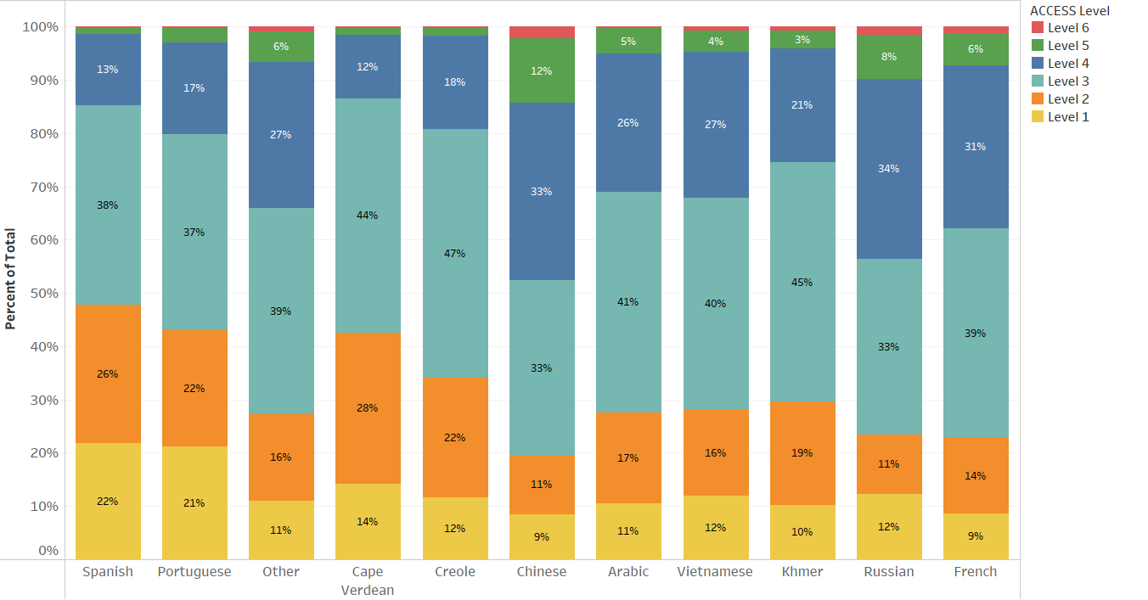

Figure 7 shows the average ACCESS proficiency level by grade cluster for the ten highest-incidence native languages.

**Figure 7. Average Proficiency Level of Students Who Speak the Ten Highest-Incidence Languages**

**by Grade Cluster**

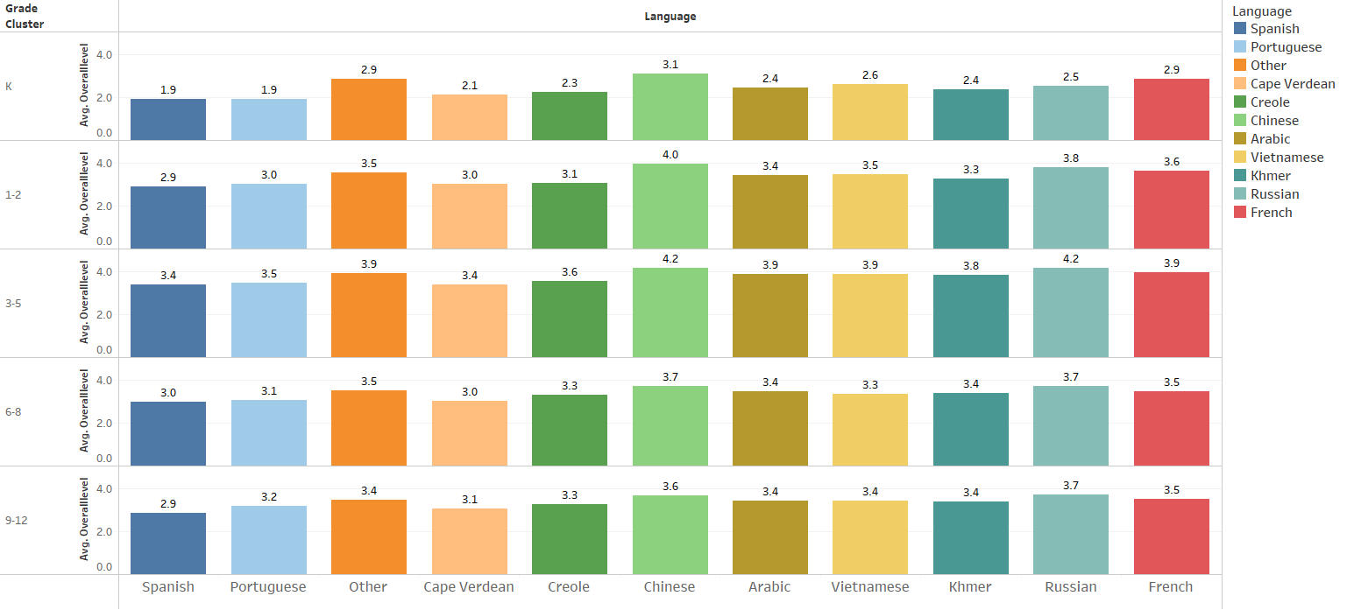

Figure 8 shows the average ACCESS proficiency level by native language and number of years in a Massachusetts school.

**Figure 8. Average Proficiency Level of Students Who Speak the Ten Highest-Incidence Languages**

**by Number of Years in MA**

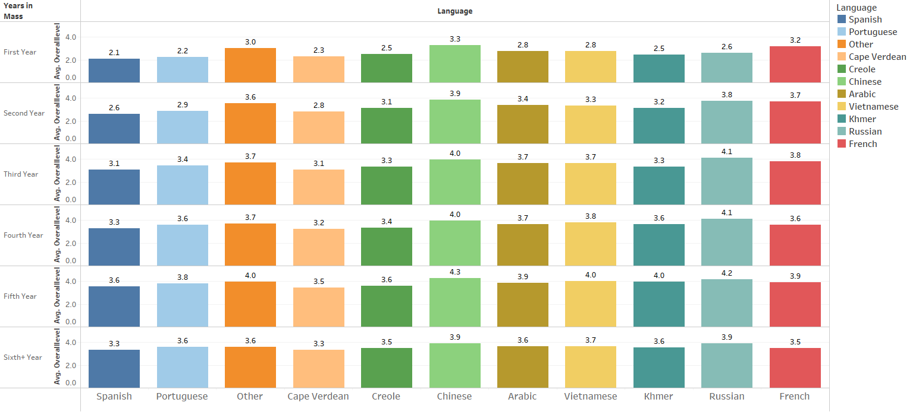

# 

# Appendix A. Performance Definitions for the ACCESS Levels of English Language Proficiency

WIDA Performance Definitions for the ACCESS Levels of English Language Proficiency - Listening and Reading Grades K-12.

The Performance Definitions are the interpretations of the six ACCESS proficiency levels (Entering, Emerging, Developing, Expanding, Bridging and Reaching) and are articulated under the headings of linguistic complexity, language forms and conventions, and vocabulary usage.

WIDA Performance Definitions for the ACCESS Levels of English Language Proficiency - Speaking and Writing Grades K-12.

The Performance Definitions are the interpretations of the six ACCESS proficiency levels (Entering, Emerging, Developing, Expanding, Bridging, and Reaching) and are articulated under the headings of linguistic complexity, language forms and conventions, and vocabulary usage.

# Appendix B. Alternate ACCESS Performance Definitions

WIDA Alternate ACESS - Performance Definitions

The Performance Definitions are the interpretations of the six Alternate ACCESS proficiency levels (Initiating, Exploring, Engaging, Entering, Emerging, and Developing) and articulate the language that English language learner students with  significant cognitive disabilities will produce and process.

# Appendix C. Additional Clarification of Future Progress Targets and Difficulty Indices

Graph C1 provides clarification of Future Progress Targets based on the following variables for ELs. Future Progress Targets for EL students in grade 6 are provided as an example:

* Future Progress Targets (2020)
* Difficulty Index for the Future Progress Targets
* Current ACCESS level
* Years enrolled in MA

In Graph C1, the ACCESS proficiency level is shown on the y-axis for each category of Years in Massachusetts. The 2020 Future Progress Target is displayed on the x-axis. The shading depicts the Difficulty Index from easiest (green) to moderate difficulty (yellow) to very difficult (red). The nonlinear growth trajectory observed in the actual student population is illustrated in the curved graph lines.

After receiving their initial ACCESS score, students taking the regular ACCESS for ELLs test have five years to reach proficiency. Each year, ACCESS targets are based the student's current ACCESS level. Students who have lower ACCESS targets tend to have lower future targets while students with higher ACCESS levels will have higher future targets. ACCESS targets are determined using growth patterns set for students in that grade, at each level of ACCESS proficiency. In general, future targets will be higher for students in grades K−5 than for older students as younger students exhibit faster language acquisition growth in those grades. Once students reach five years in Massachusetts, their future targets are automatically set at “English proficient” (an overall ACCESS level of 4.2) for the remainder of their time in EL status.

**Graph C1: 2020 Grade 6 Students’ Future Targets Relative to Years in MA,**

**Current ACCESS Proficiency Level, and Difficulty Index**

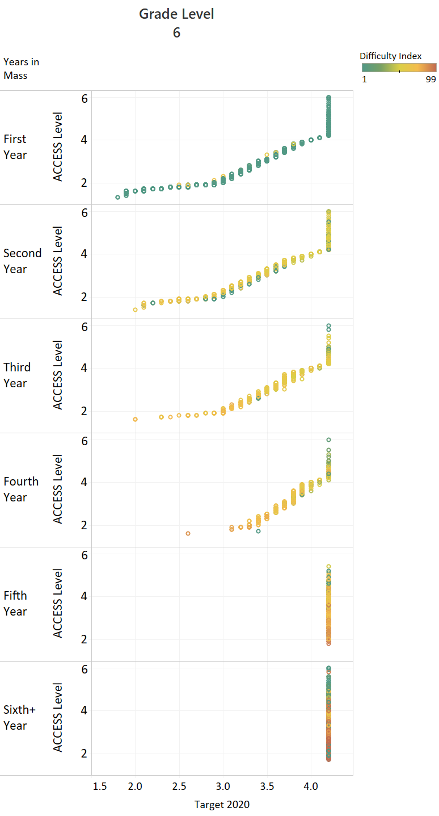

# Appendix D. How SGPAs Were Calculated

**What are Student Growth Percentiles for ACCESS (SGPAs) and how were they calculated?**

Student Growth Percentiles for ACCESS (SGPAs) measure the degree to which a student’s EL achievement has changed from the prior year(s) to the current year, in comparison to other students in the same grade who performed similarly in the past. SGPAs use students’ current and prior scores to assign an SGPA that ranges from 1 to 99. Students who have a current year’s ACCESS or Alternate ACCESS score and a prior year’s score—and have met the consecutive grade requirement—are issued an SGPA.

Between 2017−2020, SGPAs were calculated by comparing a student’s current-year score to those of students with similar scores in their cohort. Each year, the cohort group changed depending on the performance of the current year population, which resulted in a constant state average SGPA of about 50. Since the average SGPA per grade is 50, the distribution remains constant statewide with 20 percent of students scoring in each SGP growth category, from very low growth to very high growth, as shown in Figure 1. 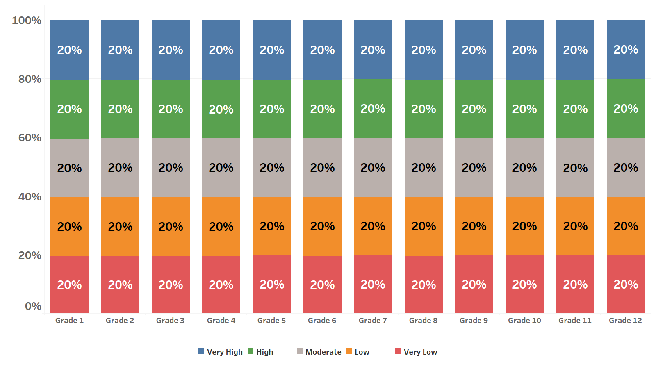

**Figure 1: 2020 SGPA Distribution by SGPA Group and Grade**

**How were SGPAs calculated in 2021 due to impacts from the pandemic?**

The pandemic functioned as an academic headwind for most students, slowing their educational progress and growth. As documented in this report, ELs who were tested exhibited lower rates of progress toward English language proficiency overall as well as lower rates of proficiency attainment, which was a significant departure from the typical achievement and growth patterns in prior years.

To accurately reflect the extent to which educational progress and growth slowed due to the impact of the pandemic, DESE modified the method for calculating SGPAs in 2021, using *baseline SGPAs* instead. For this method, a historical peer group represented the baseline scores from which current progress was measured.

Baseline SGPAs were reported on the same scale as the 2020 results, allowing for comparisons between SGPAs in 2021 to SGPAs in prior years. Because student growth toward English proficiency slowed during the pandemic, the baseline SGPAs in 2021 showed higher percentages of students in the lower growth categories in most grades, rather than a flat 20 percent in each category, as shown in Figure 2. 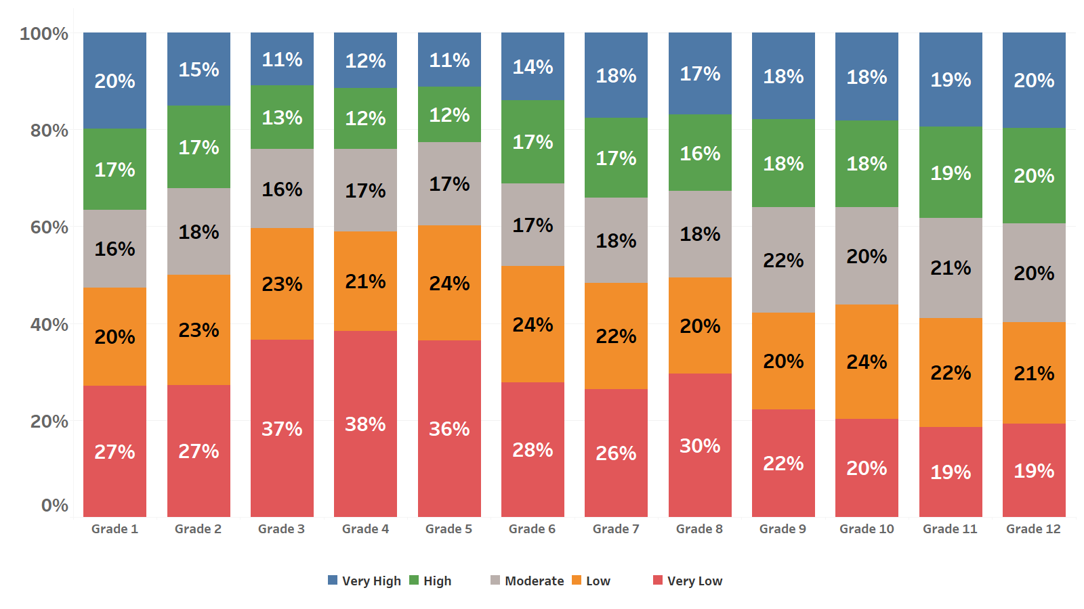

**Figure 2: Distribution of Baseline Growth, 2021 SGPA Distribution by SGPA Group and Grade**

Baseline SGPAs for tested students in high school should be viewed with caution (see Figure 3), however, since up to 50 percent of those students were absent from testing in 2021. *Baseline SGPAs* will also be reported in 2022, so we will be able to monitor the long-term impacts of the educational disruptions from 2020, along with the progress rates, attainment, and other metrics for students who were absent in 2021, but who will take the ACCESS test in 2022.

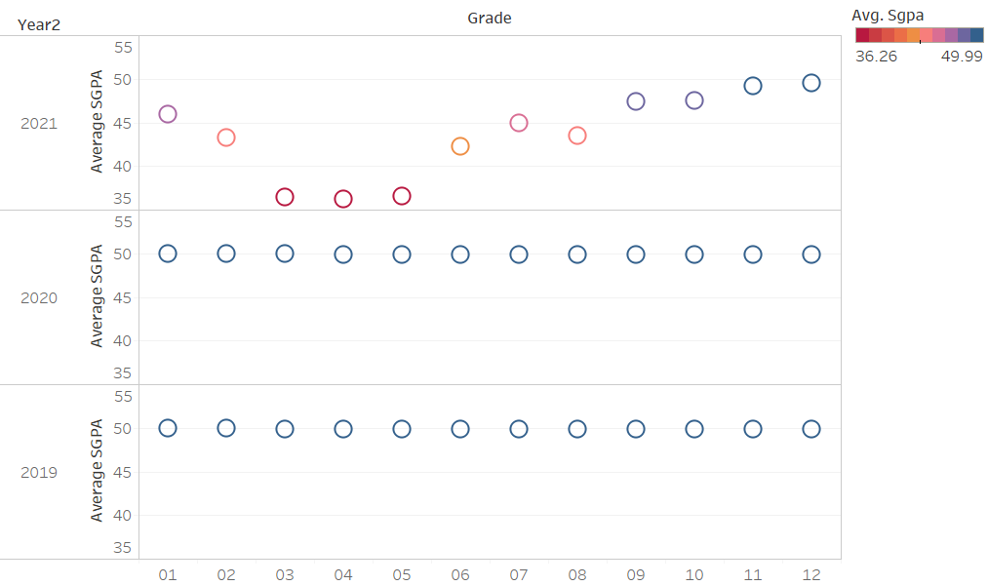

**Figure 3: Average SGPAs for 2019, 2020, and 2021 by SGPA Group and Grade**