WIDA ACCESS 2025 Statewide Results

April 2026

This document was prepared by the Massachusetts Department of Elementary and Secondary Education
Pedro Martinez, Commissioner

Board of Elementary and Secondary Education Members
Ms. Katherine Craven, Chair, Brookline
Mr. Matt Hills, Vice-Chair, Newton
Ms. Isabella Chamberlain, Student Member, Hudson
Dr. Ericka Fisher, Worcester
Dr. Christina Grant, Cambridge
Ms. Farzana Mohamed, Newton
Ms. Dálida Rocha, Worcester
Ms. Kristen Smidy, Westfield
Ms. Mary Ann Stewart, Lexington
Dr. Martin West, Newton
Dr. Stephen Zrike, Salem

Pedro Martinez, Commissioner
Secretary to the Board

The Massachusetts Department of Elementary and Secondary Education, an affirmative action employer, is committed to ensuring that all of its programs and facilities are accessible to all members of the public.
We do not discriminate on the basis of age, color, disability, national origin, race, religion, sex, gender identity, or sexual orientation.

Inquiries regarding the Department’s compliance with Title IX and other civil rights laws may be directed to the Human Resources Director, 135 Santilli Highway, Everett, MA 02149. Phone: 781-338-6105.

© 2026 Massachusetts Department of Elementary and Secondary Education
Permission is hereby granted to copy any or all parts of this document for non-commercial educational purposes. Please credit the “Massachusetts Department of Elementary and Secondary Education.”


This document printed on recycled paper

Massachusetts Department of Elementary and Secondary Education
135 Santilli Highway, Everett, MA 02149
Phone 781-338-3000 TTY: N.E.T. Relay 800-439-2370
www.doe.mass.edu
Table of Contents
Overview of 2025 Participation and Achievement 1
Participation Rates 1
Overall Achievement 1
Reporting Requirements 2
I. Background 2
Testing Formats 2
ACCESS Scores 3
Reclassification of ELs 4
WIDA Alternate ACCESS 4
II. Summary of 2025 ACCESS Participation and Achievement 4
Student Participation 4
Student Achievement 9
III. Reporting Elements 24
Reporting Element #1: ELs Making Progress toward English Language Proficiency (disaggregated by disability status) 24
Reporting Element #2: ELs Attaining English Language Proficiency 33
Reporting Element #3: ELs Who Exited English Learner (EL) Status as a Result of Their Attainment of English Proficiency 37
Reporting Element #4: Former ELs (FELs) Meeting Challenging State Academic Standards (disaggregated by disability status) 38
Reporting Element #5: ELs Who Have Not Attained English Proficiency within Six Years (disaggregated for students with and without disabilities) 42
IV. WIDA ACCESS Results for ELs from the State’s Highest Incidence Non-English Language Groups 45
Appendix A. Performance Definitions for the WIDA ACCESS Levels of English Language Proficiency 49
Appendix B. WIDA Alternate ACCESS Performance Definitions 51

Overview of 2025 Participation and Achievement
Federal and state laws require that English learners (ELs) be assessed annually to measure their English proficiency in four language domains—reading, writing, listening, and speaking—as well as the progress they are making in learning English. In fulfillment of these laws, ELs in grades K–12 are required to participate in WIDA ACCESS (formerly ACCESS for ELLs) testing, administered annually in January and February. ELs who are identified as having the most significant cognitive disabilities and who are unable to take ACCESS, even with accommodations, can be considered for participation in WIDA Alternate ACCESS.
Students who participate in WIDA ACCESS are provided with scale scores and proficiency level scores for each language domain and four language composites (oral language, literacy, comprehension, and overall English proficiency; refer to ACCESS for ELLs Interpretive Guide for Score Reports). The Department of Elementary and Secondary Education (DESE) has determined that students with an overall proficiency level of 4.2 or higher and a literacy proficiency level of 3.9 or higher be reclassified to former English learners (FELs) by the district. In addition to considering ACCESS performance, districts should observe a student’s ability to perform ordinary classwork in English (refer to Guidance on English Learner Education Services and Programming) to determine whether instructional supports may be necessary during the four-year FEL monitoring period.

Participation Rates
In 2025, 126,769 ELs were enrolled in grades K–12. Of these, 124,564 participated in WIDA ACCESS or WIDA Alternate ACCESS—a 98% participation rate. A total of 122,407 ELs participated in ACCESS and 2,157 ELs participated in Alternate ACCESS. Students in high school participated at a rate of 95% compared to students in grades K–8 (99%). This pattern is commensurate with 2024 participation rates: 99% for grades K–8, 95% for grades 9–12, and 98% overall. For more information on participation, refer to the Student Participation section of this report.

Overall Achievement
Achievement results are reported by proficiency levels for the ACCESS (levels 1–6) and Alternate ACCESS (levels 1–5) tests. ACCESS test results are presented by language domain and composite scores. In the four testing domains, average levels of achievement in 2025 were 2.9 for speaking, 2.9 for writing, 3.1 for reading, and 4.1 for listening. Average proficiency levels in 2025 for oral language, comprehension, literacy, and overall English proficiency composites were 3.4, 3.4, 2.9, and 3.0, respectively. In 2025, 13.3% of students met the criteria to reclassify as FELs by achieving the minimum overall proficiency level (4.2) and literacy level (3.9) on the ACCESS test. In 2025, 11.9% of students who took the Alternate ACCESS met test exit criteria. Refer to Guidance for Exiting Students Who Take the Alternate ACCESS for ELLs for more information.

Reporting Requirements
Since 2019, this report has been revised to include reporting elements described in Title III of the Every Student Succeeds Act (ESSA), a 2015 federal law, and in the Language Opportunities for Our Kids (LOOK) Act, a 2017 state law. The purpose of the reporting elements is to inform programs and support activities designed to enhance student outcomes. These are the five required reporting elements described in ESSA, which are also defined and described in detail in section III, Reporting Elements:
  - Reporting Element #1: Progress toward achieving English language proficiency
- Reporting Element #2: Attainment of English proficiency
- Reporting Element #3: ELs exiting EL status based on their attainment of English proficiency
- Reporting Element #4: FEL achievement on the MCAS
- Reporting Element #5: Long-term ELs (not attained English language proficiency within six years)

I. Background
This report summarizes the test results of 124,564 ELs in Massachusetts who participated in the 2025 WIDA ACCESS and WIDA Alternate ACCESS tests, which were developed by the WIDA consortium and are intended to measure the English language proficiency of ELs in 41 consortium member states, territories, and federal agencies. Massachusetts joined the WIDA consortium in May 2012 and has administered the ACCESS test since the 2012–2013 school year and Alternate ACCESS test since the 2013–2014 school year.

Testing Formats
ACCESS tests measure how well ELs have met the English Language Development (ELD) Standards developed by the WIDA consortium. The WIDA ELD Standards describe English language literacy in four academic subjects (English language arts, mathematics, social studies, and science), plus social and instructional language in four separate domains (listening, reading, speaking, and writing). The WIDA ELD Standards are aligned with the Massachusetts Curriculum Frameworks. Only students who participate in all four domains, or those who are assigned overall scores for missing domains, receive overall scores. Students are required to participate in tests designed for the grade or grade-level cluster in which they are enrolled, as follows:
WIDA ACCESS Tests
Format | Grade-Level Cluster Tests
Online | 1, 2–3, 4–5, 6–8, 9–12
Paper | K, 1, 2, 3, 4–5, 6–8, 9–12; WIDA Alternate ACCESS K–2, 3–5, 6–8, 9–12
ACCESS tests are mainly administered as computer-based (online) assessments for grades 1–12. Kindergarten tests are available on paper only, as is the Alternate ACCESS. Paper-based testing is also available as an accommodation for students in grades 1–12 with disabilities and for first-year ELs who lack familiarity with or the ability to use a computer. Large-print and braille formats are also available only on paper. Of the students who participated in ACCESS in 2025, 87.2% took the test online, and 12.8% took the test on paper. Less than one percent of students took a combination of the online and paper versions of the ACCESS assessment.
The computer-based listening and reading tests are adaptive, with students directed to questions of equal, lesser, or greater difficulty depending on how they responded to a previous cluster of questions. Based on the listening and reading results, students are routed to the appropriately tiered speaking and writing tests. For paper-based testing, students in grades 1–12 take either Tier A or B/C of the designated grade-cluster test, based on their level of English proficiency, as determined by their teacher(s) prior to testing.

ACCESS Scores
Students taking an ACCESS test receive scale scores between 100 and 600 for each of the four language domains and each of the four language composites. Scale scores convert a student’s raw score (number of correct items) onto a single continuum of English proficiency skills stretching from kindergarten to 12th grade. Therefore, even though students in different grades are assessed on different items, scale scores can be used to compare a student’s English proficiency from one grade to the next (within a language domain or within a composite).
Proficiency level scores convert scale scores into grade-specific indicators of English proficiency using a lookup table that relates scale scores to proficiency levels in each domain. English proficiency is reported in one of six English language proficiency levels: 1–Entering, 2–Emerging, 3–Developing, 4–Expanding, 5–Bridging, and 6–Reaching (for performance definitions, refer to Appendix A). Proficiency levels are reported as a whole number followed by a decimal (e.g., Level 3.4), indicating the relative progress a student has made within a particular proficiency level, rounded to the nearest tenth. For example, a student earning a score of 3.4 is in Level 3 and has completed 40% of the skills required to achieve Level 4. Proficiency levels can be used to compare relative strengths in English across language domains but not across grades, as proficiency levels are specific to each grade level.
Composite scores are also reported as scale scores and proficiency levels using a combination of domain scale scores. Composite scale scores are then converted to composite proficiency levels using a lookup table that relates scale scores to proficiency levels in each composite.
- Oral Language: 50% Listening + 50% Speaking
- Literacy: 50% Reading + 50% Writing
- Comprehension: 70% Reading + 30% Listening
- Overall: 35% Reading + 35% Writing + 15% Listening + 15% Speaking

Reclassification of ELs
The state-determined criterion districts use to exit students from EL status is an overall ACCESS score of Level 4.2 and a literacy composite score of Level 3.9.

WIDA Alternate ACCESS
The WIDA Alternate ACCESS is administered to Massachusetts ELs with the most significant cognitive disabilities. These are students in grades K–12 whose disabilities prevent participation in the ACCESS general assessment, even with the use of accommodations. Alternate ACCESS is recommended for students who also participate in the state’s academic alternate assessment, the MCAS-Alt, or who would be designated by their IEP teams to participate in it. Alternate ACCESS is administered individually by trained and certified educators in four grade-level clusters: grades K–2, 3–5, 6–8, and 9–12. Students are assessed in the four domains of reading, writing, listening, and speaking. Results are reported at five proficiency levels (1, 2, 3, 4, 5; refer to Appendix B for descriptors for each proficiency level) and on a numerical scale from 900 to 980. In all, 2,157 Massachusetts students in grades K–12 participated in Alternate ACCESS test in 2025.
In 2024 Massachusetts adopted exit criteria for students who take the Alternate ACCESS. Students who achieved an overall proficiency level equal or greater to P2 (out of a possible proficiency level of A1, A2, A3, P1, P2, and P3) on the 2013–2023 Alternate ACCESS scale are eligible for reclassification as a former English learner, pending a score of 12 on the English Language Observation Form from both the student’s special education teacher and their English as a Second Language (ESL) teacher.

II. Summary of 2025 ACCESS Participation and Achievement

Student Participation
Participation in ACCESS is defined in two ways. A student who completed all four sections of the ACCESS or Alternate ACCESS test—reading, writing, listening, and speaking—is considered to have met participation requirements. Additionally, students who were unable to complete the full ACCESS test due to the nature of their disabilities but complete at least two domains are considered to have met participation requirements. Students with disabilities who are unable to complete at least two domains due to the nature of their disabilities are exempt from participation requirements and are not included in any school, district, or state aggregations. Students who transfer to a different school between October and March of the current school year and have incomplete ACCESS data due to the time of their transfer are also exempt from participation requirements.
In 2025, 126,769 ELs were enrolled in grades K–12. Of these, 124,564 participated in ACCESS or Alternate ACCESS—a 98% participation rate. A total of 122,407 EL students participated in ACCESS and 2,157 EL students participated in the Alternate ACCESS. Participation rates for each grade span in 2024 and 2025 are shown in table 1. The column labelled “Change in Percentage Points” is simply the difference between participation rates from 2024 to 2025. There were no observed differences in participation rate from 2024 to 2025.
Table 1. ACCESS and Alternate ACCESS 2024 and 2025 Participation Rates and Change in Percentage Points by Grade Span
Grade Cluster | Participation Rate 2024 | Participation Rate 2025 | Change in Percentage Points
Kindergarten | 99% | 99% | 0
Grade 1 | 99% | 99% | 0
Grades 2–3 | 99% | 99% | 0
Grades 4–5 | 99% | 99% | 0
Grades 6–8 | 99% | 99% | 0
Grades 9–12 | 95% | 95% | 0
TOTAL | 98% | 98% | 0
Table 2 represents ACCESS participation rates for 2024 and 2025 disaggregated by student designation. The low-income designation is based on a student’s participation in one or more of the following state-administered programs: the Supplemental Nutrition Assistance Program (SNAP); the Transitional Assistance for Families with Dependent Children (TAFDC); the Department of Children and Families’ (DCF) foster care program; expanded MassHealth (Medicaid) up to 185% of the federal poverty level. The low-income designation also applies to students identified by districts as homeless or those for whom the district confirmed as having met the low-income criteria through the supplemental process and collected the required supporting documentation (SIMS DOE056). Students with disabilities include students with individualized education programs (IEPs) as reported by districts in SIMS. Additionally, data are disaggregated by students attending charter and other public schools.
Table 2. ACCESS and Alternate ACCESS 2024 and 2025 Participation Rates and Change in Percentage Points by Student Group
Student Designation | Participation Rate 2024 | Participation Rate 2025 | Change in Percentage Points
Low Income | 98% | 98% | 0
Non-Low Income | 98% | 98% | 0
Students with Disabilities | 97% | 97% | 0
Students without Disabilities | 98% | 98% | 0
Public School | 98% | 98% | 0
Charter School | 98% | 99% | 1
Total | 98% | 98% | 0

Participation by grade span is disaggregated by years of enrollment in Massachusetts schools as summarized in table 3.

Table 3. WIDA ACCESS and Alternate ACCESS 2024 and 2025 Participation Rates by Grade Span and Years of Enrollment in MA
Year | Grade Span | K Num. | K Per. | 1 Num. | 1 Per. | 2–3 Num. | 2–3 Per. | 4–5 Num. | 4–5 Per. | 6–8 Num. | 6–8 Per. | 9–12 Num. | 9–12 Per. | Total Num. | TotalPer.
2024 | First Year | 12,779 | 99 | 2,297 | 99 | 3,389 | 99 | 3,169 | 100 | 4,465 | 100 | 6,058 | 99 | 32,157 | 99
2024 | Second Year | 194 | 100 | 10,746 | 99 | 2,992 | 99 | 2,148 | 99 | 2,993 | 99 | 4,757 | 96 | 23,830 | 99
2024 | Third Year | - | - | 273 | 100 | 11,647 | 99 | 1,977 | 99 | 2,584 | 100 | 4,117 | 96 | 20,598 | 99
2024 | Fourth Year | - | - | - | - | 7,528 | 99 | 819 | 98 | 620 | 98 | 881 | 94 | 9,848 | 98
2024 | Fifth Year | - | - | - | - | 420 | 99 | 6,857 | 99 | 1,690 | 99 | 2,128 | 95 | 11,095 | 98
2024 | Sixth+ Year | - | - | - | - | - | - | 4,329 | 98 | 8,742 | 97 | 8,827 | 91 | 21,899 | 95
2024 | Total | 12,973 | 99 | 13,316 | 99 | 25,977 | 99 | 19,299 | 99 | 21,094 | 99 | 26,768 | 95 | 119,427 | 98
2025 | First Year | 13,480 | 99 | 2,121 | 100 | 3,106 | 100 | 2,778 | 100 | 3,932 | 100 | 5,693 | 99 | 31,110 | 99
2025 | Second Year | 239 | 100 | 11,599 | 99 | 3,569 | 99 | 2,660 | 100 | 3,926 | 99 | 5,763 | 98 | 27,756 | 99
2025 | Third Year | - | 100 | 276 | 99 | 11,119 | 99 | 1,850 | 99 | 2,414 | 99 | 3,876 | 96 | 19,537 | 99
2025 | Fourth Year | - | - | - | 100 | 8,315 | 100 | 2,287 | 100 | 2,074 | 99 | 3,207 | 95 | 15,884 | 99
2025 | Fifth Year | - | - | - | - | 333 | 100 | 5,867 | 99 | 527 | 99 | 680 | 94 | 7,407 | 99
2025 | Sixth+ Year | - | - | - | - | - | 100 | 4,218 | 99 | 9,045 | 98 | 9,603 | 91 | 22,870 | 95
2025 | Total | 13,721 | 99 | 13,997 | 99 | 26,446 | 99 | 19,660 | 99 | 21,918 | 99 | 28,822 | 95 | 124,564 | 98

Table 4 shows the WIDA ACCESS participation rates in districts with the highest numbers of enrolled ELs (>1,000) in 2025. All 22 districts were classified as urban per the 2020 Massachusetts Census Data.
Table 4. 2025 WIDA ACCESS and Alternate ACCESS Participation Rates for Districts with More than 1,000 ELs
Districts | Total ELs | Number Participated | Participation Rate (Percent)
Boston | 15,022 | 14,677 | 98
Worcester | 7,983 | 7,815 | 98
Lynn | 7,378 | 7,300 | 99
Lawrence | 5,875 | 5,813 | 99
Brockton | 5,264 | 5,072 | 96
Lowell | 4,395 | 4,303 | 98
Springfield | 4,172 | 4,092 | 98
Framingham | 3,428 | 3,374 | 98
New Bedford | 3,176 | 3,124 | 98
Everett | 3,105 | 3,067 | 99
Fall River | 2,957 | 2,924 | 99
Chelsea | 2,724 | 2,649 | 97
Revere | 2,579 | 2,561 | 99
Malden | 1,959 | 1,940 | 99
Quincy | 1,766 | 1,747 | 99
Marlborough | 1,605 | 1,597 | 100
Milford | 1,497 | 1,488 | 99
Waltham | 1,475 | 1,456 | 99
Methuen | 1,320 | 1,310 | 99
Haverhill | 1,191 | 1,188 | 100
Somerville | 1,170 | 1,146 | 98
Fitchburg | 1,161 | 1,154 | 99
State | 126,769 | 124,564 | 98

Student Achievement
Achievement results for the 2025 WIDA ACCESS and Alternate ACCESS tests are organized in four sections. The first two sections report results on the WIDA ACCESS test. The Language Domains section summarizes student proficiency levels in the four testing domains of speaking, writing, reading, and listening. The Composite Scores section presents student performance in terms of composite proficiency levels. The third section reports results for the Alternate ACCESS test. The last section, titled Ready to Reclassify, presents results on students achieving the minimum proficiency level (4.2 for ACCESS and the equivalent of P2 for Alternate ACCESS), indicating they are ready to be reclassified as FELs.
Language Domains
Table 5 displays the average proficiency levels for each of the language domains, disaggregated by grade span and years classified as an EL. Notably, years as an EL begins with the first year in kindergarten. Therefore, all kindergarteners are classified as first-year ELs unless they repeated kindergarten.
Table 5. 2025 Average Domain Proficiency Level by Grade Span and Years of Enrollment in MA
Grade Span | Years in MA | Number Tested | Average Listening Level | Average Speaking Level | Average Reading Level | Average Writing Level
K | First Year | 13,206 | 3.6 | 3.2 | 1.7 | 1.8
K | Second Year | 237 | 4.2 | 3.7 | 1.7 | 1.8
K | Third Year | - | - | - | - | -
K | Total | 13,444 | 3.6 | 3.2 | 1.7 | 1.8
1 | First Year | 2,104 | 3.3 | 2.3 | 2.6 | 1.9
1 | Second Year | 11,258 | 4.5 | 2.9 | 3.0 | 2.4
1 | Third Year | 272 | 4.6 | 2.9 | 2.7 | 2.2
1 | Fourth Year | - | - | - | - | -
1 | Total | 13,635 | 4.3 | 2.8 | 3.0 | 2.3
2–3 | First Year | 3,072 | 2.8 | 2.3 | 3.0 | 2.5
2–3 | Second Year | 3,523 | 3.5 | 2.8 | 3.3 | 2.9
2–3 | Third Year | 10,826 | 4.0 | 3.2 | 3.7 | 3.2
2–3 | Fourth Year | 7,912 | 4.1 | 3.3 | 3.7 | 3.5
2–3 | Fifth Year | 297 | 3.9 | 3.2 | 3.4 | 3.3
2–3 | Sixth+ Year | - | - | - | - | -
2–3 | Total | 25,631 | 3.8 | 3.1 | 3.6 | 3.1
4–5 | First Year | 2,752 | 3.8 | 2.5 | 2.8 | 2.7
4–5 | Second Year | 2,622 | 4.6 | 3.0 | 3.1 | 3.1
4–5 | Third Year | 1,797 | 5.2 | 3.4 | 3.4 | 3.5
4–5 | Fourth Year | 2,157 | 5.4 | 3.6 | 3.5 | 3.6
4–5 | Fifth Year | 5,431 | 5.6 | 3.7 | 3.9 | 3.8
4–5 | Sixth+ Year | 3,754 | 5.5 | 3.6 | 3.6 | 3.8
4–5 | Total | 18,513 | 5.1 | 3.4 | 3.5 | 3.5
6–8 | First Year | 3,903 | 3.4 | 2.4 | 2.5 | 2.5
6–8 | Second Year | 3,884 | 3.9 | 2.7 | 2.7 | 2.8
6–8 | Third Year | 2,372 | 4.4 | 3.0 | 2.9 | 3.1
6–8 | Fourth Year | 2,006 | 4.7 | 3.1 | 3.0 | 3.2
6–8 | Fifth Year | 493 | 4.9 | 3.2 | 3.0 | 3.3
6–8 | Sixth+ Year | 8,168 | 4.9 | 3.3 | 2.9 | 3.3
6–8 | Total | 20,826 | 4.4 | 3.0 | 2.8 | 3.0
9–12 | First Year | 5,679 | 3.0 | 2.1 | 2.9 | 2.6
9–12 | Second Year | 5,725 | 3.3 | 2.3 | 3.0 | 2.8
9–12 | Third Year | 3,848 | 3.5 | 2.4 | 3.1 | 3.0
9–12 | Fourth Year | 3,156 | 3.7 | 2.5 | 3.2 | 3.1
9–12 | Fifth Year | 657 | 4.1 | 2.7 | 3.5 | 3.3
9–12 | Sixth+ Year | 9,004 | 4.3 | 2.8 | 3.5 | 3.4
9–12 | Total | 28,069 | 3.6 | 2.5 | 3.2 | 3.0
All | Grand Total | 120,118 | 4.1 | 2.9 | 3.1 | 2.9

Composite Scores
Composite scores are derived from a combination of weighted scale scores in the four language domains. Four composites are reported: oral language, comprehension, literacy, and overall English proficiency (for more information, refer to ACCESS Scores). Average proficiency levels for composites are presented in table 6, disaggregated by grade span and years as an EL in Massachusetts. Percentages of students at each overall proficiency level in 2025 are presented in table 7, disaggregated by grade span and years as an EL in Massachusetts.
Table 6. 2025 Average Composite Proficiency Level by Grade Span and Years of Enrollment in MA
Grade Span | Years in MA | Number Tested | Average  Oral Level | Average Comprehension Level | Average  Literacy Level | Average  Overall Level
K | First Year | 13,206 | 3.3 | 2.0 | 1.6 | 2.0
K | Second Year | 237 | 3.9 | 2.1 | 1.7 | 2.1
K | Third Year | - | - | - | - | -
K | Total | 13,444 | 3.3 | 2.0 | 1.6 | 2.0
1 | First Year | 2,104 | 2.7 | 2.8 | 2.1 | 2.3
1 | Second Year | 11,258 | 3.5 | 3.6 | 2.5 | 2.8
1 | Third Year | 272 | 3.5 | 3.4 | 2.4 | 2.7
1 | Fourth Year | - | - | - | - | -
1 | Total | 13,635 | 3.4 | 3.5 | 2.5 | 2.7
2–3 | First Year | 3,072 | 2.5 | 2.8 | 2.6 | 2.5
2–3 | Second Year | 3,523 | 3.1 | 3.3 | 3.0 | 3.0
2–3 | Third Year | 10,826 | 3.5 | 3.8 | 3.3 | 3.3
2–3 | Fourth Year | 7,912 | 3.6 | 3.9 | 3.5 | 3.5
2–3 | Fifth Year | 297 | 3.5 | 3.5 | 3.3 | 3.3
2–3 | Sixth+ Year | - | - | - | - | -
2–3 | Total | 25,631 | 3.4 | 3.6 | 3.2 | 3.3
4–5 | First Year | 2,752 | 3.1 | 3.2 | 2.7 | 2.8
4–5 | Second Year | 2,622 | 3.7 | 3.7 | 3.1 | 3.3
4–5 | Third Year | 1,797 | 4.3 | 4.2 | 3.4 | 3.7
4–5 | Fourth Year | 2,157 | 4.5 | 4.4 | 3.5 | 3.8
4–5 | Fifth Year | 5,431 | 4.7 | 4.7 | 3.8 | 4.1
4–5 | Sixth+ Year | 3,754 | 4.5 | 4.5 | 3.7 | 4.0
4–5 | Total | 18,513 | 4.2 | 4.2 | 3.4 | 3.7
6–8 | First Year | 3,903 | 2.8 | 2.8 | 2.5 | 2.6
6–8 | Second Year | 3,884 | 3.2 | 3.1 | 2.7 | 2.8
6–8 | Third Year | 2,372 | 3.6 | 3.4 | 3.0 | 3.2
6–8 | Fourth Year | 2,006 | 3.7 | 3.6 | 3.0 | 3.3
6–8 | Fifth Year | 493 | 3.9 | 3.7 | 3.1 | 3.4
6–8 | Sixth+ Year | 8,168 | 3.9 | 3.7 | 3.1 | 3.4
6–8 | Total | 20,826 | 3.5 | 3.4 | 2.9 | 3.1
9–12 | First Year | 5,679 | 2.5 | 2.9 | 2.6 | 2.6
9–12 | Second Year | 5,725 | 2.7 | 3.1 | 2.8 | 2.7
9–12 | Third Year | 3,848 | 2.8 | 3.2 | 3.0 | 2.9
9–12 | Fourth Year | 3,156 | 2.9 | 3.3 | 3.0 | 3.0
9–12 | Fifth Year | 657 | 3.2 | 3.7 | 3.3 | 3.3
9–12 | Sixth+ Year | 9,004 | 3.3 | 3.7 | 3.3 | 3.3
9–12 | Total | 28,069 | 2.9 | 3.3 | 3.0 | 2.9
All Grades | Grand Total | 120,118 | 3.4 | 3.4 | 2.9 | 3.0

Table 7. 2025 Percent of Students at Each Overall Proficiency Level by Grade Span and Years of Enrollment in MA
Grade Span | Years in MA |  | Num. Tested | Per. at Level 1 | Per. at Level 2 | Per. at Level 3 | Per. at Level 4 | Per. at Level 5 | Per. at Level 6
K | First Year |  | 13,206 | 68 | 15 | 11 | 5 | 1 | 0
K | Second Year |  | 237 | 62 | 19 | 11 | 7 | 0 | 0
K | Third Year |  | - | - | - | - | - | - | -
K | Total |  | 13,444 | 68 | 15 | 11 | 5 | 1 | 0
1 | First Year |  | 2,104 | 52 | 26 | 18 | 3 | 1 | 0
1 | Second Year |  | 11,258 | 19 | 37 | 35 | 7 | 1 | 0
1 | Third Year |  | 272 | 18 | 47 | 32 | 3 | 0 | 0
1 | Fourth Year |  | - | - | - | - | - | - | -
1 | Total |  | 13,635 | 24 | 36 | 33 | 6 | 1 | 0
2–3 | First Year |  | 3,072 | 45 | 26 | 19 | 8 | 2 | 0
2–3 | Second Year |  | 3,523 | 20 | 31 | 33 | 13 | 3 | 0
2–3 | Third Year |  | 10,826 | 6 | 25 | 47 | 20 | 2 | 0
2–3 | Fourth Year |  | 7,912 | 5 | 18 | 45 | 28 | 3 | 0
2–3 | Fifth Year |  | 297 | 6 | 23 | 51 | 18 | 2 | 0
2–3 | Sixth+ Year |  | - | - | - | - | - | - | -
2–3 | Total |  | 25,631 | 12 | 24 | 41 | 20 | 3 | 0
4–5 | First Year |  | 2,752 | 38 | 24 | 18 | 14 | 4 | 2
4–5 | Second Year |  | 2,622 | 17 | 25 | 30 | 21 | 6 | 1
4–5 | Third Year |  | 1,797 | 7 | 17 | 35 | 31 | 10 | 1
4–5 | Fourth Year |  | 2,157 | 3 | 15 | 35 | 37 | 9 | 1
4–5 | Fifth Year |  | 5,431 | 2 | 7 | 32 | 46 | 12 | 1
4–5 | Sixth+ Year |  | 3,754 | 2 | 10 | 34 | 44 | 10 | 1
4–5 | Total |  | 18,513 | 10 | 15 | 31 | 35 | 9 | 1
6–8 | First Year |  | 3,903 | 45 | 24 | 20 | 8 | 3 | 0
6–8 | Second Year |  | 3,884 | 28 | 28 | 29 | 12 | 2 | 0
6–8 | Third Year |  | 2,372 | 13 | 28 | 39 | 18 | 2 | 0
6–8 | Fourth Year |  | 2,006 | 9 | 25 | 46 | 18 | 2 | 0
6–8 | Fifth Year |  | 493 | 5 | 23 | 46 | 24 | 1 | 0
6–8 | Sixth+ Year |  | 8,168 | 4 | 21 | 54 | 20 | 1 | 0
6–8 | Total |  | 20,826 | 18 | 24 | 40 | 16 | 2 | 0
9–12 | First Year |  | 5,679 | 43 | 27 | 19 | 8 | 2 | 0
9–12 | Second Year |  | 5,725 | 31 | 30 | 27 | 10 | 2 | 0
9–12 | Third Year |  | 3,848 | 24 | 29 | 32 | 13 | 2 | 0
9–12 | Fourth Year |  | 3,156 | 20 | 27 | 39 | 13 | 1 | 0
9–12 | Fifth Year |  | 657 | 10 | 25 | 42 | 21 | 2 | 0
9–12 | Sixth+ Year |  | 9,004 | 8 | 21 | 51 | 19 | 1 | 0
9–12 | Total |  | 28,069 | 23 | 26 | 36 | 13 | 2 | 0
All | Grand Total | 120,118 |  | 23 | 23 | 34 | 17 | 3 | 0

Figures 1 and 2 show the percentage of students in each ACCESS proficiency level in 2024 and 2025, by grade.
Figure 1. Percentage of Students in Each Proficiency Level, Grades K–6
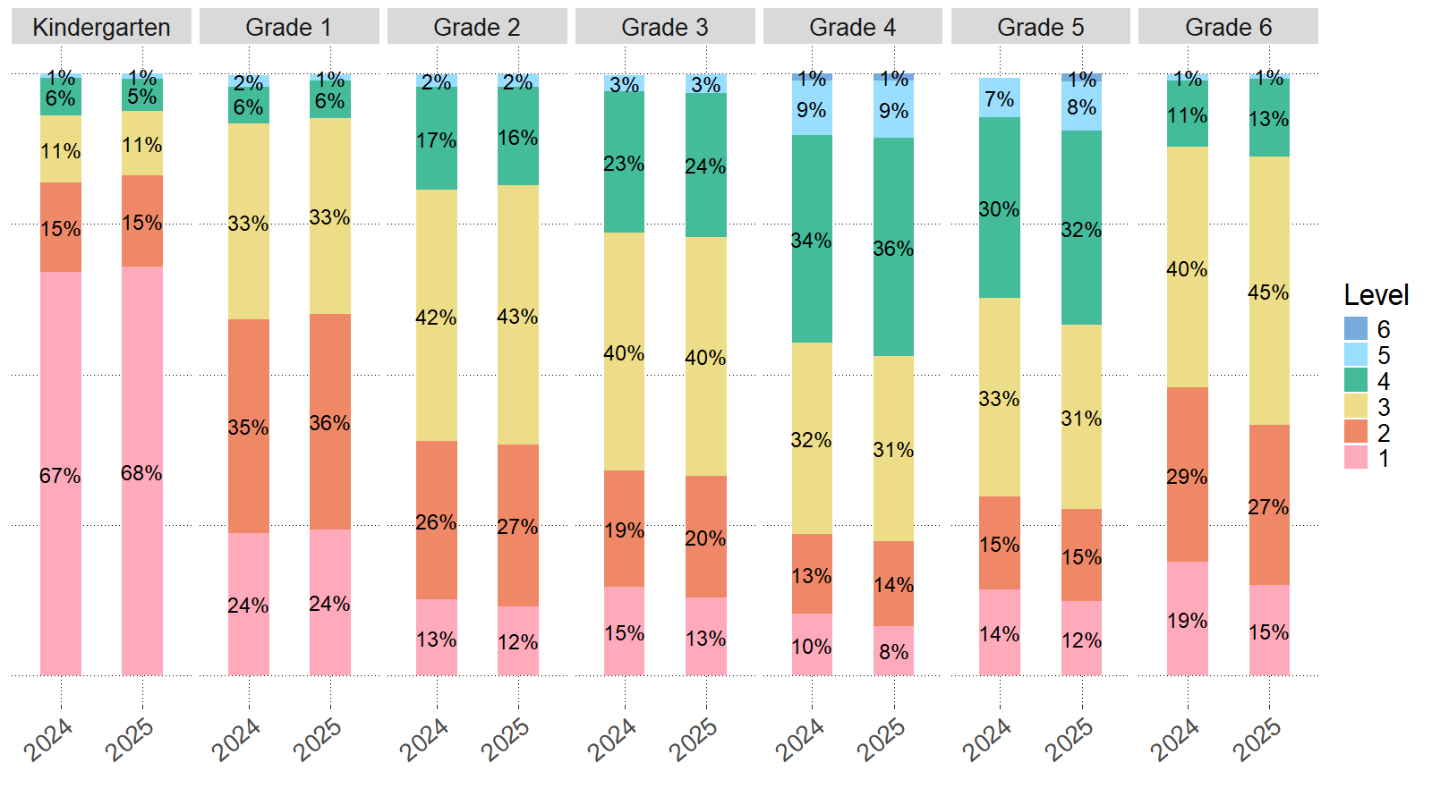
Note: Level 6 was only achieved by students in grades 4 and 5.
Figure 2. Percentage of Students in Each Proficiency Level, Grades 7–12
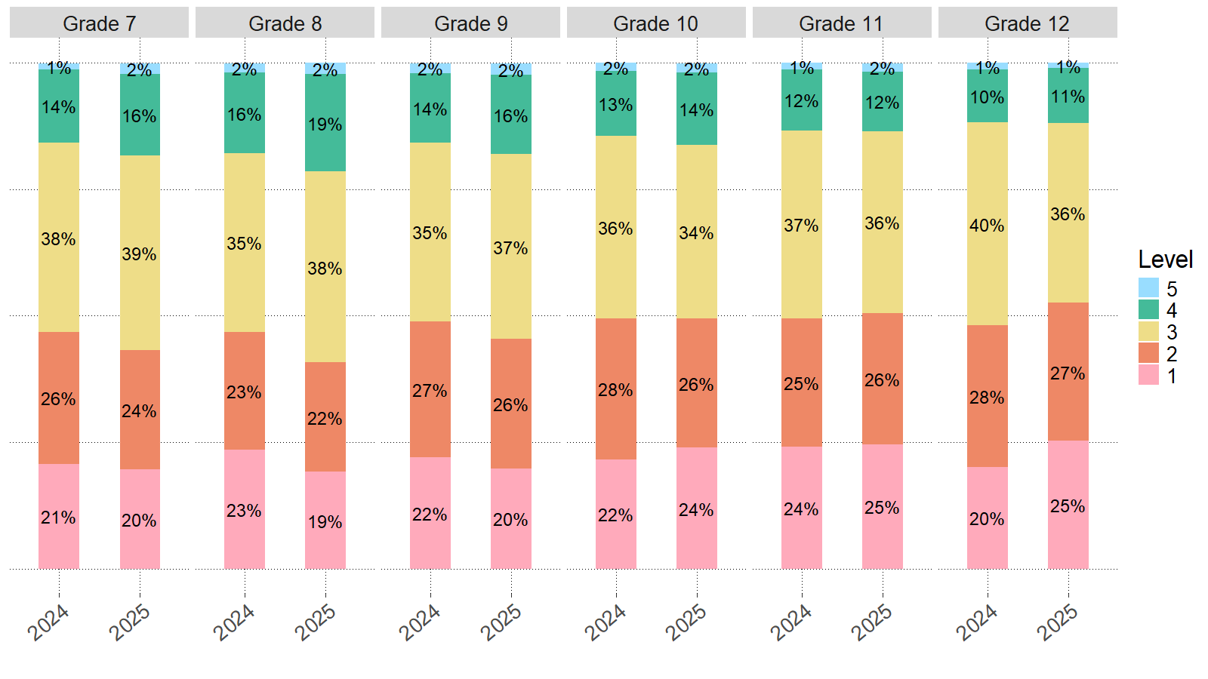
Note: No students in grades 7–12 achieved a proficiency level of 6.
Alternate ACCESS
The Alternate ACCESS assessment was first administered in Massachusetts in 2014 to ELs with the most significant cognitive disabilities. The updated version, WIDA Alternate ACCESS, was first administered in 2024. Alternate ACCESS results are reported at five proficiency levels with the same category labels as ACCESS: 1–Entering, 2–Emerging, 3–Developing, 4–Expanding, and 5–Bridging, and on a numerical scale from 900 to 980. Previously Alternate ACCESS was reported across six proficiency levels: A1–Initiating, A2–Exploring, A3–Engaging, P1–Entering, P2–Emerging, and P3–Developing (for Writing only), and on a numerical scale from 910 to 960. Refer to Appendix B for the performance definitions of WIDA Alternate ACCESS proficiency levels.
In 2025, 2,115 students participated in WIDA Alternate ACCESS. Table 8 shows the percentage of students in each WIDA Alternate ACCESS proficiency level by grade for 2025. Table 9 shows results from 2024 for comparison.

Table 8. Performance by Proficiency Level on WIDA Alternate ACCESS by Grade for 2025
Grade Span | Years in MA | Num. Tested | Per. at Level 1 | Per. at Level 2 | Per. at Level 3 | Per. at Level 4 | Per. at Level 5
K–2 | 1 | 287 | 80 | 8 | 7 | 3 | 2
K–2 | 2 | 329 | 57 | 17 | 16 | 9 | 2
K–2 | 3 | 212 | 55 | 12 | 14 | 12 | 8
K–2 | 4 | - | - | - | - | - | -
K–2 | Total | 835 | 64 | 12 | 12 | 8 | 4
3–5 | 1 | 29 | 69 | 17 | 10 | 0 | 3
3–5 | 2 | 21 | 67 | 14 | 10 | 5 | 5
3–5 | 3 | 25 | 68 | 12 | 16 | 4 | 0
3–5 | 4 | 176 | 53 | 19 | 17 | 7 | 3
3–5 | 5 | 158 | 51 | 18 | 14 | 11 | 6
3–5 | 6 | 123 | 44 | 15 | 18 | 11 | 11
3–5 | Total | 532 | 53 | 17 | 16 | 9 | 6
6–8 | 1 | 18 | 44 | 39 | 0 | 11 | 6
6–8 | 2 | 22 | 59 | 14 | 18 | 0 | 9
6–8 | 3 | 12 | 33 | 25 | 42 | 0 | 0
6–8 | 4 | 17 | 65 | 18 | 18 | 0 | 0
6–8 | 5 | 13 | 31 | 15 | 46 | 8 | 0
6–8 | 6 | 276 | 36 | 18 | 21 | 14 | 11
6–8 | Total | 358 | 39 | 19 | 21 | 12 | 9
9–12 | 1 | 13 | 77 | 23 | 0 | 0 | 0
9–12 | 2 | 26 | 58 | 31 | 4 | 8 | 0
9–12 | 3 | 16 | 44 | 25 | 19 | 13 | 0
9–12 | 4 | 31 | 39 | 23 | 19 | 6 | 13
9–12 | 5 | 11 | 9 | 36 | 18 | 18 | 18
9–12 | 6 | 293 | 38 | 16 | 20 | 14 | 12
9–12 | Total | 390 | 40 | 19 | 18 | 12 | 11
All Grades | Grand Total | 2,115 | 52 | 16 | 16 | 10 | 6

Table 9. Performance by Proficiency Level on WIDA Alternate ACCESS by Grade for 2024
Grade Span | Years in MA | Num. Tested | Per. at Level 1 | Per. at Level 2 | Per. at Level 3 | Per. at Level 4 | Per. at Level 5
K–2 | 1 | 223 | 76 | 12 | 9 | 2 | 1
K–2 | 2 | 244 | 61 | 16 | 12 | 7 | 4
K–2 | 3 | 190 | 41 | 16 | 18 | 15 | 10
K–2 | 4 | 11 | 18 | 27 | 36 | 18 | 0
K–2 | Total | 668 | 60 | 15 | 13 | 7 | 5
3–5 | 1 | 19 | 74 | 0 | 16 | 11 | 0
3–5 | 2 | 17 | 59 | 35 | 6 | 0 | 0
3–5 | 3 | 34 | 56 | 24 | 9 | 9 | 3
3–5 | 4 | 180 | 52 | 28 | 13 | 4 | 3
3–5 | 5 | 155 | 45 | 17 | 22 | 10 | 6
3–5 | 6 | 138 | 36 | 14 | 16 | 15 | 20
3–5 | Total | 543 | 47 | 20 | 16 | 9 | 8
6–8 | 1 | 12 | 58 | 33 | 0 | 8 | 0
6–8 | 2 | 12 | 58 | 8 | 17 | 17 | 0
6–8 | 3 | 22 | 55 | 14 | 23 | 9 | 0
6–8 | 4 | - | - | - | - | - | -
6–8 | 5 | 24 | 25 | 38 | 13 | 13 | 13
6–8 | 6 | 266 | 33 | 18 | 20 | 15 | 14
6–8 | Total | 345 | 36 | 19 | 19 | 14 | 12
9–12 | 1 | - | - | - | - | - | -
9–12 | 2 | 18 | 44 | 28 | 11 | 6 | 11
9–12 | 3 | 27 | 44 | 22 | 30 | 4 | 0
9–12 | 4 | - | - | - | - | - | -
9–12 | 5 | 24 | 38 | 17 | 25 | 13 | 8
9–12 | 6 | 311 | 33 | 17 | 15 | 14 | 21
9–12 | Total | 394 | 35 | 18 | 16 | 12 | 18
All Grades | Grand Total | 1,950 | 47 | 18 | 16 | 10 | 10

Ready to Reclassify
Students with an overall ACCESS proficiency level of 4.2 or higher and a literacy proficiency level of 3.9 or higher are ready to be reclassified as FELs. Similarly, students taking Alternate ACCESS are eligible to reclassify as FELs if they meet the Alternate ACCESS for ELLs (2013–2023) test equivalent of an overall level of P2 or greater. These students must also receive a score of 12 on the English Language Observation Form from both their special education teacher and their ESL teacher in order to reclassify. Table 10 shows the percentage of students whose WIDA ACCESS and WIDA Alternate ACCESS scores indicated that they attained English proficiency. In 2025, 13.3% of students taking WIDA ACCESS and WIDA Alternate ACCESS received scores indicating they were ready to exit EL status and reclassify as FELs, compared to 12.6% in 2024.

Table 10. 2024 and 2025 Percentage of Students Meeting WIDA ACCESS Criteria for English Proficiency by Test (ACCESS, Alternate ACCESS, or Both) and Grade
Grade | 2024 ACCESS (Per.) | 2025 ACCESS (Per.) | ACCESS Change (Per.) | 2024  Alternate ACCESS  (Per.) | 2025  Alternate ACCESS  (Per.) | Alternate ACCESS Change (Per.) | 2024 Both Tests  (Per.) | 2025 Both Tests  (Per.) | Both Tests Change (Per.)
K | 2.5 | 2.2 | -0.3 | 2.8 | 4.8 | 2.0 | 2.5 | 2.3 | -0.2
1 | 5.8 | 4.9 | -0.9 | 6.3 | 7.1 | 0.8 | 5.8 | 4.9 | -0.9
2 | 12.7 | 12.5 | -0.2 | 16.6 | 14.6 | -2.0 | 12.8 | 12.5 | -0.3
3 | 17.4 | 18.4 | 1.0 | 8.3 | 7.2 | -1.1 | 17.2 | 18.2 | 1.0
4 | 31.7 | 33.6 | 1.9 | 14.5 | 14.7 | 0.2 | 31.4 | 33.3 | 1.9
5 | 26.3 | 30.2 | 3.9 | 26.4 | 21.5 | -4.9 | 26.3 | 30.0 | 3.7
6 | 6.5 | 7.4 | 0.9 | 16.4 | 7.3 | -9.1 | 6.6 | 7.4 | 0.8
7 | 9.6 | 11.2 | 1.6 | 16.3 | 17.4 | 1.1 | 9.7 | 11.3 | 1.6
8 | 11.2 | 13.6 | 2.4 | 23.1 | 18.6 | -4.5 | 11.5 | 13.7 | 2.2
9 | 10.6 | 12.3 | 1.7 | 19.3 | 4.4 | -14.9 | 10.7 | 12.2 | 1.5
10 | 9.3 | 10.6 | 1.3 | 23.0 | 15.2 | -7.8 | 9.6 | 10.6 | 1.0
11 | 8.6 | 9.3 | 0.7 | 16.1 | 17.0 | 0.9 | 8.7 | 9.4 | 0.7
12 | 6.9 | 7.1 | 0.2 | 19.5 | 13.3 | -6.2 | 7.1 | 7.2 | 0.1
Total | 12.5 | 13.3 | 0.8 | 14.7 | 11.4 | -3.3 | 12.6 | 13.3 | 0.7

III. Reporting Elements
Requirements for reporting the proficiency and progress of ELs are outlined in Title III of the Every Student Succeeds Act (ESSA) and in the Language Opportunities for Our Kids Act (LOOK). The five reporting elements required by ESSA are summarized below.
- Reporting Element #1: The number and percentage of students who are making progress toward achieving English proficiency, including a disaggregation by disability status.
- Reporting Element #2: The number and percent of ELs attaining English proficiency.
- Reporting Element #3: The number and percent of ELs exiting EL status based on their attainment of English proficiency.
- Reporting Element #4: The number and percent of former ELs (FELs) meeting challenging state academic standards on the MCAS tests for English language arts (ELA), mathematics, and science and technology/engineering (STE) for each of the four years after such students are no longer receiving EL services, disaggregated for FELs with disabilities (FELSWD).
- Reporting Element #5: The number and percent of ELs who have not attained English language proficiency within six years of initial classification as an EL (i.e., five years after the first baseline year), disaggregated for ELs with disabilities in this report.
Based on these five reporting elements, this report includes the overall state results for ELs taking the WIDA ACCESS test and the Alternate ACCESS test as well as the results for FELs taking the MCAS tests. Reporting on the five elements is intended to provide districts with important feedback to promote and accelerate the achievement of ELs and FELs and to provide a basis for additional oversight of EL programming by districts and DESE.

Reporting Element #1: ELs Making Progress toward English Language Proficiency (disaggregated by disability status)
In Massachusetts, “making progress” means that a student is on track to attain English proficiency within six years of entering a Massachusetts school. Students are considered English proficient when they have achieved an overall composite score of Level 4.2 and a composite literacy score of Level 3.9 on the WIDA ACCESS test, based on a score scale between Level 1.0 (the lowest level of proficiency) to Level 6.0 (the highest level of proficiency). In 2018, DESE adopted an approach entitled “Pathways to Proficiency” that uses a student’s current year ACCESS score as the basis for determining a target for the following year. The target is the minimum score needed by the student the following year to remain on track to attain English proficiency. Students in kindergarten through grade 11 receive a target for as long as they are classified as English learners. Progress targets are not provided for students in grade 12, since it is anticipated that those students will no longer be enrolled in a K–12 program the following year. An explanation of the measures used by DESE to determine progress is provided below:
- Future Progress Target represents the minimum ACCESS proficiency level score needed on following year’s ACCESS test to remain on track to reach English proficiency within a total of six years in a Massachusetts school (one baseline year plus five years to demonstrate progress toward proficiency). Future progress targets are reported as an overall ACCESS proficiency level, ranging from Level 1.0 to Level 4.2 (lowest to highest). Each year, future progress targets are reset based on a) the number of years remaining for the student to reach proficiency, and b) the current year’s ACCESS score.
- Difficulty Index shows an estimate of how difficult it will be to reach next year’s target relative to the student’s current proficiency level and number of years in Massachusetts. The difficulty index ranges from 1 to 99, with one being the lowest difficulty (least difficult to achieve the target) and 99 the highest (most difficult to achieve the target). Generally, difficulty indices below 40 are considered easier, indices between 40 and 60 moderate, and indices above 60 harder. The difficulty index signals which students may need additional instructional assistance to meet their future targets.
For example, a student who has been classified as an English learner for three years with a comparatively low ACCESS score (e.g., Level 1.5) would receive a high difficulty index (e.g., 75), indicating that it would likely be more difficult for them to meet their future target. A student with a higher proficiency level after the same number of years in a program (e.g., a student in an EL program for three years with an ACCESS level of 3.7) would likely receive a lower difficulty index (e.g., 35). A higher difficulty index should serve as an indicator that a student may require additional resources or hours per week in a language program to accelerate their progress toward proficiency.
Future progress targets and difficulty indices were adjusted in the following situations:
- Students in their fifth year or more in Massachusetts schools receive a future progress target of 4.2, as they have one or fewer years until the six-year deadline to reach English proficiency, as stated by Reporting Element 5.
- Students who score at or above a Level 4.2 in overall proficiency but do not meet the literacy requirement for exit receive a future progress target of 4.2 for subsequent years until they meet full exit criteria.
- Students’ progress targets are adjusted if the previously set target is lower than the students’ current overall proficiency levels to ensure that targets represent progress towards English proficiency.
- For students in grades 9 through 11, adjustments are made to ensure that progress targets do not limit students to meeting proficiency by grade 12 when they might have only one or two years left in K–12 schooling. Instead, adjustments are made to ensure students have six years in Massachusetts schools to reach English proficiency. As shown in table 11, students are provided an adjusted progress target and a difficulty index that matches students in lower grades with similar overall proficiency levels, years in Massachusetts, and prior overall English proficiency as follows:
Table 11. Progress Target Adjustments
Current Grade | 9 | 9 | 9 | 10 | 10 | 10 | 10 | 11 | 11 | 11 | 11 | 11
Years in MA | 1 | 2 | 3 | 1 | 2 | 3 | 4 | 1 | 2 | 3 | 4 | 5
Match with Students in Grade | 7 | 8 | 9 | 7 | 8 | 9 | 10 | 7 | 8 | 9 | 10 | 11

- Student Growth Percentile for ACCESS (SGPA) indicates the amount of progress made by a student on the ACCESS test from one year to the next, relative to other EL grade-level students who earned similar ACCESS scores. The SGPAs in 2025 were calculated using a historical peer comparison group from which current progress was measured. This baseline method allows for comparison between SGPAs in 2025 and those from 2017 to 2024 (consult Appendix D in the 2021 ACCESS State Report for more details).
In general, SGPA indicates whether a student has made low, moderate, or high gains in their ACCESS test scores from one year to the next. SGPA is a number from 1‒99, with 40‒59 representing average growth. Higher SGPA numbers indicate more growth. SGPA allows each student a nearly equal opportunity with other ELs in their grade level to demonstrate their progress in learning English. Table 12 shows the average and standard deviation (SD) of SGPA by grade. In 2025, the average SGPA for all students was 51.7, indicating average growth.
Table 12. 2025 Average Student Growth Percentile for ACCESS by Grade
Grade | Average SGPA | SGPA SD
1 | 45.2 | 30.1
2 | 54.0 | 28.2
3 | 48.8 | 30.2
4 | 51.0 | 30.6
5 | 54.2 | 30.5
6 | 55.4 | 29.7
7 | 54.9 | 30.5
8 | 55.4 | 30.6
9 | 53.4 | 30.2
10 | 51.1 | 30.3
11 | 51.8 | 31.0
12 | 52.4 | 31.2
Total | 51.7 | 30.3

- Progress Indicator (“Yes” or “No”) shows whether the student has met last year’s progress target in the current year. If the student’s current ACCESS proficiency level score is equal to or greater than their target from the previous year, then the student is considered to have made progress. Students who were eligible to take the ACCESS test but did not participate because they were absent received a progress indicator of “0.”
For EL students taking WIDA Alternate ACCESS, DESE determines progress based on a comparison of the prior year’s results and the current year’s results to see whether the scores have increased by at least one proficiency level in one or more subdomains of the test (listening, speaking, reading, or writing) from one year to the next. Because a score of Level 4.2 is not technically possible for students taking the WIDA Alternate ACCESS, their progress indicators should be interpreted with caution.
Data that meet reporting element #1 of Title III are provided in Tables 13–15 and in figure 3, highlighting student progress in 2024 and 2025. Overall, 44% of students made progress in 2025. Table 13 provides progress indicator data by grade. Figure 3 depicts the percentage of students who made progress by school groups: elementary school (grades 1–5), middle school (grades 6–8), and high school (grades 9–12). Table 14 highlights a different perspective, showing progress indicator data by grade span and years. Table 15 disaggregates the data by student disability status, wherein students with disabilities are defined as students with IEPs as reported by districts in SIMS.
Table 13. 2024 and 2025 Progress Attainment by Grade
Grade | 2024 All Students (Num.) | 2024 Made Progress (Num.) | 2024 Per. of All Students that Made Progress | 2025 All Students (Num.) | 2025 Made Progress (Num.) | 2025 Per. of All Students that Made Progress
1 | 10,606 | 5,708 | 54 | 11,500 | 5,969 | 52
2 | 11,673 | 8,015 | 69 | 11,862 | 8,090 | 68
3 | 10,660 | 6,364 | 60 | 11,184 | 6,528 | 58
4 | 9,437 | 5,131 | 54 | 9,807 | 5,582 | 57
5 | 6,844 | 2,791 | 41 | 7,235 | 3,306 | 46
6 | 5,181 | 1,225 | 24 | 5,732 | 1,536 | 27
7 | 5,537 | 1,464 | 26 | 6,037 | 1,917 | 32
8 | 5,713 | 1,481 | 26 | 6,157 | 2,035 | 33
9 | 5,909 | 1,405 | 24 | 6,695 | 1,765 | 26
10 | 5,857 | 1,090 | 19 | 6,085 | 1,486 | 24
11 | 5,386 | 935 | 17 | 5,703 | 1,382 | 24
12 | 4,158 | 588 | 14 | 5,255 | 1,125 | 21
Total | 86,961 | 36,197 | 42 | 93,252 | 40,721 | 44

Figure 3. 2024 and 2025 Progress Attainment by School Group
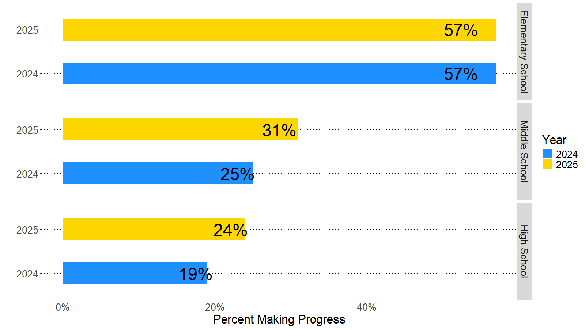
Table 14. 2024 and 2025 Progress Attainment by Grade Span and Years of Enrollment in MA
Grade Span | Years in MA | 2024 Total Students (Num.) | 2024 Made Progress (Per.) | 2025 Total Students (Num.) | 2025 Made Progress (Per.)
1 | First Year | 59 | 100 | 43 | 100
1 | Second Year | 10,282 | 54 | 11,182 | 52
1 | Third Year | 265 | 48 | 274 | 50
1 | Fourth Year | - | - | - | 0
1 | Total | 10,606 | 54 | 11,500 | 52
2–3 | First Year | 221 | 100 | 231 | 100
2–3 | Second Year | 2758 | 61 | 3,312 | 60
2–3 | Third Year | 11,495 | 67 | 10,954 | 67
2–3 | Fourth Year | 7,446 | 61 | 8,215 | 59
2–3 | Fifth Year | 412 | 45 | 330 | 40
2–3 | Sixth+ Year | - | - | - | -
2–3 | Total | 22,333 | 64 | 23,046 | 63
3–5 | First Year | 370 | 100 | 415 | 100
3–5 | Second Year | 2,001 | 44 | 2,502 | 46
3–5 | Third Year | 1,942 | 44 | 1,836 | 51
3–5 | Fourth Year | 786 | 52 | 2,269 | 50
3–5 | Fifth Year | 6,837 | 55 | 5,828 | 59
3–5 | Sixth+ Year | 4,345 | 37 | 4,192 | 42
3–5 | Total | 16,281 | 49 | 17,042 | 52
6–8 | First Year | 290 | 100 | 337 | 100
6–8 | Second Year | 2,744 | 42 | 3,681 | 46
6–8 | Third Year | 2,537 | 39 | 2,385 | 48
6–8 | Fourth Year | 580 | 35 | 2,044 | 42
6–8 | Fifth Year | 1,660 | 26 | 499 | 34
6–8 | Sixth+ Year | 8,620 | 13 | 8,980 | 14
6–8 | Total | 16,431 | 25 | 17,926 | 31
9–12 | First Year | 367 | 100 | 472 | 100
9–12 | Second Year | 4,501 | 22 | 5,383 | 36
9–12 | Third Year | 4,198 | 21 | 3,944 | 27
9–12 | Fourth Year | 872 | 25 | 3,280 | 24
9–12 | Fifth Year | 2,146 | 21 | 657 | 26
9–12 | Sixth+ Year | 9,226 | 12 | 10,002 | 13
9–12 | Total | 21,310 | 19 | 23,738 | 24
All Grades | Grand Total | 86,961 | 42 | 93,252 | 44

Table 15. 2025 Progress Attainment by Grade Span, Years of Enrollment in MA, and Disability Status
Grade Span | Years in MA | Total Students Without Disabilities (Num.) | Made Progress Without Disabilities (Per.) | Total Students With Disabilities (Num.) | Made Progress With Disabilities (Per.) | All Total Students (Num.) | All Made Progress (Per.)
1 | First Year | 42 | 100 | - | - | 43 | 100
1 | Second Year | 9,205 | 55 | 1,977 | 37 | 11,182 | 52
1 | Third Year | 183 | 57 | 91 | 36 | 274 | 50
1 | Fourth Year | - | - | - | - | - | -
1 | Total | 9,430 | 55 | 2,070 | 37 | 11,500 | 52
2–3 | First Year | 226 | 100 | - | - | 231 | 100
2–3 | Second Year | 3,086 | 62 | 226 | 34 | 3,312 | 60
2–3 | Third Year | 8,627 | 72 | 2,327 | 52 | 10,954 | 67
2–3 | Fourth Year | 5,795 | 67 | 2,420 | 42 | 8,215 | 59
2–3 | Fifth Year | 133 | 53 | 197 | 31 | 330 | 40
2–3 | Sixth+ Year | - | - | - | - | - | -
2–3 | Total | 17,868 | 69 | 5,178 | 45 | 23,046 | 63
3–5 | First Year | 406 | 100 | - | - | 415 | 100
3–5 | Second Year | 2,353 | 47 | 149 | 34 | 2,502 | 46
3–5 | Third Year | 1,591 | 53 | 245 | 35 | 1,836 | 51
3–5 | Fourth Year | 1,751 | 56 | 518 | 32 | 2,269 | 50
3–5 | Fifth Year | 3,681 | 69 | 2,147 | 42 | 5,828 | 59
3–5 | Sixth+ Year | 2,078 | 56 | 2,114 | 29 | 4,192 | 42
3–5 | Total | 11,860 | 59 | 5,182 | 35 | 17,042 | 52
6–8 | First Year | 331 | 100 | - | - | 337 | 100
6–8 | Second Year | 3,541 | 47 | 140 | 17 | 3,681 | 46
6–8 | Third Year | 2,201 | 50 | 184 | 25 | 2,385 | 48
6–8 | Fourth Year | 1,778 | 45 | 266 | 23 | 2,044 | 42
6–8 | Fifth Year | 341 | 40 | 158 | 20 | 499 | 34
6–8 | Sixth+ Year | 4,152 | 19 | 4,828 | 10 | 8,980 | 14
6–8 | Total | 12,344 | 39 | 5,582 | 11 | 17,926 | 31
9–12 | First Year | 470 | 100 | - | - | 472 | 100
9–12 | Second Year | 5,265 | 36 | 118 | 14 | 5,383 | 36
9–12 | Third Year | 3,789 | 27 | 155 | 19 | 3,944 | 27
9–12 | Fourth Year | 3,068 | 25 | 212 | 15 | 3,280 | 24
9–12 | Fifth Year | 550 | 28 | 107 | 13 | 657 | 26
9–12 | Sixth+ Year | 5,501 | 16 | 4,501 | 10 | 10,002 | 13
9–12 | Total | 18,643 | 28 | 5,095 | 10 | 23,738 | 24
All Grades | Grand Total | 70,145 | 49 | 23,107 | 26 | 93,252 | 44

Reporting Element #2: ELs Attaining English Language Proficiency
Data that meet reporting element #2 of Title III are presented in table 16, figure 4, and table 17, highlighting English proficiency attainment for students who tested in 2024 and 2025. In 2025, 13% of ELs met the criteria for English language proficiency. Table 16 provides English proficiency attainment by grade. Figure 4 depicts the percent of students who attained English proficiency by school group: elementary school (grades 1–5), middle school (grades 6–8), and high school (grades 9–12). Table 17 highlights a different perspective of the data, showing English proficiency attainment by grade span and years in Massachusetts.
Students who attained an overall ACCESS score of at least Level 4.2 and a literacy composite score of at least Level 3.9 were designated as having attained English language proficiency. Students who scored below these proficiency levels or who did not participate as required by state and federal regulations were designated not yet to have attained English proficiency.
Students who took WIDA Alternate ACCESS are not included in the calculation of reporting element #2, due to Massachusetts policies around eligibility for students who take Alternate ACCESS to exit EL status. For information on students taking Alternate ACCESS who met the testing criteria for English proficiency, see table 10.
Table 16. 2024 and 2025 English Proficiency Attainment by Grade
Grade | 2024 Num. Tested | 2024 Per. Proficient | 2025 Num. Tested |  | 2025 Per. Proficient |  | 2024–2025 Percentage Change
K | 13,062 | 3 | 13,856 |  | 2 |  | -1
1 | 13,419 | 6 | 14,087 |  | 5 |  | -1
2 | 13,699 | 13 | 13,755 |  | 13 |  | 0
3 | 12,506 | 17 | 12,834 |  | 18 |  | 1
4 | 11,077 | 31 | 11,267 |  | 33 |  | 2
5 | 8,453 | 26 | 8,522 |  | 30 |  | 4
6 | 6,921 | 7 | 7,180 |  | 7 |  | 0
7 | 7,243 | 10 | 7,506 |  | 11 |  | 1
8 | 7,225 | 11 | 7,483 |  | 14 |  | 3
9 | 8,752 | 11 | 9,054 |  | 12 |  | 1
10 | 7,662 | 10 |  | 7,731 |  | 11 |  | 1
11 | 6,869 | 9 |  | 7,267 |  | 9 |  | 0
12 | 4,955 | 7 |  | 6,227 |  | 7 |  | 0
Total | 121,843 | 13 |  | 126,769 |  | 13 |  | 0

Figure 4. 2024 and 2025 English Proficiency Attainment by School Group
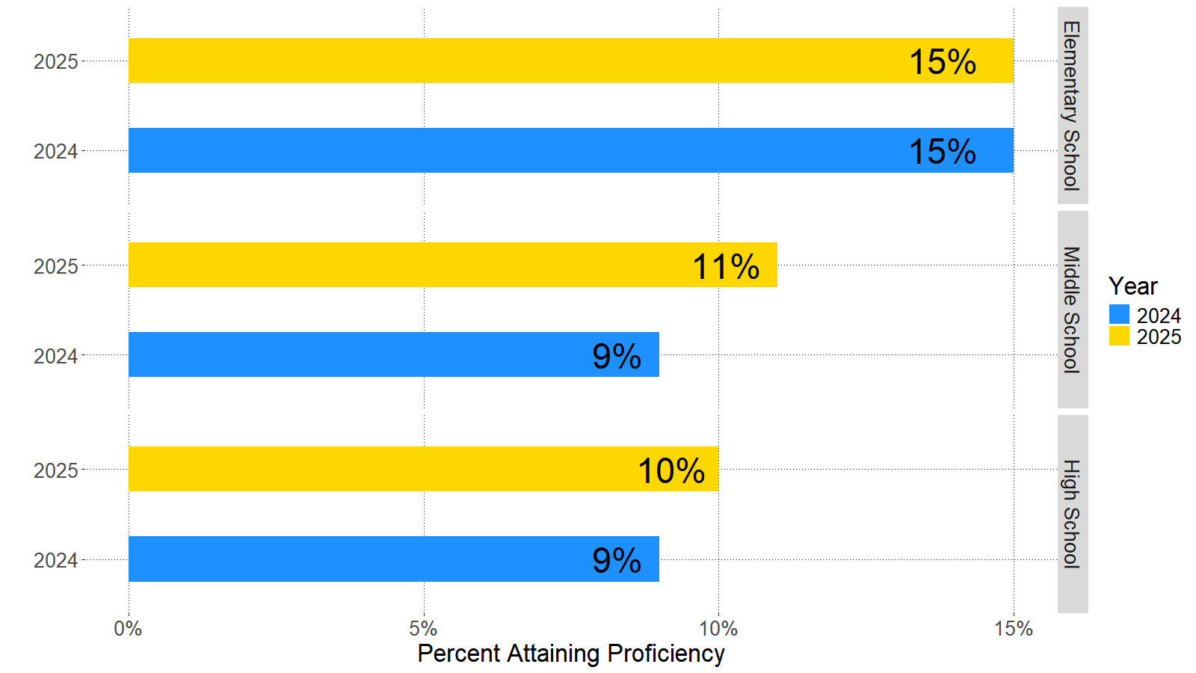

Table 17. 2024 and 2025 English Proficiency Attainment by Grade Span and Years of Enrollment in MA
Grade | Years in MA | 2024 Num. Tested | 2024 Per.  Proficient | 2025 Num. Tested | 2025 Per. Proficient | 2024–2025 Percentage Change
K | First Year | 12,868 | 3 | 13,614 | 2 | -1
K | Second Year | 194 | 3 | 240 | 3 | 0
K | Third Year | - | - | - | - | -
K | Total | 13,062 | 3 | 13,856 | 2 | -1
1 | First Year | 2,311 | 3 | 2,131 | 2 | -1
1 | Second Year | 10,835 | 7 | 11,677 | 6 | -1
1 | Third Year | 273 | 3 | 278 | 3 | 0
1 | Fourth Year | - | - | - | - | -
1 | Total | 13,419 | 6 | 14,087 | 5 | -1
2–3 | First Year | 3,410 | 6 | 3,116 | 7 | 1
2–3 | Second Year | 3,019 | 13 | 3,588 | 12 | -1
2–3 | Third Year | 11,737 | 15 | 11,191 | 15 | 0
2–3 | Fourth Year | 7,614 | 20 | 8,356 | 21 | 1
2–3 | Fifth Year | 424 | 13 | 334 | 13 | 0
2–3 | Sixth+ Year | - | - | - | - | -
2–3 | Total | 26,205 | 15 | 26,589 | 15 | 0
4–5 | First Year | 3,179 | 12 | 2,784 | 15 | 3
4–5 | Second Year | 2,164 | 21 | 2,670 | 20 | -1
4–5 | Third Year | 1,990 | 25 | 1,872 | 30 | 5
4–5 | Fourth Year | 832 | 33 | 2,297 | 33 | 0
4–5 | Fifth Year | 6,941 | 38 | 5,909 | 42 | 4
4–5 | Sixth+ Year | 4,424 | 32 | 4,257 | 37 | 5
4–5 | Total | 19,530 | 29 | 19,789 | 32 | 3
6–8 | First Year | 4,475 | 6 | 3,944 | 9 | 3
6–8 | Second Year | 3,013 | 9 | 3,947 | 10 | 1
6–8 | Third Year | 2,596 | 9 | 2,434 | 13 | 4
6–8 | Fourth Year | 630 | 12 | 2,087 | 12 | 0
6–8 | Fifth Year | 1,705 | 11 | 535 | 13 | 2
6–8 | Sixth+ Year | 8,970 | 10 | 9,222 | 11 | 1
6–8 | Total | 21,389 | 9 | 22,169 | 11 | 2
9–12 | First Year | 6,130 | 6 | 5,755 | 8 | 2
9–12 | Second Year | 4,942 | 10 | 5,904 | 9 | -1
9–12 | Third Year | 4,288 | 8 | 4,035 | 11 | 3
9–12 | Fourth Year | 936 | 12 | 3,360 | 9 | -3
9–12 | Fifth Year | 2,229 | 10 | 725 | 14 | 4
9–12 | Sixth+ Year | 9,713 | 11 | 10,500 | 12 | 1
9–12 | Total | 28,238 | 9 | 30,279 | 10 | 1
All Grades | Grand  Total | 121,843 | 13 | 126,769 | 13 | 0

Reporting Element #3: ELs Who Exited English Learner (EL) Status as a Result of Their Attainment of English Proficiency
Data that meet reporting element #3 are presented in table 18. Table 18 shows the number of students by grade span who reached English proficiency as well as the number and percent of students who exited EL status and were reclassified as FELs in 2024 and 2025. The overall percentage of proficient students who exited EL status after reaching proficiency was 98% in 2024 and 96% in 2025. The number and percent of students who exited EL status once they attained English proficiency on the ACCESS tests are based on districts’ reporting of students in the October 2025 SIMS.
Table 18. 2024 and 2025 English Proficiency and Reclassification to FEL by Grade Span
Grade Span | Indicator | 2024 | 2025
K | Attained English Proficiency on ACCESS (Num.) | 329 | 314
K | Exited EL Status and were Reclassified as FELs (Num.) | 322 | 303
K | Percent of English Proficient Students that Exited EL Status (Per.) | 98 | 96
1 | Attained English Proficiency on ACCESS (Num.) | 777 | 695
1 | Exited EL Status and were Reclassified as FELs (Num.) | 763 | 682
1 | Percent of English Proficient Students that Exited EL Status (Per.) | 98 | 98
2–3 | Attained English Proficiency on ACCESS (Num.) | 3,903 | 4,064
2–3 | Exited EL Status and were Reclassified as FELs (Num.) | 3,851 | 3,958
2–3 | Percent of English Proficient Students that Exited EL Status (Per.) | 99 | 97
4–5 | Attained English Proficiency on ACCESS (Num.) | 5,708 | 6,304
4–5 | Exited EL Status and were Reclassified as FELs (Num.) | 5,661 | 6,189
4–5 | Percent of English Proficient Students that Exited EL Status (Per.) | 99 | 98
6–8 | Attained English Proficiency on ACCESS (Num.) | 1,988 | 2,405
6–8 | Exited EL Status and were Reclassified as FELs (Num.) | 1,929 | 2,315
6–8 | Percent of English Proficient Students that Exited EL Status (Per.) | 97 | 96
9–12 | Attained English Proficiency on ACCESS (Num.) | 2,617 | 3,064
9–12 | Exited EL Status and were Reclassified as FELs (Num.) | 2,557 | 2,652
9–12 | Percent of English Proficient Students that Exited EL Status (Per.) | 98 | 87
Total | Attained English Proficiency on ACCESS (Num.) | 15,322 | 16,846
Total | Exited EL Status and were Reclassified as FELs (Num.) | 15,083 | 16,099
Total | Percent of English Proficient Students that Exited EL Status (Per.) | 98 | 96

Reporting Element #4: Former ELs (FELs) Meeting Challenging State Academic Standards (disaggregated by disability status)
Data that meet reporting element #4 are presented in tables 19 and 20 disaggregated by disability status and by number of years that students are classified as FELs. The number and percentage of FELs who met or exceeded expectations on the grades 3–8 MCAS tests in ELA, mathematics, and science and technology/engineering (STE) are reported in table 19. The number and percentage of FELs who met or exceeded expectations on the MCAS tests in grade 10 ELA, grade 10 mathematics, and high school science are presented in table 20. For the purposes of this reporting element, high school biology and introductory physics are aggregated as high school science.
For this reporting element, students who scored Meeting Expectations or Exceeding Expectations on the MCAS tests are considered at or above grade level in Massachusetts, noted as “proficient” in tables 19 and 20. FELs are defined as students who exited EL status up to four years prior to taking the reported MCAS test. First-year FELs are students who were reported as FEL for the first time in October 2025 SIMS. Students with disabilities are defined as students with IEPs as reported by districts in SIMS.
Table 19. 2025 Meeting or Exceeding Expectations on MCAS, Disaggregated by MCAS Subject, for FELs with Disabilities in Grades 3–8
Student Group | FEL Year | ELA Number Tested | ELA Number Proficient | ELA Percent Proficient | Math Number Tested | Math Number Proficient | Math Percent Proficient | STE Number Tested | STE Number Proficient | STE Percent Proficient
Without Disabilities | 1 | 16,970 | 6,233 | 37% | 16,956 | 6,669 | 39% | 5,301 | 1,717 | 32%
Without Disabilities | 2 | 7,424 | 3,232 | 44% | 7,421 | 3,086 | 42% | 2,745 | 971 | 35%
Without Disabilities | 3 | 5,140 | 2,800 | 54% | 5,135 | 2,739 | 53% | 2,071 | 858 | 41%
Without Disabilities | 4 | 659 | 353 | 54% | 656 | 334 | 51% | 146 | 69 | 47%
Without Disabilities | Total | 3,0193 | 12,618 | 42% | 30,168 | 12,828 | 43% | 10,263 | 3,615 | 35%
With Disabilities | 1 | 2849 | 341 | 12% | 2846 | 424 | 15% | 867 | 131 | 15%
With Disabilities | 2 | 1123 | 135 | 12% | 1122 | 152 | 14% | 492 | 48 | 10%
With Disabilities | 3 | 778 | 127 | 16% | 779 | 149 | 19% | 290 | 38 | 13%
With Disabilities | 4 | 100 | 6 | 6% | 99 | 16 | 16% | 26 | 5 | 19%
With Disabilities | Total | 4850 | 609 | 13% | 4846 | 741 | 15% | 1675 | 222 | 13%
Table 20. 205 Meeting or Exceeding Expectations on MCAS, Disaggregated by MCAS Subject, for FELs by Disability Status in High School
Student Group | FEL Year | ELA Number Tested | ELA Number Proficient | ELA Percent Proficient | Math Number Tested | Math Number Proficient | Math Percent Proficient | STE Number Tested | STE Number Proficient | STE Percent Proficient
Without Disabilities | 1 | 1,257 | 411 | 33% | 1,253 | 429 | 34% | 330 | 95 | 29%
Without Disabilities | 2 | 382 | 173 | 45% | 379 | 144 | 38% | 91 | 28 | 31%
Without Disabilities | 3 | 236 | 131 | 56% | 232 | 108 | 47% | 58 | 17 | 29%
Without Disabilities | 4 | 88 | 41 | 47% | 86 | 39 | 45% | 18 | 3 | 17%
Without Disabilities | Total | 1,963 | 756 | 39% | 1,950 | 720 | 37% | 497 | 143 | 29%
With Disabilities | 1 | 288 | 21 | 7% | 284 | 18 | 6% | 88 | 5 | 6%
With Disabilities | 2 | 89 | 10 | 11% | 88 | 8 | 9% | 27 | 0 | 0%
With Disabilities | 3 | 63 | 11 | 17% | 60 | 8 | 13% | 14 | 0 | 0%
With Disabilities | 4 | 28 | 3 | 11% | 27 | 3 | 11% | 12 | - | -
With Disabilities | Total | 468 | 45 | 10% | 459 | 37 | 8% | 141 | 5 | 4%

Reporting Element #5: ELs Who Have Not Attained English Proficiency within Six Years (disaggregated for students with and without disabilities)
ELs in Massachusetts are anticipated to reach proficiency on ACCESS tests within a total of six years after being classified as an English learner (one baseline year, plus five years to demonstrate growth toward proficiency). ELs are considered to have attained English proficiency when they achieve the state exit criteria on ACCESS scores of at least a Level 4.2 on the overall proficiency composite and a Level 3.9 on the literacy composite.
Data that meet reporting element #5 are shown in table 21, disaggregated by years in Massachusetts and disability status for 2024 and 2025. A student categorized as “met exit” successfully attained English proficiency before the end of their sixth year in MA schools. A student categorized as “not yet met exit” did not attain English proficiency in the reporting year but is still within the six years of classification as an EL in MA schools. A student categorized as “did not meet exit within six years” is a sixth-year EL student who has yet to reach English proficiency and will be considered a long-term EL (LTEL) in future ACCESS assessments. A student categorized as an “LTEL exit” attained English proficiency after classification as an LTEL. A student categorized as “remains an LTEL” has yet to reach proficiency and will remain classified as an LTEL. Each cell indicates the number of students and the percentage within that particular group (e.g., students with disabilities, SwD) that have or have not yet attained English proficiency broken out by number of years in MA schools. For example, in 2025, 19.4% of students with disabilities in their fifth year as an EL met English proficiency exit criteria. In 2025 overall, 4.2% of all ELs did not reach proficiency within six years of entering an MA school and will be considered new LTELs in future ACCESS assessments.

Table 21. 2024 and 2025 ELs Meeting Exit Criteria by Years in Massachusetts and Disability Status
Years  in MA | Exit Status | 2024  non-SwD  Num. (Per.) |  | 2024  SwD  Num. (Per.) |  | 2024  All  Num. (Per.) |  | 2025  non-SwD  Num. (Per.) |  | 2025  SwD  Num. (Per.) |  | 2025  All  Num. (Per.)
1 | Met Exit | 1,574 (5.3%) |  | 47 (2.1%) |  | 1,631 (5%) |  | 1,751 (6.2%) |  | 54 (1.9%) |  | 1,805 (5.8%)
1 | Not Yet Met Exit | 28,353 (94.7%) |  | 2,223 (97.9%) |  | 30,742 (95%) |  | 26,703 (93.8%) |  | 2,836 (98.1%) |  | 29,539 (94.2%)
2 | Met Exit | 2,234 (10.3%) |  | 93 (3.6%) |  | 2,327 (9.6%) |  | 2,391 (9.6%) |  | 105 (3.4%) |  | 2,496 (8.9%)
2 | Not Yet Met Exit | 19,356 (89.7%) |  | 2,484 (96.4%) |  | 21,840 (90.4%) |  | 24,980 (90.4%) |  | 2,941 (96.6%) |  | 25,530 (91.1%)
3 | Met Exit | 2,612 (14.7%) |  | 200 (6.4%) |  | 2,812 (13.5%) |  | 2,768 (16.6%) |  | 192 (93.9%) |  | 2,960 (14.9%)
3 | Not Yet Met Exit | 15,139 (85.3%) |  | 2,933 (93.6%) |  | 18,072 (86.5%) |  | 16,660 (83.4%) |  | 3,153 (93.9%) |  | 16,853 (85.1%)
4 | Met Exit | 1,768 (24.1%) |  | 222 (8.3%) |  | 1,990 (19.9%) |  | 2,742 (21.9%) |  | 323 (9.1%) |  | 3,065 (19.0%)
4 | Not Yet Met Exit | 5,567 (75.9%) |  | 2,455 (91.7%) |  | 8,022 (80.1%) |  | 12,539 (78.1%) |  | 3,562 (90.9%) |  | 13,036 (81.0%)
5 | Met Exit | 2,662 (32.5%) |  | 474 (15.2%) |  | 3,136 (27.8%) |  | 2,141 (44.7%) |  | 526 (19.4%) |  | 2,667 (35.5%)
5 | Not Yet Met Exit | 5,522 (67.5%) |  | 2,641 (84.8%) |  | 8,163 (72.2%) |  | 2,652 (55.3%) |  | 2,710 (19.4%) |  | 4,836 (64.5%)
6 | Met Exit | 1,178 (30.1%) |  | 409 (16.0%) |  | 1,587 (24.6%) |  | 1,401 (31.3%) |  | 513 (18.5%) |  | 1,914 (26.4%)
6 | Did Not Meet Exit within 6 Years | 2,730 (69.9%) |  | 2,143 (84.0%) |  |  | 4,873 (75.4%) |  | 2,072 (68.7%) |  | 2,260 (81.5%) |  | 5,332 (73.6%)
7+ | LTEL Exit |  | 1,191 (15.2%) |  | 648 (7.4%) |  | 1,839 (11%) |  | 1,242 (16.4%) |  | 697 (7.6%) |  | 1,939 (11.6%)
7+ | Remains an LTEL |  | 6,656 (84.8%) |  | 8,153 (92.6%) |  | 14,809 (89%) |  | 6,314 (83.6%) |  | 8,484 (92.4%) |  | 14,798 (88.4%)
Total | Met Exit |  | 12,028 (12.5%) |  | 1,445 (5.8%) |  | 13,483 (11.1%) |  | 13,194 (13.3%) |  | 1,713 (6.3%) |  | 14,907 (11.8%)
Total | Not Yet Met Exit |  | 73,937 (76.6%) |  | 12,736 (50.7%) |  | 86,839 (71.3%) |  | 75,633 (76.0%) |  | 14,161 (51.8%) |  | 89,794 (70.8%)
Total | Did Not Meet Exit within 6 Years |  | 2,730 (2.8%) |  | 2,143 (8.5%) |  | 4,873 (4.0%) |  | 3,072 (3.1%) |  | 2,260 (8.3%) |  | 5,332 (4.2%)
Total | LTEL Exit |  | 1,191 (1.2%) |  | 648 (2.6%) |  | 1,839 (1.5%) |  | 1,242 (1.2%) |  | 697 (2.6%) |  | 1,939 (1.5%)

IV. WIDA ACCESS Results for ELs from the State’s Highest Incidence Non-English Language Groups
This section considers WIDA ACCESS performance disaggregated by home language.
Table 22 shows the number and percent of ELs in the highest incidence non-English language groups enrolled in Massachusetts schools in 2024 and 2025. In 2025, Spanish was the largest home language group, representing 51% of ELs, followed by Portuguese, representing 18% of ELs.
Table 22. 2024 and 2025 English Learner Enrollment by Home Language
Home Language | Prevalence Rank | 2024 Num. | 2024 Per. | 2025 Num. | 2025 Per.
Spanish | 1st | 63,049 | 52 | 64,910 | 51
Portuguese | 2nd | 22,581 | 19 | 22,522 | 18
Creole | 3rd | 7,130 | 6 | 10,111 | 8
Cape Verdean | 4th | 3,768 | 3 | 3,890 | 3
Chinese | 5th | 3,140 | 3 | 3,122 | 3
Arabic | 6th | 2,933 | 2 | 3,099 | 2
Vietnamese | 7th | 1,698 | 1 | 1,706 | 1
Russian | 8th | 1,474 | 1 | 1,372 | 1
Khmer | 9th | 1,313 | 1 | 1,220 | 1
French | 10th | 833 | 1 | 925 | 1
The WIDA ACCESS achievement, by proficiency level, of students speaking the ten highest-incidence non-English languages is summarized in tables 23, 24, and 25 and in figure 5. Table 23 and figure 5 show the percentage of students by home language scoring at each WIDA ACCESS level. The language group with the highest percentages of students in the highest proficiency levels (Levels 4–6) is Chinese, followed by Khmer. Tables 24 and 25 illustrate average proficiency levels by home language disaggregated by grade span and years in Massachusetts, respectively.

Table 23. 2025 Percentage of Students at Each Proficiency Level by Home Language
Home Language | N | Per. at Level 1 | Per. at Level 2 | Per. at Level 3 | Per. at Level 4 | Per. at Level 5 | Per. at Level 6
Spanish | 60,905 | 26 | 24 | 33 | 14 | 2 | 0
Portuguese | 21,745 | 22 | 24 | 34 | 17 | 3 | 0
Cape Verdean | 9,773 | 27 | 27 | 31 | 13 | 2 | 0
Creole | 3,560 | 20 | 24 | 39 | 16 | 2 | 0
Chinese | 3,019 | 13 | 17 | 32 | 27 | 9 | 2
Arabic | 2,953 | 18 | 19 | 36 | 23 | 4 | 0
Vietnamese | 1,607 | 15 | 20 | 36 | 24 | 5 | 0
Russian | 1,338 | 12 | 16 | 35 | 28 | 8 | 1
Khmer | 1,150 | 12 | 17 | 41 | 25 | 4 | 1
French | 886 | 14 | 18 | 35 | 26 | 5 | 1

Figure 5. 2025 Percentage of Students at Each Proficiency Level by Home Language
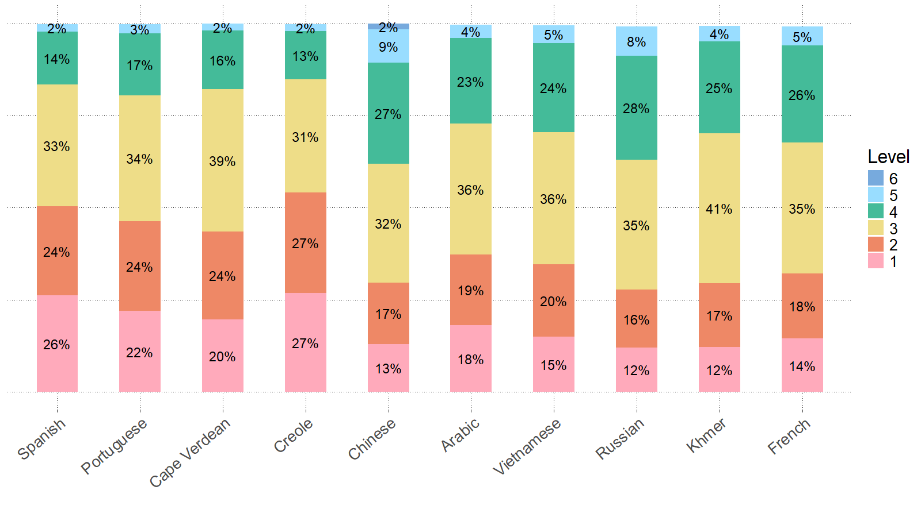

Table 24. 2025 Average Proficiency Level of Students by Home Language Disaggregated by Grade Span
Grade Span | Arabic | Cape Verdean | Chinese | Creole | French | Khmer | Portuguese | Russian | Spanish | Vietnamese
K | 2.3 | 2.1 | 2.8 | 1.8 | 2.4 | 2.3 | 1.8 | 2.4 | 1.8 | 2.3
1 | 3.0 | 2.7 | 3.5 | 2.6 | 3.1 | 2.8 | 2.6 | 3.2 | 2.6 | 3.0
2–3 | 3.5 | 3.2 | 3.8 | 3.0 | 3.5 | 3.5 | 3.2 | 3.9 | 3.1 | 3.6
4–5 | 3.9 | 3.6 | 4.1 | 3.4 | 4.0 | 4.1 | 3.6 | 4.1 | 3.6 | 4.0
6–8 | 3.1 | 3.0 | 3.4 | 3.0 | 3.5 | 3.4 | 3.1 | 3.5 | 3.0 | 3.3
9–12 | 3.1 | 3.0 | 3.6 | 3.0 | 3.2 | 3.5 | 3.1 | 3.5 | 2.8 | 3.4

Table 25. 2025 Average Proficiency Level of Students by Home Language Disaggregated by Years in Ma
Years in MA | Arabic | Cape Verdean | Chinese | Creole | French | Khmer | Portuguese | Russian | Spanish | Vietnamese
First Year | 2.5 | 2.2 | 3.1 | 2.3 | 3.1 | 2.6 | 2.2 | 2.9 | 2.0 | 2.7
Second Year | 3.1 | 2.8 | 3.6 | 3.0 | 3.4 | 3.0 | 2.9 | 3.5 | 2.6 | 3.2
Third Year | 3.6 | 3.3 | 3.8 | 3.3 | 3.7 | 3.5 | 3.3 | 3.9 | 3.1 | 3.5
Fourth Year | 3.8 | 3.4 | 3.9 | 3.5 | 3.7 | 3.7 | 3.4 | 4.2 | 3.3 | 3.7
Fifth Year | 4.2 | 3.7 | 4.4 | 3.9 | 4.0 | 4.2 | 3.9 | 4.3 | 3.8 | 4.1
Sixth+ Year | 3.6 | 3.4 | 3.7 | 3.6 | 3.5 | 3.5 | 3.5 | 3.7 | 3.4 | 3.6

Appendix A. Performance Definitions for the WIDA ACCESS Levels of English Language Proficiency

The material in this chart is available with read-aloud capabilities at WIDA Performance Definitions – Listening and Reading.
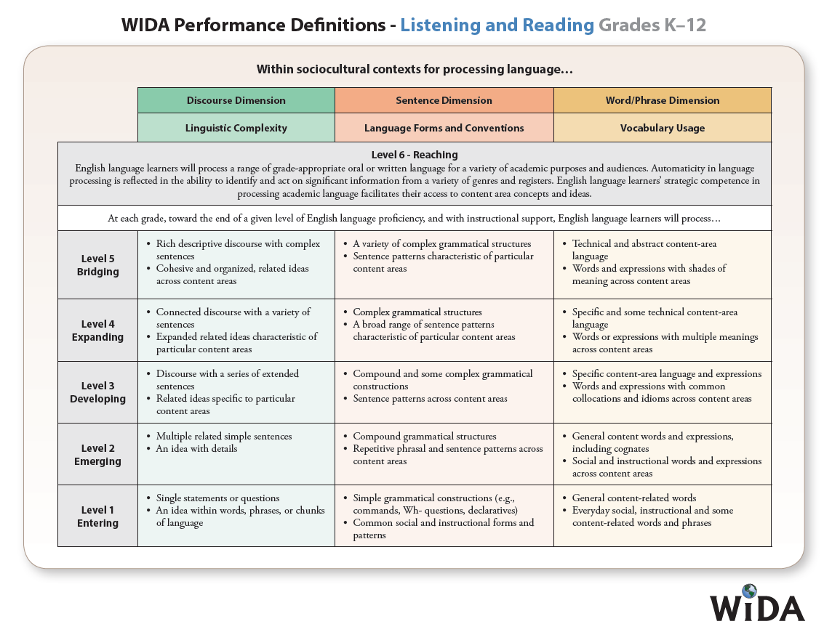

The material in this chart is available with read-aloud capabilities at WIDA Performance Definitions – Speaking and Writing.
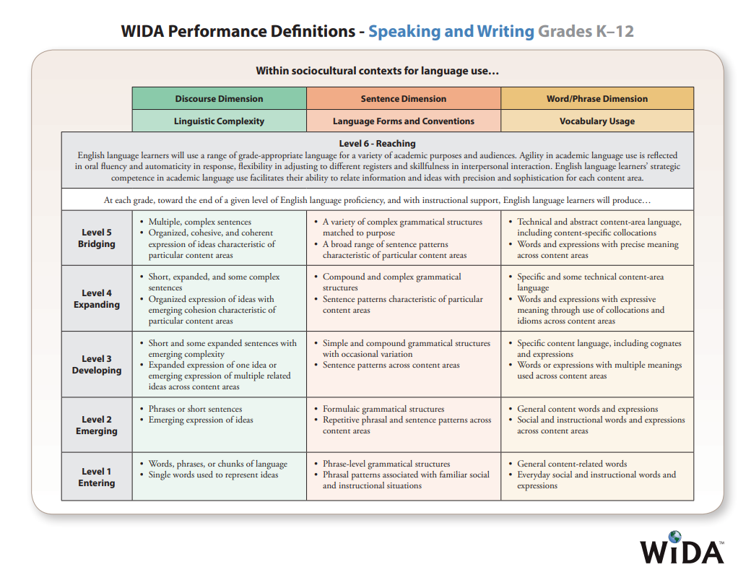

Appendix B. WIDA Alternate ACCESS Performance Definitions
The material in these charts is available with read-aloud capabilities at WIDA Alternate Proficiency Level Descriptors.
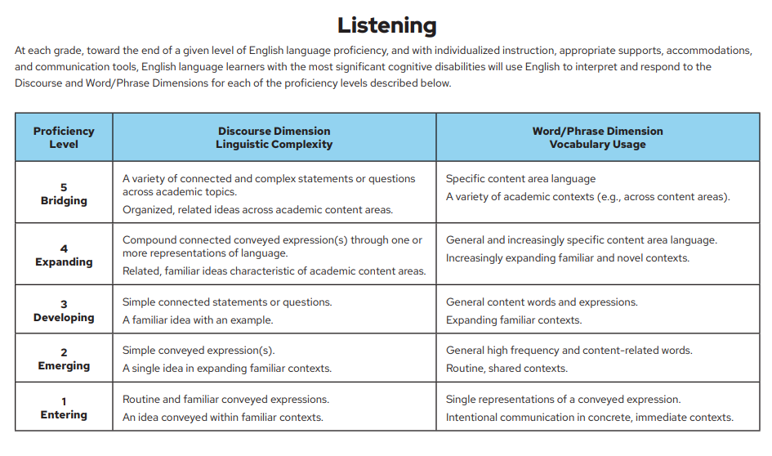
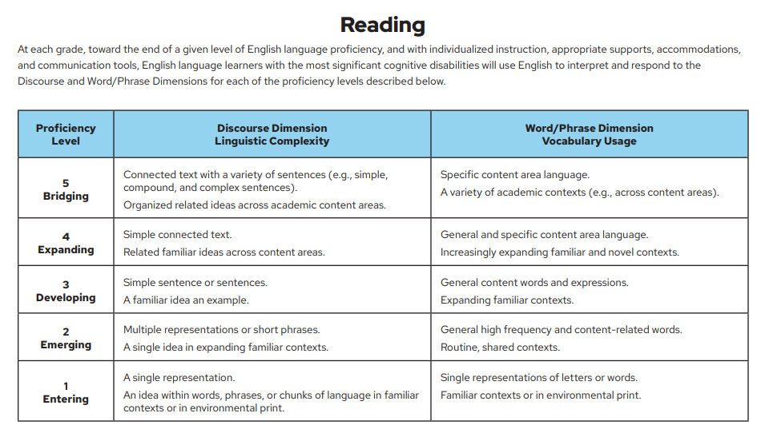

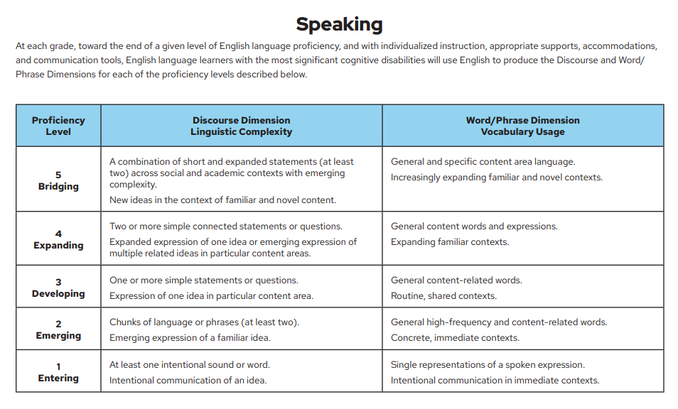
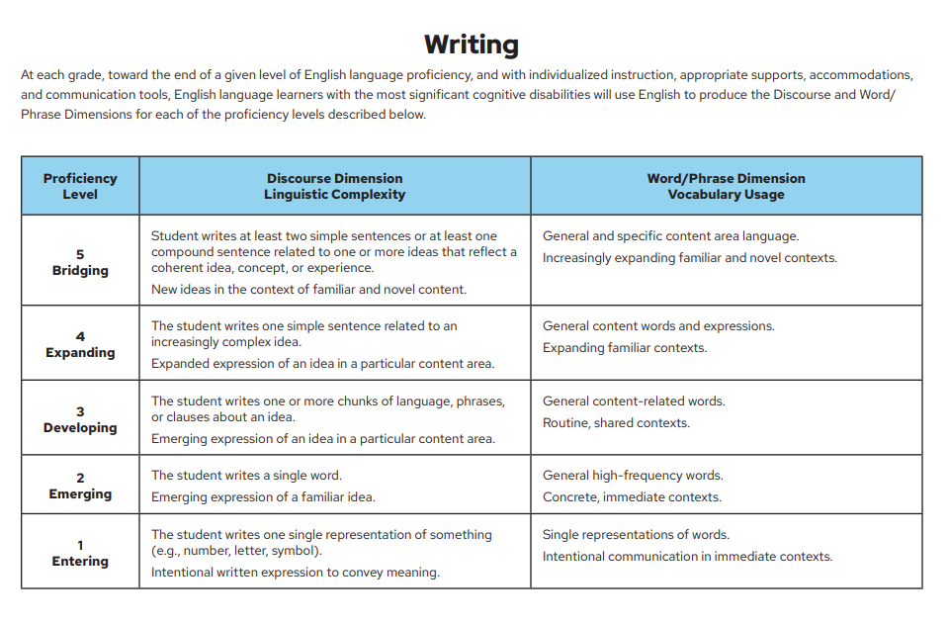

Suppressed data in all tables include any results with fewer than 10 students and are indicated by dashes (-).

