MCAS Grades 6–8 ELA Extended Response
Approved Blank Graphic Organizer
for Students with Accommodation A9
INSTRUCTIONS:
The following supplemental organizer is ONLY for students who have accommodation A9 listed in their IEP or 504 plan.
Before testing:
Students should be familiar with the available organizer prior to testing. A graphic organizer may be used as is, enlarged, or printed on different colored paper. Schools may omit sections that are not used by their students but are not permitted to add text. A locally developed text-less organizer (one that includes only lines and shapes, no words or letters) may be used without approval.
Schools should print out the allowable organizers that are used by their students and distribute to students who have accommodation A9 so that students can practice using the organizer. Schools should also remind students that during testing they may only use an organizer that has not yet been filled in.
During testing:
At the start of each test session, test administrators should check that they are only providing organizers that have not already been filled in, and that they are providing them only to students who have accommodation A9 in their IEP or 504 plan.
Test administrators should remind students that they may not use any organizers that were filled in previously, nor any other reference materials or notes. Results may be invalidated for students who use an organizer that has already been filled in.
Note: Students may ONLY be provided with a blank graphic organizer to use during testing.
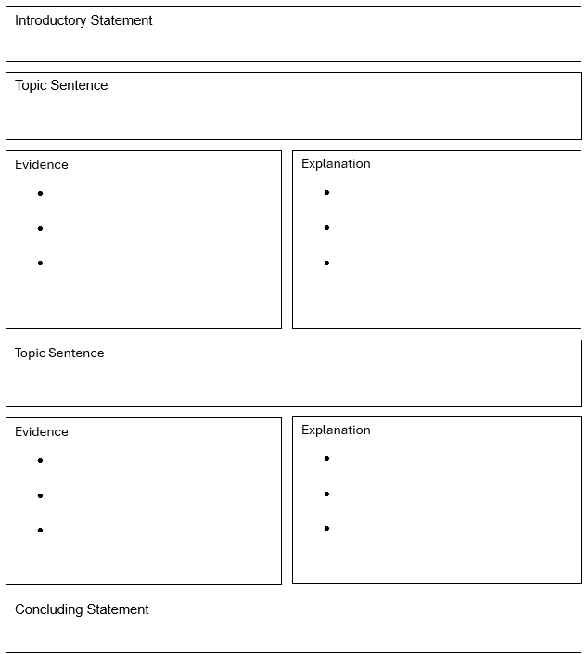
Check your work:
- Are my ideas clear and organized?
- Does the evidence from the passages(s) support my response?
- Did I fix errors in grammar, spelling and punctuation?

