# MEMORANDUM

|  |  |
| --- | --- |
| **To:** | Interested Educators and Members of the Public |
| **From:** | Rob Curtin, Chief Officer for Data, Assessment, and Accountability |
| **Date:** | November 12, 2024 |
| **Subject:** | Notice of Intent to Apply and Opportunity to Comment on DESE's Waiver Extension Request Related to the Percentage of Students Who Participate in the MCAS Alternate Assessment |

The Massachusetts Department of Elementary and Secondary Education (DESE) intends to seek an extension of its existing waiver of the federal requirement that would limit the number of students in the state who take alternate assessments to one percent of students who take the general MCAS tests.

**The purpose of this notice is to provide an opportunity for the public to comment** on the request for a waiver by DESE for the 2024-2025 school year. A waiver of the one percent requirement was granted to Massachusetts by the U.S. Department of Education in 2017, and waiver extensions were granted each year since then.

One of the requirements of the reauthorized Elementary and Secondary Education Act, also known as the [Every Student Succeeds Act](https://www.gpo.gov/fdsys/pkg/BILLS-114s1177enr/pdf/BILLS-114s1177enr.pdf) (ESSA), stipulates that states must limit the total number of students that participate in an *alternate assessment based on* *alternate achievement standards* (i.e., the MCAS-Alt) to one percent of the total number of students who participate in each state assessment. This legislative requirement is designed to ensure an excessive number of students with disabilities are not evaluated on alternate academic achievement assessments because an alternate assessment has lower academic expectations and may unnecessarily limit exposure and expectations to the full range of grade-level academic content standards. Participation in alternate assessments may also delay or prevent students from eventually meeting their state or district graduation requirements. Only students that meet the state’s definition of a student with the *most significant cognitive disabilities* may be administered alternate assessments because these students are unable to participate in standard assessments and are working on standards that are significantly modified in depth, breadth, and complexity. A waiver, if granted, indicates that while some districts have made progress in reducing the percentage of students with disabilities participating in the alternate assessment, our state requires time to educate and refine our procedures to meet the one-percent cap requirements. DESE continues to develop evolved procedures to assist districts with implementing procedures to designate students for an alternate assessment.

The percent of Massachusetts students who participated in the MCAS-Alt (in English language arts, mathematics, and/or science) since 2017 is shown below:

* In 2016–2017, 1.6 percent
* In 2017–2018, 1.5 percent
* In 2018–2019, 1.4 percent
* In 2019–2020 (estimate), 1.35 percent would have participated in the MCAS-Alt if the spring 2020 MCAS and MCAS-Alt administrations had not been canceled due to extended school closures related to the COVID-19 pandemic. (Projection based on district pre-enrollments and pre-orders of materials.)
* In 2020–2021, 1.3%
* In 2021–2022, 1.2%
* In 2022–2023, 1.2% in English language arts and mathematics and 1.1% in science and technology/engineering
* In 2023–2024, 1.2% in English Language Arts (a decrease of 97 students since 2023), 1.2% in Mathematics (a decrease of 50 students since 2023), and 1.2% in Science and Technology/Engineering (STE) (an increase of 0.1% percent from 2023 resulting from a change in content participation requirements).

Collectively, districts in Massachusetts have made steady progress to reduce the percentage of students participating in the MCAS-Alt. Reaching the 1.0 percent cap set by ESSA may take additional time. In pursuit of this goal, DESE has annually updated [guidance and resources](https://www.doe.mass.edu/mcas/alt/essa/) on this topic for Massachusetts schools and districts and will continue to provide LEAs evolved trainings, strategies, and oversight to reach the 1.0 percent cap.

We welcome your comments regarding our intent to apply for this waiver. Comments may be submitted via email to MCAS@mass.gov until December 13, 2024.

**Massachusetts “One Percent” ESSA Waiver Extension Request**

**for School Year** **2024-2025**

1. **Notice of intent to apply for a waiver and opportunity for public comment**

On November 12, 2024, the Massachusetts Department of Elementary and Secondary Education posted a *Notice of Intent to Apply and Opportunity for Comment Regarding a Waiver Extension of the Federal Requirement Related to the Percentage of Students Who Participate in Statewide Alternate Assessments* to solicit public comment by December 13, 2024.

* Notice of Intent (11/12/24)
* MCAS Headlines (11/12/24)
* MCAS-Alt Headlines (11/12/24)
* Student Assessment Services Update (11/12/24)
* Commissioner’s Weekly Update (11/18/24)
* MCAS-Alt Update (November 2024)

The postings of the Notice of Intent will be documented at the end of the submitted *Request a Waiver Extension for the 2024–2025 School Year from the 1.0 Percent Cap on the Percentage of Students with the Most Significant Cognitive Disabilities Who May Be Assessed with an Alternate Assessment Aligned with Alternate Academic Achievement Standards (AA-AAAS)*. Any comments and responses to those comments will be forwarded to the US Department of Education – Office of Elementary and Secondary Education following the closing of the public comment period.

1. **Waiver request submitted at least 90 days before start of testing window [§200.6(c)(4)(i)]**

The MCAS-Alt assessment window begins on the first day of the school year, although educators may begin the alternate assessment process at different points throughout the school year. The testing window will end with submission of these alternate assessments on Friday, March 28, 2025. We are unable to submit our extension waiver request earlier (in June 2024) because the annual assessment timeline results in participation reports and stakeholder feedback being available in fall 2024. We found it necessary to review last year’s assessment participation reports and stakeholder feedback prior to determining if an extension of the **2023–2024** waiver would again be warranted. Our review of participation data provides evidence that the alternate assessment participation numbers continue to decrease in most subjects. Our continued goal is to reach the 1.0 percent cap. Since last year was our first year implementing the substantially new definition of students with the most significant cognitive disabilities, revised eligibility guidance, and a corresponding statement of assurance, we anticipated that LEAs would require a transition period to fully implement the new guidance. **In the coming year, DESE plans to evolve its monitoring practices and technical assistance supports to ensure LEAs are correctly and fully applying the updated eligibility criteria when determining eligibility for an AA-AAAS**. We are submitting this waiver extension request in response to the USED memo to states dated September 20, 2024, that provided “Requirements to Request a Waiver/Waiver Extension for the 2024-25 School Year from the 1.0 Percent Cap on the Percentage of Students with the Most Significant Cognitive Disabilities Who May Be Assessed with an Alternate Assessment Aligned with Alternate Academic Achievement Standards (AA-AAAS)” outlining the terms and criteria for submitting waiver and waiver extension requests.

1. **Assessment participation by number and percentage of all students and students in each subgroup [§200.6(c)(4)(ii)]**

**Table 1: Overall Rates of Assessment Participation for SY 2023–24**

|  |  |  |  |  |  |  |
| --- | --- | --- | --- | --- | --- | --- |
|  | ELA Grades 3–8 and HS | | Math Grades 3–8 and HS | | Science and Technology/Engineering Grades 5, 8, and HS | |
|  | All students | Students with disabilities | All students | Students with disabilities | All students | Students with disabilities |
| Students Assessed | 474,792 | 101,734 | 474,900 | 101,829 | 207,907 | 42,836 |
| Students Enrolled | 480,706 | 104,474 | 480,583 | 104,437 | 209,861 | 43,771 |
| Assessment Participation Rate | 99% | 97% | 99% | 98% | 99% | 98% |
| Assessment Participation Rate | | | | | | |

**Table 2: AA-AAAS Participation Rates by Subgroup for SY 2023–24 - ELA**

|  |  |  |  |
| --- | --- | --- | --- |
| ELA | Total Number in Grades 3-8 & HS | Number Taking AA-AAAS in Grades 3-8 & HS | Percent Taking AA-AAAS in Grades 3-8 & HS |
| All Students | 474,792 | 5,725 | 1.21% |
| Hispanic | 118,727 | 1,703 | 1.43% |
| American Indian/Alaskan Native | 1,059 | 19 | 1.79% |
| Asian | 35,741 | 427 | 1.19% |
| Black | 46,006 | 924 | 2.01% |
| Hawaiian/Pacific Islander | 418 | 4 | 0.96% |
| White | 251,428 | 2,390 | 0.95% |
| Two or More Races | 21,243 | 257 | 1.21% |
| Male | 243,396 | 3,944 | 1.62% |
| Female | 230,653 | 1,781 | 0.77% |
| English Learner | 60,909 | 1,003 | 1.65% |
| Limited Income | 214,947 | 3,868 | 1.80% |

**Table 3: AA-AAAS Participation Rates by Subgroup for SY 2023–24 - Math**

|  |  |  |  |
| --- | --- | --- | --- |
| Mathematics | Total Number in Grades 3-8 & HS | Number Taking AA-AAAS in Grades 3-8 & HS | Percent Taking AA-AAAS in Grades 3-8 & HS |
| All Students | 474,900 | 5,839 | 1.23% |
| Hispanic | 118,886 | 1,772 | 1.49% |
| American Indian/Alaskan Native | 1,066 | 20 | 1.88% |
| Asian | 35,833 | 435 | 1.21% |
| Black | 46,097 | 938 | 2.03% |
| Hawaiian/Pacific Islander | 421 | 5 | 1.19% |
| White | 251,195 | 2,403 | 0.96% |
| Two or More Races | 21,186 | 265 | 1.25% |
| Male | 243,609 | 4,015 | 1.65% |
| Female | 230,558 | 1,824 | 0.79% |
| English Learner | 61,493 | 1,116 | 1.81% |
| Limited Income | 215,002 | 3,977 | 1.85% |

**Table 4: AA-AAAS Participation Rates by Subgroup for SY 2023–24 – Science**

|  |  |  |  |
| --- | --- | --- | --- |
| Science and Technology/Engineering | Total Number in Grades 3–8 & HS | Number Taking AA-AAAS in Grades 3-8 & HS | Percent Taking AA-AAAS in Grades 3-8 & HS |
| All Students | 207,907 | 2,511 | 1.21% |
| Hispanic | 52,508 | 769 | 1.46% |
| American Indian/Alaskan Native | 478 | 6 | 1.26% |
| Asian | 15,712 | 188 | 1.20% |
| Black | 21,210 | 375 | 1.77% |
| Hawaiian/Pacific Islander | 178 | 2 | 1.12% |
| White | 108,845 | 1,060 | 0.97% |
| Two or More Races | 8,905 | 110 | 1.24% |
| Male | 106,858 | 1,720 | 1.61% |
| Female | 100,585 | 791 | 0.79% |
| English Learner | 25,725 | 468 | 1.82% |
| Limited Income | 94,564 | 1,694 | 1.79% |

**Table 5: AA-AAAS Rates by Subject, by year**

|  |  |  |  |
| --- | --- | --- | --- |
| School Year | ELA | Mathematics | Science |
| 2017–2018 | 1.6% | 1.6% | - |
| 2018–2019 | 1.5% | 1.5% | - |
| 2019–2020 | - | - | - |
| 2020–2021 | 1.3% | 1.3% | 1.0% |
| 2021–2022 | 1.2% | 1.2% | 1.2% |
| 2022–2023 | 1.2% | 1.2% | 1.1% |
| 2023–2024 | 1.2% | 1.2% | 1.2% |
| *2024–2025 (estimate) | 1.1% | 1.1% | 1.1% |

**Table 6: 2024 MCAS and MCAS-Alt Participation by Nature of Primary Disability**

NOTE: Percentage may not total 100% due to rounding.

|  |  |  |  |  |
| --- | --- | --- | --- | --- |
| **Primary Disabilityb** | **A:**  **Number of All Assessed Participants in Disability Categorya** | **B:**  **Number of MCAS-Alt Participants in Disability Category** | **C:**  **Percentage of All Assessed Students in Disability Category Who Took MCAS-Alt (B/A)** | **D:**  **Percentage of MCAS-Alt Participants in Disability Category (B/6,109)** |
| Autism | 15,270 | 3,247 | 21.3% | 53.2% |
| Communication | 11,835 | 134 | 1.1% | 2.2% |
| Developmental Delay | 1,939 | 91 | 4.7% | 1.5% |
| Emotional | 11,251 | 28 | 0.2% | 0.5% |
| Health | 22,009 | 122 | 0.6% | 2.0% |
| Intellectual | 3,990 | 1,433 | 35.9% | 23.5% |
| Multiple Disabilities | 758 | 362 | 47.8% | 5.9% |
| Neurological | 6,907 | 515 | 7.5% | 8.4% |
| Physical | 352 | 12 | 3.4% | 0.2% |
| Sensory/Deaf and Blind | 86 | 18 | 20.9% | 0.3% |
| Sensory/Hard of Hearing or Deaf | 615 | 43 | 7.0% | 0.7% |
| Sensory/Vision Impairment or Blind | 338 | 31 | 9.2% | 0.5% |
| Specific Learning Disabilities | 37,198 | 42 | 0.1% | 0.7% |
| Unidentified Disability | 174 | 31 | 17.8% | 0.5% |
| **Total** | **112,722** | **6,109** | **5.4%** | **100.0** |
| a The number of students with disabilities participating in standard MCAS and MCAS-Alt for accountability purposes in at least one subject. | | | | |
| b Primary disability data were reported by districts to the Department's Student Information Management System (SIMS) in March and June 2024. | | | | |

1. **34 CFR § 200.6(c)(4)(iii) requires assurances from the SEA that it verified that each district with more than 1.0 percent participation in the alternate assessment has: (A) Followed participation guidelines; and (B) Will address any disproportionality in participation in the alternate assessment.**
2. The state has reviewed the 2023–2024 MCAS-Alt statement of assurances for each LEA. **We received the *Statement of Assurance* from all 112 LEAs who were required to respond.** Through reviewing each statement of assurance, DESE determined that although many LEAs completed each requirement, some LEAs are still in the process of adopting the revised alternate assessment eligibility criteria (i.e., definition of *students with the most significant cognitive disabilities*) and working towards educating IEP Teams on the revised eligibility determination. In addition, beginning last school year, each LEA was required to complete the new [***Companion Document: Alternate Assessment Participation Tool***](https://www.doe.mass.edu/mcas/alt/essa/participation-tool.pdf) for each student that participates in the MCAS-Alt.We began outreach and training efforts last year to understand the types of assistance needed for ongoing training resources and support. An updated tiered monitoring plan has also been implemented.The updated participation guidelines described in the state’s MCAS-Alt resources and training materials can be found at:

<https://www.doe.mass.edu/mcas/alt/default.html> <https://www.doe.mass.edu/mcas/participation.html> <https://www.doe.mass.edu/mcas/accessibility/default.html>

1. An evolved and updated statement of assurances requires districts not only to be aware of any disproportionate designation, but also to **explain their method to determine if disproportionality is present. As a new procedure for the 2024–2025 school year, DESE has provided a risk ratio tool kit (see exhibits), plus additional resources** and training to support LEAs in how to determine, and if necessary, how to address the disproportionate representation of students from subgroups:
   * English learners, who are 1.5 times more likely statewide to take the MCAS-Alt than non-ELs
   * African American students, who are 1.7 times more likely to take the MCAS-Alt than non-African American students
   * Hispanic/Latino students, who are 1.20 times as likely to take the MCAS-Alt than non-Hispanic/Latino students
   * male students, who are about twice as likely to take the MCAS-Alt than female students
   * low-income students, who are 2.0 times as likely to take the MCAS-Alt than students who are not low income

As an active member of the National Center for Education Outcome’s Community of Practice, DESE has adopted the guidance described in the NCEO publication *Disproportionality in the Alternate Assessment Calculator: A Tool for State and Local Education Agencies.*

The statement of assurances supports districts in addressing disproportionality by providing them with access to a [publication from issued by The National Center on Educational Outcomes (NCEO)](https://nceo.umn.edu/docs/OnlinePubs/NCEOBrief18.pdf), outlining specific steps for examining disproportionality in alternate assessments.

1. **Progress on the state’s plan and timeline to reduce the number of students taking the AA-AAS [(§200.6(c)(4)(v)]**
2. **Improved Massachusetts Participation Guidelines for AA-AAAS (evolved guidance *planned tiered support plan for 2024–2025 school year*)**

Last year, DESE released a new definition of a student with the most significant cognitive disabilities, and began providing technical assistance around the new definition (see exhibits). The state engaged to educate districts—particularly districts that have exceeded the 1.0 percent threshold in previous years—regarding these [new materials and updated resources](http://www.doe.mass.edu/mcas/alt/essa/) that can support them in lowering their district’s alternate assessment participation rates.

As stated in the previous waiver extension request, Massachusetts focused on disseminating **the state’s new definition** **of a student with the most significant cognitive disabilities** and educating districts on how to implement the state’s new definition. The state engaged to educate districts—particularly districts that have exceeded the 1.0 percent threshold in previous years—regarding these [new materials and updated resources](http://www.doe.mass.edu/mcas/alt/essa/) that can support them in lowering their district’s alternate assessment participation rates. Massachusetts required that LEAs review specific cognitive and adaptive behavior functioning levels of all students designated for an alternate assessment. The new eligibility criteria was emphasized in last year’s statement of assurances sent to all districts over the 1.0 percent cap. The 2023–2024 school year was a transition year for schools to learn and adopt the new eligibility criteria. Our LEAs communicated to DESE through the submitted statement of assurances and informal questions that some schools and educators did not have objective evaluation data required to comply with all aspects of the definition and criteria. For example, some LEAs indicated that not all schools completed the new Tool. Additionally, some LEAs did not have updated measures of cognitive and adaptative behavior for students designated for the alternate assessment. DESE delivered two new training courses on Alternate Assessment Participation Criteria in January and February 2024. In response to districts’ request for information on how to obtain adaptive behavior assessment data, DESE provided appropriate resources and information.

In fall 2024, DESE delivered several updated webinars that included a focus on the new participation requirements. Over 3,000 educators or administrators participated in these training sessions and DESE made recordings of the sessions available online (see exhibits). Over 3,000 educators or administrators participated in these training sessions.

As a new step in fall 2024, DESE’s Office of Student Assessment Services partnered with our Office of Special Education Policy and Planning to deliver new training courses included in our monthly *Special Education Leaders Meetings* (see exhibits). The information sessions were attended by primarily special education directors. We described the updated participation requirements and new disproportionality calculator tool.

Last year’s new definition of **a student with the most significant cognitive disabilities** marked a substantial change for our districts. We anticipate greater progress reaching the 1.0 percent cap during the 2024–2025 school year.

The overall number and percentage of students who participated in the **2024 MCAS-Alt** in each subject is shown below.

* **English Language Arts (ELA)**: 5,725/474,792 = **1.21**%
  + A decrease of 97 students since 2023
* **Mathematics**: 5,839/474,792 = **1.23 percent**
  + a decrease of 50 students since 2023
* **Science and Technology/Engineering (STE)**: 2,511/207,907 = **1.21 percent**
  + An increase of 129 students from 2023*

*The increase in students participating in the science and technology/engineering MCAS-Alt can be linked to DESE’s recent revised guidance on MCAS-Alt participation. Last year’s MCAS-Alt trainings and resources clarified that student participation in the general or alternate assessment must be consistent for all content areas. A student that is designated for the MCAS-Alt must participate in alternate assessment in all grade content areas. Therefore, all participation rates should be similar, as indicated by the subject participation percentages for 2023–2024 school year.

Since 2017, the state has annually taken steps that have achieved a steady reduction in the participation rate (see figure 1 on next page).

|  |  |  |  |
| --- | --- | --- | --- |
|  | **ELA** | **Math** | **Science** |
| 2017 | 1.60% | 1.61% |  |
| 2018 | 1.47% | 1.48% |  |
| 2019 | 1.38% | 1.39% | 1.31% |
| 2021 | 1.29% | 1.30% | 0.99% |
| 2022 | 1.24% | 1.25% | 1.16% |
| 2023 | 1.24% | 1.24% | 1.14% |
| 2024 | 1.21% | 1.23% | 1.21% |

1. **Additional Steps to Support and Provide Oversight**

Last school year the Student Assessment Office increased collaboration with our Office of Special Education Policy and Planning and Office of Public School Monitoring. We have continued this collaboration to add additional materials and resources (as described above in section A). We have already convened several webinars during this school year for the state’s LEA special education directors and educators that include emphasis on topics that affect the one percent cap (e.g., alternate assessment eligibly, statement of assurances, ESSA requirements, parent notification requirement). DESE has reviewed attendance participation for our fall webinars and found that over 3,000 district educators and administrators attended one or more of these MCAS-Alt trainings this fall. Our training sessions continue to focus on strategies to implement the **updated eligibility definition for a student with the most significant cognitive disability**. Through our statement of assurances and training sessions, we have found that some of our districts need technical assistance to understand how to assess students for adaptative behavior, which is an important component of the new eligibility requirement. DESE’s Alternate Assessment Participation Criteria training sessions (described in section A).

As a new procedure, this fall DESE’s Office of Public School Monitoring has begun reviewing MCAS-Alt eligibility decisions by incorporating the new eligibility requirements and *Participation Tool* requirements in our web-based monitoring system (WBMS) — an online only application (see excerpt from the *WBMS application* on page 16).

The state will continue to closely monitor each district regarding 1) the percentage of assessed students taking the MCAS-Alt; 2) progress and trends over two or more years in reducing the district’s overall MCAS-Alt percentage; 3) whether the district has identified and is addressing any disproportionality in their student subgroup participation in the MCAS-Alt; and 4) whether the district is using the ***revised definition for students with the most significant cognitive disabilities as their criteria***. These priorities are again reflected in the revised statement of assurances sent to districts this year.

In another improved and evolved step, the state will complete a new monitoring process and training process. All districts that have over 2.0 percent of students participating in the MCAS-Alt assessment will receive a targeted webinar session, and DESE will ask for participation acknowledgement (e.g., names and titles of educators that attended that webinar). DESE is once again **requesting that districts** complete the *Alternate Assessment Participation Tool* for every student who participates in an alternate assessment as additional assurance that the student meets these new guidelines. As an improved resource for fall 2024, DESE provided a sample *Alternate Assessment Participation Tool (see exhibit)* to assist districts in correctly following the criteria for participation in the alternate assessment. The IEP team must document evidence used to determine whether the student meets the *revised eligibility definition for a student with the most significant cognitive disabilitie*s.

1. **Addressing any Disproportionality**

As described in section 4(B) above, DESE will continue to promote the use of the [publication issued by The National Center on Educational Outcomes (NCEO)](https://nceo.umn.edu/docs/OnlinePubs/NCEOBrief18.pdf) to assist districts with understanding disproportionality in designation for an alternate assessment. As an evolved procedure and resource, DESE updated the statement of assurances to include a requirement to explain how each district determined whether disproportionality was present. A new risk ratio tool has been made available (see exhibits) for districts to analyze participation by subgroup. This fall DESE launched a training session (see exhibits) describing how to use the risk ratio tool and other resources to address disproportionality. At the recent training, districts were able to ask questions and receive technical support. Last school year, during the development of the state’s definition for students with the most significant cognitive disabilities, we convened meetings with stakeholders in the state offices, LEAs and advocacy organizations. Specifically, we engaged the Center for Law & Education to discuss methods to prevent students from historically marginalized subgroups being designated for alternate assessments. We intend to offer additional feedback sessions to gain more knowledge from our stakeholder groups, including the Massachusetts Advocates for Children.

As with previous years, a **memo from the Commissioner and statement of assurances** will be sent in early December to districts that exceeded 1.0 percent of tested students taking the MCAS-Alt in 2024. (See the Exhibits section for a draft of this communication.)

1. **Summary of Waiver Extension Request**

The state carefully reviewed the *Requirements to Request a Waiver/Waiver Extension for the 2024-25 School Year from the 1.0 Percent Cap on the Percentage of Students with the Most Significant Cognitive Disabilities Who May Be Assessed with an Alternate Assessment Aligned with Alternate Academic Achievement Standards (AA-AAAS)* and our previous actions and guidance. The state completed the following actions:

* conducted new and revised technical assistance training sessions to districts, explaining the 1% cap
* reviewed statements of assurances received from LEAs (all LEAS responded as required)
* posted updated revised technical assistance training documents and resources
* convened regular meetings with State Director of Special Education, the Student Assessment Office, and the Special Education Planning and Policy Office (SEPP)
* collaborated with the One Percent Community of Practice (CoP), coordinated by the National Center on Educational Outcomes (NCEO) (ongoing)
* coordinated with other DESE offices on the topic of disproportionality in order to identify root causes (ongoing)
* identified districts with especially high rates of alternate assessment participation
* created opportunities for districts to share knowledge on how to reduce participation rates collaborate with high percentage rate districts
* reviewed increases in MCAS-Alt Science and Technology/Engineering participation and determined results aligned with recent policy changes
* reviewed all our strategies for reducing the MCAS-Alt participation rates

DESE significantly evolved alternate assessment resources, guidance, training sessions, and alternate assessment eligibility criteria last school year. The state’s 2023-24 school year alternate assessment participation decreased slightly. Only the student’s IEP Team can make determinations as to whether the student is designated for an alternate assessment. IEP Teams annual review dates do not occur at a specific point in time; rather, IEP Teams annual meetings occur throughout the student’s school year and may occur after a student has participated in the state-wide content assessment. Given these factors, we anticipated that Massachusetts’ districts would take time to fully and correctly implement the revised guidance and would exceed the one percent threshold last school and will likely exceed the one percent threshold for 2024-25 school year. However, the state’s steady alternate assessment participation reduction provides evidence to our commitment to meeting the 1.0 percent cap. The steady participation reduction undoubtedly resulted from the evolved policies, monitoring, and resources to limit the number of students participating in alternate academic achievement assessments.

The communication DESE received from special education directors and educators last year and this school year indicates that districts have begun to incorporate the revised eligibility definition for a student with the most significant cognitive disabilities. Since districts have begun implementing the revised guidance and practices throughout the schools, DESE’s offices of Student Assessment Services and Public School Monitoring have received more questions on how to apply the new revised alternate assessment eligibility criteria. DESE anticipates gradual reduction during the 2024-25 school year and we look forward to working closely with the districts with the expectation to meet the one percent cap in the future.

EXHIBITS

Documents and guidance for district leaders and edcutors for reducing the number of students   
taking AA-AAS

**Exhibit from the Web Based Monitoring (WBS) Program through our Office of Public School Monitoring**

https://www.doe.mass.edu/psm/

<https://www.doe.mass.edu/psm/tfm/default.html>

<https://www.doe.mass.edu/psm/integrated/default.html>

Image of online monitoring checklist

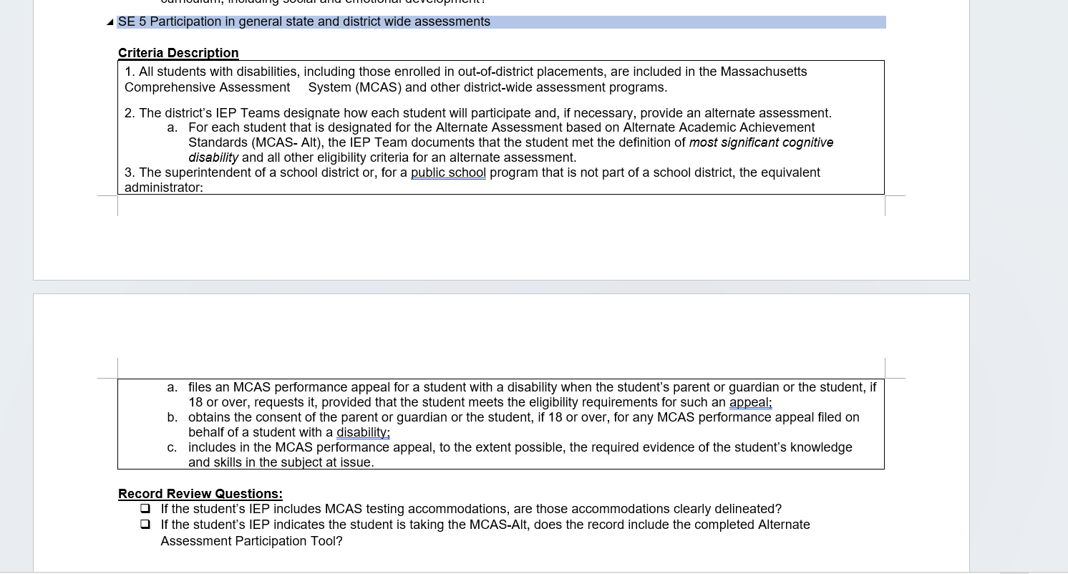

**Exhibit of Decision Making tool available in DESE’s publications:**

**Appendix A: Decision-Making Tool for MCAS Participation by Students with Disabilities**

Use the definition and the questions below to guide discussions of how students will participate in MCAS testing.

Massachusetts defines “students with the most significant cognitive disabilities” as those who meet **all** of the following criteria:

* have cognitive disabilities evidenced by significant delays in attaining age-level academic achievement standards, even with systematic, extensive individually designed instruction, related services, and modifications
* have cognitive disabilities that significantly impact their educational performance and ability to apply learning from one setting to another
* require extensive, direct individualized instruction and substantial supports to achieve measurable gains on the challenging State academic content standards for the grade in which the student is enrolled
* perform significantly below average in general cognitive functioning and adaptive behavior.   
  Note: “Significantly below average”is defined as a student functioning two or more standard deviations below the mean on commonly accepted norm-referenced assessments in both cognitive functioning and adaptive behavior (e.g., two or more adaptive skill areas such as daily living skills, communication, self-care, social skills, and academic skills).

Question 1: Does this student with disabilities meet the definition for "students with the most significant cognitive disabilities" as described above?
YES: The student is eligible for the MCAS-Alt. Note: Simply because the student is eligible does not warrant the Team to administer the MCAS-Alt. Students taking the MCAS-Alt likely will face challenges earning their high school diploma.
NO: Proceed to question 2.

Question 2: Does this student with disabilities require specific and allowable accommodations and accessibility features to demonstrate knowledge and skills on assessments?
YES: The student's IEP or 504 plan must include the specific allowable accommodations and accessibility features for MCAS testing, which should generally mirror accommodations the student receives during routine instruction.
NO: The student must participate in the standard MCAS testing using available accessibility features. Accommodations may be included int he student's IEP or 504 plan later if the student's needs change.

**Exhibit of Alternate Assessment Participation Tool Companion Document**

Available at DESE’s website: https://www.doe.mass.edu/mcas/alt/essa/default.html

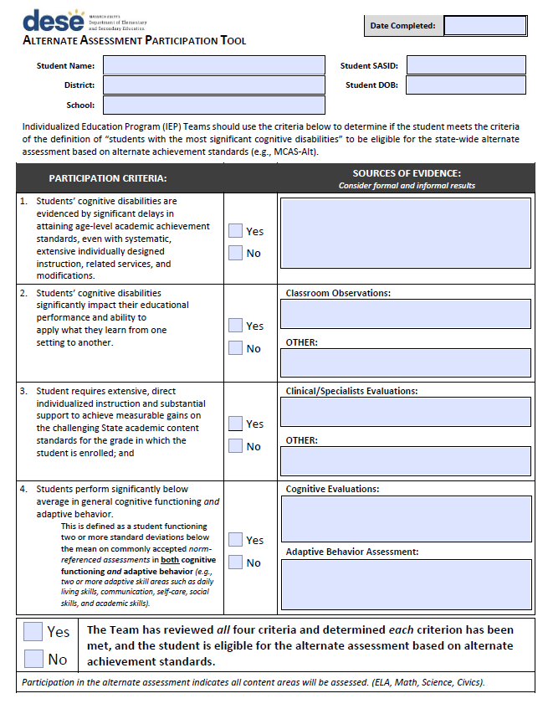

**Exhibit of Alternate Assessment Participation Tool Companion Document**

Sample for Districts (new document for 2024–2025)

Available at the DESE’s website: https://www.doe.mass.edu/mcas/alt/essa/default.html

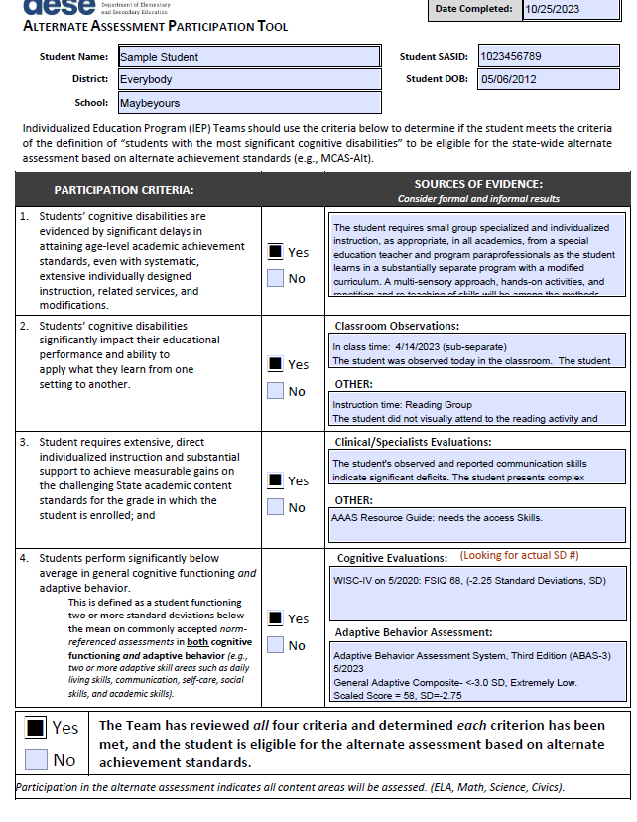

**Exhibit of Updated Training Resources Materials for Districts to determine if students are eligible for the Alternate Assessment (Revised document for 2024–2025)**

Available at the DESE’s website: https://www.doe.mass.edu/mcas/alt/essa/default.html

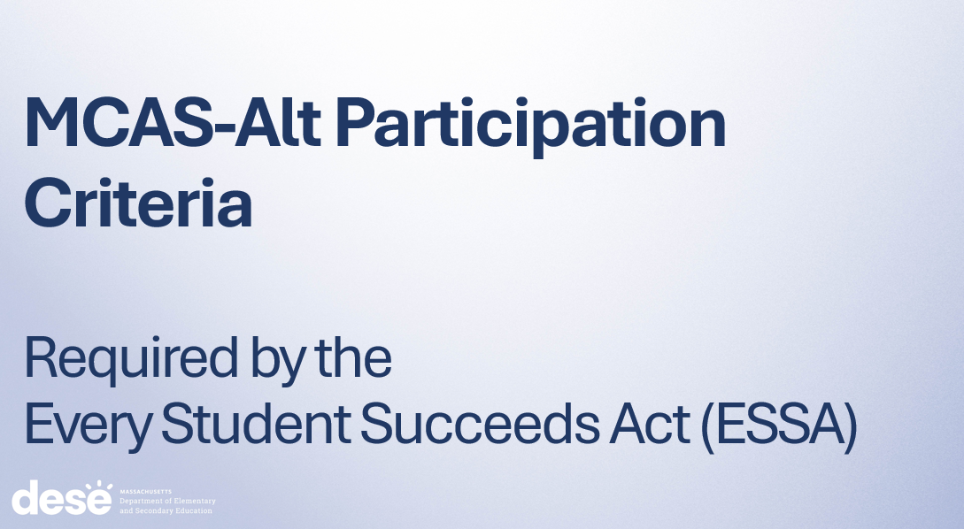

**Exhibit of New Sample Formula Worksheet to Calculate Disproportionality Risk Ratio**

Available at DESE’s website: https://www.doe.mass.edu/mcas/alt/essa/default.html

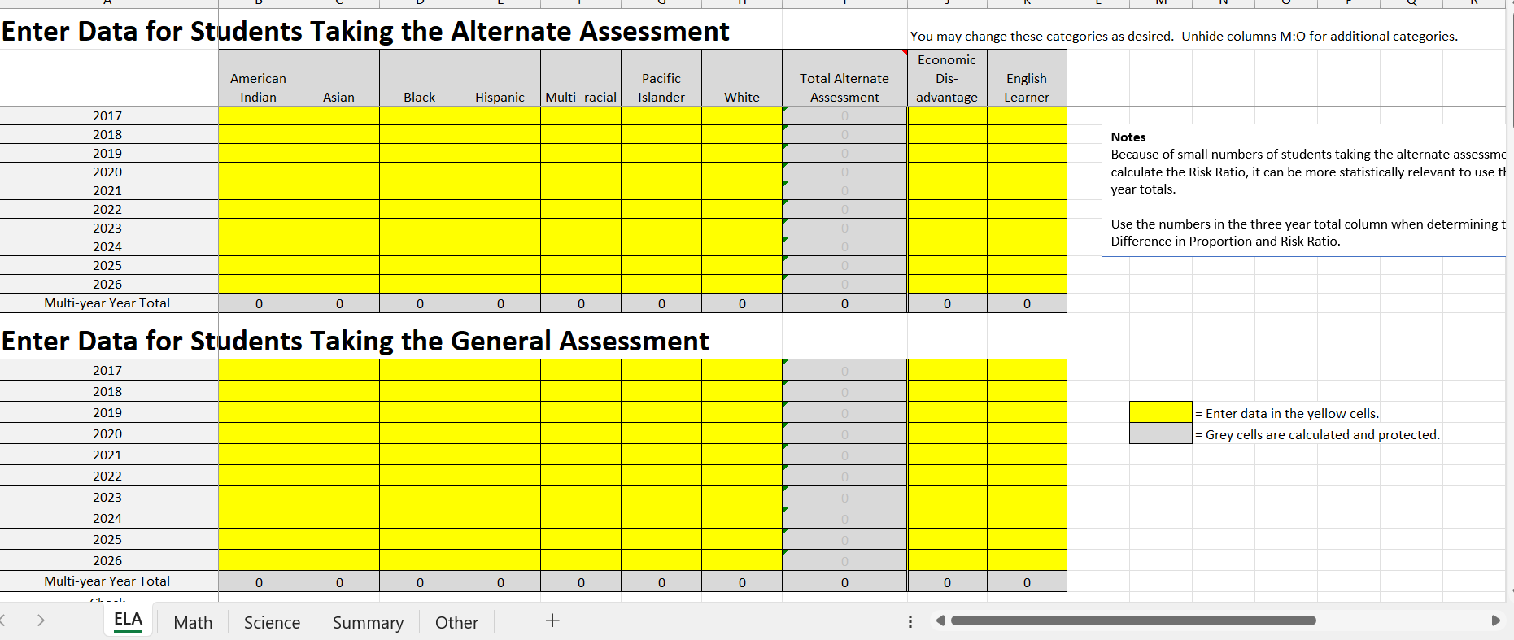

**Exhibit of training notifications, resources and other materials provided to schools that describe revised alternate assessment participation criteria.**

Available at the DESE’s website: <https://www.doe.mass.edu/mcas/alt/resources.html>

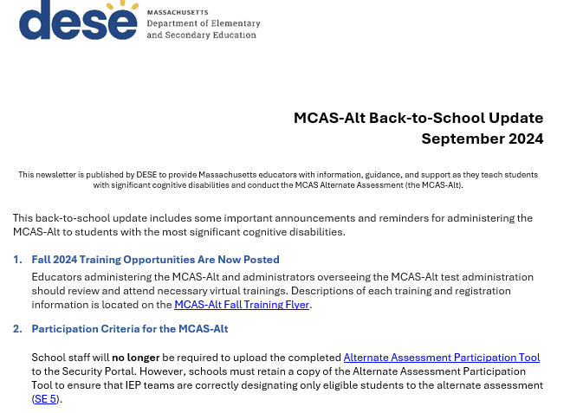

**Exhibit of evidence of webinar training to special education leaders on MCAS-Alt participation requirements, alternate assessment companion tool and significant disproportionality analysis.**

Found at DESE’s website: https://www.doe.mass.edu/sped/

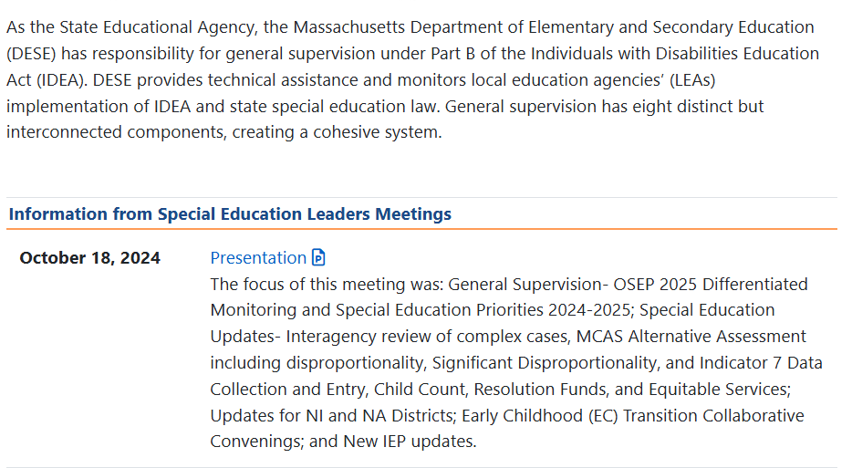

Commissioner’s Memo

and Statement of Assurances Request

to Districts Regarding Exceeding One Percent Alternate Assessment Participation

(Draft)

(to be sent on or about November 29, 2024)



# MEMORANDUM

|  |  |
| --- | --- |
| **To:** | Interested Educators and Members of the Public |
| **From:** | Russell D. Johnson, Acting Commissioner |
| **Date:** | 11/29/2024 |
| **Subject:** | Notice of Intent to Apply and Opportunity to Comment on the Department's Waiver Extension Request Related to the Percentage of Students Who Participate in the MCAS Alternate Assessment |

The Every Student Succeeds Act (ESSA) places a 1.0 percent cap on the number of students with disabilities who may participate in statewide **alternate assessments** each year (ESSA Section 1111(b)(2)(d)(i)). This cap has been in effect since the 2016-2017 school year and applies to all states. Participation in alternate assessments is limited to only students that meet the eligibility definition of a student with *the most* *significant cognitive disabilities.*

Trainings and publications clarify the alternate assessment participation guidelines of **the state’s eligibility definition of students with the most significant cognitive disabilities,** plus additional relevant resources, including **participation data** for your district each year since 2017, is available at [www.doe.mass.edu/mcas/alt/essa/](http://www.doe.mass.edu/mcas/alt/essa/). **Your district has assessed more than one percent of the total number of assessed students on the MCAS-Alt.** Educators and administrators in your district must be closely examine which students are designated for those assessments. While the district may already have made progress in reducing the number being alternately assessed, the overall percentage is still above the one percent threshold. **The revised eligibility definition and improved guidance should assist your IEP teams make evidenced-based decision on which students may participate in alternate assessments.**

You or your designee must respond to this memorandum with the information requested in the attached Statement of Assurances **no later than January 31, 2025.** The information you provide will be used to support the Massachusetts application for a waiver of the “one percent cap” from the U.S. Department of Education for the 2024‒2025 school year.

This request is being sent by email rather than regular mail so that you (or your designee) can respond electronically and return your district’s response more efficiently. Please address your responses **by January 31** to Robert W. Pelychaty, Manager of Inclusive Assessment, at [robert.pelychaty@mass.gov](mailto:robert.pelychaty@mass.gov). If you have questions or wish to discuss this further, please contact the office of Student Assessment Services at 781-338-3625 or by email at mcas@mass.gov.

Thank you for your attention to this timely and important information.

**STATEMENT OF ASSURANCES**

*Please complete the information on this form and submit it no later than* ***January 31, 2025,*** *to the Manager of Inclusive Assessment, Robert W. Pelychaty, Office of Student Assessment, at* ***Robert.Pelychaty@mass.gov.***

|  |  |
| --- | --- |
| **District:** | |
| Name of person completing this form: | Title: |
| The superintendent has reviewed and approved the submission of the following responses to DESE.  (Please note that all responses are available to the public upon request.)  ☐ Yes ☐ No | |

**Please check one:**

☐ My district **does not** **expect to exceed one percent** of the number of tested students taking the MCAS-Alt in the 2024–2025 school year**.** (Complete **questions 1-3** on this form only.)

☐ My district **expects to exceed one percent** of the number of tested students taking the MCAS-Alt in the 2024–2025 school year. (Complete **all questions** on this form.)

Your district’s MCAS-Alt participation data is available at [www.doe.mass.edu/mcas/alt/essa/participants-district.xlsx](http://www.doe.mass.edu/mcas/alt/essa/participants-district.xlsx).

1. Please check Yes or No for each of the following statements**. (*Updated procedures for 2024–2025**)

|  |  |  |
| --- | --- | --- |
| Yes | No | **\*Revised assurances for 2024–2025** |
| ☐ | ☐ | IEP teams follow the state’s (DESE’s) previously updated guidelines and eligibility criteria for students with the most significant cognitive disabilities (available online at [www.doe.mass.edu/mcas/alt/essa/](http://www.doe.mass.edu/mcas/alt/essa/)) regarding which students should take the MCAS-Alt. |
| ☐ | ☐ | **\***For each student participating in the MCAS-Alt, the district completed and **retained a copy of the required** [**Companion document: Alternate Assessment Participation Tool**](https://www.doe.mass.edu/mcas/alt/essa/participation-tool.pdf)**.** |
| ☐ | ☐ | The district provides IEP teams with the \***updated** annual trainings materials and presentation (available at [www.doe.mass.edu/mcas/alt/essa/](http://www.doe.mass.edu/mcas/alt/essa/)) on the requirements to limit the number of students taking the MCAS-Alt to one percent statewide. |
| ☐ | ☐ | **\*The district considered the use of special access accommodations (such as read-aloud, scribe, word prediction, and other assistive technology programs for the student to access the standard academic assessment, prior to designating the student to the MCAS-Alt.** |
| ☐ | ☐ | The district provides opportunities for **interaction and collaboration** among general and special educators to meet the need of adapting the academic curriculum for students with significant cognitive disabilities. |
| ☐ | ☐ | The districts informs **all** **parents, in writing,** when their child is designated to take an alternate assessment. Written statements include information about that this designation may affect their child’s ability to eventually meet the state’s graduation requirements. (Notification of parents is required under ESSA. Sample Parent Notification Letters with translations are available at [www.doe.mass.edu/mcas/alt/essa/](http://www.doe.mass.edu/mcas/alt/essa/)). |
| ☐ | ☐ | The district has provided or will provide **professional development** to general *and* special education staff in the following areas:   * Identification of appropriate accommodations for instruction and assessment. * Implementation of universal design for learning principles in the classroom. * How to apply effective co-teaching strategies. * Development of strategies to include students with the most significant cognitive disabilities in the general academic curriculum. |

For any boxes marked “No” above, please describe the reason and how the district plans to address this in the coming school year:

1. **\***How did the district (please describe your method to) determine if any **disproportionate representation exists students assigned to the MCAS-Alt** in the following subgroups: English Learners, African American Students, Hispanic/Latino students, male/female students, low-income students, taking alternate assessments? (*DESE provides [new tools](https://www.doe.mass.edu/mcas/alt/essa/dispro-calculator.xlsx) and [resources](https://www.doe.mass.edu/mcas/alt/essa/OnePercent.pptx) informed by the National Center on Educational Outcomes [NCEO] outlining specific steps for examining disproportionality in alternate assessments [nceo.umn.edu/docs/OnlinePubs/NCEOBrief18.pdf](https://nceo.umn.edu/docs/OnlinePubs/NCEOBrief18.pdf).)

**\*Describe the method used to determine if disproportionality exists in the district.**

☐ No, at this time our district is not aware of the disproportionate representation of students taking the MCAS-Alt.

☐ Yes, the district is aware that there is disproportionate representation.

If yes, please describe the steps the district will take in the coming year (or the steps already taken) to find the root cause of and reduce the impact of any disproportionate representation of students in the above-referenced subgroups among those taking the MCAS-Alt:

1. Please review the statements and indicate below whether these statements reflect your district’s practices.

When designating a student to take the MCAS-Alt, our district’s decisions **are not** based on whether the student:

1. was absent excessively
2. performed poorly (or for whom a poor performance was anticipated) on MCAS tests
3. took MCAS-Alt previously
4. is in a specific disability category
5. is an English learner
6. is from a low-income family or is a child in foster care
7. would contribute positively to the school’s accountability rating if by teams the student took the MCAS-Alt.

☐ Yes, our district follows the above guidelines.

☐ No, our district does **not** follow the above guidelines.

If no, please describe the steps your district will take the implement these guidelines in the

future:

**Questions 4–10 should be completed only if your district expects to exceed one percent of the**

**number of tested students taking the MCAS-Alt in 2023–2024.**

1. What was your district’s **actual percentage** of students participating in MCAS-Alt in **SY 2023–24?  
     
   _____ %**
2. What is your district’s **projection** for the percentage of students participating in MCAS-Alt in **SY 2024–25?**

**_____ %**

1. Are there **unique** **circumstances in the district** (e.g., specialized schools or programs) that might draw large numbers of students with the most significant cognitive disabilities to live in the district, which in turn might result in an excess of one percent of students taking the MCAS-Alt? If so, provide a description of those unique circumstances.

|  |
| --- |
|  |

1. How does your district’s primary disability categories data in SY 2023**–**24 compare to the state’s primary disability categories data, for students participating in the MCAS-Alt? You may use the worksheet on the last page of this document to help you make this comparison.

List primary disability categories in your district that were **above** state percentage in SY 2023**–**24:

|  |
| --- |
|  |

List primary disability categories in your district that were **below** state percentage in SY 2023**–**2024:

|  |
| --- |
|  |

1. After reviewing data on students with the ***most significant cognitive disabilities***, were there any patterns that emerged? For example, were students who attend a specific class or school more likely to participate in the alternate assessment? Does the participation rate vary by content area?

|  |
| --- |
|  |

1. Are IEP decisions in *all* schools within your district **consistently** implementing thestate’s guidelines and criteria (available online at [www.doe.mass.edu/mcas/alt/essa/](http://www.doe.mass.edu/mcas/alt/essa/) regarding which students should take the MCAS-Alt? Please consider the following for all IEP teams within your district, including students in outplacements.
   * Do the chairpersons meet on a regular basis?
   * Do all IEP teams understand the revised definition of *students with the most significant disabilities?*
   * Do all IEP teams first consider whether students could participate in the general assessment with appropriate support and accommodations in each content area?

|  |
| --- |
|  |

1. Describe your district’s action plan to assist schools to verify that only the eligible students (those that meet the new definition of a ***student most significant cognitive disabilities)*** are participating in the alternate assessment. (Plan should include actionable steps and how the district will monitor progress or address challenges, e.g., ensured evaluation teams are collecting specific evaluation scores on cognitive and adaptive behavior.)

|  |
| --- |
|  |

**District Worksheet**

**Percentage of Students in Each Primary Disability Category Taking the MCAS-Alt**

**Instructions:** The table below may be used to compare your district’s rate of students taking the MCAS-Alt with the state average for students in each disability category. Complete the empty cells and compare this information with statewide percentages in the right-hand column.

By comparing your district’s percentage in each disability category with the state’s percentage, you will be able to determine whether any disability categories should be examined for over-representation among students taking the MCAS-Alt. The percentage of students assessed by MCAS-Alt in each disability category can be determined by dividing the number of students in a disability category taking the MCAS-Alt by all students (MCAS + MCAS-Alt) assessed in that disability category.

For example, if 100 students with autism participated in MCAS and MCAS-Alt in grades 3–8 and 10, and 35 of those students took the MCAS-Alt, then **35/100 = 35%**. Since this is higher than the percentage of students with autism statewide taking MCAS-Alt (**21.3%** from the table below), the autism disability category should be examined for over-representation among students taking MCAS-Alt, and students should be reconsidered to take the general assessment with accommodations.

District information on student assessment formats (i.e., tested versus alternate assessment) and the nature of primary disabilities can be found in your district’s **DropBox** atgateway.edu.state.ma.us/ in the file: **Spring2024_MCAS_official_[your district code].csv**. **Additional instructions for using the district worksheet will be available at the** [**MCAS-Alt’s ESSA website**](https://www.doe.mass.edu/mcas/alt/essa/)**.**

After completing the worksheet below, identify primary disability categories in your district that should be examined more closely for over-representation when compared with the state averages.

**Content Area** (Check one): ☐ ELA ☐ Mathematics ☐ Science and Technology/Engineering

|  |  |  |  |  |
| --- | --- | --- | --- | --- |
| **Nature of Disability**  **(SIMS Disability Code)** | **# in Disability Category Taking**  **MCAS Tests**  **(District)** | **# in Disability Category Taking**  **MCAS-Alt**  **(District)** | **% in Disability Category Taking**  **MCAS-Alt**  **(District)** | **% Within Each Disability Category Taking MCAS-Alt**  **(State)** |
| **Autism (11)** |  |  |  | 21.3% |
| **Communication (03)** |  |  |  | 1.1% |
| **Developmental Delay (13)** |  |  |  | 4.7% |
| **Emotional (05)** |  |  |  | 0.2% |
| **Health (07)** |  |  |  | 0.6% |
| **Intellectual Disability (01)** |  |  |  | 35.9% |
| **Multiple Disabilities (10)** |  |  |  | 47.8% |
| **Neurological (12)** |  |  |  | 7.5% |
| **Physical (06)** |  |  |  | 3.4% |
| **Sensory/Deafblind (09)** |  |  |  | 20.9% |
| **Sensory/Hard of Hearing or Deaf (02)** |  |  |  | 7.0% |
| **Sensory/Vision Impairment or Blind (04)** |  |  |  | 9.2% |
| **Specific Learning Disability (08)** |  |  |  | 0.1% |