2020 Strand Cover Sheet
Student: Pete Seeger
Grade: 4
Content: Mathematics
Strand: Number and Operations-Fractions
Skill: Create visual representation of simple fractions

MCAS-Alt Skills Survey for Grade 4 Mathematics.
Skills survey demonstrates student is unable to do the majority of skills in number and operations-fractions.

MCAS-Alt Bar Graph
Demonstrates progress in learning the skill of creating visual representations of simple fractions in both accuracy and independence. 9 different dates starting November ending in January.

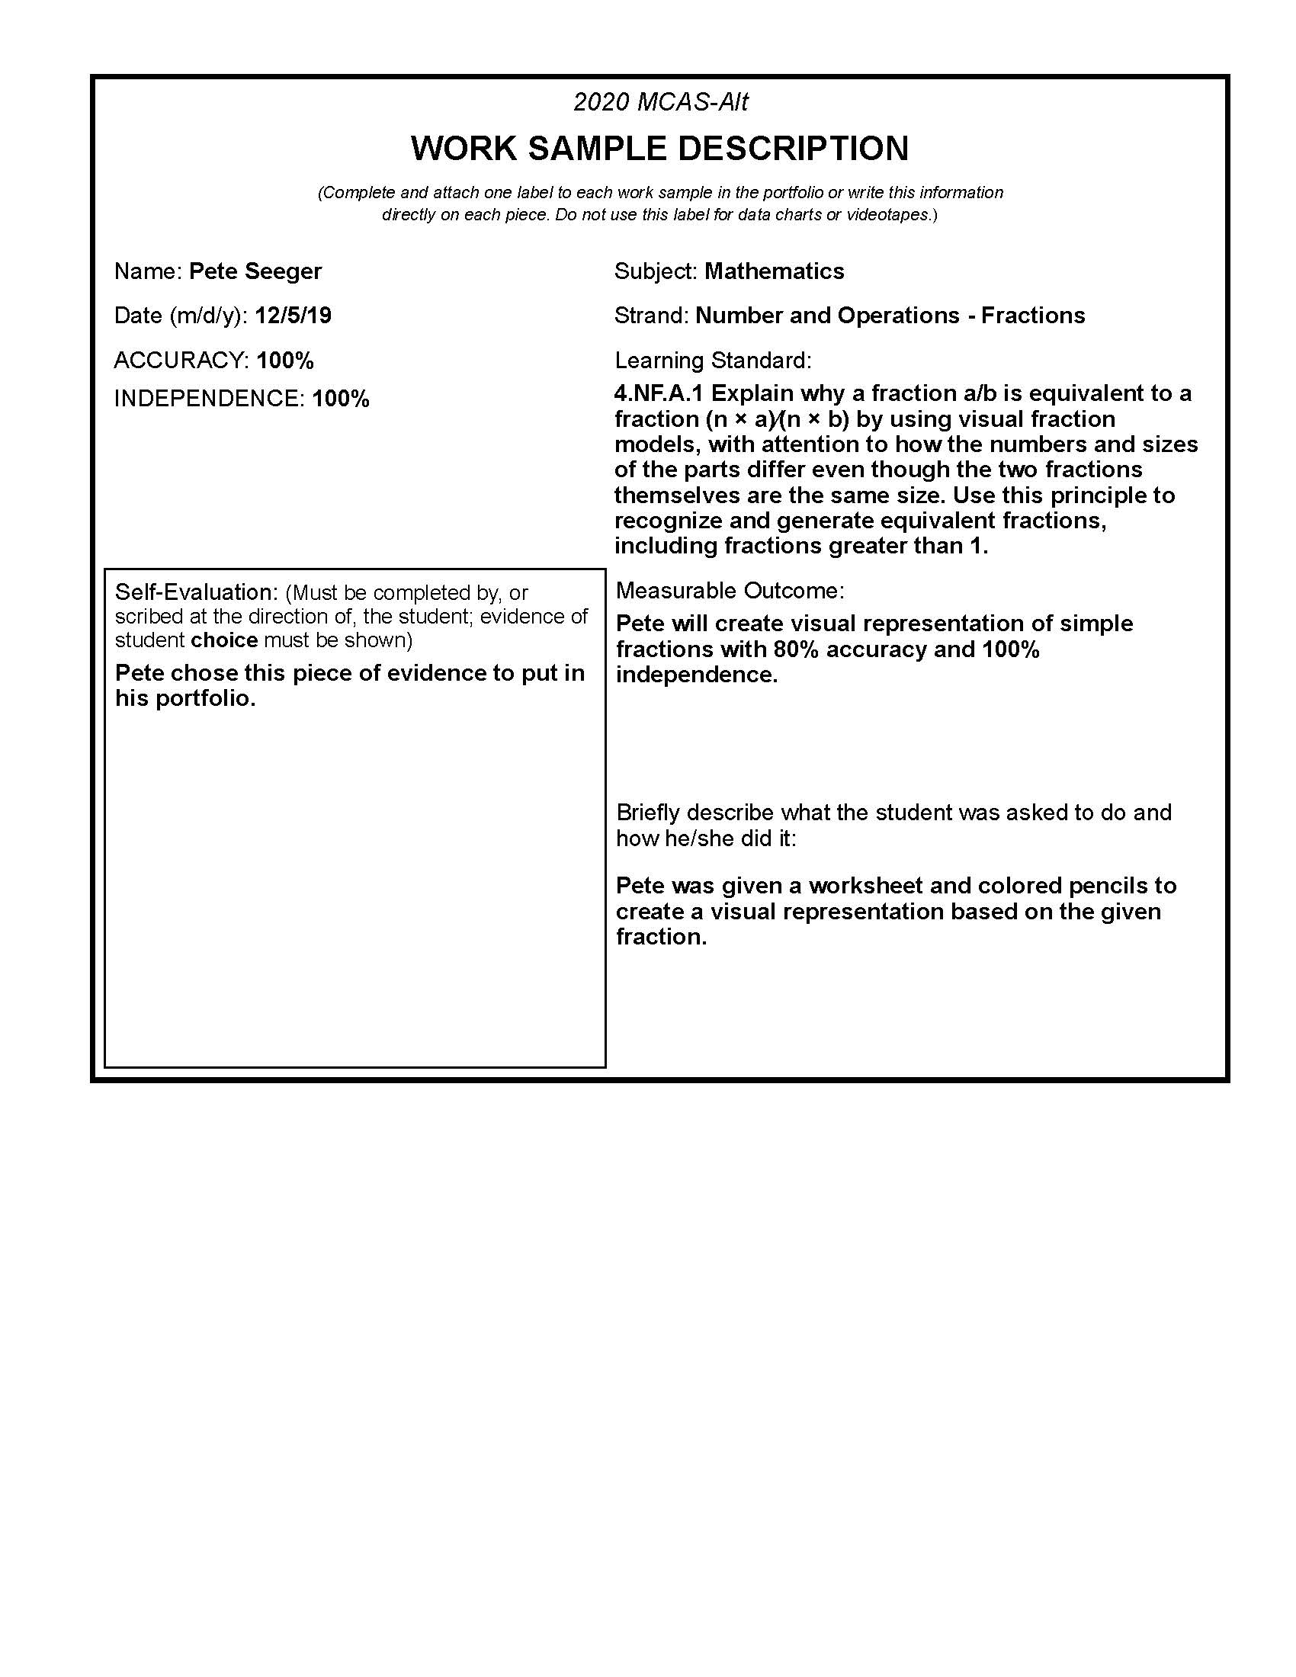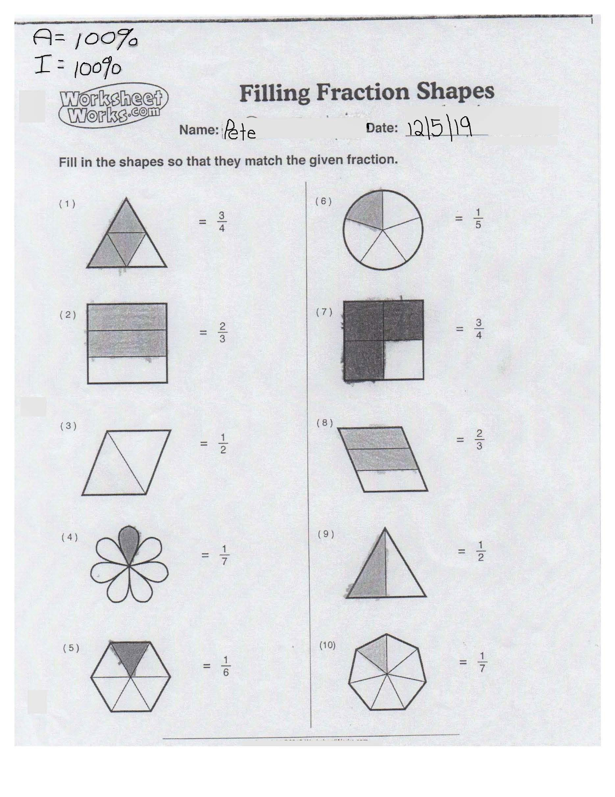Student's self-evaluation:
He chose it because he liked it and he thought it was too easy. He completed the work at school.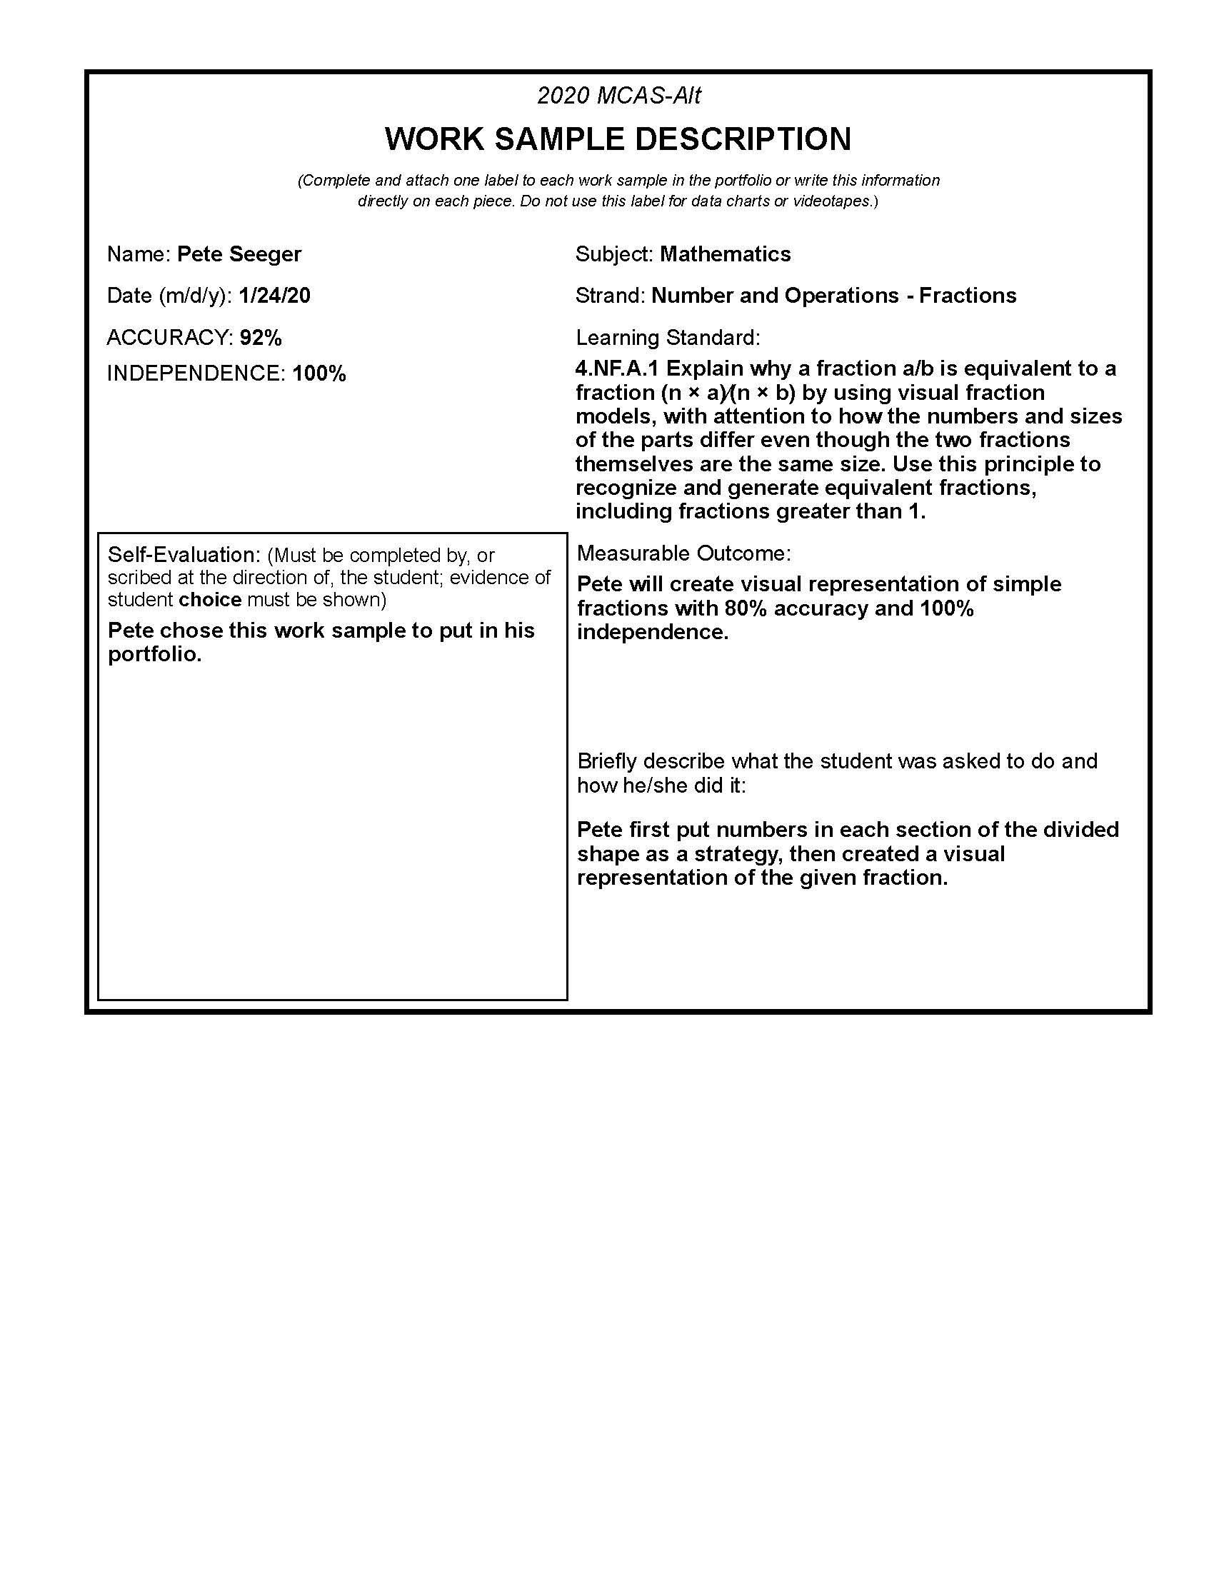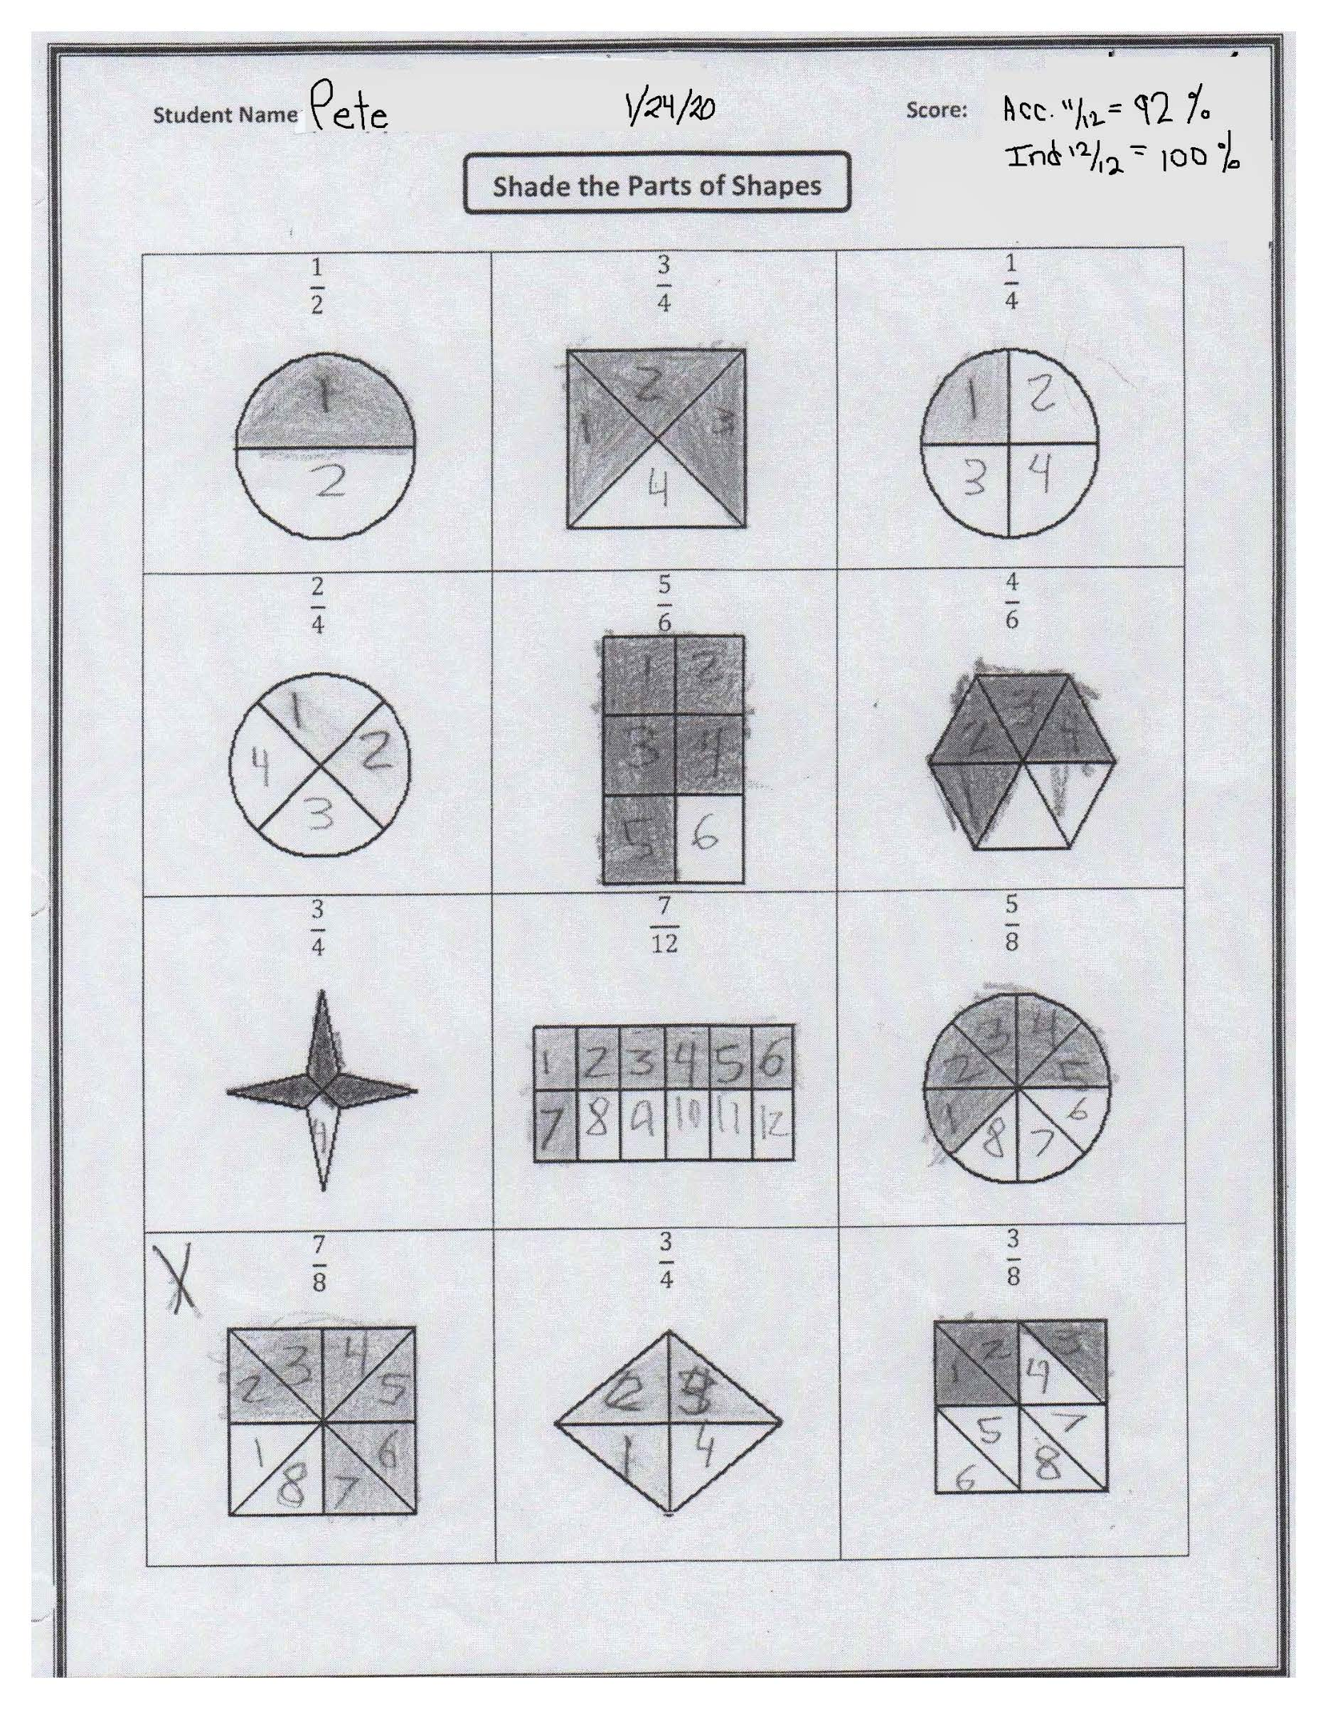Student's Self-Evaluation:
Student evaluated his work. He did his best work.