2020 Strand Cover Sheet
Student: Jim Croce
Grade: 6
Content: English Language Arts
Strand: Language
Skill:  Identify synonyms
MCAS-Alt Skills Survey for Grade 6 Language (Vocabulary Acquisition and Use) 
Skills survey demonstrates student is unable to find words or pictures that are similar in meaning with more than 25% independence.


MCAS-Alt Bar Graph
Demonstrates progress in learning the skill identifying synonyms. He has made progress in both accuracy and independence ending at 85% accuracy and 100% independence.  Data points describe various ways in which he learned to identify a synonym on 10 different dates starting 12/2/19 ending 2/10/20.
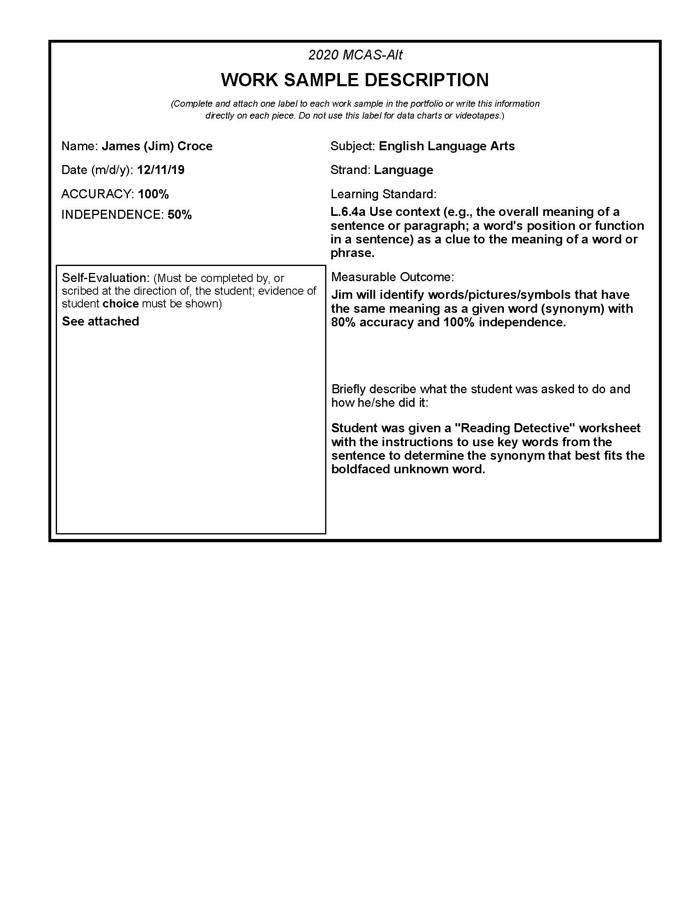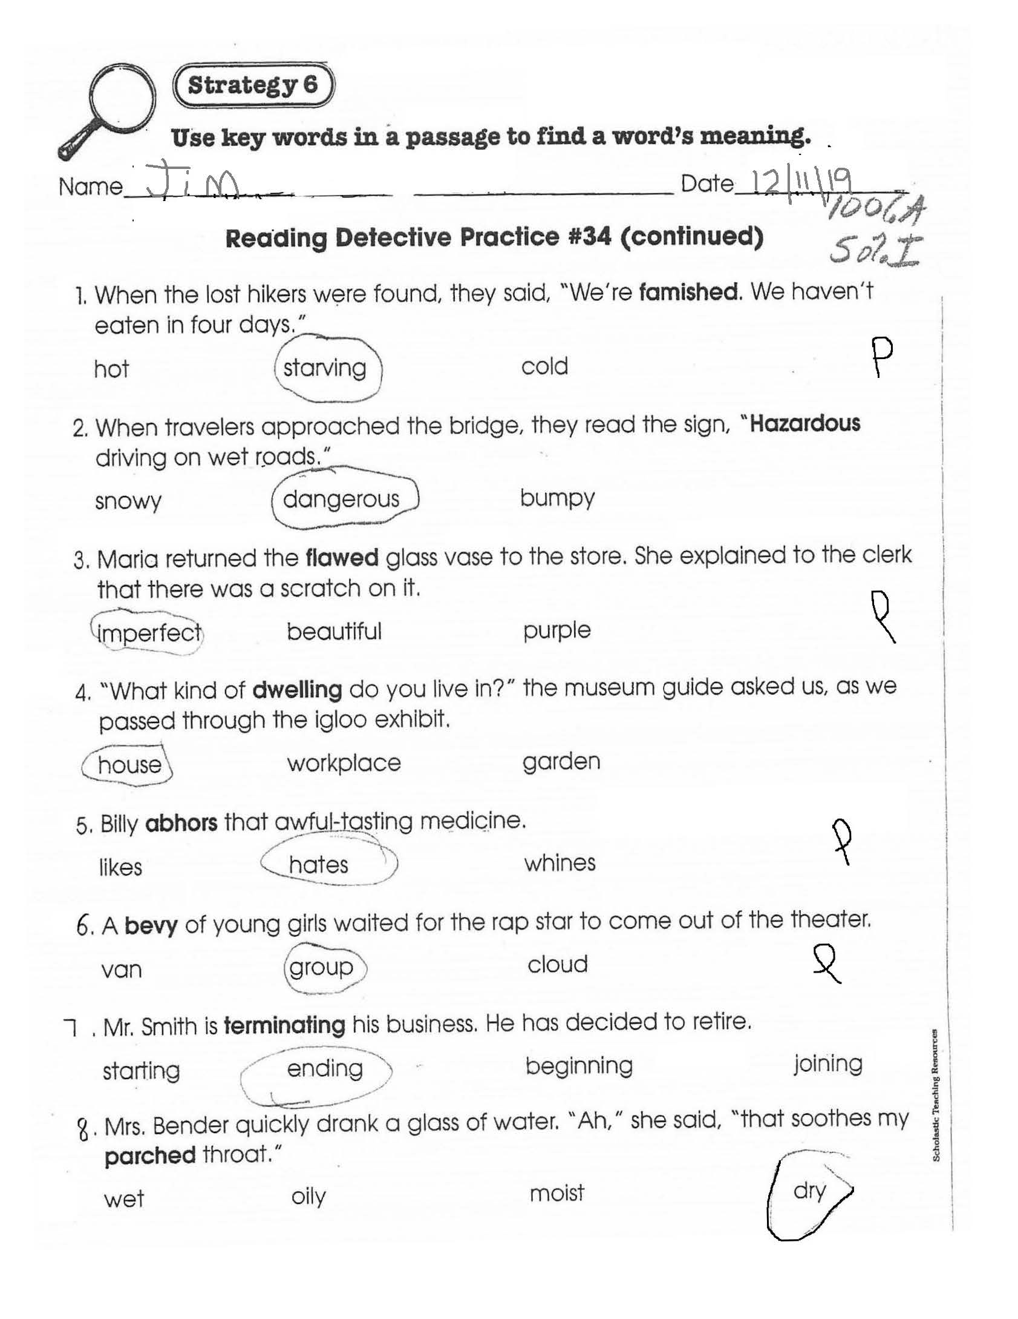Student's Self-Evaluation:
He worked hard, did his best work and was proud of his work.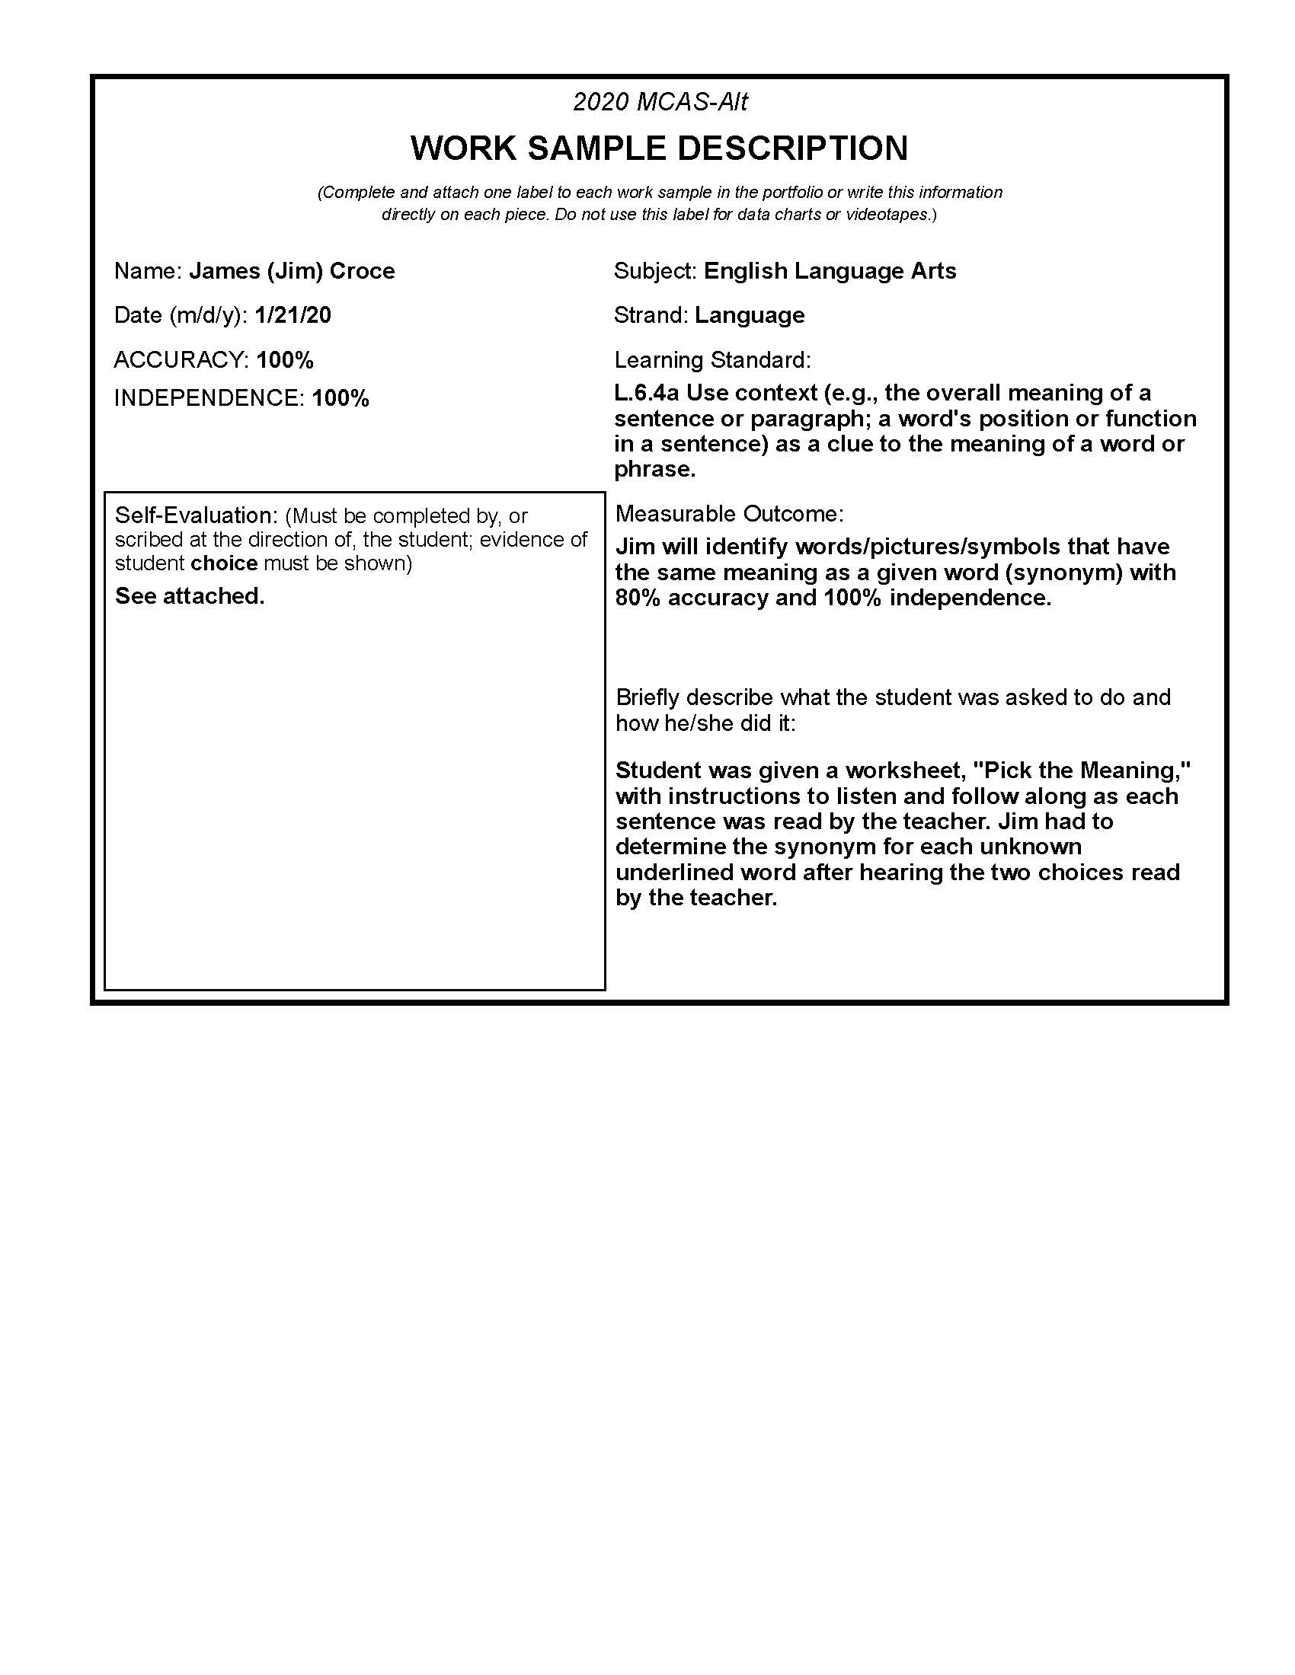Student-created work sample of identifying synonyms of an underlined word in each sentence.  He was 100% independent and 100% accurate.
Student’s Self-Evaluation:
Student evaluated his work to determine he worked hard, did his best and was happy with the work he did. 
