2024 Strand Cover Sheet
Student: 
Grade: 08
Content: Science and Technology/Engineering
Strand: Physical Science
Core Idea: Matter and Its Interactions
2024 STE Summary Sheet
Student: 
Grade: 08
Date: 2/9/2023
Content: Science and Technology/Engineering
Strand: Physical Science
Core Idea: Matter and Its Interactions
Science Practice: 2. Planning and carrying out investigations

Entry Point: Record observations (e.g., firsthand experiences, media) to collect data related to the characteristics (hardness, color, flexibility, texture) of solids and liquids

Brief Description of activity describes exploring familiar items and identifying if characteristics belong to each item
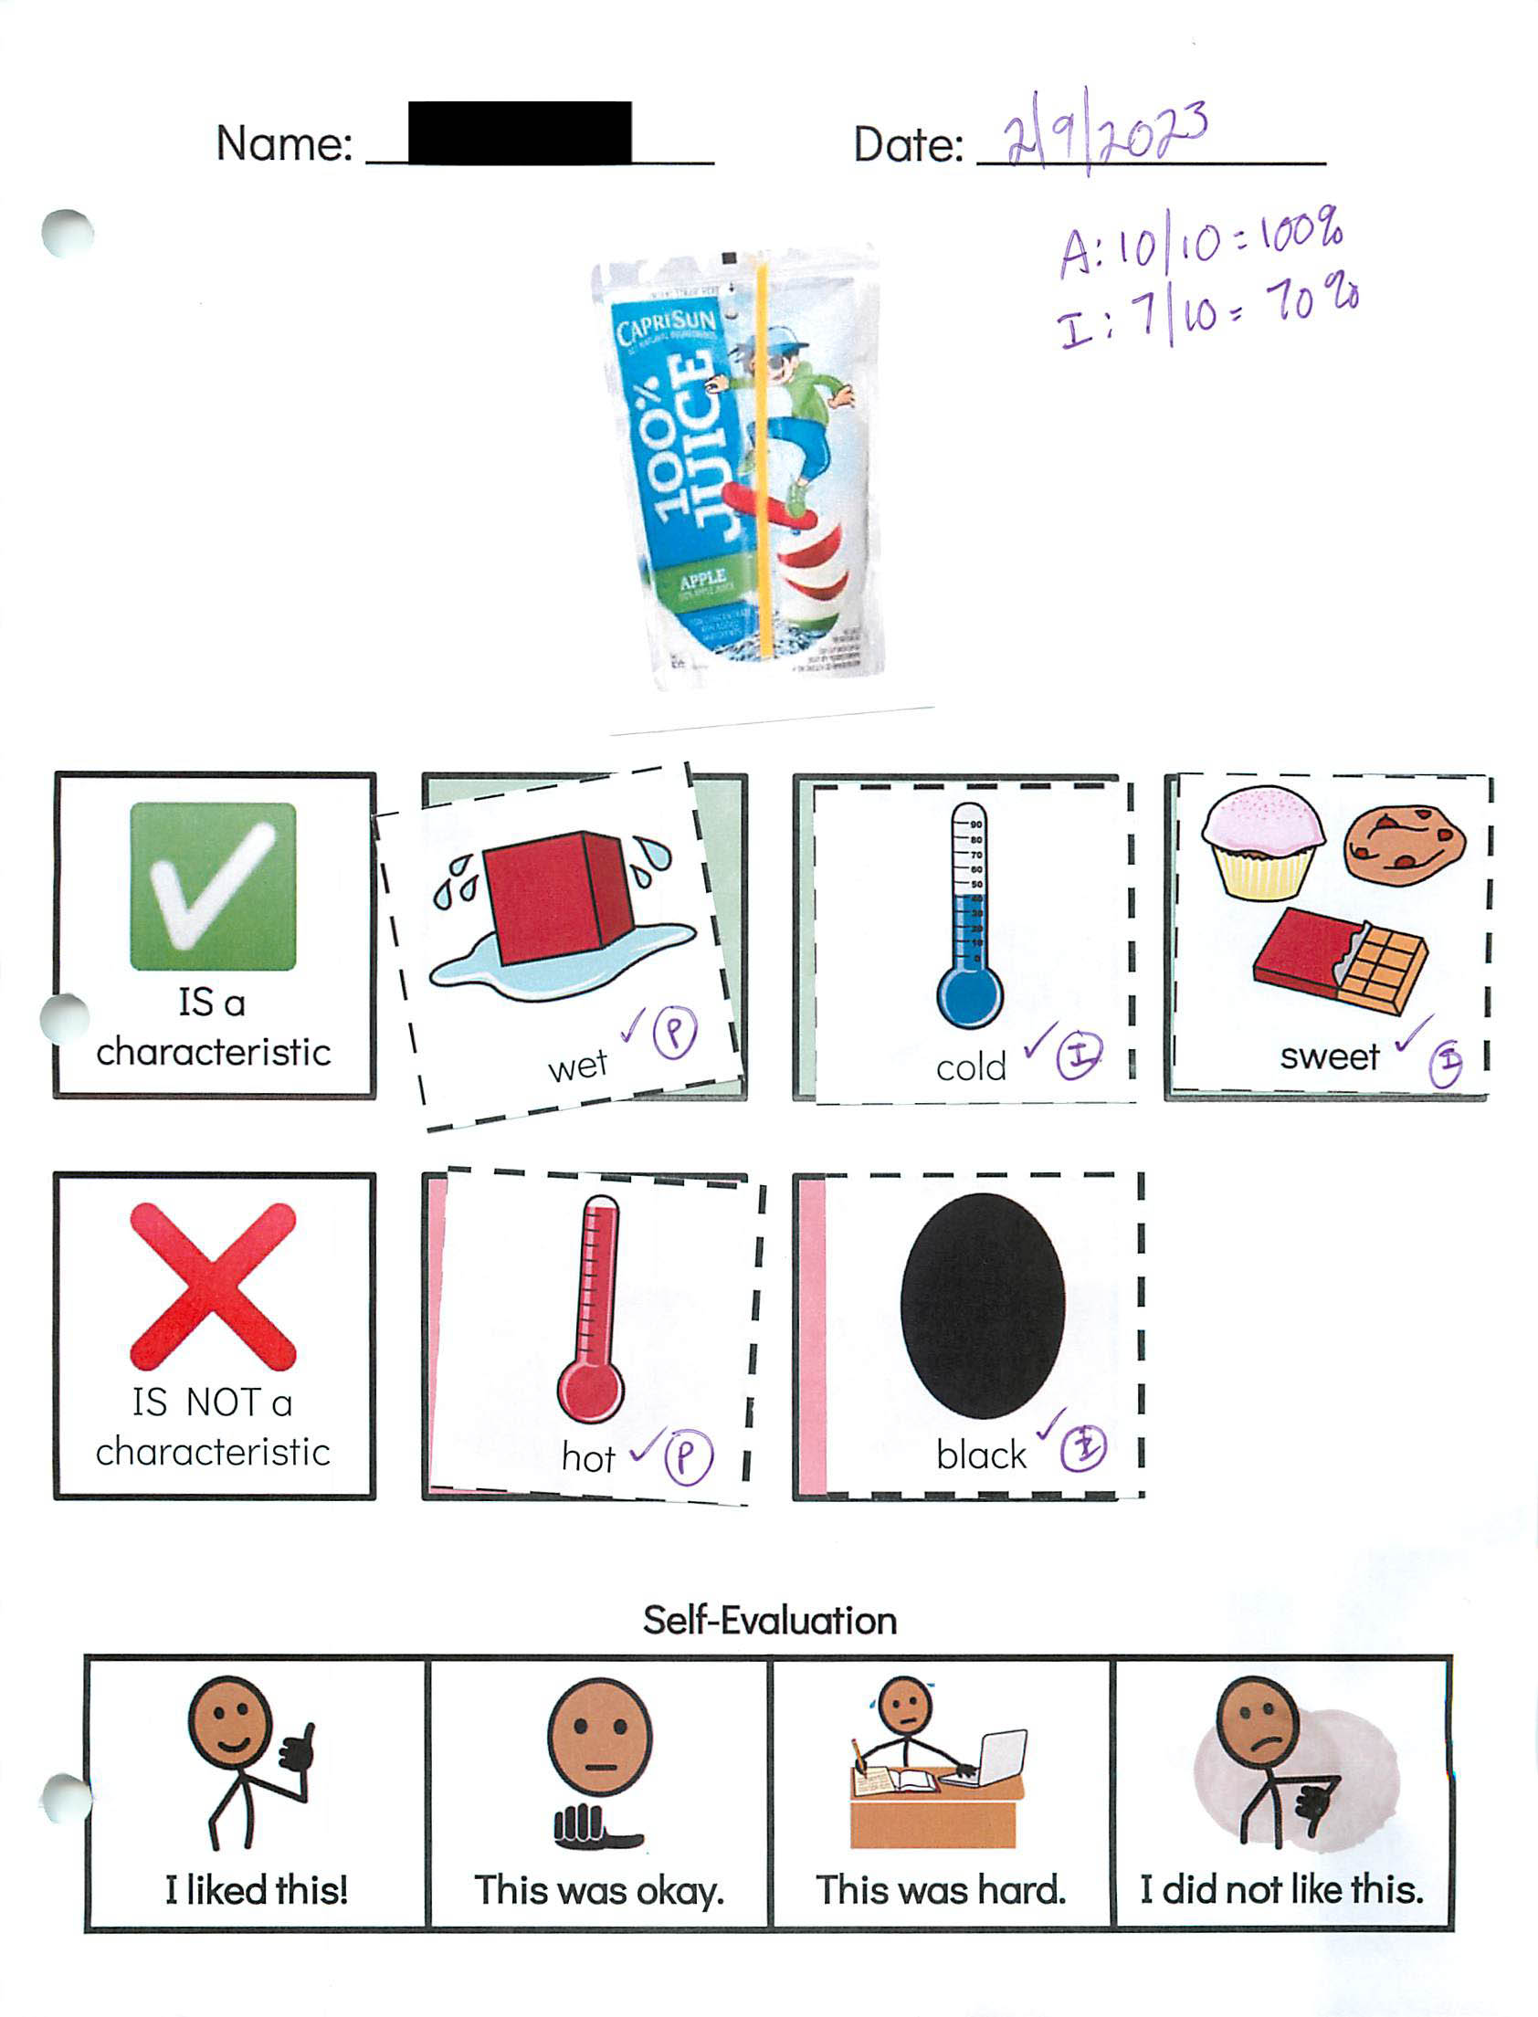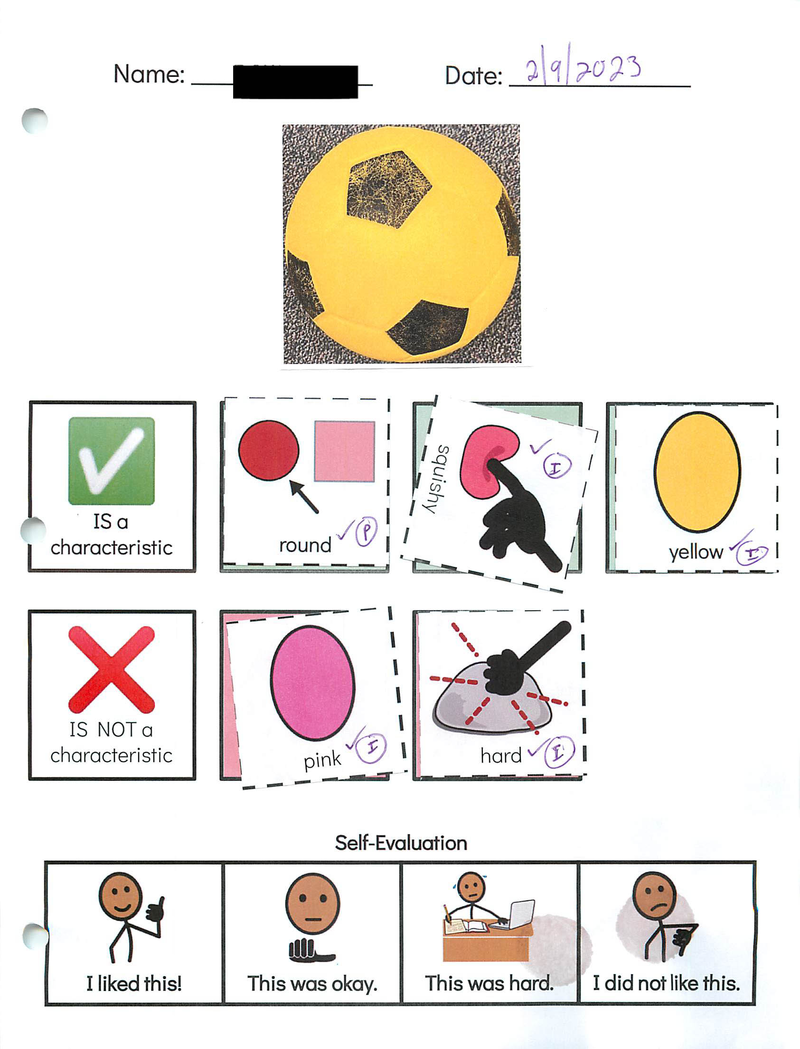2024 STE Summary Sheet
Student: 
Grade: 08
Date: 2/17/2023
Content: Science and Technology/Engineering
Strand: Physical Science
Core Idea: Matter and Its Interactions
Science Practice: 1. Asking questions/defining problems

Entry Point: Record relevant questions about the characteristics of solids and liquid based on observations.

Brief Description of activity describes recording relevant questions of characteristics of liquids and solids by gluing sentence strips of statements onto page of relevant or not relevant questions 
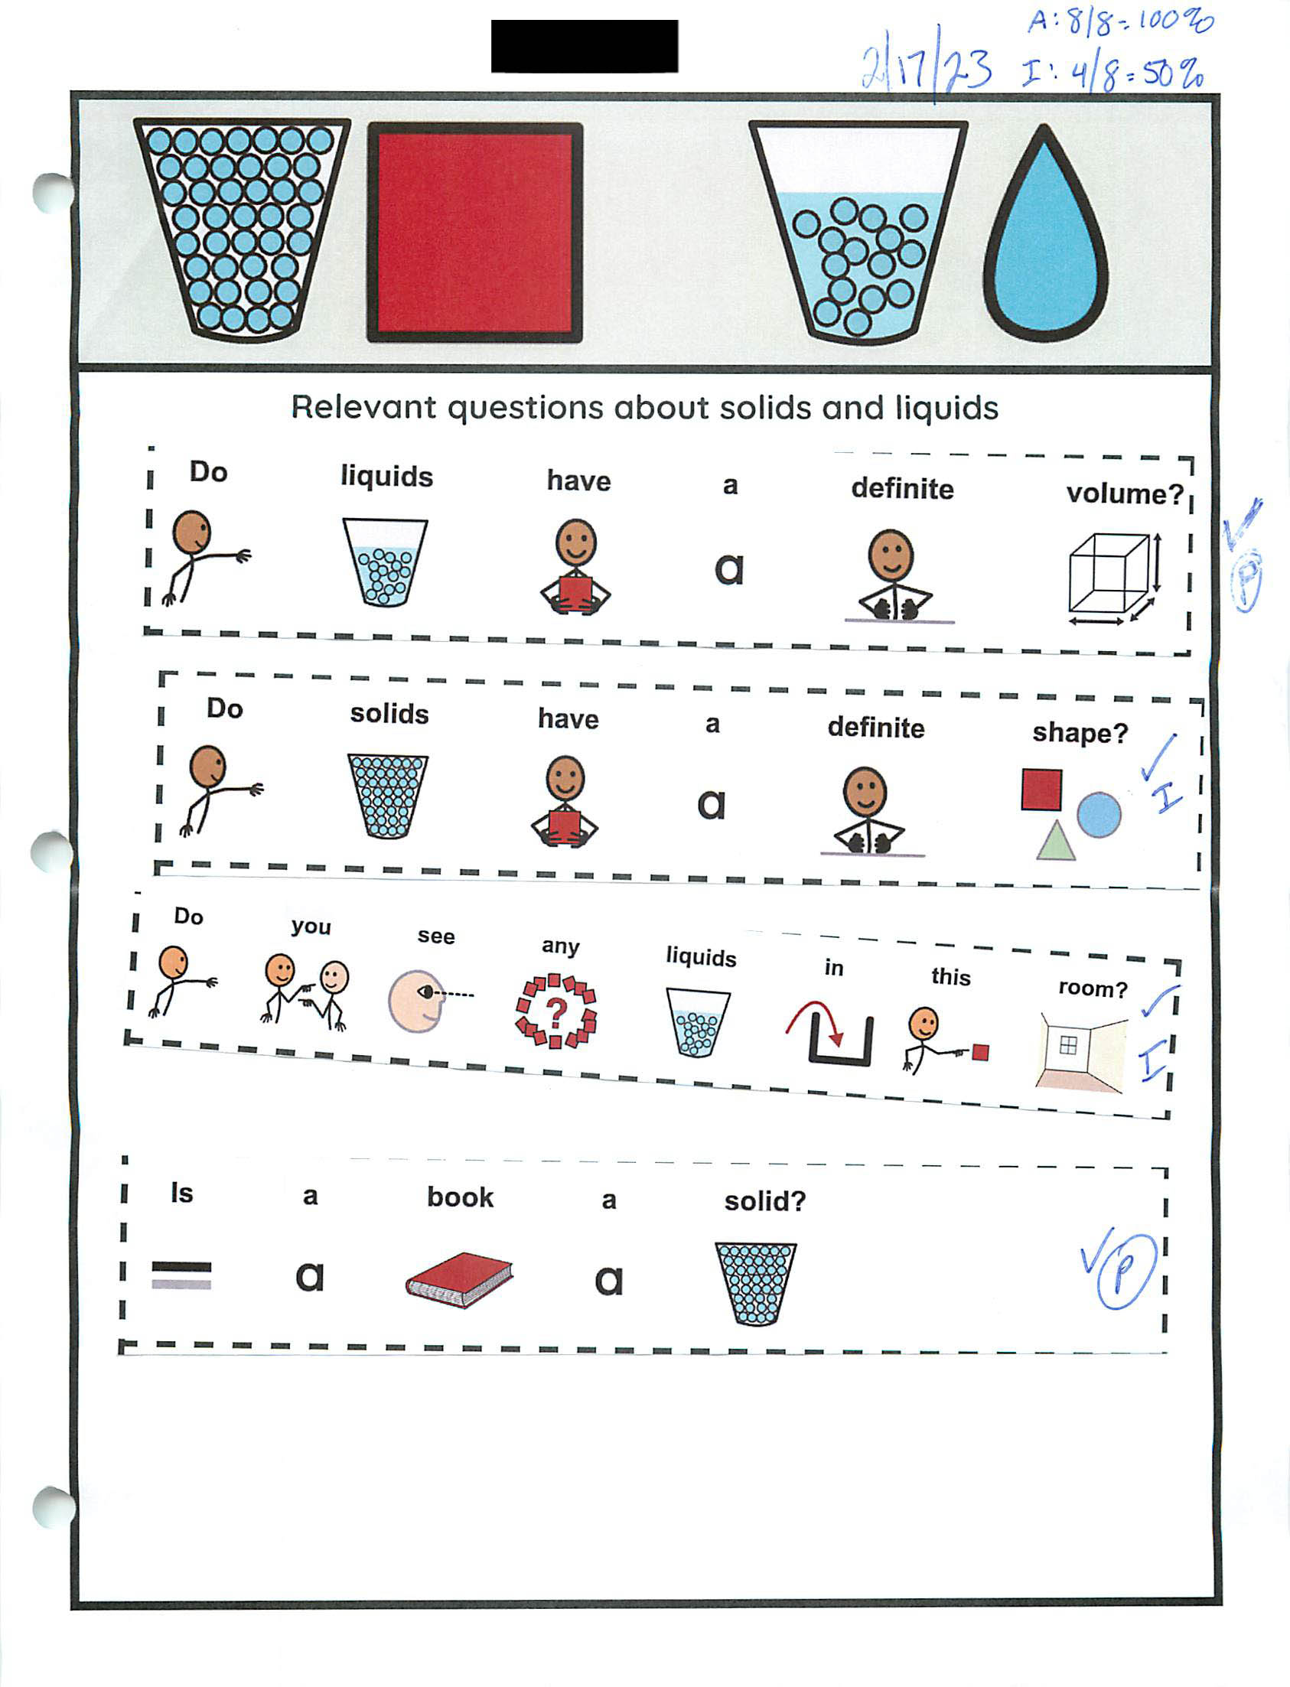Self-evaluation dated 2/17/23 where the student indicated "I liked this work!" from a choice of options. 
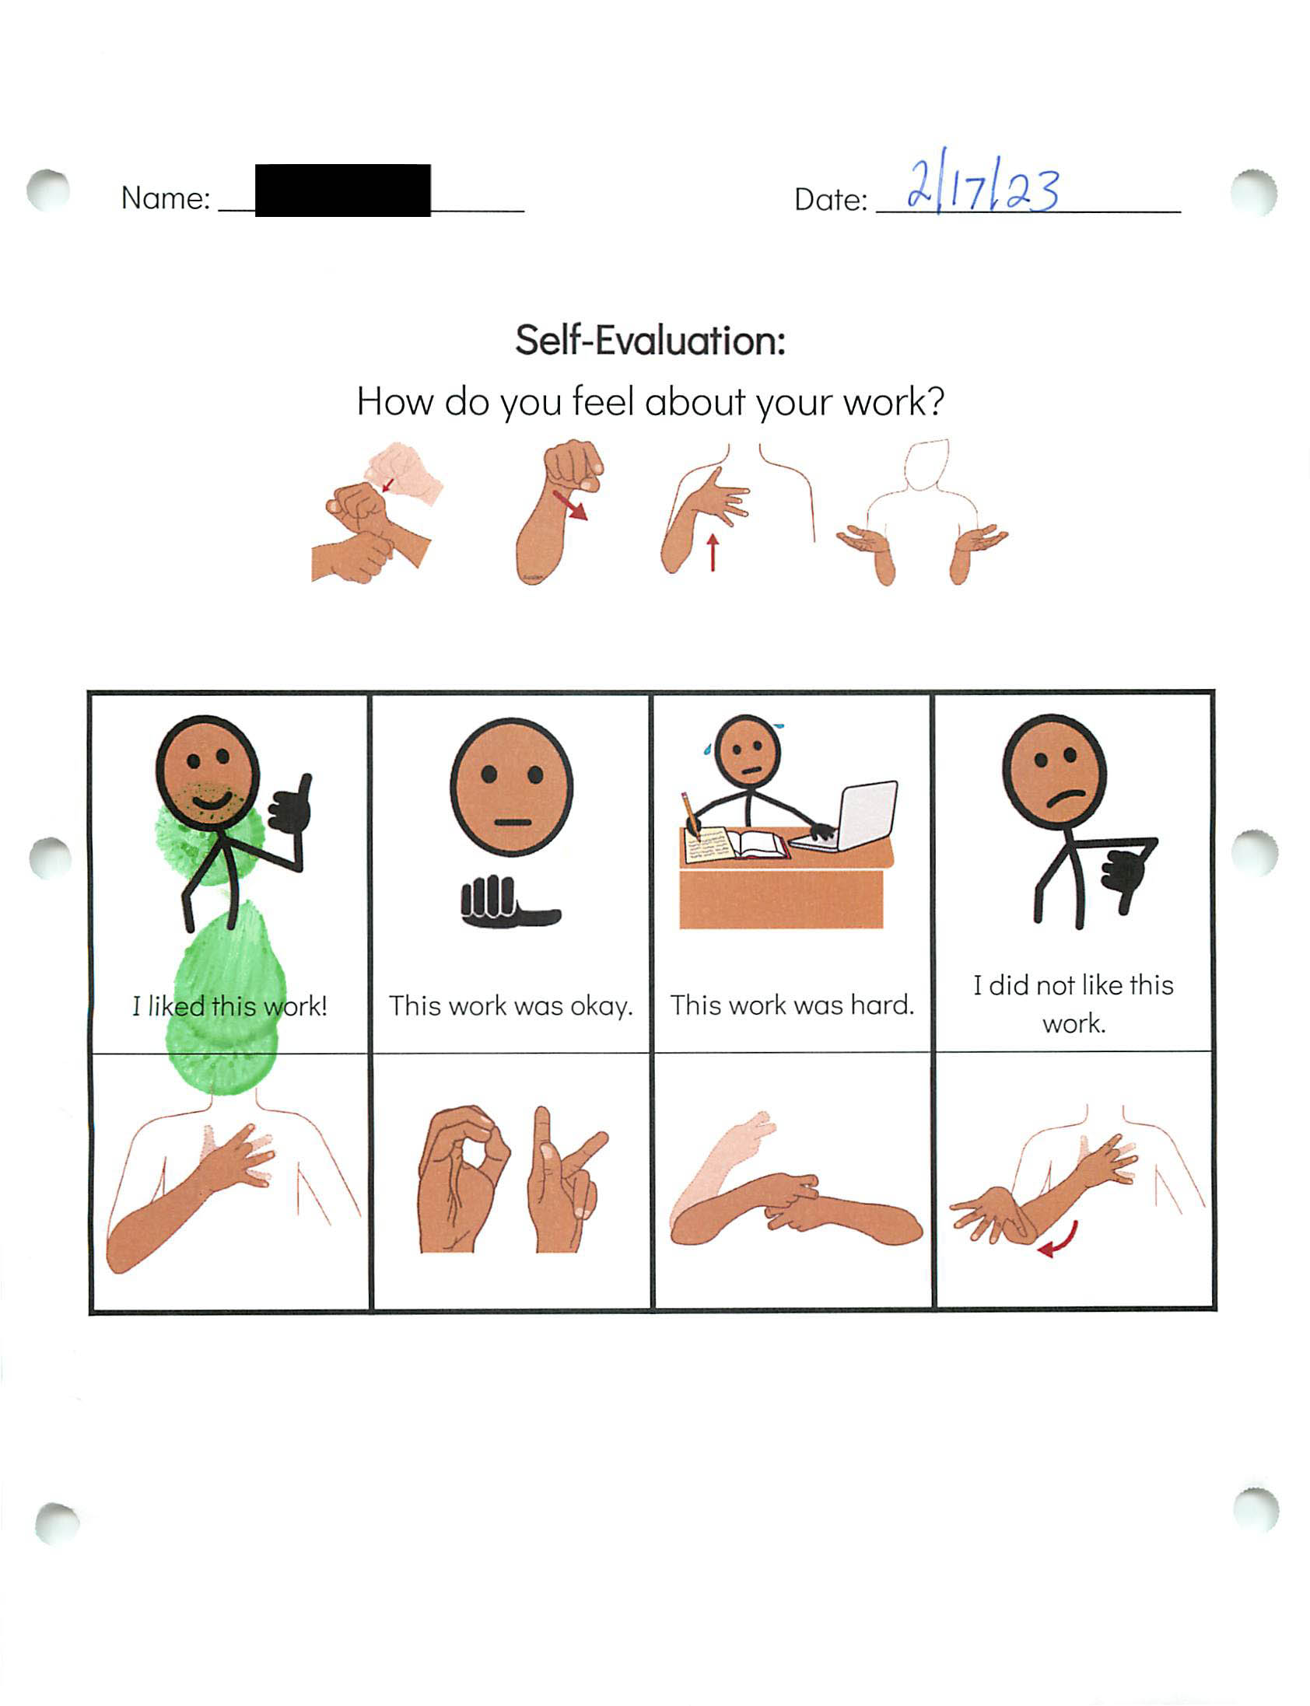2024 STE Summary Sheet
Student: 
Grade: 08
Date: 3/3/2023
Content: Science and Technology/Engineering
Strand: Physical Science
Core Idea: Matter and Its Interactions
Science Practice: 4. Using mathematics and computational thinking

Entry Point: Use counting and number to show data about the weight of a whole object and the weight of the object when broken into pieces

Brief Description of activity describes how student showed numerical data of towers of Duplo blocks when weighed whole and broken into pieces
