

**Guidelines for Scoring**

**2024 MCAS-Alt**

**MCAS Alternate Assessment**

**Massachusetts Comprehensive Assessment System**

This document was prepared by the   
Massachusetts Department of Elementary and Secondary Education

Jeffrey C. Riley

Commissioner

The Massachusetts Department of Elementary and Secondary Education, an affirmative action employer, is committed to ensuring that all of its programs and facilities are accessible to all members of the public. We do not discriminate based on age, color, disability, gender identity, national origin, race, religion, sex, or sexual orientation. Inquiries regarding the Department’s compliance with Title IX and other civil rights laws may be directed to the Human Resources Director, 135 Santilli Hwy, Everett, MA Phone 781-338-6105.  
   
   
  
© 2024 Massachusetts Department of Elementary and Secondary Education  
*Permission is hereby granted to copy for non-commercial educational purposes any or all parts of this document.*

*Please credit the “Massachusetts Department of Elementary and Secondary Education.”*   
   
   
Massachusetts Department of Elementary and Secondary Education  
135 Santelli Hwy, Everett, MA 02149  
Phone 781-338-3000 TTY: N.E.T. Relay 800-439-2370  
www.doe.mass.edu

|  |  |
| --- | --- |
|  | Purpose of the Scoring Guidelines |

The purpose of the *Guidelines for Scoring 2024 MCAS-Alt* is to train scorers to evaluate the 2024 MCAS Alternate Assessment (MCAS-Alt). These guidelines provide important information so that scorers can give valid scores on statewide MCAS-Alt assessments and maintain consistency in applying the scoring rules during the scoring process. Massachusetts educators are also encouraged to use these guidelines to familiarize themselves with the process used to evaluate the MCAS-Alt assessments for their students.

MCAS-Alt is the state’s alternate assessment for students with the most significant cognitive disabilities who cannot be assessed on standard MCAS tests, even with accommodations, due to the severity of their disabilities. Students must be deemed eligible to participate in the alternate assessment based on the state’s definition and criteria.

It is important to assess the academic performance of all students concerning learning standards and to include students with disabilities in MCAS reporting, so results provided to their schools can be used to improve instruction. The MCAS-Alt ensures that students with the most significant cognitive disabilities have an opportunity to show what they know academically and to receive instruction at a level that is challenging and attainable.

By participating in alternate assessments and including their scores in the results of their school and district, students have a greater chance of being considered when decisions are made to allocate staff and resources. Requirements for conducting the MCAS-Alt are provided in the *2024 Educator’s Manual for MCAS-Alt*, available at www.doe.mass.edu/mcas/alt/resources.html.

|  |  |
| --- | --- |
|  | Table of Contents |

|  |  |
| --- | --- |
| Introduction and Background | 1 |
| General Guidelines for Scorers | 2 |
| Content Areas Assessed by MCAS-Alt: Grades 3, 4, and 5 | 3 |
| Content Areas Assessed by MCAS-Alt: Grades 6, 7, and 8 | 4 |
| Content Areas Assessed by MCAS-Alt: High School | 5 |
| Required Assessment Contents | 6 |
| Summary of Scoring Process: Scorers | 7 |
| Summary of Scoring Process: Table Leaders | 9 |
| Scoring: *Complexity* | 10 |
| Scoring: *Completeness* | 12 |
| Scoring: *Demonstration of Skills and Concepts (DSC*) and *Independence (IND)* | 20 |
| Scoring: ELA−Writing | 21 |
| Scoring: Science and Technology/Engineering (STE) (Grades 5 and 8), and High School Biology and Introductory Physics | 24 |
| Scoring: *Self-Evaluation (S-E)* | 25 |
| Scoring: *Generalized Performance (GP)* | 26 |
| Scoring Rules in Special Cases | 27 |
| Maintaining Validity and Reliability | 28 |
| Appendix A: Comment Key | 29 |
| Appendix B: MCAS-Alt Glossary | 30 |
| Appendix C Skills Survey | 31 |
| Appendix D: Sample Data Charts | 32 |
| Appendix E: MCAS-Alt Scoring and Writing Rubric | 35 |
| Appendix F: STE Strand Cover Sheet and STE Summary Sheet | 37 |
| Appendix G: Teacher-Documented Work Sample | 39 |
| Appendix H: Informational Text–Supplemental List and Literature and Informational Text Types | 40 |

|  |  |
| --- | --- |
|  | Introduction and Background |

The MCAS Alternate Assessment (MCAS-Alt) has been administered annually in Massachusetts since 2001. According to state and federal laws, all students with disabilities are required to participate in statewide assessments, either by taking standard MCAS tests with or without accommodations or by taking the MCAS-Alt. Decisions regarding how each student will participate in MCAS must be made by the student’s IEP team and documented in the student’s IEP.

**Contents and Structure of the MCAS-Alt**

The MCAS-Alt consists of 1) the MCAS-Alt Skills Survey, which is a standardized, measurable, and scorable component that must be completed before selecting entry points or access skills for subsequent, deeper assessment in the required strand and subject; 2) a collection of “primary evidence” consisting of data charts, work samples, and photographs/video based on the selected entry points or access skills in the specific areas identified for submission in the required subject; and 3) optional “supporting documentation” that describes or shows the context of the assessment activities, including materials, setting, format, and student reflections. The collection of evidence is organized into “strands” according to the standards specified for assessment in each grade and content area**.** Each strand includes the following products and information related to the specific topics and domains being assessed:

* + **MCAS-Alt Skills Survey** (see sample in Appendix D)
  + **one data chart** showing the student’s performance on at least eight different dates, based on a skill listed in the state’s Resource Guide for Students with Disabilities in the learning standard and subject required for assessment. (ELA-Reading, Language and Mathematics)
  + at least **two pieces of evidence**, including work samples, video clips, and/or photographs, showing the student’s performance based on the skill listed on the data chart, with a brief description of how the student demonstrated the skill.
  + examples of **supporting documentation**, including materials and tools used by the student, reflection sheets, and other supporting documentation at the discretion of the teacher.

Exceptions to the above assessment requirements are described on pages 21–23 for ELA-Writing (all grades) and on page 24 for Science and Technology/Engineering (grades 5 and 8 and high school Biology and Introductory Physics).

Detailed instructions for conducting the MCAS-Alt are available in the Department’s publication entitled the Educator’s Manual for MCAS-Alt, which is updated annually. The Educator’s Manual is posted on the Department’s website at www.doe.mass.edu/mcas/alt/resources.html.

**Scoring the MCAS-Alt**

After the skills surveys and evidence collections are submitted to the Department on March 28, 2024, they are reviewed and scored at a scoring institute sponsored by the Department and Cognia, the state’s alternate assessment contractor. The *Guidelines for Scoring 2024 MCAS-Alt* (this publication) provides detailed information on the processthat will be used by scorers to review and rate each student’s alternate assessment. This publication isavailable at www.doe.mass.edu/mcas/alt/results.html.

|  |  |
| --- | --- |
|  | **General Guidelines for Scorers** |

Carefully review the following guidelines and each step of the scoring process included in this booklet, including all scoring rules and onscreen displays in the AltScore program.

Scorers must:

* **Score objectively and impartially.**

Put aside opinions about the appropriateness of the student’s placement, program, or services; opinions on why the student is participating in the alternate assessment; and personal feelings about statewide assessment in general.

* **Review all evidence in a strand before scoring the strand.**
* **Score only what is provided in each strand.**

Do not make inferences or assumptions about what the student or teacher may have intended or should have included. Use *actual evidence*, rather than the description of the evidence provided by the teacher, as the basis for determining the score.

* + - * **Avoid biases in reviewing the assessment based on overall presentation, neatness, and/or organization of the contents.**

* **Score each rubric area separately for each strand.**
* **Respect student and teacher confidentiality.**

In accordance with the Family Educational Rights and Privacy Act (FERPA), do not discuss confidential student information with anyone. Do not use the names of teachers or students when discussing the contents of any assessment. Do not score any assessment if you are familiar with the student or teacher who submitted it.

* **Respect the contents of the assessments.**

Student assessments must be returned in the same condition in which they were submitted. Maintain the order of all contents in the three-ring binder. Remove notes, flags, and placeholders you may have used during scoring.

* **Keep food and drinks away from the binders.** Store uncovered, sticky, or greasy edibles underneath the scoring table at all times.
* **Score at a reasonable pace, without rushing.**

Read each question and answer it based on the evidence in front of you. Be methodical without taking too long. Each strand should take no more than about fifteen minutes to score. Ask for assistance only if you get stuck.

|  |  |
| --- | --- |
|  | Content Areas Assessed by MCAS-Alt: Grades 3, 4, and 5 |

Requirements for grades 3,4, and 5:
ELA:
Reading (informational or literary
Language (vocabulary acquisition and use)
Writing (text types and purposes)
Math:
2 domains for each grade level
Science- Choose 3 of the 4 Disciplines:
Life Science
Earth and Space Science
Physical Science
Tech/Eng 

**\*** STE assessments may include evidence collected during the current and one immediately preceding school year.

|  |  |
| --- | --- |
|  | Content Areas Assessed by MCAS-Alt: Grades 6, 7, and 8 |

Requirements for grades 6,7, and 8:
ELA:
Reading (informational or literary
Language (vocabulary acquisition and use)
Writing (text types and purposes)
Math:
2 domains for each grade level
Science- Choose 3 of the 4 Disciplines:
Life Science
Earth and Space Science
Physical Science
Tech/Eng 

**\*** STE assessments may include evidence collected during the current and one immediately preceding school year.

|  |  |
| --- | --- |
| . | Content Areas Assessed by MCAS-Alt: High School |

|  |  |  |
| --- | --- | --- |
| **A student in this grade** | **Must be assessed in the following** | |
| **Content areas** | **Content areas** |
| 9 **or** 10 | * **Science and Technology/Engineering \*** | * **Choose one discipline:** * **Biology**   **or**   * **Introductory Physics** |
| 10 | * **English Language Arts** | * **One portfolio strand each in:**   + - **Reading (Literature or Informational Text)**     - **Language (*Vocabulary Acquisition and Use*)**     - **Writing (*Text Types and Purposes*)** |
| * **Mathematics** | * **One portfolio strand each in any three of the following strands:** * **Number and Quantity (The Number System)** * **Statistics and Probability** * **Algebra** * **Geometry** * **Functions** |

**\*** STE assessments may include evidence collected during the current and one immediately preceding school year. Review the STE assessment format on page 24.

|  |  |
| --- | --- |
|  | Required Assessment Contents |

**Assessment Overview**

The MCAS-Alt consists of 1) a completed MCAS-Alt Skills Survey for each assessed strand; and 2) either two or three assessed strands in each content area, depending on the subject and student’s grade (see tables on pages 3–5) organized in a three-ring binder for each student. Guidelines for assembling the MCAS-Alt are provided in the *2024 Educator’s Manual for MCAS-Alt*, available at www.doe.mass.edu/mcas/alt/resources.

**Required Forms**

* MCAS-Alt Cover Sheet
* Student’s Weekly Schedule
* Student’s Introduction
* Verification Form
* School Year Calendar

The overall score will not be affected if a required form is missing, but the scorer should provide comment 54 or 55 from the Comment Key (Appendix A), as appropriate.

**Contents of ELA-Reading and Language, and Mathematics:**

The “evidence” shown below must be included, at minimum, in each required strand (except ELA−Writing and STE which have different formats and requirements). Additional supporting documentation may be submitted at the teacher’s discretion (see below). The measurable outcome being assessed must **remain the same** throughout each strand.

**A complete strand includes the following components:**

**Core set of evidence consists of:
Strand Cover Sheet, 
Completed Skills Survey,
Data Chart,
2 pieces of primary evidence demonstrated by the student.**

* Primary evidence may be a **work sample**, **video sample**, **photograph,** or **series of photos** clearly showing a final product. Video samples may be up to 3 minutes in duration. Evidence must be labeled with name, date, percent accuracy, and percent independence, and must include a brief description of the activity (either written directly on the evidence or a Work Sample Description form).

**Supporting Documentation (Optional):**

* Work Sample Description form(s)
* Tools, templates, organizers, reference sheets, computer screenshots, description, or sample screen of an Augmentative and Alternative Communication (AAC) or other technology-based device used by the student.
* Reflection sheets or other examples of self-evaluation.

|  |  |
| --- | --- |
|  | Summary of Scoring Process: Scorers |

**The Scorer:**

**Enters the 10-digit barcode found on the white envelope (beneath the student’s name label) into the AltScore program**

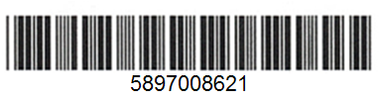

**The barcode will always begin with 8542**

* **Receives a three-ring binder from the Table Leader**
* **Removes it from unsealed white envelope**
* **Stores the envelope under or near the binder**

Unsealed portfolio envelope

**Confirms that demographic information in the AltScore program matches the MCAS-Alt Cover Sheet of the assessment to be scored**Screenshot of demographic information for AltScore

**Selects a strand to score**

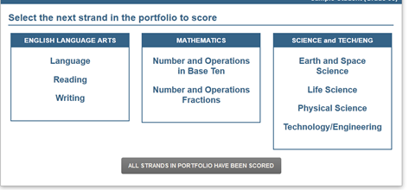

**4**

**2**

**1**

**3**

|  |  |
| --- | --- |
|  | Summary of Scoring Process: Scorers (Continued) |

**The Scorer:**

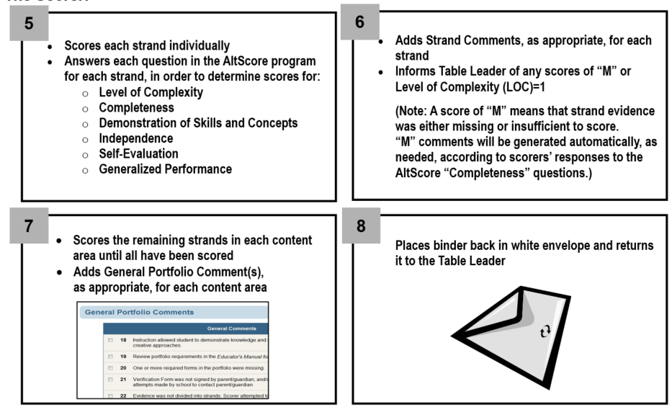

|  |  |
| --- | --- |
|  | Summary of Scoring Process: Table Leaders |

**The Table Leader:**

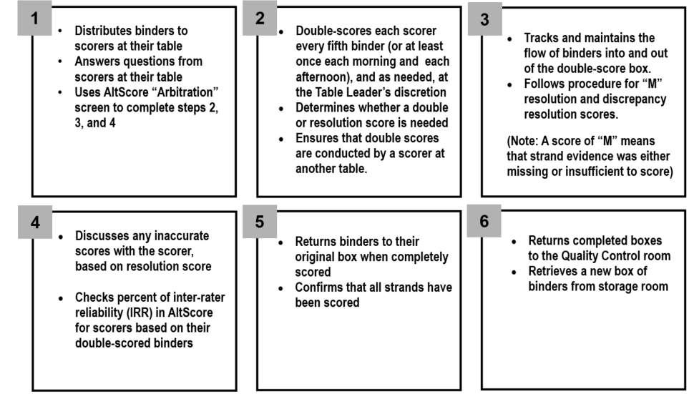

|  |  |
| --- | --- |
|  | Scoring: *Complexity* |

The following numbered questions appear in AltScore, the online program that guides scorers through the scoring process. Many of the AltScore questions will be different for **ELA−Writing** and **Science and Technology/Engineering**.

1. **DOES THE MEASURABLE OUTCOME CONTAIN AN ACCEPTABLE ENTRY POINT OR ACCESS SKILL FOUND IN THE RESOURCE GUIDE FOR THIS STRAND/DOMAIN?**

Scorer must confirm that:

* The strand includes a measurable outcome (listed on line 5 on the Strand Cover Sheet).
* The entry point or access skill is listed in the Resource Guide. Line 4 of the Strand Cover Sheet lists the **page number** in the Resource Guide on which the entry point or access skill is listed (If the page number is not listed, use **CTRL+F** and type in a keyword to search.)
* The wording of the entry point or access skill has not been **excessively modified** in the measurable outcome (i.e., the original meaning and intent of the entry point or access skill have been maintained).
* If the measurable outcome is not based on an entry point or access skill found in the Resource Guide, the scorer reports to the table leader who will request the **floor manager’s approval** before answering NO.

***Examples* of entry points that were modified in the measurable outcome:**

1. Entry point (Mathematics–The Number System): Represent a real-life negative quantity using a vertical or horizontal number line.

**Acceptable modification of the measurable outcome:**

* *Student will represent a real-life negative quantity using a number line with 80% accuracy and 100% independence*. (**Note**: “…vertical or horizontal” was deleted.)

1. Entry point (Mathematics–Number and Operations–Fractions): Solve a multiplication word problem involving fractions using manipulatives.

**An unacceptable modification of the measurable outcome:**

* *Student will solve a multiplication word problem using manipulatives* *with 80% accuracy and 100% independence.*

(**Note:** Measurable outcome from the *Number and Operations−Fractions* domain must include “fractions.”)

**If the answer to question 1 is YES, the scorer answers this follow-up question:**

* **DOES THE MEASURABLE OUTCOME INCLUDE MULTIPLE SKILLS** (e.g., “addition and subtraction”)?

|  |  |
| --- | --- |
|  | *Scoring: Complexity* (Continued) |

1. **IS THE SKILL ADDRESSED DURING A STANDARDS-BASED ACTIVITY? (ONLY WHEN LOC=2)**

Scorers must confirm that:

* The student has addressed the skill in the context of an academic (i.e., standard-based) activity.
* If Level of Complexity =2 (i.e., “access skills”), the student addressed the skill in the context of an academic (i.e., standard-based) activity (see line 4, Strand Cover Sheet).

**Examples**:

***Academic*** activities expose the student to the tools, concepts, and materials of the **content area** required for assessment, for example:

* Student will *turn her device on/off* to participate in a counting sequence activity within 10 seconds of a directive.
* Student will *visually track materials* representing informational text within a specified amount of time.
* Student will *orient or manipulate materials* used to create a possible solution(s) to a simple design problem model.

***Non-academic***activities might include:

* Carrying a jug of water
* Engaging in personal hygiene (e.g., bathroom routines)
* Choosing a motivational reward

The scoring rubric below is the basis for the score in Level of Complexity. The AltScore program will score this area automatically, based on scorers’ responses to the AltScore “Complexity” questions.**Scoring Rubric for Level of Complexity.
Each rubric area documents how a student addresses the Curriculum Frameworks from not at all to grade-level.**

|  |  |
| --- | --- |
|  | Scoring: *Completeness* |

1. **DOES THE STRAND INCLUDE A COMPLETED SKILLS SURVEY, A DATA CHART, AND AT LEAST TWO PIECES OF PRIMARY EVIDENCE?**

For all strands (*except* **ELA−Writing** and **STE**), scorers must confirm that the strand includes at least: 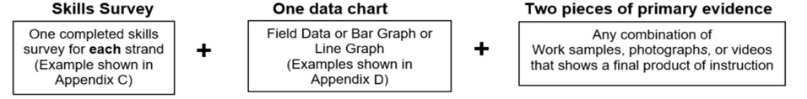

If the answer to question 1 is YES, then the scorer will review primary evidence and determine which, if any, of the following are included:

__ Photographs and/or videos __ Teacher-Documented work sample (see p.18) __ None of these

(If photographs and/or videos, or teacher-Documented work samples are checked above, **Questions 11 and 12** will be activated in AltScore.)

If a completed skills survey, plus one data chart and two pieces of evidence are **not** included in the strand, the scorer answers NO. Scorer will be directed to **Scoring:** **Self-Evaluation**

1. **Is the student’s name, % accuracy, and % independence listed on the data chart?**

Scorers must confirm that the following information is listed:

* Student’s correct name
* Percent (%) accuracy and percent (%) independence for at least 8 data points

1. **Is The First Data Point On The Data Chart Below 80 Percent For Accuracy And/Or Independence?**

Scorer must confirm that: The earliest (typically first) data point on the data chart is below 80% for either Accuracy or Independence, or both.

|  |  |
| --- | --- |
|  | Scoring: *Completeness (Data Chart)* |

1. D**OES THE DATA CHART INCLUDE AT LEAST 8 DIFFERENT VALID DATES?**

Scorer must confirm that:

* All dates for **English Language Arts** (**ELA)** and **Mathematics** occur in the current school year (i.e., between 7/1/23 and 3/28/24).
* All dates for **Science and Technology/Engineering (STE)** include the current and up to one previous school year (i.e., between 7/1/22 and 3/28/24)
* No data points are included that indicate 0% accuracy and 0% independence – those are not valid data points.

**5A. DO AT LEAST 8 BRIEF DESCRIPTIONS ADDRESS ONLY THE SKILL IDENTIFIED IN THE MEASURABLE OUTCOME?**

Scorer must confirm that:

* On at least 8 dates, the student was assessed on the same skill listed in the measurable outcome, as documented in the brief descriptions for each activity included at the bottom portion of the data chart.
* Scorer should not score any data point that assesses a skill that is different from the skill listed in the measurable outcome.

**For example, in ELA−Literature**, if the measurable outcome is:

*Student will compare and contrast characters in a story with 80% accuracy and 100% independence.*

* **An acceptable brief description might be**: *After reading Cinderella, the student used a Venn diagram to compare and contrast the character traits of Cinderella and her stepsisters.*
* **An unacceptable brief description might be:** *Student answered questions about Cinderella and her stepsisters after reading two chapters and recorded her answers on a worksheet.* (“Answering questions” is **not** the same skill as “comparing and contrasting.”)

**5B. DO AT LEAST 8 BRIEF DESCRIPTIONS ADDRESS ALL OF THE SKILLS FOUND IN THE MEASURABLE OUTCOME?** (Only appears if scorer answers **yes** to “multiple skills” question)

Scorer must confirm that:

* If multiple skills are listed in the measurable outcome (e.g., addition and subtraction), then **all** the skills must be addressed on at least 8 different dates (e.g., were both addition *and* subtraction included in the descriptions of at least 8 data points?)

**This question only appears if the scorer indicated that the measurable outcome included multiple skills**

(See bottom of page 10).

**For example,in ELA–Reading**, themeasurable outcome is: Student will *identify the main idea* ***and*** *key details in an informational text* with 80% accuracy and 100% independence.

**Acceptable Brief Description:** The student read *Martin Luther King, Jr., and wrote the main idea from the first two paragraphs and* *listed the key details*. (NOTE: The brief descriptions on the data chart must show that both skills were addressed on at least 8 dates.)

**Unacceptable Brief Description:** The student read Martin Luther King, Jr., and found the main idea for each paragraph.

(Note: Student did not perform both skills listed in the measurable outcome, since the teacher said the student would *identify the main idea* ***and*** *key details*

If the answer to Question 5A or 5B is NO, question 6 will not appear.

|  |  |
| --- | --- |
|  | Scoring: *Completeness (Data Chart)* (Continued) |

1. **DO AT LEAST 8 BRIEF DESCRIPTIONS ON THE DATA CHART SHOW HOW THE STUDENT ADDRESSED THE SKILL? (I.E., WHAT ACTIVITY, INSTRUCTIONAL APPROACH, AND/OR MATERIALS WERE USED)**

Scorer must confirm that:

A minimum of 8 brief descriptions were provided that indicate what the student did (skill) and how the student demonstrated the skill (e.g., activity, instructional approach, materials used).

It should be clear to the scorer how the activity was conducted. If not, the scorer should click NO.

* The skill listed in the measurable outcome **and** the method(s) or approach(es) used by the student to demonstrate the skill or respond to questions should BOTH be included in the brief description.

***For example,*** the following brief descriptions indicate **what** the student did and **how** they performed the activity:

**In ELA−Reading**, the measurable outcome:Student will *answer simple comprehension questions about informational text.*

**Acceptable brief descriptions:**

* After reading *All About Penguins*, the student **answered 5 questions** about penguins’ habits (**SKILL** beingassessed inthe measurable outcome) on a **worksheet** (**HOW** the student demonstrated the skill).
* Students ***orally*** **answered 8 questions** about the possible reasons for extinction (**SKILL** being assessed in the measurable outcome), based on the class assignment to read *Gone but Not Forgotten* (**HOW** the activity was conducted).
* Student read *National Geographic for Kids* online and **answered 8 comprehension questions** (**SKILL** being assessed in the measurable outcome)on his ***computer*** (**HOW** the activity was conducted).

**In ELA−Reading**, the measurable outcome is:Student will *identify the main idea* about a literary text.

**Unacceptable brief description:**

* Student identified the main idea in *Silly Penguins* (i.e., **HOW** was not addressed).

|  |  |
| --- | --- |
|  | Scoring: *Completeness (Data Chart)* (Continued) |

**Note to Scorers:**

A scorer’s response of “NO” to any of the preceding questions will result in a score of “M” in both Demonstration of Skills and Concepts (i.e., accuracy) and Independence, which will result in an overall score of *Incomplete* in the content area.

A score of “M” means that the required information in the strand was either missing or insufficient to provide a score.

“M” comments will be generated automatically, based on the scorer’s “NO” response(s).

All scores of “M” will be reviewed by a Floor Manager (Massachusetts Teacher Consultant).

|  |  |
| --- | --- |
|  | Scoring: *Completeness (Data Chart)* (Continued) |

**For ELA—Reading: Informational or Literary Text**

**R1. DO AT LEAST 8 BRIEF DESCRIPTIONS INCLUDE TEXT TITLES? IF NOT, ARE COPIES OF THE ACTUAL TEXT INCLUDED ELSEWHERE IN THE STRAND?**

Scorers must confirm that:

* At least 8 brief descriptions for ELA−Reading include the **title of the text**, a reference to the topic of the text (e.g., a text about ghosts) used during each activity, or a **photocopy** of the text (e.g. if it was teacher-created or taken from a website). If titles of texts are not listed on the data chart, look for a list elsewhere in the strand.

**R2. DO ALL ACTIVITIES ON THE DATA CHART ASSESS EITHER INFORMATIONAL TEXT OR LITERARY TEXT?**

After reviewing the *Literature and Informational Text* hyperlink in AltScore (see Appendix H), scorers must confirm that:

* The activities listed on the data chart assessed **either** ***informational* or *literary* text**, but not both.

**ELA−Reading: A definition of “Text”**

For the ELA−Reading strand, “text” is at least one complete sentence (not phrases or isolated words). Isolated words or phrases may be assessed, but only if these have been extracted from the text listed on the data chart, and/or in brief descriptions, and/or from the photocopied text submitted in the strand.

The student may demonstrate **comprehension** of text either in writing (including scribed by the teacher), verbally, or through use of actions (e.g., pointing to one picture from an array that represents the text), symbols (e.g., selection of pictures, illustrations, or text), or technology (e.g., a computer or electronic communication system).

|  |  |
| --- | --- |
|  | Scoring: Completeness (Primary Evidence) |

1. **IS THE STUDENT’S NAME, VALID DATE, % ACCURACY, AND % INDEPENDENCE LISTED ON AT LEAST TWO PIECES OF PRIMARY EVIDENCE, OR LISTED ON WORK SAMPLE DESCRIPTION LABELS?**

Primary evidence includes any combination of work samples, videos, or photographs.

Scorers must confirm that:

* At least **two** pieces of evidence include the student’s correct name, valid date, percent (%) accuracy, and percent (%) independence, listed either directly on the piece or on a Work Sample Description form attached (or adjacent) to the evidence.

1. **DO AT LEAST TWO PIECES OF PRIMARY EVIDENCE DIRECTLY ADDRESS THE SKILL IDENTIFIED IN THE MEASURABLE OUTCOME?**

Scorers must confirm that:

* At least two pieces of primary evidence address the skill listed in the measurable outcome.

1. **DO AT LEAST TWO PIECES OF EVIDENCE ADDRESS ALL OF THE SKILLS FOUND IN THE MEASURABLE OUTCOME?** (E.G., “ADDITION AND SUBTRACTION”)

Scorers must confirm that:

* If multiple skills are listed in the measurable outcome, then all skills listed are addressed in at least two pieces of primary evidence (work samples, videos, or photographs).

**This question only appears if the scorer indicated that the measurable outcome included multiple skills**

(See bottom of page 10).

|  |  |
| --- | --- |
|  | Scoring: Completeness (Primary Evidence) (Continued) |

1. **DO THE PHOTOGRAPH(S) OR VIDEO(S) SHOW A FINAL PRODUCT AND IS EACH ONE CLEARLY LABELED?**

If photographs or videos are **not** included, then scorers will not see this question. After reviewing the photographs or videos, scorers must confirm that:

* The photo or video documents the skill listed in the measurable outcome.
* A final product from the activity is visible.
* Products are clearly labeled with name, valid date, % accuracy, and % independence.
* Video samples are no more than 3 minutes in length (i.e., scorers should view only the first 3 minutes of the video)

1. **DOES THE “TEACHER-DOCUMENTED WORK SAMPLE” INCLUDED AS PRIMARY EVIDENCE PROVIDE SUFFICIENT INFORMATION TO DETERMINE WHAT THE STUDENT DID FOR EACH TASK AND HOW THE STUDENT ADDRESSED THE MEASURABLE OUTCOME?**

A “**teacher-documented work sample”** is a piece of primary evidence produced by the teacher on behalf of a student who is unable to generate his or her written work samples. In the teacher-documented work sample, a teacher may document one or more student responses on a single date that addresses the same measurable outcome.

* If teacher-documented work samples are **not** included, then scorers will not see this question.
* See a sample “teacher-documented work sample” in Appendix G.

Scorers must confirm that:

* The teacher-documented work sample provides documentation of a series of trials conducted on the same date.
* The student’s responses are recorded for each trial, task, or question, together with the % accuracy and % independence.
* The teacher-documented work sample must include detailed information describing the context of each activity and how it was conducted. (Note: click the hyperlink in the AltScore program for further information and an example.)

:

|  |  |
| --- | --- |
|  | Scoring: *Completeness (Primary Evidence)* (Continued) |

**For ELA—Reading**

**R3. DO AT LEAST TWO PIECES OF PRIMARY EVIDENCE INCLUDE TITLES OR PHOTOCOPIES OF TEXTS?**

Scorers must confirm that:

* At least two pieces of primary evidence include the **title** of the text used during the activity or a **photocopy** of the text if it was teacher-created or taken from a website.

**Note:** In AltScore, refer to the list of informational texts that require only the title and do **not** require a photocopy of the text (see Appendix H or use the hyperlink located in AltScore to view).

**R4. DO AT LEAST TWO PIECES OF PRIMARY EVIDENCE DOCUMENT ACTIVITIES BASED SOLELY ON INFORMATIONAL OR LITERARY TEXT?**

After reviewing the *Literature and Informational Text* handout (Appendix H), scorers must confirm that:

* At least two pieces of primary evidence document the same text type (i.e., either Literary **or**Informational text, but not both) listed in the measurable outcome. Copies of the text should be provided when the text is teacher-created or internet-based, unless it is included on the supplementary list of well-known informational text in Appendix H.

|  |  |
| --- | --- |
|  | Scoring: Demonstration of Skills & Concepts (DSC) and Independence (IND) |

For all strands **except ELA−Writing** and **STE (**grades 5, 8, and High School Biology and Introductory Physics**)**, the scorer must determine the dates of the **final 1/3-time frame** of the data points on the data chart (or at least the last 3 dates on the data chart).

Scorer performs the following steps in AltScore:

1. Enters the **date, % accuracy, and % independence for each acceptable piece of primary evidence**.
2. Enters the **date, % accuracy, and** **% independence** in the final 1/3-time frame on the data chart (or last 3 data points).
3. AltScore will automatically calculate an average of all scores in the final 1/3-time frame (including primary evidence, when applicable) for DSC and IND, based on the scoring rubric shown below.
4. Scorer reviews the averages calculated by AltScore and confirms that the scores “appear to be correct,” based on the scoring rubrics shown below.

M-The strand contains insufficient information to determine a score.
1-Primarily inaccurate and demonstrates minimal understanding in this strand 
(0–25% accurate).
2-Limited and inconsistent with regard to accuracy, and demonstrates limited understanding in this strand (26–50% accurate). 
3-Mostly accurate and demonstrates some understanding in this strand (51–75% accurate). 
4-Demonstrates consistent accuracy and understanding in this strand (76–100% accurate).
Independence:
M-The strand contains insufficient information to determine a score.
1-Student requires extensive verbal, visual, and physical assistance to demonstrate skills in this strand   (0–25% independent)
2-Student requires frequent verbal, visual, and physical assistance to demonstrate skills in this strand  (26–50% independent).
3-Student requires some verbal, visual, and physical assistance to demonstrate skills in this strand (51–75% independent)
4-Student requires minimal verbal, visual, and physical assistance to demonstrate skills in this strand (76–100% independent).

**For ELA–Writing**

**W1. IS THERE A COMPLETED SKILLS SURVEY AND 3 DIFFERENT WRITING SAMPLES WITH CORRESPONDING PRE-SCORED WRITING RUBRICS?**

Scorers must confirm that:

* A completed ELA Writing Skills Survey is included.
* A minimum of **three different final writing samples** were submitted together with **three completed Writing scoring rubrics** attached or adjacent to each sample. If any are missing, the scorer clicks NO and follows prompts.
* If a student’s writing sample contains personal bathroom-related activities, do not count the writing sample as one of the three required samples. Check with your table leader if you are uncertain.

Writing samples may be created using the student’s primary mode of communication, including samples that are:

* handwritten or word-processed by the student
* dictated or signed to a scribe with the student’s own words transcribed verbatim (scribes may assume correct capitalization and punctuation.)
* created using a symbol-based communication system or icons

Writing samples may be submitted in any combination of the following **text types**:

1. **Opinion / Argument:** stating a claim, opinion, preference, or analysis based on a text or topic, citing reasons and evidence from a text, where possible.
2. **Informative / Explanatory text:** conveying or explaining facts, information, or ideas on a topic, including descriptions taken and/or adapted from a text.
3. **Narrative (including poetry):** telling a story based on real or imagined events from a text or from personal experience, including fiction, drama (script), a personal reflection, or an event sequence; using figurative language (e.g., similes, metaphors), imagery, sounds of words (e.g., rhyme), meter, and/or repetition to express emotion or tell a story.

Teachers are required to pre-score their students’ final writing samples (not the baseline sample) by completing a separate **writing scoring rubric** for each final writing sample.

**W2. IS THE STUDENT'S NAME, VALID DATE, AND % INDEPENDENCE INCLUDED ON EACH OF THE THREE FINAL WRITING SAMPLES (EITHER ON THE SAMPLE OR THE WORK SAMPLE DESCRIPTION)?**

Scorers must confirm that:

• Each final writing sample includes the student’s name, a valid date, and % independence, listed either on the piece or on a Writing Work Sample Description either attached or adjacent to the evidence.

**W3. IS THERE A BASELINE SAMPLE SUBMITTED?**

Scorers must confirm that:

* A **baseline writing sample** was submitted that consists of either a draft, outline, notes, completed graphic organizer, or partially completed writing sample. Check the Work Sample Description to determine whether the sample was considered “final” or “baseline.”
* If a baseline sample was NOT submitted, then the scorer clicks NO. (NOTE: This will not affect the final score in this strand)
* **Note:** Completed writing scoring rubrics are **not** required for baseline samples because these will not be included in the score.

**W4. IS THE LEVEL OF COMPLEXITY ON THE SUBMITTED RUBRICS ACCESS SKILLS (2) OR ENTRY POINTS (3)?**

* Scorers review the pre-scored writing rubric to determine if Level of Complexity = 2 or 3.
* Scores will see questions 5 and 5A for entry points (Level of Complexity= 3).
* Scorers will see question 5B for access skills (Level of Complexity = 2).

**W5. DOES THE WRITING SAMPLE INCLUDE ONLY…?**

* Single words/pictures/symbols,
* list of single words,
* fill-in-the-blank, matching, true/false, circling correct responses, selecting multiple-choice response(s), **or**
* text provided by the teacher, with **no** evidence of original text expressed by the student.

If **yes to W5**, then the scorer clicks YES and proceeds to question W5A.

If **no,** Scorer clicks **NO** and enters the writing rubric scores provided by the teacher. Scorers do NOT change any scores.

**W5A. IF THE WRITING SAMPLE DOES INCLUDE ONE OR MORE OF THE EXAMPLES LISTED IN W5, DOES THE PRE-SCORED WRITING RUBRIC CONTAIN SCORES OF 3 OR 4 IN *EXPRESSION OF IDEAS AND CONTENT*, *KNOWLEDGE OF CONVENTIONS*, *TEXT STRUCTURE*, OR *USE OF VOCABULARY*?**

Scorer must confirm that:

* A writing sample includes one or more of the examples listed in W5 above **and** that
  + **scores of 3 or 4** are provided by the teacher for the *Expression of Ideas and Content, Knowledge of Conventions, Text Structure,* or *Use of* *Vocabulary.*
* If so, the scorer clicks YES. **Scorer must change the scores of 3 or 4 in the areas available on the rubric, to** **scores of 1 or 2** (according to the writing rubric descriptions for each area) and must enter the revised scores onscreen, rather than the scores provided by the teacher.
  + **scores of 1 or 2** are provided by the teacher for the *Expression of Ideas and Content, Knowledge of Conventions, Text Structure,* or *Use of* *Vocabulary.*
* If so, the scorer clicks NO to this question and enters the writing rubric scores provided by the teacher.

**NOTE**: The scores in the four areas of the writing rubric listed above will be used to determine the score for the Demonstration of Skills and Concepts.

**W5B. DOES THE WRITING SAMPLE DOCUMENT THE STUDENT’S PARTICIPATION IN THE CREATION OF A WRITTEN PRODUCT?** (FOR THE LEVEL OF COMPLEXITY = 2 ONLY)

Scorer confirms that a written product is provided for a student who is working on “access skills” with a description of the student’s participation.

**FOR SCIENCE AND TECHNOLOGY/ENGINEERING (STE) IN GRADES 5, 8 AND HIGH SCHOOL BIOLOGY AND INTRODUCTORY PHYSICS**

**S1. IS THERE ONE COMPLETED STE SKILLS SURVEY FOR THE ENTIRE STE DISCIPLINE, AND AT LEAST 3 STE SUMMARY SHEETS?**

Scorers must confirm that:

* + **One completed STE Skills Survey is included for the entire STE discipline** (i.e., all science practices have been surveyed with at least one checked box beneath each practice).
* At least **three** STE Summary Sheets per strand were submitted.
* If the scorer answers NO, the scorer will be redirected to **Scoring: Self-Evaluation**

**S2. DO AT LEAST THREE STE SUMMARY SHEETS PER STRAND HAVE PRIMARY EVIDENCE ATTACHED WITH VALID NAME, DATE, AND % ACCURACY AND INDEPENDENCE?**

Scorers must confirm that:

* At least **three** STE summary sheets have primary evidence (e.g., work samples) attached.
* Each summary sheet includes the student’s name, valid date, and % accuracy and independence.
* If the scorer answers NO, the scorer will be redirected to Scoring: Self-Evaluation

**S3. ARE THREE DIFFERENT SCIENCE PRACTICES REFLECTED ON EACH STE STRAND COVER SHEET?**

Scorers must confirm that:

* The **three** summary sheets reflect **three** different science practice numbers. (See Sample STE Summary Sheet in Appendix F.)
* If the scorer answers NO, the scorer will be redirected to **Scoring: Self-Evaluation**

**S4. DO ACTIVITIES ON THREE STE SUMMARY SHEETS ASSESS THE SAME CORE IDEA?**

**Core Idea** is found on the Strand Cover Sheet (Line 4) (See Sample Strand Cover Sheet in Appendix F)

Scorers must:

* In AltScore, select from the dropdown menu the **Core Idea** listed on the Strand Cover Sheet.
* Review the list of related topics within the selected Core Idea.
* Confirm that the activities relate to *any* of the listed topics.

**S5. DOES EACH PIECE OF EVIDENCE DOCUMENT THE ENTRY POINT/ACCESS SKILL LISTED ON THE STE SUMMARY SHEET?**

Scorers must confirm that:

* The evidence documents the entry point/access skill listed on the STE Summary Sheet (e.g., the entry point states, *Illustrate, construct, and/or label a model to show/explain the parts of a plant.* The evidence shows a picture of a plant with parts labeled.)
* **Note:** If STE Summary Sheets were completed last year and this year, please alert your table leader.

|  |
| --- |
| **STE SUMMARY SHEET ⎯ DATA ENTRY** |

In AltScore, scorers will enter the Science Practice numbers (1−8) and the overall percentages of accuracy and independence for the three most recent and complete STE Summary Sheets in the strand.

**Note:** If three different science practices are not indicated on the STE Summary Sheet, click BACK to return to question #3 and answer NO.

|  |  |
| --- | --- |
|  | Scoring: Self-Evaluation (S-E) |

**Instructions to Scorers**

The scorer should review the evidence in the strand for examples of self-evaluation. The following examples should each be counted as one example of self-evaluation, if it is **performed by the student** (as indicated on the evidence, in an attached note, or on a Work Sample Description label):

* + selecting student’s own work for the assessment
  + choosing materials/activities
  + reflecting on performance
  + goal setting
  + graphing or monitoring own performance
  + completing a K-W-L chart (i.e., “What I know? What I want to know? What did I learn?”)
  + checking off or listing tasks as they are accomplished.
  + self-correcting errors in the work sample

The scorer indicates whether none, one, or multiple example(s) of self-evaluation were found in the strand.

**Scoring Rules**

1. If the same self-evaluation activity was used on multiple pieces of primary evidence, count each as an example of self-evaluation.
2. Do not count a stamp, sticker, or teacher expressing praise as examples of self-evaluation.
3. If a teacher scribes a student’s responses to a self-evaluation question, that should count as an example.
4. Count any example that uses pictures and/or symbols, rather than words, to self-evaluate, as shown below.

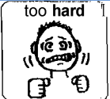

The score for *Self-Evaluation* will be determined by AltScore based on the scoring rubric below:

|  |  |  |
| --- | --- | --- |
|  | **SCORING RUBRIC:**  **Self-Evaluation** |  |
| M | 1 | 2 |
| Evidence of self-correction, monitoring, goal setting, and reflection was **not found** in this strand. | Student self-corrects monitors, sets goals, and reflects on only **one piece of evidence** in this strand. | Student self-corrects monitors, sets goals, and reflects on **two or more pieces of evidence** in this strand. |

|  |  |
| --- | --- |
|  | Scoring: *Generalized Performance (GP)* |

**Instructions to Scorers**

**Scoring Rules**

1. Activities in **community settings** (i.e., outside the school, including homework) always count as one example of GP when this is indicated in the evidence or in the brief description.
2. **Use of** **age-inappropriate instructional materials** (e.g., dolls, nursery rhymes, etc.) by a student in grades 6–10 will result in a score of GP = 1, regardless of other factors contributing to the GP score. In this case, add Comment G from the Comment Key. Check with your Table Leader if you are uncertain.

**Instructions to Scorers**

The scorer should review all evidence and brief descriptions for examples of “generalized performance.” Generalized Performance reflects the number of **instructional approaches** and **activity formats** used by the student to acquire and demonstrate knowledge and skills, including any of the following variations:

* *Media and materials* (e.g., uses a variety of materials, such as printed text, manipulatives, art materials, computer, etc.)
* *Activity formats* (e.g., classroom projects, research, experiments, worksheets, open/constructed responses)
* *Presentation formats* (e.g., oral, written, multimedia)
* *Response formats* (e.g., handwritten, word-processed, oral presentation, or visual display)
* Application of skills and/or knowledge in a setting outside the school

The scorer should indicate in AltScore whether one or multiple example(s) of generalized performance were found in the strand.

**For ELA−Writing and STE ONLY**

The scorer does not need to indicate a score for Generalized Performance for strands in ELA−Writing and STE. When the minimum requirements are met, a score of GP=2 will be generated automatically for these strands.

The score for *Generalized Performance* will either be “**1” or “2**,” based on the rubric below:

|  |
| --- |
| **SCORING RUBRIC FOR EACH STRAND:**  **Generalized Performance (GP)** |

|  |  |
| --- | --- |
| 1 | 2 |
| Student demonstrates knowledge and skills in this strand using a **single** context or **one** instructional approach. | Student demonstrates knowledge and skills in this strand using **two or more** contexts or instructional approaches. |

|  |  |
| --- | --- |
|  | Scoring Rules in Special Cases |

1. **Can pieces of primary evidence also be included as points on the data chart? If so, is the strand complete?**

Yes. At the teacher’s discretion, the work samples, videos, and other primary evidence may beincluded as data points on a data chart, but it is *not* required. Regardless of whether primary evidence is also included as data points on the chart, scorers will count the evidence for determining completeness, provided the work reflects the skill listed in the measurable outcome. If a work sample is also included on the data chart, the percentage of accuracy and independence will only be counted once by AltScore.

1. **What if a required strand is not submitted?**

The scorer must indicate that the strand was not submitted by checking the box “strand required but not submitted” on the final AltScore screen.

1. **What if a strand was submitted that was not required for a student in that grade?**

If a strand was submitted in a discipline or domain that was **not** required, scorers should **not score** the strand.

1. **Can primary evidence be submitted from previous school years?**

The requirement is that submitted evidence should have been created during the current school year. Only **Science and Technology/Engineering (STE)** assessments in grades 5, 8, and high school may contain evidence accumulated over two consecutive school years, the current and one previous year (i.e., beginning July 1, 2022).

1. **Can photographs (or a series of photographs) and video samples be submitted as primary evidence?**

Products submitted in a strand will be counted and scored as primary evidence if the final product of instruction is visible and photo(s) or video(s) clearly describes how the student demonstrated the measurable outcome. Each product must be labeled with all required information. Video samples must be intelligible (or transcribed in writing), clear enough for a scorer to see the final product, and no longer than three (3) minutes in duration.

|  |  |
| --- | --- |
|  | Maintaining Validity and Reliability |

**Training and Qualification of Scorers**

Before the first day of actual scoring, prospective scorers receive intensive training supervised by Department staff. After training is completed, each prospective scorer, Table Leader, scoring specialist, and Floor Manager must pass a qualifying test before scoring any student assessments.

**Qualifying Test**

To qualify, prospective scorers must individually score several pre-calibrated, simulated MCAS-Alt strands using the AltScore onscreen scoring program. These “qualification strands” cover a range of scenarios scorers are likely to encounter in the actual scoring of student assessments. Prospective scorers are permitted to refer to the following publications while taking the qualifying test:

* + *Guidelines for Scoring 2024 MCAS-Alt* (this publication)
  + *Resource Guide* *to the Massachusetts Curriculum Frameworks for Students with Disabilities* (Fall 2022 edition) (digital version)
  + *Training for MCAS-Alt Scorers* − PowerPoint presentation handout
  + Sample strands used during scorer training

The passing scores for the qualifying test are as follows:

* + Scorers must achieve a score of at least **85 percent** correct
  + Table Leaders, Floor Managers, and MCAS-Alt scoring specialists must achieve a score of at least **90 percent** correct.

Prospective scorers, Table Leaders, scoring specialists, and Floor Managers who do *not* qualify on the first attempt are allowed to review their tests and receive additional training, after which a second qualifying test is administered. Those who do not qualify on the second attempt will be excused from scoring. Table Leaders and scoring specialists who score 85–89 percent will be invited to participate as scorers, but not as Table Leaders or scoring specialists.

**Maintaining the Accuracy and Consistency of Scores**

All scoring discrepancies and scores of “M” for DSC and IND are resolved by a scoring specialist and Floor Managers.

Table Leaders and Department staff will track each scorer’s inter-rater reliability (IRR). For assessments in grades 3–10, this is accomplished by double-scoring at least one student’s entire assessment (i.e., skills surveys and strands) each morning and afternoon for each scorer, or at least one entire assessment out of every five scored. Table Leaders and scoring specialists will be double-scored on at least two complete assessments each week, with discrepancies resolved by a Floor Manager. Each scorer’s rate of agreement with an expert scorer (i.e., inter-rater reliability) must be maintained at a level of 80 percent or higher for all rubric areas in the double-scored assessments. When the rate of agreement falls below 80 percent, scorers are retrained and subsequently double-scored for the remainder of that day and may be released from scoring at the discretion of the Department if their rate of agreement falls below 80 percent two or more subsequent times.

|  |  |
| --- | --- |
|  | Appendix A: Scorer Comment Key |

Scorer comment keys
Strand comments for writing, level of complexity and general comments 

|  |  |
| --- | --- |
|  | Appendix B: MCAS-Alt Glossary |

**The following terms are used to describe and score the MCAS-Alt:**

**Access Skills:** Student outcomesthat address a social or motor skill during a standards-based (i.e., academic) activity in the required strand

**Conceptual Category:** The high school Mathematics standards are clustered in “conceptual categories:” Number and Quantity (N), Algebra (A), Functions (F), Modeling, Geometry, and Statistics and Probability (S) which together present a coherent view of high school mathematics.

**Content Area:** The subject assessed by the MCAS-Alt, including English Language Arts and Literacy (ELA), Mathematics, and Science and Technology/Engineering (STE)

**A core set of evidence:** The minimum amount of evidence required for a strand to receive a score. For subjects, other than ELA−Writing and STE, this includes:

* + - * **One data chart** showing a student’s progress over time in learning the measurable outcome; **PLUS**
      * **Two additional pieces of primary evidence** (e.g., work samples)showing the student’s performance of the same measurable outcome shown on the data chart.

**Domain:** A topic or cluster of related Mathematics standards in grades PreK−8, according to the Massachusetts Curriculum Framework.

**Entry Point:** An academic outcome based on a learning standard that has been modified below grade-level expectations. Entry points are listed at progressively lower levels of complexity in the Fall 2023 *Resource Guide* *to the Massachusetts Curriculum Frameworks for Students with Disabilities (the “Resource Guide”).* **Learning Standard:** Specific statement of what *all* students should know and be able to do by the end of each grade.

**Measurable Outcome:** A specific goal for a student taking the MCAS-Alt that serves as the basis of his or her data charts and/or primary evidence. Measurable outcomes are based on entry points and access skills listed in the Resource Guide that identify the specific skill to be assessed in the strand/domain required for the assessment of a student in that grade. Measurable outcomes have been individualized with percentages of accuracy and independence (e.g., “[Student] will add 3-digit numbers with 80 percent accuracy and 100 percent independence”)

**Primary evidence:** A work sample, photograph, video sample, or teacher-documented work sample that documents the student’s knowledge or demonstration of a skill.

***Resource Guide to the Massachusetts Curriculum Frameworks for Students with Disabilities*:** The Resource Guides list the Massachusetts learning standards in each subject and grade and identify student outcomes (i.e., entry points and access skills) based on each standard at successively lower levels of complexity (i.e., from more-to-less complex).

**Strand:** A unit of scorable evidence in the alternate assessment; a cluster of related standards in the Massachusetts Curriculum Framework.

**Supporting documentation:** Products that show the context and/or format of an instructional activity, but not the final product or performance of the activity, i.e., how did the instruction occur? Examples of supporting documentation might include a blank graphic organizer, a computer screenshot of a program or application used by the student, a reflection sheet, or a work description.

|  |  |
| --- | --- |
|  | Appendix C: Sample MCAS-Alt Skills Survey |

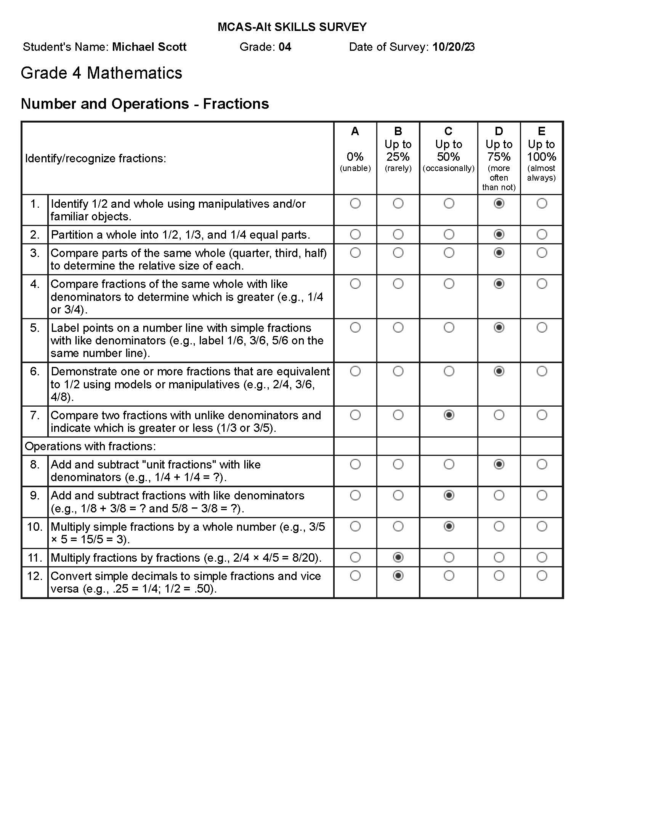

|  |  |
| --- | --- |
|  | Appendix D: Data Chart–Sample Field Data Chart |

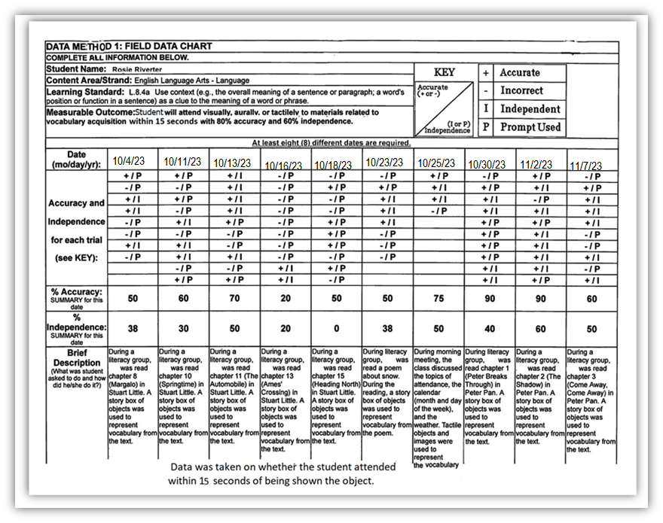

|  |
| --- |
| Appendix D: Data Chart–Sample Bar Graph |

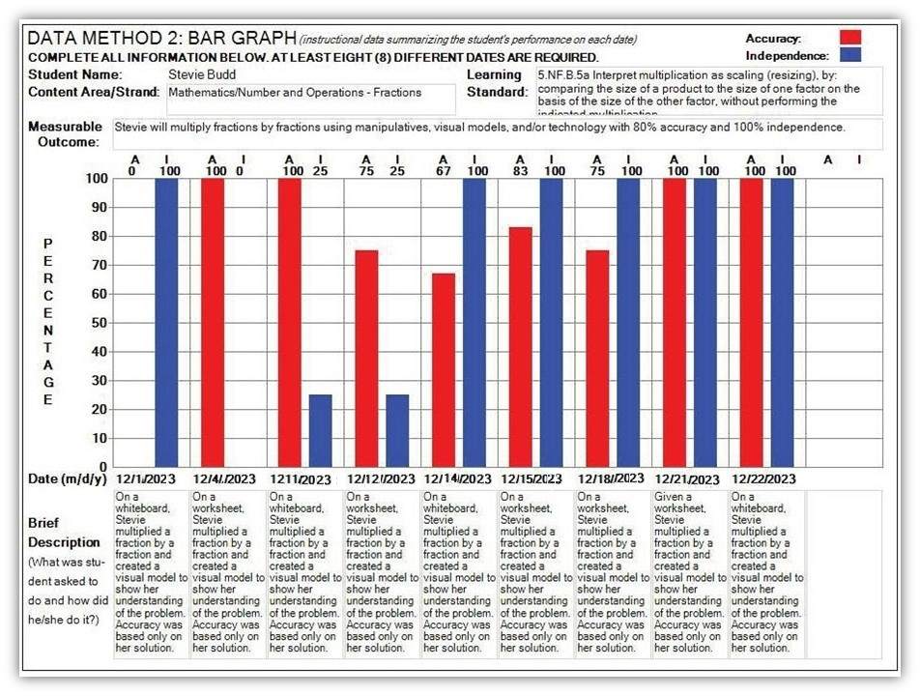

|  |
| --- |
| Appendix D: Data Chart–Sample Line Graph |

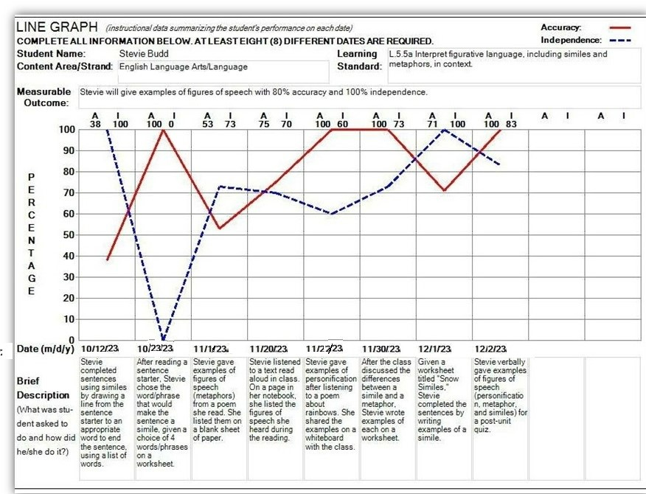

|  |  |
| --- | --- |
|  | Appendix E: MCAS-Alt Rubric for Scoring Strands |

Rubric for scoring each strand
Level of Complexity 1-5
Demonstration of Skills and Concepts (accuracy): M-5
Independence: M-5
Self-evaluation: M-2
Generalized Performance 1-2

|  |  |
| --- | --- |
|  | Appendix E: Rubric for Scoring ELA−Writing |

ELA-Writing Scoring Rubric contains
Level of Complexity
Expression of ideas and content
Knowledge of Conventions
Text Structure
Use of Vocabulary


|  |  |
| --- | --- |
|  | Appendix F: STE Strand Cover Sheet for Grades 5 and 8 STE, andHigh School Biology and Introductory Physics |

Strand cover sheet  for Science and technology Engineering
Includes student's name grade, discipline, core idea and summary description 

|  |  |
| --- | --- |
|  | Appendix F: STE Summary Sheet for Grades 5 and 8 STE, andHigh School Biology and Introductory Physics |

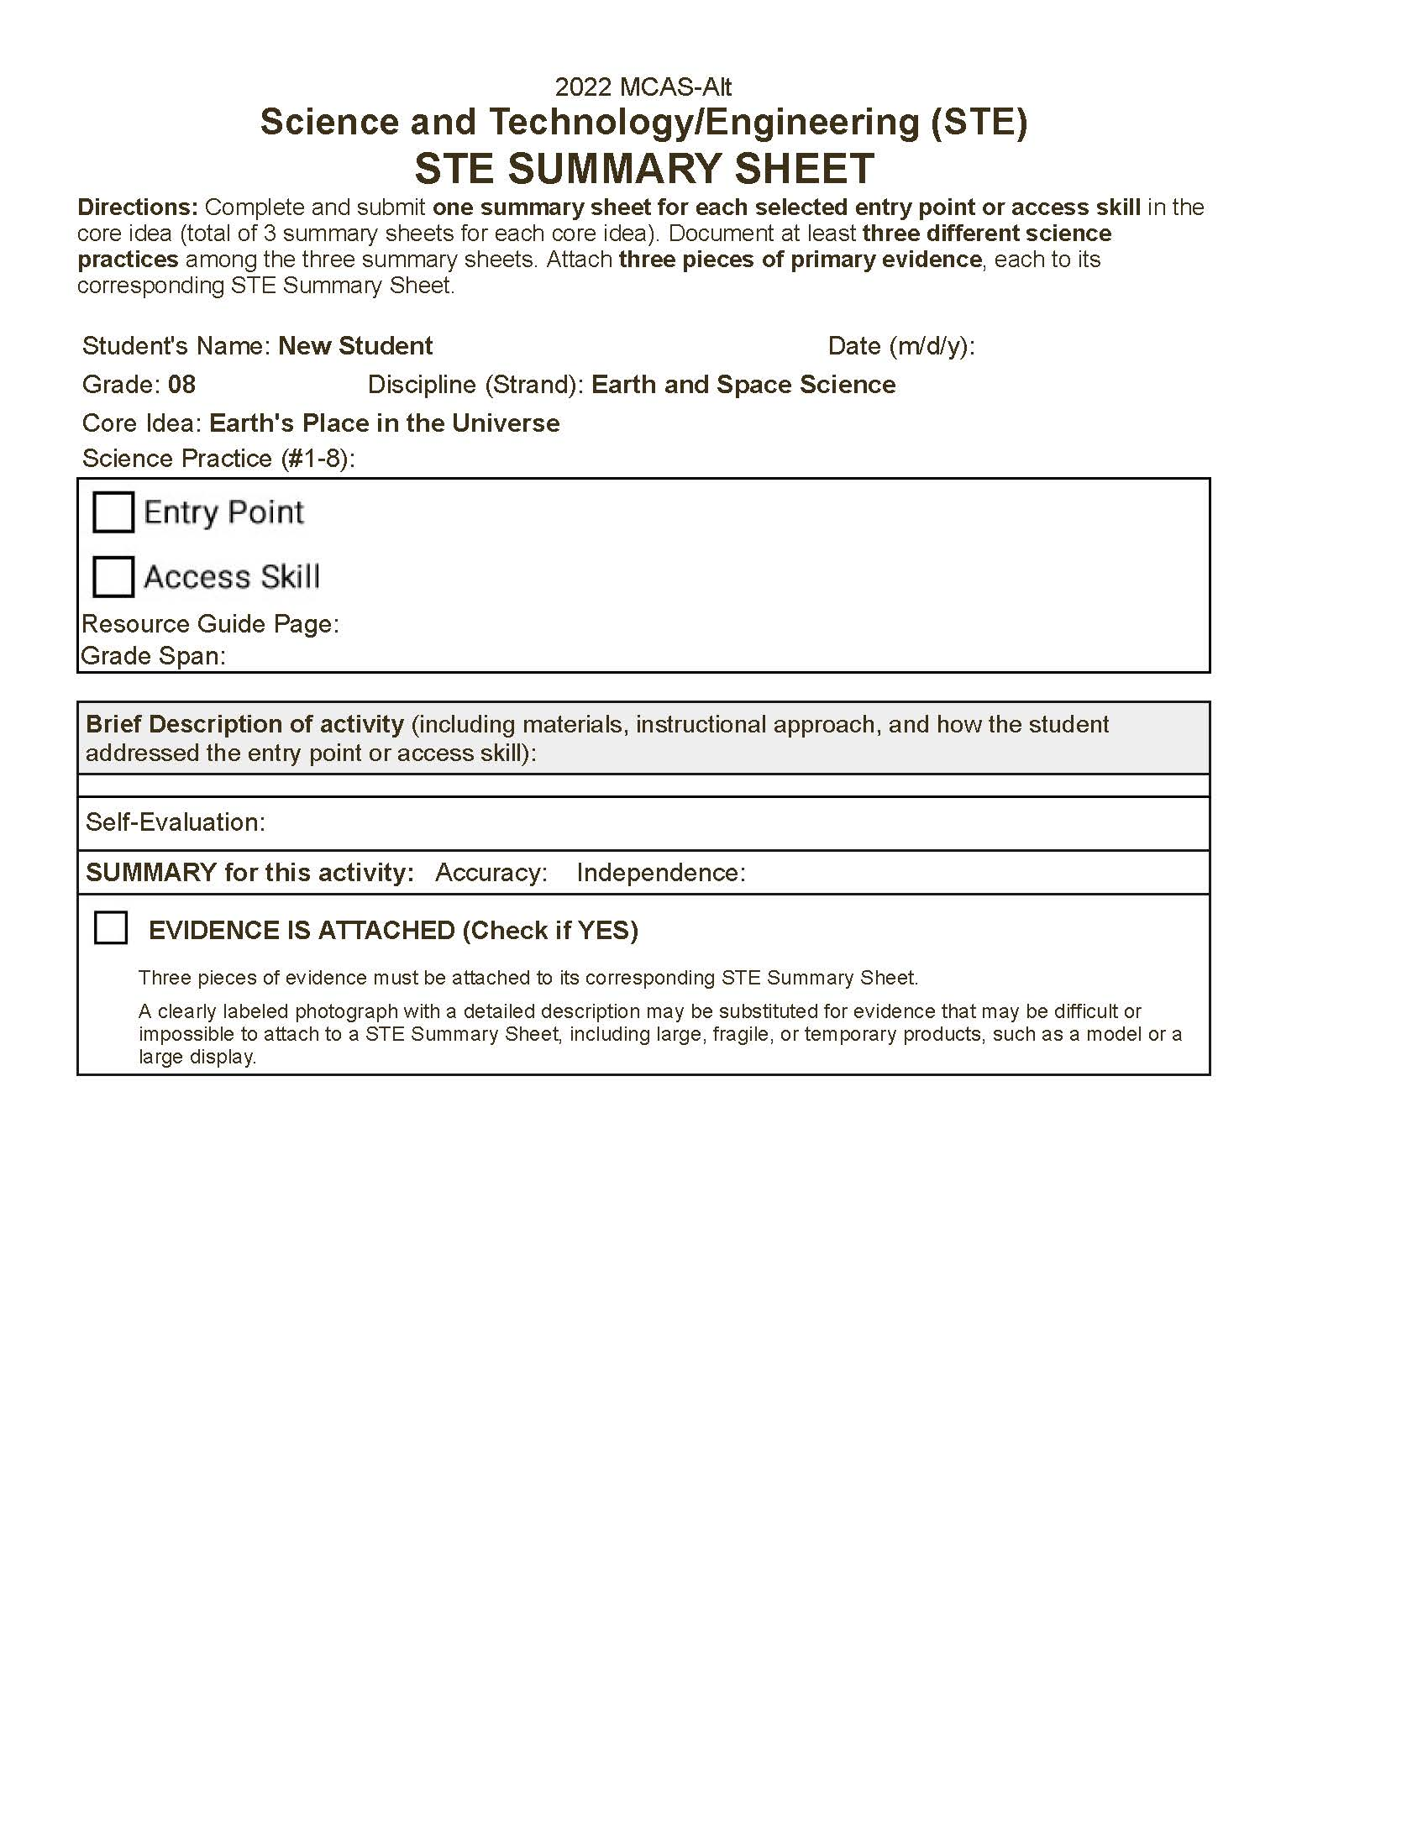

|  |  |
| --- | --- |
|  | **Appendix G: Sample of Teacher-Documented Work Sample** |

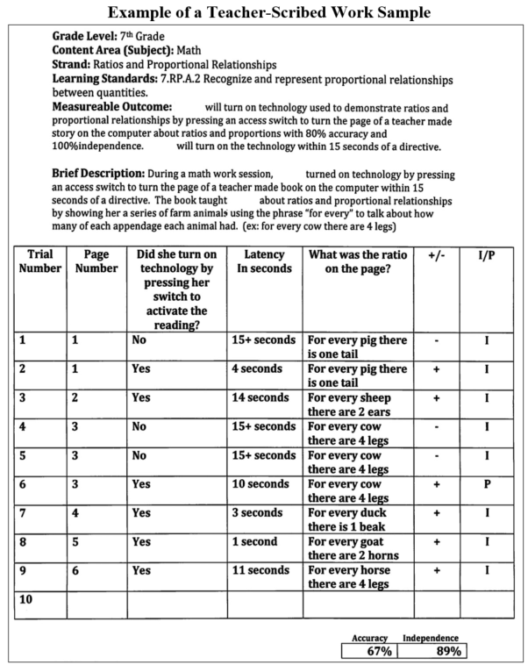

|  |  |
| --- | --- |
|  | Appendix H: Informational Text – Supplemental List |

Teachers are directed to include a photocopy of any Internet-based or teacher-created texts being submitted in the student’s ELA-Reading assessment. **The following *informational* texts** **do not require a photocopy** **for the** **ELA−Reading−Informational Text** **strand because they are widely used and well-known:**

* + ***News-2-You*** (symbol and text-based)
  + ***Scholastic for Kids*** 
    - ***Science Spin***
  + ***Weekly Reader***
  + ***Time for Kids***
  + ***Newsweek for Kids***
  + ***National Geographic for Kids***
  + ***Newsela*** (daily online news articles at five different reading levels from grades 3–12)
  + ***Unique Learning Systems*** (symbol and text-based)
  + ***Wonderopolis*** or ***Camp Wonderopolis***
  + **Digital Textbooks (provide the name of the textbook)**

Teachers may simply list the title and topic of articles, plus the name of the publication, from the sources listed above either in the brief description or directly on the evidence. For example:

***“(Student) read an article about goats from National Geographic for Kids***

***and answered five comprehension questions on a worksheet.”***

|  |  |
| --- | --- |
|  | Appendix H: Literature and Informational Text Types |

